Optimized High-Speed and Area-Efficient VLSI Architecture for Three-Operand Binary Adders

# 1Ramesh Babu Kolikapudi, 2Gangolu Rajesh, 3R Hanumanth Naik, 4Raju Thommandru

**1,2Asst. Professor, Dept. of ECE, Chalapathi Institute of Technology, Guntur, AP, India.**

**3Assoc. Professor, Dept. of EEE, Chalapathi Institute of Technology, Guntur, AP, India.**

**4Assoc. Professor, Dept. of ECE, Chalapathi Institute of Technology, Guntur, AP, India.**

**ABSTRACT: Arithmetic and logic unit has been the most significant unit in any electronic devices. In the recent advancement, for an arithmetic and logic unit to be significant it needs to have an efficient algorithmic operation such as Multiplications and addition. Three- operand binary adder is the basic functional unit to perform the modular arithmetic in various cryptography and pseudorandom bit generator (PRBG) algorithms. A parallel prefix two-operand adder such as Han-Carlson (HCA) can be used for three-operand addition that significantly reduces the critical path delay at the cost of additional hardware. This paper presents Low power and high Speed three input Binary Adder. Project will be developed using Verilog HDL. Xilinx ISE tool is used to perform the Simulation and Synthesis. The simulation results of presented adder will represent that it will have less power dissipation, lesser area and less delay compared to Carry save adder (CS3A).**

**KEYWORDS: carry save adder (CSA), Han- Carlson adder (HCA), Three input adder, Arithmetic and logic unit.**

# INTRODUCTION

Digital systems are highly complex at their most detailed level. They may consist of millions of elements i.e., transistors or logic gates. For many decades, logic schematics served as thengua. Franca of logic design, but not anymore. Today, hardware complexity has grown to such a degree that a schematic with logic gates is almost useless as it shows only a web of connectivity and not functionality of design. Since the 1970s, computer engineers, electrical engineers and electronics engineers have moved toward Hardware description language (HDLs). Digital circuit has rapidly evolved over the last twenty five years [1].

The earliest digital circuits were designed with vacuum tubes and transistors. Integrated circuits were then invented where logic gates were placed on a single chip. The first IC chip was small scale integration (SSI) chips where the gate count is small. When technology became sophisticated, designers were able to place circuits with hundreds of gates on a chip [2]. These chips were called MSI chips with advent of LSI; designers could put thousands of gates on a single chip. At this point, design process is getting complicated and designers felt the need to automate these processes.

With the advent of VLSI technology, designers could design single chip with more than hundred thousand gates. Because of the complexity of these circuits computer aided techniques became critical for verification and for designing these digital circuits [3]. One way to lead with increasing complexity of electronic systems and the increasing time to market is to design at high levels of abstraction. They are used for specification, simulation and synthesis of an electronic system. This helps to reduce the complexity in designing and products are made to be available in market quickly. The components of a digital system can be classified as being specific to an application or as being standard circuits.

To achieve optimal system performance while maintaining physical security, it is necessary to implement the cryptography algorithms on hardware. Modular arithmetic such as modular

exponentiation, modular multiplication and modular addition is frequently used for the arithmetic operations in various cryptography algorithms. Therefore, the performance of the cryptography algorithm depends on the efficient implementation of the congruential modular arithmetic operation. The most efficient approach to implement the modular multiplication and exponentiation is the Montgomery algorithm whose critical operation is based on three- operand binary addition. The three- operand binary addition is also a primary arithmetic operation in the linear congruential generator (LCG) based pseudo-random bit generators (PRBG) [4].

The three-operand binary addition can be carried out either by using two two- operand adders or one three-operand adder. Carry-save adder (CS3A) is the area-efficient and widely adopted technique to perform the three-operand binary addition in the modular arithmetic used in cryptography algorithms and PRBG methods. However, the longer carry propagation delay in the ripple-carry stage of CS3A seriously influences the performance of the MDCLCG (Modified dual coupled linear congruential generator) and other cryptography architectures on IoT based hardware devices [5].

In order to shorten the critical path delay, a parallel prefixed twooperand adder such as Han-Carlson (HCA) can also be used for three-operand binary addition. It reduces the critical path delay but increases the area. Therefore, it is necessary to develop an efficient VLSI architecture to carry out the fast three- operand binary addition with minimum hardware resources.

# LITERATURE SURVEY

M. M. Islam, M. S. Hossain, M. K. Hasan,

M. Shahjalal, and Y. M. Jang, et. al. [6] presents FPGA implementation of high- speed area-efficient processor for elliptic curve point multiplication over prime field. Elliptic Curve Cryptography (ECC) has recognized much more attention over the last few years and has time-honored itself among the renowned public key cryptography schemes. The performance of hardware implementation for ECC is affected by basic design elements such as a coordinate system, modular arithmetic algorithms, implementation target, and underlying finite fields. This paper shows the generic structure of the ECC system implementation which allows the different types of designing parameters like elliptic curve, Galois prime finite field GF(p), and input type. The ECC system is analyzed with performance parameters such as required memory, elapsed time, and process complexity on the MATLAB platform.

K. Panda et. al. [7] presents a modified Montgomery modular radix-2 iterative multiplier for the effective implementation of 1024-bit BBS (Blum Blum Shub) generator hardware. The BBS effective implementation technique depends on the larger integer multiplication that can make it as computationally expensive. The two- operand adders are replaced with three- operand adders by this approach. For three-operand addition, most generally utilized adder is CSA that can experience the higher critical path delays. The results of this 1024-bit BBS implementation is operates at high frequency (71.2 MHz) and achieved improvement in latency.

Z. Liu, J. GroBschadl, Z. Hu, K. Jarvinen,

H. Wang, and I. Verbauwhede, et. al. [8] presents Elliptic curve cryptography with efficiently computable endomorphisms and its hardware implementations for the Internet of Things. In this work, we study

the computation of this operation on a twisted Edwards curve with an efficiently computable enmorphism, which allows reducing the number of point doublings by approximately 50 percent compared to a conventional implementation. We develop several optimizations to the operation and we describe two hardware architectures for computing the operation. Our designs offer various trade-offs and optimizations between performance and resource requirements and they are valuable for IoT applications.

Z. Liu, D. Liu, and X. Zou, et. al. [9] presents An efficient and flexible hardware implementation of the dual-field elliptic curve cryptographic processor. This paper presents field-programmable gate array (FPGA) implementation of a high-speed, low-area, side-channel attacks (SCAs) resistant ECC processor over a prime field. The paper proposes novel hardware architectures for point addition and point doubling operations on the twisted Edwards curve, where the processor takes only 516 and 1029 clock cycles to perform each point addition and point doubling, respectively. The implemented design is time-area-efficient as it offers fast scalar multiplication with low hardware utilization without compromising the security level.

S.-R. Kuang, et. al. [10] presents a multiplication method using Montgomery Modular to perform modular multiplication very quickly. The Montgomery Modular (MM) multiplication can be utilized in the process of encryption using PKC (Public Key Cryptography). The MM with larger integers consumes huge time in PKC. Hence several algorithms are presented for performing MM very fast and Montgomery’s algorithm is one among them. This approach replaced the complicated divisions in MM with sequence of modular shifting additions. The Montgomery algorithm is divided in

to two types depends on input and output operands representation. The two types are SCS-MM (Semi- Carry-Save Montgomery modular Multiplication) and FCS-MM (Full Carry-Save MM). This technique uses carry save adder for multiplication process. This carry save addition increases critical path delay.

# THREE OPERAND BINARY ADDER

The three-operand binary addition is one of the critical arithmetic operations in the congruential modular arithmetic architectures. Carry-save adder (CSA) is the commonly used technique to perform the three-operand binary addition. It computes the addition of three operands in two stages. The first stage is the array of full adders. Each full adder computes “carry” bit and “sum” bit concurrently from three binary input ai,bi and ci. The second stage is the ripple-carry adder that computes the final n-bit size “sum” and one-bit size “carry-out” signals at the output of three-operand addition. The “carry-out” signal is propagated through the n number of full adders in the ripple- carry stage. Therefore, the delay increases linearly with the increase of bit length. The architecture of the three-operand carry-save adder is shown in Fig.1 shows the critical path delay depends on the carry propagation delay of ripple carry stage.

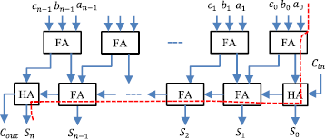

**Fig 1: THREE OPERAND CARRY SAVE ADDER (CS3A)**

The major drawback of the CS3A Adder is largest critical path delay which

increases with an increase of bit length. This critical propagation path delay influences the overall latency of the congruential modular arithmetic-based cryptography and PRBG architectures. Hence, to shorten the critical path delay, two stages of parallel prefix two-operand adder can also be used. The Han-Carlson adder provides a reasonably good speed at low gate complexity.

Thus, the three-operand addition can be performed using Han-Carlson adder (HCA) in two stages, as shown in Fig. 2. The maximum combinational path delay of HC3A depends on the propagate chain.

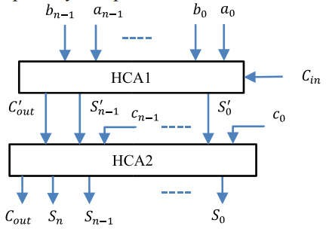

**Fig. 2: BLOCK LEVEL ARCHITECTURE OF HCA-BASED THREE-OPERAND ADDER (HC3A)**

The HCA-based three-operand binary adder (HC3A) greatly reduces the critical path delay in comparison with the three- operand carry-save binary adder. However, the area increases with increase of bit length. Therefore, to minimize this trade-off between area and delay, a new highspeed, area-efficient three-operand adder technique and its efficient VLSI architecture is proposed.

The proposed VLSI architecture of the three-operand binary adder and its internal structure is shown in Fig. 3. The new adder technique performs the addition of three n-bit binary inputs in four different stages. The proposed adder technique is a parallel prefix adder. However, it has fourstage structures instead three-stage

structures in prefix adder to compute the addition of three binary input operands such as bit-addition logic, base logic, PG (propagate and generate) logic and sum logic.

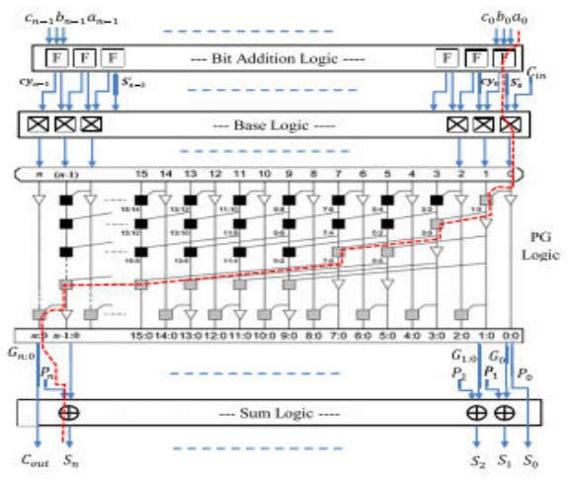

**Fig. 3: FIRST ORDER VLSI ARCHITECTURE OF PROPOSED THREE- OPERAND ADDER**

The logical expressions of all these four stages are defined as follows:

In the first stage (bit-addition logic), the bitwise addition of three n-bit binary input operands is performed with the array of full adders, and each full adder computes “sum (Si)” and “carry (cyi)” signals. The logical expressions for computing sum (Si) and carry (cyi) signals are defined in Stage-1.

Stage-1: Bit Addition Logic:

S_i = ai _ bi _ ci,

cyi = ai · bi + bi · ci + ci · ai

In the first stage, the output signal “sum (Si)” bit of current full adder and the output signal “carry” bit of its right- adjacent full adder are used together to compute the generate (Gi) and propagate (Pi) signals in the second stage (base logic). The computation of Gi and Pi signals are represented by the “squared saltire-cell” as shown as:

Stage-2: Base Logic:

Gi:i = Gi = S_i · cyi−1, G0:0 = G0 = S_0· Cin

Pi:i = Pi = S_i_ cyi−1, P0:0 = P0 = S_0_ Cin

The third stage is the carry computation stage called “generate and propagate logic” (PG) to precompute the carry bit and is the combination of black and grey cell logics. The logical diagram of black and grey cell is shown below:

Stage-3: PG (Generate and Propagate) Logic:

Gi: j = Gi:k + Pi:k · Gk−1: j , Pi: j = Pi:k · Pk−1: j

The final stage is represented as sum logic in which the “sum (Si)” bits are computed from the carry generate Gi: j and carry propagate Pi bits using the logical expression,

Stage-4: Sum Logic:

Si = (Pi _ Gi−1:0), S0 = P0, Cout = Gn:0

# RESULT ANALYSIS

This section evaluates the performance of the proposed three-operand adder and shows the simulation results. For the implementation of this project the software tool required is Xilinx ISE 14.7. The simulation and synthesis results are executed by using Xilinx ISE14.7 This project uses the spartan3e for synthesis of the design. The code is developed using the Verilog HDL Language.

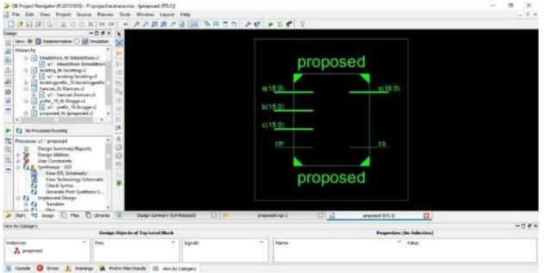

**Fig. 4: BLOCK DIAGRAM OF PROPOSED SYSTEM**

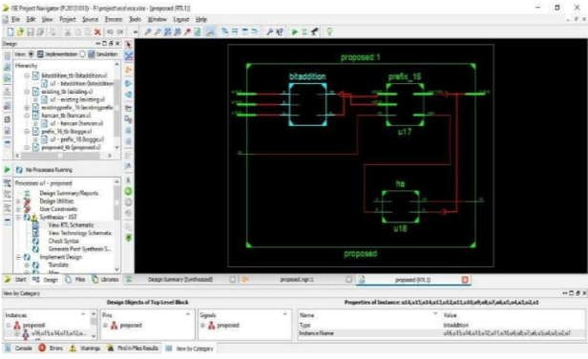

**Fig. 5: RTL SCHEMATIC**

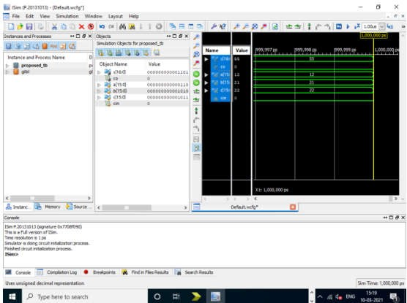

**Fig. 6: OUTPUT WAVE FORM**

Fig. 6 shows the output waveform of proposed adder where we performed addition of 16 bit input data of a b c and cin and gives the output is 16 bit sum.

The properties of physical synthesis analysis are compromised with maximum combinational gate delay, consumption of area, Power, ADP, PDP are represented in Table 1.

**Table 1: COMPARATIVE ANALYSIS**

|  |  |  |
| --- | --- | --- |
| **Parameters** | **CS3A** | **HC3A** |
| Delay (ns) | 2.12 | 0.80 |
| Power 𝜇W | 94.89 | 70.85 |
| Area 𝜇m2 | 829.16 | 139.01 |
| Area X Delay (𝜇m2 X ns) (ADP) | 1757.82 | 788.79 |
| Power X Delay (𝜇W X ns) (PDP) | 107.38 | 48.18 |

times faster than the corresponding CS3A adder architecture. It is also worth noting that the proposed adder has significantly less ADP and PDP compared to CS3A adder. This can be concluded that this adder is significantly better in terms of delay and power compared to other adders.

**ADP**

2000

1500

1000

500

0

CS3A HC3A

**Adder architectures**

**Area X Delay (m2 X ns) (ADP)**

**Fig. 7: AREA-DELAY PRODUCT (ADP)**

**PDP**

120

100

80

60

40

20

0

CS3A HC3A

**Adder architectures**

**Power X Delay (W X ns) (PDP)**

**Fig. 8: POWER-DELAY PRODUCT (PDP)**

Implementation of the described Low power and high Speed three input Binary Adder represents that described method acquires less power, less area and less delay which automatically increases the speed. ADP and PDP plots are represented in Fig. 7 and Fig. 8 respectively.

# CONCLUSION

In this paper, Low power and high Speed three input Binary Adder is described. A parallel prefix two-operand adder such as Han-Carlson (HCA) can be used for three- operand addition. The proposed three- operand adder technique is a parallel prefix adder that uses four-stage structures to compute the addition of three input operands. For the implementation of this project the software tool required is Xilinx ISE 14.7. The code is developed using the Verilog HDL Language. From the physical synthesis results, this is clear that the proposed adder architecture is 3 to 9

# REFERENCES

1. Thommandru, R. (2024). Quantum Key Distribution for Securing 6G Networks: Shaping the Future of Mobile Communication. MJARET, 4(5), 16-20.
2. Thommandru, R., & Saravanakumar, R. (2022). Survey on MIMO Antenna for 5G Applications. Mathematical Statistician and Engineering Applications, 71(3), 2181-2191.
3. Reddy, V., Sk, K. B., Roja, D., Purimetla, N. R., Vellela, S. S., & Kumar, K. K. (2023, November). Detection of DDoS Attack in IoT Networks Using Sample elected RNN-ELM. In 2023 International Conference on Recent Advances in Science and Engineering Technology (ICRASET) (pp. 1-7). IEEE.
4. Sai Srinivas Vellela, M Venkateswara Rao, Srihari Varma Mantena, M V Jagannatha Reddy, Ramesh Vatambeti, Syed Ziaur Rahman, "Evaluation of Tennis Teaching Effect Using Optimized DL Model with Cloud Computing System", International Journal of Modern Education and Computer Science(IJMECS), Vol.16, No.2, pp. 16-28, 2024. DOI:10.5815/ijmecs.2024.02.02
5. Vullam, N., Roja, D., Rao, N., Vellela, S. S., Vuyyuru, L. R., & Kumar, K. K. (2023, November). Enhancing Intrusion Detection Systems for Secure ECommerce Communication Networks. In 2023 International Conference on the Confluence of Advancements in Robotics, Vision and Interdisciplinary Technology Management (IC-RVITM) (pp. 1-7). IEEE.
6. Vullam, N., Roja, D., Rao, N., Vellela, S. S., Vuyyuru, L. R., & Kumar, K. K. (2023, December). An Enhancing Network Security: A Stacked Ensemble Intrusion Detection System for Effective Threat Mitigation. In 2023 3rd International Conference on Innovative Mechanisms for Industry Applications (ICIMIA) (pp. 1314-1321). IEEE.
7. Basha, S. K., Purimetla, N. R., Roja, D., Vullam, N., Dalavai, L., & Vellela, S. S. (2023, December). A Cloud-based Auto-Scaling System for Virtual Resources to Back Ubiquitous, Mobile, Real-Time Healthcare Applications. In 2023 3rd International Conference on Innovative Mechanisms for Industry Applications (ICIMIA) (pp. 1223-1230). IEEE.
8. Rao, A. S., Dalavai, L., Tata, V., Vellela, S. S., Polanki, K., Kumar, K. K., & Andra, R. (2024, February). A Secured Cloud Architecture for Storing Image Data using Steganography. In 2024 2nd International Conference on Computer, Communication and Control (IC4) (pp. 1-6). IEEE.
9. Reddy, B. V., Sk, K. B., Polanki, K., Vellela, S. S., Dalavai, L., Vuyyuru, L. R., & Kumar, K. K. (2024, February). Smarter Way to Monitor and Detect Intrusions in Cloud Infrastructure using Sensor-Driven Edge Computing. In 2024 IEEE International Conference on Computing, Power and Communication Technologies (IC2PCT) (Vol. 5, pp. 918-922). IEEE.
10. Biyyapu, N., Veerapaneni, E. J., Surapaneni, P. P., Vellela, S. S., & Vatambeti, R. (2024). Designing a modified feature aggregation model with hybrid sampling techniques for network intrusion detection. Cluster Computing, 1-19.
11. Reddy, N. V. R. S., Chitteti, C., Yesupadam, S., Desanamukula, V. S., Vellela, S. S., & Bommagani, N. J. (2023). Enhanced speckle noise reduction in breast cancer ultrasound imagery using a hybrid deep learning model. Ingénierie des Systèmes d’Information, 28(4), 1063-1071.
12. Vellela, S. S., Vuyyuru, L. R., MalleswaraRaoPurimetla, N., Dalavai, L., & Rao, M. V. (2023, September). A Novel Approach to Optimize Prediction Method for Chronic Kidney Disease with the Help of Machine Learning Algorithm. In 2023 6th International Conference on Contemporary Computing and Informatics (IC3I) (Vol. 6, pp. 1677-1681). IEEE.
13. Davuluri, S., Kilaru, S., Boppana, V., Rao, M. V., Rao, K. N., & Vellela, S. S. (2023, September). A Novel Approach to Human Iris Recognition And Verification Framework Using Machine Learning Algorithm. In 2023 6th International Conference on Contemporary Computing and Informatics (IC3I) (Vol. 6, pp. 2447-2453). IEEE.
14. Vellela, S. S., Roja, D., Sowjanya, C., SK, K. B., Dalavai, L., & Kumar, K. K. (2023, September). Multi-Class Skin Diseases Classification with Color and Texture Features Using Convolution Neural Network. In 2023 6th International Conference on Contemporary Computing and Informatics (IC3I) (Vol. 6, pp. 1682-1687). IEEE.
15. Praveen, S. P., Nakka, R., Chokka, A., Thatha, V. N., Vellela, S. S., & Sirisha, U. (2023). A Novel Classification Approach for Grape Leaf Disease Detection Based on Different Attention Deep Learning Techniques. International Journal of Advanced Computer Science and Applications (IJACSA), 14(6).
16. Vellela, S. S., Reddy, V. L., Roja, D., Rao, G. R., Sk, K. B., & Kumar, K. K. (2023, August). A Cloud-Based Smart IoT Platform for Personalized Healthcare Data Gathering and Monitoring System. In 2023 3rd Asian Conference on Innovation in Technology (ASIANCON) (pp. 1-5). IEEE.
17. Vellela, S. S., & Balamanigandan, R. (2023). An intelligent sleep-awake energy management system for wireless sensor network. Peer-to-Peer Networking and Applications, 16(6), 2714-2731.
18. Vullam, N., Yakubreddy, K., Vellela, S. S., Sk, K. B., Reddy, V., & Priya, S. S. (2023, June). Prediction And Analysis Using A Hybrid Model For Stock Market. In 2023 3rd International Conference on Intelligent Technologies (CONIT) (pp. 1-5). IEEE.
19. Rao, K. N., Gandhi, B. R., Rao, M. V., Javvadi, S., Vellela, S. S., & Basha, S. K. (2023, June). Prediction and Classification of Alzheimer’s Disease using Machine Learning Techniques in 3D MR Images. In 2023 International Conference on Sustainable Computing and Smart Systems (ICSCSS) (pp. 85-90). IEEE.
20. Vellela, S. S., Vullum, N. R., Thommandru, R., Rao, T. S., Sowjanya, C., Roja, D., & Kumar, K. K. (2024, May). Improving Network Security Using Intelligent Ensemble Techniques: An Integrated System for Detecting and Managing Intrusions in Computer Networks. In 2024 International Conference on Advances in Modern Age Technologies for Health and Engineering Science (AMATHE) (pp. 1-7). IEEE.
21. Vullam, N., Vellela, S. S., Reddy, V., Rao, M. V., SK, K. B., & Roja, D. (2023, May). Multi-Agent Personalized Recommendation System in ECommerce based on User. In 2023 2nd International Conference on Applied Artificial Intelligence and Computing (ICAAIC) (pp. 1194-1199). IEEE.
22. Praveen, S. P., Sarala, P., Kumar, T. K. M., Manuri, S. G., Srinivas, V. S., & Swapna, D. (2022, November). An Adaptive Load Balancing Technique for Multi SDN Controllers. In 2022 International Conference on Augmented Intelligence and Sustainable Systems (ICAISS) (pp. 1403-1409). IEEE.
23. Vellela, S. S., & Balamanigandan, R. (2022, December). Design of Hybrid Authentication Protocol for High Secure Applications in Cloud Environments. In 2022 International Conference on Automation, Computing and Renewable Systems (ICACRS) (pp. 408-414). IEEE.
24. Vellela, S. S., & Balamanigandan, R. (2024). Optimized clustering routing framework to maintain the optimal energy status in the wsn mobile cloud environment. Multimedia Tools and Applications, 83(3), 7919-7938.
25. VenkateswaraRao, M., Vellela, S., Reddy, V., Vullam, N., Sk, K. B., & Roja, D. (2023, March). Credit Investigation and Comprehensive Risk Management System based Big Data Analytics in Commercial Banking. In 2023 9th International Conference on Advanced Computing and Communication Systems (ICACCS) (Vol. 1, pp. 2387-2391). IEEE.
26. Vellela, S. S., Reddy, B. V., Chaitanya, K. K., & Rao, M. V. (2023, January). An integrated approach to improve e-healthcare system using dynamic cloud computing platform. In 2023 5th International Conference on Smart Systems and Inventive Technology (ICSSIT) (pp. 776-782). IEEE.
27. Kumar, K. K., Rao, T. S., Vullam, N., Vellela, S. S., Jyosthna, B., Farjana, S., & Javvadi, S. (2024, March). An Exploration of Federated Learning for Privacy-Preserving Machine Learning. In 2024 5th International Conference on Innovative Trends in Information Technology (ICITIIT) (pp. 1-6). IEEE.
28. SrinivasVellela, S., Praveen, S. P., Roja, D., Krishna, A. R., Purimetla, N., Rao, T., & Kumar, K. K. (2024, April). Fusion-Infused Hypnocare: Unveiling Real-Time Instantaneous Heart Rates for Remote Diagnosis of Sleep Apnea. In 2024 International Conference on Knowledge Engineering and Communication Systems (ICKECS) (Vol. 1, pp. 1-5). IEEE.
29. Vellela, S. S., KOMMINENI, K. K., Rao, D. M. V., & Sk, K. B. (2024). An Identification of Plant Leaf Disease Detection Using Hybrid Ann and Knn. Sai Srinivas Vellela, Dr K Kiran Kumar, Dr. M Venkateswara Rao, Venkateswara Reddy B, Khader Basha Sk, Roja D, AN IDENTIFICATION OF PLANT LEAF DISEASE DETECTION USING HYBRID ANN AND KNN, Futuristic Trends in Artificial Intelligence, e.
30. Polasi, P. K., Vellela, S. S., Narayana, J. L., Simon, J., Kapileswar, N., Prabu, R. T., & Rashed, A. N. Z. (2024). Data rates transmission, operation performance speed and figure of merit signature for various quadurature light sources under spectral and thermal effects. Journal of Optics, 1-11.
31. Thommandru, R., Krishna, C. M., Suguna, N., Sathish, M., & Kiran, K. (2024, January). Millimetre Wave Self-Isolated MIMO Antenna with High Isolation and Radiation Efficiency. In 2024 2nd International Conference on Intelligent Data Communication Technologies and Internet of Things (IDCIoT) (pp. 191-196). IEEE.
32. Thommandru, R., Krishna, C. M., Suguna, N., Sathish, M., & Kiran, K. (2024, January). Millimetre Wave Self-Isolated MIMO Antenna with High Isolation and Radiation Efficiency. In 2024 2nd International Conference on Intelligent Data Communication Technologies and Internet of Things (IDCIoT) (pp. 191-196). IEEE.
33. Vellela, S. S., & Balamanigandan, R. (2024). Optimized clustering routing framework to maintain the optimal energy status in the wsn mobile cloud environment. *Multimedia Tools and Applications*, *83*(3), 7919-7938.
34. Vuyyuru, L. R., Purimetla, N. R., Reddy, K. Y., Vellela, S. S., Basha, S. K., & Vatambeti, R. (2024). Advancing automated street crime detection: a drone-based system integrating CNN models and enhanced feature selection techniques. *International Journal of Machine Learning and Cybernetics*, 1-23.
35. Krishna, C. V. M., Krishna, G. G., Vellela, S. S., Rao, M. V., Sivannarayana, G., & Javvadi, S. (2023, December). A Computational Data Science Based Detection of Road Traffic Anomalies. In 2023 Global Conference on Information Technologies and Communications (GCITC) (pp. 1-6). IEEE.
36. Vellela, S. S., & Balamanigandan, R. (2024). An efficient attack detection and prevention approach for secure WSN mobile cloud environment. Soft Computing, 1-15.
37. Saravanakumar, R., Raja, A., Narayan, P., Rajesh, G., Vinoth, M., & Thommandru, R. (2024, September). Dual-Band Performance Enhancement of Square Wheel Antennas with FR4 Substrate for Sub 7GHz Applications. In 2024 International Conference on Advances in Computing Research on Science Engineering and Technology (ACROSET) (pp. 1-7). IEEE.
38. Thommandru, R., Krishna, C. M., Suguna, N., Sathish, M., & Kiran, K. (2024, January). Millimetre Wave Self-Isolated MIMO Antenna with High Isolation and Radiation Efficiency. In 2024 2nd International Conference on Intelligent Data Communication Technologies and Internet of Things (IDCIoT) (pp. 191-196). IEEE.
39. Saravanakumar, R., Thommandru, R., Kumar, E. K., Al Ansari, M. S., Manage, P. S., & Muthuvel, S. K. (2024, April). Cross Scoop Fractal Antenna Design with Notch at 15 Degree for Emerging Applications at 5.2 GHz. In 2024 International Conference on Recent Advances in Electrical, Electronics, Ubiquitous Communication, and Computational Intelligence (RAEEUCCI) (pp. 1-7). IEEE.
40. Saravanakumar, R., Ponnapalli, V. P., Thommandru, R., Khatak, S., Manohara, H. T. P., & Thenmozhi, A. (2024, March). Analysis Circular Wave Guide Antenna for 5G Mid-Band Applications. In 2024 10th International Conference on Advanced Computing and Communication Systems (ICACCS) (Vol. 1, pp. 560-566). IEEE.
41. Thommandru, R., Krishna, C. M., Suguna, N., Sathish, M., & Kiran, K. (2024, January). Millimetre Wave Self-Isolated MIMO Antenna with High Isolation and Radiation Efficiency. In 2024 2nd International Conference on Intelligent Data Communication Technologies and Internet of Things (IDCIoT) (pp. 191-196). IEEE.
42. Thommandru, R., & Saravanakumar, R. (2022). Survey on MIMO Antenna for 5G Applications. Mathematical Statistician and Engineering Applications, 71(3), 2181-2191.
43. Kommineni, K.K., Prasad, A. Enhancing Data Security and Privacy in SDN-Enabled MANETs Through Improved Data Aggregation Protection and Secrecy. Wireless Pers Commun (2024). <https://doi.org/10.1007/s11277-024-11635-w>
44. Madhuri, A., Jyothi, V. E., Praveen, S. P., Sindhura, S., Srinivas, V. S., & Kumar, D. L. S. (2024). A new multi-level semi-supervised learning approach for network intrusion detection system based on the ‘goa’. Journal of Interconnection Networks, 24(supp01), 2143047.
45. Thommandru, R., Kalyani, K., Rani, B. S., Karunakar, K., Sai, A. V., & Guptha, P. IoT Based Automatic Vehicle Accident Detection and Rescue System.
46. Madhuri, A., Praveen, S. P., Kumar, D. L. S., Sindhura, S., & Vellela, S. S. (2021). Challenges and issues of data analytics in emerging scenarios for big data, cloud and image mining. Annals of the Romanian Society for Cell Biology, 412-423.
47. Vellela, S. S., Balamanigandan, R., & Praveen, S. P. (2022). Strategic Survey on Security and Privacy Methods of Cloud Computing Environment. Journal of Next Generation Technology, 2(1).
48. Sk, K. B., Roja, D., Priya, S. S., Dalavi, L., Vellela, S. S., & Reddy, V. (2023, March). Coronary Heart Disease Prediction and Classification using Hybrid Machine Learning Algorithms. In 2023 International Conference on Innovative Data Communication Technologies and Application (ICIDCA) (pp. 1-7). IEEE.
49. Vellela, S. S., & Krishna, A. M. (2020). On Board Artificial Intelligence With Service Aggregation for Edge Computing in Industrial Applications. Journal of Critical Reviews, 7(07).
50. Kumar, E. R., Chandolu, S. B., Kumar, K. P. V., Rao, M. V., Muralidhar, V., Nagarjuna, K., & Vellela, S. S. (2023, November). UAVC: Unmanned Aerial Vehicle Communication Using a Coot Optimization-Based Energy Efficient Routing Protocol. In 2023 International Conference on Recent Advances in Science and Engineering Technology (ICRASET) (pp. 1-5). IEEE.
51. Vellela, S. S., Sowjanya, C., Vullam, N., Srinivas, B. R., Durga, M. L., Jyosthna, B., & Kumar, K. K. (2024, March). An Examination of Machine Learning Applications in the Field of Cybersecurity Approaches for Detecting and Mitigating Threats. In 2024 Third International Conference on Intelligent Techniques in Control, Optimization and Signal Processing (INCOS) (pp. 1-6). IEEE.