## Optimized Lossless and Reversible Data Hiding Approaches in Encrypted Image Sharing with Multiple Hiders

# 1Aswani Lalitha, 2Anjali Kumari, 3Gangolu Rajesh, 4Raju Thommandru,

**1,4Assoc. Professor, Dept. of ECE, Chalapathi Institute of Technology, Guntur, AP, India.**

**2,3Asst. Professor, Dept. of ECE, Chalapathi Institute of Technology, Guntur, AP, India.**

**ABSTRACT: Data hiding is an effective approach for protecting information by embedding it within a cover medium, making it imperceptible to anyone who may try to detect its presence. This technique typically involves three parties: the image provider, data hider, and receiver. Based on the security model and key management, data hiding schemes can be categorized into three types: share independent secret keys (SIK), shared one key (SOK), and share no secret keys (SNK). In the SIK model, both the image provider and data hider independently share secret keys with the receiver. In contrast, the SNK model does not require the sharing of any secret keys.This paper proposes Reversible and Lossless Data Hiding Schemes in Encrypted Image Secret Sharing involving multiple data hiders. The proposed method combines data hiding schemes for cipher-text images encrypted using public key cryptography that possess probabilistic and homomorphic properties.In the lossless scheme, additional data is embedded into the least significant bit (LSB) planes of cipher-text pixels by replacing the pixel values with new ones. For the reversible scheme, a histogram shrink preprocessing is applied before encryption, and half of the cipher-text pixel values are modified to accommodate the hidden data. These two schemes are compatible, allowing both data embedding operations to be carried out simultaneously in the encrypted image. Experimental results demonstrate the effectiveness and efficiency of the proposed method.**

***KEYWORDS: Secret Sharing, Reversible Data Hiding, Lossless Data Hiding, Encrypted Image, Public Key Cryptography.***

## INTRODUCTION

Data in the large amount gets transferred through public communication channels due to easily availability of the Internet. The transmitted data has to be protected from the illegitimate users. Data hiding is one of the approach used in the protection of the data [1].

It is scheme of transmitting data with the help of some cover media such that no one can determine the presence of hidden data inside it. The cover media can be digital images, digital videos, audio or even HTML codes. In the data hiding schemes, the pixels of the cover media are modified to carry the bits of secret data, and the modification is made up to a level that it is invisible to the human eyes.

If the hidden data and the cover media can be recovered without any loss, the data hiding is termed as Reversible Data Hiding (RDH) [2]. This technique ensures that the cover can be losslessly recovered after the extraction of the embedded data. Due to its important reversibility, the RDH technique is also used for distortion-unacceptable covers, such as military, medical, and legal forensic images. The cover image after hiding secret data is termed as marked image. RDH schemes can be carried out in different ways like based on compressed domain, histogram shifting, difference expansion, prediction error expansion, etc. In compressed domain data hiding schemes, host image is compressed, and then secret data bits are embedded inside it. Various modifications have been proposed in these compressed standards like JPEG, JPEG2000, etc.

Due to the need for image privacy- preserving, contentowner is reluctant to display images to data-hider, especially those images that contain sensitive information. Encryption is an effective and common technique for protecting image

privacy, as it converts a meaningful image into a meaningless image that is difficult for any unauthorized user to recognize [3]. Therefore, it is necessary to design reversible data hiding in encrypted images (RDH-EI). For instance, in cloud storage, the content-owner desires to store the image in the cloud with privacy-preserving by encrypting the image before uploading it to the cloud. For management purposes, the cloud service provider will embed some additional data into the encrypted image without accessing the content. On the receiver side, the authorized receiver can perfectly restore the original image after decryption and data extraction as needed.

Lossless data hiding has drawn attention to researchers in watermarking and digital rights management (DRM) systems [4]. For conventional data hiding or watermarking applications, at the encoder, the secret information can be embedded into the original images by use of algorithms designed by researchers, and then the image containing hidden data can be transmitted to the receiver. After reception of the marked media, only the secret information need to be extracted, and the ownership of such media can be authenticated. Different from conventional watermarking applications, for lossless data hiding, while decoding, both the original image, and the hidden data embedded into the image, need to be recovered and extracted perfectly. Therefore, evaluation of lossless data hiding algorithms would be somewhat different from conventional viewpoints.

When having the encrypted image containing the additional data, a receiver knowing the data hiding key may extract the embedded data, while a receiver with the private key of the cryptosystem may perform decryption to retrieve the original plaintext image. In other words, the embedded data can be extracted in the encrypted domain, and cannot be extracted

after decryption since the decrypted image would be same as the original plaintext. This paper presents Reversible Data Hiding and Lossless Data Hiding Schemes in Encrypted Image Secret Sharing with Multiple Data-Hiders. A combined data hiding schemes for cipher-text images encrypted by public key cryptography with probabilistic and homomorphic properties.

## LITERATURE SURVEY

Nour Kittawi, Ali Al-Haj, et. al. [5] presents a novel algorithm is proposed to reversibly hide data into encrypted grayscale medical images in a separable manner. The proposed algorithm hides two watermarks in a given encrypted image. The first watermark is embedded by replacing selected encrypted image pixels based on data hiding key, and the second watermark is embedded in the watermarked encrypted image using the histogram shifting reversible data hiding method. The experimental results demonstrate that the proposed algorithm has high embedding capacity, high visual image quality, and high entropy.

Yingqiang Qiu, Zhenxing Qian, Lun Yu, et. al. [6] proposes a novel reversible data hiding (RDH) method with an adaptive embedding capability by extending the generalized integer transformation (GIT). We modify the GIT algorithm to a further generalized form, and accordingly we propose an adaptive embedding algorithm. When hiding data into the original image, parameters of the extended GIT can be identified according to the content of each block. On the decoding side, the original image can be losslessly recovered after extracting the hidden message. Experimental results show that the proposed method outperforms state-of-the- art integer-transformation based RDH methods.

Y.-C. Chen, C.-W. Shiu, and G. Horng, et al. [7] proposed that one message bit is concealed into one pixel pair via

modifying the encrypted parity-check bits. By comparing the decrypted parity-check bits, the embedded message bit can be extracted and the original image can be reconstructed.

Siren Cai, Xinlu Gui, et. al. [8] proposes an efficient data hiding scheme based on reference pixel and block selection to further improve the embedding performance of histogram shifting. Specifically, we first divide the original image into non-overlapping blocks of an adjustable size. Then for each block, we assign the median of pixels as the reference pixel and the number of pixels equal to the reference value as the smooth level. In this way, difference histograms for each smooth level can be constructed. We embed the secret data using histogram shifting from the highest level histogram to lower level ones instead of sequential embedding. By this means, our proposed reversible data hiding scheme can adaptively embed data in the smooth blocks and thus improve the marked image quality with a comparable embedding capacity. The experimental results also demonstrate its superiority over some state-of-the-art reversible data hiding works.

1. Zhang, et. al. [9] presents the pixel flipping based method in which the original image is encrypted by stream cipher, and one message bit is concealed into one stream-ciphered block by flipping the three least significant bits (LSBs) of pixels. The embedded data and the original image are jointly restored by estimating the texture complexity of each block. Since then, many improvements have been made, and these methods focused on enhancing data extraction accuracy, separating data extraction and image recovery, vacating room before encryption and the implementation of other covers. All of them were designed to increase the embedding capacity as high as possible while maintaining low distortion. W.

Puech, M. Chaumont, and O. Strauss, et. al. [10], introduced an RDHEI method that encrypts the original image by the AES and embeds one message bit into an AES encrypted block by bit-plane replacement. The embedded data can be extracted by directly reading the bit of replaced location. The original image is restored by calculating the local standard deviation of decrypted blocks.

## REVERSIBLE DATA HIDING AND LOSSLESS DATA HIDING

**SCHEMES IN ENCRYPTED IMAGE SECRET SHARING**

The block diagram of Reversible Data Hiding (RDH) and Lossless Data Hiding (LDH) Schemes in Encrypted Image Secret Sharing with Multiple Data-Hiders is represented in below Fig. 1.

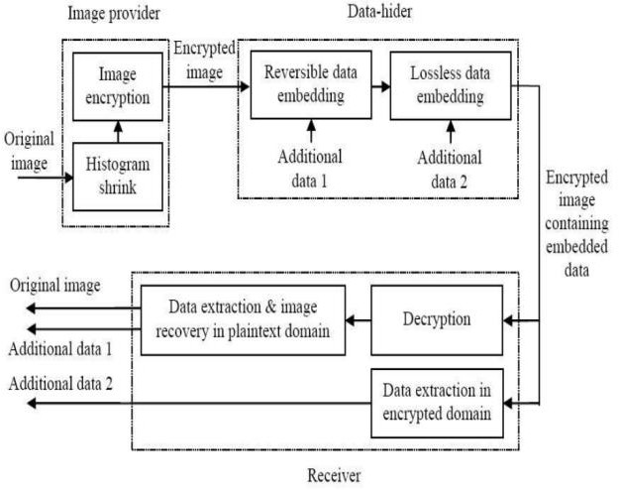

**Fig. 1: BLOCK DIAGRAM OF ENCRYPTED IMAGE SECRET SHARING**

Modules at the Transmitter Side: 1. Input image initialization. 2. Image encryption.

3. Image segmentation. 4. Key- modulation. 5. Assembler.

In Input Image Initialization module, we initialize the given image (i.e.) get the input image from user by using the keyword „uigetfile‟. This contains only the pathname and filename. To read the image filename, we used „imread‟ command. This read image was store in a variable as a matrix. Then we estimate the size of the given image using „size‟ command. This give information of size of given image to

estimate whether the given text was within the size of input image. In encryption phase, the exclusive-or results of the original bits and pseudo- random bits are calculated. When stream cipher is employed.

The term image segmentation refers to the partition of an image into a set of regions that cover it. The goal in many tasks is for the regions to represent meaningful areas of the image, such as the crops, urban areas, and forests of a satellite image. In other analysis tasks, the regions might be sets of border pixels grouped into such structures as line segments and circular arc segments in images of 3D industrial objects. Regions may also be denied as groups of pixels having both a border and a particular shape such as a circle or ellipse or polygon. When the interesting regions do not cover the whole image, we can still talk about segmentation, into foreground regions of interest and background regions to be ignored.

The proposed technique embeds message through a public key modulation mechanism and performs data extraction by exploiting the statistical distinguish ability of encrypted and non encrypted image blocks. Since the decoding of the message bits and the original image is tied together, our proposed technique belongs to the category of non separable RDH solutions Compared with the state-of-the- art methods, the proposed approach provides higher embedding capacity and is able to achieve perfect reconstruction of the original image as well as the embedded message bits.

Assembler: The decoder in the data center has the decryption key K and attempts to recover both the embedded message and the original image simultaneously from [[f]]w, which is assumed to be perfectly received without any distortions. Note that this assumption is made in almost all the existing RIDH methods.

Modules at the Receiver Side: 1. Assembled image. 2. Segmentation. 3. Data extraction and Image Recovery.

Assembled Image: The decoder in the data center has the decryption key K and attempts to recover both the embedded message and the original image simultaneously from [[f]]w, which is assumed to be perfectly received without any distortions. Note that this assumption is made in almost all the existing RDH methods.

Segmentation: 24 bit color image is best define by RGB color model in which each color appears in its primary spectral component of red, green and blue. This model is based on Cartesian coordinate system. Line joining the two corners has equal values for red, green and blue. This produces various shades of grey. The locus of all these points is called the grey line. In RGB model, each pixel is composed of RGB values and each of these colors requires 8- bit for its representation. Hence each pixel is represented by 24 bits.So total number of color possible with 24-bit RGB image.

Data Extraction and Image Recovery: The decoder in the data center has the decryption key K and attempts to recover both the embedded message and the original image simultaneously from [[f]]w, which is assumed to be perfectly received without any distortions. Note that this assumption is made in almost all the existing RIDH methods. Due to the interchangeable property of XOR operations, the any attacker without the data-hiding key cannot obtain the parameter values and the pixel-groups, therefore cannot extract the embedded data. Furthermore, although the receiver having the data-hiding key can successfully extract the embedded data, he cannot get any information about the original image content.

## RESULT ANALYSIS

Three test images including ”Lena”,”Peppers”, ”Boat” and ”Sailboat” from the standard dataset are used for the experiments. All the test images are gray- scale images sized by 512 × 512.

The embedding rate of the RDH & LDH with Multiple Data-Hiders method is compared with several state-of-the-art methods. As shown in Table 1, the embedding rate of the proposed method is significantly higher than these state-of-the- art methods. Meanwhile, the embedding rate of the proposed method is a constant value, which means that it is not affected by the image distribution. In these state-of- the-art methods, the embedding rates depend on image distribution. Images with smooth textures can achieve higher embedding rates, while images with complex textures have lower embedding rates, which can be avoided in the proposed method. This is because they vacate embedding room before encryption by the correlation of natural images, such as MSB prediction and adaptive coding. Instead, the RDH & LDH with Multiple Data-Hiders method vacates embedding room after encryption and embeds data into encrypted images with bit-plane replacement.

**Table 1: EMBEDDING RATE COMPARATIVE ANALYSIS (bps)**

|  |  |  |  |
| --- | --- | --- | --- |
| Images | RDH &  LDH with Multiple Data- Hiders | MSB  prediction | Adaptive coding |
| Lena | 3.5 | 1.7 | 2.4 |
| Peppers | 3.5 | 1.9 | 2.9 |
| Sailboat | 3.5 | 1.6 | 2.3 |

## Encryption Process:

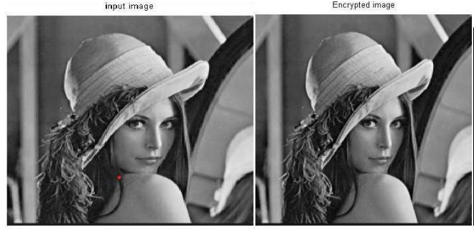

**Fig. 2: INPUT IMAGE, ENCRYPTED IMAGE**

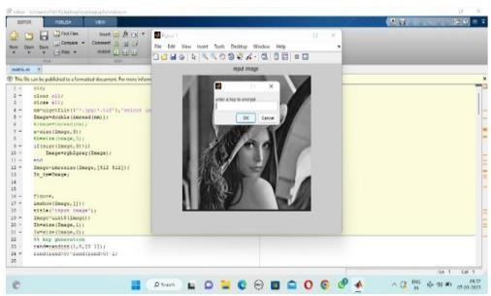

**Fig. 3: ENCRYPTION KEY IMAGE**

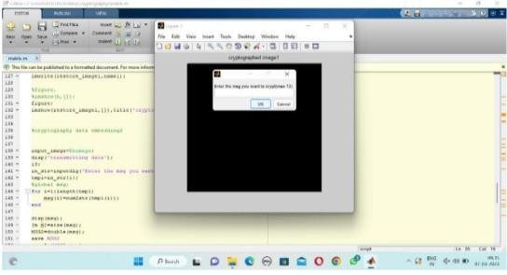

**Fig. 4: SECRET DATA INPUT**

## Decryption Process:

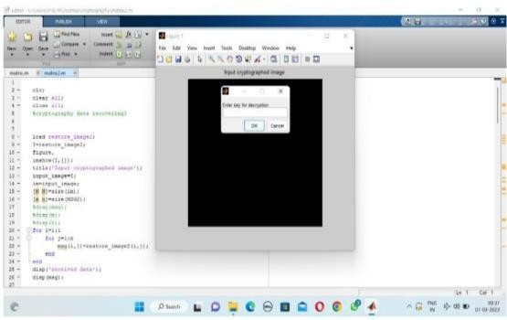

**Fig. 5: ENTRY KEY FOR DECRYPTION**

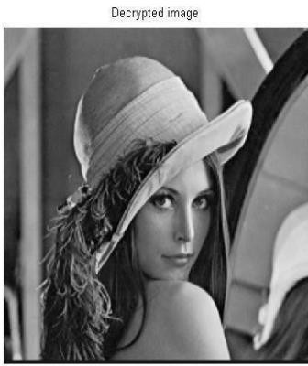

**Fig. 6: DECRYPTED IMAGE**

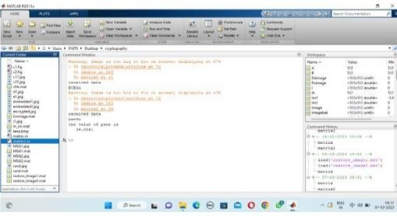

**Fig. 7: RECEIVED DATA**

The original image is reconstructed efficiently without any noise or disturbance with described Reversible Data Hiding (RDH) and Lossless Data Hiding (LDH) Schemes in Encrypted Image Secret Sharing with Multiple Data- Hiders. Finally, the experimental results illustrate the effectiveness of the proposed method.

## CONCLUSION

This paper presents Reversible Data Hiding (RDH) and Lossless Data Hiding (LDH) schemes for Encrypted Image Secret Sharing involving multiple data hiders. The proposed approach combines data hiding techniques for cipher-text images encrypted using public key cryptography with probabilistic and homomorphic properties. In the lossless scheme, new values replace the cipher-text pixel values to embed additional data into the least significant bit (LSB) planes of the cipher-text pixels.The two schemes, lossless and reversible, are designed to be compatible, allowing the data embedding operations of both schemes to be performed simultaneously within the encrypted image. This ensures that the original image can be reconstructed accurately without any distortion or noise. Experimental results further demonstrate the effectiveness of the proposed method.

## REFERENCES

1. Thommandru, R. (2024). Quantum Key Distribution for Securing 6G Networks: Shaping the Future of Mobile Communication. MJARET, 4(5), 16-20.
2. Thommandru, R., & Saravanakumar, R. (2022). Survey on MIMO Antenna for 5G Applications. Mathematical Statistician and Engineering Applications, 71(3), 2181-2191.
3. Reddy, V., Sk, K. B., Roja, D., Purimetla, N. R., Vellela, S. S., & Kumar, K. K. (2023, November). Detection of DDoS Attack in IoT Networks Using Sample elected RNN-ELM. In 2023 International Conference on Recent Advances in Science and Engineering Technology (ICRASET) (pp. 1-7). IEEE.
4. Sai Srinivas Vellela, M Venkateswara Rao, Srihari Varma Mantena, M V Jagannatha Reddy, Ramesh Vatambeti, Syed Ziaur Rahman, "Evaluation of Tennis Teaching Effect Using Optimized DL Model with Cloud Computing System", International Journal of Modern Education and Computer Science(IJMECS), Vol.16, No.2, pp. 16-28, 2024. DOI:10.5815/ijmecs.2024.02.02
5. Vullam, N., Roja, D., Rao, N., Vellela, S. S., Vuyyuru, L. R., & Kumar, K. K. (2023, November). Enhancing Intrusion Detection Systems for Secure ECommerce Communication Networks. In 2023 International Conference on the Confluence of Advancements in Robotics, Vision and Interdisciplinary Technology Management (IC-RVITM) (pp. 1-7). IEEE.
6. Vullam, N., Roja, D., Rao, N., Vellela, S. S., Vuyyuru, L. R., & Kumar, K. K. (2023, December). An Enhancing Network Security: A Stacked Ensemble Intrusion Detection System for Effective Threat Mitigation. In 2023 3rd International Conference on Innovative Mechanisms for Industry Applications (ICIMIA) (pp. 1314-1321). IEEE.
7. Basha, S. K., Purimetla, N. R., Roja, D., Vullam, N., Dalavai, L., & Vellela, S. S. (2023, December). A Cloud-based Auto-Scaling System for Virtual Resources to Back Ubiquitous, Mobile, Real-Time Healthcare Applications. In 2023 3rd International Conference on Innovative Mechanisms for Industry Applications (ICIMIA) (pp. 1223-1230). IEEE.
8. Rao, A. S., Dalavai, L., Tata, V., Vellela, S. S., Polanki, K., Kumar, K. K., & Andra, R. (2024, February). A Secured Cloud Architecture for Storing Image Data using Steganography. In 2024 2nd International Conference on Computer, Communication and Control (IC4) (pp. 1-6). IEEE.
9. Reddy, B. V., Sk, K. B., Polanki, K., Vellela, S. S., Dalavai, L., Vuyyuru, L. R., & Kumar, K. K. (2024, February). Smarter Way to Monitor and Detect Intrusions in Cloud Infrastructure using Sensor-Driven Edge Computing. In 2024 IEEE International Conference on Computing, Power and Communication Technologies (IC2PCT) (Vol. 5, pp. 918-922). IEEE.
10. Biyyapu, N., Veerapaneni, E. J., Surapaneni, P. P., Vellela, S. S., & Vatambeti, R. (2024). Designing a modified feature aggregation model with hybrid sampling techniques for network intrusion detection. Cluster Computing, 1-19.
11. Reddy, N. V. R. S., Chitteti, C., Yesupadam, S., Desanamukula, V. S., Vellela, S. S., & Bommagani, N. J. (2023). Enhanced speckle noise reduction in breast cancer ultrasound imagery using a hybrid deep learning model. Ingénierie des Systèmes d’Information, 28(4), 1063-1071.
12. Vellela, S. S., Vuyyuru, L. R., MalleswaraRaoPurimetla, N., Dalavai, L., & Rao, M. V. (2023, September). A Novel Approach to Optimize Prediction Method for Chronic Kidney Disease with the Help of Machine Learning Algorithm. In 2023 6th International Conference on Contemporary Computing and Informatics (IC3I) (Vol. 6, pp. 1677-1681). IEEE.
13. Davuluri, S., Kilaru, S., Boppana, V., Rao, M. V., Rao, K. N., & Vellela, S. S. (2023, September). A Novel Approach to Human Iris Recognition And Verification Framework Using Machine Learning Algorithm. In 2023 6th International Conference on Contemporary Computing and Informatics (IC3I) (Vol. 6, pp. 2447-2453). IEEE.
14. Vellela, S. S., Roja, D., Sowjanya, C., SK, K. B., Dalavai, L., & Kumar, K. K. (2023, September). Multi-Class Skin Diseases Classification with Color and Texture Features Using Convolution Neural Network. In 2023 6th International Conference on Contemporary Computing and Informatics (IC3I) (Vol. 6, pp. 1682-1687). IEEE.
15. Praveen, S. P., Nakka, R., Chokka, A., Thatha, V. N., Vellela, S. S., & Sirisha, U. (2023). A Novel Classification Approach for Grape Leaf Disease Detection Based on Different Attention Deep Learning Techniques. International Journal of Advanced Computer Science and Applications (IJACSA), 14(6).
16. Vellela, S. S., Reddy, V. L., Roja, D., Rao, G. R., Sk, K. B., & Kumar, K. K. (2023, August). A Cloud-Based Smart IoT Platform for Personalized Healthcare Data Gathering and Monitoring System. In 2023 3rd Asian Conference on Innovation in Technology (ASIANCON) (pp. 1-5). IEEE.
17. Vellela, S. S., & Balamanigandan, R. (2023). An intelligent sleep-awake energy management system for wireless sensor network. Peer-to-Peer Networking and Applications, 16(6), 2714-2731.
18. Vullam, N., Yakubreddy, K., Vellela, S. S., Sk, K. B., Reddy, V., & Priya, S. S. (2023, June). Prediction And Analysis Using A Hybrid Model For Stock Market. In 2023 3rd International Conference on Intelligent Technologies (CONIT) (pp. 1-5). IEEE.
19. Rao, K. N., Gandhi, B. R., Rao, M. V., Javvadi, S., Vellela, S. S., & Basha, S. K. (2023, June). Prediction and Classification of Alzheimer’s Disease using Machine Learning Techniques in 3D MR Images. In 2023 International Conference on Sustainable Computing and Smart Systems (ICSCSS) (pp. 85-90). IEEE.
20. Vellela, S. S., Vullum, N. R., Thommandru, R., Rao, T. S., Sowjanya, C., Roja, D., & Kumar, K. K. (2024, May). Improving Network Security Using Intelligent Ensemble Techniques: An Integrated System for Detecting and Managing Intrusions in Computer Networks. In 2024 International Conference on Advances in Modern Age Technologies for Health and Engineering Science (AMATHE) (pp. 1-7). IEEE.
21. Vullam, N., Vellela, S. S., Reddy, V., Rao, M. V., SK, K. B., & Roja, D. (2023, May). Multi-Agent Personalized Recommendation System in ECommerce based on User. In 2023 2nd International Conference on Applied Artificial Intelligence and Computing (ICAAIC) (pp. 1194-1199). IEEE.
22. Praveen, S. P., Sarala, P., Kumar, T. K. M., Manuri, S. G., Srinivas, V. S., & Swapna, D. (2022, November). An Adaptive Load Balancing Technique for Multi SDN Controllers. In 2022 International Conference on Augmented Intelligence and Sustainable Systems (ICAISS) (pp. 1403-1409). IEEE.
23. Vellela, S. S., & Balamanigandan, R. (2022, December). Design of Hybrid Authentication Protocol for High Secure Applications in Cloud Environments. In 2022 International Conference on Automation, Computing and Renewable Systems (ICACRS) (pp. 408-414). IEEE.
24. Vellela, S. S., & Balamanigandan, R. (2024). Optimized clustering routing framework to maintain the optimal energy status in the wsn mobile cloud environment. Multimedia Tools and Applications, 83(3), 7919-7938.
25. VenkateswaraRao, M., Vellela, S., Reddy, V., Vullam, N., Sk, K. B., & Roja, D. (2023, March). Credit Investigation and Comprehensive Risk Management System based Big Data Analytics in Commercial Banking. In 2023 9th International Conference on Advanced Computing and Communication Systems (ICACCS) (Vol. 1, pp. 2387-2391). IEEE.
26. Vellela, S. S., Reddy, B. V., Chaitanya, K. K., & Rao, M. V. (2023, January). An integrated approach to improve e-healthcare system using dynamic cloud computing platform. In 2023 5th International Conference on Smart Systems and Inventive Technology (ICSSIT) (pp. 776-782). IEEE.
27. Kumar, K. K., Rao, T. S., Vullam, N., Vellela, S. S., Jyosthna, B., Farjana, S., & Javvadi, S. (2024, March). An Exploration of Federated Learning for Privacy-Preserving Machine Learning. In 2024 5th International Conference on Innovative Trends in Information Technology (ICITIIT) (pp. 1-6). IEEE.
28. SrinivasVellela, S., Praveen, S. P., Roja, D., Krishna, A. R., Purimetla, N., Rao, T., & Kumar, K. K. (2024, April). Fusion-Infused Hypnocare: Unveiling Real-Time Instantaneous Heart Rates for Remote Diagnosis of Sleep Apnea. In 2024 International Conference on Knowledge Engineering and Communication Systems (ICKECS) (Vol. 1, pp. 1-5). IEEE.
29. Vellela, S. S., KOMMINENI, K. K., Rao, D. M. V., & Sk, K. B. (2024). An Identification of Plant Leaf Disease Detection Using Hybrid Ann and Knn. Sai Srinivas Vellela, Dr K Kiran Kumar, Dr. M Venkateswara Rao, Venkateswara Reddy B, Khader Basha Sk, Roja D, AN IDENTIFICATION OF PLANT LEAF DISEASE DETECTION USING HYBRID ANN AND KNN, Futuristic Trends in Artificial Intelligence, e.
30. Polasi, P. K., Vellela, S. S., Narayana, J. L., Simon, J., Kapileswar, N., Prabu, R. T., & Rashed, A. N. Z. (2024). Data rates transmission, operation performance speed and figure of merit signature for various quadurature light sources under spectral and thermal effects. Journal of Optics, 1-11.
31. Thommandru, R., Krishna, C. M., Suguna, N., Sathish, M., & Kiran, K. (2024, January). Millimetre Wave Self-Isolated MIMO Antenna with High Isolation and Radiation Efficiency. In 2024 2nd International Conference on Intelligent Data Communication Technologies and Internet of Things (IDCIoT) (pp. 191-196). IEEE.
32. Thommandru, R., Krishna, C. M., Suguna, N., Sathish, M., & Kiran, K. (2024, January). Millimetre Wave Self-Isolated MIMO Antenna with High Isolation and Radiation Efficiency. In 2024 2nd International Conference on Intelligent Data Communication Technologies and Internet of Things (IDCIoT) (pp. 191-196). IEEE.
33. Vellela, S. S., & Balamanigandan, R. (2024). Optimized clustering routing framework to maintain the optimal energy status in the wsn mobile cloud environment. *Multimedia Tools and Applications*, *83*(3), 7919-7938.
34. Vuyyuru, L. R., Purimetla, N. R., Reddy, K. Y., Vellela, S. S., Basha, S. K., & Vatambeti, R. (2024). Advancing automated street crime detection: a drone-based system integrating CNN models and enhanced feature selection techniques. *International Journal of Machine Learning and Cybernetics*, 1-23.
35. Krishna, C. V. M., Krishna, G. G., Vellela, S. S., Rao, M. V., Sivannarayana, G., & Javvadi, S. (2023, December). A Computational Data Science Based Detection of Road Traffic Anomalies. In 2023 Global Conference on Information Technologies and Communications (GCITC) (pp. 1-6). IEEE.
36. Vellela, S. S., & Balamanigandan, R. (2024). An efficient attack detection and prevention approach for secure WSN mobile cloud environment. Soft Computing, 1-15.
37. Saravanakumar, R., Raja, A., Narayan, P., Rajesh, G., Vinoth, M., & Thommandru, R. (2024, September). Dual-Band Performance Enhancement of Square Wheel Antennas with FR4 Substrate for Sub 7GHz Applications. In 2024 International Conference on Advances in Computing Research on Science Engineering and Technology (ACROSET) (pp. 1-7). IEEE.
38. Thommandru, R., Krishna, C. M., Suguna, N., Sathish, M., & Kiran, K. (2024, January). Millimetre Wave Self-Isolated MIMO Antenna with High Isolation and Radiation Efficiency. In 2024 2nd International Conference on Intelligent Data Communication Technologies and Internet of Things (IDCIoT) (pp. 191-196). IEEE.
39. Saravanakumar, R., Thommandru, R., Kumar, E. K., Al Ansari, M. S., Manage, P. S., & Muthuvel, S. K. (2024, April). Cross Scoop Fractal Antenna Design with Notch at 15 Degree for Emerging Applications at 5.2 GHz. In 2024 International Conference on Recent Advances in Electrical, Electronics, Ubiquitous Communication, and Computational Intelligence (RAEEUCCI) (pp. 1-7). IEEE.
40. Saravanakumar, R., Ponnapalli, V. P., Thommandru, R., Khatak, S., Manohara, H. T. P., & Thenmozhi, A. (2024, March). Analysis Circular Wave Guide Antenna for 5G Mid-Band Applications. In 2024 10th International Conference on Advanced Computing and Communication Systems (ICACCS) (Vol. 1, pp. 560-566). IEEE.
41. Thommandru, R., Krishna, C. M., Suguna, N., Sathish, M., & Kiran, K. (2024, January). Millimetre Wave Self-Isolated MIMO Antenna with High Isolation and Radiation Efficiency. In 2024 2nd International Conference on Intelligent Data Communication Technologies and Internet of Things (IDCIoT) (pp. 191-196). IEEE.
42. Thommandru, R., & Saravanakumar, R. (2022). Survey on MIMO Antenna for 5G Applications. Mathematical Statistician and Engineering Applications, 71(3), 2181-2191.
43. Kommineni, K.K., Prasad, A. Enhancing Data Security and Privacy in SDN-Enabled MANETs Through Improved Data Aggregation Protection and Secrecy. Wireless Pers Commun (2024). <https://doi.org/10.1007/s11277-024-11635-w>
44. Madhuri, A., Jyothi, V. E., Praveen, S. P., Sindhura, S., Srinivas, V. S., & Kumar, D. L. S. (2024). A new multi-level semi-supervised learning approach for network intrusion detection system based on the ‘goa’. Journal of Interconnection Networks, 24(supp01), 2143047.
45. Thommandru, R., Kalyani, K., Rani, B. S., Karunakar, K., Sai, A. V., & Guptha, P. IoT Based Automatic Vehicle Accident Detection and Rescue System.
46. Madhuri, A., Praveen, S. P., Kumar, D. L. S., Sindhura, S., & Vellela, S. S. (2021). Challenges and issues of data analytics in emerging scenarios for big data, cloud and image mining. Annals of the Romanian Society for Cell Biology, 412-423.
47. Vellela, S. S., Balamanigandan, R., & Praveen, S. P. (2022). Strategic Survey on Security and Privacy Methods of Cloud Computing Environment. Journal of Next Generation Technology, 2(1).
48. Sk, K. B., Roja, D., Priya, S. S., Dalavi, L., Vellela, S. S., & Reddy, V. (2023, March). Coronary Heart Disease Prediction and Classification using Hybrid Machine Learning Algorithms. In 2023 International Conference on Innovative Data Communication Technologies and Application (ICIDCA) (pp. 1-7). IEEE.
49. Vellela, S. S., & Krishna, A. M. (2020). On Board Artificial Intelligence With Service Aggregation for Edge Computing in Industrial Applications. Journal of Critical Reviews, 7(07).
50. Kumar, E. R., Chandolu, S. B., Kumar, K. P. V., Rao, M. V., Muralidhar, V., Nagarjuna, K., & Vellela, S. S. (2023, November). UAVC: Unmanned Aerial Vehicle Communication Using a Coot Optimization-Based Energy Efficient Routing Protocol. In 2023 International Conference on Recent Advances in Science and Engineering Technology (ICRASET) (pp. 1-5). IEEE.
51. Vellela, S. S., Sowjanya, C., Vullam, N., Srinivas, B. R., Durga, M. L., Jyosthna, B., & Kumar, K. K. (2024, March). An Examination of Machine Learning Applications in the Field of Cybersecurity Approaches for Detecting and Mitigating Threats. In 2024 Third International Conference on Intelligent Techniques in Control, Optimization and Signal Processing (INCOS) (pp. 1-6). IEEE.