**MODERN CONSTRUCTION MATERIAL**

Shivani Devi

Assistant Professor, Department of Civil Engineering, HIET Shahpur, HP, India

shivani@hiet.co.in

***Abstract:***

*Material used for different type of construction is called construction material. If we talk about our old time construction, material is limited to only our naturally available material like stone, wood, clay etc. But with the advancement construction material has been also developed like concrete, steel etc. Now we are not limited to natural available material but human has developed various new sustainable material which has advanced properties. In this paper I am come up with such latest or modern construction material which are currently being used or studies are still going on those materials. In keeping in mind about the environment and sustainable development a lot of different such construction materials are developed till date. Such few materials like self-healing concrete, translucent concrete, Flexible concrete, hempcrete etc. are discussed in this paper. This paper is based on secondary source. For the research paper, paper published earlier related to the topic are studied, related articles and journals are also considered for the same.*

***Keywords:***

*Self-healing concrete, translucent concrete, bendable concrete, Hemp Crete*.

**Introduction**

As we all know if we talk about construction material then the basic material which comes on our mind is the concrete or we can say conventional concrete which is the mixture of cement, sand, aggregate and water. We are not now limited to concrete only. If talk about today scenario environment is the basic concern. As we know construction is also one of the largest industry which enhances environment pollution. Today to reduce carbon content in the environment is the basic concern. So keeping in mind all this more modification have been done on concrete and new different types of concrete have been developed which are helpful in reducing carbon footprints, which we can say modern construction material. A lot of such materials are developed and researches are still going on those material which are sustainable and ecofriendly. Few of such materials are discussed here like what they are, how they are made and what are their advantages and disadvantages.

**Literature Research:**

1. **Self-healing concrete:**

Also known by name self-repairing concrete as concrete have very low tensile strength so it is common phenomena in concrete to have crack in it, to repair such cracks, new concrete is developed in which cracks are automatically (autogenously and autonomously) repaired.

**1.1 Methods of self-healing in concrete**

**1.1.1 Autogenous Self-Healing Concrete:** This method is only effective for small cracks (hair line cracks). In this healing material is unhydrated cement particles. Hydration of clinkers minerals present in cement initiates healing activity. Water should be present for initiation of this healing

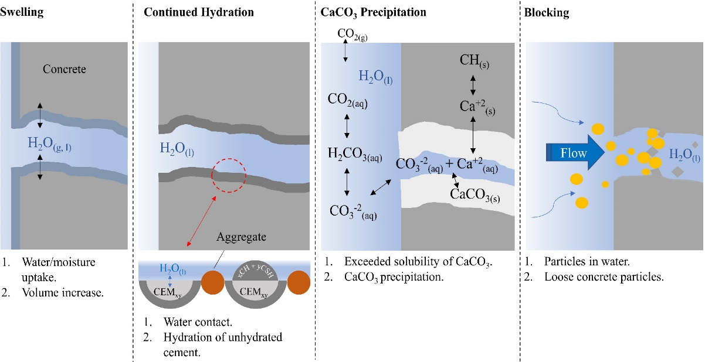

Figure 1

Mechanism of Autogenous Self –Healing concrete

Source:Internet(<https://onlinelibrary.wiley.com/cms/asset/53fe0670-0c1b-4519-bee2->bd0210508e50/eng212565-fig-0003-m.jpg

**1.1.2 Autonomous Self-Healing Concrete:** In this method performance of self-Healing concrete is improved and provisions for extra self-healing are provided.

**1.1.2.1 Vascular Self-Healing Method:** It is type of Autonomous self-healing in which chemically inert material hollow tube having good bond with concrete is made and healing agent is filled inside the tube and embedded in concrete. When these tubes encounter a crack, healing agent inside the hollow tubes leaks out due to hydrostatic pressure along with capillary or gravitational forces to seal the crack.

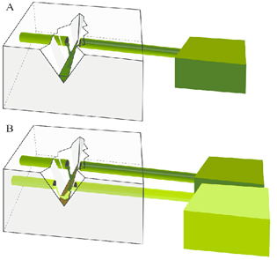

Figure 2

A) One Channel Vascular system. B) Multiple Channel Vascular System

Source: Internet (Research Gate)

**1.1.2.2 Capsules based Self-Healing Concrete:** It is also type of Autonomous self-healing in which cylindrical or spherical shape micro capsules are used. Capsules shell can be made from silica, ceramics, glass etc. These capsules are incorporated in concrete when these come in contact with one another, they break and open and healing components are released and crack gets cured. Healing agent can be epoxy resins, methyl methacrylate monomers.

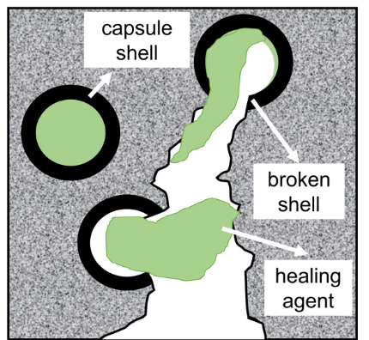

Figure 3

Source: Autogenous Self-Healing: A Better Solution for Concrete, Journal of Material in Civil Engineering, ASCE Library

**1.1.2.3 Bacterial or Microbial Self-Healing concrete:** It is also type of Autonomous self-healing in which Calcium carbonate CaCO3 helps in repairing the micro cracks in concrete. Calcium nutrients containing microbial spores and healing agents first produced in batches and then incorporated in concrete laterally. The selection of bacteria which is to be used for self-healing depends on the capability of bacteria to survive in alkaline environment.

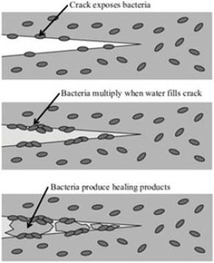

Figure 4

Source:https://civilengineeringstudy.in/self-healing-concrete-crack-repair/

**1.2 Advantages:**

* Repairs cracks,
* Increase durability
* Reduce Carbon emission

**1.3 Disadvantages:**

* Costly
* In different environment bacteria grows differently
* Water should be present during autogenous healing

1. **Hemp Crete:**

For a sustainable construction, environmental friendly materials are developing day by day. Such new material is called hemp Crete which is made from fibers of hemp plant, lime and water. This concrete reduces carbon emissions as hemp is product of agriculture. If we say about mechanical properties of hempcrete as compare to conventional concrete, then they are not so up to mark to that of conventional concrete. But this hempcrete is used a filler material in construction of ecofriendly and sustainable structures. Due to presence of pores in hempcrete it can control sudden humidity changes in its environment.

**2.1 Advantages:**

* Light weight
* Low cost
* Reduced carbon emissions
* Thermal and acoustic material

**2.2 Disadvantages:**

* Low compressive strength
* Low modulus of elasticity

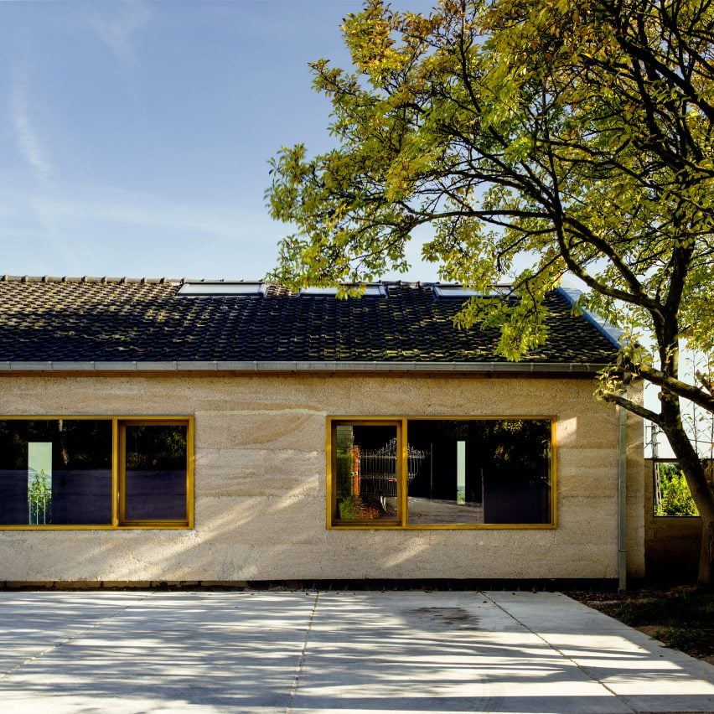

Figure 5

https://www.dezeen.com/2017/07/06/ein-hod-tav-group-israel-house-canabis-artists-house/

1. **Translucent Concrete:**

Also known by name Light Transmitting concrete. As name indicate it is an energy saving and ecofriendly material which gains its importance from architectural point.

In this concrete optical fibers are used in fine concrete (cement and fine aggregates) in order to transmit light from one face to other face of concrete. These optical fibers are placed in such a way that they can be visible from both faces of the concrete. These fibers are arranged in different patterns as we want. The optical fibers are introduced @ 4% -5% by volume of mix into the mixture. Aggregates are eliminated in this concrete and fast setting cement is preferred.

**3.1 Advantages:**

* Reduce power consumption
* Environment friendly construction

**3.2 Disadvantages:**

* Very Expensive
* Requires skilled labour for placing concrete in between optical fibers.

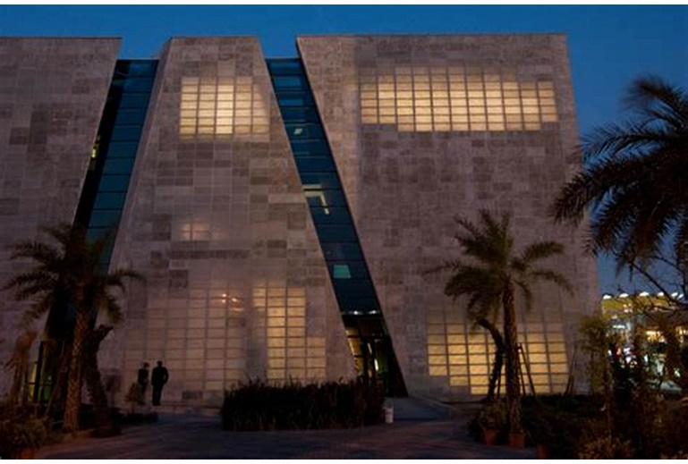

Figure 7

Italian Pavilion World Expo Shanghai china

https://www.pinterest.com/pin/374924737704742623/

1. **Bendable Concrete:**

Also known by name Flexible Concrete. As it is an Engineered Cementitious Composite which is made by addition of polymer fibers in cement, sand, aggregates and water. Polymer fibers like steel fiber, plastic fiber, polyvinyl alcohol fiber are used. In addition to fiber, plasticizers are also used in this concrete. Fibers added in this concrete improve the strength and strain capabilities. In order to avoid friction between fibers anti friction coating is provided as a result of which fiber particle slide over each other. The intrusion of these slithery fibers make concrete flexible and minimize crack formation

**4.1 Advantages:**

* Flexible and stronger
* Reduce carbon footprints
* More earthquake resistant due to its flexible property to that of conventional concrete.
* Fiber provide tensile strength
* Repair cost is less as there is less formation of cracks.

**3.2 Disadvantages:**

* Initial cost is very high
* Requires skilled labour
* Compressive strength is less to that of conventional concrete.

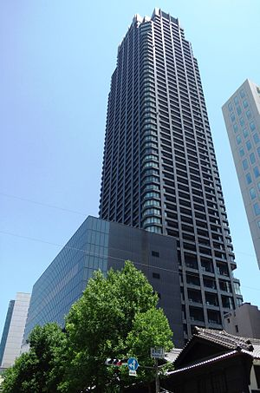

Figure 9

Kitahama, Japan’s tallest residential tower, in Osaka japan

**References:**

[1] Jonkers, H., (2011) “Bacteria-based self-healing concrete'” HERON 56 (1)

[2] Salmabanu Luhar and Suthar Gourav (2015), “A Review Paper on Self-Healing Concrete”, Journal of Civil Engineering Research

[3] Kim Van Tittelboom , Nele De Belie ,Willem De Muyncka,Willy Verstraete ,(2008), “ Use of bacteria to repair cracks in concrete”

[4] Durability study on HVFA based bacterial concrete a literature study by m dhaarani1 and k prak

[5] Qureshi, T., Kanellopoulos, A., & Al-Tabbaa, A, (2018), “Autogenous self-healing of cement with expansive Minerals-I: Impact in early age crack healing”, Construction and Building Materials, Vol- 192 768-784

[6] Pelletier, M.M., Brown, R. Shukla, A Bose, (2010), “Self-healing concrete with a microencapsulated healing agent”, University of Rhode Island, Kingston, USA

[7] Qureshi, T. S., & Al-Tabbaa, A., (2016), “Self-healing of drying shrinkage cracks in cement-based materials incorporating reactive MgO”, Smart Materials and Structures, Vol- 25

[8] Vempada, S. R., Reddy, S. S. P., Rao, M. S., & Sasikala, C. I., (2011), “Strength enhancement of cement mortar using microorganisms-an experimental study”, International Journal of Earth Sciences and Engineering, Vol- 4 ,933-936.

[9] G. Balčiunas, S. Vejelis, S. Vaitkus, A. Kairyte, (2013), “Physical properties and structure of composite made by using hemp hurds and different binding materials”, Procedia Eng., Vol- 57

[10] H. Bedlivá, N. Isaacs, (2014), “Hempcrete - An environmentally friendly material”, Advanced Material Research, 1041 83-86

[11] P. de Bruin (2008), “Hemp Concretes Hemp Concretes”, Swedish University of Agricultural Sciences.

[12] F. Delhomme, A. Hajimohammadi, A. Almeida, C. Jiang, D. Moreau, Y. Gan, X. Wang, A. Castel (2020), “Physical properties of Australian hurd used as aggregate for hemp concrete”, Material Today Communication, Vol- 24

[13] R. Bajpai,(2013), “ Application of Transparent Concrete in Construction World”, Journal on Civil Engineering, vol. 4

[14] P. M. Shanmugavadivu, V. Scinduja, T. Sarathivelan, and C. V. Shudesamithronn, (2014), “An experimental study on light transmitting concrete”, International Journal of Research in Engineering and Technology, vol. 3

[15] A. Kumar and R. Ahlawat, (2017), “Experimental Study on Light Transmitting Concrete”, International Journal of Innovative Science, Engineering & Technology, vol. 4

[16] B. F. Bashbash, R. M. Hajrus, D. F. Wafi, and M. Alqedra, (2013), “Basics of light transmitting concrete”, Global Advanced Research Journal of Engineering, Technology and Innovation, vol. 2

[17] Soumyajit Paul, Avik Dutta, (2013), "Translucent Concrete”, International Journal of Scientific and Research Publications, Volume 3, Issue 10, 2013,

[18] Aashish Ahuja, Khalid Mosalam, Tarek Zohdi, (2014), "Computational Modeling of Translucent Concrete Panels", American Society of Civil Engineers

[19] Gadhiya, S., Patel, T. N., & Shah, D, (2015), “Bendable concrete: a review”, International Journal of Structural and Civil Eng., Vol-4(1)

[20] Liao, F. C., Cheng, M. J. & Hwang, R. L, (2015), “Influence of Urban Microclimate on Air-Conditioning Energy Needs and Indoor Thermal Comfort in Houses”, Advances in Meteorology,Hindawi Publishing Corporation

[21] Balaji R, (2018), “Experimental Study on ECC Concrete”, International Journal of Recent Scientific Research Vol. 9.