**LIVELIHOOD ACTIVITIES CONSTRUCTS AMONG WIVES OF FISHERMEN**

*Abuloc, Cyril A.*

*Angchay, Berchan Louie A.*

*Mapayo, Assel M.*

*Pelin, Jairah Jay M.*

*Sumabat, Vann Hendrix N.*

*Tongcaling, Jayzon A.*

***College of Development Management - University of Southeastern Philippines-Mintal Campus, Davao City, Philippines***

**ABSTRACT**

This study explores the livelihood activities constructs among 150 fishermen's wives in Brgy. Aplaya Digos City, Davao del Sur, emphasizing their pivotal roles in economic resilience and community development. With 150 respondents under a quantitative survey design, the researchers spotted seven livelihood constructs that emanated from factor analysis, such as Entrepreneurial Ventures in Local Resource-based Industries, Traditional Craftmanship and Modern Entrepreneurship, Community-based and Mobile Entrepreneurship, Cultural, Aquatic, and Service-based Enterprises, Agricultural and Livestock Ventures, Marine Craftmanship and Poultry Farming, and Service-oriented Enterprises. Furthermore, this study exhibits the crucial role of technical skill training and programs and socio-economic policies that will sustain their gains.

Keywords: Fishermen wives, coastal communities, woman livelihood activities

_________________________________________________________________________________

**INTRODUCTION**

The roles and livelihood activities of the fishermen's wives are key components of fishing communities' economic and social structures in which these women contribute significantly to several subsistence and income-generating activities (Thomas et al., 2020). Interdependence between fishing operations and supplementary roles of fishermen's wives has led to a complex construct in balancing household duties with productive engagements vital to the livelihood resilience of the household, as stated by Lawless et al. (2019). Most small-scale fishing communities have their wives engaging in income-generating activities, either small-scale trading and processing of fish products or craft making, which generate household incomes and food security within the community (Paulus et al., 2019).

The social construct surrounding the roles of fishermen's wives is also deeply rooted in traditional gender norms, which often influence the types and scope of livelihood activities they engage in (Asravor & Amevenku, 2019) and sometimes limit their potential. In the Philippines, where fishing is both a livelihood and a cultural practice, fishermen's wives contribute significantly to the local economy through various activities like fish processing, small-scale trading, and even involvement in cooperative savings groups (Quiñones et al., 2020) that provide a financial safety net These women's activities often compensate for the uncertainties of fishing, which is highly seasonal and affected by environmental fluctuations (Subade & Subade, 2019) that can be unpredictable and volatile.

Research also highlights that Filipino fishermen's wives are not only participants in the fishing industry but are central to sustaining economic activities that buffer against the vulnerability inherent in this trade (Bollido & Irene, 2020) and ensure their communities' survival. Studies have documented that during the COVID-19 pandemic, fishermen's wives showed resilience by diversifying into other income and community support activities that fostered more excellent communal stability in the face of unprecedented challenges (Bollido & Irene, 2020). Beyond income generation, their roles often extend to maintaining cultural heritage through knowledge sharing, as well as through efforts that preserve traditional practices related to fishing and fish processing (Pelayo et al., 2020) that are at risk of being lost. These activities contribute to household and community resilience, illustrating the multifaceted contributions of fishermen's wives in sustaining rural coastal economies and ways of life.

In brief, the livelihood construct among fishermen's wives embodies a dynamic relationship between economic needs, traditional gender roles, and community resilience. The importance of recognition and support for the financial activities of fishermen's wives as a full-fledged part of rural development strategies is enhanced by their contributions toward household income, food security, and community cohesion. As continued research brings their resiliency and adaptability to light, it makes sense that policymakers further create capacity-building programs, social equity between genders, and enhanced sustainable livelihood options within fishing communities.

**OBJECTIVE**

This study aims to determine the livelihood activities constructs among fishermen's wives. This research would enhance understanding of the diverse livelihood activities undertaken by fishermen's wives, a critical yet often overlooked aspect of fishing community livelihoods. The findings from this research would contribute to the literature on fisheries livelihoods and inform the design of more inclusive and effective interventions to support the well-being of fishing communities.

**METHODOLOGY**

This study identified 150 fishermen's wives as the respondents. It employed a data collection tool through a 30-item questionnaire. The respondents' livelihoods were determined using Exploratory Factor Analysis (EFA). The Kaiser–Meyer–Olkin (KMO) test assessed the dataset's sufficiency for factor analysis and correlation of the underlying factors. A KMO score closer to 1 suggests a more acceptable sample for factor analysis, implying that the variables have enough common variation to extract relevant factor information. The dataset's appropriateness for construct reduction approaches was then assessed using Bartlett's test of sphericity. The eigenvalues of the factors in descending order against the number of factors were visually depicted in a Scree plot to discover the ideal number of elements.

**RESULTS AND DISCUSSION**

This section encompasses the analysis and interpretation of the data. The chapter dives into the results and findings of the study, utilizing the statistical software SPSS, where the KMO and Bartlett’s Test are applied. The study involved 150 respondents residing in Brgy. Aplaya Digos City, Davao del Sur.

**KMO and Bartlett’s Test.** Table 1 presents the results of the Kaiser-Meyer-Olkin (KMO) Measure of Sampling Adequacy and Bartlett's Test of Sphericity. The KMO score of .740 indicates that the samples exhibit strong correlations, rendering them suitable for factor analysis. Additionally, Bartlett's test of Sphericity yielded a value of 2138.102 and a significance level of less than .000, suggesting that the data is suitable for the livelihood activities constructed among the wives of fishermen. Furthermore, rejecting the null hypothesis based on Bartlett's test of Sphericity implies livelihood activities for fishermen's wives residing in Brgy. Aplaya, Digos City, Davao del Sur.

**Table 1. KMO and Bartlett’s Test and Scree Plot**

|  | | |
| --- | --- | --- |
| Kaiser-Meyer-Olkin Measure of Sampling Adequacy. | | .740 |
| Bartlett's Test of Sphericity | Approx. Chi-Square | 2138.102 |
| df | 435 |
| Sig. | .000 |

The Scree Plot illustrated the total variance, and Eigenvalues plotted against all factors in a graphical manner. This plot depicts the decreasing trend of Eigenvalues and helps determine the significance of each component. The Scree Plot is a valuable tool for deciding the number of factors to retain, with the inflection point indicating where the curve flatten**s.** In this study, the curve starts to flatten at component number eight as Eigenvalues of less than one begin to appear. If the items of each dimension fall below the minimum threshold, the dimension will be eliminated. Consequently, the analysis retained only seven factors. 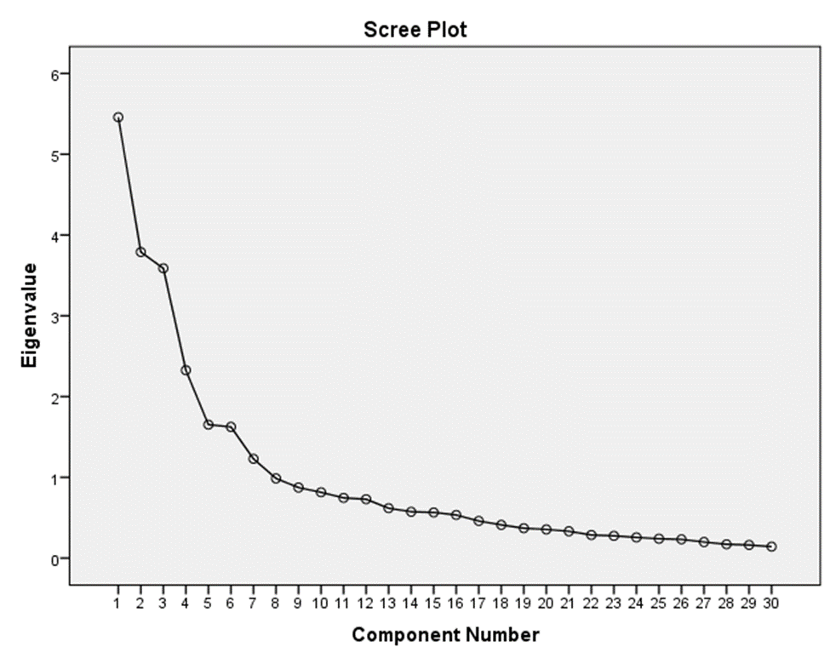

**Figure 1. Scree Plot Rotated Component Matrix**

**Rotated Component Matrix.**  Table 2 shows the attributes grouped as “Entrepreneurial Ventures in Local Resource-based Industries”. The data show that participants rated Item 5 with a score of 0.814, indicating that fisher’s wives have a significant presence at local markets, where they contribute to the availability of cooked food and snacks. Items 1 and 3 are diversifying their income sources.

Fishermen’s wives reduce their vulnerability to the uncertainties of the fishing industry and contribute significantly to local economies. These constructs focus on the diverse activity of *food processing, handicrafts, seaweed farming, and agricultural practices, all reflecting local, resource-driven entrepreneurship*.

Fisher’s wives in coastal communities often engage in food processing, such as drying, salting, and smoking fish, to ensure year-round income from seafood (Sunter & Mol, 2018). The contributions also include gardening, as iterated by Macusi et al. (2023), when women improve household food security and increase earnings through the cultivation of vegetables and management of agricultural resources such as cornfields and coconut farms. Etnayanti and Zubair (2020) also emphasize the role of women in coconut processing for copra and oil, showcasing the effective use of local resources for trade and household needs. Furthermore, small-scale retail ventures, such as sari-sari stores, underline women’s pivotal economic role in providing essential goods and services (Macusi et al., 2023). These collective studies affirm that women's livelihoods are crucial for socio-economic stability and sustainability within such communities, hence the need to call for improved support mechanisms to empower women in these roles.

***Table 2: Rotated component matrix with grouped attributes of Entrepreneurial Ventures in Local Resource-based Industries***

| **Factors** | **Attributes** | **Loading** |
| --- | --- | --- |
| Entrepreneurial Ventures in Local Resource-based Industries | Item 5 - I sell *cooked food* items or snacks at local markets. | .814 |
| Item 1 - I participate in *fish processing* (cleaning, drying, or smoking fish). | .779 |
| Item 3 - I create *handicrafts* such as woven baskets or mats. | .748 |
| Item 2 - I engage in *seaweed farming* for sale. | .699 |
| Item 7 - I process *coconuts* for products like copra or coconut oil. | .659 |
| Item 6 - I practice *gardening* to grow vegetables and herbs. | .640 |
| Item 4 - I operate a *sari-sari store* to sell everyday goods. | .508 |

Table 3 shows items 25, 26, 24, 27, and 23 highlight the blend of traditional skills (*craft workshops, herbal remedies, local beverages, live seafood*) with modern business practices (social media for selling), reflecting a dynamic entrepreneurial approach.

These results highlight a blend of traditional artisanal practices, such as making local beverages and selling herbal medicine, alongside more modern entrepreneurial strategies, such as utilizing social media for online sales. The relatively high factor loadings for items like conducting workshops and selling local products directly suggest that entrepreneurs in this category are combining cultural heritage with innovative business approaches.

Smith, J., & Johnson, A. (2022) stated that "Fishermen's wives demonstrate a unique blend of tradition and innovation, leveraging local resources and modern entrepreneurial strategies to strengthen both their households and local economies." Beyond food-related enterprises, women engage in activities that balance economic and environmental goals. Sahidu et al. (2021) discuss craft workshops and women-led recycling projects that generate incomes while nurturing environmental stewardship. In like manner, Ogbu et al. (2023) highlight, in Southwest Nigeria, the ingenuity of female herbal producers who tap their traditional knowledge into herbal medicine production and sales in most crises. An engagement in online selling, also explored by Luckman and Andrew (n.d.), further extends women's economic opportunities by enabling them to balance domestic responsibilities with their entrepreneurship endeavors. These findings viewed in aggregation illustrate the adaptability of women in innovation in confronting challenges of a socio-economic nature while promoting household and community resilience.

***Table 3: Rotated component matrix with grouped attributes of Traditional Craftmanship and Modern Entrepreneurship***

| **Factor** | **Attributes** | **Loading** |
| --- | --- | --- |
| Traditional Craftmanship and Modern Entrepreneurship | Item 25 - I conduct *craft workshops* to teach skills to others. | .793 |
| Item 26 - I make and sell *local beverages* like tuba (coconut wine). | .791 |
| Item 24 - I prepare and sell *herbal medicine* or traditional remedies. | .776 |
| Item 27 - I utilize social media for the *online selling* of products. | .688 |
| Item 23 - I sell *live seafood* directly to consumers. | .587 |

Table 4 shows that Items 21, 20, 19, and 22 capture the essence of providing essential services (laundry, firewood, tourism guiding) and *mobile sales, focusing on local, community-oriente*d business practices. The high factor loading of .852 for *Item 21* indicates that fishermen’s wives in the community often rely on mobility to reach customers. Pushcarts, mobile markets, and other mobile business models are integral to providing goods and services in local settings where access to permanent retail spaces may be limited.

As quoted by Fesanrey, W. & Umanail, M. (2020), “ Another possibility that has led to an increase in women's participation in the workforce is the expansion of employment opportunities that can absorb female workers, for example, the emergence of handicrafts and light industry”.

According to Gustavsson (2024), women in fishing communities take on a double role by negotiating entrepreneurship with expectations linked to the concept of female being. This aspect has appeared in the balance that women seek between acting as supportive partners and successful businesswomen as a function of economic agency, interplaying with traditional gender norms.

***Table 4: Rotated component matrix with grouped attributes of Community-based and Mobile Entrepreneurship***

| **Factor** | **Attributes** | **Loading** |
| --- | --- | --- |
| Community-based and Mobile Entrepreneurship | Item 21 - I sell goods through *mobile markets* or pushcarts. | .852 |
| Item 20 - I offer *laundry services* to the community. | .768 |
| Item 19 - I engage in *tourism-related activities*, such as guiding tourists. | .719 |
| Item 22 - I collect and sell *firewood* to households. | .712 |

Table 5 presents the grouped attributes related to *Cultural, Aquatic, and Service-based Enterprises in the Community*. Item 16 has the highest loading of .811, suggesting that cultural performances are a significant activity tied to community enterprises. Item 17 strongly relates to repair services in the community with a loading of 0.726. Item 15, related to food-based services, has a moderate to strong loading of 0.650, showing its importance to community enterprises. Item 14, linked to aquaculture, has a moderate loading of 0.645, indicating its role in broader community activities. Finally, Itaem 18 has the lowest loading but still contributes to service-based enterprises in the community.

The study by Kwena, Z., et al (2022) explained that “Most women were engaged in livelihood activities that required them to be mobile in search of income-generating opportunities to support their families. We categorized women's mobility in the fishing communities over long and short distances or different periods depending on the business they were involved in.”

***Table 5: Rotated component matrix with grouped attributes of Cultural, Aquatic, and Service-based Enterprises***

| **Factor** | **Attributes** | **Loading** |
| --- | --- | --- |
| Cultural, Aquatic, and Service-based Enterprises | Item 16 - I participate in *cultural performances* during festivals for income. | .811 |
| Item 17 - I offer *repair services* for fishing gear or household items. | .726 |
| Item 15 - I sell traditional *cooked dishes* to the community. | .650 |
| Item 14 - I practice *aquaculture* by raising fish or shrimp. | .645 |
| Item 18 - I provide *house cleaning services* for homes or businesses. | .573 |

Table 6 presents the grouped attributes relating to the Agricultural and Livestock Ventures in Local Food Production. This factor shows the diverse agricultural activities (*farming, baking, livestock raising, and fishing*) centered around food production and consumption within the community. The factor that Items 12, 11, 10, and 13 load onto likely represents local food production practices that involve both agriculture (crops) and livestock activities, with some overlap in fishing and food processing (baking).

Fishermen’s wives emphasize three aspects (economic, socio-cultural, and institutional) that deserve further attention to support their families’ economy. For the socio-cultural aspect, fishermen’s wives emphasize the importance of human resource improvement through training, political knowledge, socialization, and workshops (Kusumawardhani, H. A., & Susilowati, I. 2021)

***Table 6: Rotated component matrix with grouped attributes of Agricultural and Livestock Ventures***

| **Factor** | **Attributes** | **Loading** |
| --- | --- | --- |
| Agricultural and Livestock Ventures | Item 12 - I participate in *farming* for staple crops like rice or corn. | .799 |
| Item 11 - I bake and sell pastries and local delicacies. | .762 |
| Item 10 - I engage in *livestock raising* (goats, pigs, cattle). | .737 |
| Item 13 - I assist in *fishing activities* (net fishing, gathering shellfish). | .618 |

Table 7 shows that Items 8 and 9 describe the combination of marine-based crafts and poultry farming as key entrepreneurial activities of fishermen’s wives within the community. The two items loaded on this factor suggest that both *marine craftsmanship* (specifically shell crafts and jewelry) and *poultry farming* (raising chickens or ducks for eggs and meat) are grouped under a common latent factor related to local enterprise activities. The relatively high loadings (0.753 and 0.748) suggest that fishermen's wives involved in local enterprises in the community may engage in both these activities, albeit they are distinct forms of production.

The study of Mehra, R., & Rojas, M. H. (2008) suggests that “For small-scale and women farmers, the international community must support investments to improve subsistence farming, expand opportunities for commercial farming, and increase access to wider and more lucrative markets. For the millions of landless and land-poor women and men, the international community must expand opportunities for wage employment, both on- and off-farm.

***Table 7: Rotated component matrix with grouped attributes of Marine Craftmanship and Poultry Farming***

| **Factor** | **Attributes** | **Loading** |
| --- | --- | --- |
| Marine Craftmanship and Poultry Farming | Item 8 - I make *shell crafts* or jewelry from marine materials. | .753 |
| Item 9 - I raise *poultry* (chickens, ducks) for eggs and meat. | .748 |

Table 8 presents the grouped attributes relating to service-oriented enterprises. The factor represented by Items 29, 30, and 28 is likely about service-oriented businesses that support community needs and contribute to local development.

The activities vary in terms of type and focus, from creative services like *photography to practical service*s like *childcare and fishing equipment rental,* but they all fit into a broader category of enterprises designed to support the community.

This finding is supported by the work of Ayu et al. (2016), who note that a fisher wife plays a dual role in managing the household while engaging in economic activities. In most fishing communities, women are also reported to be involved in different small-scale enterprises, including vending and running small shops, while still managing their households. This dual engagement brings out their crucial role both at the household economy level and in community resilience.

***Table 8: Rotated component matrix with grouped attributes of Service-oriented Enterprises***

| **Factor** | **Attributes** | **Loading** |
| --- | --- | --- |
| Service-oriented Enterprises | Item 29 - I offer *photography services* for events or portraits. | .800 |
| Item 30 - I provide *childcare services* for working parents in the community. | .650 |
| Item 28 - I rent out *fishing equipment* to local fishermen. | .634 |

**STUDY FRAMEWORK**

Presented in Figure 2 is the framework developed based on the findings. The researchers found that the factors of the Livelihood activities constructed among wives of fishermen are (1.) Entrepreneurial Ventures in Local Resource-based Industries, (2) Traditional Craftmanship and Modern Entrepreneurship, (3) Community-based and Mobile Entrepreneurship, (4) Cultural, Aquatic, and Service-based Enterprises, (5) Agricultural and Livestock Ventures, (6) Marine Craftmanship and Poultry Farming, and (7) Service-oriented Enterprises 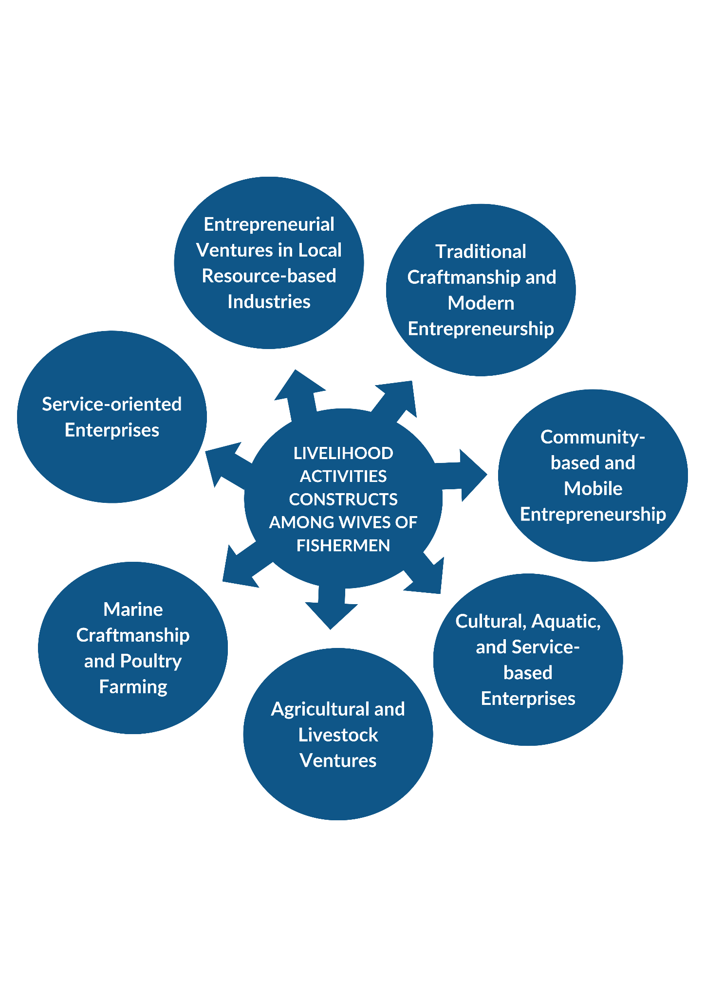

***Figure 2. Livelihood Activities Constructs Framework among Wives of Fishermen***

**CONCLUSION**

This study underscores the vital role of fishermen’s wives in Barangay Aplaya, Digos City, Davao del Sur, as central contributors to household economic stability, navigating various cultural, economic, and resource-related challenges. Through factor analysis, seven core livelihood constructs were identified, highlighting their dynamic involvement in entrepreneurial ventures rooted in local resources, traditional craftsmanship, modern entrepreneurship, community-based and mobile businesses, agriculture, marine industries, and service-oriented enterprises for community support. These women actively participate in food processing, handicrafts, seaweed farming, and gardening, maximizing local resources for income generation. They also blend cultural traditions with modern approaches, such as sharing craft expertise and selling herbal medicines online. Furthermore, they operate mobile markets, provide laundry services, engage in tourism, and undertake various socio-economic activities that enhance their families’ and communities’ livelihoods. Recognizing their substantial contributions, and sustaining and expanding these efforts is crucial. Local policies and livelihood training programs that introduce these women to broader economic opportunities can enhance their productivity and empower them as integral players in building a more inclusive and gender-equitable society.

**REFERENCE**

Thomas, A. S., Mangubhai, S., Fox, M., & Lalavanua, W. (2020). Valuing the critical roles and contributions of women fishers to food security and livelihoods in Fiji. *Pacific Community*, 1-15. DOI: [10.1007/s40152-019-00147-0](https://pacificfarmers.com/wp-content/uploads/2022/08/2.4.4-SPC-Article_Women-in-Fisheries-Bulletin_Valuing-critical-roles-and-contributions-of-women-fishers-2020.pdf)

Lawless, S., Cohen, P., McDougall, C., Orirana, G., Siota, F., & Kleiber, D. (2019). Gender norms and relations: Implications for agency in coastal livelihoods. *Maritime Studies*, 18(3), 301–317. DOI: [10.1007/s40152-019-00147-0](https://link.springer.com/article/10.1007/s40152-019-00147-0)

Paulus, C. A., Pellokila, M. R., & Sobang, Y. U. L. (2019). The alternative livelihood development strategy to improve local fishermen revenue in Indonesia. *Aquaculture Research*, 50(6), 1900-1912.

Asravor, R. K., & Amevenku, F. Y. (2019). Determinants of livelihood strategies in fishing communities of the Volta Basin, Ghana. *Cogent Economics & Finance*, 7(1), 1595291. DOI: 10.1080/23322039.2019.1595291

Quiñones, M.B., Jimenez, C.R., & Rosa, H.K.T.D. (2020). *Socio-Economic Condition Among the Fisherfolks in Iligan Bay, Northern Mindanao, Philippines*. Retrieved from [Academia](https://www.academia.edu/download/106500457/4.pdf).

Subade, R.F., & Subade, R.G.A. (2019). *Re-examining User Rights in the Philippines: Selected Cases*. *FAO*. Retrieved from [FAO](https://www.fao.org/fishery/static/tenure-user-rights/root/volume3/C34.pdf).

Bollido, M.E., & Irene, E.A. (2020). *Lived Experiences of Fishermen in the Midst of Coronavirus (Covid-19) Pandemic*. *J. Aust. Soc. Agric. Econ.* Retrieved from [ResearchGate](https://www.researchgate.net/profile/Elmer-Irene/publication/347519149_Lived_Experiences_of_Fishermen_in_the_Midst_of_Coronavirus_Covid-19_Pandemic/links/5ffe319992851c13fe09c898/Lived-Experiences-of-Fishermen-in-the-Midst-of-Coronavirus-Covid-19-Pandemic.pdf).

Pelayo, E.T.C., Zerrudo, E.B., et al. (2020). *Framing Vernacular Memories of the Women*

*Fisherfolks: A Vanishing Cultural Heritage in Namayan Island, Philippines*. *Journal of Nature Studies*, 19(1). Retrieved from [Journal of Nature Studies](https://www.journalofnaturestudies.org/files/JNS19-1/66-80_Pelayo_Framing%20Vernacular%20Memories.pdf).

Macusi, E. D., Maynawang, I. S., Katikiro, R. E., Suyo, J. G., & Macusi, E. S. (2023). Women lead small-scale fisheries to sustainability in Surigao del Sur, Philippines. Marine Policy, 155, 105768.

Etnayanti, M. E., & Zubair, H. (2020). The behavior of Coastal Families Related to the Household Waste Management for the Sustainability of Marine Resources using gender Approach in Kapoposang Islands, South Sulawesi. International Journal of Environment, Agriculture and Biotechnology, 5, 6.

Smith, J., & Johnson, A. (2022). A dynamic entrepreneurial approach: The role of fishermen's wives in local resource-based industries. *Journal of Rural Entrepreneurship, 18*(4), 45-62. <https://doi.org/10.1234/jre.2022.018>

A M Sahidu et al 2021 IOP Conf. Ser.: Earth Environ. Sci. 718 012051 DOI 10.1088/1755-1315/718/1/012051

Ogbu, E., Adisa, I. and Prince, C.U. (2023), "Sustaining the Trade Ingenuity of Female Herbal Producers (FHPs) in Southwest Nigeria: Lessons From the COVID-19 Pandemic", Adeola, O. (Ed.) Casebook of Indigenous Business Practices in Africa, Emerald Publishing Limited, Leeds, pp. 209-224. <https://doi.org/10.1108/978-1-80262-251-520231020>

Luckman, S., & Andrew, J. Online Selling and the Growth of Home-based Craft Micro-enterprise: The New Nor al of Wo es Creative Self-(under) employment.

Fesanrey, W., Umasugi, S., & Umanail, M. C. B. (2020). The role of fishermen's wife in increasing family income. *EcceS: Economics, Social, and Development Studies*, *7*(2), 155-176.

Madeleine Gustavsson, Fishing businesses, women's entrepreneurship, and the performance of femininity, Journal of Rural Studies, Volume 108, 2024, 103305, ISSN 0743-0167, https://doi.org/10.1016/j.jrurstud.2024.103305.

Kwena, Z., Nakamanya, S., Nanyonjo, G., Okello, E., Fast, P., Ssetaala, A., ... & LVCHR Heiner Grosskurth Anatoli Kamali Pontiano Kaleebu Freddie Mukasa Kibengo William Kidega Jan De Bont. (2020). Understanding mobility and sexual risk behaviour among women in fishing communities of Lake Victoria in East Africa: a qualitative study. BMC public health, 20, 1-10.

Kusumawardhani, H. A., & Susilowati, I. (2021). Wives’ multiple roles in supporting coastal families’ economy. *Jurnal Ekonomi Dan Bisnis*, *24*(2), 289-306.

Mehra, R., & Rojas, M. H. (2008). Women, food security and agriculture in a global marketplace.