**Explicative Ranking Abstraction of Thermodynamic Hydrate Inhibitor Modeling**

By

**D. I. Egu1; V. C. Amaefule2; R.C. Okoloekwe3; A. A. Omeche4; U.J. Eze5**

1,2Department of Petroleum Engineering, Madonna University Nigeria

3Department of Civil Engineering, Madonna University Nigeria

4Department of Electrical and Electronics Engineering, Madonna University Nigeria

5Department of Computer Engineering, Madonna University Nigeria

**Email:** [daniyke98@gmail.com](mailto:daniyke98@gmail.com)

**ABSTRACT**

Huge financial resources are spent on prevention, control and management thermodynamic gas hydrates particularly during down times. The poor ranking, selection and choice of thermodynamic inhibitor concentrations is a major challenge due to inadequate prediction of the hydrate depression temperatures necessary to control this problem. The non availability of much simpler models for quick computation is perhaps the main reason for most technical failures in the field. The aim of this study is to carry out a comparative ranking sensitivity analysis modeling of some thermodynamic hydrate inhibitors. Theobjectives are to develop and predict simple depression temperature equations as functions of the inhibitor concentrations from the Hammerschimdt and Nielsen-Bucklin equations, to carry out comparative analysis and predict equations of predicted results in order to understand the behavior of the curve patterns and to carry out hydrate inhibitor ranking and selection from predicted results in order to improve the choice of selection for effective performance thereby improving modeling time and quality. The method used involves a total of seven thermodynamic hydrate inhibitors with a concentration range from 5 to 50 wt%, while mathematical programs and model predictions were developed with Microsoft Excel spreadsheet. Comparative results of all predicted depression temperature with inhibitor concentrations show that methanol performed better from 5 wt% to 40 wt%. Results of comprehensive predicted depression temperature model gave $dT=0.0031C^{2}+1.4503C-1.6504;$ with square regression of $R^{2}=1.0$. The predicted inhibitor ranking due to hydrate depression temperature is best from methanol (MeOH) at 175.872oF; ethanol (EtOH) at 118.0349oF; sodium chloride (NaCl) at 114.4619oF; potassium chloride (KCl) at 103.5248oF; predicted comprehensive equation at 78.6146oF; calcium chloride (CaCl2) at 76.6799oF; di-ethylene glycol (DEG) at 68.6595oF; and tri-ethylene glycol (TEG) at 68.3905oF.

**Key words:** Thermodynamics, inhibitors, hydrates, concentration, depression temperature, ranking.

1. **Background of study**

Kinetic hydrate inhibitors are low molecular weight water – soluble polymers or copolymers that prevent hydrate blockage by bonding to the hydrate surface and delaying hydrate crystal nucleation and/or growth (Kelland, 2019; Zheng et al., 2021). Examples are sodium carbonate decahydrate – Na2CO3 10H2O and copper sulphate pentahydrate – CuSO4 5H2O. The formation of hydrates depends on the presence of sufficient amount of water, presence of hydrate former and appropriate temperature and pressure conditions. Methane hydrate is an ice-like substance formed when methane and water combine at low temperature (up to approximately 25oC) and moderate pressures (greater than 450 to 750Psi). This means that hydrates may form from natural gases at elevated temperatures well above zero degrees centigrade (Harris et al., 2022; Semenov et al., 2024).

Hydrate inhibitors are typically used to lower the hydrate formation temperature of the gas. Methane (MeOH) and ethylene glycol are the most commonly used inhibitors in the industry. Gas hydrates occur in the pore spaces of sediments and may form cements, nodes or layers (Egu et al., 2022). They are also found in naturally occurring deposits under oceanic sediments or within continental sedimentary rock formations (Jose et al., 2020). The three kinds of hydrates are organic, inorganic, and gas (or clathrates). Methane clathrate (CH4 5.75H2O) or (4CH4 23H2O), also called methane hydrate, hydromethane, methane ice, natural gas hydrate or gas hydrate is a solid clathrate compound in which a large amount of methane is trapped within a crystal structure of water forming a solid substance (Ilozobhie et al., 2023). Hydrates are classified by the crystal structures they form. There are three common structures namely: type I, type II and type H. The size of the hydrate former molecule dictates which type of hydrate will form. The smallest guest molecules form type II, the intermediate ones for type I and the largest form type H (Okereke et al 2020).

Meanwhile, gas hydrates are also naturally found in sub oceanic sediments in the polar regions (or shallow water) and in continental slope sediments (or deep water) where pressure and temperature conditions combine to make them stable (Hao et al., 2023). Hydrates can be identified by stating the name of the anhydrous component followed by the Greek prefix indicating the number of moles of water present, then the word hydrate. This means that hydrates are named by the ionic compound followed by a numerical prefix and suffix –“hydrate”. The “nH2O” notation indicates that “n” (described by a Greek prefix) number of loosely bonded water molecule is associated per formula-unit of the salt. An anhydrite is a hydrate that has lost water (Fabien et al., 2019).

Nevertheless, there are four basic methods of prevention of hydrate formation. These include;

* Removal of water from the system.
* Raising the system temperature above equilibrium.
* Decreasing the system pressure below equilibrium.
* Introduction of inhibitors.

Huge financial resources are spent on hydrate prevention and control particularly during down times. The poor ranking, selection and choice of thermodynamic inhibitor concentrations is a major challenge due to the inadequate prediction of the hydrate depression temperatures necessary to control this problem. Inadequate modeling techniques and software with skilled hydrate engineers is a major concern to improving the quality of hydrate control and prevention particularly with the aid of simple equations. The non understanding of predicted depression curve patterns can also lead to wrong selection of inhibitors giving rise to huge system failure and considerable loss of revenue. The non availability of much simpler models for quick computation is perhaps the main reason for most technical failures in the field. The aim of this study is to carry out a comparative ranking sensitivity analysis modeling of some thermodynamic hydrate inhibitors. Theobjectives of this study are to develop and predict simple depression temperature equations as functions of the inhibitor concentrations from the Hammerschimdt and Nielsen-Bucklin equations, to carry out comparative analysis of predicted results in order to understand the behavior of the curve patterns, to carry out hydrate inhibitor ranking and selection from predicted results in order to improve the choice of selection for effective performance, and to develop a general equation from all predicted equations in order to improve modeling time and quality. This study will improve the choice of selection of thermodynamic gas hydrate inhibitors through the ranking modeling sensitivity analysis. The development of simple gas hydrate equations will also enhance the understanding of the impact of depression temperatures on the inhibitor concentrations (George et al.2018). This may perhaps be used for the upgrading of existing models for simplification purpose and quality assessment.

**2.0 Hydrate formation mechanism**

One key industry flow assurance problem is hydrates formation on production lines. Hydrates are ice-like crystalline structures, formed from water and hydrocarbon molecules at high pressure and low temperature temperature (Baojiang et al., 2020). Hydrates often give rise to the plugging of pipeline-riser sections designed to convey hydrocarbon from the reservoir to the topsides facility. Typically, expenditure on the mitigation of hydrates plug formation in offshore oil production facilities is projected at about 15% (Paul and Rolf, 2023). There is a crucial need to moderate the operational cost associated with production from deepwater oil fields; especially with the current low oil price regime that industry is experiencing. MEG (Mono Ethylene Glycol) is typically associated with high cost, as a result of the relatively large dosage and volume required for it's effectiveness in mitigating hydrates (Narendra et al., 2019). Also, recent experience from some deepwater oil fields, indicates the formation of hydrates on MEG lines. Hence, the need to study and compare LDHI (Low Dosage Hydrates Inhibitors) and MEG hydrates mitigation potentials in deepwater oil fields.

The concept of flow assurance is new to the oil and gas industry and focused on analyzing the approaches geared towards ensuring a smooth flow of crude oil from sub-surface to the topsides (Prajaka et al 2018; Sotirious et al., 2022). Some major flow assurance challenges include slug mitigation in oil and gas fields, corrosion inhibition and most recently the need for cost-effective mitigation of hydrates in typical deepwater oil field scenarios (Qin et al., 2019; Saket et al., 2023), described a hydrate as an ice-like crystalline structure formed when molecules of gas get trapped within hydrogen-bonded water at high pressure and low temperature conditions. Hydrates exist in two structural forms (Structure I and Structure II). According to Qin et al. (2019), a combination of water and smaller molecules such as methane, ethane, carbondioxide and hydrogen sulphide would give rise to the formation of Structure I hydrates, while Structure II hydrates are formed by relatively larger molecules such as propane and isobutene combining with water (Englezos et al. 2018). There is also a focus of current research on the prediction of hydrates structure H

**2.1 The presence of a hydrate former**

Hydrate formers are the molecules that combine with water at relatively high pressure and low temperature to form hydrates. They include methane, ethane, propane, iso-butane, hydrogen sulphide and carbon dioxide (Pawan and Jitendra, 2018). The Physical and chemical properties of a former include:

1. **Size**

A guest molecule must be sufficiently small. Its size must be between 3.8 Å and 7 Å. If it is larger than 7 Å, it may be too large to enter the cage formed by the water molecules.

1. **Solubility**

A molecule may be sufficiently small but it may not form a hydrate if the molecule is soluble in water. However, carbon dioxide, hydrogen sulphide and sulphur oxide, which are quite soluble in water are hydrate formers. As a rule of thumb, gases more soluble than SO2 (e.g. ammonia and hydrogen chloride) do not form hydrates.

1. **Hydrogen bond**

If the molecule interferes with the hydrogen bonding, a hydrate will not form. For instance, methanol does not form a hydrate because it is hydrogen-bonded and hence interferes with the hydrogen bonding among the water molecules (Hao et al., 2020).

**2.3 Effect of temperature and pressure**

Hydrate formation is favoured by low temperature and relatively high pressure. The exact temperature and pressure depends on the composition of the former. However, hydrates form at temperatures greater than 0°C (32°F). For instance, methane hydrate formation in natural gas systems requires the presence of free water, temperatures lower than 40 °F and pressure greater than 166 psig or temperature greater than 70 °F and pressure higher than 2900 psig . (Jose, et al., 2021)

**2.4 Sufficient amount of water**

Water is essential for hydrate formation. Water has several unusual properties which can be attributed to the shape of the water molecule and the interactions that result from its shape. The water molecule consists of a single atom of oxygen bonded to two hydrogen atoms. In the water molecule, the bond between the oxygen and hydrogen atoms is a covalent bond (i.e. a shared pair of electrons). There are two pairs of unbounded electrons on the “back” of the oxygen molecule. Heavy water can also form hydrates because heavy water still exhibits hydrogen bonding (Jianbo et al., 2023). However, with heavy water, a slightly higher pressure will be required to form hydrates than in regular water (Moghaddam et al., 2024).

**2.5 Hydrates Formation and its effect on Production**

The formation of hydrates, which occurs when water and gas molecules combine at high pressure and low temperature most often pose a difficult challenge towards production optimization from a typical offshore oil production asset. Hydrates often form in gas fields as well as oil fields, plugging pipeline-riser systems. The location and seriousness of hydrates plug in well or pipeline-riser system depends on the following key factors (Dhifaf et al., 2020; Egu et al., 2022)

* Design.
* Operating phase.
* Fluid composition

The presence of gas hydrate crystals on pipeline-riser systems or in a well-bore can cause undesirable effects ranging from blockage of production flowline-riser systems and offshore transfer lines (Sayani et al., 2022).

Most importantly, there is the need to note that partial or complete plug of the inner part of a gas pipeline for instance can lead to high pressure build-up within the pipeline; resulting to a collapse of the pipeline (Davide et al., 2023). With respect to cost implications, challenges encountered as a result of formation of gas hydrates are not cost effective for operators since billions of US dollars is spent annually to proffer solutions for solving hydrate formation. Also, application of strategies to solve hydrate formation in pipelines has led to non-productive time since shut-in of production wells and pipelines is imminent. Citing (Semenov et al., 2024), on the average 5 – 15 million US dollars is spent annually to prevent hydrate formation in gas or gas-condensate fields.

2.6 **Hydrates Inhibition Strategies**

Hydrates inhibition strategies are key considerations in the design of offshore oil production facilities. This is important, because the formation of hydrates plug, often leads to production disruption and most often equipment breakdown (Wenyuan et al., 2020).

**2.6.1 Thermodynamic hydrate inhibitors (THIs)**

The thermodynamic approach generally attempts to alter the physical conditions or the chemical composition of a system, so that the hydrate state is thermodynamically unfavourable. These include: water removal, increasing temperature, decreasing pressure, addition of "antifreeze" (methanol, ethanol, ethylene glycol) to the fluid, or via a combination of these. From an engineering standpoint, maintaining temperature and/or pressure outside hydrate formation conditions requires design and equipment modifications, such as insulated or jacketed piping. Such modifications are often unfeasible or costly to implement and maintain (Simon et al., 2024). The most common approach used by operators to mitigate hydrate problems in pipelines is the use of “antifreeze” or thermodynamic inhibitors, which changes the hydrate stability curve and allows the system to operate in conditions where hydrates cannot form.

Thermodynamic hydrate inhibitors (THIs) are in common use in the industry and notably, MEG (Mono ethylene glycol) is the most often used hydrate inhibitor. MEG is used mainly because of it's wide spread availability and it's ability to compete with water molecules as regards hydrogen bonding; thereby thermodynamically preventing the formation of hydrates (Dhifaf et al., 2020). In general, THIs are suitable for long distance oil pipelines, gas pipelines and gas-condensate tie-backs. Methanol and MEG are the most used THIs. The ability of methanol and Meg to suppress hydrates thermodynamically is the key factor that makes them commonly used performance (Jianbo et al., 2023). Another key factor that supports the use of methanol and MEG is the highly developed thermodynamic models associated with THIs; enabling standard estimation of the volumes of THI for hydrates inhibition. The main drawback for THIs is their requirement of relatively huge volumes for effective hydrates inhibition in typical offshore oil fields with relatively high water-cut mitigation (Narendra et al., 2019).

**2.6.2 Low Dosage Hydrates Inhibitors (LDHI)**

Low dosage hydrates inhibitors are beginning to serve as another option for hydrates inhibition such as MEG and methanol. The key advantage of LDHIs is that they require low volume/dosage as compared to THIs (Prajaka et al., 2018). Accurate deployment of LDHIs could lead to a safe operation of hydrates prone deepwater oil fields and moderate operational expenditure; as well as extend field life lifetime. According to George et al., (2018), low dosage hydrates inhibitors (LDHI) are mainly classified into:

* Kinetic Hydrates Inhibotors (KHIs)
* Anti-agglomerant

**2.6.3 Kinetic Hydrates Inhibitors (KHIs)**

Typically, KHIs are mainly water soluble polymers which provide resistance to and delay the nucleation of hydrates crystals as well the the growth process. The ideas of KHIs were conceptualized when observations were made on certain type of fish which had ability not to freeze at below zero seawater temperatures (Sotirious et al., 2022). The first set of KHIs were derived from polymers of pyrrolidione or caprolactam ring based structures. The major limitation in the deployment of KHI is the limit in operational sub-cooling region as well as the limitation in time for the effectiveness of KHI. The effectiveness of the first set of KHI in mitigating hydrates formation (at up to 14.4°F sub-cooling) was limited to 24 hrs range (Kelland, 2019).

**2.6.4 Anti-agglomerants**

Anti-agglomerants are typically surfactants that ingress into the hydrates structure and break it down into small particles. Anti-agglomerants operate via a different approach as compared to KHIs. In deploying AAs, they allow the hydrates lattice to form but the hydrates crystals are limited in agglomeration and kept in small particles and also non adherent. It has the following key limitations:

* Does not protect the gas phase.
* Require liquid hydrocarbon phase.
* Often not effective at temperature below 38oF (Qin et al., 2019).

**3.0 Methodology**

**3.1 Materials**

Materials used in this study are soft and hard copies of seven thermodynamic hydrate inhibitors in wt %. They include methanol (MEOH), ethanol (EtOH), diethylene glycol (DEG), triethylene glycol (TEG), sodium chloride (NaCl), calcium chloride (CaCl2) and potassium chloride (KCl).

Their molar masses are;

* Methanol (MEOH) = 32g/mol
* Ethanol (EtOH) = 46g/mol
* Diethylene glycol (DEG) = 146g/mol
* Triethylene glycol (TEG) = 150g/mol
* Sodium chloride (NaCl) = 58.5g/mol
* Calcium chloride (CaCl2) = 111g/mol
* Potassium chloride (KCl) = 74.5g/mol

The analysis is done on Microsoft excel spread sheet.

**3.2 Method**

The procedures used as shown in Fig. 1 below are as follows;

* To check for the quality of the thermodynamic hydrate inhibitor concentrations by re-developing the depression temperature curves for both the Hammerschimdt and Nielsen-Bucklin equations.
* The development of soft mathematical programs or soft codes with Microsoft Excel spreadsheet for each inhibitor concentration in order to compute the hydrate depression temperatures.
* Development of depression temperature result curves for each of the seven (7) inhibitors.
* Development of new equations for each of the seven (7) inhibitors.
* Development and comparison of all predicted equations.
* Development of a simpler comprehensive equation of the depression temperature as a function of the inhibitor concentration from the earlier comparison.
* Comparative sensitivity ranking analysis of all results
* Conclusion and recommendation.
  + 1. **Hydrate prediction modeling**

The prediction of hydrates was done using the seven inhibitors. It is however assumed that sufficient water is present to form a hydrate. Thus the depression temperature for methanol (MEOH), ethanol (EtOH), diethylene glycol (DEG), triethylene glycol (TEG), sodium chloride (NaCl), calcium chloride (CaCl2) and potassium chloride (KCl) was calculated using both the Hammerschimdt and Nielsen-Bucklin equations. The Nielsen-Bucklin equation is used for better predictions for methanol weight greater than 25% by weight.

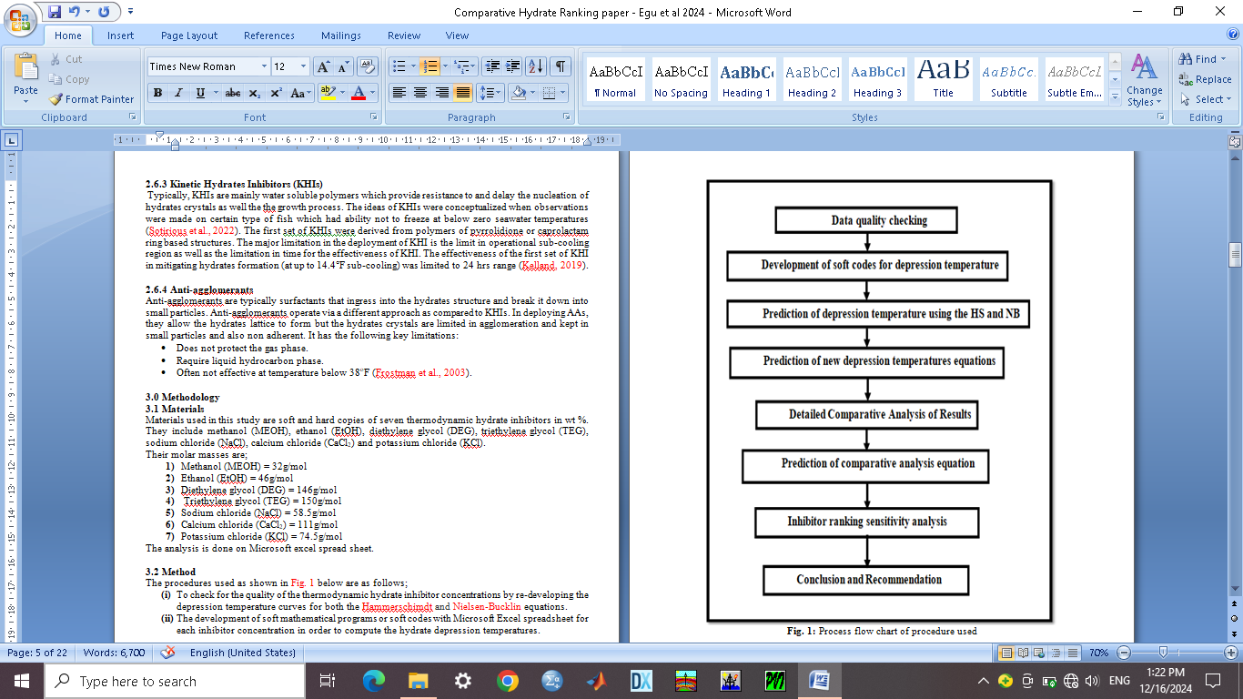

**Fig. 1:** Process flow chart of procedure used

1. **The Hammerschimdt equation**

A simple and widely used method for approximate effect of chemicals on hydrate forming temperature is the Hammerschimdt equation give as;

$∆T=\frac{K_{H}W}{M\left(100-W\right)}$ (1)

Where; ΔT is the depression temperature in oF; M is the molar mass of the inhibitor in g/mol; W is the concentration of the inhibitor in weight percent in the aqueous phase; and KH is a constant with a value of 2355.

However, in order to use the Hammerschimdt equation, you must first estimate the hydrate conditions without an inhibitor present. The Hammerschimdt equation only predicts the deviation from the temperature without an inhibitor present, not the hydrate forming conditions themselves. The Hammerschimdt equation is limited to concentrations of about 30wt% for methanol and ethylene glycol (EG) and only to about 20wt% for other glycols. The freezing point depression method used in this project bears a resemblance to the Hammerschimdt equation but applies to only a few percent solution.

1. **The Nielsen-Bucklin equation**

The prediction of hydrate inhibition using methanol as an inhibitor was applied by Nielsen and Bucklin (1983). Their equation as used in this work is give as;

$∆T=-72In\left(1-x_{m}\right)$ (2)

Where; ΔT is the depression temperature in oF and xm is the mole fraction of methanol. This equation is accurate up to a mole fraction of 0.8 (about 88 wt%). This equation can be rearranged to estimate the methanol concentration if given the temperature depression value;

$x_{m}=1-exp\left[\frac{-∆T}{72}\right]$ (3)

To calculate the weight percent from this mole fraction, the following equation is used;

$X_{m}=\frac{x_{m}M_{M}}{18.015+x_{m}\left(M_{M}-18.015\right)}$ (4)

Where; Xm is the weight fraction of methanol and MM is the molar mass of methanol.

Meanwhile the Nielsen-Bucklin equation was developed for use with methanol; however the equation is actually independent of the choice of inhibitor. The equation involves only the properties of water and the concentration of the inhibitors. This theoretically means that it can be used for any inhibitor, where the molecular weight of the solvent is substituted for MM in equation 4.

* 1. **Prediction of models**

The Hammerschimdt and Nielsen-Bucklin equations have a wide range of characteristics that makes them industrially desirable, so the predicted equations in this study are functions of the Hammerschimdt and Nielsen-Bucklin equations. Soft mathematical programs of depression temperatures in oF were developed for inhibitor concentrations of 5wt%, 10wt%, 15wt%, 20wt%, 40wt% and 50wt% for both equations for each inhibitor. Average depression temperatures were estimated and the comparative results produced in order to understand the behavior of the predicted and actual results. However, all predicted depression temperatures for all inhibitors were combined and used for the development and prediction of a comprehensive equation applicable with all the thermodynamic hydrate inhibitors.

* 1. **Prediction of hydrate ranking**

The prediction of hydrate ranking style was done with all the depression temperature ranges where those with maximum or highest values were selected first after all sensitivity modeling are completed.

**4.0 Results**

Results of gas hydrate depression temperatures were predicted with respect to the inhibitor concentrations of 5, 10, 20, 30 and 50 wt% for methanol, ethanol, di-ethylene glycol (DEG), tri-ethylene glycol (TEG), sodium chloride, calcium chloride and potassium chloride. The results were used for ranking of inhibitors and prediction of simple equations of the depression temperatures as functions of the inhibitor concentrations. Comparative result analysis was done to improve the understanding of the behavior of gas hydrate predictions with kinetic inhibitors in fluid systems.

**4.1 Results of depression temperature modeling with the Hammerschimdt and Nielsen-Bucklin equations.**

The results of predicted depression temperature with inhibitor concentrations for the Hammerschimdt equation gave a maximum temperature of approximately 72.96875oF for methanol at 50 wt% inhibitor concentration and a minimum of temperature of 0.819298oF for TEG as shown in Table 1. The graphical result curves are shown in Fig. 2 as methanol prediction ability from maximum range makes it a better inhibitor option. However, results of predicted depression temperature with inhibitor concentrations for the Nielsen-Bucklin equation gave a maximum temperature of 146.6555oF for ethanol at 40 wt% inhibitor concentration, and a minimum predicted temperature of 2.440912oF for TEG at 5 wt% inhibitor concentration as shown in Table 2. The graphical result curves are shown in Fig. 3 indicating a divergence behavior of ethanol with respect to other inhibitors.

**4.2 Comparative sensitivity results of predicted depression temperature modeling**

Comparative results of predicted depression temperatures with the Hammerschimdt and Nielsen-Bucklin methanol curves as shown in Fig. 4 gave a minimum and maximum range from 7.357oF at 5 wt% to 40.508oF at 20 wt%. The predicted curve is located mid-way between the Hammerschimdt and Nielsen-Bucklin curves. This is means an average estimated result with a predicted mathematical equation of $dT=0.0514C^{2}+0.9164C+1.552;$ with square regression of $R^{2}=0.999$ as shown in Fig. 5. Where dT represents the depression temperature (oF) and C represents the inhibitor concentration (wt%). Comparative results of predicted depression temperatures with the Hammerschimdt and Nielsen-Bucklin ethanol curves as shown in Fig. 6 gave a minimum and maximum range from 6.629oF at 5 wt% to 32.59oF at 20 wt%. The predicted curve is located very close to the Nielsen-Bucklin ethanol curve. This means; it is an approximated result with an actual predicted mathematical equation of $dT=0.0249C^{2}+1.1058C+0.4949;$ with square regression of $R^{2}=1.0$ as shown in Fig. 7. Where dT represents the depression temperature (oF) and C represents the inhibitor concentration (wt%).

Comparative results of predicted depression temperatures with the Hammerschimdt and Nielsen-Bucklin di-ethylene glycol (DEG) curves as shown in Fig. 8 gave a minimum and maximum range from 5.5085oF at 5 wt% to 69.208oF at 50 wt%. The predicted curve is located away from the Hammerschimdt and Nielsen-Bucklin DEG curves. It has a predicted mathematical equation of $dT=6E-05C^{3}+0.0024C^{2}+1.1051C-0.0955;$ with square regression of $R^{2}=1.0$ as shown in Fig. 9. Where dT represents the depression temperature (oF) and C represents the inhibitor concentration (wt%).

**Table 1: Results of predicted depression temperature with inhibitor concentrations for the Hammerschimdt equation**

|  |  |  |  |  |  |  |  |
| --- | --- | --- | --- | --- | --- | --- | --- |
| **Inh conc** | **(MeOH)** | **(EtOH)** | **(DEG)** | **(TEG)** | **(NaCl)** | **(CaCl)** | **(KCl)** |
| 5 | 3.840461 | 2.671625 | 0.841745 | 0.819298 | 2.100765 | 1.10716 | 1.649593783 |
| 10 | 8.107639 | 5.640097 | 1.777017 | 1.72963 | 4.434948 | 2.337337 | 3.482475764 |
| 15 | 12.87684 | 8.957801 | 2.822321 | 2.747059 | 7.043741 | 3.712242 | 5.53099092 |
| 20 | 18.24219 | 12.69022 | 3.998288 | 3.891667 | 9.978632 | 5.259009 | 7.83557047 |
| 40 | 48.64583 | 33.84058 | 10.6621 | 10.37778 | 26.60969 | 14.02402 | 20.89485459 |
| 50 | 72.96875 | 50.76087 | 15.99315 | 15.56667 | 39.91453 | 21.03604 | 31.34228188 |

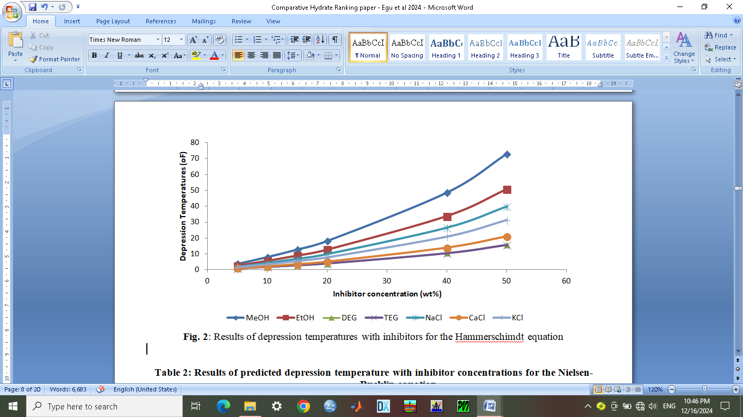

**Fig. 2**: Results of depression temperatures with inhibitors for the Hammerschimdt equation

**Table 2: Results of predicted depression temperature with inhibitor concentrations for the Nielsen-Bucklin equation**

|  |  |  |  |  |  |  |  |
| --- | --- | --- | --- | --- | --- | --- | --- |
| **Inh conc** | **(MeOH)** | **(EtOH)** | **(DEG)** | **(TEG)** | **(NaCl)** | **(CaCl)** | **(KCl)** |
| 5 | 12.23273 | 8.284992 | 2.508965 | 2.440912 | 6.432847 | 3.31856 | 5.002011 |
| 10 | 26.97793 | 17.64882 | 5.108525 | 4.967487 | 13.49733 | 6.797497 | 10.37764 |
| 15 | 45.54162 | 28.4151 | 7.805469 | 7.585957 | 21.33114 | 10.4531 | 16.18724 |
| 20 | 70.61971 | 41.07923 | 10.60738 | 10.30326 | 30.12253 | 14.30429 | 22.50709 |
| 40 | - | 146.6555 | 23.05206 | 22.33115 | 82.89043 | 32.17322 | 55.42847 |
| 50 | - | - | 30.18661 | 29.19349 | 138.8852 | 43.10326 | 80.07307 |

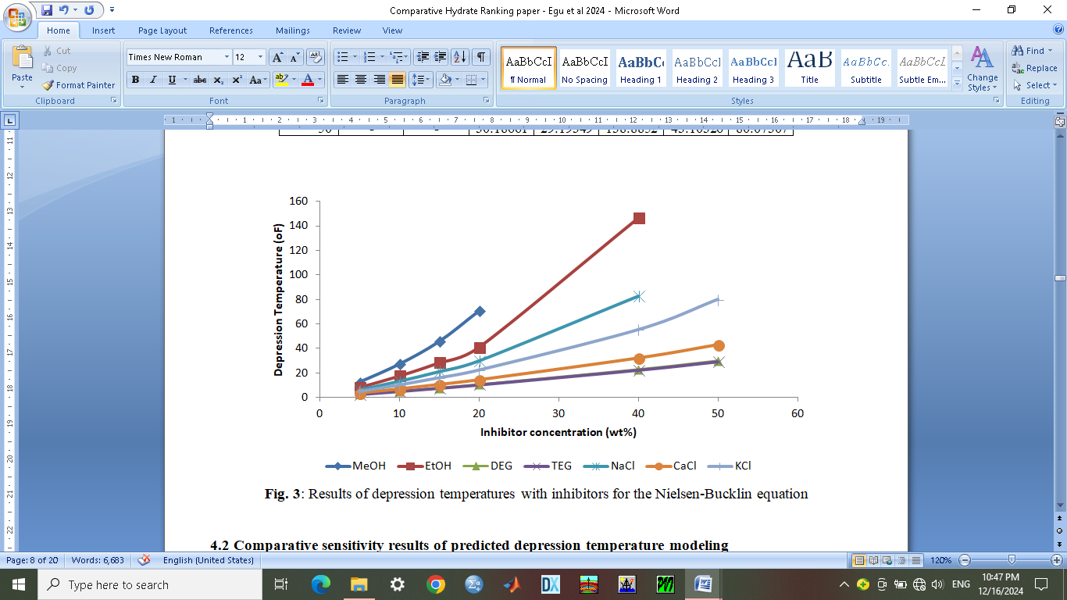

**Fig. 3**: Results of depression temperatures with inhibitors for the Nielsen-Bucklin equation

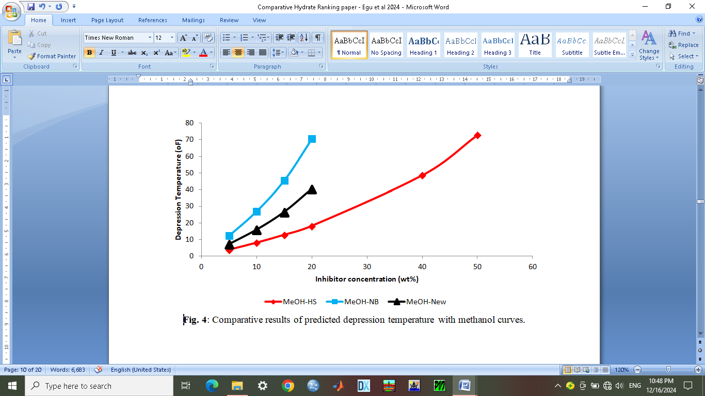

**Fig. 4**: Comparative results of predicted depression temperature with methanol curves.

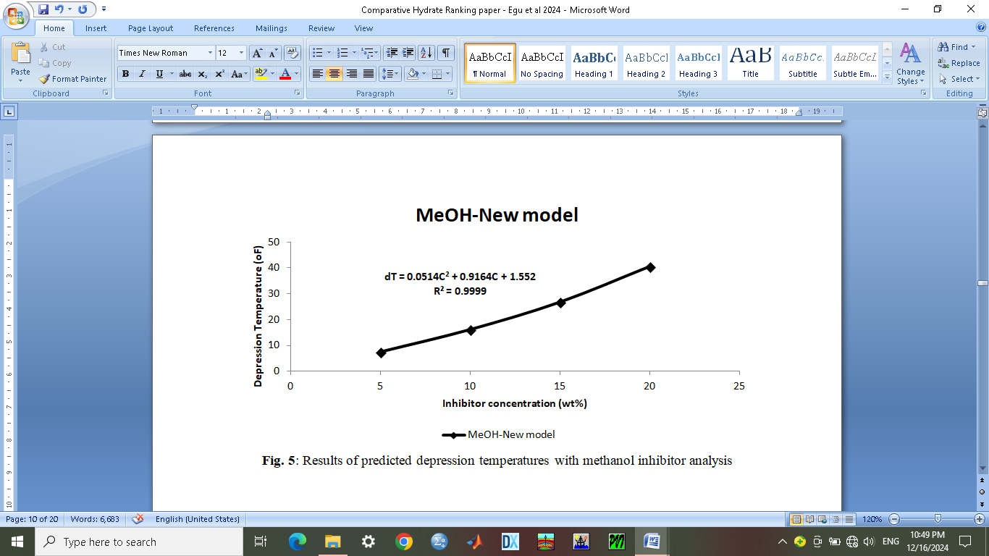

**Fig. 5**: Results of predicted depression temperatures with methanol inhibitor analysis

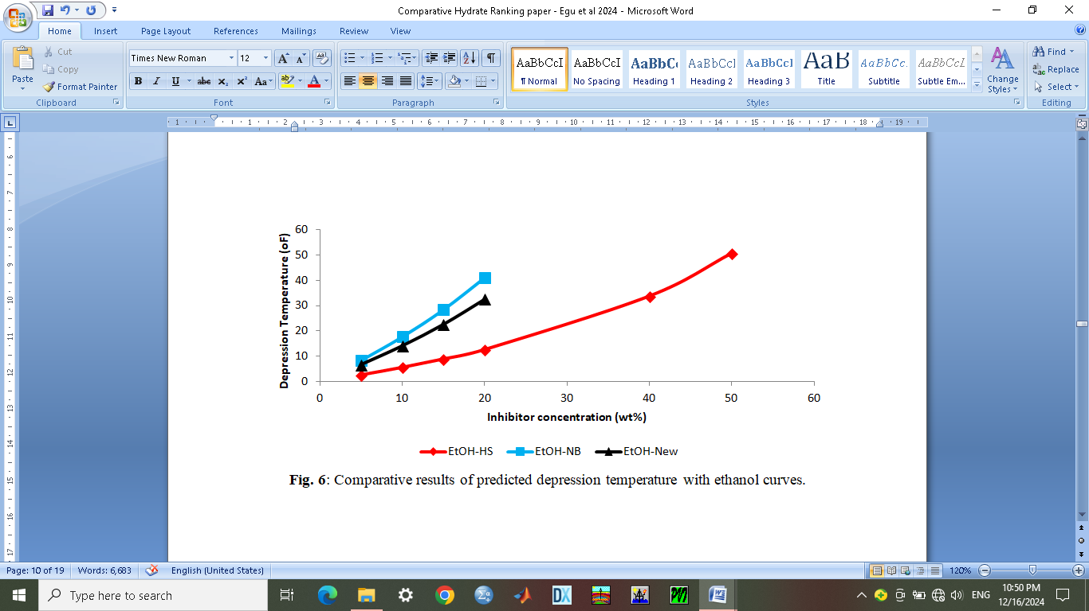

**Fig. 6**: Comparative results of predicted depression temperature with ethanol curves.

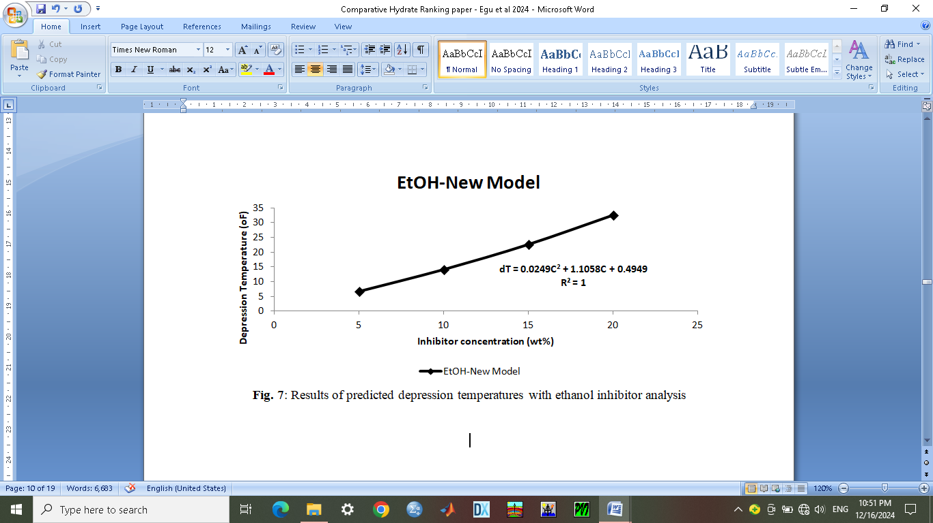

**Fig. 7**: Results of predicted depression temperatures with ethanol inhibitor analysis

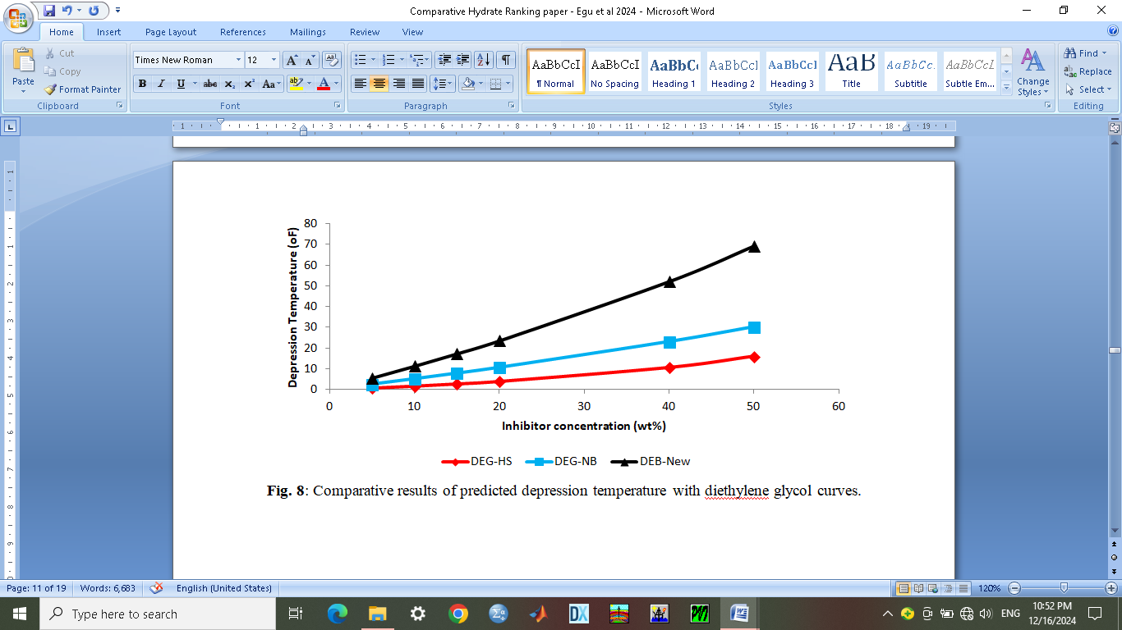

**Fig. 8**: Comparative results of predicted depression temperature with diethylene glycol curves.

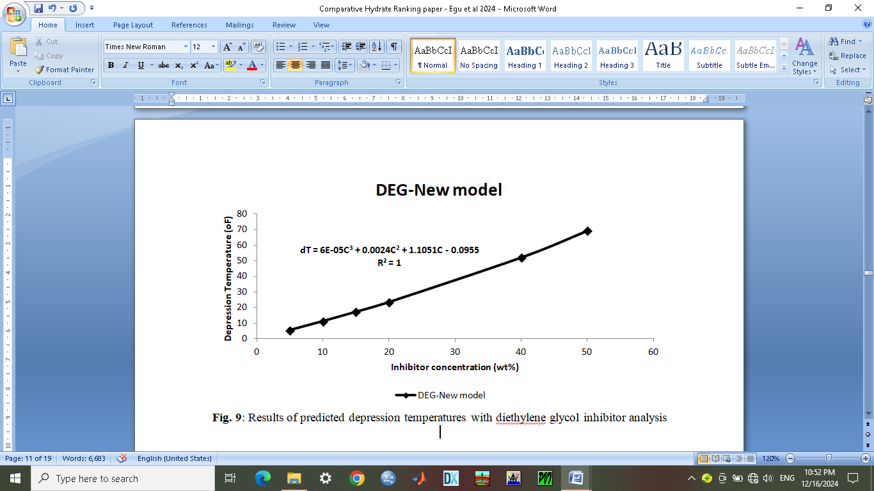

**Fig. 9**: Results of predicted depression temperatures with diethylene glycol inhibitor analysis

Comparative results of predicted depression temperatures with the Hammerschimdt and Nielsen-Bucklin tri-ethylene glycol (TEG) curves as shown in Fig. 10 gave a minimum and maximum range from 5.4949oF at 5 wt% to 68.603oF at 50 wt%. The predicted curve is also located away from the Hammerschimdt and Nielsen-Bucklin TEG curves. It has a predicted mathematical equation of $dT=0.0072C^{2}+0.9987C+0.4555;$ with square regression of $R^{2}=1.0$ as shown in Fig. 11. Where dT represents the depression temperature (oF) and C represents the inhibitor concentration (wt%).

Comparative results of predicted depression temperatures with the Hammerschimdt and Nielsen-Bucklin sodium chloride (NaCl) curves as shown in Fig. 12 gave a minimum and maximum range from 6.2771oF at 5 wt% to 80.653oF at 40 wt%. The predicted curve is located on same plane/path with the Nielsen-Bucklin NaCl curves. It has a predicted mathematical equation of $dT=0.0282C^{2}+0.8479C+1.5669;$ with square regression of $R^{2}=0.999$ as shown in Fig. 13. Where dT represents the depression temperature (oF) and C represents the inhibitor concentration (wt%). Comparative results of predicted depression temperatures with the Hammerschimdt and Nielsen-Bucklin calcium chloride (CaCl2) curves as shown in Fig. 14 gave a minimum and maximum range from 5.6697oF at 5 wt% to 76.969oF at 50 wt%. The predicted curve is located away from the Hammerschimdt and Nielsen-Bucklin CaCl2 curves. It has a predicted mathematical equation of $dT=0.0111C^{2}+0.962C+0.8299;$ with square regression of $R^{2}=0.999$ as shown in Fig. 15. Where dT represents the depression temperature (oF) and C represents the inhibitor concentration (wt%). Comparative results of predicted depression temperatures with the Hammerschimdt and Nielsen-Bucklin potassium chloride (KCl) curves as shown in Fig. 16 gave a minimum and maximum range from 6.0005oF at 5 wt% to 38.525oF at 50 wt%. The predicted curve is located slightly away from the Hammerschimdt KCl curve. It has a predicted mathematical equation of $dT=0.0004C^{3}-0.0054C^{2}+1.3558C-0.7652;$ with square regression of $R^{2}=1.0$ as shown in Fig. 17. Where dT represents the depression temperature (oF) and C represents the inhibitor concentration (wt%).

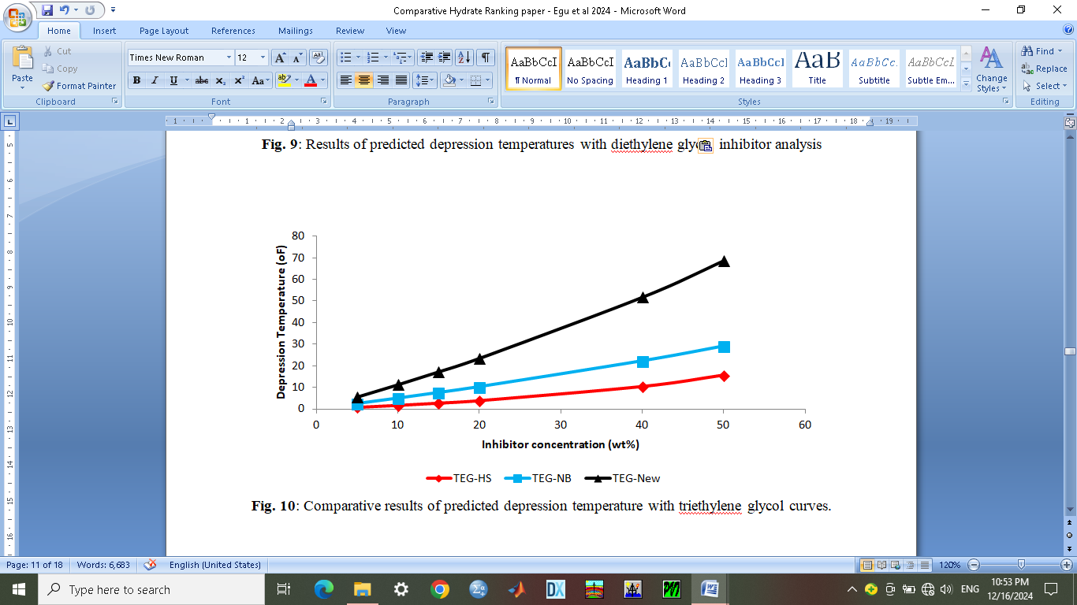

**Fig. 10**: Comparative results of predicted depression temperature with triethylene glycol curves.

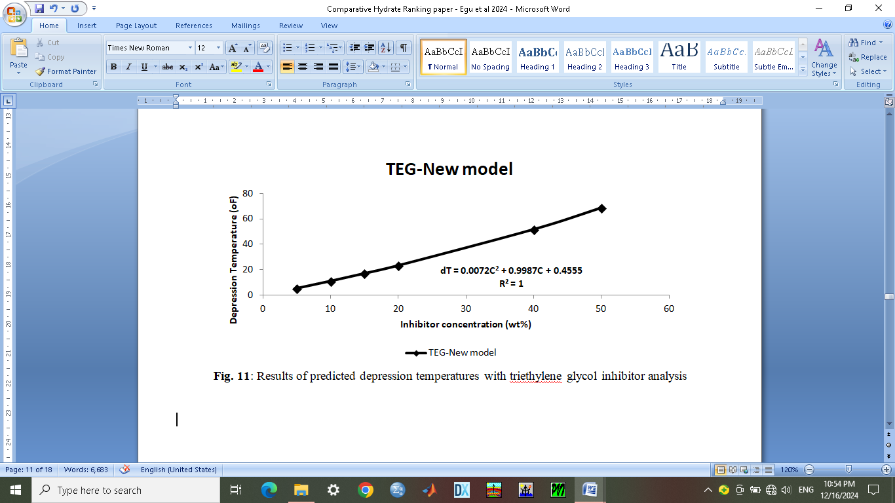

**Fig. 11**: Results of predicted depression temperatures with triethylene glycol inhibitor analysis

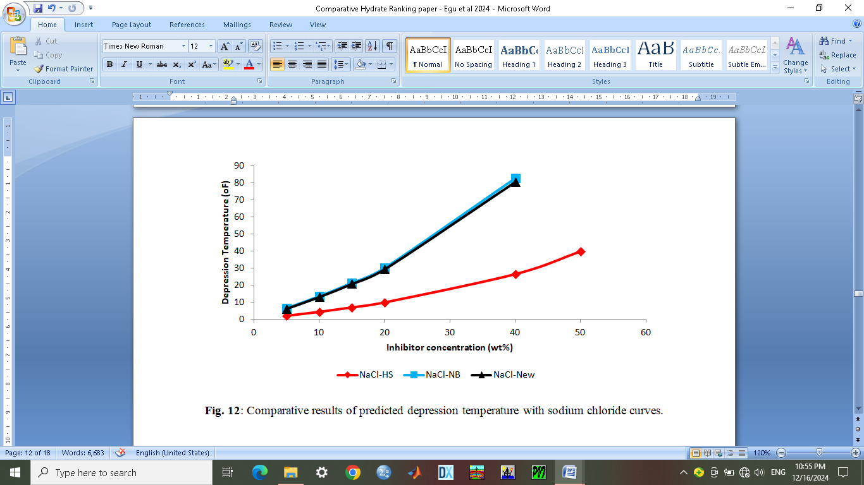

**Fig. 12**: Comparative results of predicted depression temperature with sodium chloride curves.

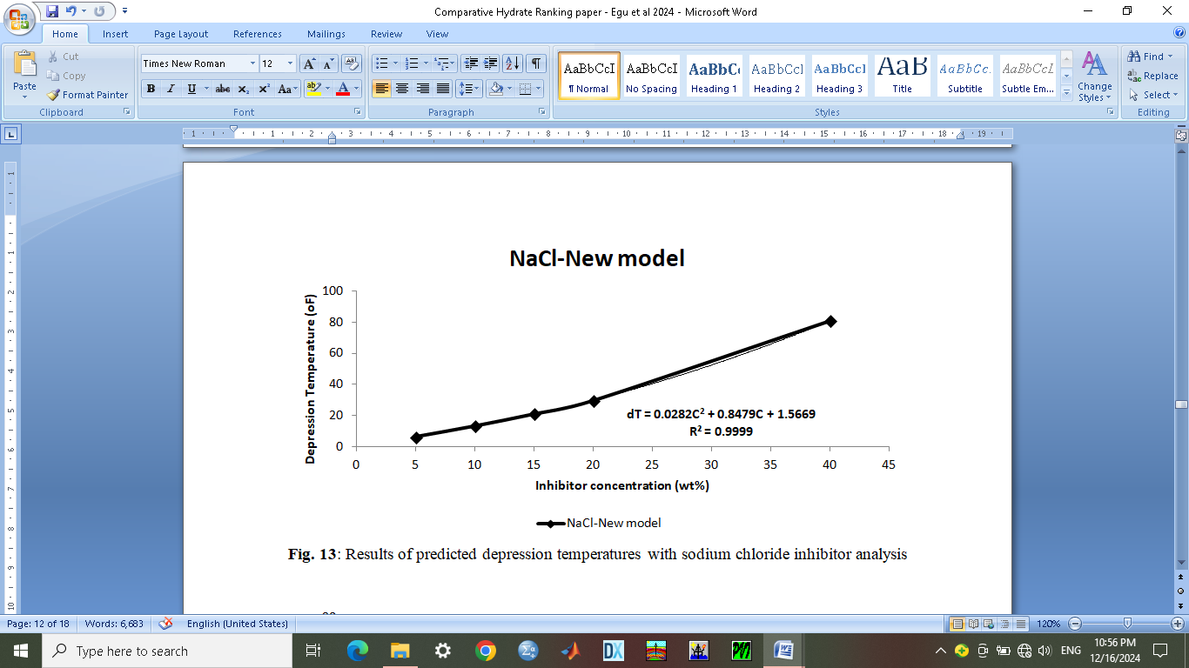

**Fig. 13**: Results of predicted depression temperatures with sodium chloride inhibitor analysis

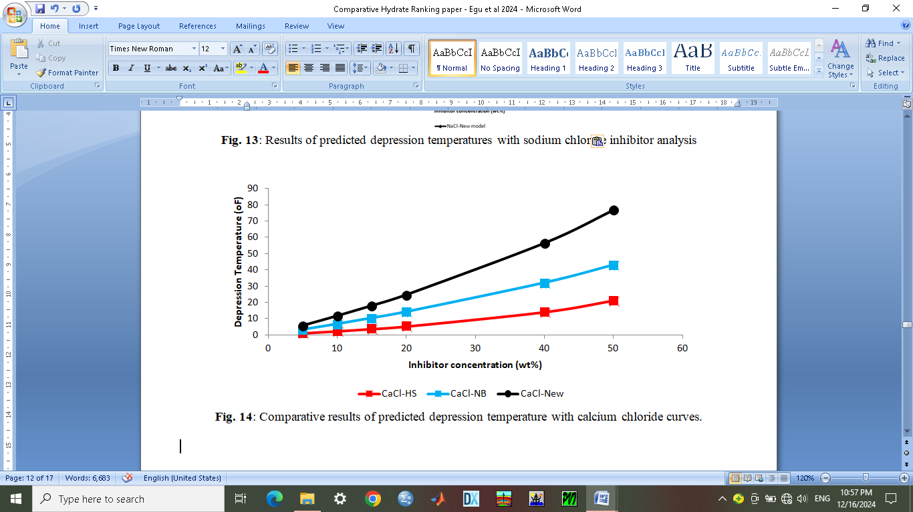

**Fig. 14**: Comparative results of predicted depression temperature with calcium chloride curves.

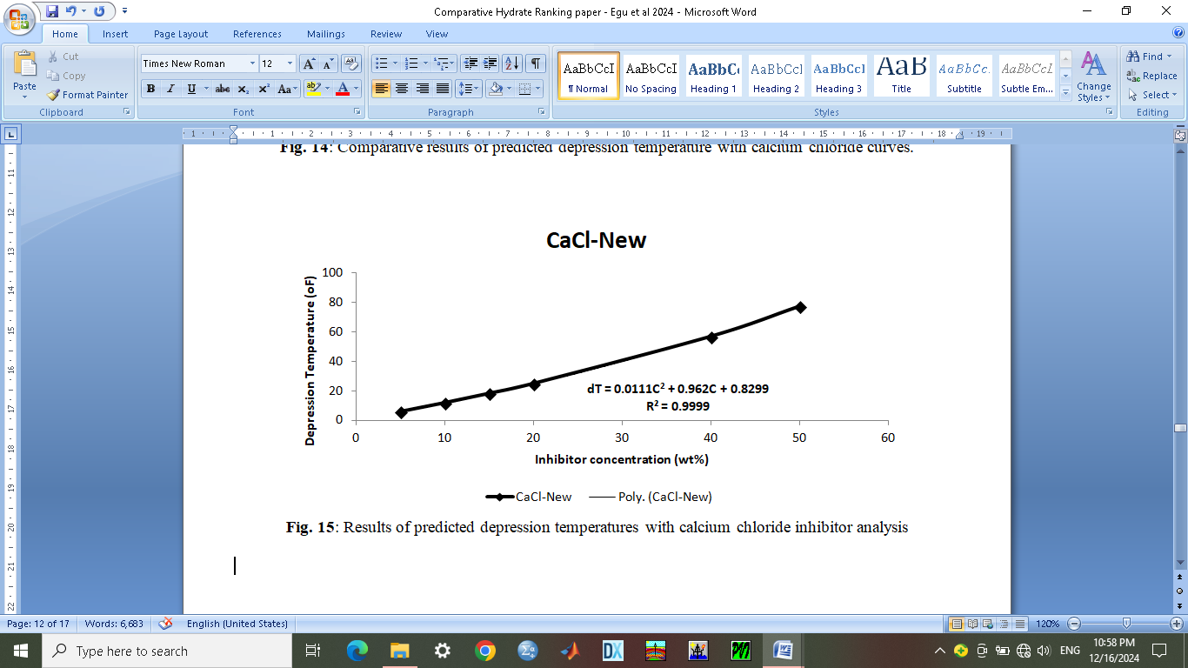

**Fig. 15**: Results of predicted depression temperatures with calcium chloride inhibitor analysis

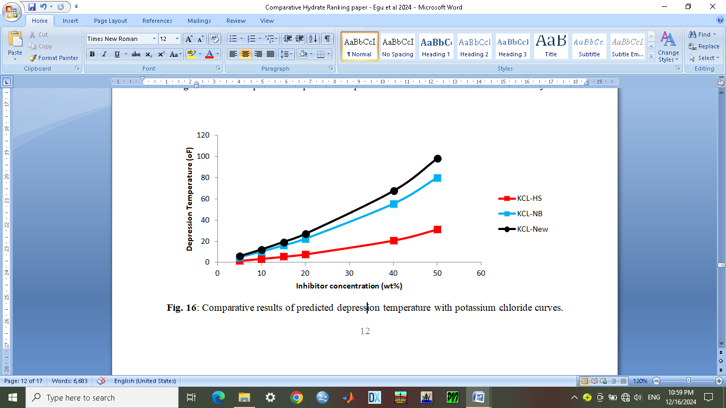

**Fig. 16**: Comparative results of predicted depression temperature with potassium chloride curves.

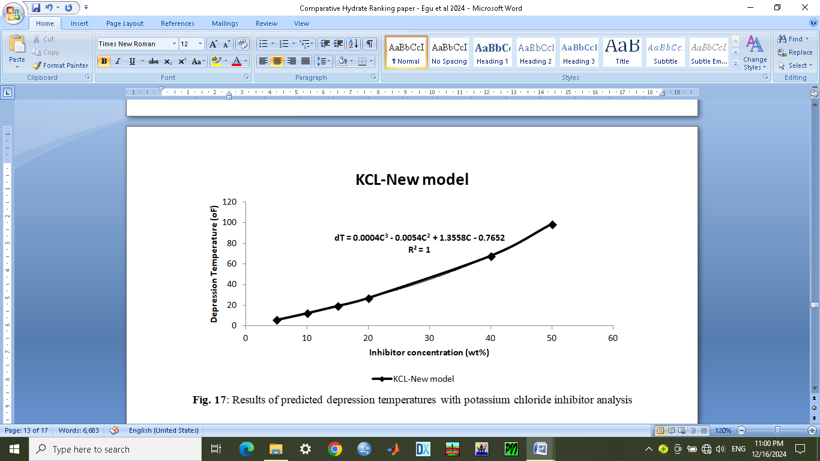

**Fig. 17**: Results of predicted depression temperatures with potassium chloride inhibitor analysis

**4.2 Comparative sensitivity analysis results of all predicted equations**

The comparative sensitivity results of predicted depression temperature with inhibitor concentrations from the earlier predicted equations as shown in Table 3 gave a minimum and maximum range from 5.49488oF at 5 wt% for TEG-new to 98.52453oF at 50 wt% for KCL-new. The predicted comparative model range is from 6.133804oF at 5 wt% to 78.3262oF at 50 wt%. Comparative results of all predicted depression temperature with inhibitor concentrations as shown in Fig. 18 shows that methanol performed better from 5 wt% to 40 wt%. Results of comprehensive predicted depression temperature for all inhibitor concentration analysis gave an equation given as $dT=0.0031C^{2}+1.4503C-1.6504;$ with square regression of $R^{2}=1.0$ as shown in Fig. 19. Where dT represents the depression temperature (oF) and C represents the inhibitor concentration (wt%).

**4.3 Comparative sensitivity ranking results due to depression temperature range**

The predicted hydrate depression temperature equations were equated or compared with the new comprehensive equation for the purpose of ranking of the inhibitors in terms of their concentration range from 5 wt% to 50 wt%. It was observed that in terms of the maximum predicted depression temperature limit values as shown in Table 4, the ranking from first inhibitor is methanol (MeOH) at 175.872oF; ethanol (EtOH) at 118.0349oF; sodium chloride (NaCl) at 114.4619oF; potassium chloride (KCl) at 103.5248oF; predicted comprehensive equation at 78.6146oF; calcium chloride (CaCl2) at 76.6799oF; di-ethylene glycol (DEG) at 68.6595oF; and tri-ethylene glycol (TEG) at 68.3905oF.

**Table 3: Comparative sensitivity results of predicted depression temperature with inhibitor concentrations from earlier predicted equations**

|  |  |  |  |  |  |  |  |  |
| --- | --- | --- | --- | --- | --- | --- | --- | --- |
| **Inh conc** | **MeOH-New** | **EtOH-New** | **DEG-New** | **TEG-New** | **NaCl-New** | **CaCl-New** | **KCl-New** | **New Comp Model** |
| 5 | 7.35699 | 6.62900 | 5.50849 | 5.49488 | 6.277071 | 5.669693 | 6.000489 | 6.133804 |
| 10 | 16.0440 | 14.0956 | 11.2474 | 11.2137 | 13.18406 | 11.64814 | 12.47921 | 12.84462 |
| 15 | 26.6791 | 22.6329 | 17.2389 | 17.1776 | 20.85342 | 17.97132 | 19.5148 | 20.29546 |
| 20 | 40.5076 | 32.5901 | 23.5085 | 23.4109 | 29.46387 | 24.68195 | 27.20637 | 28.76707 |
| 40 | 54.0956 | 37.9768 | 52.0755 | 51.7121 | 80.65332 | 56.6124 | 67.80049 | 61.77077 |
| 50 | 60.0546 | 44.8213 | 69.2083 | 68.6031 | 81.09322 | 76.96887 | 98.52453 | 78.3262 |

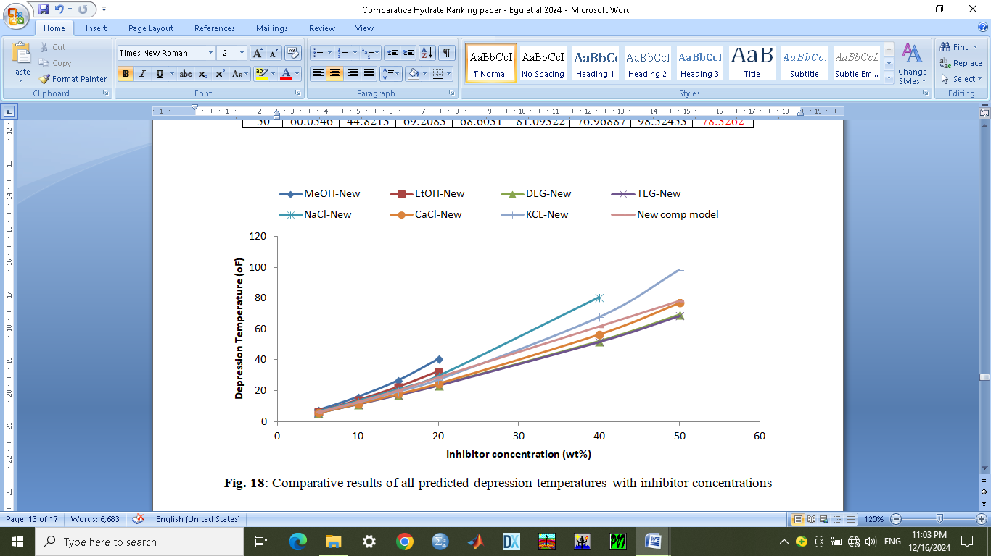

**Fig. 18**: Comparative results of all predicted depression temperatures with inhibitor concentrations

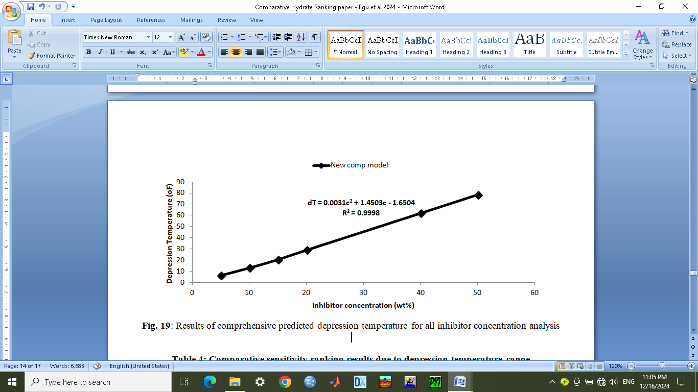

**Fig. 19**: Results of comprehensive predicted depression temperature for all inhibitor concentration analysis

**Table 4: Comparative sensitivity ranking results due to depression temperature range**

|  |  |  |  |  |  |  |  |  |
| --- | --- | --- | --- | --- | --- | --- | --- | --- |
| **Inhibitor conc.** | **(MeOH)** | **(EtOH)** | **(DEG)** | **(TEG)** | **(NaCl)** | **(CaCl)** | **(KCl)** | **New Comp** |
| 5 | 7.419 | 6.6464 | 5.4975 | 5.629 | 6.5114 | 5.9174 | 5.9288 | 5.6786 |
| 10 | 15.856 | 14.0429 | 11.2555 | 11.1625 | 12.8659 | 11.5599 | 12.6528 | 13.1626 |
| 15 | 26.863 | 22.6844 | 17.2235 | 17.056 | 20.6304 | 17.7574 | 19.7068 | 20.8016 |
| 20 | 40.44 | 32.5709 | 23.4465 | 23.3095 | 29.8049 | 24.5099 | 27.3908 | 28.5956 |
| 40 | 120.448 | 84.5669 | 51.7885 | 51.9235 | 80.6029 | 57.0699 | 70.4268 | 61.3216 |
| 50 | 175.872 | 118.0349 | 68.6595 | 68.3905 | 114.4619 | 76.6799 | 103.5248 | 78.6146 |
| **Ranking** | **1st** | **2nd** | **7th** | **8th** | **3rd** | **6th** | **4th** | **5th** |

**5.0 Conclusion**

This aim of this erudition has been achieved in this study by developing and predicting simple depression temperature equations as functions of the inhibitor concentrations from the Hammerschimdt and Nielsen-Bucklin equations. This will aid quicker interpretation and save cost. Comparative analysis of predicted results for the seven inhibitors was done in order to understand the behavior of the curve patterns with respect to inhibitor type and concentration as a function of the depression temperatures. Hydrate inhibitor ranking and selection from the predicted results was also done in order to improve the choice of selection for effective performance. This will enhance performance evaluation of inhibitors rank selected based on depression temperature which will assist to control or prevent hydrate formation problems. However, in contribution to knowledge of petroleum engineering is that gas hydrate modeling was simplified with improved understanding of the relationship between depression temperatures, inhibitor concentrations, ranking and choice of selections as critical tools for hydrate control and prevention. The major finding of this project is that with carefully planned mathematical procedure using Microsoft Excel spreadsheet, simple prediction equations can be developed for effective management of hydrates with two variables. It is recommended that further studies be done with cheaper biodegradable hydrate inhibitors for much better performance evaluation.

**Reference**

Baojiang, S., Weigi, F., Zhiyuan, W., Jianchun, X., Litao, C., Jintang, W. and Jianbo, Z. (2020). Characterizing the Rheology of Methane Hydrate Slurry in a Horizontal Water-Continuous System. SPE Journal Series, 25(03); 1026-1041. <https://doi.org/10.2118/195586-PA>

Davide, P., Raul, A.T. and Hannah, D. (2023). From Chicory Roots to Salmon Fish Waste: All the Challenges of a Trip to Sustainability for Scale Inhibitors and Low Dosage Hydrate Inhibitors. SPE-213870-MS Paper Presented at the SPE International Conference on Oil Field Chemistry, Woodlands, Texas, U.S.A., June. <https://doi.org/10.2118/213870-MS>

Dhifaf, S., Omar, A., Stefan, I., Maxim, L., Callum, S. and Ahmed, B. (2020). Hydrate Equilibrium Modeling for Gas Mixtures Containing Methane, Nitrogen and Carbon dioxide. OTC-30586-MS Paper Presented at the Offshore Technology Conference (OTC), Houston, Texas, U.S.A., May. <https://doi.org/10.4043/30586-MS>

Egu D.I., Ilozobhie, A.J. and Osuala J.C. (2022). Cogent prognostics of mellowed wax ubiety temperature modeling of Nigerian crude oil. SPE-212026-MS paper presented at the SPE Nigeria Annual International Conference and Exhibition, 1-3 August, Nigeria.

<https://doi.org/10.2118/212026-MS>

Englezos, P., Mani, M. and Jacky, C. (2018). Gas Recovery Through the Injection of Carbon dioxide or Concentrated Flue Gas in a Natural Gas Hydrate Reservoir. OTC-28374-MS Paper Presented at the Offshore Technology Conference Asia, Kuala Lumpur, Malaysia, March. <https://doi.org/10.4043/28374-MS>

Fabien, P., Celma, A., Mohammed, A., Ambrosio, C., Alberto, P., Antonio, C. and Philippe, G. (2019). Remediation of Hydrate Plug in Gas Export Line – A West Africa Deep Water Case. OTC-29946-MS Paper Presented at the Offshore Technology Conference Brazil, Rio De Janerio, Brazil, October 28. <https://doi.org/10.4043/29946-MS>

George, J.M., Alenjandro, F.Q. and Mathew, T.R. (2018). Geomechanical Stability and Overall System Behaviour of Sloping Oceanic Accumulations of Hydrates Responding to Dissociation Stimuli. OTC-28496-MS Paper Presented at the Offshore Technology Conference Asia, Kuala Lumpur, Malaysia, March 20. <https://doi.org/10.4043/28496-MS>

Hao, Q., Angi, Q., Yan, W., Luis, Z., Carolyn, K., Scot, B., Sean, D., Thiery, P. and Khalid, M. (2020). Predicting Hydrate Plugging Risk in Oil Dominated Systems Using a Transient Hydrate Film Growth Prediction Tool. OTC-30545-MS Paper Presented at the Offshore Technology Conference, Houston, Texas, U.S.A., May. <https://doi.org/10.4043/30545-MS>

Hao, X., Hao, L. and Jing, F. (2023). Gas Hydrate Structure Evolution Revealed by Coarsening Molecular Dynamics Simulation. URTEC-3817836-MS Paper Presented at the SPE/AAPG/SEG Unconventional Resources Technology Conference, Denver, Colorado, U.S.A., June. <https://doi.org/10.15530/urtec-2023-3817836>

Harris, S.R., Muhammad, S.K., Qureshi, M.A., Mohammad, A.R., Thomas, S. and Bhajan, L. (2022). Analytical Modeling of Gas Hydrates in Porous Media. OTC-31645-MS Paper Presented at the Offshore Technology Conference Asia, Virtual and Kuala Lumpur, Malaysia, March 18. <https://doi.org/10.4043/31645-MS>

Ibim, A.G., Kelechi, U.U., Okafor, G.O. (2020). Critical Analysis of Gas Hydrate Formation and Prevention in Gas Well Facilities in Nigeria Oil Rich Region. International Journal of Scientific Innovations, 8(01); 236-245.

Ilozobhie, A.J., Obalola, H.A., Egu, D.I. and Okpata, J.B. (2023): A Review of Multiphase Flow Modeling in Horizontal and Vertical Wells. International Journal of Novel Research and Development (IJNRD), vol.8, issue 10, 1-12. <https://www.ijnrd.org/papers/IJNRD2310379>

Jakyung, K., Daejun, C., Park, K. and Seo, Y. (2018). Risk Management of Hydrate Reformation Using Synergistic Inhibition During Methane Hydrate Production. ISOPE-I-18-653 Paper Presented at the 28th International Ocean and Polar Engineering Conference, Sapporo, Japan, June 10.

Jianbo, Z., Shujie, L., Yilong, X., Binbin, Z., Wang, Z., Yin, B., Shuxia, L., Gao, Y. and Baojing, S. (2023). Experimental Investigation on Hydrate Formation and Decomposition Behaviour in Micro-pore Channels. SPE-216581-MS Paper Presented at the ADIPEC, Abu Dhabi, United Arab Emirate, October 2. <https://doi.org/10.2118/216581-MS>

Jose, G.D., Salmin, D.C., Stoner, H., Wu, D., Luis, E.Z., Carolyn, A.K., Khalid, M., Scot, B., Philippe, P. and Adriana, T. (2020). Effect of Alcohols on Asphaltene-Particle Size and Hydrate Non-Plugging Behaviour of Crude Oil. OTC-30916-MS Paper Presented at the Offshore Technology Conference, Houston, Texas, U.S.A., May. <https://doi.org/10.4043/30916-MS>

Jose, G.D., Ahmad, A.A., Luis, E.Z. and Carolyn, A.K. (2021). Reducing THI Injection and Gas Hydrate Agglomeration by Under Inhibition of Crude Oil Systems. OTC-31161-MS Paper Presented at the Offshore Technical Conference, Virtual and Houston, Texas, U.S.A., August 09. <https://doi.org/10.4043/31161-MS>

Kelland, M.A. (2019). Challenges with Gas Hydrate Formation. IOP Conference Series: Materials Science and Engineering, 700(2019); 012057. <https://doi.org/10.1088/1757-899X/700/1/012057>

Melchuna, A., Glenat, P., Rivero, M. and Sum, A.K. (2018). Measurements of Dispersant Additive on Hydrate Slurry Transport. BHR-2018-143 Paper Presented at the 11th North American Conference on Multiphase Production Technology, Banff, Canada

Moghaddam, F.S., Abdi, M.A. and James, L.A. (2024). Investigating the Effects of Carbon Dioxide Concentration on Hydrate Formation Risk From Water Alternating Gas (WAG) Changeover Operations. SPE-218101-MS Paper Presented at the SPE Canadian Energy Technology Conference and Exhibition, Calgary, Alberta, Canada, March 12. <https://doi.org/10.2118/218101-MS>

Narendra, K., Niaz, B.C. and Juan, G.B. (2019). A 3-in-1 Approach to Evaluate Gas Hydrate Inhibitors. Energies, 12 (2921); 1-17. <https://doi.org/10.3390/en12152921>

Nielsen, R.B. and Bucklin, R.W. (1983). Why Not Use Methanol for Hydrate Control? Hydro. Proceedings, 55(04): 71-75.

Okereke, N., Edet, P., Afolabi, F., Izuwa, N., Kanshio, S., Nwogo, N., Nwanwe, O. and Odo, J. (2020). Techno-Economic Assessment of the Hydrate Mitigation Potential of LDHI and MEG in Deep Water Scenario. SPE-203665-MS Paper Presented at the Nigeria Annual International Conference and Exhibition, Victoria Island, Lagos, Nigeria, 11-13 August. <https://doi.org/10.2118/203665-MS>

Paul, C. and Rolf, S. (2023). A Novel Technology to Efficiently Detect Hydrate Formation in Sunsea Flow lines. OTC-32470-MS Paper Presented at the Offshore Technology Conference, Houston Texas, U.S.A., May. <https://doi.org/10.4043/32470-MS>

Pawan, G. and Jitendra, S.S. (2018). Semi-Clathrate Hydrate of Methane and Quaternary Ammonium Salts for Natural Gas Storage and Gas Separation. OTC-28266-MS Paper Presented at the Offshore Technology Conference Asia, Kuala Lumpur, Malaysia, March. <https://doi.org/10.4043/28266-MS>

Prajaka, J.A., Himawan, J., Affandy, S.A., Sutikno, J.P. and Handogo, R. (2018). Hydrate Formation Calculation in the Natural Gas Purification Unit. IOP Conference Series: Material Science and Engineering, 543(2019): 012084. <https://doi.org/10.1088/1757-899X/543/1/012084>

Qin, H., Vishal, S., Hua, W., Luis, E.Z. and Koh, C.A. (2019). Machine Learning Models to Predict Gas Hydrate Plugging Risks Using Flow Loop and Field Data. OTC-29411-MS Paper Presented at the Offshore Technology Conference, Houston Texas, U.S.A., May. <https://doi.org/10.4043/29411-MS>

Saket, K.S., Saket, K. and Arvind, K. (2023). Methanol Recovery with Carbon dioxide Sequestration as Hydrates in Deep Marine Environments: An Extensive Examination of Potential, Technical Advancements, and Economic Feasibility. SPE-217277-MS Paper Presented at the Asia-Pacific Unconventional Resources Symposium, Brisbane, Australia, November. <https://doi.org/10.2118/217277-MS>

Sayani, J.K., Yadavalli, S.S., Mamidi, L.T. and Kamireddi, V.R. (2020). Investigation of the Kinetic Behaviour of Gas Hydrates Based on Induction Time for a High CO2 Mixed Gas Multiphase Pipeline System. SPE-203121-MS Paper Presented at the Abu-Dhabi International Petroleum Exhibition and Conference, Abu Dhabi, United Arab Emirate, November. <https://doi.org/10.2118/203121-MS>

Sayani, J.S., Venkateswara, R.K., Srinivasa, R.P. and Georgios, K. (2022). Development of a Simple Statistical Model for the Prediction of Gas Hydrate Formation Conditions. PSIG-2201 Paper Presented at the PSIG Annual Meeting, San Diego, California, U.S.A., May

Semenov, M.E., Varfolomeev, M.A., Mirzakimov, U.Z., Son, E.R., Pavelyev, R.S., Chirkova, Y.F. and Stoporev, A.S. (2024). Research and Development Aimed at Creating Hydrate-Based Technology for Storage and Transportation of Hydrocarbon Gases. SPE-218678-MS Paper Presented at the SPE Conference at Oman Petroleum and Energy Show, Muscat, Oman, April. <https://doi.org/10.2118/218678-MS>

Simon, R., Khiari, R., Hani, S., Rudy, A., Emerick, L., Annie, F., Nicolas, L. and Charlotte, D. (2024). How Anti-agglomerant can Replace MEG to Mitigate Hydrate Risk in Mature Gas Fields. OTC-35138-MS Paper Presented at the Offshore Technology Conference, Houston, Texas, U.S.A., May. <https://doi.org/10.4043/35138-MS>

Sotirious, L., Dionisia, D.L., Mirlan, T. and Mahmut, P. (2022). Examination of Cysteine, Glutamine and Isoleucine as Methane – Propane Gas Hydrate Kinetic Inhibitors. SPE-212055-MS Paper Presented at the SPE Annual Caspian Technical Conference, Nur-Sultan, Kazakhstan, November 15. <https://doi.org/10.212055-MS>

Udegbunam, L.U., DuQueenay, J.R., Osario, L., Walker, V.K. and Bettran, J.G. (2018). Phase Equilibria, Kinetics and Morphology of Methane Hydrate Inhibited by Antifreeze Proteins: Application of a Novel 3-in-1 Method. Journal of Chemical Thermodynamics, 117; 155-163.

Wenyuan, L., Hu, J., Sun, F., Sun, Z., Chu, H. and Xiangfang, L. (2020). Study on Risk Prediction of Hydrate Formation in Deep Water Gas Wells During Production Process. SPE-196547-MS Paper Presented at the SPE/IATMI Asia-Pacific Oil and Gas Conference and Exhibition, Bali, Indonesia, October 25. <https://doi.org/10.2118/196547-MS>

Zheng, L., Sun, B., Wang, Z. and Jianbo, Z. (2021). Optimization Strategies of Production Parameters to Prevent Hydrate Reformation in Marine Gas Hydrate Production System. SPE-205695-MS Paper Presented at the SPE/IATMI Asia-Pacific Oil and Gas Conference and Exhibition, Virtual, October 04. <https://doi.org/10.2118/205695-MS>