**Pseudo Pedantic of Wells in Byzantine Reservoirs Using Seismic Wave Sapience**

**By**

**D. I. Egu1; A.J. Ilozobhie2**

1Department of Petroleum Engineering, Madonna University Nigeria

2Department of Physics, University of Calabar, Nigeria

**Email:** [daniyke98@gmail.com](mailto:daniyke98@gmail.com)

**Abstract**

The pseudo-characterization of seismic shear wave impedance and velocity ratio on the acoustic impedance in abstruse reservoirs has given rise to obscureness of seismic data juxtaposition such as reservoir thicknesses delineated below quarter of a wavelength (1/4k) and seismic cross plot amphibolies. The aim of this pedagogic is to ruminate and characterize these critical seismic attributes in intricate reservoirs. Materials used are high resolution 3D post-stacked and check shot seismic data, 3 composite well log suites (X1, X2, and X3) and a base map from the X-field in the Niger Delta, Nigeria. Schlumberger-Petrel simulator was used to produce variant cross plots models of critical attributes sensitive to formation fluid saturation and pressure while lithology/fluid contacts were cross plotted with acoustic impedance. Comprehensive results of Vp/Vs against acoustic impedance showed presence of hydrocarbons and water from both wells located in reservoirs HD 5000 and HD 9000. Gas sand with average densities from 2.0703g/cc to 2.1490g/cc exist in well X1 and 2.0809g/cc to 2.1702g/cc exist in well X2. Oil was identified in well X1 in reservoir HD 9000 with density from 2.0577g/cc to 2.1266g/cc. Results of S-impedance against acoustic impedance showed also the presence of hydrocarbon, shales and a wet trend line. These resultant variations of lithology/fluid juxtaposition due to acoustic impedance perhaps located previously hidden gas-water and oil-water contacts at different locations in the reservoirs. It is however recommended that further studies be done on the characterization of these oil/wet trend lines with increased data volume.

**Key words:** Reservoirs, wells, acoustic impedance, velocity, juxtaposition, lithology, attribute.

**1.0 Introduction**

Acoustic impedance contrast at the interface between two lithologies may be too small to generate a normal-incidence reflection. For example, a [shale](https://www.sciencedirect.com/topics/engineering/shale) with low density and high P-wave velocity might have nearly the same [acoustic impedance](https://www.sciencedirect.com/topics/engineering/acoustic-impedance) as an oil-filled [sandstone](https://www.sciencedirect.com/topics/materials-science/sandstone) with high density and low P-wave velocity. Without an acoustic impedance contrast, such [oil reservoirs](https://www.sciencedirect.com/topics/engineering/oil-reservoir) are extremely difficult to detect using traditional P-wave surface seismic acquisition and processing (Egu and Ilozobhie, 2020). Effective characterization of complex reservoirs using both the S- and P- seismic waves may perhaps reduce the risk mostly experienced in exploration. The interpretation due to vacillation attributes of P- and S- wave velocities and acoustic impedances are used for hydrocarbon delineation particularly due to variations in lithologies in stratigraphic traps (Maghsood et al., 2004; Ilozobhie et al., 2023). However, fluid distribution and types can be estimated from multi-component characterization of seismic attributes. The shear wave modulus and reservoir fluid compressibility are critical factors that affects the subsurface propagation of P-waves in liquids and solids (Oliver et al., 2001; Ilozobhie and Egu, 2021).

Shear waves are produced and propagated only in solids and they do not depend on rock fluids. Secondary (Vs) and primary (Vp) seismic wave velocities are technically applied for lithologic identification with improved performance from P- wave sources alone (Fig. 1). The accurate prediction of rock types is the principal objective of seismic hallmarks which can be acquired from multi-component seismic data such as the ratio of Vp/Vs. Lithologic delineation from changes in fluid types are immensely enhanced by detailed reflector dexterity of S and P-waves traits (Sofolabo et al., 2020). In P-waves, particle motion is parallel to the direction of propagation, while in S-waves, particle motion is perpendicular to the direction of propagation. In land-based surface seismic data acquisition, P-waves can be recorded by single-component [geophones](https://www.sciencedirect.com/topics/engineering/geophones) that detect vertical motion in the rock formation.

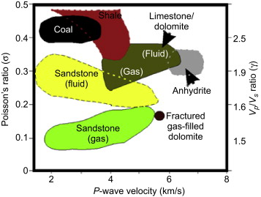

**Fig. 1:** Vp/Vs ratio and lithology (Olabode and Sara, 2018).

In typical marine seismic surveys, P-waves can also be detected by towed-streamer [hydrophones](https://www.sciencedirect.com/topics/engineering/hydrophones) (or pressure sensors) surrounded by water (Olabode and Sara, 2018). The field of S-waves is [three-dimensional](https://www.sciencedirect.com/topics/engineering/three-dimensional-computer-graphics); therefore, three-component sensors (with three geophone-accelerometers in orthogonal orientation in each sensor) are required to fully characterize it. Processing of land multi-component S-wave surveys is often problematic because inhomogeneity of near-surface layers causes large travel time variations for the S-waves. Increasing complexity of the HD Field in the Niger Delta (Ilozobhie and Egu, 2022), Nigeria coupled with previous non-accurate seismic data, low capability of seismic interpreters and software with lack of proper application of the knowledge of seismic attributes particularly Vp/Vs and shear wave impedance derived from seismic data to effectively predict or discriminate lithologies such as hydrocarbon having low velocity ratios has reduced the potential viability of this lucrative interpretation option (Ilozobhie and Egu, 2020; Mathew et al., 2021).

The aim of this study is to investigate the behaviour of seismic wave velocity ratios and shear wave impedance on the acoustic impedance for pseudo-characterization of wells in heterogeneous reservoirs (HD). The objectives are to develop cross-plots of Vp/Vs against acoustic impedance for wells X1 and X2 in reservoirs HD5000 and HD9000, to develop cross-plots shear wave impedance against acoustic impedance for wells X1 and X2 in reservoirs HD5000 and HD9000, and to effectively characterize the reservoirs using the seismic attributes of Vp/Vs and shear wave impedance form seismic data of reservoirs HD5000 and HD9000.

**2.0 Methodology**

The study area is located in the coastal swamp depobelt region within the Niger Delta basin, southern Nigeria as shown in the base map (Fig. 2). It is located between longitudes 108,000m to 110,000m northing and latitudes 52,1000m to 524,500m easting. The study lasted for 13 months (February 2018 – March 2019).

**2.1 Materials**

The data used in this study include a base map (Fig. 2), Well log data, a 3D post-stack seismic data, Tops/Markers, Check-shot survey data from X-Field in the Coastal Swamp Depobelt within the Niger Delta basin. The data consists of suites of well logs from three wells (Well X1, X2, and X3). The seismic data is of very high resolution. The data was analyzed using Hampson Russell Software (HRS).

**2.2 Method**

Cross-plot analysis was carried out using Schlumberger-Petrel simulator to determine the rock attributes that better discriminates the reservoir to ascertain those attributes that are sensitive to 3D effects caused by changes in the reservoir fluid saturation and pressure. Cross-plots are visual representation of the relationship between any two variables which are used to detect significant departures from a background trend; in other words to detect anomalies which are related to lithology/fluid contrasts. Two rock properties were cross plotted with acoustic impedance.

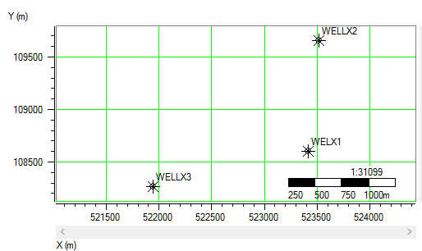

**Fig. 2:** The base map of the study field (Shell Petroleum Nigeria)

**3.0 Results**

**3.1 Results of VP/VS Ratio versus Acoustic-Impedance Cross-plot Space**

The cross-plot result of VP/VS ratio against P-Impedance for well X1 in reservoir HD5000 showed discrimination in three zones with variations in densities of gas sand from 2.0703g/cc; water sand from 2.2119 g/cc to 2.2592g/cc and shale from 2.3064g/cc to 2.3851g/cc (Fig. 3). Results of cross plot of Vp/Vs ratio against acoustic impedance for well X1 in reservoir HD9000 produced discrimination in two zones with density variations of oil sand from 2.1783g/cc to 2.3162g/cc (Fig. 4). Results of cross plot of Vp/Vs ratio against acoustic impedance for well X2 in reservoir HD 5000 produced discriminations in three zones with density variations of gas sands from 2.0809g/cc to 2.1702g/cc, water sands from 2.2297g/cc to 2.2594g/cc and shale from 2.3636g/cc to 2.4231g/cc (Fig. 5). These cross-plots showed better fluid as well as lithology discrimination.

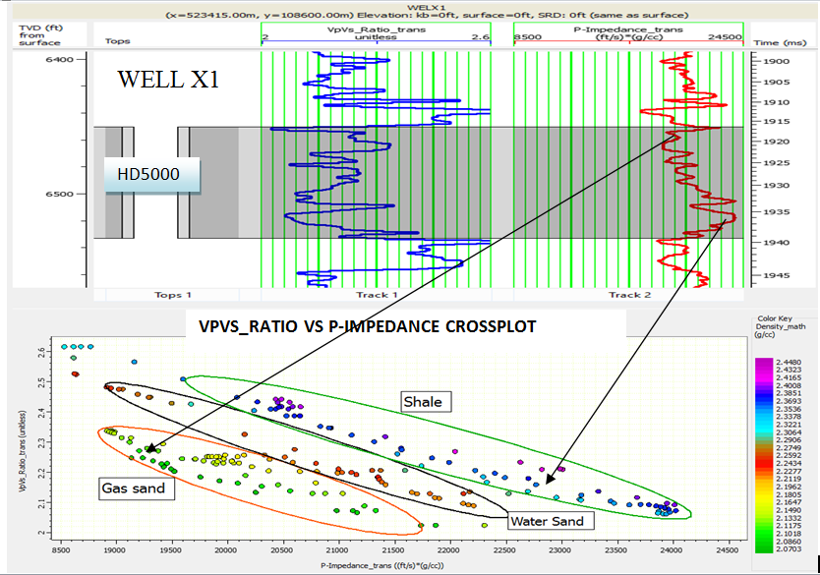

**Fig. 3:** Crossplot of Vp/Vs ratio vs. Acoustic impedance for Well X1 (Reservoir HD5000)

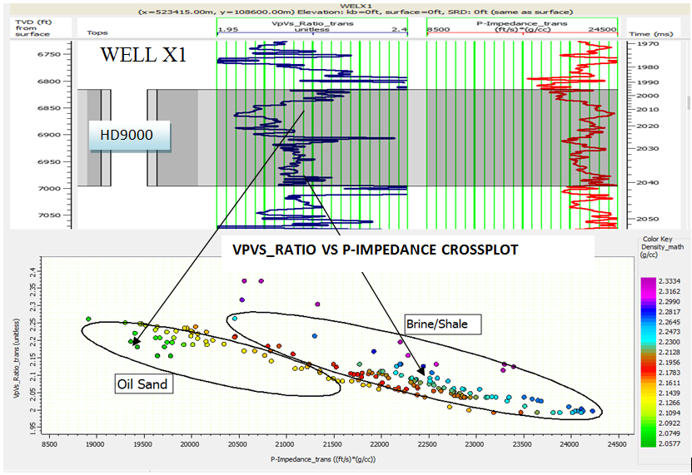

**Fig. 4:** Crossplot of Vp/Vs ratio vs. Acoustic impedance for Well X1 (Reservoir HD9000)

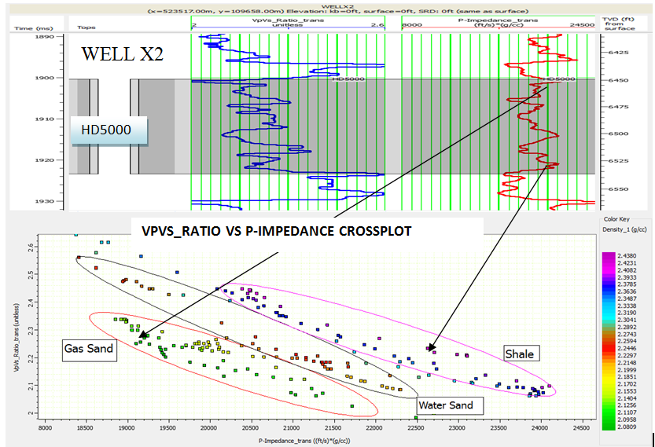

**Fig. 5:** Crossplot of Vp/Vs ratio vs. Acoustic impedance for Well X2 (Reservoir HD5000)

**3.2 Results of S-Impedance versus Acoustic-Impedance Cross-plots Space**

Results of S-impedance against acoustic impedance cross plot for well X1 in reservoir HD5000 produced discrimination in two zones with density variations of gas sand clusters from 2.0577g/cc to 2.0922g/cc and shale clusters from 2.1726g/cc to 2.2875g/cc (Fig. 6). Results of S-impedance against acoustic impedance cross plot for well X2 in reservoir HD 5000 produced discrimination in two zones with density variations of gas sand clusters from 2.0577g/cc to 2.0922g/cc shale clusters from 2.1726g/cc to 2.2760g/cc (Fig. 7). Results of S-impedance against acoustic impedance cross plot for well X1 in reservoir HD 9000 produced discrimination in one zone with wide density variation from 2.0577g/cc to 2.2875g/cc (Fig. 8). The crossplot of Shear-Impedance versus acoustic Impedance better discriminates the reservoir sand (Reservoir HD5000 Well X1/X2) into two zones using transformed Shale volume log as a colour code. They include gas sand clusters, oil and shale clusters. However in reservoir HD9000 (Well X1), the clusters are inseparable (shale clusters). This cross plot shows better fluid as well as lithology discrimination.

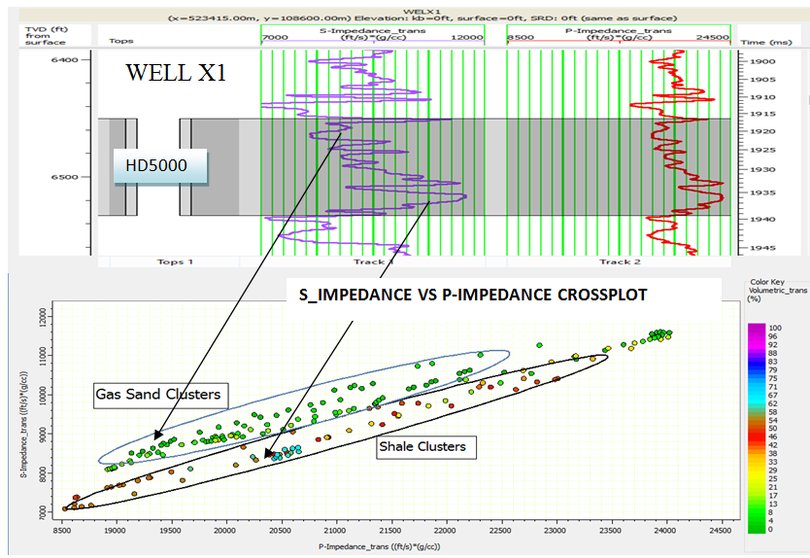

**Fig. 6:** Cross-plot of S-Impedance vs. Acoustic impedance for Well X1 (Reservoir HD5000)

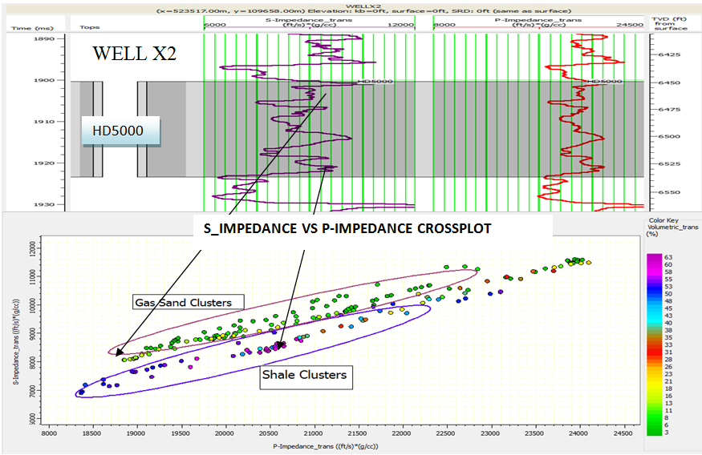

**Fig. 7:** Cross-plot of S-Impedance vs. Acoustic impedance for Well X2 (Reservoir HD5000)

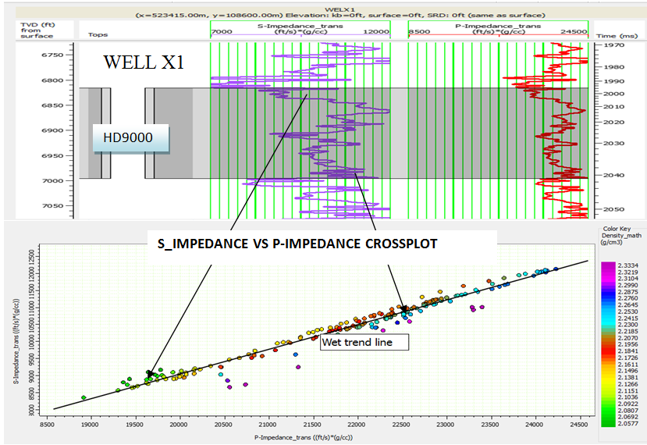

**Fig. 8:** Cross-plot of S-Impedance vs. Acoustic impedance for Well X1 (Reservoir HD9000)

**3.3 Comparative analysis of results**

Comprehensive results of Vp/Vs against acoustic impedance as shown in Table 1 clearly showed the presence of hydrocarbons and water from both wells located in reservoirs HD 5000 and HD 9000. Gas sand with average densities from 2.0703g/cc to 2.1490g/cc exist in well X1 and 2.0809g/cc to 2.1702g/cc exist in well X2. Oil was identified in well X1 in reservoir HD 9000 with density from 2.0577g/cc to 2.1266g/cc. Water sands was identified in wells X1 for both reservoirs and well X2 in HD 5000.The water density in well X1 (HD 5000) is from 2.2119g/cc to 2.2592g/cc; in well X2 (HD 5000) from 2.2297g/cc to 2.2594g/cc and in well X1 (HD 9000) from 2.1783g/cc to 2.3162g/cc.

Comprehensive results of S-impedance against acoustic impedance as shown in Table 2 clearly showed also the presence of hydrocarbon, shales and a wet trend line1,3,5. Gas sand clusters was obtained in two wells in reservoirs HD 5000 with density variations of 2.0577g/cc to 2.0922g/cc in well X1 and 2.0577g/cc to2.0922g/cc in well X2. Shale clusters were also identified in wells X1 and X2 in reservoirs HD 5000 with density variations of 2.1726g/cc to 2.287g/cc in well X1 and 2.1726g/cc to 2.2760g/cc in well X21. The wet trend line was obtained only in well X1 in reservoir HD 9000 with density variation of 2.0577g/cc to 2.2875g/cc.

Analytical comparative study of both results of Vp/Vs and S-impedance against the acoustic impedance showed similar attributes where results of wells X1 in reservoir HD 5000 in Table 1 gave gas sands, water sands and shales while results of Table 2 confirmed the findings with the presence of gas sands and shale clusters. Similarly, well X2 in reservoir HD 5000 which produced gas sands, water sands and shales (Table 1) was confirmed with results of Table 2 which produced gas and shale4. Well X1 in reservoir HD 9000 produced oil and brine in Table 1 while it was confirmed with wet trend line in Table 2.

It was observed that the discrimination zone in reservoir HD 9000 penetrated by well X1 gave an oil sand for Vp/Vs against acoustic impedance and a wet trend line in the S-impedance against acoustic impedance. This limitation implies that the oil/wet trend line show should be verified and/or validated in terms of reservoir location, volume, area, thickness and other reservoir properties using appropriate well logging and well test techniques.

**Table 1: Comprehensive Results of Vp/Vs against Acoustic Impedance**

|  |  |  |  |  |
| --- | --- | --- | --- | --- |
| Reservoirs | Wells | Minimum Density (g/cc) | Maximum Density (g/cc) | Discrimination |
| HD 5000 | **X1** | **2.0703** | **2.1490** | **Gas sand** |
| **X1** | **2.2119** | **2.2592** | **Water sand** |
| **X1** | **2.3064** | **2.3851** | **Shale** |
| **X2** | **2.0809** | **2.1702** | **Gas sand** |
| **X2** | **2.2297** | **2.2594** | **Water Sand** |
| **X2** | **2.3636** | **2.4231** | **Shale** |
| HD 9000 | **X1** | **2.0577** | **2.1266** | **Oil Sand** |
| **X1** | **2.1783** | **2.3162** | **Brine/Shale** |

**Table 2: Comprehensive Results of S-Impedance against Acoustic Impedance**

|  |  |  |  |  |
| --- | --- | --- | --- | --- |
| Reservoirs | Wells | Minimum Density (g/cc) | Maximum Density (g/cc) | Discrimination |
| HD 5000 | **X1** | **2.0577** | **2.0922** | **Gas sand clusters** |
| **X1** | **2.1726** | **2.2875** | **Shale clusters** |
| **X2** | **2.0577** | **2.0922** | **Gas sand clusters** |
| **X2** | **2.1726** | **2.2760** | **Shale clusters** |
| HD 9000 | **X1** | **2.0577** | **2.2875** | **Wet trend line** |

**4.0 Conclusion**

It was observed that results of comprehensive cross plot analysis of Vp/Vs and S-impedance against acoustic impedance showed that the top reservoir HD 5000 penetrated by wells X1 and X2 has only gas and water (brine) while the bottom reservoir HD 9000 has only oil and water which was also penetrated only by well X1. These resultant variations of litho-fluids arrangement from the top to bottom in the sub-surface are gas – water – oil – water.

It is clear that these comprehensive cross plot analyses showed better understanding of fluid and lithology delineation. All the results of Vp/Vs against acoustic impedance attributes gave better description while better discrimination/separation of clusters was observed along the p-impedance axis for effective lithology identification. However, shear wave impedance against acoustic impedance attributes adequately described reservoir conditions in terms of gas saturations and brine-filled reservoirs but a better discrimination/separation of clusters is observed along the s-impedance axis which discriminates between lithology in the reservoir.

**Conflict of interest:** There is no conflict of interest.

**Significance statement**

This technical ideology is actually to improve the existing technical narrative of pseudo-characterization of wells in heterogeneous reservoirs and capacitated by clear understanding of the behavioural traits of seismic wave velocity ratios and shear wave impedance properties with the acoustic impedance domain of rocks.

**Author’s contributions**

The first Author provided the frame work of this study such as the title, contributed in result analysis, discussion and conclusion. The second Author provided the statement of problem, aim and objectives, materials and method.

**References**

Egu D. I. and Ilozobhie, J. A. (2020). Astute Expository of Vacillation Attributes of Geoseismo-Thermal Ruminative of the Turonian Maastrichtian Fika Shale in Parts of the Bornu Basin, North-Eastern Nigeria. SPE-203606-MS paper virtually presented at the SPE Nigeria Annual International Conference and Exhibition, 11-13 August, Nigeria. <https://doi.org/10.2118/203606-MS>

Ilozobhie, A.J. and Egu, D.I.(2021). Dynamic reservoir sand characterization of an oil field in the Niger Delta from seismic and well log data. Arabian journal of Geosciences, 14(853). <https://doi.org/10.1007/s12517-021-06542-4>

Ilozobhie, A.J. and Egu, D.I. (2020). Dynamic Reservoir Sand Characterization of an Oil Field in the Niger Delta from Seismic and Well Log Data. Arabian Journal of Geosciences. Arabian Journal of Geosciences 14 (10), 853 <https://doi.org/10.1007/s12517-020-05741-9>

Ilozobhie, A.J. and Egu, D.I. (2022). Elliptical Mathematical Scholium of Petrophysical Modulation of Volume of Shale Paradigm from Linear and Non-Linear Confluxibilities. International Center for Research and Resources Development (ICRRD) journal, 3(4), 133-146. <https://doi.org/10.53272/icrrd>

Ilozobhie, A.J., Egu, D.I., Obalola, H.A. and Mzough, O.M. (2023): Improving Resolution Qualities in Low P-impedance Sand Channels with Synthetic and Recursive Seismic Modeling Techniques. Australian Journal of Basic and Applied Science, 17(12): 20-28. <https://doi.org/10.22587/ajbas.2023.17.12.3>

Maghsood, A., Isa, T. and Koichi, S. (2004). Integrated seismic-guided characterization of a carbonate reservoir in Abu-Dhabi, U.A.E. SPE paper 90533-MS presented at the annual technical conference and exhibition, September, 26-29. DOI: <https://doi.org/10.2118/90533-MS>

Mathew, B. Naoki, S., Hiroshi, H., Hiroaki, Y., Hiroshi, N., Syed, M., Adam, H. and Mark, G.K. (2021). Revealing hidden information: High-Resolution logging-while-drilling slowness measurements and imaging using advanced dual ultrasonic technology. The society of petrophysicists and well log analysts (SPWLA) journal, 62(01):89-108. DOI: <https://doi.org/10.30632/PJV62N1-2021a6>

Olabode, J.O. and Sara, G. (2018). Comparing seismic inversion methods on a carbonate reservoir. A case study from Mishrif reservoir, Rumaila Field, Iraq. SPE paper 192956-MS presented at the Abu Dhabi international petroleum exhibition and conference, November 12-15. DOI: <https://doi.org/10.2118/192956-MS>

Oliver, G., Stanislas, V. and Alberto, C. (2001). Integrated history-matching of production and 4D seismic data. SPE paper SPE-71599-MS presented at the annual technical conference and exhibition, September 30 – October 3. DOI: <https://doi.org/10.2118/71599-MS>

Sofolabo, A., Tamunonengiofori, D. and Joseph, E. (2020). Integration of seismic inversion attributes in field development and production optimization of sedimentary basin in central depobelt of Niger Delta area. Society of Exploration Geophysicists (SEG) paper 3428022 presented at the international exposition and annual meeting, October 11-16. DOI: <https://doi.org/10.1190/segam2020-3428022.1>