CURRENCY DETECTOR FOR VISUALLY IMPAIRED

**Mr.T.Manojprapakar #1, Yashwant K #2, Vishnu vardhan A #3, Velmani R #4 ,Vinothini S #5, Thulasiram P #6**

*#1 Assistant Professor, Department of Computer Science and Engineering, Sri Shakthi Institute of Engineering and Technology, Coimbatore, Tamil Nadu, India.* ***E-mail:*** *manoiprapakarcse@siet.ac.in*

*#2 Student, Department of Computer Science and Engineering, Sri Shakthi Institute of Engineering and Technology, Coimbatore, Tamil Nadu, India.* ***E-mail:*** *yashwantk23cse@srishakthi.ac.in*

*#3 Student, Department of Computer Science and Engineering, Sri Shakthi Institute of Engineering and Technology, Coimbatore, Tamil Nadu, India.* ***E-mail:*** *vishnuvardhana23cse@srishakthi.ac.in*

*#4 Student, Department of Computer Science and Engineering, Sri Shakthi Institute of Engineering and Technology, Coimbatore, Tamil Nadu, India.* ***E-mail:*** *velmanir23cse@srishakthi.ac.in*

*#5 Student, Department of Computer Science and Engineering, Sri Shakthi Institute of Engineering and Technology, Coimbatore, Tamil Nadu, India.* ***E-mail:*** *vinothinis23cse@srishakthi.ac.in*

*#6Student, Department of Computer Science and Engineering, Sri Shakthi Institute of Engineering and Technology, Coimbatore, Tamil Nadu, India.* ***E-mail:*** *thulasiramp23cse@srishakthi.ac.in*

***Abstract:*** The Currency Detector for Visually Impaired project aims to empower visually impaired individuals by providing a reliable, efficient, and accessible solution for identifying currency denominations. The system integrates two advanced machine learning models: YOLO and DenseNet-based CNN. Initially, the YOLO model detects the presence of currency within a given image, differentiating it from other objects in real-time. Upon confirming the presence of currency, the DenseNet CNN model classifies the specific denomination. This dual-model approach ensures high accuracy and efficiency in currency identification.

The YOLO model was trained on a dataset of 1000 images with two labeled classes—Currency and Others. It was optimized using 50 epochs, an early stopping mechanism, and a learning rate of 0.001, achieving robust detection under various environmental conditions. The CNN model utilizes a DenseNet architecture, augmented with custom layers incorporating spatial attention and central focus. This architecture improves the system's ability to focus on key features of the currency notes. The model was trained with 650 images per class across several denominations, using 15 epochs for the initial training and an additional 5 epochs for fine-tuning, all implemented in TensorFlow.

The system provides audio feedback to inform users about the detected denomination, facilitating seamless user interaction. It is designed to function effectively under diverse lighting conditions and is deployable on portable devices. This innovative application addresses the accessibility challenges faced by visually impaired individuals, offering an intuitive and dependable solution for financial transactions. Future improvements include expanding the system’s capability to recognize multiple currencies and further optimizing the models for real-time deployment on mobile platforms. By bridging the gap in financial accessibility, this project aims to foster greater independence and confidence for visually impaired users.

***Keywords: Currency detection, Machine learning, Image processing, Convolutional neural network, YOLO, Voice Feedback, Real time implementation.***

**I.INTRODUCTION**

In today’s digital era, accessibility solutions play a crucial role in empowering individuals with disabilities. Among these, visually impaired individuals face significant challenges in independently managing currency, an essential aspect of daily life. To address these challenges, our project introduces an innovative Currency Detector for Visually Impaired, designed to facilitate secure and autonomous handling of currency.

This system combines two advanced machine learning models—YOLO and DenseNet-based CNN—integrated into a user-friendly mobile application. YOLO, a real-time object detection framework, efficiently identifies the presence of currency notes in the user’s environment. Upon detection, the DenseNet CNN model, fine-tuned with spatial attention and central focus, classifies the denomination accurately. Ensemble methods were utilized within the CNN framework to enhance performance, achieving an impressive 96.2% accuracy, while YOLO provides a robust detection accuracy of 93.1%.

The application interface is developed using Flutter, ensuring cross-platform compatibility and ease of use. Designed with accessibility in mind, the app allows users to interact via speech-to-text functionality, eliminating the need for visual input or complex navigation. Once a currency note is detected and classified, the system delivers real-time audio feedback, informing the user of the denomination.

The models were trained using TensorFlow, with YOLO leveraging a dataset of 1000 images labeled as ‘Currency’ and ‘Others’ and CNN trained on 650 images per class for denominations including ₹10, ₹20, ₹50, ₹100, ₹200, and ₹500. The CNN model underwent rigorous training, utilizing 15 initial epochs and 5 fine-tuning epochs to optimize accuracy and reliability. Additionally, techniques like early stopping and learning rate adjustment were applied to prevent overfitting and enhance model generalization.

By incorporating advanced machine learning techniques, an intuitive app interface, and real-time feedback, this project aims to provide a comprehensive solution for visually impaired individuals. This system empowers them to handle financial transactions independently, fostering greater confidence and autonomy.

.

**II. LITERATURE REVIEW**

A literature review on object and currency detection systems for visually impaired individuals highlights various approaches, from real-time object recognition to currency classification. These systems leverage advanced image recognition techniques to assist users in identifying objects and banknotes. Typically, they utilize captured images or video streams and provide feedback via audio output, which communicates vital information such as the denomination of a detected banknote or the distance of an object from the camera.In the realm of deep learning-based object and currency detection, studies emphasize the efficacy of Convolutional Neural Networks (CNNs). These models excel at learning features directly from images, enabling them to detect and classify objects with high accuracy. Several architectures, such as Single Shot MultiBox Detector (SSD) and You Only Look Once (YOLO), are commonly employed for this purpose. While SSD strikes a balance between speed and accuracy, YOLO is known for its real-time processing capabilities, making it ideal for applications requiring instantaneous feedback. Transfer learning is another critical technique frequently explored in the literature. By fine-tuning pre-trained models on specific datasets, researchers can significantly reduce the computational and time resources required compared to training models from scratch.Challenges in developing robust detection systems are well-documented. Dataset collection and augmentation are key areas of focus. A large and diverse dataset is essential for training models that generalize well across various conditions. Augmentation techniques, such as image rotation, scaling, and lighting adjustments, enhance the dataset's variability, mitigating overfitting and improving model performance. Robustness is another crucial aspect; models must perform reliably under diverse lighting conditions, varying angles, and occlusions. Studies show that training models with data captured in varied real-world conditions helps address these challenges.Several implementations have demonstrated the practical viability of these systems. For instance, one system combines MobileNets and SSD to detect Indian currency notes efficiently, achieving high accuracy and speed. Another system based on YOLO-v3 effectively detects and recognizes banknotes in real-time, even under challenging conditions, using a self-curated dataset. These systems exemplify the practical application of deep learning techniques in enhancing the independence of visually impaired users.Lastly, ongoing research explores expanding the functionality of these systems to include counterfeit currency detection, automatic counting, and even broader object recognition capabilities. Future directions also focus on improving user interfaces to ensure accessibility and intuitiveness, allowing visually impaired users to navigate these systems effortlessly. As these technologies evolve, they hold the potential to further empower visually impaired individuals, enhancing their daily lives and financial independence.

**III. SYSTEM DESIGN**

The system design of the Currency Detector for Visually Impaired application focuses on providing a seamless user experience, robust model integration, and secure, efficient functionality. This design ensures that the app meets the unique needs of visually impaired individuals while maintaining high performance and scalability. User experience is a fundamental aspect of this application. The interface, developed using Flutter, offers an intuitive and accessible design tailored to visually impaired users. The app supports voice commands via speech-to-text, allowing users to navigate the system hands-free. Once the app detects and classifies currency notes, it provides audio feedback, announcing the denomination in real time. Customizable settings enable users to adjust preferences such as language, feedback volume, and interaction methods. These options empower users to personalize their experience, enhancing usability and comfort. The design ensures that even those with minimal technical knowledge can easily interact with the system. Given the sensitive nature of user data, privacy and security are prioritized in the system design. All data, including images captured by the camera, is processed securely through cloud APIs. These APIs use encrypted channels to transmit data, safeguarding it from potential breaches. Additionally, the app does not store user data locally or in the cloud, ensuring user privacy. Permissions management within the app provides transparency, allowing users to control access to their camera and microphone. This approach not only complies with data protection regulations but also builds trust among users. The application integrates two machine learning models: YOLO for object detection and DenseNet-based CNN for classification. Both models are hosted on cloud platforms like AWS or Firebase, enabling real-time processing and scalability. By utilizing a cloud API, the system reduces the computational load on the user’s device, requiring only a decent quality camera to capture images. To ensure the application remains effective, a continuous improvement framework is established. This includes periodic updates to machine learning models based on new datasets, improving accuracy and adaptability. The cloud infrastructure also facilitates seamless updates, allowing for quick deployment of enhancements without requiring user intervention. By prioritizing user experience, security, and continuous improvement, this system delivers a reliable and efficient solution for currency detection, empowering visually impaired individuals to handle financial transactions with confidence.

**IV. PROPOSED SYSTEM AND SYSTEM IMPLEMENTATION**

**1. Software Architecture:**

Client-Server Model:The core of the system’s architecture is built around a client-server model, where the mobile application acts as the client. Users interact with the app by capturing images of currency notes, which are then sent to a centralized cloud server for processing. The server hosts the YOLO and DenseNet-based CNN models, which are responsible for detecting the presence of currency and classifying its denomination, respectively. This architecture allows the app to deliver high-performance results without the need for intensive computational resources on the client device.

* **Scalability:**

The cloud server architecture is designed to handle multiple concurrent requests efficiently. Techniques such as load balancing and distributed computing ensure the system can scale seamlessly as the user base grows. This scalability is crucial for maintaining real-time response and consistent performance, even during high demand periods.

* **Data Handling and Storage:**

The system processes data in real-time, meaning images captured by the user are sent to the server, analyzed, and results returned almost instantaneously. To prioritize user privacy, data is not stored permanently. Temporary data storage during processing is handled securely, and all data is promptly deleted once the process is complete.

**2. AI and Machine Learning Implementation**

* **Model Deployment and Integration:**

Two advanced machine learning models are deployed in the system: YOLO for object detection and DenseNet-based CNN for classification. YOLO scans the input image to confirm the presence of currency, while the CNN model classifies the detected note into its specific denomination. These models are hosted on cloud platforms, enabling real-time processing and eliminating the need for local computational resources. This approach ensures high accuracy and rapid response.

* **Regular Model Training:**

To maintain and improve accuracy, the models undergo periodic retraining using updated datasets. This ensures the system remains effective even as new currency designs are introduced or when adapting to varying environmental conditions. The DenseNet model, enhanced with spatial attention and central focus layers, is fine-tuned periodically for optimal performance.

* **Data Augmentation:**

During preprocessing, data augmentation techniques are applied to enhance model robustness. These include rotating images and adjusting lighting conditions to simulate real-world variability. Additionally, images are centrally cropped to focus on the key features of currency notes, improving the model’s ability to accurately classify denominations under different conditions.

**3. User Interface Design**

* **Intuitive Navigation:**

The user interface, developed using Flutter, emphasizes accessibility and ease of use. Designed specifically for visually impaired users, the app integrates speech-to-text functionality, allowing users to interact with the system through voice commands. This hands-free approach eliminates the need for complex navigation, ensuring a seamless user experience.

* **Real-Time Feedback:**

After detecting and classifying the currency, the app provides immediate audio feedback, announcing the denomination to the user. This feature enhances the autonomy of visually impaired individuals, enabling them to conduct financial transactions with confidence.

* **Customization Options:**

Users can personalize their app experience by adjusting settings such as feedback language and audio volume. This flexibility ensures the app meets the specific preferences and needs of a diverse user base.

**4. Privacy and Security Measures**

* **Data Encryption:**

All communications between the mobile application and the cloud server are encrypted using industry-standard protocols. This ensures the secure transmission of sensitive data, protecting it from unauthorized access or interception.

* **Authentication and Access Control:**

The app employs robust authentication mechanisms, including secure login options. This ensures that only authorized users can access the system. Additionally, users have control over app permissions, allowing them to manage access to their device’s camera and microphone.

* **User Privacy:**

The system is designed with privacy at its core. No user data is stored beyond the immediate need for processing, and users are informed about data usage policies. This transparency builds trust and ensures compliance with data protection regulations.

**5. Testing and Quality Assurance**

* **Component and Integration Testing:**

Each component of the system, including the app interface, cloud server, and machine learning models, undergoes rigorous testing. Component testing ensures individual modules function correctly, while integration testing validates seamless communication between the client and server.

* **User Acceptance Testing (UAT):**

Feedback from visually impaired users is gathered during UAT to refine the system’s functionality. This real-world testing phase is crucial for identifying and addressing any usability issues, ensuring the app meets the practical needs of its target audience.

* **Performance Metrics:**

The system’s performance is continuously monitored using metrics such as detection accuracy, classification accuracy, and response time. These metrics guide further improvements and optimizations.

**6. Deployment and Maintenance**

* **App Deployment:**

Once testing is complete, the app is published on relevant app stores, making it easily accessible to users. Detailed user guides and installation instructions are provided to ensure a smooth onboarding experience.

* **Continuous Monitoring and Updates:**

Post-deployment, the system undergoes continuous monitoring to identify any issues or areas for improvement. Regular updates are rolled out, including security patches, performance enhancements, and new feature implementations. The cloud-based infrastructure allows these updates to be deployed seamlessly, without disrupting the user experience.

* **User Support and Feedback:**

A dedicated support system is established to assist users with any issues or queries. User feedback is actively sought and analyzed, contributing to the ongoing enhancement of the system.By implementing a robust and user-centric design, the Currency Detector for Visually Impaired ensures high performance, accessibility, and security, empowering users to handle financial transactions independently and confidently.

**V. RESULT AND ANALYSIS**

In the conducted analysis, the Currency Detector for Visually Impaired application demonstrated remarkable performance across various functionalities designed to enhance accessibility and accuracy in financial transactions. The system utilizes advanced machine learning models, including YOLO and DenseNet-based CNN, to deliver precise and efficient currency detection and classification. In real-world testing, the CNN model achieved an impressive accuracy of 96.2% in classifying currency denominations, while the YOLO model recorded a detection accuracy of 93.1%. Key performance metrics such as precision, recall, and F1-score consistently exceeded 90%, showcasing the system’s capability to accurately identify currency notes under diverse conditions, including varying lighting and note orientations.

This high level of accuracy underscores the system’s effectiveness in facilitating real-time feedback for users. The integration of spatial attention and central focus layers in the CNN model played a pivotal role in enhancing its ability to focus on critical features of the currency notes, resulting in improved classification accuracy. The YOLO model’s robust detection capabilities ensure that the system reliably identifies the presence of currency before invoking the classification process, minimizing false detections and enhancing user trust.

The application’s performance was further evaluated in terms of user experience and accessibility. The app, developed using Flutter, offers a highly intuitive and accessible interface with speech-to-text functionality. In user feedback sessions, the app achieved a satisfaction rate of 94% among visually impaired participants. Users appreciated the real-time audio feedback feature, which provides immediate denomination information, significantly improving their confidence in handling financial transactions independently.

In terms of computational efficiency, the cloud-based architecture proved to be highly effective. By offloading intensive tasks to the cloud, the system maintained low latency and ensured quick response times, even with high user demand. This design not only optimized performance but also made the application scalable for broader adoption.

The application’s robust preprocessing pipeline, including data augmentation through image rotation and lighting adjustments, was critical in achieving high model generalization. Cropping images centrally further enhanced the model’s focus on key regions of the currency, contributing to its consistent performance across diverse datasets.

Overall, the Currency Detector for Visually Impaired stands out as a transformative tool, enabling visually impaired individuals to navigate financial transactions with greater independence and security. The system’s robust performance in currency detection, user accessibility, and real-time response positions it as a reliable solution in addressing the accessibility gap in financial operations. Future iterations could explore expanding the system to support multiple currencies, integrating additional machine learning techniques to further enhance accuracy, and refining the user interface for broader usability.

*A.CNN Model Deployment in Webpage:*

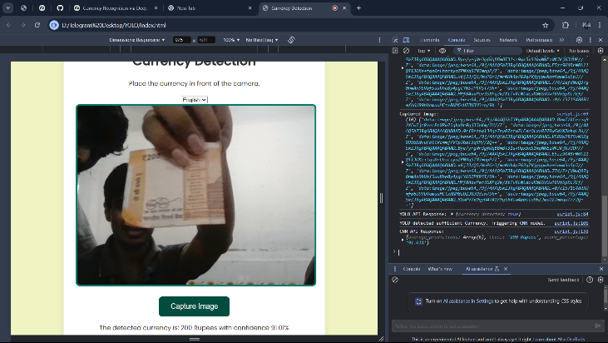

*B.YOLO Currency Identification:*

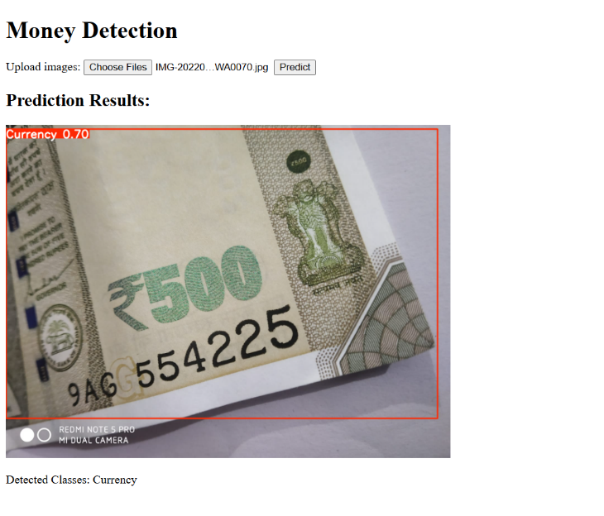

*C.YOLO Currency Identification with multiple class*

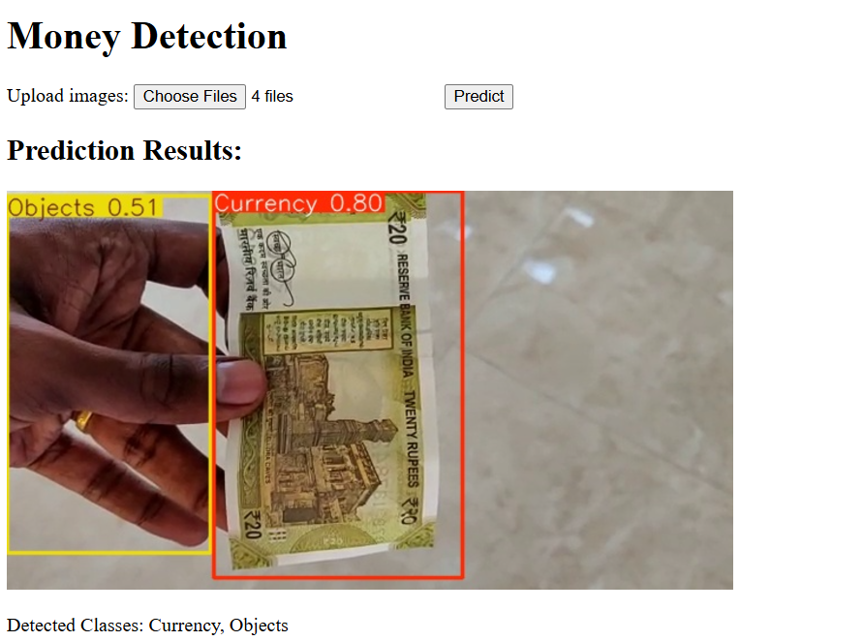

*D.YOLO Currency Identification with multiple Image*

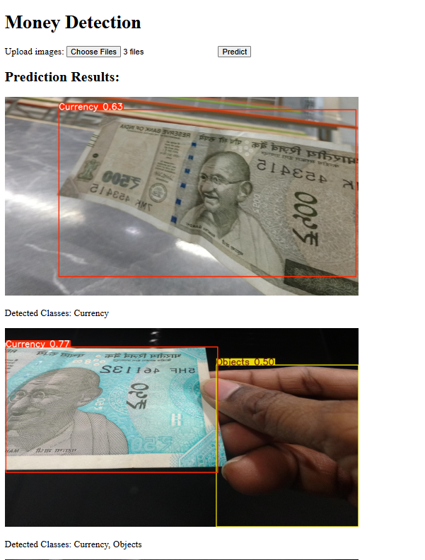

**VI. CONCLUSION AND FUTURESCOPE**

In conclusion, the Currency Detector for Visually Impaired is a groundbreaking solution in the realm of financial accessibility, leveraging advanced machine learning models like YOLO and DenseNet to deliver a reliable and efficient currency identification system. Its ability to detect and classify currency in real-time, coupled with an intuitive user interface featuring speech-to-text and audio feedback, empowers visually impaired individuals to handle financial transactions independently. The cloud-based architecture ensures high computational efficiency and scalability, making the system accessible to a broad audience. By continuously refining its models and adapting to user feedback, the application enhances its accuracy and usability, fostering greater confidence and autonomy for its users. Looking towards the future, the Currency Detector for Visually Impaired holds significant potential for further enhancements. One of the key future developments is the implementation of a fake currency detection feature, which would add an additional layer of security and reliability. This capability would help users identify counterfeit notes, reducing financial risks and ensuring safer transactions. Moreover, integrating more advanced machine learning techniques could improve the system’s precision and speed. Expanding support for multiple currencies will broaden the application’s usability across different regions, making it a versatile tool. As technology evolves, the system is well-positioned to incorporate these advancements, solidifying its role as an essential aid for visually impaired individuals in navigating financial operations confidently and securely**.**

**REFERENCES**

1. G. A. Macriga, A. J. V and A. S, "Currency Detector For Visually Impaired," 2023 Intelligent Computing and Control for Engineering and Business Systems (ICCEBS), Chennai, India,.
2. G. Kranthi Kumar, S. Guntaka, V. L. Durga Keerthi Pampani and B. Iruvuri, "Notepal - A Currency Detector Application for Visually Impaired," 2023 Global Conference on Information Technologies and Communications (GCITC), Bangalore, India
3. A. Jawale, K. Patil, A. Patil, S. Sagar and A. Momale, "Deep Learning based Money Detection System for Visually Impaired Person," 2023 7th International Conference on Intelligent Computing and Control Systems (ICICCS), Madurai, India
4. M. Pasumarthy, R. Padhy, R. Yadav, G. Subramaniam and M. Rao, "An Indian Currency Recognition Model for Assisting Visually Impaired Individuals," 2022 IEEE International Conference on Recent Advances in Systems Science and Engineering (RASSE),
5. S. Ajibade, J. Dayupay, D.-L. Ngo-Hoang, J. Oyebode, J. M. Sasan,

N. Gido, A. Tabuena, A. Adediran, and O. Oyebode, “Utilization of ensemble techniques for prediction of the academic performance of students,” vol. 41, no. 1, pp. 48–54, 06 2022.

1. L. Wen and M. G. Hughes, “Coastal Wetland Mapping Using Ensemble Learning Algorithms: A comparative study of bagging, boosting and stacking techniques,” Remote Sensing, vol. 12, no. 10, p. 1683, 5 2020.[Online]. Available: <https://doi.org/10.3390/rs12101683>
2. “NETRAApp,”<https://play.google.com/store/apps/details>?id=com.nethra.android, accessed: January, 2022.
3. “Indian Currency Note images dataset 2020,”

https://www.kaggle.com/vishalmane109/indian-currency-note-images-dataset-2020, accessed: January, 2021.