# Pharmacogenetics and Pharmacogenomics of Opioids: A Review

Samrudhi Pawar1, Mr. Nihal Bijali2, Mr. Sagar Jadkar3

1student , B pharmacy , lokmangal college of pharmacy , Solapur , Maharashtra , India

2Professor , B pharmacy , lokmangal college of pharmacy , Solapur , Maharashtra , India

3 professor , B pharmacy , lokmangal college of pharmacy , Solapur , Maharashtra , India

ABSTRACT

Pain can be reduced in a variety of ways, including pharmacotherapy and surgery. Opioids are a class of drugs that efficiently treat moderate to severe acute and ongoing discomfort, which can accentuate several characteristics of their daily lives. Regarding acute discomfort, the expected physiological response to disagreeable stimuli, which is typically linked to serious illness or trauma (State Medical Boards Federation of the United States, 1998. The term "chronic pain" refers to suffering that lasts longer than the expected duration of recuperation or everyday suffering for the expected duration of recuperation or everyday suffering for extending beyond three months (Davis et al., 2017). The utilization of opioids is commonly used as the standard of care for both acute and chronic pain related to palliative care.

Keywords :Pharmacogenetics, pharmacogenomics, pain, opioids .

Classification of Opioids:

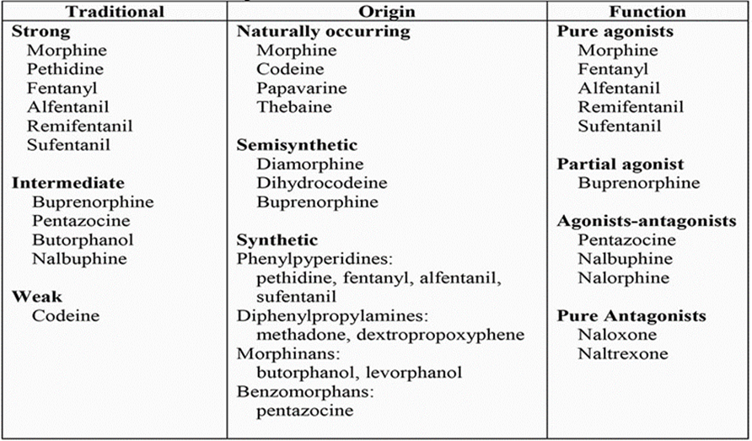

The therapeutic margin for opioids

One of the most severe symptoms of opioid agonist poisoning is a narrow therapeutic index, with   
Opioids' therapeutic margin  
The most severe toxicity caused by opioid agonists is typified by a limited therapeutic index, respiratory depression, which is a potentially fatal illness, so most of the time there is a careful balancing act between opioids and reducing pain without using respiratory depressants ,which is a potentially fatal illness, so most of the time there is a careful balancing act between opioids and reducing pain without using respiratory depressants. This is a feature that distinguishes the therapeutic use of opioids.   
In order to treat post-operative pain in adult patients, for instance, the need for morphine doses must decrease with age. It is also important to understand the patient's features, how they perceive pain, how intense it is, how long it should persist, and narcotic medicines and dosage selection. Understanding opioid metabolism is critical, as variations in concentrations of parent drugs or their metabolites can significantly influence therapeutic outcomes. Opioid metabolism shows Variations in the concentrations of the parent medication or its active metabolites at the site of action may be the cause of interindividual heterogeneity in the opioid response. Opioid metabolism affects active site concentrations in addition to variations in absorption and distribution (see Transporters of Opioids section). The primary enzymes responsible for the significant metabolism of all opioid medications are CYPs (cytochrome P450) and UDP-glucuronosyltransferases (UGTs), which also play a role in secondary metabolic pathways. Even so, a large number of opioids are metabolized by CYP3A4. The highly polymorphic CYP2D6 plays a crucial role in increased clinical interest in less potent opioids.

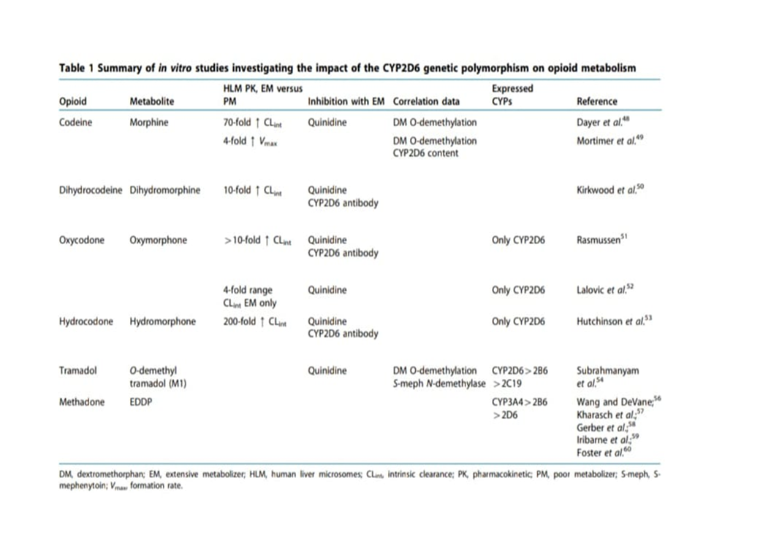

CYP450 isoforms in vitro investigations (Table 1). It is commonly known that a portion of the patient population lacks the ability to convert codeine into morphine, a strong mu opioid agonist and painkiller. The first in vitro investigation to identify the potential genetic mechanism behind this impairment showed that CYP2D6 plays a part in codeine O-demethylation, with EM and PM human liver microsomes differing in intrinsic clearance (CLint) by more than 70 times. Furthermore, quinidine's strong suppression of morphine production and a noteworthy association between codeine's O-demethylation rates and the prototypical CYP2D6 substrate dextromethorphan underscored the function of CYP2D6.48 Mortimer et al.49 reported similar results, demonstrating a high association between liver CYP2D6 concentration and codeine O-demethylation.

pharmacogenetics. Because of the notable interindividual variability in P-gp expression and function, the transport of opioid substrates by P-gp is a crucial factor to take into account when studying opioid pharmacogenetics. For instance, in healthy individuals, the expression of liver ABCB1 mRNA fluctuates 200 times, while the corresponding protein levels vary 20 to 50 times.143,144 In the same way, intestinal P-gp protein expression varies two to ten times.145 The naturally occurring genetic variants of the ABCB1 gene are potential causes of this variance. In fact, the ABCB1 gene that codes for P-gp is extremely polymorphic; more than 100 SNPs have been found so far, and each one may have an impact on the transporter's expression and/or functionality. Kerb146 has recently reviewed the location and frequency of the most prevalent ABCB1 SNPs.

Evidence currently available on opioids and pharmacogenomics  
Pharmacogenetic effects have been noted for opioid transporters (like P-glycoprotein), receptors (like and others), and individual responses to opioids. OPRM1), drug metabolism, and signal transduction pathways (such as ANKK1) neurotransmitter enzymes (like COMT) and enzymes (like CYP2D6). In spite of With the discovery of several potential functional gene variations, the majority of these still need to be confirmed in bigger human samples, hence few are considered clinically actionable, which means that only a limited number can be utilized.

CYP2D6 (member 6 of cytochrome P450 family 2 subfamily D)  
With regard to actionable opioid variations, the CYP2D6 (cytochrome P450 family 2 subfamily D member 6) gene provides the most compelling data. About 25% of popular drugs are metabolized by the CYP2D6 enzyme, which is mostly expressed in the liver and is encoded by the CYP2D6 gene [28]. It is the main metabolic pathway for common, significant drug classes used in palliative care, such as tricyclic antidepressants, antihistamines, serotonin selective reuptake inhibitors, and certain antiemetics [29]. A significant amount of the regularly used opioids in the globe are codeine, tramadol, oxycodone, and hydrocodone, all of which are partially metabolized by CYP2D6 [30]. The combination of each person's inherited alleles determines the metabolizer phenotype, or CYP2D6 enzyme function.. Among the search phrases were phenotypic descriptors (analgesia/toxicity, cancer pain, neuropathic pain, nociceptive pain) and opioids of interest (buprenorphine, codeine, fentanyl, hydrocodone, hydromorphone, methadone, morphine, oxycodone , tramadol, opioids.

On March 1, 2022, each database was viewed. While PharmGKB was last updated on February 5, 2022, CPIC is updated in real time. Together, these databases create sizable, globally renowned central annotated datasets on effects of gene variants on response to opioid medications and pain. The RAMESES publication criteria were used for narrative reviews. A narrative review was utilized to comprehensively gather the most recent research on this subject and facilitate a more in-depth narrative-style debate on its relevance to palliative care, thereby establishing an intersection between the two fields.   
The current limitations of pharmacogenomic-guided prescription   
Although clinically relevant data exists for pharmacogenomics and opioids, worries over the cost-benefit ratio of existing or potential of CYP2D6 genotyping. Ideally, pharmacogenomic testing should be conducted prior to therapy to aid in making decisions. However, in reality, pharmacogenomic testing most likely takes place following a patient's referral to palliative care teams, meaning Inappropriate opioid use may have already caused toxicity in certain patients. Retrospective PGx testing might still be useful. explain adverse impacts or inefficiency, and provide more confidence in later treatment decisions. Given the current evidence, it is unknown what percentage of patients may benefit depending on whether the test is being performed for all actionable variants or only specific variants of interest. Nowadays, most opioid pharmacogenomic testing are either self-funded or acquired through research projects. Most physicians are not equipped to interpret pharmacogenomic test findings, advise patients on where to get tested, or understand the latest pharmacogenomic information [16]. Since opioid pharmacogenomic testing is not yet the norm, self-funded tests might be utilized.

variations of interest with recognized labs

Lastly, while scheduling the test for maximum clinical value, the turnaround period of several weeks must be taken into account. Palliative care options are available. taking care to reflect the advancements made in the field of personalized oncology, specifically to support opioid pharmacogenomic testing via research initiatives while also training and educating medical professionals in the field. in summary, the only pharmacogenomic drugs that now support and influence the prescription of opioids, both now and in the future, are codeine and tramadol. However, the pace of research in this where additional opioids, like methadone (CYP2B6) and oxycodone (CYP2D6), are present. already offer some proof of pharmacogenetic connections to medication response, and a number of other genes, some of which have been studied in more opioids than the others.

Clinical validation is necessary for these encouraging outcomes, and it's possible that worldwide norms in this field may soon grow. Patients now have more access and affordability thanks to the pharmacogenetics tests' increasing turnover and declining costs   
More and more, clinicians will be asked inquiries on this and be requested to furnish details and advice regarding this field of care According to the available data, pharmacogenomic testing should concentrate on the CYP2D6 gene and its actionable variations if it is intended to be incorporated into the practice of prescription opioids. Pharmacogenomics is a potentially significant field of broad understanding, and palliative care, like other medical specialties, will be affected and impacted by this body of information more and more.

Conclusion: Evidence from the studies discussed in this review suggests that opioid genetics could be a useful strategy for accomplishing the objective of individualized pain management. Prescription procedures could be enhanced by PGx, allowing for safer and more efficient use of pharmaceuticals. COMT, CYP2D6, CYP3A4, CYP3A5 Important genes including ABCB1, OPRM1, and OPRD1 ought to be tested for in analgesic genetic studies. With the help of PGx guidelines, physicians may reliably prescribe the best medications at the right dosages, which should save healthcare payers money and help address the present opioid issue.   
Even though this gene collection has produced encouraging results, our understanding of the routes and mechanisms influencing pain response limits the strength of all the evidence.

References:

S Kumar, P Kundra ,K Ramsamy ,A Surendiran Anaesthesia 74 (11) 1456-1470,2019

Bachmann K (2009) Drug Metabolism. Available at: https://www.sciencedirect.com/topics/biochemistry-genetics-and-molecular-biology/ drug-metabolism (accessed 18 December 2018)

Centers for Disease Control and Prevention (2018) National Vital Statistics System, Mortality, WONDER. Available at: https://wonder.cdc. gov/

Aniwaa Owusu Obeng , Issam Hamadeh, Michael Smith

Pharmacotherapy: the journal of human Pharmacology and drug therapy 37(9) 1105-1121,2017

Andrew A Somogyi, Daniel T Barratt, Janet K Coller

Clinical Pharmacology & Therapeutics 81 (3), 429-444, 2007

Macintyre, P.E. & Ready, L.B. Acute Pain Management: A Practical Guide 2nd edn. (WB Saunders, London, 2001).

Senthilkumar Sadhasivam Vidya Chidambaran

Pharmacogenomics 13 (15), 1719-1740, 2012

Quigley C. Opioid switching to improve pain relief and drug tolerability. Cochrane Database Syst Rev. 2004;3

SNPedia. rs1799971 [17 April 2022]. Available from:

International Narcotics Control Board. Estimated world requirements for 2021 - Statistics for 2019. New York: United Nations; 2021

A brief review of genetics and pharmacogenetics of opioid use disords Wade Berrettini Dialogues in clinical neuroscience 19 (3) 229-236 2017

The pharmacogenetics of opioid treatment for pain management

Ashley Singh Clement Zai , Ayeshah G Mohiuddin James L Kennedy Journal of Psychopharmacology 34(11) 1200-1209 , 2020

Pharmacogenetics of opioid response

AA Somogyi, JK Coller, DT Barratt

Clinical Pharmacology & Therapeutics 97 (2), 125-127, 2015

Pharmacogenomics and patient treatment parameters to opioid treatment in chronic pain: a focus on morphine, oxycodone, tramadol, and fentanyl

Renae A Lloyd, Elizabeth Hotham, Catherine Hall, Marie Williams, Vijayaprakash Suppiah

Pain Medicine 18 (12), 2369-2387, 2017

review of the pharmacogenomics of buprenorphine for the treatment of opioid use disorder

Hemanuel Arroyo Seguí, Kyle Melin, Darlene Santiago Quiñones, Jorge Duconge

Journal of translational genetics and genomics 4, 263, 2020

Pharmacogenomics of analgesics in anesthesia practice: A current update of literature Keith Gray, Sanjib D Adhikary, Piotr Janicki

Journal of Anaesthesiology Clinical Pharmacology 34 (2), 155-160, 2018

Pharmacogenomics in pain management: a review of relevant gene-drug associations and clinical considerations Emily Brandl, Zachery Halford, Matthew D Clark, Chris Herndon

Annals of Pharmacotherapy 55 (12), 1486-1501, 2021

Pharmacogenomics and prescription opioid use Mongi Benjeddou, Ana M Peiró Pharmacogenomics 22 (04), 235-245, 202

.