**ADVANCEMENTS IN AUTOMATED EYE DISEASE DETECTION: MACHINE LEARNING APPLICATIONS IN OPHTHALMOLOGY**

**Krishnaveni Kondagadupula1, Maragoni Swapna2, Shilpa Rathod3, Remalli Rohan4**

1M. Sc-Data Science - PG Scholar, Department of Computer Science,

Telangana Social Welfare Residential Degree College for Women, Jagathgirigutta, Hyderabad, India.

2,3Degree lecturer, Department of Computer Science,

Telangana Social Welfare Residential Degree College for Women, Jagathgirigutta, Hyderabad, India

4Researcher, Computer Science Educator, Hyderabad, Telangana, India.

**ABSTRACT**

Preventing vision loss requires the early detection of eye conditions such macular degeneration, glaucoma, and diabetic retinopathy. This article aims to investigate the role of machine learning (ML) and artificial intelligence (AI) in automating the detection of various disorders using color fundus photography (CFP). Examining the different machine learning (ML) approaches for efficient classification and prediction of eye disorders, such as support vector machines (SVM), K-nearest neighbor (KNN), logistic regression (LR), and artificial neural networks (ANN), is the goal. We also look into sophisticated image processing techniques like Bag of Visual Words (BoVW) and Speeded up Robust Features (SURF) and feature extraction methods like Principal Component Analysis (PCA) in order to increase accuracy. Despite encouraging results, issues like processing vast amounts of data, generalizing the model, and integrating it into clinical practice still exist. Future work should concentrate on integrating multi-modal data, strengthening interpretability, and strengthening model resilience. Technological developments in deep learning and hybrid models will improve automated systems; diagnostic capabilities even further, leading to better patient outcomes and early diagnosis.

**Keywords:** Glaucoma, Macular degeneration, Diabetic retinopathy, Cataracts, Refractive errors, Machine Learning, Eye Disorders.

1. **INTRODUCTION**

The prevalence of eye disorders, which include a broad spectrum of conditions affecting the visual system, is increasing worldwide as a result of lifestyle choices, environmental factors, and an aging population. A person's quality of life depends on their vision, and losing it can have serious negative effects on their physical, mental, and financial health. In order to recognize, prevent, and manage eye disorders early on, it is crucial to comprehend their types, causes, hazards, and risk factors. The World Health Organization (WHO) estimates that 2.2 billion individuals worldwide suffer from vision impairment, much of which can be treated or prevented with early detection. Eye illnesses have a significant worldwide influence on people and society, as well as on healthcare expenses.

* 1. **Eye Disease Types:**

Eye disorders can be roughly divided into several kinds, each of which affects a distinct area of the eye or a different component of vision. Typical symptoms include:

* 1. **Refractive Errors:**

These include myopia (nearsightedness), hyperopia (farsightedness), and astigmatism, which are caused by abnormalities in the shape of the eye or by the eye's incapacity to focus light on the retina. Globally, these are the most frequent causes of visual impairment as shown in figure 1.

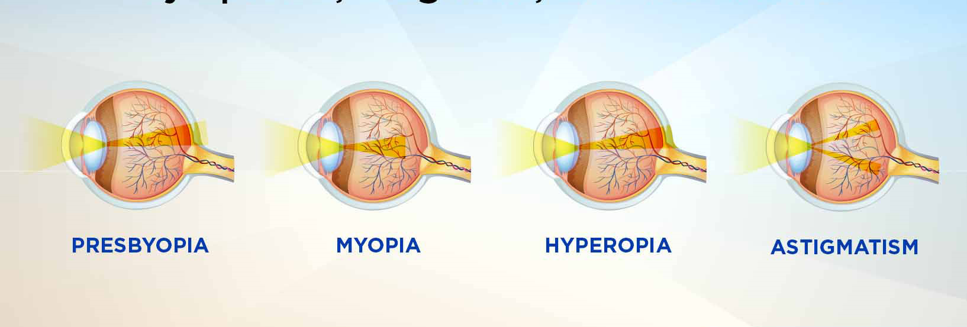

**Figure1:** Refractive errors

* 1. **Cataracts:**

Cataracts, which cause clouding of the eye's lens, are one of the main causes of blindness in the world. Although traumatic, congenital, or secondary cataracts can sometimes develop, age-related cataracts are the most common type as shown in figure 2.

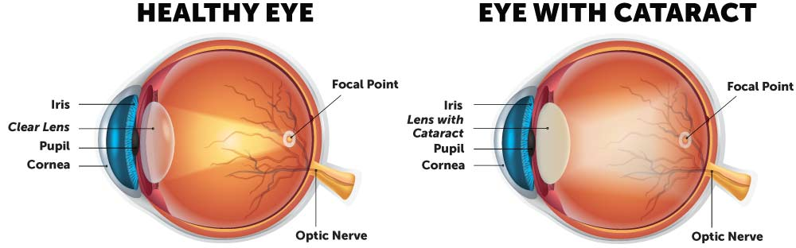

**Figure 2:** Cataracts

* 1. **Age-Related-Macular Degeneration (AMD):**

This disorder causes progressive loss of central vision by affecting the macula, the core region of the retina. One of the most prevalent causes of blindness in older persons, particularly those over 50, is AMD as shown in figure 3.

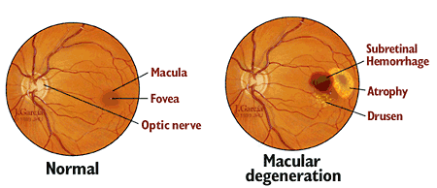

**Figure 3:** Age-related-macular degeneration (AMD)

* 1. **Glaucoma:**

Glaucoma, a class of eye conditions that harm the optic nerve and are frequently brought on by elevated intraocular pressure, can cause irreversible blindness if treatment is not received. Usually, it advances without any obvious symptoms until there is a considerable loss of vision as shown in figure 4.

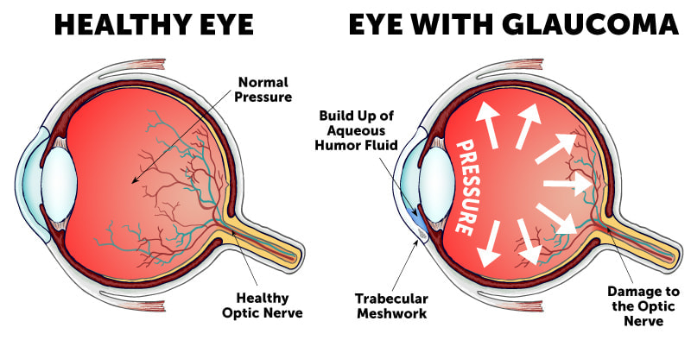

**Figure 4:** Glaucoma

* 1. **Diabetic Retinopathy:**

A consequence of diabetes, this disorder damages the blood vessels in the retina and, if uncontrolled blood sugar levels persist over time, can cause blindness or visual impairment as shown in figure 5.

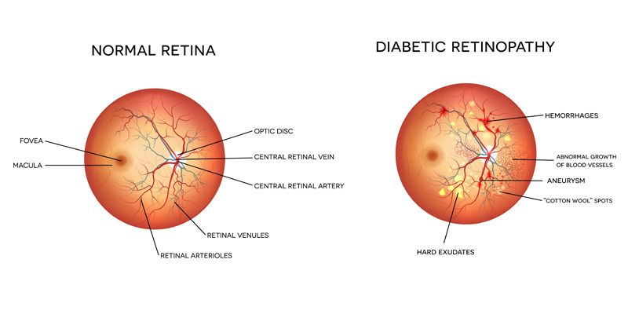

**Figure 5:** Diabetic retinopathy.

* 1. **Dry Eye Disease:**

This causes irritation, inflammation, and discomfort and happens when the eye does not produce enough tears or when the tears evaporate too quickly.

* 1. **Infectious and Inflammatory Conditions:**

If neglected, eye infections (such conjunctivitis or keratitis) and autoimmune diseases (like uveitis) can result in pain, discomfort, and blindness.

* 1. **Retinal Disorders:**

These include disorders that affect the retina and can result in irreversible visual loss, such as retinitis pigmentosa and retinal detachment.

1. **LITERATURE SURVEY**

The need for early detection to avoid vision loss is highlighted by the increasing prevalence of eye conditions such as diabetic retinopathy, glaucoma, and macular degeneration. Improvements in artificial intelligence (AI) and machine learning (ML) present viable ways to automate the identification of these disorders using color fundus photography (CFP). In order to increase diagnostic precision and clinical integration, this research examines a variety of machine learning and image processing techniques given in the table1.

Malik et al. [1] created a standardized data storage technique for machine learning in the detection of eye diseases and discovered that more straightforward tree-based models (such Random Forest and Decision Trees) performed better than more intricate ones. In contrast to conventional logistic regression, Yao et al. [2] BP-ANN model was able to predict diabetic retinopathy (DR) in Type 2 diabetes with high accuracy. The promise of mobile technology in pediatric eye care was demonstrated by Munson et al. [3] when they developed the CRADLE app for early leukocoria identification. By creating a predictive model for undetected glaucoma based on age and intraocular pressure, Oskarsdottir et al. [4] helped older persons detect the condition early. Ratanapakorn et al. [5] addressed the lack of healthcare professionals by creating software that can detect DR from fundus images with 96.25% accuracy. In their study on thyroid eye disease, Muralidhar et al. [6] emphasized the importance of early identification in order to avoid severe hyperthyroid symptoms.

To improve the identification of diabetic eye disease and lower the risk of vision loss, Nazir et al. [7] integrated fuzzy k-means clustering with FRCNN. A model developed by Sreeja and Kumar [8] can identify retinal hemorrhages with over 96% accuracy, which helps in early detection of DR. A 98.79% accurate facial analysis model was created by Akram and Debnath [9] to diagnose a variety of eye conditions. Nanotechnology in eye drop administration was proposed by Vaneev et al. [10] as a more effective treatment. Chelaramani et al. [11] improved predictions for a range of eye disorders using little labeled data by utilizing multi-task learning. Morrison et al. [12] assisted in treatment decisions by predicting glaucoma device failure using logistic regression and random forests.

**Table 1.** Summary of Methodologies

|  |  |  |  |  |
| --- | --- | --- | --- | --- |
| **Author** | **Dataset** | **Feature Extraction** | **Algorithm** | **Results** |
| Malik et al.[1] | Patient data formatted according to international standards. | Symptoms recorded in a structured format, including age, illness history, clinical observations | Decision Tree, Random Forest, Naive Bayes, Neural Networks | Decision trees and Random Forests had over 90% accuracy, while neural networks and Naive Bayes had lower accuracy. |
| Litong Yao et al.[2] | 530 Chinese residents (423 with type 2 diabetes) aged 18 years or older. | Duration of diabetes, waist-to-hip ratio, HbA1c, family history of diabetes | Multivariable Logistic Regression (MLR), Back Propagation Artificial Neural Network (BP-ANN) | BP-ANN: AUC = 0.84; MLR: AUC = 0.77 (P < 0.001). |
| Micheal C. Munson et al.[3] | 52,982 longitudinal photographs of children (20 with eye disorders, 20 control children). | Detection of leukocoria in photographs using image analysis | CRADLE application | 80% sensitivity in detecting leukocoria; detected abnormalities 1.3 years before diagnosis (95% CI: 0.4 to 2.3 years) |
| Sigridur E. Oskarsdottir et al[4] | Data from a population screening of 32,918 individuals aged 55-79 in Malmö, Sweden. | Age and intraocular pressure (IOP) | Multiple regression analysis | R² = 0.97 for model fit; Predicted undetected glaucoma rate <5% for IOP < 25 mmHg, 81% for IOP > 35 mmHg and age 75-79. |
| Tanapat Ratanapakorn et al[5] | 400 fundus images (21 normal, 379 diabetic retinopathy - 162 non-proliferative, 217 proliferative). | Clinical significant features for DR detection | MATLAB programming with Image Processing Toolbox | Sensitivity: 98%, Specificity: 67%, Accuracy: 96.25%; Classification accuracy for DR types: 66.58%. |
| Alankrita Muralidhar et al[6] | Clinical evaluation of 106 patients with TED. | Clinical assessment based on ITEDS VISA proforma | Univariate and multivariate logistic regression | Proportion of hyperthyroid patients: 46.23%, hypothyroid: 33.96%; 54.7% had mild disease, 37.7% moderate to severe, and 7.5% sight-threatening disease. |
| Tahira Nazir et al.[7] | Diaretdb1, MESSIDOR, ORIGA, DR-HAGIS, HRF. | Bounding-box annotations generated from ground-truths | Fast Region-based Convolutional Neural Network (FRCNN) with fuzzy k-means clustering (FKM) | Mean IoU of 0.95 and mAP value above 0.94 for detection and segmentation of glaucoma, DR, and DME |
| Sreeja K.A. et al.[8] | DIARETDB1 and clinical images. | GLCM features, splat-based segmentation | kNN, SVM, ANN | 96% sensitivity and accuracy |
| Akram et al.[9] | Custom dataset of 1753 images. | PCA, t-SNE for feature selection | Deep Convolutional Neural Network (DCNN), SVM | 98.79% accuracy, 97% sensitivity, 99% specificity |
| Sahil Chelaramani et al.[11] | 7,212 labeled and 35,854 unlabeled fundus images across 3,502 patients. | Fundus image categories, multi-label disease classification | MTL, knowledge distillation with teacher ensemble | Achieved 83% accuracy, 75% top-5 accuracy, and 48 BLEU score across disease prediction tasks. |
| Carlos Salvador Fernandez Escamez et al.[13] | 90 early glaucoma eyes and 85 healthy eyes. | RNFL thickness (in every quadrant, clock-hour, average thickness) measured with OCT | Tree gradient boosting, weighted decision tree | The accuracy of separating early glaucoma from healthy eyes was 89%, with an AUC of 0.953 (95% CI: 0.903-0.998). |
| Chen Guo et al.[14] | 250 fundus images (glaucoma, maculopathy, myopia, retinitis pigmentosa, normal). | RNFL thickness, fundus image color information | MobileNetV2, transfer learning | Achieved 96.2% accuracy, 90.4% sensitivity, and 97.6% specificity; MobileNetV2 outperformed others. |
| Aruna Ramanan P et al.[15] | Eye disease dataset (CSV format). | Symptoms related to cataract, glaucoma, and retinal diseases | Decision Tree, Naïve Bayes | >90% (Decision Tree) |
| Ahmed Al Marouf et al.[16] | Benchmark dataset of eye diseases. | Symptoms of cataracts, glaucoma, exophthalmos, ocular hypertension | SVM, Random Forest, k-NN, etc. | 99.11% (SVM, 10-fold CV) |
| Thanaa Hasan Yousif et al.[18] | Kaggle (6,000 images: CNV, DME, and healthy eyes). | SqueezeNet-based image embedding using Orange tool | K-Nearest Neighbor (KNN), Artificial Neural Network (ANN), Logistic Regression (LR), Stacking (KNN + ANN + LR) | ANN: 95.8% accuracy, Stacking: 96.1% accuracy |
| Ahlam Shamsan et al.[19] | CFP images of eye diseases. | MobileNet and DenseNet121 models with PCA (low dimensional features), Fusion of MobileNet and handcrafted features | Artificial Neural Network (ANN) | AUC: 99.23%, Accuracy: 98.5%, Precision: 98.45%, Specificity: 99.4%, Sensitivity: 98.75% |
| Ramakrishnan Sundaram et al.[20] | Fundus images (glaucoma, diabetic retinopathy, healthy). | Speeded Up Robust Feature (SURF), Bag of Visual Words (BoVW) with k-means clustering | Error-Correcting Output Code (ECOC) SVM | Accuracy: 92% |
| Malhi et al.[21] | Messidor,  e-Optha, DiaretDb fundus images. | Exudates (distance from macula), microaneurysms (count) | Support Vector Machine (SVM), K-Nearest Neighbor (KNN), Decision Tree | 92.1% for exudates (SVM & KNN), 99.9% for microaneurysms (Decision Tree). |
| Hou et al.[22] | Serum metabolomics and clinical data from 516 participants. | 12 metabolic features from serum metabolomics and clinical factors | Logistic Regression, XGBoost | AUCs of 0.842 (Logistic Regression) and 0.897 (XGBoost) for the prediction of myopic retinopathy. |
| Ahmed et al.[23] | Multiple publicly available retinal disease datasets | Convolutional Neural Network (CNN) | VGG16, ResNet, Inception, SVM, MLP | CNN-based models show high accuracy of 99% for multiple eye diseases |

Fernandez Escamez et al. [13] developed an OCT-based model for precise early glaucoma detection. Using transfer learning with MobileNetV2, Guo et al. [14] were able to classify eye disorders from fundus photos with 96.2% accuracy. By using decision trees, Ramanan et al. [15] were able to diagnose diseases including glaucoma and cataracts with 84% accuracy. Using Random Forest, SVM, and feature selection, Al Marouf et al. [16] were able to predict eye illnesses with 99.11% accuracy. An SVM-based model for early glaucoma detection with an emphasis on usability was developed by Verma et al. [17] Hasan et al. [18] used a stacked model that used ANN, logistic regression, and KNN to obtain 96.1% accuracy on eye scans. By combining features from MobileNet and DenseNet121, Shamsan et al. [19] were able to classify eye disorders with 98.5% accuracy. Using SVM, Sundaram et al. [20] created a 92% accurate model for predicting eye diseases in places with inadequate resources. early intervention, Malhi et al. [21] achieved 99.9% accuracy in grading microaneurysms in Dr. Hou et al. [22] found metabolic variables linked to childhood myopic retinopathy, indicating the need for early intervention. Ahmed et al. [23] examined the role that deep learning—particularly CNN models like VGG16 and ResNet—plays in the detection of eye disorders, however they pointed out that more study and bigger datasets are required to increase accuracy.

1. **CONCLUSION**

Several algorithms and hybrid feature extraction techniques have been shown to provide excellent classification accuracy in automated eye disease diagnosis, facilitating early detection and better patient outcomes. Methods like the Bag of Visual Words and data mining tools like Orange have the potential to automate diagnosis in clinical settings, particularly in situations with limited medical resources. These developments show that AI in ophthalmology has a bright future, improving diagnostic procedures' accessibility and efficiency. There are a number of important directions that automated eye disease diagnosis can go in the future. First, the accuracy and generalizability of the model across various populations can be enhanced by the utilization of sizable, varied datasets. Faster decision-making will improve patient care thanks to real-time fundus image analysis techniques. Furthermore, combining several imaging modalities, such fundus photography and OCT, could result in a more thorough understanding of eye disorders. Incorporating these technologies into routine practice requires user-friendly clinician interfaces, and establishing trust among healthcare practitioners will require comprehensive clinical studies and real-world validations. The influence of AI-driven eye disease diagnostics will be further increased by reasonably priced solutions, especially for underprivileged areas.

1. **REFERENCES**
2. Malik, S. et al (2019). Data Driven Approach for Eye Disease Classification with Machine Learning.
3. Yao, L. et al (2019). Multivariable Logistic Regression and Back Propagation Artificial Neural Network to Predict Diabetic Retinopathy.
4. Munson, M. C. et al (2019). Autonomous early detection of eye disease in childhood photographs.
5. Oskarsdottir, S. E. et al (2019). Predicting undetected glaucoma according to age and IOP: a prediction model developed from a primarily European-derived population. *Acta Ophthalmologica*, 97(4), 423-428.
6. Ratanapakorn, T. et al (2019). Digital image processing software for diagnosing diabetic retinopathy from fundus photographs. *Clinical Ophthalmology*, 13, 43-49.
7. Muralidhar, A. et al (2020). Clinical profile of thyroid eye disease and factors predictive of disease severity. *Indian Journal of Ophthalmology*.
8. Nazir, T.et al (2020). Retinal Image Analysis for Diabetes-Based Eye Disease Detection Using Deep Learning. *Institute for Sustainable Industries and Liveable Cities, Victoria University*.
9. Sreeja, K. A., & Kumar, S. S. (2020). Automated Detection of Retinal Hemorrhage based on Supervised Classifiers. *Department of Electronics and Communication Engineering, SCMS School of Engineering and Technology.*
10. Akram, A., & Debnath, R. (2020). An automated eye disease recognition system from visual content of facial images using machine learning techniques. *Turkish Journal of Electrical Engineering & Computer Sciences*, 28(3), 1706-1720. Doi: 10.3906/elk-2005-19.
11. Vaneev, A. et al (2021). Nanotechnology for Topical Drug Delivery to the Anterior Segment of the Eye. *Int. J. Mol. Sci.*, 22, 12368.
12. Chelaramani, S. et al (2021). Multi-Task Knowledge Distillation for Eye Disease Prediction. *Journal of Medical Imaging*, 8(4), 1-11.
13. Morrison, P. et al (2021). Apply Machine Learning Methods to Predict Failure of Glaucoma Drainage. *International Journal of Data Mining & Knowledge Management Process*, 11(1), 45-56.
14. Fernandez Escamez, C. S. et al (2021). High Interpretable Machine Learning Classifier for Early Glaucoma Diagnosis. *International Journal of Ophthalmology*, 14(3), 401-407.
15. Guo, C., Yu, M., & Li, J. (2021). Prediction of different eye diseases based on fundus photography via deep transfer learning. *Journal of Clinical Medicine*, 10(24), 5481.
16. Ramanan, A. et al (2022). Eye Disease Prediction Using Machine Learning Techniques. *International Journal of Emerging Technology in Computer Science & Electronics (IJETCSE)*, 29(4), 1-7.
17. Al Marouf, A. et al (2022). An Efficient Approach to Predict Eye Diseases from Symptoms Using Machine Learning and Ranker-Based Feature Selection Methods. *Bioengineering*, 10(25), 1-20.
18. Verma, R et al (2022). Machine Learning Classifiers for Detection of Glaucoma. *International Journal of Artificial Intelligence*, 2252-8938.
19. Yousif, T. H et al (2023). Machine learning-based diagnosis of eye-diseases. *Engineering Technical College, Al-Furat Al-Awsat Technical University, Al-Najaf, Iraq*.
20. Shamsan, A et al (2023). Automatic classification of colour fundus images for prediction of eye disease types based on hybrid features. *Diagnostics*, 13(1706).
21. Sundaram, R., & Ravichandran, K. S. (2023). An automated eye disease prediction system using bag of visual words and support vector machine. *School of Computing, SASTRA Deemed-to-be-University, Thanjavur, Tamil Nadu, India*.
22. Malhi, A. et al (2023). Detection and diabetic retinopathy grading using digital retinal images. Journal of Medical Imaging and Health Informatics.
23. Hou, X.-W et al (2023). Machine Learning-Based Integration of Metabolomics Characterization Predicts Progression of Myopic Retinopathy in Children and Adolescents.
24. Abdullah, A. A., Aldhahab, A., & Al Abboodi, H. M. (2024). Review of Eye Diseases Detection and Classification Using Deep Learning Techniques. BIO Web of Conferences, 97, 00012.