"Women Empowering Safety: A Mobile Solution for Women's Protection"

Sagar Choudhary1, Aman Gupta2

1*Assistant Professor, Department of Computer Science and Engineering, *Quantum University, Roorkee,* India.

2* MCA student, Department of Computer Science and Engineering, *Quantum University, Roorkee,* India.

**Abstract**:  
This paper explores the development and potential impact of a women's safety mobile application aimed at providing real-time assistance in emergency situations. The system leverages the device’s volume button to trigger an emergency alert, sending live location details to the nearest police station and activating audio/video recording for evidence. The system ensures data security through AES encryption and cloud backups, safeguarding sensitive user data. With features such as real-time location sharing, AI-powered route suggestions for safety, anonymous reporting of unsafe locations, and multilingual support, the system is designed to cater to diverse users across different regions. Additionally, it integrates with emergency services to ensure a faster response time by notifying authorities in real time.

The system employs technologies such as GPS for real-time location tracking, cloud storage solutions like Google Cloud and AWS for securing data, and robust notification systems powered by Firebase Cloud Messaging (FCM) to keep users informed during emergencies. The system integration with emergency services ensures a faster response time by notifying authorities in real time. Additionally, the platform supports features such as an alert button, recording features for evidence collection, and offline mode functionality in case of limited connectivity. By focusing on user experience, security, and emergency responsiveness, this system aims to be a reliable solution for women's safety in both urban and rural settings.

**Keyword:** Women's Safety, Emergency Response, Real-Time Location Sharing, AI-Powered Safety Routes, Audio/Video Evidence, Offline Functionality, Multilingual Support.

**Introduction**

Women’s safety is an urgent and significant concern that continues to grow, particularly in today’s fast-paced world. Whether in urban cities or rural areas, women often face situations where they find themselves in danger and need immediate help. However, despite the widespread availability of communication tools, the response time for assistance can still be delayed, putting women at risk. This delay is often the difference between safety and harm, highlighting the need for a more effective solution.[1] To tackle this challenge, we have conceptualized a system designed specifically to provide real-time assistance in emergency situations, offering women a sense of security and the assurance that help is just a button press away.[2]

The system is engineered to be as intuitive and efficient as possible. In any emergency, users can simply press the volume button on their phone to trigger a distress signal. This action immediately sends the live location details to the nearest police station, ensuring that authorities are informed and can respond as quickly as possible. In addition to sending location information, the system automatically activates audio and video recording to capture crucial evidence, which is then securely stored for later use.[3]

But the system doesn't stop there. It incorporates advanced features designed to assist users both during emergencies and in their day-to-day activities. For instance, it provides real-time location sharing, enabling friends or family members to track the user’s movements and receive timely updates during an emergency. Additionally, the system uses AI-powered route suggestions to help users navigate the safest paths, avoiding potentially dangerous areas. The system also allows users to anonymously report unsafe locations, contributing to a crowdsourced database of locations that are unsafe for women. This helps not only the individual user but also the wider community by sharing valuable safety data.

Security and privacy are paramount in this system. Given the sensitive nature of the data involved, we have implemented AES encryption to protect all personal information. To ensure data is not lost, all information is backed up securely on cloud storage platforms. Moreover, the system is designed to function even in offline mode, allowing it to continue working when internet connectivity is unavailable. This feature ensures that users can rely on the system regardless of their location or network conditions.[4]

One of the key features of the system is its ability to notify the last contacted person automatically during an emergency. This person will receive live location details and an alert of the emergency, enabling them to respond quickly and provide additional assistance if needed. Furthermore, registered users within the community will receive notifications of nearby emergencies, which can lead to faster response times and potentially save lives by alerting people in the vicinity who may be able to offer assistance.

The system also makes it easier for users to contact help directly by automatically calling the last contacted person or emergency contacts without the user needing to navigate through their phone manually. This ensures that the right people are informed and can act swiftly in case of an emergency.[5]

This system is not just a technological tool, it is a comprehensive, reliable solution that aims to redefine how we approach women’s safety. It is accessible, easy to use, and built to work across diverse environments, whether in bustling cities or remote rural areas. By providing real-time alerts, location tracking, and evidence collection, this system serves as a crucial step forward in making women feel safer and ensuring that help is always within reach when they need it the most.

**Problem Statement:**

**Crime against women:**

|  |  |
| --- | --- |
| **State/Ut** | **Year 2022** |
| Andhra Pradesh | 25503 |
| Arunachal Pradesh | 335 |
| Assam | 14148 |
| Bihar | 20222 |
| Chhattisgarh | 8693 |
| Goa | 273 |
| Gujarat | 7731 |
| Haryana | 16743 |
| Himachal Pradesh | 1551 |
| Jharkhand | 7678 |
| Karnataka | 17813 |
| Kerala | 15213 |
| Madhya Pradesh | 32765 |
| Maharashtra | 45331 |
| Manipur | 248 |
| Meghalaya | 690 |
| Mizoram | 147 |
| Nagaland | 49 |
| Odisha | 23648 |
| Punjab | 5572 |
| Rajasthan | 45058 |
| Sikkim | 179 |
| Tamil Nadu | 9207 |
| Telangana | 22066 |
| Tripura | 752 |
| Uttar Pradesh | 65743 |
| Uttarakhand | 4337 |
| West Bengal | 24738 |
| **Total For States:** | **426433** |
| A&N Islands | 178 |
| Chandigarh | 325 |
| D&N Haveli and Daman & Diu | 126 |
| Delhi | 142 |
| Jammu & Kashmir | 3716 |
| Ladakh | 15 |
| Lakshadweep | 16 |
| Puducherry | 200 |
| **Total For Union Territories :** | **18823** |
| **Total all India:** | **445256** |

**Table 1:** - Crime against women 2022 in India.[34]

The safety of women has emerged as a critical issue across the globe, and it continues to be one of the most concerning topics in today's society. Women, whether in urban or rural areas, often face situations where they are at risk and require immediate assistance. However, despite advancements in communication and emergency services, many women still find themselves in vulnerable positions, where timely help is not always accessible. The problem is further compounded by the fact that emergency response systems are not always quick or reliable enough to provide real-time assistance, which can be life-threatening in critical situations.[6]

In many emergency cases, women struggle to reach out for help due to various reasons—fear of the attacker, the inability to physically dial emergency numbers, or the absence of immediate access to communication channels. This delay in contacting authorities or loved ones often leads to worse outcomes, especially when immediate intervention is required. Additionally, the lack of a system that can offer constant monitoring or help in low-connectivity areas creates a significant gap in women's safety.[7]

Current technologies and systems, such as personal safety apps, often fall short due to the lack of instant connection to emergency services, limitations in real-time location tracking, and delays in response. Women in unsafe situations frequently do not have enough time to manually trigger alerts or navigate through complex interfaces. They need a more direct, faster, and effective solution.[8]

**Chart 1 :** Violence against women increased by 12.9% from 2018 to 2022 in India.

This situation calls for the development of a reliable, easy-to-use system that ensures immediate help can be triggered at the press of a button. The system must address the need for real-time assistance by offering seamless communication with emergency services, sharing live location data instantly, and enabling recording for evidence purposes. Additionally, the system must offer a way to communicate with the last contacted person and send alerts to registered users, ensuring a larger support network during critical moments.[9]

By solving the issue of delayed responses, communication gaps, and providing immediate assistance in emergencies, this system can play a crucial role in enhancing women’s safety, empowering them to take control in unsafe situations, and reducing the risks they face daily. This system is designed not only to help in emergency situations but also to offer continuous support and safety in everyday life, ensuring women feel protected and secure at all times.[10]

**Chart 2 :** Crimes against women under the Indian Penal Code in India, 2022.

**Methodology**

The primary objective of our proposed system is to provide a robust and reliable mechanism for ensuring the safety of women, particularly in situations where they feel threatened or vulnerable. This system has been designed as a comprehensive solution that seamlessly integrates advanced technologies to facilitate real-time emergency responses and enhance user security. By leveraging modern innovations, the system aims to empower women with tools that offer immediate assistance and reassurance in times of distress. It not only addresses immediate safety concerns but also builds a long-term sense of confidence and trust among its users. The focus is on delivering a multi-layered safety approach that operates efficiently across various scenarios, ensuring women have a dependable way to protect themselves and report emergencies with ease.

1. **Emergency Alert System**: A cornerstone of this system is the Emergency Alert System, which has been meticulously crafted to deliver swift and effective responses during critical situations. Women can activate the alert with a simple and discreet action—pressing the phone's volume button 2-3 times. This small yet powerful trigger sets off a chain of actions: the user's live location is immediately sent to the nearest police station and relevant authorities, ensuring prompt intervention and potentially saving lives. Simultaneously, the system activates audio and video recording to capture valuable evidence that can be crucial for legal or investigative purposes. Additionally, the recordings are securely stored within the app, ensuring they remain tamper-proof and accessible only to authorized personnel. This feature is particularly impactful for women facing unsafe environments, as it bridges the gap between distress and immediate help, offering both preventive and reactive measures to ensure their safety and peace of mind. It not only serves as a tool for immediate assistance but also acts as a deterrent against potential perpetrators.[11]

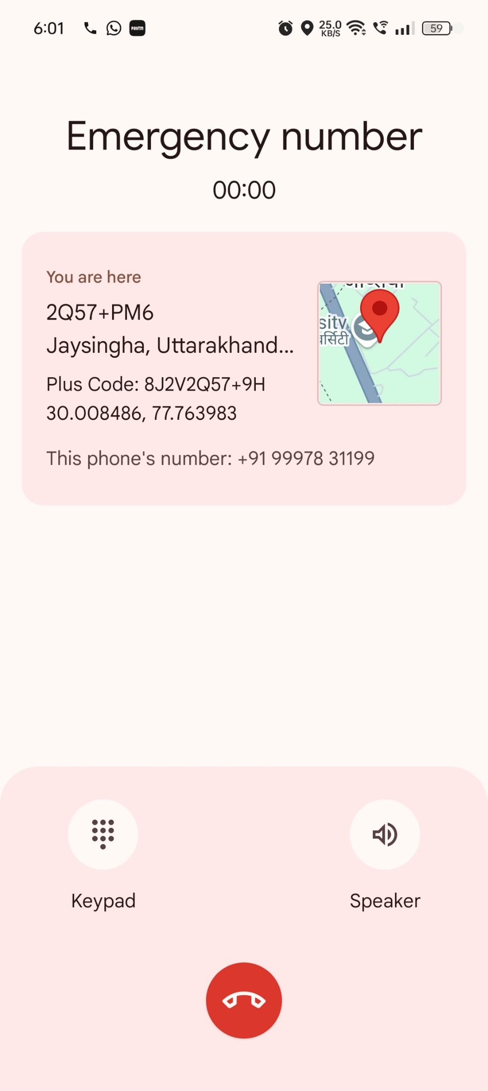

1. **Real-Time Location Sharing**: When the emergency alert is triggered, the system automatically tracks the user's current location and sends it to the authorities. The system uses GPS (Global Positioning System) for real-time location sharing, updating the user’s location accurately at all times. This feature ensures that police and emergency services receive immediate and precise location data, significantly reducing response time.[12]

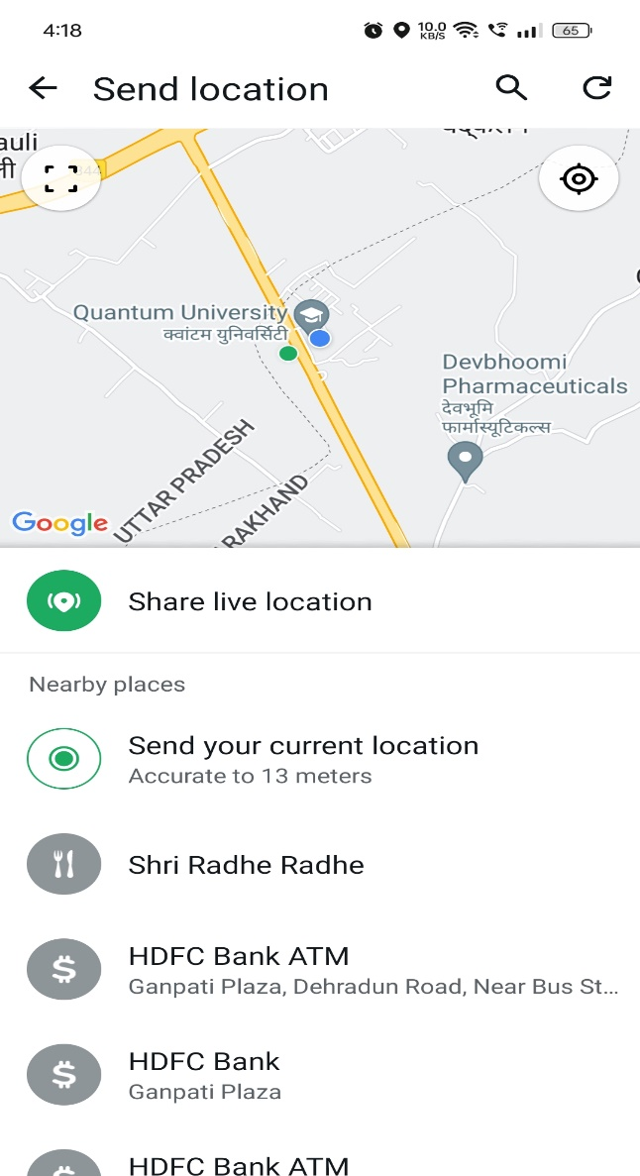

1. **Audio/Video Recording for Evidence**: The audio and video recording feature plays a major role in the system. When the emergency alert is activated, the system automatically records surrounding audio and video, which can serve as proof of the incident.[56] This feature is especially important for women who may face violence or harassment and need evidence for their defense. The evidence is securely stored in cloud storage, encrypted to protect the data, and is accessible for future use.[13]
2. **AI-Powered Route Suggestions for Safe Paths**: The system also uses AI (Artificial Intelligence), which analyzes real-time data to suggest the safest routes. If a woman needs to leave an unsafe area, the system uses AI to provide the safest and shortest route. AI algorithms consider road conditions, traffic, and safe zones, providing recommendations that enhance travel safety, especially for women who are concerned about their security.[14]

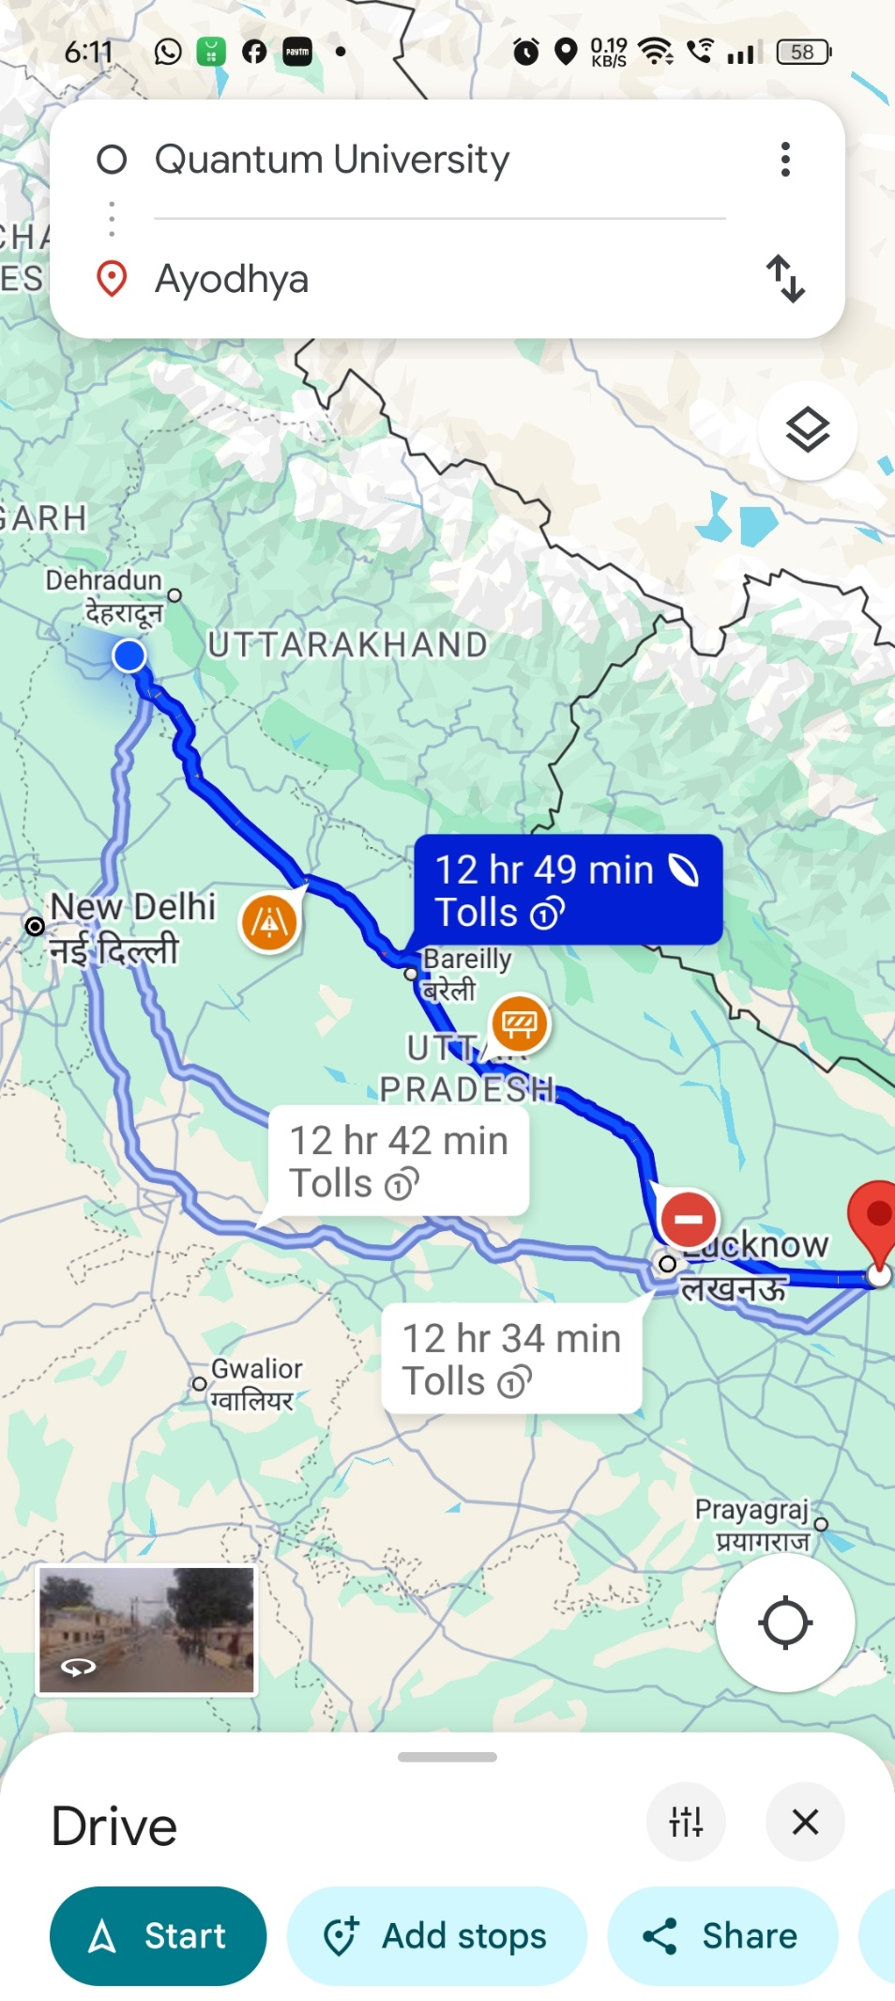

1. **Last Contact Person Notification**: Another important feature of the system is to notify the last contacted person. When the emergency alert is triggered, the system automatically sends a notification to the user’s last contact, informing them that the alert has been activated and the user needs help. This feature is especially useful for women who travel alone and might not have time to update their close contacts.[15]

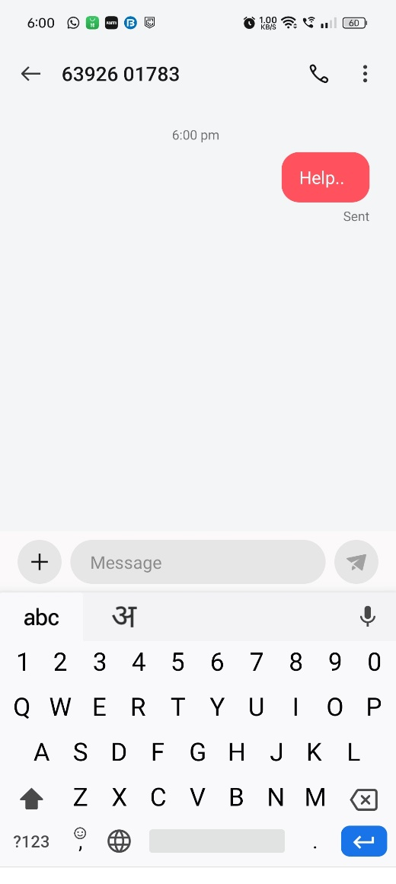

1. **Anonymous Reporting of Unsafe Locations**: The system includes an option for users to anonymously report unsafe locations. If a user feels that a specific area or street is unsafe, they can report it to the authorities through the system without revealing their identity. This feature promotes community safety, allowing every user to contribute to making their surroundings safer.[16]
2. **Data Security and Privacy**: Data security is a highly critical aspect of the system. It uses AES (Advanced Encryption Standard) encryption to keep user data secure. [57] All personal and sensitive data is stored in encrypted format, and only authorized authorities can access it. The system’s data is backed up on highly secure cloud storage solutions, such as Google Cloud and AWS. Additionally, the system works in offline mode, which is useful in areas with weak internet connectivity.[17]
3. **System Integration with Emergency Services**: The system is integrated directly with emergency services. When the emergency alert is triggered, it notifies police, ambulance, and fire services. This direct integration provides fast and accurate information to emergency services, significantly reducing response times. Authorities are immediately alerted to the emergency, enabling them to take action right away.[18]
4. **Offline Mode for Limited Connectivity**: The system is specifically designed for locations where internet connectivity may be a challenge. If a user's internet connection weakens, the system continues to work in offline mode. During this mode, location data and emergency alerts are temporarily stored, and once the internet becomes available, the data is sent automatically. This feature ensures the system remains functional, regardless of connectivity issues.[19]
5. **Easy User Interface**: The system features a simple and intuitive user interface, making it easy for anyone to use, regardless of their technological expertise. Once the emergency alert is triggered, the system automatically sends the location, starts recording, and notifies authorities. Users only need to react in an emergency situation, with the system handling everything else.[20]
6. **Alerts to Registered Users**: When an emergency alert is activated, the system also sends alerts to registered users. This notification informs them of an emergency in the vicinity and allows them to take action if they are available to help. This feature encourages community-based support in emergencies and empowers users to assist each other.[21]
7. **Multilingual Accessibility:** Another important feature of this system is its multilingual accessibility, allowing people from different linguistic backgrounds to use the system in their preferred language. The system supports a variety of languages, making it easier for users across different states and regions to adopt it. This feature is particularly useful in areas where people speak different languages and dialects. The system has been optimized for multiple languages, ensuring that users can receive alerts, understand instructions, and manage their emergency situations effectively in their regional language. Multilingual support ensures that the system is accessible to users from diverse backgrounds, making the safety experience seamless and personalized for every user.[22]

**Technology Overview**

The system is designed to leverage advanced technologies to ensure women’s safety effectively and efficiently. Here’s a detailed overview of the key technologies that will be integrated into the system:

1. **GPS for Location Tracking:**

GPS (Global Positioning System) will be the backbone of the system's location-tracking functionality. The system will use GPS to continuously track the user's live location. During an emergency, the system will send the real-time location to the nearest police station, emergency services, and pre-defined contacts. This technology ensures precise and up-to-date location sharing, which is critical for prompt assistance in distress situations. GPS tracking will also enable users to share their location with loved ones as an added layer of safety.[23]

1. **Accelerometer for Action Detection:**

The accelerometer in mobile devices will play a key role in detecting rapid physical actions, such as pressing the phone's volume button multiple times. This detection will serve as the trigger for activating the emergency alert system. By analyzing motion patterns and input from the accelerometer, the system ensures that accidental triggers are minimized, and only intentional actions result in alert activation.[24]

1. **APIs for Messaging and Calling:**

APIs (Application Programming Interfaces) will facilitate seamless communication between the system and external entities. For example:

* + **Messaging APIs** will enable the system to send SMS notifications to emergency contacts and authorities with details of the situation, such as the user’s current location.
  + **Calling APIs** will allow the system to initiate automatic emergency calls to helplines or pre-configured numbers. These APIs will ensure fast and reliable communication during emergencies, making it easier to get help promptly.[25]

1. **Cloud Storage for Data Security:**

The system will use cloud-based solutions to securely store all sensitive data, including audio and video recordings captured during emergencies. Cloud storage ensures that this data remains accessible only to authorized personnel while being protected from unauthorized access or data loss. [64] Advanced encryption techniques like AES (Advanced Encryption Standard) will be applied to maintain user privacy and data security.[26]

1. **AI-Powered Analytics for Route Suggestions:**

Artificial Intelligence (AI) will enhance the system's functionality by analyzing real-time data to suggest the safest routes for users. Using machine learning algorithms, the system will evaluate factors such as traffic patterns, crime statistics, and user reports to recommend secure travel paths. This AI-driven feature will reduce the likelihood of users encountering unsafe areas during their journey.[27]

1. **Multilingual Accessibility through Language Translation APIs:**

To ensure accessibility for users from diverse linguistic backgrounds, the system will integrate language translation APIs. These APIs will enable the system to operate in multiple languages, allowing users to interact with the system in their preferred language. This functionality eliminates language barriers and makes the system usable for individuals from different states and regions, including rural areas.[28]

1. **Offline Mode for Network Limitations:**

To cater to areas with poor internet connectivity, the system will include an offline mode. In this mode, the system will store alerts and location data locally on the device. Once the network is restored, the system will automatically send the stored data to the relevant authorities. This ensures that the system remains functional and reliable even in remote or low-network areas.[29]

1. **Integration with Emergency Services:**

Direct integration with emergency services, such as police, ambulance, and fire departments, will be implemented. When an alert is triggered, the system will immediately notify these services, providing them with essential details like location and the nature of the emergency. This direct connection will streamline the response process, reducing the time taken to assist the user.[30]

1. **User-Friendly Interface:**

The system’s interface will be designed to be intuitive and simple. Even users who are not tech-savvy can easily navigate through the system and activate emergency features. A well-thought-out UI/UX design will ensure that users can operate the system efficiently under stressful situations.[31]

1. **Secure Anonymous Reporting Mechanism:**

Users can anonymously report unsafe locations using the system, enabling the community and authorities to identify and address high-risk areas. This feature empowers users to contribute to building a safer environment while protecting their identity.[32]

**Feasibility Analysis**

Feasibility Analysis is a crucial aspect of evaluating the practicality of the system we aim to develop. It helps determine whether the system is technically, economically, and operationally viable, ensuring that the resources required for its development and implementation are available and justified.

**1. Technical Feasibility**

* This section assesses whether the technologies required for the system are available and compatible with each other. It focuses on whether the system can be built using the existing tools, technologies, and expertise.
* Key considerations:
  + Availability of technologies (GPS, APIs, Accelerometer, AI Algorithms, Encryption) needed for system development.
  + Integration capabilities of the tools and platforms (e.g., GPS, APIs) within the system architecture.
  + Expertise required to work with these technologies.

**Example:** The integration of GPS for real-time location tracking and APIs for messaging/calling is feasible, as these technologies are widely available and widely used in various applications.

**2. Economic Feasibility**

* This analysis focuses on whether the system is financially viable. It evaluates the cost of developing, maintaining, and operating the system in comparison to the expected benefits.
* Key considerations:
  + Development costs, including the technology, resources, and developers needed to build the system.
  + Maintenance costs, such as server hosting, cloud storage, and software updates.
  + Long-term financial feasibility and potential benefits, ensuring the system will generate value in the future.

**Example:** Using cloud services like AWS or Google Cloud can reduce initial infrastructure costs and allow for scalability, making the system more economically viable.

**3. Operational Feasibility**

* This focuses on whether the system will be adopted and used effectively by its intended users. It examines whether the system will meet user needs and whether users will find it easy to use.
* Key considerations:
  + Usability and user experience, ensuring the system is user-friendly and accessible.
  + Accessibility in both urban and rural areas, allowing the system to cater to diverse geographic locations.
  + Multilingual support to ensure users from different regions can use the system effectively.

**Example:** The emergency alert button, activated by pressing the volume button, is a simple, intuitive process that makes it accessible to users of all ages and technical proficiency.

**4. Legal and Ethical Feasibility**

* This section ensures that the system complies with relevant laws and ethical guidelines, particularly concerning data privacy and user consent.
* Key considerations:
  + Adherence to data privacy and security regulations, such as GDPR, to protect user information.
  + Ensuring user consent for features like audio/video recording and respecting privacy rights.

**Example:** The use of AES encryption ensures that sensitive data is securely stored, and unauthorized access is prevented, which helps avoid legal complications related to data privacy.

**5. Market Feasibility**

* This evaluates the demand for the system in the market and examines the competition. It helps determine whether there is a need for the system and if it can compete effectively in the market.
* Key considerations:
  + Analysing competitors’ products and features to identify gaps in the market that the system can fill.
  + Assessing the market potential and user demand for the system.

**Example:** The system’s unique features—real-time tracking, AI-powered route suggestions, and emergency alert capabilities—make it stand out from competitors, providing a safer and more efficient solution for women’s safety.

**System Design and Architecture**

The system architecture is thoughtfully designed to deliver a robust, scalable, and highly efficient solution tailored to enhance women's safety. It prioritizes real-time emergency response, seamless data security, and user convenience, ensuring a user-friendly experience without compromising functionality. Key architectural components are carefully integrated to provide resilient performance and adaptability across diverse scenarios. By employing advanced technologies, the system can efficiently handle high user traffic, maintain uninterrupted operations, and adapt to varying conditions without performance degradation. These features ensure that the platform remains not only reliable and resilient but also future-proof, allowing it to evolve alongside emerging technological advancements. This architecture underscores a commitment to providing users with a trustworthy and innovative safety solution tailored to meet their unique needs.

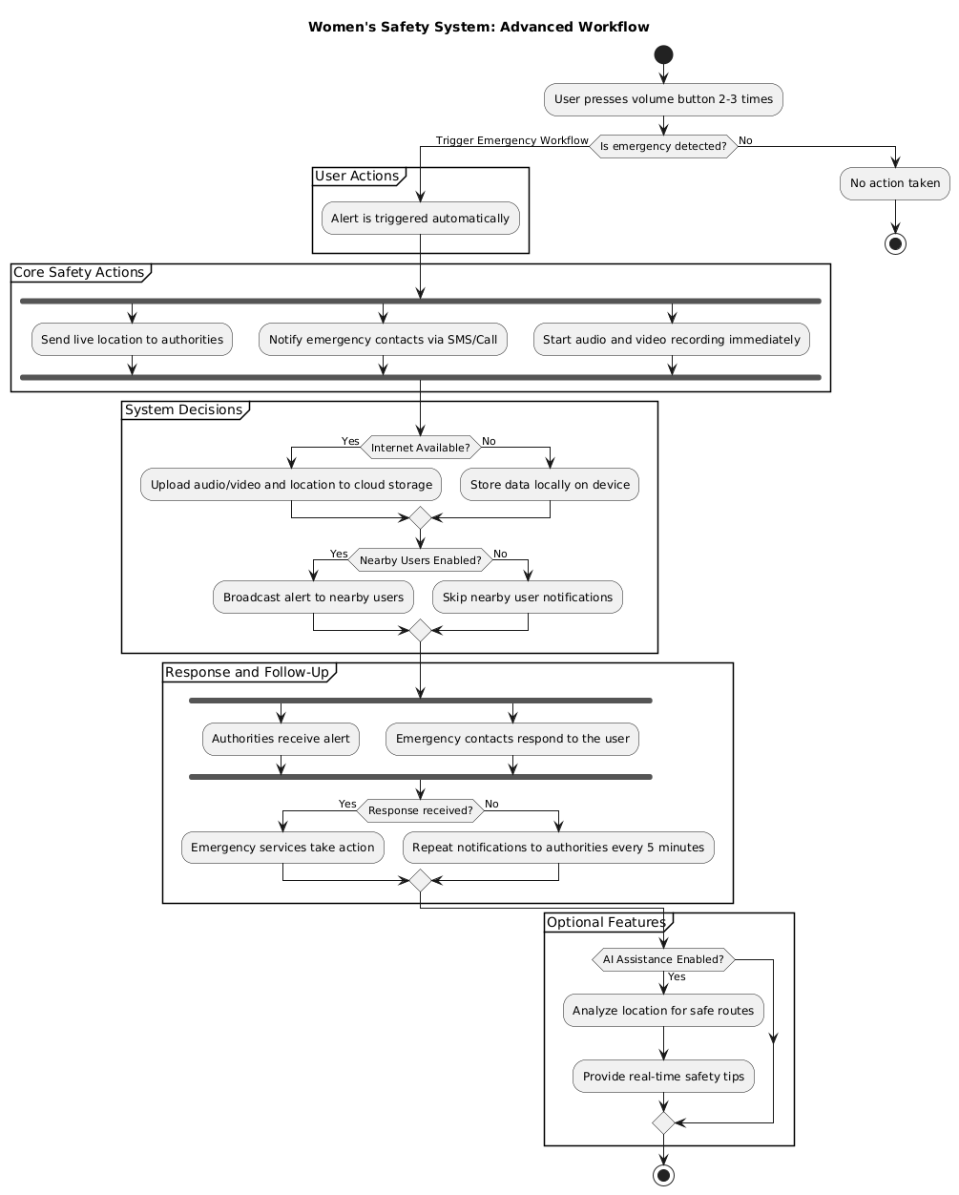

**Fig-1:** Flowchart of Women’s Safety System

**User Interaction Flow**

The **user interaction flow** is one of the most critical aspects of the system. The entire user experience is designed to be seamless, intuitive, and fast, especially during emergency situations. Upon activating the emergency alert via the phone’s volume button, the system will:

1. **Trigger the Emergency Alert**: The user simply presses the volume button 2-3 times to activate the emergency alert. This is designed to be quick and easy to perform in panic situations. The alert immediately sends the user's live location to the nearest authorities.[33]
2. **Audio/Video Recording**: Once the alert is triggered, the system automatically starts recording audio and video, capturing evidence in real-time. This feature is crucial for providing proof in legal proceedings.[35]
3. **Notification to Emergency Contacts**: Simultaneously, the last contacted person and any registered emergency contacts are notified with a message containing the emergency alert and location information.[36]
4. **Alert to Nearby Users**: In addition to notifying emergency contacts and authorities, the system will send alerts to nearby users who are within proximity. These users will receive a message with the user’s location and an emergency alert, allowing them to potentially assist if they are able to help. This creates a community-based safety network where users can rely on each other during emergencies.[37]

**Scalability and Maintenance:**

The **system scalability** is an essential aspect of the architecture, as it must support a growing user base over time. Here’s how the system can scale:

1. **Cloud-Based Infrastructure**: The system will be built on a cloud infrastructure (e.g., AWS, Google Cloud) to handle data storage and processing. Cloud platforms provide easy scaling solutions, enabling the system to support millions of users without significant hardware upgrades.[38]
2. **Modular Design**: The architecture will be modular, meaning new features or enhancements can be added without affecting the core system. For example, integrating new language support or advanced AI algorithms for better route suggestions can be done with minimal disruptions.[39]
3. **Load Balancing**: To ensure high availability during peak hours, especially in emergencies, the system will employ load balancing techniques. This will distribute user requests across multiple servers, ensuring that no single server becomes a bottleneck.[40]
4. **Automatic Updates and Maintenance**: The system will incorporate automatic updates, ensuring that security patches, new features, and optimizations are deployed efficiently. Routine maintenance tasks, like database optimization or data backup, will run in the background without affecting user experience.[41]

**System Integration:**

The system will rely on seamless integration with multiple external services and APIs to ensure smooth operation. Key integrations include:

1. **Location Services**: GPS will be integrated to provide real-time tracking of the user’s location. This ensures accurate and up-to-date location information is sent to authorities and emergency contacts.[42]
2. **Communication APIs**: The system will integrate messaging and calling APIs (e.g., Twilio) to notify authorities and emergency contacts, ensuring that communication is prompt and reliable. These APIs will help the system send messages or make calls without requiring direct user interaction.[43]
3. **Emergency Services**: The system will integrate with emergency services (e.g., police, ambulance) to notify them when an emergency alert is triggered. This integration will allow authorities to receive detailed information, such as location, incident type, and severity, in real-time.[44]
4. **Cloud Storage**: Secure cloud storage will be used to store sensitive user data, such as audio/video recordings, in an encrypted format. This ensures that data remains safe from unauthorized access.[45]

**Security Architecture**

Security is paramount for user trust and system integrity. The system will employ multiple layers of security:

1. **Data Encryption**: Data encryption is a cornerstone of the system's security strategy, designed to protect sensitive user data and emergency recordings from unauthorized access. The system employs Advanced Encryption Standard (AES-256) to encrypt data both during transmission and storage. Encryption in transit ensures that all data exchanged between the user and the system remains secure from interception or tampering using Transport Layer Security (TLS). At rest, sensitive information, such as user profiles and emergency audio/video recordings, is safeguarded through robust encryption protocols, ensuring that even in the event of a data breach, the information remains inaccessible. Additionally, the system integrates a secure Key Management System (KMS) to handle encryption keys, featuring regular key rotation and strict access controls. This layered approach ensures compliance with data protection regulations while reinforcing user trust in the system.[46]
2. **Two-Factor Authentication (2FA)**: Two-Factor Authentication (2FA) adds an essential layer of security by requiring users to verify their identity through two separate factors: something they know (like a password) and something they have (like a one-time code). This ensures that even if login credentials are stolen or compromised, unauthorized access to user accounts is prevented. The system will prompt users to enable 2FA during account setup, using methods such as SMS-based OTPs, email verification codes, or authenticator apps. This approach significantly enhances account security by making it extremely difficult for attackers to gain access without the second factor, thereby protecting sensitive user information and maintaining system integrity.[47]
3. **Data Privacy**: The system will comply with data protection laws (e.g., GDPR) to ensure that user privacy is respected. Sensitive data will be stored securely, and users will have full control over their data.[48]

**Offline Functionality**

Recognizing the potential challenges of unreliable internet connectivity, the system is designed to work in **offline mode**. Key features that will function offline include:

1. **Location Tracking**: While the system cannot transmit data without internet connectivity, it will store the user’s location in a local cache. Once the internet connection is restored, the system will automatically transmit the stored data.[49]
2. **Alert Storage**: Emergency alerts will be stored temporarily on the device. Once the network connection is available, the alert will be sent to the nearest authorities.[50]

**Expected Outcomes**

The expected outcomes section provides clarity on how the system will prove useful after its implementation. This point highlights the results we expect from the designed system and how it will improve the user experience.

1. **Improvement in User Safety**:

The primary and most important outcome is the enhancement of women's safety. In an emergency situation, the user can easily press the volume button on their phone to send an alert. This alert, along with the user's real-time location, will be sent to the nearest authorities and emergency contacts. The benefit here is that emergency response agencies will receive an accurate location quickly, allowing them to send help without delay. This will directly enhance the safety of the user.[51]

1. **Faster Emergency Response**:

The second expected outcome is a reduction in the emergency response time. When an emergency is triggered, the system sends the real-time location and alert to the authorities. This ensures that authorities quickly know where the user is and what situation they are facing. Authorities will be able to arrive on the scene promptly, ensuring timely assistance in time-sensitive situations. This fast response will directly contribute to user safety, helping them avoid or mitigate the consequences of an incident.[52]

1. **Community Support and Awareness**:

Another expected outcome is the creation of a safety network within the community. When an emergency alert is triggered, nearby users will also receive the alert. This will make people more aware of their surroundings and encourage them to assist others in emergency situations. This feature promotes a community-based support system and raises awareness about helping others during critical moments. It helps establish a social safety network where people support each other in times of need.[53]

1. **Data Security and Privacy**:

Data security is also a significant expected outcome. Sensitive information, such as the user’s location and audio/video recordings, will be stored using AES encryption. Cloud storage will be used, and the data will be kept in an encrypted format to ensure unauthorized individuals cannot access it. This will guarantee that user data remains secure and private. The system will comply with privacy laws, such as GDPR, to protect the user’s information from unauthorized usage.[54]

1. **Scalability and Availability**:

The system has been designed to be scalable, ensuring that it continues to perform efficiently as the user base grows. If the system experiences higher load, it can be managed smoothly through cloud infrastructure and load balancing techniques. Scalability ensures that the system maintains high performance even with increased demand. Availability is also crucial, and the system will be designed to be available 24/7. In case of server issues, failover systems and automatic recovery mechanisms will ensure that the system remains operational, allowing users to access it during emergencies at any time.[55]

**Conclusion**

The development of this system is a crucial and transformative step toward addressing the persistent issue of women’s safety in today’s world. With the increasing number of safety concerns and the need for immediate assistance during emergencies, this system leverages advanced mobile technology to provide a solution that not only promises real-time emergency response but also ensures data security, reliability, and user convenience.

At the heart of the system is its simplicity and user-cantered design. Recognizing that panic often hinders quick thinking during distressing situations, the system allows women to take swift action with minimal effort. A simple press of the phone’s volume button can activate a comprehensive emergency protocol that sends the user’s live location to authorities, initiates audio and video recording, and notifies pre-designated emergency contacts. This streamlined process reduces the chances of confusion or hesitation, ensuring that women can rely on the system to function swiftly and efficiently when needed most.

One of the standout features of the system is the real-time location tracking and sharing functionality, which ensures that emergency responders are provided with the user’s exact location. In addition, the automatic audio and video recording feature provides valuable evidence, ensuring that critical incidents are documented and can be used in legal proceedings. This evidence not only supports the victim’s testimony but also acts as a deterrent for potential perpetrators.

The system goes a step further by fostering a sense of community safety through its alerting mechanism. When an emergency alert is triggered, nearby users within the system are also notified, potentially enabling them to offer immediate help. This feature empowers individuals to act as a collective force for good, promoting a network of safety where people can support each other in times of need. The system's design also includes features for anonymous reporting of unsafe locations, further strengthening the safety network by allowing users to warn others about potentially hazardous areas.

The system's offline functionality is another major advantage, especially in remote or poorly connected regions. Recognizing that a lack of internet access can be a significant barrier to safety in many areas, the system ensures that essential functions, like location tracking and alert storage, continue to operate even without an active internet connection. Once connectivity is restored, the system transmits the stored data, ensuring no critical information is lost.

Security and privacy are central to the system’s design. With the use of AES encryption and cloud storage, all sensitive data, including the user’s location and multimedia recordings, are protected from unauthorized access. The system ensures compliance with data protection laws, such as GDPR, ensuring users’ privacy is respected and that they have full control over their data. Two-factor authentication (2FA) further secures user accounts, adding an additional layer of protection against potential security breaches.

The scalability of the system is another key feature, ensuring that as the user base grows, the infrastructure can handle increased demand without compromising performance. Cloud-based infrastructure and load balancing techniques ensure the system remains responsive even during peak usage hours, such as in times of widespread emergencies. Additionally, the modular design allows for easy integration of new features, such as AI-powered route suggestions or the addition of new languages, making the system adaptable and future-proof.

The system’s potential to revolutionize women’s safety lies not just in its immediate utility, but also in its long-term impact. By integrating GPS tracking, real-time communication, and advanced AI technologies, the system offers a comprehensive safety net that can significantly reduce the risks women face in their daily lives. Its ability to instantly connect users with emergency services, provide evidence for legal proceedings, and offer real-time assistance creates a more secure environment for women everywhere.

Ultimately, this system is not just a technological solution but a step toward societal change. It empowers women by providing them with the tools they need to protect themselves, ensuring they can take control of their safety in potentially life-threatening situations. As the system continues to evolve and gain widespread adoption, it holds the promise of creating a world where women can move freely and confidently, knowing that help is just a button press away. With its comprehensive, user-friendly, and scalable design, this system is poised to become an essential part of the safety infrastructure for women everywhere, giving them the confidence and security they deserve.

**References:**

[1] V. Circle, “Women's Safety at Workplace: Challenges and Solutions,” *Nurture an Engaged and Satisfied Workforce | Vantage Circle HR Blog*, Oct. 28, 2024. <https://www.vantagecircle.com/en/blog/womens-safety-workplace/>

[2] C. N. S. V. Kumar, U. Sakthivelu, R. Naresh, and S. S. Kumar, “Secured Smart Meal Delivery System for Women’s Safety,” in *Advances in computational intelligence and robotics book series*, 2024, pp. 275–290. doi: 10.4018/979-8-3693-1435-7.ch017.

[3] Apiko, “Developing an Emergency Alert Application with a Personal Panic Button: A Detailed Case Study,” Medium, May 19, 2023. [Online]. Available: <https://apiko-software.medium.com/developing-an-emergency-alert-application-with-a-personal-panic-button-a-detailed-case-study-72b018f8e81d>.

[4] V. Technologies, “Fort Knox for Your Data: How AES Encryption Secures Your Business.” <https://www.veritas.com/information-center/aes-encryption>.

[5] A. Paradkar and D. Sharma, “All in one Intelligent Safety System for Women Security,” Nov. 2015. [Online]. Available: <https://d1wqtxts1xzle7.cloudfront.net/50814824/bindu_sri-libre.pdf?1481370932=&response-content-disposition=inline%3B+filename%3DAll_in_one_Intelligent_Safety_System_for.pdf&Expires=1734096421&Signature=OKbC6BSs24AHeXl~xyBWuRn78RfshPoszNmL16uPYEo9VC1zH5-yH65rTguvbPUb9V-ADUVeJyZkbJTiNDbjrxdzrnAr3SEsuKXZZPx-G6ZtCuzgK-SntFjopHSeN~RQfiIqnFLhxB55Fo-dug0qKTq4Lo2fEKRbdtcaZ0I7es4IWy90W3slElJV7knP0sadgNoq6IF49f7VZjYVPcp8j54EurHwvwwbMe24FD1W7jV670xvAO~t1xHZ-RjeV36ceg1G7gzYIMtj33iKFnjQ~Ar38gWWa~JMSLbBr1tx2Mg-UR4GFQ63DMgACFH0~mPH8iFkESfd3ddkeSgys4L0Dw__&Key-Pair-Id=APKAJLOHF5GGSLRBV4ZA>

[6] Anna Tibaijuka *et al.*, “The Global Assessment on Women’s Safety,” report. [Online]. Available: <https://www.preventionweb.net/files/13380_7380832AssesmentFinal1.pdf>

[7] “5 reasons to support women during emergencies - World,” *ReliefWeb*, Mar. 08, 2019. <https://reliefweb.int/report/world/5-reasons-support-women-during-emergencies>.

[8] “Limitations of personal safety apps | Transport Scotland.” <https://www.transport.gov.scot/publication/there-s-an-app-for-that-women-s-safety-on-public-transport-in-scotland/limitations-of-personal-safety-apps/>.

[9] M. Chernish and E. Briuzghina, “Hot Ideas for Location-Based Applications with Examples,” *Clockwise Software*, Nov. 20, 2024. <https://clockwise.software/blog/location-apps-are-conquering-the-world-geolocation-services/>.

[10] Ijraset, “Women Safety App Project,” *IJRASET*. <https://www.ijraset.com/research-paper/women-safety-app-project>.

[11] P. Sarkar, A. Singh, and M. A. Islam, “Emergency Alert System for Women’s Safety,” *IJIREEICE*, vol. 7, no. 3, pp. 53–55, Mar. 2019, doi: 10.17148/ijireeice.2019.7311.

[12] N. M. Maier, G. R. Eisner, and R. T. Inc, “US8755767B2 - Method and system for an emergency location information service (E-LIS)          - Google Patents,” May 16, 2006. <https://patents.google.com/patent/US8755767B2/en>.

[13] B. Indulia, “The Case for Adopting Audio-Video Recording and Transcription of Oral Evidence in Civil and Criminal Trials | SCC Times,” SCC Times, Sep. 19, 2024. <https://www.scconline.com/blog/post/2024/09/19/the-case-for-adopting-audio-video-recording-and-transcription-of-oral-evidence-in-civil-and-criminal-trials/>.

[14] R. Singh, “AI Route Optimization: How to do it in 2024? - NextBillion.ai,” *NextBillion.ai*, Aug. 08, 2024. <https://nextbillion.ai/blog/ai-route-optimization>.

[15] “5 Key Features of an Emergency Notification System,” *Preparis*. <https://www.preparis.com/article/5-key-features-emergency-notification-system>.

[16] Plan International, “THE STATE OF THE WORLD’S GIRLS 2018,” 2018. [Online]. Available: <https://plan.fi/wp-content/uploads/2021/05/unsafeinthecity-en.pdf>.

[17] B. K. Jena, “AES Encryption: Secure Data with Advanced Encryption Standard,” *Simplilearn.com*, Jul. 16, 2024. <https://www.simplilearn.com/tutorials/cryptography-tutorial/aes-encryption>.

[18] R. Damaševičius, N. Bacanin, and S. Misra, “From Sensors to Safety: Internet of Emergency Services (IoES) for Emergency Response and Disaster Management,” *Journal of Sensor and Actuator Networks*, vol. 12, no. 3, p. 41, May 2023, doi: 10.3390/jsan12030041.

[19] A. Bugadi, “The Importance of Offline Mode in Applications: Ensuring Seamless User Experiences,” *BlueWhaleApps*, Jun. 26, 2023. https://bluewhaleapps.com/blog/the-importance-of-offline-mode-in-applications-ensuring-seamless-user-experiences.

[20] S. V. S. N. T. Jaba Swetha and R. Adapa, “IoT Based Security System for Smart City Applications,” VIGNAN’S FOUNDATION FOR SCIENCE, TECHNOLOGY AND RESEARCH, project report, 2024. [Online].

Available:<https://vignan.ac.in/aqardownload/abet/IoT%20Based%20Security%20System%20For%20Smart%20City%20Applications-K.Lova%20Raju.pdf>.

[21] *Emergency Alert and Warning Systems*. 2017. doi: 10.17226/24935.

[22] “The Significance of Multilingual Features in Mobile Applications – True Trans | Professional Translation Services.” <https://truetrans.in/the-significance-of-multilingual-features-in-mobile-applications/>.

[23] “A mobile application for Women’s Safety: WoSApp,” *IEEE Conference Publication | IEEE Xplore*, Nov. 01, 2015. <https://ieeexplore.ieee.org/abstract/document/7373171>.

[24] J. Ryu, J. Seo, H. Jebelli, and S. Lee, “Automated Action Recognition Using an Accelerometer-Embedded Wristband-Type Activity Tracker,” *Journal of Construction Engineering and Management*, vol. 145, no. 1, Oct. 2018, doi: 10.1061/(asce)co.1943-7862.0001579.

[25] “An Analysis of Public REST Web Service APIs,” *IEEE Journals & Magazine | IEEE Xplore*, Aug. 01, 2021. <https://ieeexplore.ieee.org/abstract/document/8385157>.

[26] “Data Security and Privacy Protection for Cloud Storage: A Survey,” *IEEE Journals & Magazine | IEEE Xplore*, 2020. <https://ieeexplore.ieee.org/abstract/document/9142202>.

[27] I. P. Kozlov, “Optimizing Public Transport Services using AI to Reduce Congestion in Metropolitan Area,” Nov. 12, 2022.

<https://research.tensorgate.org/index.php/IJIAC/article/view/34>.

[28] <https://air.ashesi.edu.gh/items/9cf4e786-d105-4d84-ae9e-be683afb3661>.

[29] R. Tambe, “Offline Capabilities in Mobile Apps: Enabling Seamless User Experience,” *Smart Sight Innovations*, Oct. 06, 2023. <https://www.smartsight.in/technology/offline-capabilities-in-mobile-apps-enabling-seamless-user-experience/>.

[30] C. Francalanci and B. Pernici, “Data Integration and Quality Requirements in Emergency Services,” in *Communications in computer and information science*, 2018, pp. 211–218. doi: 10.1007/978-3-319-72125-5_17.

[31] V. Vlachoudis and CERN, “FLAIR: A POWERFUL BUT USER FRIENDLY GRAPHICAL INTERFACE FOR FLUKA,” conference-proceeding, 2009. [Online].

Available: <https://flair.web.cern.ch/doc/Flair_MC2009.pdf>.

[32] “Reportcoin: A Novel Blockchain-Based Incentive Anonymous Reporting System,” *IEEE Journals & Magazine | IEEE Xplore*, 2019.

<https://ieeexplore.ieee.org/abstract/document/8710270>.

[33] K. Vasoya, “Build Smart SOS Device with Emergency Alert Button and Alarm,” *Electronics for You*, Sep. 17, 2024. <https://www.electronicsforu.com/electronics-projects/smart-sos-device-raises-alarm-sends-location>.

[34] <https://timesofindia.indiatimes.com/india/india-records-51-cases-of-crime-against-women-every-hour-over-4-4-lakh-cases-in-2022-ncrb-report/articleshow/105731269.cms>.

[35] B. Indulia, “The Case for Adopting Audio-Video Recording and Transcription of Oral Evidence in Civil and Criminal Trials | SCC Times,” *SCC Times*, Sep. 19, 2024. <https://www.scconline.com/blog/post/2024/09/19/the-case-for-adopting-audio-video-recording-and-transcription-of-oral-evidence-in-civil-and-criminal-trials/>.

[36] O. O. Adetunji, B. C. Chikezie, T. P. Ogundare, and M. Osayame-Ebohon, “Dual-Activation Emergency Situation Notification System: A Feature Driven Development Approach,” *International Journal of Safety and Security Engineering*, vol. 13, no. 4, pp. 647–656, Sep. 2023, doi: 10.18280/ijsse.130406.

[37] “Wireless Emergency Alerts (WEA),” *Federal Communications Commission*, Sep. 16, 2024. <https://www.fcc.gov/consumers/guides/wireless-emergency-alerts-wea>.

[38] C. Kloch, E. B. Petersen, and O. B. Madsen, “Cloud Based Infrastructure, the New Business Possibilities and Barriers,” *Wireless Personal Communications*, vol. 58, no. 1, pp. 17–30, Apr. 2011, doi: 10.1007/s11277-011-0286-7.

[39] D. Trush, “Modular Software Architecture in Mobile Development: Pros and Cons,” *Modular Software Architecture in Mobile Development | DashDevs*, Aug. 15, 2024. <https://dashdevs.com/blog/modular-architecture-in-mobile-development/>.

[40] “Server Load Balancing,” *Google Books*.

<https://books.google.co.in/books?hl=en&lr=&id=l9uD3---smAC&oi=fnd&pg=PR5&dq=3.%09Load+Balancing:+&ots=oLX9wAeRTB&sig=I59C2ICXjr9wmbuT44RRY4kEZyo&redir_esc=y#v=onepage&q=3.%09Load%20Balancing%3A&f=false>.

[41] C. Giuffrida, A. Kuijsten, and A. S. Tanenbaum, “Safe and automatic live update for operating systems,” *ACM SIGPLAN Notices*, vol. 48, no. 4, pp. 279–292, Mar. 2013, doi: 10.1145/2499368.2451147.

[42] M. B. Powerfleet, “What Is A Commercial GPS Tracker And How Does It Work?,” *MiX by Powerfleet*. <https://www.mixtelematics.com/us/resources/blog/what-is-a-commercial-gps-tracker-and-how-does-it-work/>.

[43] Twilio, “Communication APIs for SMS, Voice, Email & Authentication | Twilio,” *Twilio*. <https://www.twilio.com/en-us>.

[44] M. L. V. Carret, A. C. G. Fassa, and M. R. Domingues, “Inappropriate use of emergency services: a systematic review of prevalence and associated factors,” *Cadernos De Saúde Pública*, vol. 25, no. 1, pp. 7–28, Jan. 2009, doi: 10.1590/s0102-311x2009000100002.

[45] “Cloud Storage as the Infrastructure of Cloud Computing,” *IEEE Conference Publication | IEEE Xplore*, Jun. 01, 2010. <https://ieeexplore.ieee.org/abstract/document/5565955>.

[46] M. Zeghid, M. Machhout, L. Khriji, A. Baganne, and R. Tourki, “A Modified AES Based Algorithm for Image Encryption,” 2007. [Online].

Available: <https://d1wqtxts1xzle7.cloudfront.net/94611946/7580.pdf?1669038798=&response-content-disposition=inline%3B+filename%3DA_Modified_Aes_Based_Algorithm_For_Image.pdf&Expires=1734175131&Signature=KVFIK6Y6qE6omv2PH20CrJKdXQPH5jMZYkSCwYknxJBOzfMxEFMCN6XaD~gtlj5LR0~nvE5bz8-M7QVbTYB6-8xAPgHbajv6qDztYHQNEsAsGUD7rSpXKQdK1g90WPQiGiBS18XvMj7Tu-v1vpNVrTLAsJ38h8logk9IwRPuLBc8RMNcOQlK2Vo72QiJQbKfCpHrp7r3Eryk2qF6TSlfrmOlcaMo0W4BvH4tuEaN1IFAiVKe~a7qt5zOg9MuIpnzJZFmcYIP-8RiZ0lbZPoHTQa8nPk323CsJeUL7dsvu8zalHYVyQF5-q9-6aujCgxwcZzer-vbkTqIBoZ-ltYgMg__&Key-Pair-Id=APKAJLOHF5GGSLRBV4ZA>.

[47] T. Petsas, G. Tsirantonakis, E. Athanasopoulos, and S. Ioannidis, “Two-factor authentication: is the world ready?,” *Two-factor Authentication: Is the World Ready?*, Apr. 2015, doi: 10.1145/2751323.2751327.

[48] P. Jain, M. Gyanchandani, and N. Khare, “Big data privacy: a technological perspective and review,” *Journal of Big Data*, vol. 3, no. 1, Nov. 2016, doi: 10.1186/s40537-016-0059-y.

[49] “What are the challenges and solutions for offline functionality in mobile apps?,” *Quora*. <https://www.quora.com/What-are-the-challenges-and-solutions-for-offline-functionality-in-mobile-apps>.

[50] Wikipedia contributors, “Wireless Emergency Alerts,” *Wikipedia*, Dec. 11, 2024. <https://en.wikipedia.org/wiki/Wireless_Emergency_Alerts>.

[51] Ms.S.Jayapratha, “CREATING APPLICATION ON ANDROID FOR WOMEN’S SAFETY,” *IJERT*, Mar. 2024, doi: 10.17577/IJERTCONV12IS01036.

[52] R. Damaševičius, N. Bacanin, and S. Misra, “From Sensors to Safety: Internet of Emergency Services (IoES) for Emergency Response and Disaster Management,” *Journal of Sensor and Actuator Networks*, vol. 12, no. 3, p. 41, May 2023, doi: 10.3390/jsan12030041.

[53] R. Damaševičius, N. Bacanin, and S. Misra, “From Sensors to Safety: Internet of Emergency Services (IoES) for Emergency Response and Disaster Management,” *Journal of Sensor and Actuator Networks*, vol. 12, no. 3, p. 41, May 2023, doi: 10.3390/jsan12030041.

[54] GeeksforGeeks, “Advanced Encryption Standard (AES),” *GeeksforGeeks*, Jul. 16, 2024. <https://www.geeksforgeeks.org/advanced-encryption-standard-aes/>.

[55] “High Availability and Scalability Support for Web Applications,” *IEEE Conference Publication | IEEE Xplore*, Jan. 01, 2007.

<https://ieeexplore.ieee.org/abstract/document/4090041>.

[56] S. Choudhary, “THE SUCCESS OF COMPUTER ASSISTED EDUCATION,” *Journal of Emerging Technologies and Innovative Research (JETIR)*, vol. 6, no. 6, pp. 386–387, 2019, [Online]. Available: https://www.jetir.org/papers/JETIR1908858.pdf

[57] S. Choudhary, G. Pundir, Y. Singh, and IRJET, “Detection and Isolation of Zombie Attack under Cloud Computing,” journal-article, Jan. 2020. [Online]. Available: https://www.irjet.net