**Quality Assurance Compliance Checklist Manager**

**Kumuda M1, Nischitha P2, Darshil paramar3 , Mrudula HR4, Vidya Shree KR5**

1Assistance professor, Information science and Engineering, T.john Institute of Technology, Bengaluru, Karnataka, India

2,3,4,5Student,Information science and Engineering, T.john Institute of Technology, Bengaluru, Karnataka, India

**ABSTRACT (Font-Times New Roman, Bold, Font Size -12)**

**The QA Compliance Checklist Management System (QACCMS) was developed to digitize and streamline quality assurance processes, ensuring compliance with organizational standards through an efficient and transparent platform. Designed as a cross-platform mobile application using tools like Visual Studio Code and Android Studio, the system supports real-time tracking of compliance tasks, offline functionality, and detailed analytics. The study employed an iterative, user-centered methodology to gather requirements, design system architecture, and develop a scalable solution using technologies such as React Native, Java, and AWS. Comprehensive testing, including unit, integration, and user acceptance tests, validated the system’s performance and reliability. Results demonstrated significant improvements in task accuracy, user accountability, and process efficiency. The findings underscore the importance of leveraging modern development environments and cloud-based solutions to address the challenges of traditional QA processes. This system provides a robust framework for managing compliance operations and offers a scalable solution for future enhancements.**

**Keywords:** Quality Assurance, App Development, Checklist, Software Testing.

1. **INTRODUCTION (Font-Times New Roman, Bold, Font Size -12)**

**The QA Compliance Checklist Management System (QACCMS) addresses the growing need for digital transformation in quality assurance processes. Traditional methods, often reliant on manual documentation and periodic audits, are prone to inefficiencies and human errors, leading to delays and compromised compliance standards. This system was conceptualized to digitize the QA checklist process, providing organizations with a real-time, transparent, and efficient solution to manage compliance tasks. Built as a cross-platform mobile application, QACCMS leverages modern development tools such as Visual Studio Code and Android Studio, alongside robust backend technologies like Java and AWS. The system’s user-friendly interface supports functionalities such as role-based access, offline task completion, and detailed reporting. This document outlines the purpose, methodology, and findings of the study, emphasizing the system’s potential to enhance accountability, streamline operations, and ensure adherence to quality standards.**

**2.Methodology**

The development of the QA Compliance Checklist Management System was developed using an incremental approach where the development was done in stages to ensure that the system is not only functional but also meet usability and scalability requirements.

**Requirement Gathering:** All the stakeholders such as the QA managers and the operational staff were engaged in order to come up with the gaps that exist in the current manual systems.

**Workshops System and Design interviews:** were The conducted design in phase order included to the identify development the of functional detailed and architectural non-functional diagrams requirements. and prototypes.

For the interface part, such tools as Figma were applied while the system’s architecture was described in a way that would enable smooth integration of the frontend, backend, and database.

**Development:** The system was developed using agile methodology. Key technologies included:

Frontend Development: React Native and Flutter for cross-platform compatibility.

Backend Development: Java for handling business logic and database interactions.

**Database:** MySQL for structured data storage.

**Testing:**In this paper, the approach used to design the system was through implementing a comprehensive testing strategy

Unit order Testing: to To assess validate the individual reliability components and effectiveness of the ResponseTesting system. Some of the comprehensive testing types include carried outin order to ensure the reliability and performance of the system.

**Unit Testing:** To validate individual components.

**Integration testing :** for a smooth communication.

**System Testing:** To evaluate the system’s overall performance under real-world conditions.

**Deployment:**The application was made available for use gradually and in stages. This process commenced with a controlled ‘pilot’ test. Feedback from this pilot phase was utilized to make final refinements in readiness for total implementation.

**Maintenance and Updates:** a maintenance strategy was formulated to cater for bug fixing, future updates, and new features implementation that would come as a result of user opinions.

**3.Project Overview**

 The system digitizes the QA checklist process by providing real-time task tracking, comprehensive reporting, and enhanced accountability. It supports efficient management of compliance operations with features like role-based access, offline capabilities, and detailed audit trails.

**4.System Overview**

System Description QACCMS is a mobile application for the digital management of QA checklists. Its intuitive interface and automatic mechanisms for monitoring progress, generating reports, and maintaining compliance with standards of compliance make it a great tool for streamlining the entire process. The system is usable by users who may technically proficient and non-proficient.

**5.Key Features**

* Digital check-lists for different internal processes.
* Access and permissions based on a role
* Checklist tracking in real-time and offline
* Audit logs for compliance with regulation.

**6.Litrature Survey**

The system also takes into consideration factors such as compatibility and user-friendly designs (Brown et al., 2021). Also, the integration of analytics into QA processes provides measurable insights for process enhancement. Thus, organizations can understand the trends in compliance and the areas that need improvement, thus enhancing their quality management systems to meet the set standards (Garcia and Thompson, 2018). The use of offline functionality makes sure that QA activities are not affected by network problems which is important especially in remote and field working (Miller, 2022). The QA Compliance Checklist Management System incorporates these developments to solve the problems of conventional QA processes while being depicted as all-embracing and effective. The QA Compliance Checklist Management System takes advantage of these to overcome the challenges that are associated with the conventional QA processes and in doing so, it presents itself as a complete and effective solution.

**7.Architecture**

**Architectural Overview:**The system's architecture seamlessly integrates diverse components into a cohesive whole: a dynamic mobile front end, a powerful backend controlling the ebb and flow of information, and staunch database foundations ensuring reliability.

**Frontend:** a fluid mobile interface crafted using React Native or Flutter charms users with intuitive design and fluid functionality.

**Backend:** At the beating heart, a robust and seasoned Java-based logic layer pulsates, orchestrating the storage and processing of vital records with precision and care.

**Database:** Anchoring the architecture, a hardy MySQL database safely harbors checklist, user, and report data through changing tides.

**Backend Services:** As the neural network behind the interface, backend services deftly choreograph checklist progress monitoring, task updates, and user authentication with intricate synchronicity.

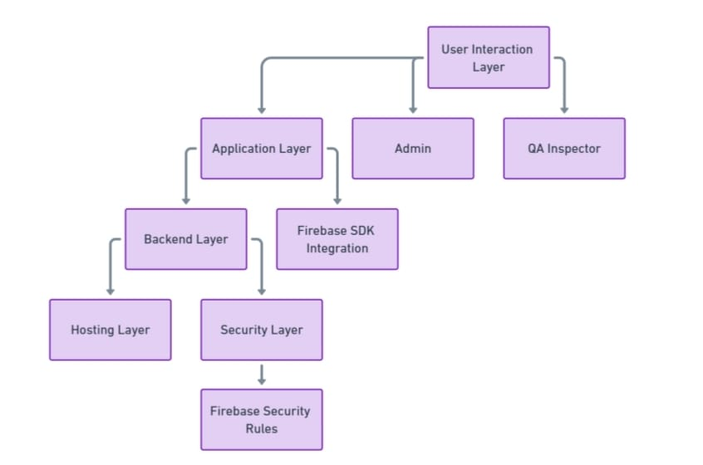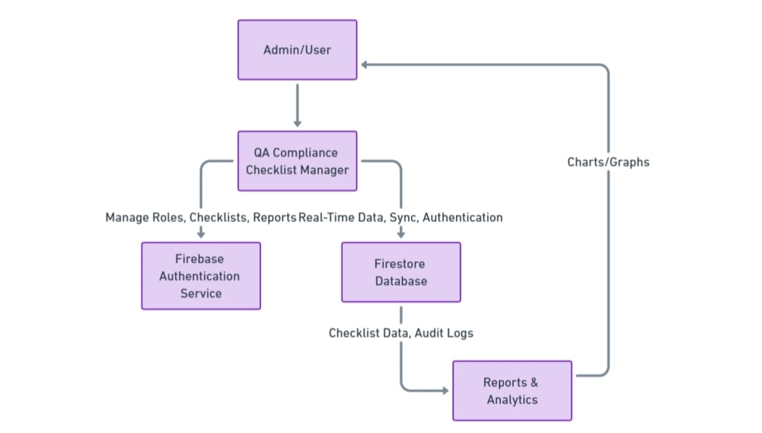

context analysis diagram

System architecture

**8.Design**

**Supervisor Design :**We design the system to facilitate user-backend service interactions. Users are able to fully comfortably on each piece with layout and responsiveness as it will bring all into a user-friendly environment.

Data Design The data is designed in a systematic way to not only maintain the integrity but also facilitate the user roles, checklists, reports queries efficiently.

User Interface Design Using Figma wireframes, the interface offers an aesthetic and user-friendly user experience.

**9.Integration**

**Backend Syncing:** The checklist data is synced in real time to ensure consistency across the platforms.

**Query Parameters and Input Data:** A great place to give value to the user and also incurring unwanted exposure.

#### **10.Testing and Validation**

**Testing Plan** The system is evaluated using test cases for functionality, performance, and user experience:

|  |  |  |  |
| --- | --- | --- | --- |
| Test Case ID | Description | Expected Result | Status |
| TC-001 | Create a new checklist | Checklist is created and visible | Pass/Fail |
| TC-005 | Mark items as complete | Status updates to "Completed" | Pass/Fail |
| TC-006 | Generate a report for a checklist | Accurate report generation | Pass/Fail |
| TC-009 | Ensure data integrity | Data remains consistent after operations | Pass/Fail |
| TC-010 | Validate report delivery | Correct recipient details are displayed | Pass/Fail |

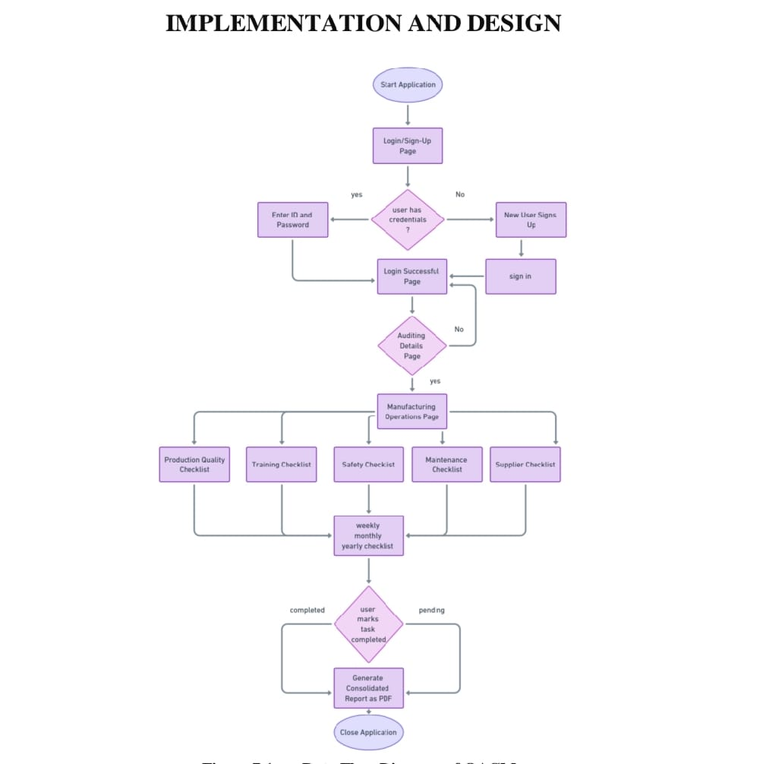

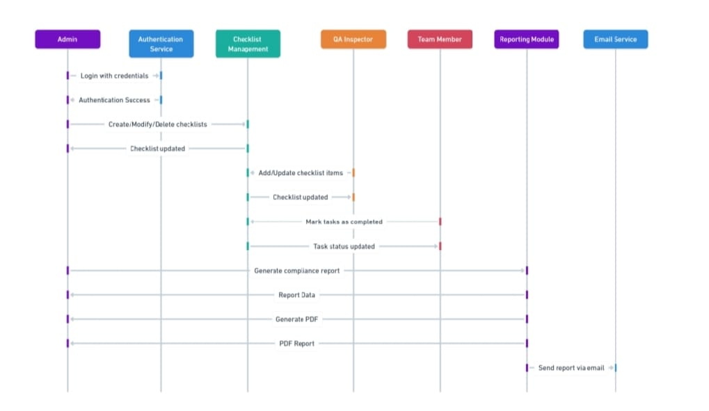

**Sequence Diagram**

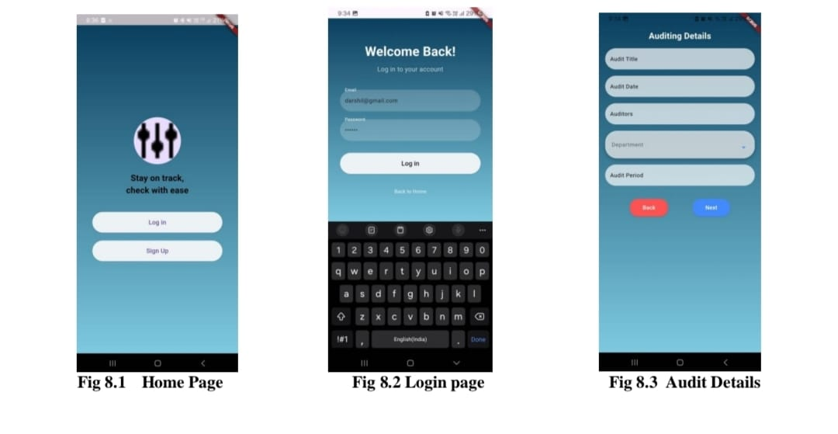

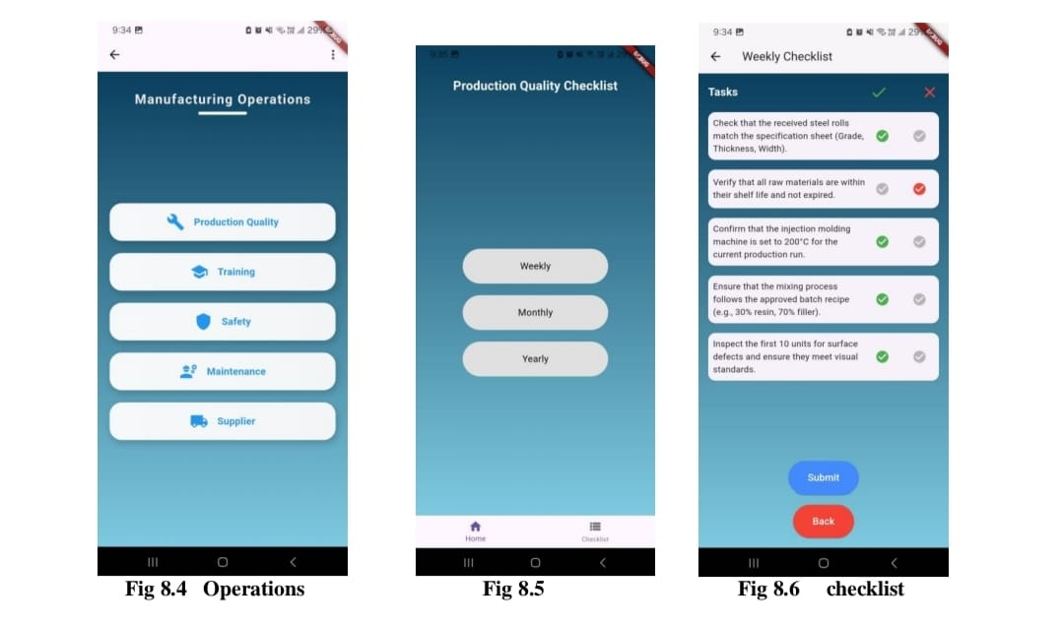

#### Technology Stack

**Frontend:** React Native, Flutter

**Backend:** Java

**Database:** MySQL

**Wireframes:** Figma

****Integrated Development Environments (IDEs)** :**Visual Studio Code and Android Studio

#### **12.Conclusion**

#### The QA Compliance Checklist Management System is a scalable and efficient tool for organizations aiming to digitize their QA processes. By leveraging modern technologies and a user-centric design, the system provides a comprehensive solution for quality assurance management.

1. **References**

1. Aalok V. Agarwala, Paul G. Firth, Meredith A. Albrecht, Lisa Warren, and Guido Musch. 2015.

An electronic checklist improves transfer and retention of critical information at intraoperative

handoff of care. Anesth. Analg. 120, 1 (January 2015), 96--104.

2. Jochen Bergs, Johan Hellings, Irina Cleemput, Ö Zurel, Vera De Troyer, Monique Van Hiel,

Jean-Luc Demeere, Donald Claeys, and Dominique Vandijck. 2014. Systematic review and meta

analysis of the effect of the World Health Organization surgical safety checklist on postoperative

complications. Br J Surg 101, 3 (February 2014), 150--158.

3. Aalok V. Agarwala, Paul G. Firth, Meredith A. Albrecht, Lisa Warren, and Guido Musch. 2015.

An electronic checklist improves transfer and retention of critical information at intraoperative

handoff of care. Anesth. Analg. 120, 1 (January 2015), 96--104.

4. Heidi S. Kramer and Frank A. Drews. Checking the lists: A systematic review of electronic

checklist use in health care. Journal of Biomedical Informatics.

5. Aleksandra Sarcevic, Brett Rosen, Leah Kulp, Ivan Marsic, and Randall Burd. 2016. Design

challenges in converting a paper checklist to digital format for dynamic medical settings. In

Proceedings of the 10th EAI International Conference on Pervasive Computing Technologies for

Healthcare (Pervasive Health 2016), 1--8