MEDICINAL IMPORTANCE OF TRADITIONAL HERBAL PLANT HARITAK
(TERMINALIA CHEBULA):AN OVERVIEW

Ms. Praniti Padawalkar (Author) Mr. Anil Landage (Guide)

ABSTRACT

The herbal plant Terminalia chebula (commonly known as Haritaki) has been widely recognized for its extensive medicinal applications in both traditional and modern therapeutic systems. Its bioactive components demonstrate significant pharmacological properties, including antioxidant, anti-inflammatory, antibacterial, antifungal, wound healing, and immunomodulatory activities. This deciduous tree, belonging to the family Combretaceae, is valued in Ayurveda for its diverse therapeutic benefits, especially as a part of the Ayurvedic formulation Triphala. The phytochemical profile of T. chebula includes flavonoids, glycosides, tannins, and phenolic acids, contributing to its antimicrobial, adaptogenic, hepatoprotective, and purgative properties. Modern studies also highlight its potential in managing chronic diseases such as arthritis, oxidative stress, and microbial infections. This overview aims to summarize the botanical characteristics, pharmacological activities, and traditional uses of T. chebula, offering a comprehensive perspective on its therapeutic potential.

Keywords: Terminalia chebula, Haritaki, pharmacological properties, Ayurveda, Triphala, phytochemistry.

INTRODUCTION

Medicinal plants have been used to combat ailments since the dawn of civilization. They are a vital and cost-effective source of unique phytoconstituents used in drug development. 1,2,3. Several hundred plant genera have been utilized medicinally in indigenous systems of medicine for centuries, and modern medicine has yet to replace them. According to the World Health Organisation, 80% of the global population relies on traditional medicines made from plant extracts or active components. 4. Plant medications are widely used in affluent countries, including the United States.[1]

Herbal medicines are affordable, natural, and have higher safety margins with minimal or no side effects. 6. Terminalia chebula (T. chebula) is a flowering evergreen tree from the Combretaceae family. This plant is also known as black myrobalan, ink tree, or chebulic myrobalan in English, haritaki in Sanskrit and Bengali, harad in Hindi, harada in Marathi and Gujarati, Kark Chettu in Telugu, and Kadukkai in Tamil. In Tibet, T. chebula is referred to as the "King of Medicine." 7 Division: Magnoliophyta Class: Magnoliopsida Order: Myrtales Family: Combretaceae. Genus: Terminalia Species: Chebula. Habit and Habitat. T. chebula is a medium to big, densely branched deciduous tree with a height of up to 30 m and a girth of 1-1.5 The Leaves are 10-30 cm long, elliptical with a sharp tip and cordate [1]
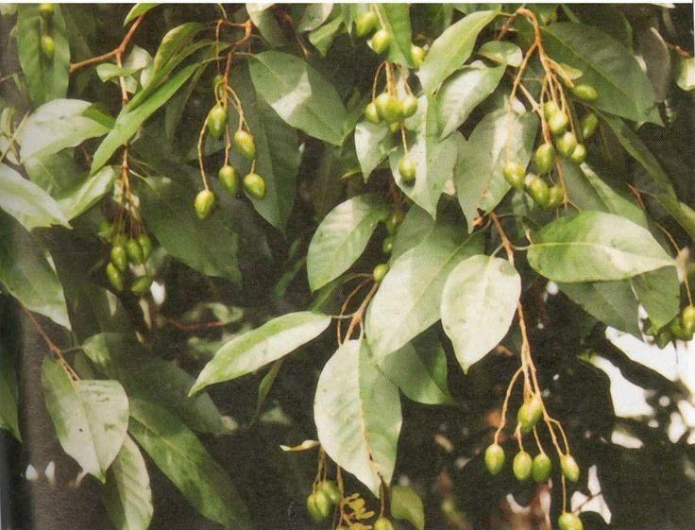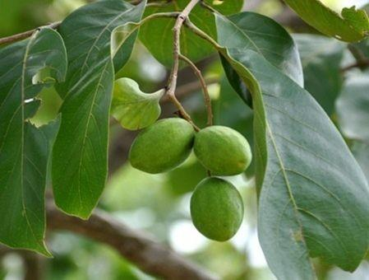

Fig 1:Terminalia chebula plant. Fig 2 : Terminalia chebula fruits

BOTANICAL DESCRIPTION

TAXONOMY

Kingdom: Plantae
Subkingdom: Tracheobionta
Super division: Spermatophyta
Division: Magnoliophyte
Class: Magnoliopsida
Subclass: Rosidae
Order: Myrtales
Genus: Terminalia
Species: Terminalia chebula[1]

Botanic Description This medium-sized, deciduous tree can reach up to 25 meters in height and has a short, cylindric bole measuring 5-10 meters in length and 60-80 cm in diameter at breast height. The crown is rounded and has spreading branches. The bark is dark brown and longitudinally cracked with woody scales, and the branchlets are rusty-villous or glabrescent. The leaves are alternate or opposite, thin-coriaceous, oblong or elliptic-obovate, 7-12 cm x 4-6.5 cm, rounded at base, obtuse to subacute at apex, whole, and hairy beneath. The petiole can be up to 2 cm long and has two glands at the base of the blade. Flowers are in axillary spikes 5-7 cm long, solitary or sometimes branching, about 4 mm across, yellowish-white, unpleasantly perfumed, with a 5-lobed calyx, no corolla, 10 exserted stamens, and an inferior, 1-celled ovary. The fruit is an oblong or oval drupe.[1]

PHYTOCHEMICAL PROPERTIES

T. chebula includes a variety of phytoconstituents, including tannins, flavonoids, sterols, amino acids, fructose, resin, and fixed oils. However, it is particularly high in tannin content (about 32%). The tannin concentration of T. chebula varies depending with its geographic location . Tannin is mostly composed of chebulic acid, chebulinic acid, chebulagic acid, gallic acid, corilagin, and ellagic acid.[1]

TRADITIONAL VALUES

Haritaki, in Sanskrit, means "carries away" (all ailments). It is part of the traditional Ayurvedic combination known as "Triphala" (three fruits). Tiphalpha, an Ayurvedic medicine, purifies and detoxifies the body to improve health. Its high vitamin C content provides considerable anti-mutagenic action. Haritaki has a variety of benefits, including purgative, stomachic, tonic, alterative, adaptogen, hepatoprotective, febrifuge, antispasmodic, astringent, expectorant, anti-asthmatic, antiviral, and hypoglycemic properties. According to Ayurveda, it can treat a variety of disorders, including ophthalmia, haemorrhoids, dental caries, bleeding gums, ulcers, and more [2]

PHARMACOLOGICAL ACTIVITY

Antioxidant activity

Activity of antioxidants Four components and six extracts from Terminalia chebula fruit shown varying degrees of effectiveness in antioxidant activity . In rats, its fruit has radioprotective and antioxidant effects . There have also been reports of the protective effects of an aqueous extract of Terminalia chebula fruit against the oxidative damage caused by tert-butyl hydroperoxide (t-BHP) in rat liver and cultured rat primary hepatocytes . It has greater antioxidant activity than alpha-tocopherol; flavonol aglycones and their glycaemic acid, hydroxybenzoic acid derivatives, and hydroxycinnamic acid derivatives were detected by HPLC analysis using diode array detection.[1]

Anti-inflammatory activity

Anti-arthritic and anti-inflammatory properties In both CFA-induced and formaldehyde-induced arthritis, Nair et al. found that the hydro-alcoholic extract of T. chebula significantly reduced joint swelling when compared to control. Treatment with Terminalia chebula also decreased synovial expression of TNF-R1, IL-6, and IL-1β, as well as serum TNF-α levels. By preventing the production of inducible nitricoxide, an aqueous extract of T. chebula's dried fruit demonstrated anti-inflammatory properties. Rats with Freund's adjuvant-induced arthritis showed a dose-dependent anti-inflammatory response to Terminalia chebula in a polyherbal formulation (Aller-7). [3]

Anti - bacterial activity

Antimicrobial action Several bacterial species were susceptible to the antibacterial action of Terminalia chebula . Helicobactor pyroli (H. pyroli), a common bacteria linked to the development of gastritis, ulcers, and stomach malignancies, has its urease activity well inhibited, according to one group of researchers . There have also been reports of Terminalia chebula's antibacterial activity against human pathogenic bacteria that are both Gramme positive and Gramme negative (30). Against methicillin-resistant Staphylococcus aureus, gallic acid and its ethyl ester, which were separated from the ethanolic extract of Terminalia chebula, shown antibacterial action (31). The bacteria Xanthomonas Campestris pv. Citri strain XC-100 was inhibited by Terminaliachebula diffusate, suggesting that it could be used to treat citrus canker disease .[1]

Anti -fungal activity

Anti-fungal action The antifungal activity against certain dermatophytes and yeasts has been described by Shinde et al. By using the paper disc method to screen for pathogenic fungus, alcoholic and ethyl acetate extracts of Terminalia chebula leaves were found to be more effective than the reference standard carbendazim. According to reports, T. chebula's aqueous extract exhibits anti-fungal efficacy against a variety of yeasts and dermatophytes, including Candida albicans, Floccosum, Microsporum gypseum, and Epidermophyton rubrum . The methanol extract of Terminalia chebula exhibited anticandidal action against Candida albicans that were resistant to clotrimazole in vitro. [3]

Wound healing activity

Using an alcoholic extract of Terminalia chebula leaves to treat rat dermal wounds resulted in faster healing, with increased contraction rates and shorter epithelializa periods.[2]

Molluscicidal Activity

Upadhyay et al. found that the ethanolic extract of Terminalia chebula fruit exhibited molluscicidal action against the vector snail Lymnaea acuminata, which was duration and concentration dependent.[3]

Anti-anaphylactic and adaptogenic activity

. Anti-anaphylactic and adaptogenic properties Shin et al found that combining Terminalia chebula with other medicinal herbs improves resistance to stresses in multiple ways. Giving Terminalia chebula during anaphylactic shock decreases serum histamine levels, indicating substantial anti-anaphylactic activity. T. chebula, along with other therapeutic herbs, enhances resistance to many stresses. [3]

Anti-nociceptive activities

Kaur et al. found that Terminalia chebula fruit extracts from petroleum ether, chloroform, ethanol, and water had analgesic efficacy in mice utilizing the tail immersion method. The plant's ethanolic extract showed analgesic effects at doses of 200,400 and 800 mg/kg body weight per day. [3]

Purgative property

A purgative effect of an oil fraction from Terminalia chebula has been demonstrated.[2]

Immunomodulatory action.

Aqueous extract of Terminalia chebula increased humoral antibody (HA) titers and delayed type hypersensitivity.[2]

Skin disease

It is beneficial for skin conditions with discharges, such as allergies, urticaria, and other erythematous illnesses. [2]

USES

Digestive System

Anulomana Karma promotes proper bowel movements. Haritaki (1 to 3 g) is provided with hot/lukewarm water to relieve Ama (undigested food contents) in Irritable Bowel Disease (IBD) with low digestive ability. Additionally, it can help with appetite loss, vomiting, abdominal pain, early ascites, haemorrhoids, hepatomegaly, splenomegaly, and parasitic infestations. 3-6 gm of powdered Haritaki might alleviate constipation. Haritaki powder (10 gm) can be consumed with grapes to relieve hyperacidity. 10. To cure constipation, take 10-15 g of dry Haritaki or Triphala powder, which contains Hairtaki, Vibhitaki, and Amalaki, with tepid water after supper. Useful for splenomegaly (3 to 5 grammes once or twice).[3]

Skin

Chandil et al. (2020). World Journal of Pharmaceutical Research, Volume 9, Issue 10, p. 489. Skin: Haritaki is effective in treating Erysipelas and other skin conditions by preventing pus collection and acting as a Rasayana. Haritaki oil is highly effective for wound healing, particularly in burns. It helps to enhance skin condition.[3]

Rasayana

It Is an anti-aging, rejuvenative, and nutritious remedy that involves cooking 2 - 4 dry Haritaki fruits in 4 parts milk until soft. After cooling, add a little ghee and honey. This meal can be used everyday to boost immunity , improve body weight (Bruhmani), and increase life expectancy/span by sustaining health (Ayushya). Haritaki functions as a rejuvenator (by eliminating the mala in the body). Haritaki is given with various components in different seasons (ritu) for rasayana karma (rejuvenation and anti-ageing), as previously explained. Dosage for Rasayanakarma: 2-4 grammes. It initiates the natural detoxification of bodily harmful compounds.[3]

Urinary System

Good for diabetes (take 3 grammes of Haritaki powder every morning and evening with a little honey), dysuria, urine retension, calculus, and urinary tract diseases. Chronic Haritaki use aids in the management of diabetes. [3]

CLINICAL STUDIES

Recent research suggests that Terminalia chebula may have potential usefulness for treating chronic diseases in Australia, notwithstanding its traditional therapeutic applications. T. chebula extracts exhibited antibacterial action against Staphylococcus aureus .Chebulagic acid from immature seeds inhibited collagen-induced arthritis in mice. A study found that 'Triphala', a blend of three plant fruit powders, including T. chebula, had cancer-preventing properties .Triphala is a common Ayurvedic medicine composition. Triphala supplementation significantly decreased benzo(a)pyrene-induced forestomach papillomagenesis in mice. Triphala boosts antioxidant levels in animals, potentially aiding in chemoprevention.[2]

The ethanol extract from Terminalia chebula has been shown to have considerable anti-oxidative stress properties . The ethanolic extract of Haritaki (Terminalia chebula) was tested for cardioprotective effects against isoproterenol (200mg/Kg subcutaneously)-induced myocardial damage in rats. T. chebula at a dose of 500mg/kg (orally) significantly reduced lipid peroxide levels and enzyme activity, including LDH, CK, AST, and AL T.[2]

CONCLUSION

Haritaki, revered as a "magic drug" in Ayurvedic medicine, has been used for decades due to its rich ethnomedical significance. It contains various bioactive phytoconstituents, including chebulic acid, chebulinic acid, chebulagic acid, ellagic acid, gallic acid, and corilagin, which contribute to its antimicrobial, antioxidant, anti-hyperglycemic, anticancer, and organ-protective effects on nerves, heart, kidneys, and liver. Known for its versatility, Haritaki exhibits a broad spectrum of pharmacological and medicinal activities. This review highlights its pharmacognostic and pharmacological properties, emphasizing its potential for further medicinal evaluation, making it a true "wonder herb."

The pharmaceutical industry is increasingly focusing on developing novel plant-based medications by leveraging leads from traditional medical systems. Ethnobotanical and traditional uses of plant-derived natural substances have gained significant attention due to their proven efficacy and safety. This approach remains a highly effective method for identifying new lead compounds for treating various diseases. A comprehensive review of Terminalia chebula highlights its widespread use among ethnic groups, vaidyas, hakims, and Ayurvedic practitioners. Researchers are now investigating this plant for deeper scientific exploration.

REFERENCE
[1].Gupta PC. Biological and pharmacological properties of Terminalia chebula Retz.
(Haritaki) – An overview. Int J Pharm Pharm Sci. 2012;4(Suppl 3):62–8.

[2].Gupta A, Mishra AK, Bansal P, Singh R, Kumar S, Gupta V. Phytochemistry and
pharmacological activities of Haritaki – A review. J Pharm Res. 2010;3(2):417–24.

[3].Chandil S, Pansare TA, Bamoriya H. Medicinal Importance of Traditional Herbal
Plant Haritaki (Terminalia chebula): An Overview. World Journal of Pharmaceutical
Research. 2020;9(10):477-513. doi:10.20959/wjpr202010-18532.

