An overview of Punica Granatum Pharmacology and its Phytochemistry

Author Name - *Nirmal Prachi Digambar

Co - Author:

1)Khemnar Akshada Gorakshnath

2) Khawale Rutuja Sanjay

Research Scholar: B Pharmacy

Guidence: Prof.Rokade V.G

College Name: Ashvin College of pharmacy ,Manchi Hill

* Abstract = Punica granatum, commonly known as pomegranate, is a fruit renowned for its rich phytochemical composition and diverse biological activities. This review examines the key phytochemicals present in pomegranate, including polyphenols, flavonoids, and ellagitannins, which contribute to its antioxidant, anti-inflammatory, and anticancer properties. The intricate chemical structures of these compounds, such as punicalagins and anthocyanins, play a crucial role in their biological efficacy. Recent studies highlight the therapeutic potential of pomegranate extracts in various health conditions, including cardiovascular diseases, diabetes, and neurodegenerative disorders. This abstract emphasizes the need for further research to fully elucidate the mechanisms behind the beneficial effects of P. granatum and its potential applications in functional foods and medicine.
* Introduction =

The pomegranate (Punica granatum L.) has been cultivated by humans since ancient times. Belonging to the Punicaceae family, it thrives in tropical and subtropical regions. Its name comes from the Latin "Malum granatum," meaning "granular apple," reflecting its distinctive seed-filled structure.[1]The pomegranate tree features a twisted, thorny trunk and elongated green leaves. It thrives in varying climates, producing globose fruits 6-12 cm in diameter. The peel's coloration ranges from yellow and green to intense red and dark purple.[2] Punica granatum L., known as a perishable superfruit, is cultivated globally. This plant typically grows as a shrub or small tree and is native to the Mediterranean regions, thriving in various climates and environments.[3]Recurrent aphthous stomatitis (RAS) is a common oral condition that affects approximately 20% of the population. Characterized by the presence of painful, recurring ulcers in the mouth, RAS can significantly impact individuals' quality of life and oral health. Its prevalence highlights the need for effective management strategies and further research.[4]The pomegranate tree and its juice are beneficial to health, nutrition, and medicine, and they contain a number of bioactive substances.[5]

* Scientific classification of Punica granatum L =
* Kingdom: Plantae .
* Division: Magnoliophyta.
* Class: Magnoliopsida.
* Subclass: Rosidae .
* Order: Myrtales.
* Family: Punicaceae .
* Genus and Species: Punica granatum L. [6]

lessen RAS symptoms, a number of symptomatic therapy options have been made available. The majority of these treatments are topical and intended to reduce pain and inflammation, prevent secondary infections, and aid in the healing of ulcers.[7]Recurrent aphthous stomatitis (RAS) is a multi-factorial process. Three major factors, including genetic factor, hematologic and immunologic abnormalities, and local factors are determined to cause this disorder[8]

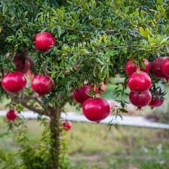

Fig, pomegranate

* Characteristics of Punica granatum =
* Punica granatum bark =

The bark of P. granatum is tough, brown, and twisted, growing up to 5 meters tall. Traditionally, this bark has been used to treat diarrhea, [9]Inflammation, nosebleeds, sore throat, ulcers, and hoarseness are common issues. Additionally, the bark of P. granatum is effective against parasitic diseases like malaria. Its extracts are also noted for inhibiting iron corrosion, attributed to their high thermal properties and acidity.[10][11]

### Punica granatum flower =

Pomegranate flowers bloom in the summertime, attracting various birds to their trees.[12] These flowers are distinguished by their stacked oval petals, which feature a light pink hue. Traditionally, pomegranate flowers are used to treat cardiovascular disorders, manage diabetes, and help with obesity. [13] Their appealing color and health benefits make them an important part of both nature and traditional medicine.[14]That's interesting! Pomegranate flowers have been recognized for their antimicrobial properties, which can be beneficial in combating various bacterial infections, including those caused by Salmonella enteritidis and other strains. Their effectiveness might be attributed to the bioactive compounds present in the flowers, such as flavonoids and tannins, which can inhibit bacterial growth.[15]

Pomegranate flowers are indeed rich in bioactive components like tannins, terpenes, terpenoids, flavonoids, and organic oils. These compounds contribute to their antimicrobial, antioxidant, and anti-inflammatory properties;

* Tannins: Known for their ability to bind and precipitate proteins, they can help inhibit bacterial growth.
* Terpenes and Terpenoid: These compounds often have strong antimicrobial effects and can enhance the therapeutic potential of other ingredients.
* Flavonoids: Renowned for their antioxidant properties, flavonoids can also support immune function and protect against oxidative stress.
* Organic Oils: These may have antimicrobial properties and can be used in various applications, including natural remedies.

Together, these components make pomegranate flowers a promising candidate for further research in natural medicine and food preservation.[16][17][18]

* Punica granatum leaves =

The ovate, green, glossy leaves of P. granatum can reach a maximum length of 3 cm. As stated by [19]. Pomegranate leaves are perennial and have been studied for various traditional uses over the years. Notably, they are used in the treatment and management of cholesterol levels and for aiding in body weight loss. Their medicinal properties have made them a subject of interest in herbal medicine.[20]The leaves of the pomegranate plant possess anti-inflammatory, anti-cholinesterase, and cytotoxic properties. These characteristics contribute to their potential health benefits, making them valuable in various therapeutic applications and herbal remedies.[21]The study reported the presence of anti-bacterial and antibiotic properties in the pomegranate leaves, highlighting their potential for use in combating infections and promoting health.[22]

### Punica granatum seeds =

### 

### Among the various parts of the *Punica granatum* plant, the seeds are the most extensively researched and documented. Enclosed within the fruit, pomegranate seeds are surrounded by vibrant red arils and can number in the hundreds. These seeds have a range of traditional and medicinal uses, including preventing miscarriage and treating urinary disorders.[23][24]

In addition to these applications, pomegranate seeds possess notable pharmaceutical properties. They exhibit antimicrobial effects, which can help combat various infections, and show potential anti-cancer activity[25]. Furthermore, pomegranate seeds are rich in antioxidants, contributing to their protective health benefits.[26]

The seeds are packed with a variety of phytochemical compounds, such as anthocyanins, tannins, fatty acids, flavonoids, and sterols, along with some organic volatile oils. These bioactive compounds play a significant role in the seeds' health-promoting properties, making them a valuable component of the pomegranate fruit[27]. Overall, the rich nutritional profile and diverse medicinal benefits of pomegranate seeds continue to attract research interest and highlight their importance in both traditional and modern medicine.[28]

### Punica granatum juice extracts =

Pomegranate juice is widely regarded as a highly beneficial beverage, rich in vitamin C. It is extracted from the sweet red arils and the pulp of the fruit, along with its peels. This juice is recognized for its significant phenolic content, which contributes to its health benefits. Key polyphenolic compounds, such as punicalagin and punicalin, have been isolated from pomegranate juice extracts, highlighting its antioxidant properties.[29]

In addition to its polyphenols, pomegranate juice is a valuable source of essential minerals, including potassium, phosphorus, calcium, manganese, zinc, and copper. These nutrients play crucial roles in various bodily functions, from bone health to metabolic processes. Overall, pomegranate juice not only offers a refreshing taste but also serves as a nutritious addition to a balanced diet, supporting overall health and well-being.[30]

* Phytochemicals and chemical structures of P. granatum =

The pomegranate (Punica granatum) is rich in various phytochemicals, particularly in its bark and peel. Extracts from the bark, especially from the region of Fez, demonstrated high levels of phenolics, with polyphenols (272.82 ± 32.05 µg/mL) and flavonoids (387.25 ± 1.75 µg/mL) being the most abundant. Notably, the bark lacked saponins and alkaloids. In contrast, the methanol extract of the peel revealed novel pyrrolizine alkaloids, specifically Punicagranine-1.[31]

Adiga et al. reported that the entire pomegranate plant is particularly high in flavonoids, which may contribute to anti-cancer and cardioprotective effects, as well as cognitive enhancement. Their research on the aqueous peel extract indicated significant improvements in cognition, including learning and memory, in a test group compared to a control group.[32] This highlights the potential of pomegranate peel extracts in treating dementia-related disorders and promoting cognitive health.[33]

### 1] Alkaloids=

Pelletierine, an alkaloid extracted from *Punica granatum*, has generated some controversy regarding its presence in the plant. Moga et al. noted these debates, while Wong et al. highlighted its potential anti-cancer properties. Other derivatives of pelletierine identified in pomegranate include pseudopelletierine, N-methylpelletierine, isopelletierine, 1-pelletierine, and di-pelletierine.[34]

Additionally, pomegranate contains other alkaloids such as caffeine and pyridine chloride, further contributing to its diverse phytochemical profile. These compounds may play various roles in the plant's health benefits, including potential therapeutic effects.[35]

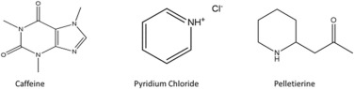

Fig 1, Alkaloids compounds

### 2] Anthocyanins =

Anthocyanins are crucial bioactive compounds responsible for the coloration of

pomegranates throughout their ripening.[36] Key anthocyanins identified include delphinidin, cyanidin, and pelargonidin. Research by Wang, Özen, et al. has also highlighted vitisin A as a significant bioactive component[37]. Additional anthocyanin constituents identified are cyanidin-3-O-pentoside, pelargonidin-3-O-glucoside, cyanidin-3-O-glucoside, and delphinidin-3-O-glucoside.[38][39]

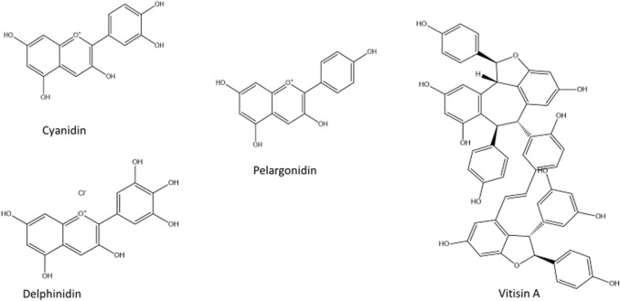

Fig. 2. Chemical structures of anthocyanins/ anthocyanidins compounds isolated from pomegranate.

3] Tannins =

Pomegranate is a polyphenol-rich fruit containing tannins

throughout its seeds and peels. These tannins contribute to various pharmacological properties, including antimicrobial and antiviral effects.[40] Key tannin derivatives found in pomegranate include gallotannins and ellagitannins. Notable isolated tannins include 1,2,3-Tri-O-galloyl-β-4C1-glucose, 2-O-Galloylpunicalin, 3,3′-Di-O-methylellagic acid, castalagin, castalin, and punicalagin, among others. These compounds enhance the fruit's health benefits and bioactivity.[41]

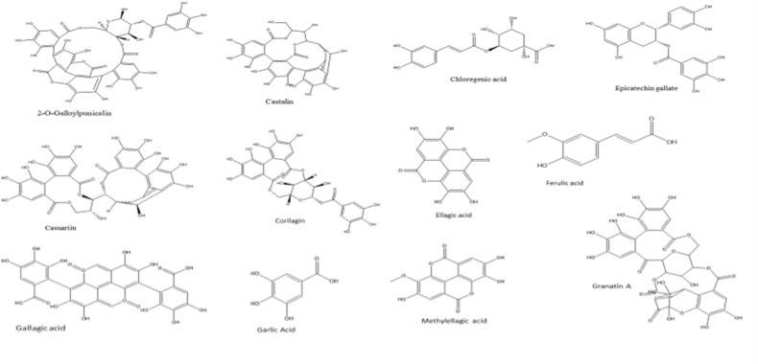

Fig. 3. Chemical structures of tannins compound isolated from pomegranate.

4] Flavonoids =

Pomegranates exhibit a range of pharmacological activities, including antimicrobial, antioxidant, anti-atherosclerotic, antiviral, anti-inflammatory, and anti-cancer properties, primarily attributed to their rich flavonoid content. [42]Flavonoids have been identified throughout the entire fruit, including the peels, seeds, leaves, juice, flowers, pericarps, and barks. Common flavonoids in *P. granatum* include prunin, catechin, chrysin, cyanidin, apigenin, biochanin, glucoside, luteolin, and taxifolin, [43]

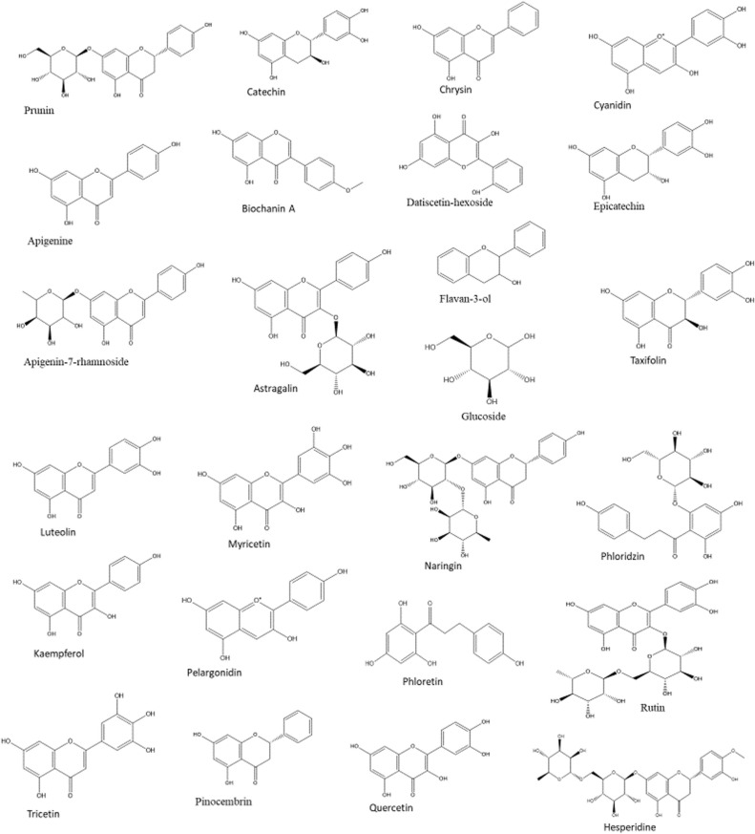

Fig. 4. Chemical structures of flavonoids isolated from pomegranate.

5]Phenolics =

identified several phenolic compounds, including punicalin, gallic acid, ellagic acid, and pyrogallol. Additional phenolics noted in the research include coumaric acid, salicylic acid, vanillic acid, sesamin, and caffeic acid [35]. Notably, phenolic compounds in *P. granatum* have demonstrated inhibitory effects against α-glucosidase activity, suggesting potential benefits in managing blood sugar levels.[44]

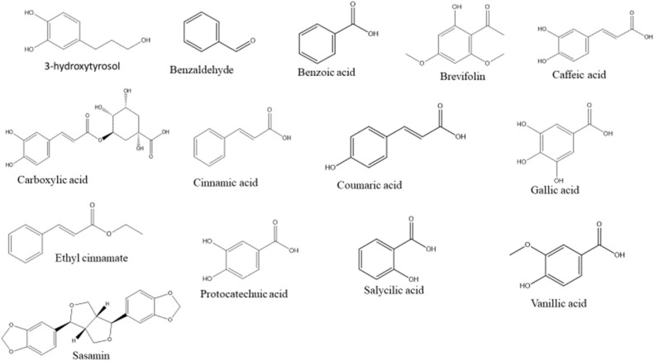

Fig. 5. Chemical structures of phenolic compounds isolated from pomegranate.

6]Proanthocyanidins =

Medicinal plants have garnered increased interest due to their rich content of bioactive compounds such as proanthocyanidins, tannins, and flavonoids, which exhibit various pharmacological activities [46], [45].

Proanthocyanidins play a crucial role in releasing catechin, which synergizes with ascorbic acid to effectively suppress free radicals [47].

In pomegranate, identified proanthocyanidins include procyanidin dimers B2 and B3, along with sugars such as arabinose, xylose, galactose, mannose, and rhamnose.[48]

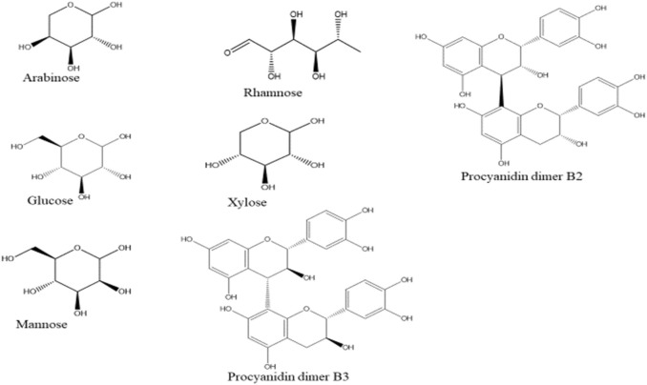

Fig. 6. Chemical structures of proanthocyanidins isolated from pomegranate.

7]Sterols =

Sterols, classified as natural steroids, are among the least abundant bioactive compounds in pomegranate [49],[50]. Their primary function is to reduce cholesterol absorption and lower low-density lipoprotein cholesterol (LDL-C) levels in plasma . The main sterol compound identified by Puneeth and Sharath Chandra [51] is asiatic acid. Additionally,reported the presence of stigmasterol, sitosterol, and cholesterol. Pomegranate seeds also contain sex steroids such as estrone, testosterone, and estriol. Other recognized sterols in pomegranate include daucosterol, sitosteryl acetate, and campesterol.[52]

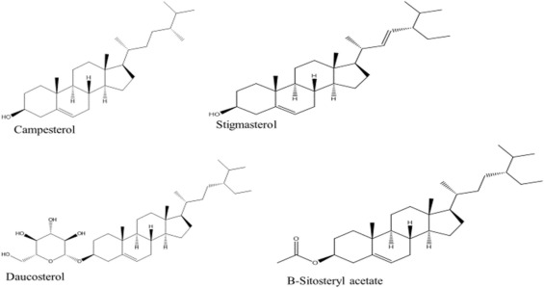

Fig. 7. Chemical structures of sterol compounds isolated from pomegranate.

8]Vitamin C =

Vitamin C is present in pomegranate juice and plays a crucial role in providing both nutritional and therapeutic benefits [53]Its consumption is linked to significant improvements in reducing fatigue and enhancing quality of life [54]

Due to the many cultivars of pomegranate, the presence and concentration of bioactive components can vary between specific tissues and cultivars, influenced by the climatic conditions in which they are grown. These bioactive molecules result from the intricate interactions between plants and their environments.[55]

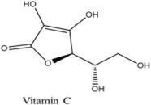

Fig. 14. Chemical structures of vitamin compounds isolated from pomegranate.

* Pharmacological activities and molecular mechanisms of P. granatum =

Punica granatum, commonly known as pomegranate, has gained attention for its potential therapeutic benefits, particularly in treating mouth ulcers. The leaf extracts of this plant are recognized for their rich composition of bioactive compounds that exhibit antioxidant, antibacterial, and anti-inflammatory properties, making them effective in managing oral lesions.[56]

* Antioxidant Properties =

Pomegranate extracts are known for their ability to neutralize oxygen free radicals, which are unstable molecules that can lead to oxidative stress and inflammation. This oxidative stress is a significant contributor to ulcer formation. By mitigating these free radicals, pomegranate extracts help reduce inflammation and promote a healthier oral environment.According to the Institute of Medicine (U.S.), dietary antioxidants from food can significantly mitigate the adverse effects of reactive oxygen and nitrogen species on normal physiological functions in humans ,Pomegranate peel is recognized as a rich source of natural antioxidants, and its antioxidant capacity has been validated in several studies.[57]

examined the antioxidant capacity of aqueous extracts from pomegranate and red grape by-products, finding that pomegranate by-products had a total phenolic content of 134.79 mg gallic acid equivalents (GAEs)/g, significantly higher than the 32.16 mg GAE/g found in red grape by-products. This suggests that pomegranate by-products could serve as valuable raw materials for pharmaceutical formulations. [58]

In vitro studies attribute the high antioxidant capacity of pomegranate extracts mainly to ellagitannins . Urolithin, a natural metabolite of ellagitannins, exists as Urolithin A (Uro-A) and Urolithin B (Uro-B), which exhibit lower antioxidant activity than their precurs]. Uro-A has shown protective effects against cisplatin-induced renal oxidative damage in mice [ ]however, evidence supporting urolithin as an effective antioxidant is limited, indicating a need for further research. [59] and have demonstrated that pomegranate peel extracts can reduce levels of thiobarbituric acid reactive substances (TBARS), oxidized low-density lipoprotein (Ox-LDL), lipid peroxidation, and other oxidative biomarkers associated with cardiovascular risk, underscoring their potential antioxidant properties.[60]

* Antibacterial Properties =

In addition to their antioxidant effects, pomegranate leaf extracts have demonstrated antibacterial properties. Research indicates that these extracts can inhibit the production of enterotoxins in *Staphylococcus aureus*, a common bacterium associated with various infections. By reducing the activity of this pathogen, pomegranate extracts may help prevent complications that can arise from mouth ulcers, further supporting oral health.[61]The antibacterial activity of pomegranate peel is largely attributed to its phenolic compounds, which have the potential to prevent or treat infections. These compounds can precipitate membrane proteins and inhibit enzyme activity, leading to bacterial death and exerting antibacterial effects [62]

Al-Zoreky et al. demonstrated that pomegranate peel extracts (PPE) effectively inhibited *Listeria monocytogenes*, *Staphylococcus aureus*, *Escherichia coli*, and *Yersinia pestis* in models of small intestinal colitis found that PPE, containing 13% (w/w) ellagic acid, could inhibit Gram-positive bacteria such as *Propionibacterium acnes*, *S. aureus*, and *S. epidermidis* at a concentration of 2 mg/disk. [63]

Due to their antibacterial properties, natural plant extracts like PPE have been increasingly used in the development of packing membranes. Hanani et al. compared the antibacterial effects of extracts from pomegranate peels, papaya peels, and pineapple peels, concluding that only the membranes incorporating PPE effectively inhibited all tested bacteria, including *L. monocytogenes*, *Bacillus cereus*, *E. coli*, and *Salmonella*.[64],[65].

* Anti-inflammatory Effects =

Anti flammation plays a critical role in the development and persistence of mouth ulcers. Pomegranate extracts can significantly reduce the production of inflammatory factors such as interleukin-2 (IL-2), interferon gamma, and tumor necrosis factor-alpha (TNF-α). By dampening the inflammatory response, these extracts contribute to alleviating the discomfort associated with mouth ulcers and facilitate the healing process.[66]

* Wound Healing Properties =

The wound healing capabilities of pomegranate extracts are also noteworthy. They can promote the proliferation and synthesis of collagen in tissues, a vital component for wound healing. Enhanced collagen production can lead to faster recovery from ulcers, thereby reducing healing time and improving overall outcomes.[67]

Several studies have shown that the topical application of pomegranate extracts can effectively treat minor mouth ulcers. Patients often experience reduced pain and discomfort, alongside a quicker healing process. This combination of benefits not only enhances patient compliance but also offers a natural alternative for managing oral health issues. Overall, pomegranate leaf extracts represent a promising option in the treatment of mouth ulcers, leveraging their multifaceted properties for improved oral care.[68]

* Conclusion =

Despite existing limitations, pomegranate peel extracts (PPEs) show potential benefits in improving specific disease biomarkers. As a valuable by-product, pomegranate peel is rich in bioactive substances, particularly phenolic compounds like tannins, flavonoids, and polyphenols, which exhibit significant biological activity. PPEs have demonstrated antioxidant effects by reducing oxidative biomarkers such as TBARS, oxidized low-density lipoprotein (Ox-LDL), and lipid peroxidation in healthy individuals.

Compounds such as punicalagin and ellagic acid in pomegranate peel have chemopreventive properties against various cancers, including prostate, breast, and colon cancer, partly through the action of the ellagic acid-derived metabolite urolithin. Furthermore, the bioactive substances in pomegranate peels contribute to anti-inflammatory, antibacterial, and cardiovascular health benefits, as well as promote healing, highlighting their modulatory and interventional roles in health.

Punica granatum L., commonly known as pomegranate, is a highly valued medicinal plant with a wide range of pharmacological, industrial, and commercial applications. This edible tree produces various components, including beverages, juices, jams, and food additives, as well as ingredients for cosmetic products like shampoos and soaps. Originating from the Mediterranean region, pomegranate has been utilized for centuries for its therapeutic and medicinal properties. Traditionally, it has been employed in the treatment of ailments such as coughs, colds, ulcers, intestinal disorders, dandruff, and cardiovascular diseases.

Recent research highlights the potential of pomegranate and its active compounds in the prevention and treatment of various health issues, including cancer, viral infections, inflammation, obesity, diabetes, malaria, liver fibrosis, and fungal and bacterial infections. Notably, studies using in silico molecular docking techniques have suggested that pomegranate polyphenols may inhibit interactions between the SARS-CoV-2 spike glycoprotein and the ACE2 receptor, indicating potential applications for COVID-19 treatment or prevention. However, further investigations are essential to elucidate the mechanisms involved and to conduct well-designed, large-scale randomized clinical trials to assess the efficacy and safety of pomegranate and its compounds in this context.

Pomegranate is rich in over 100 bioactive compounds, such as punicalin, ellagic acid, and castalagin, which are responsible for its therapeutic effects. While many of these phytochemicals have been isolated from various parts of the plant, including seeds, bark, and peels, only a few have undergone clinical validation. Additionally, pomegranate serves as an excellent source of antioxidants, such as vitamin C, which protect against harmful free radicals.

Research has shown that pomegranate can mitigate numerous diseases through various mechanisms, including regulation of critical signaling pathways (Nrf2, NF-kB, MAPK, COX-2, PPARs, and Akt) and enhancing antioxidant defenses via enzymatic activities. To fully understand the health benefits of pomegranate, more scientific studies are needed to evaluate the effectiveness and safety of its phytochemicals in both animal and human models. A diet rich in fruits and vegetables, including pomegranate, can provide significant health benefits and reduce the risk of chronic diseases.

* Reference =

1] a. el barnossi . et al , tangerine , banana , & pomegranate peels valorization for a sustainable environment: a review , biotechnology reports, 29 (2021), p. e00574..

2] D. Holland, K. Hatib, et al .Pomegranate: Botany , horticulture , breeding Horticultural Reviews, John Wiley & Sons, Inc, Hoboken, NJ, USA (2009), pp. 127-191,.

3] H.R. Puneeth, et al , A review on potential therapeutic properties of Pomegranate (Punica granatum L.) Plant Sci. Today, 7 (1) (2020), pp..

4] Chavan M, Ja in H, Diwan N, Khedkar S, Shete A, Durkar S.Recurrent aphthous stomatitis: a review. J Oral Pathol Med. 2012;41:577- 83.

5] Chandra, R. , Vilas, et al . (2010). Fruit, Vegetable and Cereal Science and Biotechnology Global Scenario of Pomegranate (Punica granatum L.) Culture with Special Reference to India..

6] Melgarejo, D. Núñez-Gómez , et al Pomegranate (Punica granatum L.) a dry pericarp fruit with fleshy seeds , Trends in Food Science and Technology, 102 (November 2019) (2020), pp. 232-236,.

7] Sara darakhshan , et al , e eects of pomegranate peel extract on recurrent aphthous stomatitisS. Curr. Issues Pharm. Med. Sci., Vol. 32, No. 3, Pages 115-120 . .

8] Burket LW, Greenberg MS, Glick M. Burket's oral medicine: diagnosis & treatment. 12th ed. Hamilton : BcDecker ; 2015. pp. 73–77..

9] K.L. Mashavhathakha , Yield and Quality of Pomegranate on Selected Geographical Areas in Western Cape Province, South Africa University of South Africa (2014)..

10] S. Ge, L. Duo, et al , A unique understanding of traditional medicine of pomegranate, Punica granatum L. and its current research status J.Ethnopharmacol., 271 (27) (2021), Article 113877, 10.1016/j.jep.2021.113877.

11] A. Marsoul, M. Ijjaali, F. Elhajjaji, et al , Phytochemical screening, total phenolic and flavonoid methanolic extract of pomegranate bark (Punica granatum L): Evaluation of the inhibitory effect in acidic medium 1 M HCl Mater. Today.: Proc., 27 (2020), pp. 3193-3198, 10.1016/j.matpr.2020.04.202.

12] L. Pienaar , The economic contribution of south africa’s pomegranate industryDiv. Macro Resour. Econ. (Issue March) (2021). .

13] J.A. Guerrero-Solano, O.A. Jaramillo-Morales, et al , Punica protopunica balf., the forgotten sister of the common pomegranate (Punica granatum L.): Features and medicinal properties—a review Plants, 9 (9) (2020), pp. 1-15,.

14] D. Wang, C. Özen, I.M. Abu-Reidah, S. Chigurupati, J.K. Patra, J.O. Horbanczuk, A. Józwik, N.T. Tzvetkov, P. Uhrin, A.G. Atanasov

Vasculoprotective effects of pomegranate (Punica granatum L.)

Frontiers in Pharmacology, Vol. 9, Frontiers Media S.A. (2018).

15] B.A. Wafa, et al . Antimicrobial effect of the Tunisian Nana variety Punica granatum L. extracts against Salmonella enterica isolated from chicken meat and phenolic composition of its peel extractInt. J. Food Microbiol., 241 (2017), pp. 123-131, 10.1016/j.ijfoodmicro .2016.10.007.

16] Ben, M. Bouaziz, et al . Salmonella enterica (serovars Kentucky and Enteritidis) identified from chicken meat: antimicrobial action of Tunisian Nana cultivar Punica granatum L. extracts and phenolic composition of its peel extract Int. J. Food Microbiol., 241 (2017), pp. 123-131, 10.1016/j.ijfoodmicro .2016.10.007.

17] D. Wang, et al . Atanasov Vasculoprotective effects of pomegranate (Punica granatum L.)Frontiers in Pharmacology, Vol. 9, Frontiers Media S.A. (2018), 10.3389/fphar.2018.00544.

18] S. Ge, L. Duo, et al .A unique understanding of traditional medicine of pomegranate, Punica granatum L. and its current research status J. Ethnopharmacol., 271 (27) (2021), Article 113877, 10.1016/j.jep.2021.113877.

19] J.A. Guerrero-Solano, O.A. Jaramillo-Morales, T. Jiménez-Cabrera, T.A. Urrutia-Hernández, A. Chehue-Romero, E.G. Olvera-Hernández, M. BautistaPunica protopunica balf., the forgotten sister of the common pomegranate (Punica granatum L.): Features and medicinal properties—a reviewPlants, 9 (9) (2020), pp. 1-15, 10.3390/plants9091214.

20] D. Wang, C. Özen, I.M. et al . Vasculoprotective effects of pomegranate (Punica granatum L.)Frontiers in Pharmacology, Vol. 9, Frontiers Media S.A. (2018), 10.3389/fphar.2018.00544.

21] J. Bekir, M. Mars, et al .Assessment of antioxidant, anti-inflammatory, anti-cholinesterase and cytotoxic activities of pomegranate (Punica granatum) leaves

Food Chem. Toxicol., 55 (2013), pp. 470-475, 10.1016/J.FCT.2013.01.036.

22 ]A . Trabelsi , et al . Phytochemical study and antibacterial and antibiotic modulation activity of Punica granatum (Pomegranate) leaves . Scientifica (2020), p. 2020, 10.1155/2020/8271203.

23] A. Chehue-Romero, T.A. Urrutia-Hernández, J.A. Guerrero-Solano, O.A. Jaramillo-Morales, T. Jiménez-Cabrera, M. Bautista, and T.A. Olvera-Hernández Features and therapeutic properties of Punica protopunica balf., the neglected sister of the common pomegranate (Punica granatum L.): a review Plants, 9 (9) (2020), pp. 1-15,

24] Moga A., Dimienescu O.G., Balan A., Dima L., Toma S.I., Bîgiu N.F., Blidaru A.Punica granatum phytochemicals' pharmacological and therapeutic qualities: Potential implications in breast cancer marius10.3390/molecules26041054 in Molecules, 26 (4) (2021).

25] K.C. Nagulapalli Venkata, et al . The bioactive components of pomegranates target several oncogenic and oncosuppressive signaling pathways to prevent and treat cancer.

73 (2021), pp. 265-293, 10.1016/j.semcancer.2021.01.006 Semin. Cancer Biol.

26] R. Setiadhi, I. Sufiawati, et al , Evaluation of antibacterial activity and acute toxicity of pomegranate (Punica granatum l.) seed ethanolic extracts in swiss webster mice . J. Dentomaxillofacial Sci., 2 (2) (2017), p. 119, 10.15562/jdmfs.v2i2.536

27] D. Wang, et al . Vasculoprotective effects of pomegranate (Punica granatum L.)Front. Pharmacol., 9 (MAY) (2018), pp. 1-15, 10.3389/fphar.2018.00544.

28] S. Ge, L. Duo, J. Wang, Yang GegenZhula, J, Z. Li, Y. TuA unique understanding of traditional medicine of pomegranate, Punica granatum L. and its current research statusJ. Ethnopharmacol., 271 (27) (2021), Article 113877, 10.1016/j.jep.2021.113877.

29] O.A. et al . Opara Stability of total phenolic concentration and antioxidant capacity of extracts from pomegranate co-products subjected to in vitro digestion BMC Complement. Altern. Med., 16 (1) (2016), pp. 1-10, 10.1186/s12906-016-1343-2.

30] M. Karimi, et al , Pomegranate as a promising opportunity in medicine and nanotechnology Trends Food Sci. Technol., 69 (2017), pp. 59-73, 10.1016/j.tifs.2017.08.019 .

31] A. Marsoul, M. Ijjaali, et al . A. BoukirPhytochemical screening, total phenolic and flavonoid methanolic extract of pomegranate bark (Punica granatum L): Evaluation of the inhibitory effect in acidic medium 1 M HCl

Mater. Today.: Proc., 27 (2020), pp. 3193-3198,10.1016/j.matpr.2020.04.202

32] H.Yi Sun, et al . Punicagranine, a new pyrrolizine alkaloid with anti-inflammatory activity from the peels of Punica granatum

Tetrahedron Lett., 60 (18) (2019), pp. 1231-1233, 10.1016/j.tetlet.2019.03.056

33] A. Marsoul, M. Ijjaali, et al ,Phytochemical screening, total phenolic and flavonoid methanolic extract of pomegranate bark (Punica granatum L): Evaluation of the inhibitory effect in acidic medium 1 M HCl

Mater. Today.: Proc., 27 (2020), pp. 3193-3198,10.1016/j.matpr.2020.04.202

34] T.L. Wong, K.R. Strandberg, et al .Pomegranate bioactive constituents target multiple oncogenic and oncosuppressive signaling for cancer prevention and interventionSemin. Cancer Biol., 73 (2021), pp. 265-293, 10.1016/j.semcancer.2021.01.006.

35] S. Eghbali,et al , Therapeutic effects of punica granatum (pomegranate): an updated review of clinical trials J. Nutr. Metab. (2021), 10.1155/2021/5297162

36]A. Moga, O.G. Dimienescu, A. Balan, ,L. Dima, S.I. Toma, N.F. Bîgiu, A. Blidaru , Pharmacological and therapeutic properties of Punica granatum phytochemicals: Possible roles in breast cancer marius

Molecules, 26 (4) (2021),

37]A. Topalović, M. Knežević, L. Ivanović, S. Gačnik, M.Mikulic - PetkovsekPhytochemical screening of wild pomegranate (Punica granatum L.) juices from the market J. Food Compos. Anal., 100 (April) (2021), 10.1016/j.jfca.2021.103933

38]M. Fourati, S. Smaoui, H. Hlima, Ben, K. Elhadef, O. Braïek, Ben, K. Ennouri, A.C. Mtibaa, L. Mellouli,Bioactive compounds and pharmacological potential of pomegranate (punica granatum) seeds - a review,Plant Foods Hum. Nutr., Vol. 75 (Issue 4) (2020), pp. 477-486, 10.1007/s11130-020-00863-7

39]D. Wang, C. özen, I.M. Abu-Reidah, S. Chigurupati, J.K. Patra, J.O. Horbanczuk, A. Józwik, N.T. Tzvetkov, P. Uhrin, A.G. Atanasov

). Vasculoprotective effects of pomegranate (Punica granatum L.)

Front. Pharmacol., 9 (MAY) (2018), pp. 1-15, 10.3389/fphar.2018.00544

40]T. Jafari, A.A. Fallah, M. Bahrami, Z. LorigooiniEffects of pomegranate peel extract and vitamin E on oxidative stress and antioxidative capacity of hemodialysis patients: a randomized controlled clinical trial J. Funct. Foods, 72 (2020), Article 104069, 10.1016/j.jff.2020.104069 .

41]Suručić, M. Travar, M. Petković, B. Tubić, M.P. Stojiljković, M. Grabež, K. Šavikin, G. Zdunić, R. ŠkrbićPomegranate peel extract polyphenols attenuate the SARS-CoV-2 S-glycoprotein binding ability to ACE2 receptor: in silico and in vitro studies Bioorg. Chem., 114 (June) (2021), 10.1016/j.bioorg.2021.105145 .

42]B.G. Vijayakumar, D. Ramesh, et al , In silico pharmacokinetic and molecular docking studies of natural flavonoids and synthetic indole chalcones against essential proteins of SARS-CoV-2 Eur. J. Pharmacol., 886 (2020), Article 173448, 10.1016/j.ejphar.2020.173448

43]A.A. Khan, A.M. Alanazi , et al, Pomegranate peel induced biogenic synthesis of silver nanoparticles and their multifaceted potential against intracellular pathogen and cancerSaudi J. Biol. Sci., 28 (8) (2021), pp. 4191-4200, 10.1016 /j.sjbs.2021.06.022

44]A. Topalović, M. Knežević, L. Ivanović, S. Gačnik, M. Mikulic-PetkovsekPhytochemical screening of wild pomegranate (Punica granatum L.) juices from the market J. Food Compos. Anal., 100 (April) (2021), 10.1016/j.jfca.2021.103933

45]S.O. Abarikwu , et al , Plants in the management of male infertilith Andrologia, Vol. 52 (Issue 3) (2020), pp. 1-22, 10.1111/and.13509

46]J.O. Unuofin , et al UHPLC-QToF-MS characterization of bioactive metabolites from Quercus robur L. grown in South Africa for antioxidant and antidiabetic properties Arab. J. Chem., 14 (3) (2021), Article 102970, 10.1016/J.ARABJC.2020.102970

47]A. Caruso, A. Barbarossa, A. Tassone, J. Ceramella, A. Carocci, A. Catalano, G. Basile, A. Fazio, D. Iacopetta, C. Franchini, M.S. Sinicropi

Pomegranate: Nutraceutical with promising benefits on human health

Appl. Sci. (Switz. ), 10 (19) (2020), pp. 1-34, 10.3390/app10196915

48]P. Kandylis, et al , Food applications and potential health benefits of pomegranate and its derivativesFoods, 9 (2) (2020),

49]Q. Xiang, M. Li, J. Wen, F. Ren, Z. Yang, X. Jiang, Y. Chen

The bioactivity and applications of pomegranate peel extract: A review

J. Food Biochem., 00 (2022), p. 14105, 10.1111/jfbc.14105

50]X. Li, et al ,The bioavailability and biological activities of phytosterols as modulators of cholesterol metabolism , Molecules, 27 (2) (2022), p. 523, 10.3390/molecules27020523

51]T.L. wang , et al ,Pomegranate bioactive constituents target multiple oncogenic and oncosuppressive signaling for cancer prevention and intervention

Semin. Cancer Biol., 73 (2021), pp. 265-293, 10.1016/j.semcancer.2021.01.006

52]L.feamndes , et al , Physicochemical composition and antioxidant activity of several pomegranate (Punica granatum L.) cultivars grown in Spain Eur. Food Res. Technol., 243 (10) (2017), pp. 1799-1814, 10.1007/s00217-017-2884-4

53]M. Daglia , et al ,Chemical characterization and preliminary evaluation of the efficacy and tolerability of a food supplement based on pomegranate extract, B vitamins, and vitamin C against prolonged fatigue in healthy consumersProcesses, 10 (2) (2022), 10.3390 /pr10020208

54]J.O. Unuofin, et al ,bAntioxidant effects and mechanisms of medicinal plants and their bioactive compounds for the prevention and treatment of type 2 diabetes: an updated review Oxid. Med. Cell. Longev. (2020), 10.1155/2020/1356893

55]M. Kaufman, et al Pomegranate oil analysis with emphasis on MALDI-TOF/MS triacylglycerol fingerprinting J. Agric. Food Chem., 55 (25) (2007), pp. 10405-10413, 10.1021/jf072741q

56]M. Viuda-Martos, et al , Pomegranate and its many functional components as related to human health: a review Compr. Rev. Food Sci. Food Saf., 9 (6) (2010), pp. 635-654, 10.1111/j.1541-4337.2010.00131.x

57]Krinsky NI, Beecher GR, Burk RF, Chan AC, Erdman JJ, Jacob RA, et al. Dietary Reference Intakes for Vitamin C, Vitamin E, Selenium, and Carotenoids. Washington, DC: National Academies Press; (2000). p. 95–185.

58]Gil MI, Tomás-Barberán FA, Hess-Pierce B, Holcroft DM, Kader AA. Antioxidant activity of pomegranate juice and its relationship with phenolic composition and processing. J Agric Food Chem. (2000) 48:4581–9. 10.1021/jf000404a

59]Rosenblat M, Volkova N, Borochov-Neori H, Judeinstein S, Aviram M. Anti-atherogenic properties of date vs. pomegranate polyphenols: the benefits of the combination. Food Funct. (2015) 6:1496–509. 10.1039/c4fo00998c

60]Jing T, Liao J, Shen K, Chen X, Xu Z, Tian W, et al. cisplatin-induced nephrotoxicity in mice via modulation of inflammation and oxidative stress. Food Chem Toxicol. (2019) 129:108–14. 10.1016/j.fct.2019.04.031

61]Naz S, Siddiqi R, Ahmad S, Rasool SA, Sayeed SA. Antibacterial activity directed isolation of compounds from Punica granatum. J Food Sci. (2007) 72:M341–5. 10.1111/j.1750-3841.2007.00533.x

62]Haslam E. Natural polyphenols (vegetable tannins) as drugs: possible modes of action. J Nat Prod. (1996) 59:205–15. 10.1021/np960040+

63]Al-Zoreky NS. Antimicrobial activity of pomegranate (Punica granatum L.) fruit peels. Int J Food Microbiol. (2009) 134:244–8. 10.1016/j.ijfoodmicro.2009.07.002

64] Al-Zoreky NS. Antimicrobial activity of pomegranate (Punica granatum L.) fruit peels. Int J Food Microbiol. (2009) 134:244–8. 10.1016/j.ijfoodmicro.2009.07.002

65]Panichayupakaranant P, Tewtrakul S, Yuenyongsawad S. Antibacterial, anti-inflammatory and anti-allergic activities of standardised pomegranate rind extract. Food Chem. (2010) 123:400–3.

66]Hosseini B, Saedisomeolia A, Wood LG, Yaseri M, Tavasoli S. Effects of pomegranate extract supplementation on inflammation in overweight and obese individuals: a randomized controlled clinical trial. Complement Ther Clin Pract. (2016) 22:44–50. 10.1016/j.ctcp.2015.12.003

67]AlMatar M, Islam MR, Albarri O, Var I, Koksal F. Pomegranate as a Possible Treatment in Reducing Risk of Developing Wound Healing, Obesity, Neurodegenerative Disorders, and Diabetes Mellitus. Mini Rev Med Chem. 2018;18(6):507–26. doi: 10.2174/138955751766617041911472

68]Yaxian Mo , et al , ]Pomegranate Peel as a Source of Bioactive Compounds: A Mini Review on Their Physiological Functions .2022 Jun 9;9:887113. doi: 10.3389/fnut.2022.887113.