**A Review On Formulation and Evaluation of Multipurpose Herbal Cream**

**Author** – **1. Labade Ashwini Digambar , 2. Sagar Swamini Navnath**

Email ID – ashwinilabade1107@gmail.com

Email ID – sagarswamini68@gmail.com

Research Scholar – B. Pharmacy , Ashvin College Of Pharmacy, Manchi Hill, Ashvi Bk, sangamner, Ahmednagar, Maharashtra, India

**Guide Name – Asst. Prof. Tagad Ashwini V.**

Email ID – tagad.ashu@gmail.com

**Guide**, Ashvin College Of Pharmacy, Manchi Hill, Ashvi Bk, sangamner, Ahmednagar, Maharashtra, India.

**Abstract** :

Herbal cosmetics are medicines that enhance human attractiveness. The current study aims to create herbal creams with multiple applications. The current research aimed to create a herbal cream that can moisturize, nourish, brighten, and treat numerous skin disorders. Herbal creams made from Aloe barbadensis (Aloe Vera leaves) have been evaluated for their anti-inflammatory properties, moisturizer and anti-wrinkle. Azadirachta Indica, or neem leaves have antiseptic, astringent, and ringworm-infection-treating properties. Turmeric rhizomes, or Curcuma longa, are used as antiseptics and for their antioxidant, wound-healing, and skin-nourishing properties. Creams are semisolid preparations used for external application with friction, directly applied to the skin using absorbent materials, and are used medicinally and cosmetically. The cream’s components are chosen based on their therapeutic properties, using various evaluation parameters.

**Keywords** :

Herbal Cosmetics, Herbal Cream, Herbal Plants, Herbal Formulation.

**Introduction** :

The Cream is defined as a semisolid emulsion that is either oil-in-water (o/w) or water-in-oil (w/o) and is meant for external application. The cream is categorized as oil in water or water in oil emulsion. This product is applied to the outer or superficial skin and has the potential to stay in place for longer periods of time.

Products that are made utilizing a variety of approved pharmaceutical chemicals to create a base and one or more natural substances to deliver specific benefits solely are referred to as herbal formulations. The desire for natural materials and natural extracts in cosmetics preparations was sparked by customers’ usage of natural herbs and their products for their therapeutic value in product production. These products are known as herbal creams.

**Ideal properties of herbal cream** :

1. Sterilization is required.
2. The excipients had to be dependable to each other.
3. A cooling effect on the skin should be expected upon external application.
4. It began to condensate at body temperature.
5. The cold cream’s pH should be between 4.6 and 6.0.
6. It entered the epidermis (via a characteristic handle).

**Benefits of Herbal Cream** :

1. All skin types can afford it.
2. Controls abundance oil secretion.
3. Maintains the skin’s pH adjustment.
4. Helps acne and pimples.
5. Easily available.
6. Economical.
7. It boosts the body’s vitality level.
8. Various phyto-constituents can be combined.

* **SOME COMMON PLANT USING FOR PREPARATION OF MULTIPURPOSE HERBAL CREAM :**

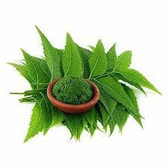**1. Neem** :

**Family:** Meliaceae.

**Biological source:** Fresh or dried leaves and seed oil Azadirachta indica.

**Biological name:** Azadirachta indica.

**Uses** **:** Anti-Inflammatory, Antiarthritic, Antipyretic, Hypoglycaemic, Antifungal, Spermicidal, Antimalarial, Antibacterial, Diuretic properties.

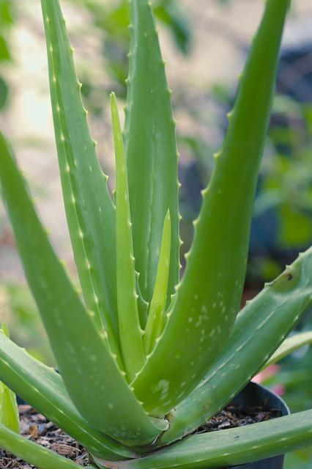**2**. **Aloe vera :**

**Family:** Asphodelaceae.

**Biological source:** Dried latex of takes off of Aloe Vera.

**Biological Name:** Aloe barbadensis miller

**Uses :** Anticancer, Antioxidant, Antidiabetic, Antihyperlipedemic, Burns, wounds, Anti – Inflammatory properties.

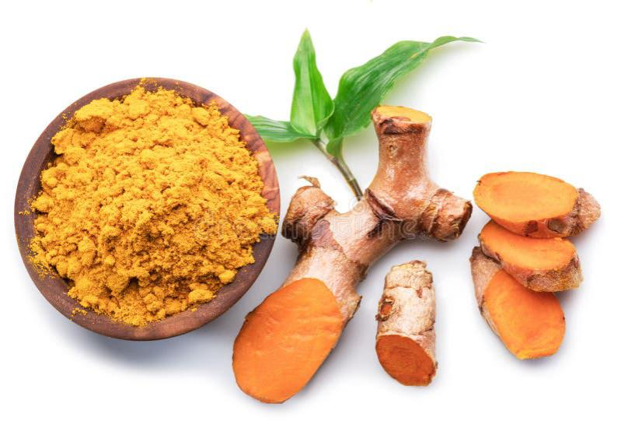**3.Turmeric :**

**Family:** Zingiberaceae.

**Biological Name:** Curcuma longa

**Biological Source :** Turmeric is the dried rhizome of Curcuma longa Linn.

**Uses :** Aromatic, Anti-inflammatory, Stomachic, Uretic, Anodyne for biliary, calculus, Stimulant, Tonic, Blood purifier, Antiperiodic, Colouring agent.

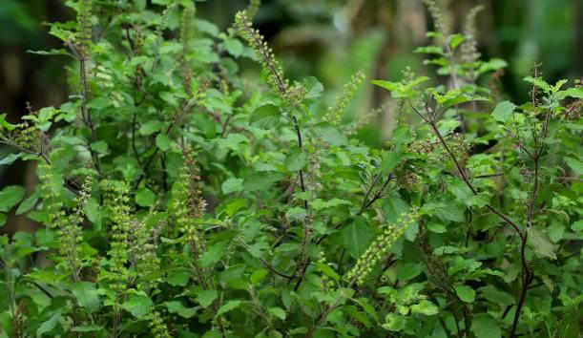**4.Tulsi :**

**Family:** Lamiaceae.

**Biological name:** Ocimumtenuiflorum**.**

**Biological source:** Fresh and dried leaves of Ocimum species like Ocimum sanctum L.also, Ocimum basilicum L. And so on.

**Uses** : Anti-inflammation, Lowers cholesterol, Eliminates toxins, protects against radiation, prevents gastric ulcers, Lowers fevers, Improves digestion, Antioxidants and other nutrients. Reduces stress, Enhances stamina.

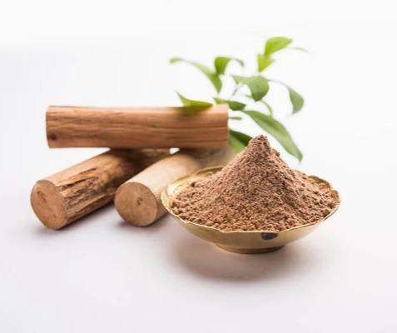**5. Sandalwood :**

**Family :** Santalaceae

**Biological Name** : Santalum album

**Biological Source**: Sandalwood oil is extracted from the heartwood of various species of sandalwood trees.

**Uses :** Anticancer, Insect repellent property, Antioxidant, Anti-inflammatory, Antipyretic, Antibacterial. etc.

**General Method for Preparing Herbal Cream By Slab Technique :**

• Prepare the oil phase: Heat liquid paraffin and beeswax in a glass beaker at 75°C .

• Prepare the aqueous phase: Dissolve borax and methylparaben in distilled water in a separate beaker at 75°C .

• Combine the phases: Slowly add the aqueous phase to the oil phase while stirring .

• Add extracts: Add extracts of aloe vera, neem, tulsi, and turmeric to the mixture and stir until smooth .

• Add fragrance: Add a few drops of rose oil as a fragrance.

• Mix on a slab: Transfer the cream to a slab and mix it in a geometric pattern to achieve a smooth texture and to ensure all ingredients are properly mixed.

• Add distilled water: Add a few drops of distilled water if necessary.

• For stability and analytical testing, the prepared Polyherbal Cream was left for approximately an hour in a cool, dry location away from the sun until it set completely. It was then utilized 48 hours later at room temperature.

• Packed in container and store in cool place.

**Evaluation of Multipurpose Herbal Cream:**

**Physical Properties:** In this test, the cream was observed for color, odor, texture, state.

**pH of the Cream:** A standard buffer solution was used to calibrate the pH meter. After weighing and dissolving around 0.5g of the cream in 50.0 ml of distilled water, the pH of the mixture was determined.

**Viscosity:** Using a Brookfield viscometer set to 100 rpm, the formulation’s viscosity was measured.

**Dye test:** The cream and scarlet red dye are combined. Examine the cream under a microscope after placing a drop on a microscopic slide and covering it with a cover slip. Should the scattered globules seem crimson, the ground will be colourless. It’s an o/w cream. In w/o type cream, on the other hand, the dispersed globules appear colourless on the red ground.

**Homogeneity:** The formulations were tested for the Homogeneity by visual appearance and by touch.

**Appearance:** The appearance of the cream was judged by its color, pearlscence and roughness and graded.

**After feel:** Emolliency, slipperiness and amount of residue left after the application of fixed amount of cream was checked.

**Irritancy test:** Mark an area (1sq.cm) on the left hand dorsal surface. The cream was applied to the specified area and time was noted. Irritancy, Erythema, edema, was checked if any for regular intervals up to 24 hrs and reported.

**Type of smear :** The type of smear that developed on the skin following the application of the cream base was non-greasy.

**Removal:** The cream applied on skin was easily removed by washing with tap water.

**Conclusion:** Topical formulations containing bioactive ingredients have an impact on the biological processes of the skin and supply the nutrients required for healthy skin. There are several naturally occurring herbs that can be used in different ways to make creams. In comparison to commercially available semisolid treatments, the current investigation showed that herbal cream is extremely safe and does not cause any harmful or unfavourable effects. Using tulsi, neem, and aloe vera gel The cream has a multifunctional impact. Herbal creams are used to stimulate blood circulation, rejuvenates. Those muscles and help to maintain the elasticity of the skin and remove dirt from skin pores. The idea that natural medicines are safer and have fewer negative effects than synthetic ones makes them more palatable.

**References :**

1.Sahu RK, Roy A, Kushwah P, Sahu A. Formulation and development of face cream containing natural products.Research Journal of Topical and Cosmetic Science. 2012: 3(1): 16-19.

2. Roy A, Kushwah P, Khare M, Mudotiya R. Formulation and development of Whitening polyherbal face cream. Research Journal of Topical and Cosmetic Science. 2012: 3(1): 23-27.

3.Shreyasi, Mukut Raj, Shailesh Sharma, Hansraj Bishnoi and Gajendra Singh“A review article on Anti Viral Herbal Plant” World Journal of Pharmacy and Pharmaceutical Sciences, Volume 11, Issue 1, 637-660.

4.Gautam A, Kashyap SJ, Sharma PK, Garg VK, Visht S, Kumar N. Identification, evaluation and standardization of herbal drugs: A review. Der Pharmacia Lettre. 2010;2(6):302-15.

5. Singh IP, Ahmad F, Chatterjee D, Bajpai R, Sengar N. Natural products: drug discovery and development. Drug Discovery and Development: From Targets and Molecules to Medicines. 2021:11-65.

6.Mittal I, Naim MJ, Singh A, Mandal S. International Journal of Modern Pharmaceutical Research.

7.krishnan n, afsal vi, jamal f, rasheed r, pp ss. Formulation and evalution of herbal vanishing cream.

8.Sumit K, Vivek S, Sujata S, Ashish B. Herbal cosmetics: used for skin and hair. Inven. J. 2012 Oct 10;2012:1-7.

9.Saudagar RB, Sisodiya MH. Review on herbal cosmetics. World Journal of Pharmaceutical Research. 2018 Feb 9;7(7):573-91.

10.Heinrich M, Barnes J, Prieto-Garcia J, Gibbons S, Williamson EM. Fundamentals of Pharmacognosy and Phytothearpy E-BOOK. Elsevier Health Sciences; 2017 Nov 24.

11.Chauhan NN, Vasava MP, Patel MS. Comparision of formulated and marketed herbal creak cream by evalution parameters.

12. A review on herbal cosmetics Lovepreet Kaur, Ajeet Pal Singh, Amar Pal Singh, Taranjit Kaur St. Soldier Institute of Pharmacy, Lidhran Campus, Behind NIT (R.E.C), Jalandhar-Amritsar by pass NH-1 Jalandhar 144011, Punjab, India. Volume 9, issue 3 ,2021

13.Manisha Yogesh Sonalkar, Sachin Annasaheb Nitave. Formulation and evaluation of polyherbal cosmetic cream. World J Pharm Pharm Sci 2016;5:772-9.

14. Sk Uddandu Saheb, Aduri Prakash Reddy, K Rajitha, B Sravani, B Vanitha. Formulation and evaluation of cream from naturally Containing plant extracts. World J Pharm Pharm Sci 2018;7:851-62.

15. Priyanka Sharma, Amit C Kharkwal, Harsha Kharkwal, MZ Abdin, Ajit Varma. A review on the pharmacological properties of Aloe Vera. Int J Pharm Sci Rev Res 2014;29:31-7.

16. Somnath S. Davkhar, Arti S. Bhandari, Sanjivani A. Akolkar, Formulation and Evaluation of Multipurpose Herbal Cream; Systematic Review Pharmacy;2023, Volume 14 ,Issue

17. Shendage A. S, Kale H. B, Jadhav Sunita T, Formulation and Evaluation of Herbal Cold Cream by Using Turmeric; International Journal of Creative Research Thoughts,October2022. Volume 10, Issue 10: 440-445.

18.Shweta Kapoor, Swarnlata Saraf. Formulation and Evaluation of Moisturizer Containing Herbal Extracts for the Management of Dry Skin, Pharmacognosy Journal, 2010; Volume2,Issue 11: 409- 4.

19. Ross and Wilson. Anatomy and Physiology in Health and Illness,11.

20. Prashant Chavan, Mallinath Kalshetti, Nikhi. Navindgikar; Formulation and Evaluation of Polyherbal Cream; International Journal of Current Pharmaceutical Research, May 2020 Volume 12, Issue 4: 75-77.