HERBS USED IN THE TREATMENT OF APHTHA

AUTHOR’S: Ms. Khemnar Akshada Gorakhshnath*, Ms. Nirmal Prachi Digambar, Ms. Khwale Rutuja Sanjay, Prof. Rokade V. G.

B. Pharm., Ashvin College Of Pharmacy, Manchi Hill

Mail: khemnarakshada0204@gmail.com

ABSTRACT:
Aphtha, or mouth ulcers, are painful sores on the mucous membrane inside the mouth, usually appearing on the inside of the lips or cheeks. They can make eating, drinking, and speaking uncomfortable. These ulcers may be caused by stress, trauma, poor dental hygiene, and lack of certain nutrients like iron and vitamins B12 and C. They are a common issue affecting the oral mucosa, with two primary causes being aphthous stomatitis (canker sores) and local trauma.
There are three types of mouth ulcers based on size and number. Minor ulcers are small and typically heal within 10 days to 2 weeks. Major ulcers are larger and can take weeks to heal, potentially leaving scars. Herpetiform ulcers appear as clusters of small sores.
Mouth ulcers can result from various factors including genetics, stress, nutritional deficiencies, trauma, certain food allergies, tobacco use, and some medications. Symptoms include pain when eating or drinking and difficulty with spicy or acidic foods. Herbal remedies have been historically significant in treatment and often have fewer side effects. Certain herbs like guava, aloe vera, papaya, turmeric, and pomegranate are effective for healing mouth ulcers and improving health.

KEY WORDS: Herbal medicine, herbal drug, mouth ulcers, canker sore, herbal formulation and oral herbal gel

INTRODUCTION:
Aphtha, the medical term for a mouth ulcer, is characterized by a lesion on the mucous membrane inside the cavity.[1,2] They are painful, oval or round lesions that mainly appear on the inside of the lips or cheeks.[3] These ulcers can make eating, drinking, and speaking uncomfortable, which can have a big impact on day-to-day living. They can occur as a result of stress, trauma, or underlying medical issues. In order to control symptoms and promote recovery, effective therapies are necessary [4].Poor dental hygiene, infections, stress, indigestion, mechanical injury, food allergies, hormone imbalances, skin diseases, and nutritional deficiencies—particularly in iron and vitamins B12 and C—are among the common causes of mouth ulcers.Aphthous ulcers, another name for mouth ulcers, can hurt when you eat, drink, or wash your teeth [5,6].One of the most prevalent conditions affecting the oral mucosa membrane is oral ulcers [7]. Mouth ulcers are open sores of the skin or mucous membrane lining that are characterized by the sloughing of inflammatory dead tissue [8].

The two main causes of oral ulceration, a common condition, are aphthous stomatitis, also known as "canker sores," and local trauma. Incidents like the abrasive friction from broken dental fillings or orthodontic braces, as well as accidentally biting one's lip, can cause local trauma, a common trigger. On the other hand, the etiology of aphthous stomatitis, a condition that is still mostly unknown, manifests as the recurrence of mouth ulcers.[9]With its base extending deep into the submucosa, muscle, or even periosteum, an ulcer is a major tissue defect that transcends the epithelial-connective tissue border.[10]Ulcers that form on the body's mucous membranes are known as aphthous ulcers. They are also known as canker sores, aphthae, aphthosis, and aphthous stomatitis. Recurrent round or oval sores or ulcers inside the mouth, as under the tongue, where the skin is only loosely linked to the bone beneath, are known as aphathous ulcers. Both male and female genitalia may be impacted. Most of the time, recurrent aphthous ulcers are an annoyance, but for certain people, they can lead to major health issues.[11]

TYPES OF MOUTH ULCER:
On the basis of ulcer size and number, mouth ulcer can be classified as minor, major and herpetiform [12,13] .
The main types of mouth ulcer are:

- Minor Ulcer : These are around 2-8mm in diameter and they usually clear up in 10 days to 2 week
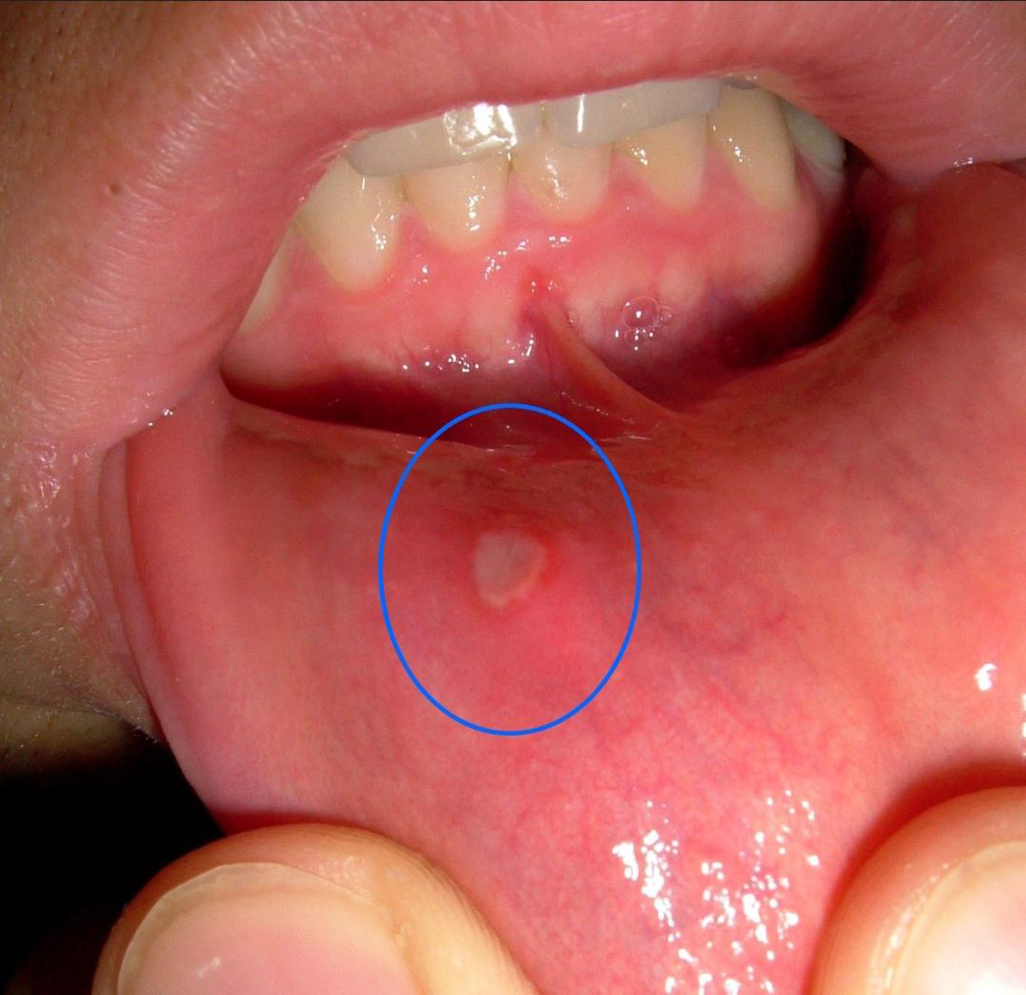
Fig. Minor Ulcer

- Major Ulcers: These are bigger and deeper, often with a raised or irregular border. This type of ulcer can take several weeks to heal and may leave a scar in the mouth[14 ,15]

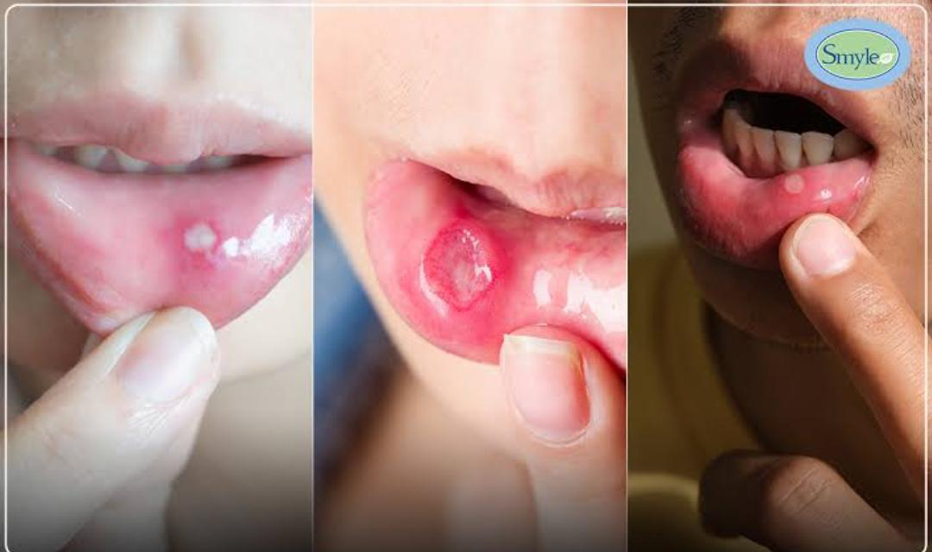
Fig. Major Ulcer

- Herpetiform Ulcers: This type of ulcer is a cluster of dozens of smaller sores about the size of pinheads. [16]

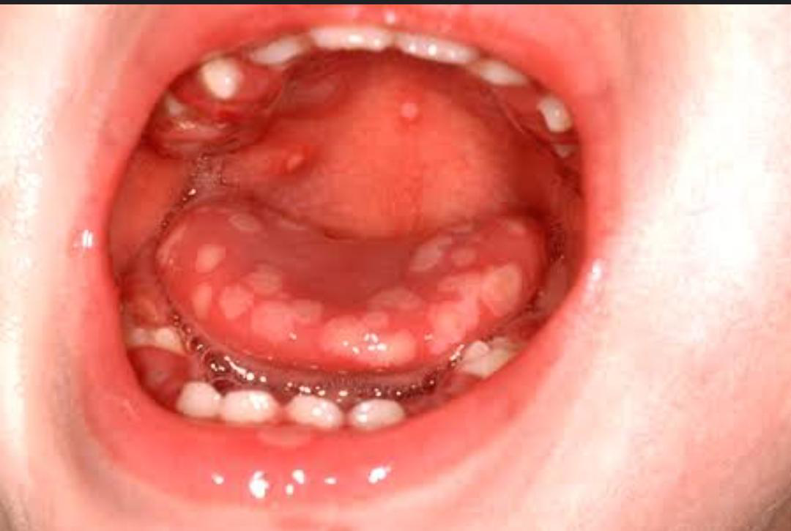
Fig. Herpetiform Ulcer

CAUSES OF MOUTH ULCER :

- GENETIC FACTOR:
Mouth ulcers can run in some families. Families are tied to those who have little children. Patients with mouth ulcers and identical twins are related, with 30 to 40% of patients having a familial history.[17]

- PHYSICAL OR PSYCHOLOGICAL STRESS:
According to a general population poll, 5–50% of people were affected by everyday stressful duties like tests, while 50–60% of students and military personnel were particularly affected.[18]

- NUTRITIONAL DEFICIENCY:
Mouth ulcers may arise from a lack of iron, folic acid, or vitamin B12.Importing iron or vitamin supplements alone, however, seldom solves these deficits.[19]
- TRAUMA:
One of the main risk factors for mouth ulcers is trauma. Mouth ulcers are still present today and can be unintentionally caused by self-biting, eating sharp objects, brushing your teeth, receiving anesthesia injections, and receiving dental care.[20]

- FOOD ALLERGIES:
Chocolate, coffee, peanut cereals, almonds, cheese, strawberries, tomatoes, wheat flour, and gluten-containing foods are among the foods that might cause mouth ulcers. When specific foods were eliminated from the diet, 50% of patients showed improvement.[21]

- IMMUNE DISORDER:
Although there is no proof, immunological problems may contribute to mouth ulcers. The cytotoxic action of monocytes and lymphocytes on the oral epithelium causes ulceration. However, the actual cause of the oral ulcer remains unknown. According to histologic studies, inflammatory cells are positioned incorrectly in mucosal ulcers. T-helper cells are crucial during the pre-ulcerative and healing stages. Increase the rate of neutrophil adhesion and Tumor necrosis is released as a result of decreased mucus T-cell function and levels.[22]

- TOBACCO SMOKING:
Numerous studies have linked smoking to the development of mouth ulcers. Additionally, you ought to keep records of your tobacco and snuff consumption. Only 9% of mouth ulcer patients actively smoke, compared to 25% of control participants, and people with mouth ulcers do not smoke. It is unknown how cigarettes' alleged benefits in curing mouth ulcers and their ability to reduce inflammation work. [23]

- DRUGS:
Nicorandil, NSAIDs, Ibuprofen, and nicotine replacement therapy are among the drugs that cause mouth ulcers.[24]

SYMPTOMS OF MOUTH ULCER :
1. Pain:
When eating, drinking, or brushing teeth, mouth ulcers frequently produce pain or discomfort [25].

2. Difficulty Eating or Drinking:
People may experience discomfort or agony when eating or drinking, particularly when consuming acidic or spicy foods, as a result of the pain and sensitivity associated with mouth ulcers.

3. Irritation or Burning Sensation:
Some patients may feel a tingling or burning feeling in the vicinity of the ulcer.

4. Swelling:
There may be a small enlargement or inflammation of the tissues surrounding the ulcer.

5. Red or White Lesion: The ulcer itself may have a distinct border and appear either red or white [26].
IMPORTANTS OF HERBAL REMEDIES :

Humans first used natural substances or medicines to treat a wide range of illnesses or afflictions, as evidenced by the development of medicine and pharmacy. Combining them with plants, plant parts, animal parts, and even strong extracts of these improves their effectiveness. The action of these substances is derived from pure chemical compounds that were isolated and utilized as prototypes for the construction of synthetic chemical compounds; nevertheless, the issue with these new synthetic drugs is that they become more potent as a result. However, the drawbacks of these synthetic drugs are their expense and adverse effects. Additionally, their use necessitates medical monitoring and more effective medicine delivery than merely demonstrating activity.Herbal medicines are simple to use, require little preparation, and have few or no serious adverse effects.[27] Approximately 75–80% of people on the planet still receive their primary medical care from herbal remedies, primarily in developing countries. because many mistakenly believe that herbal medicines are safe, affordable, and easy to obtain.
Before modern medicine evolved and spread, traditional medicine existed for hundreds of years and is still in use today. The WHO just released this definition.
Before modern medicine evolved and spread, traditional medicine existed for hundreds of years and is still in use today. The WHO recently released this definition. Traditional medicine is the most costly type of indigenous medicine used by physicians. traditional concoction consisting of minerals, medicinal herbs, and organic substances. Traditional or herbal medicine can be found in the Rigveda, Atharvaveda, Charak Samhita, Sushruta Samhita, and other works of Indian, Chinese, Egyptian, Greek, Roman, and Syrian literature.[28]Despite the availability of contemporary pharmaceuticals, herbal remedies have remained significant due to socioeconomic, cultural, and historical aspects. [29]A plant or part of a plant that is valued for its tasty, appealing, or medicinal qualities is called a herb.

BENEFITS OF HERBAL MEDICINES:

- Herbal products and medicinal plants are grown and processed in an environmentally safe and sustainable manner.
- Herbal remedies have been used for a long time and are more widely accepted and tolerated by patients.
- Medicinal herb cultivation and processing are environmentally beneficial.
- Herbal remedies are safe and effective for long-term, seemingly uneventful use[30]

HERBAL REMEDIES USE IN TREATMENT OF MOUTH ULCER:

Phytogenic substances have been utilized to cure and prevent ulcers by traditional herbalists and Native healers. Flavonoids (such as quercetin, naringin, silymarin, anthocyanosides, and derivatives of sophoradin), saponins (from Panax japonicas and Kochia scoparia), tannins (from Linderaeumbellatae), gums, and mucilages (such as gum guar and myrrh) are a few examples of plant compounds with anti-ulcer activity. Many people have utilized natural medicines including capsicum (chili), licorice, and aloe gel. Many plant extracts are used to cure ulcers in ethnomedical traditions.[31]

HERBS USED IN THE TREATMENT OF MOUTH ULCER :

1) Guava:
The biological source of Guava is Psidium guajava. It belongs to family Myrtaceae.

MORPHOLOGY:
Depending on the species, guava fruits can be round or oval and range in length from 4 to 12 centimeters (1.6 to 4.7 inches). They have a strong, common scent that is less harsh than lemon rind. The outer skin might be smooth and pleasant or harsh and frequently bitter. The thickness of the skin varies from species to species and is typically green before maturity, though it might be yellow, maroon, or green when ripe. The pulp inside can be off-white (called "white" guavas) or deep pink (called "red" guavas), and it can be either sweet or sour. Depending on the species amount and hardness of the seeds in the core pulp varies.

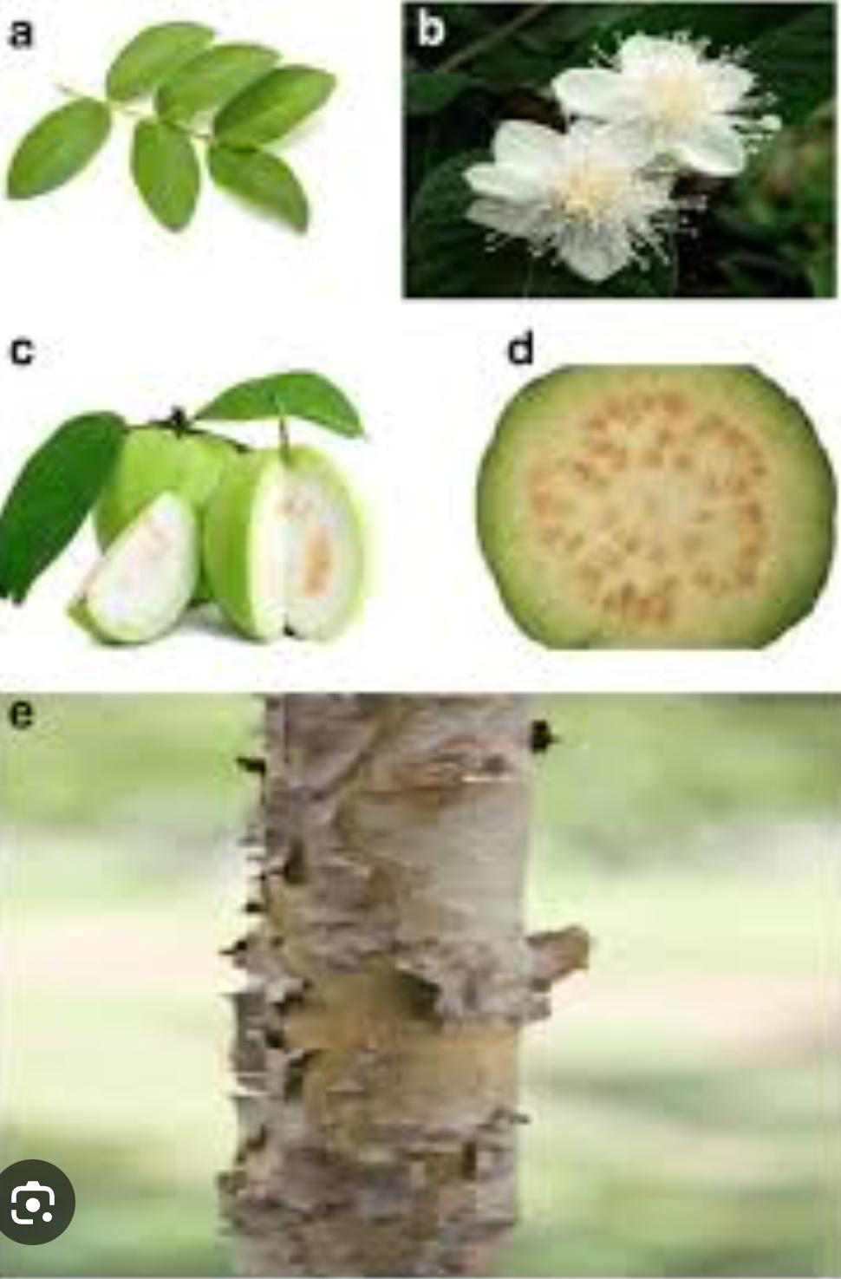

PLANTS PART USED:
Leaves, roots, fruits

CHEMICAL CONSTITUENTS :
Guava leaves include both carotenoids and polyphenols such as (+)-gallocatechin and leucocyanidin. Because some of these phytochemicals form the fruit skin and flesh color, red-orange guavas have higher polyphenol and carotenoid levels than yellow-green guavas

USES:
- Guavas are often used to make sweets, preserves, jellies, jams, and marmalades (like Brazilian goiabada and Colombian and Venezuelan bocadillo) due to their high pectin content. They are also used as a marmalade jam that is served on toast.
- To reduce the acidity of salted items like sauces, red guavas can be used as the foundation instead of tomatoes.

- Guava fruits and leaves can be infused to make a drink known as chá⁾de-goiabeira, or "tea" of guava tree leaves, which is regarded as therapeutic in Brazil. [32]

2) ALOE-VERA:
The biological source of Aloe vera is Aloe barbadensis. It belongs to the family Xanthorrhoeacea.

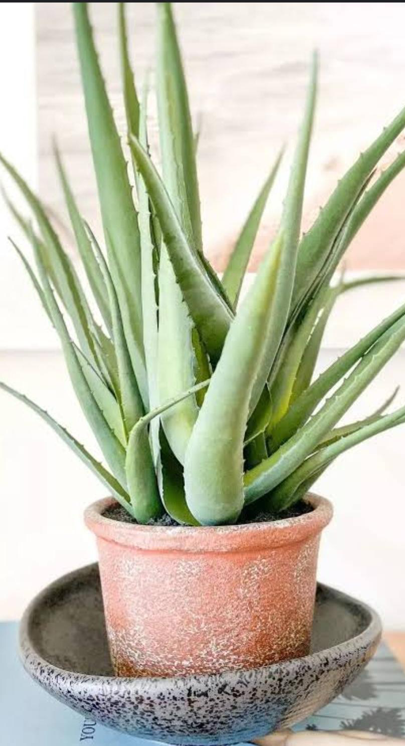

MORPHOLOGY:
Aloe vera is a short-stemmed or stemless plant that grows through offsets and usually reaches a height of 60 to 100 cm (24 to 39 in). Succulent and sturdy, its leaves range in color from green to grey-green and occasionally include white dots on both the upper and bottom surfaces. There are tiny white teeth on the serrated leaf edges. It blooms in the summer on a spike that can reach a height of 90 cm (35 in), with pendulous yellow tubular corollas that are 2–3 cm (0.8–1.2 in) long. Aloe vera, like other members of its genus, generates arbuscular mycorrhiza, improving its ability to absorb mineral nutrients from the soil.

PLANTS PART USED :
Leaves, flowers, stems, roots, fruits, seeds

CHEMICAL CONSTITUENTS :
Fatty acids, prostaglandins, anthraquinones, and saccharides are among the several chemical components found in aloe vera. It also contains vitamins, minerals, amino acids, and enzymes. Aloe vera also contains lignins, beta-sitosterol, gibberellin, uric acid, cholesterol, triglycerides, steroids, and salicylic acid.

USES:
- Periodontal surgery, chemical burns, aphthous ulcers, gum abscesses, dry socket, lichen planus, benign pemphigus, and gingival problems linked to diseases like AIDS and leukemia are just a few of the dental and oral health ailments for which it is used.

- Migratory glossitis, geographic tongue, burning mouth syndrome, denture sore mouth, candidiasis, desquamative gingivitis, vesiculobullous illnesses, acute monocytic leukemia, and xerostomia are among the ailments that aloe vera can treat.
- Analgesic, antibacterial, antiviral, antifungal, antioxidant, immune-modulating, antiseptic, and anti-inflammatory actions are just a few of the medical qualities that aloe vera possesses.[33]

3) PAPAYA:
The biological origin of papaya is Carica papaya Linn, belonging to the Caricaceae family, renowned for its diverse medicinal benefits. Papaya fruits are known for their antiulcer properties, while the seeds exhibit antimicrobial,anthelmintic and antiamoebic effects.

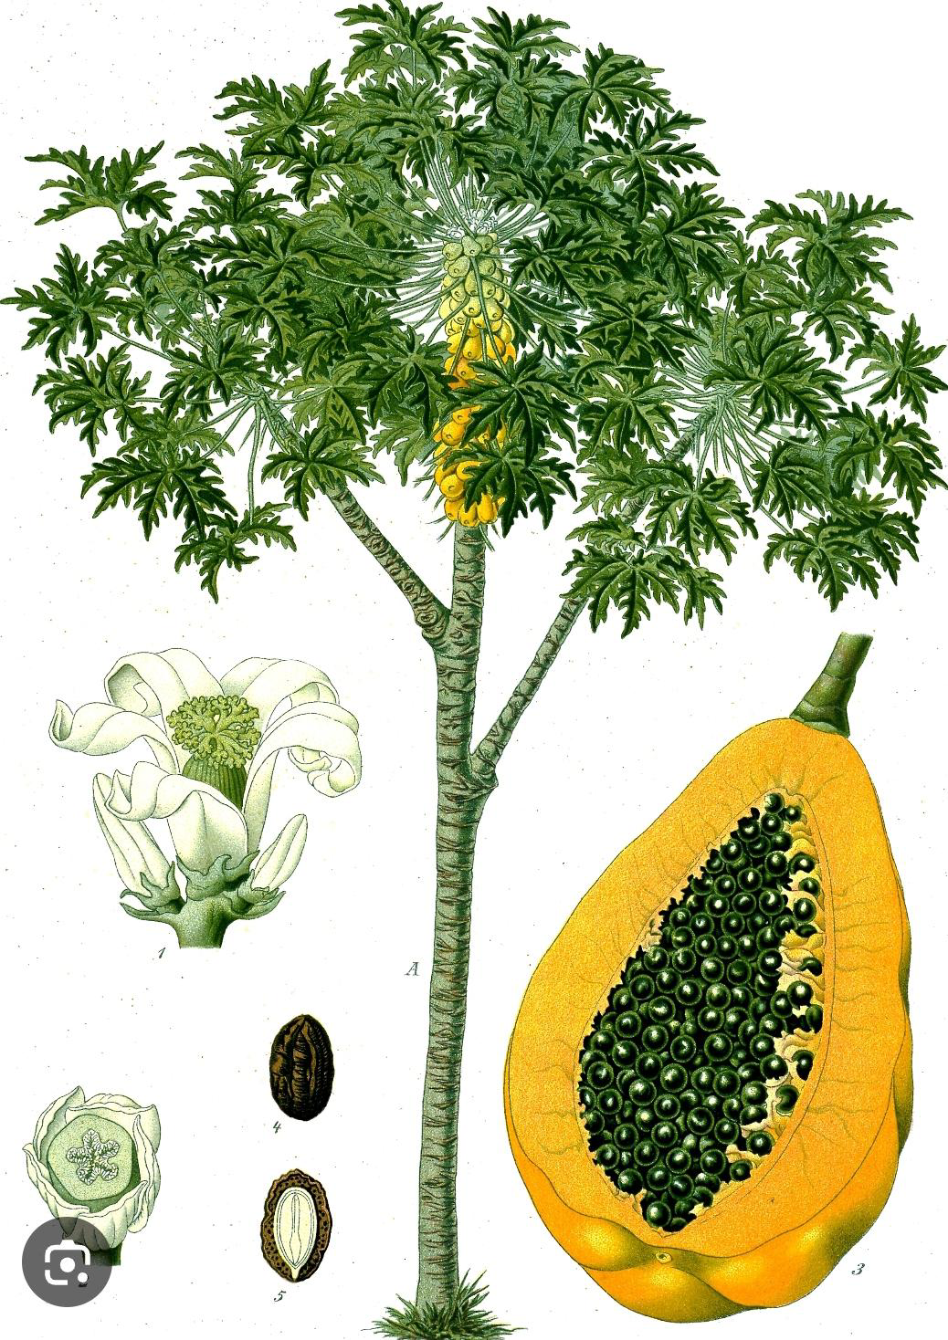

MORPHOLOGY :
Growing to a height of 20 to 30 feet, the papaya plant is a tall, herbaceous perennial tree with a single stem. Its leaves are smooth-edged, palmately lobed or deeply incised, and up to 2½ feet broad. They are held up by petioles that are one to three feet long. The hollow stems have noticeable scars and range in color from pale green to tan brown. They have a diameter of around 8 inches.
PLANTS PART USED :
Bark , leaves and fruits.

CHEMICAL CONSTITUENTS :
Papain, the main active ingredient in papayas, is a strong digestive enzyme that is well known for its adaptability. Vitamins C and E, as well as vital minerals like potassium, are rich in papaya fruit. It also contains the strong proteolytic enzymes papain and chymopapain.

USES :
A combination of proteolytic enzymes found in the unripe fruit, papain is made from the dried and purified latex of Carica papaya fruit.
- It is commonly used to tenderize meat and is also a component of soft contact lens cleaning solutions.
- Papain, which functions as a protein digestant similar to pepsin, is used to reduce episiotomy symptoms by acting on milk casein.[34]

4) TURMERIC :
Curcuma longa, a member of the Zingiberaceae family, is the biological source of turmeric.Turmeric's antiulcer properties in the stomach and duodenum have been tested in rats. Curcuma longa's volatile oil has anti-inflammatory and anti-arthritic properties. Curcumin extracts that were soluble in fat and water demonstrated potent antioxidant activity on par with that of vitamins C and E.

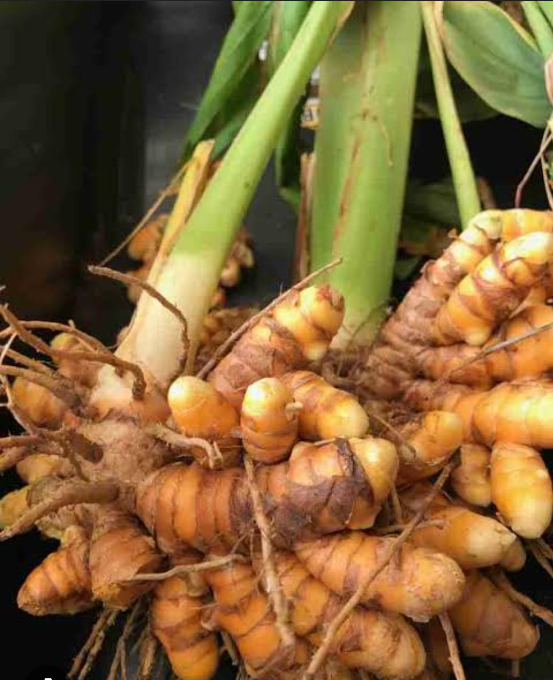

MORPHOLOGY :
A perennial herbaceous plant, turmeric can grow up to 1 m (3 ft 3 in) in height. There are aromatic, cylindrical,highly branching rhizomes that range in color from yellow to orange. There are two rows of alternating leaves. They are separated into the petiole, leaf blade, and leaf sheath. A fake stem is created from the leaf sheaths. The petiole's length ranges from 50 to 115 cm (20 to 45 in). Simple leaf blades typically measure between 76 and 115 cm (30 an 45 in) in length, with a rare exception of 230 cm (91 in). They are oblong to elliptical, narrowing at the tip, and range in width from 38 to 45 cm (15 to 18 in).

PLANTS PART USED :
Rhizomes and stem

CHEMICAL CONSTITUENTS :
Diaryl heptanoids, a class of curcuminoids that includes curcumin, demethoxycurcumin, and bisdemethoxycurcumin, are among the phytochemical components of turmeric. Curry powder contains significantly less curcumin (an average of 0.29%), while analyzed commercial samples of turmeric powder include up to 3.14% curcumin (the average was 1.51%).Turmeric contains about 34 essential oils, with turmerone, germacrone, atlantone, and zingiberene being the main components.

USES:
- It can be found in a wide range of items, including cereals, sauces, gelatin, popcorn color, baked goods, dairy products, ice cream, yogurt, yellow cakes, orange juice, and biscuits.
- It can be used in a variety of East Asian cuisines, like pickles made with fresh turmeric that have big chunks of soft turmeric in them.
- Like ginger, fresh turmeric is also used, though it is more often used in its dried, powdered form. Fresh turmeric is often used in East Asian culinary traditions, particularly in pickles that feature large chunks of soft turmeric.[35]

5) POMEGRANATE :
Punica granatum (Pg), commonly known as pomegranate (Pg), is a member of the monogeneric family, Punicaceae, and is mainly found in Iran which is considered to be its primary centre of origin.

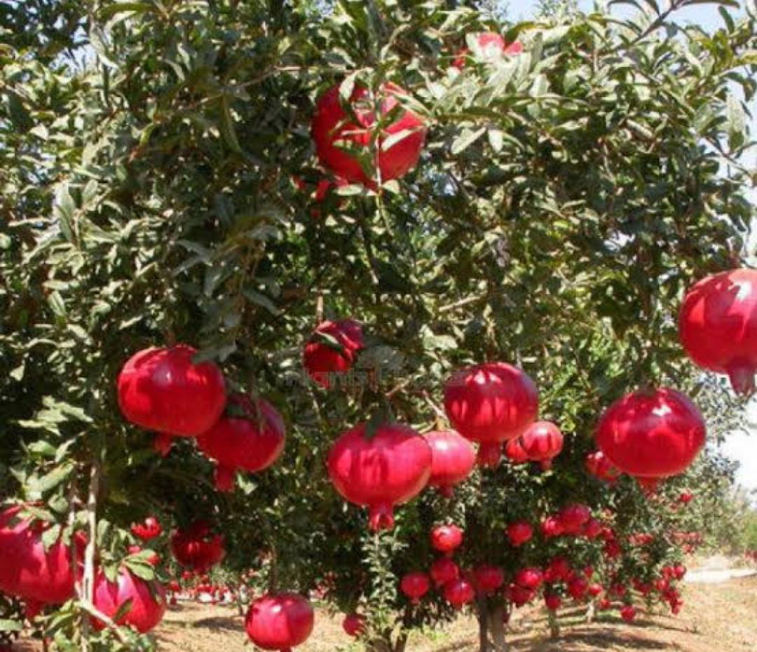

MORPHOLOGY :
The pomegranate plant is a large shrub or small tree that has smooth, evergreen leaves and showy orange to red flowers. It has rounded fruit with a dry outer covering (husk) made up of two layers: (1) a hard-outer layer called an epicarp, (2) a soft inner layer called a mesocarp.The pomegranate tree has smooth, evergreen leaves that are narrow and oblong, and are usually 3–7 cm long and 2 cm broad. The pomegranate tree has bright red flowers that are 3 cm in diameter and have three to seven petals. The flowers are orange-red in color and have pointed sepals and many stamens. The pomegranate fruit is a rounded, hexagonal-shaped fruit that is 6–12 cm wide and weighs around 200 g.

PLANTS PART USED :
flowers, peels, and bark

CHEMICAL CONSTITUENTS :
The chemical composition of the fruits differs depending on the cultivar, growing region, maturity, cultivation practice, climate, and storage circumstances .About 50% of the total fruit weight corresponds to the peel, which is an important source of bioactive compounds such as phenolics, flavonoids, ellagitannins, and proanthocyanidin compounds, minerals, mainly potassium, nitrogen, calcium, phosphorus, magnesium, and sodium, and complex polysaccharides. The edible part of the pomegranate fruit (50%) consists of 40% arils and 10% seeds. Arils contain 85% water, 10% total sugars, mainly fructose and glucose, and 1.5% pectin, organic acid, such as ascorbic acid, citric acid, and malic acid, and bioactive compounds such as phenolics and flavonoids, principally anthocyanins .The seed cover of the fruit contains delphinidin-3-glucoside, cyanidin-3-glucoside, delphinidin-3,5-diglucoside, cyanidin-3,5-diglucoside, pelargonidin-3,5-diglucoside, and pelargonidin-3-glucoside with delphinidin-3,5-diglucoside being the main anthocyanin in pomegranate juice .12–20% of total seed weight of pomegranate comprises seed oil and is self-possessed with more than 70% of the conjugated linolenic acids. The fatty acid component of pomegranate seed oil comprises over 95% of the oil, of which 99% is triacylglycerols. Minor components of the oil include sterols, steroids, and a key component of mammalian myelin sheaths, cerebroside .Interestingly, punicic acid, which is a conjugated isomer unique to pomegranate oil, constitutes 70–76% of the seed oil .Phenolic compounds, together with flavonoids, anthocyanins, and tannins, are the main group of antioxidant phytochemicals that are important due to their biological and free radical scavenging activities .Phenolic acids, flavonoids, and tannins are present in different parts of pomegranate fruit and this may be one of the reasons why many of the studies demonstrated that combinations of pomegranate extracts from different parts of the fruit were more effective than a single extract .In a comparative analysis, anthocyanins from pomegranate fruit were found to possess higher antioxidant activity than vitamin-E (α-tocopherol), β-carotene, and ascorbic acid .

USES:

- Pomegranates contain anti-cancer phytonutrients, which are similar to those found in broccoli.
- Pomegranates can help with digestive health.
- Pomegranates contain fiber, which can help slow the absorption of sugar into the bloodstream.
- P. granatum has shown to reduce the gingival bleeding and decreases the risk of periodontal disease progression.[36]

Herbal Drug Used In Mouth Ulcer

Sr No. | Common  Name | Scientific  Name | Family | Chemical Constituents | Additional Uses | Reference
1 | Guava  leaves, Am-rood | Psidium gua-java | Myrtaceae | Flavonoids  (quercetin and it’s  glycosides), tannins | Antimalarial,  anthelmintic,  antiulcer, anti-spasmodic, anal-gesicproperties | [32]
2 | Indian  cherry  leaves,  Lasoda,  Tenti | Cordia di-chotoma | Boraginaceae | Alkaloids, flavonoids, amino acids | Used for head-aches and ulcers including decoc-tion for sore throat | [37]
3 | Liquorice,  Muleth | Glycyrrhia  g  labra L., | Leguminoseae | Saponin, flavonoid, liquirtin, isoliquer-tin liquiritigenin and rhamno-liquirilin | Anti-inflammatory  and expectorant, controls coughing and has hormonal effects. | [38]
4 | Turmeric  Haldi | Curcuma  longa | Zingiberaceae | Diarylheptanoids,curcumin, dimeth-oxy curcumin, and bisdemethoxycur-cumin | Anti-inflammator, antiulcer and anti-arthritic activity | [34]
5 | Pomegran-ate  flowers | Punica m L. | Punicacea | Polyphenols, gallic acid, ellagic acid and ethyl bre-vifolincarboxy-late, triterpenesoleanolicacid | Peptic ulcers, oral  and anal ulcers, intra-nasal ulcers, antioxidative, an-timicrobial, anti-inflammatory,  analgesic and  wound healing  properties. | [36]
6 | Betel leaves, Paan | Piper betle L. | Piperaceae | Alkaloids, carbohy- drate, amino acids,  tannins and steroids | Anti-ulcer, Anti- bacterial, Anti-fungal, Antioxi-dant, Anti-inflammatory ac-tivities, | [39]
7 | Aloe vera | Aloe bar-badensis  Miller | Liliaceae | Amino acids, an-thraquinones, en-zymes, minerals,  vitamins, lignins,  monosaccharides,  polysaccharides,  salicylic acid, sapon-ins, and sterols are among the many substances found in plants. | Properties that are anti-inflammatory, anti-oxidant, anti-cancer, healing, anti-ulcer, and anti-diabetic | [33]
8 | Capsicum | Capsicum  annuum L. | Solanaceae | Capsaicin, paprika  oleoresin, and dihy-  drocapsaicin | GI issues include  gas in the stom-ach, cramps,  stomach pain,  diarrhoea, and  mouth ulcers,  among others. | [40]
9 | Noni Fruit,  Indian  Mul-berry, Nuna | Morindacitri-folia Linn. | Rubiaceae | Anthraquinones,  flavonoids and phe-  nolics | Abnormal men-  struation, acne/  boils, constipation,  diarrhoea, arthritis, diabetes, fever,  high blood pressure, gastric and  other ulcers, arthritis,diabetes,fever, high blood pressure, gastric and other ulcers. | [40]

CONCLUSION
Aphtha, or mouth ulcers, are painful sores inside the mouth that affect eating, drinking, and speaking. They can be caused by stress, trauma, poor dental hygiene, and nutrient deficiencies. There are three types: minor, major, and herpetiform ulcers. Symptoms include pain and difficulty with certain foods. Herbal remedies, like guava and aloe vera, may help in healing.

REFERENCE :

- Vorvick, L. J. (2012). Mouth ulcers on MedlinePlus. ADAM Inc.
- Yogesh S. Thorat, Asha M. Sarvagod, Shital V. Kulkarni, Avinash H. Hosmani. Treatment of Mouth ulcer by Curmcumin loaded Thermoreversible Mucoadhesive gel. International Journal of Pharmacy and Pharmaceutical sciences.2015;7(10):399-402.
- Divyesh yogi, Ghanshyam patel, Bhavin Bhimani, Sunita Chaudhary, Upendra Patel . Formulation and Evaluation of Gel containing Amlexanox for Mouth Ulcer. International Journal of Pharmaceutical Research and Bio-Science. 2015;4(2):356-364.
- B b b. Rina G. Maskare, Shital D. Thakre, Om D. Patle, Shirali S. Vishwakarma, Dhyanesh N. Dahake, Rima J. Jagnit, Rohit S. Rahangdale. Novel Formulation for Treatment of Mouth Ulcer. Asian Journal of Pharmacy and Technology.
- B. Niyaz Basha, Kalyani Prakasam, Divakar Goli .Formulation and evaluation of Gel containing Fluconazole- Antifungal Agent. International Journal of Drug
Development & Research .2011;3(4):109-128.
- Mohsin J. Jamadar, Rajmahammad Husen Shaikh . Preparation and evaluation of herbal gel formulation . Journal of Pharmaceutical Research and Education.2017;1(2):201-224.
- Porter SR, Leao JC. Oral ulcers and its relevance to systemic disorders. Alimentary pharmacology & therapeutics. 2005 Feb;21(4):295-306
- Vimala G, Gricilda Shoba F. A review on antiulcer activity of few Indian medicinal plants.
International journal of microbiology. 2014 May 25;2014.
- "Ulcer." Dictionary.com Unabridged (Online). n.d. Retrieved July 19, 2015, from https://www.dictionary.com/browse/ulcer.
- Strassburg, M., Knolle, G., & Loevy, H. T. (1994). Diseases of the oral mucosa: A color atlas. (No Title)
- Subiksha PS. Various remedies for recurrent aphthous ulcer-a review. Journal of Pharmaceutical Sciences and Research. 2014 Jun 1;6(6):251.
- Heidar Khademi, Pedram Iranmanesh, Alimoeini, Atefeh Tavangar . Evaluation of the Effectiveness of the Iralvex gel on the Recurrent Aphthous Stomatitis Managemant. International Scholarly Research Notices.2014:1-5.
- Sumitra Singh, Bhagwati Devi Rohilla Formulation and evaluation of herbal gel from different parts of Cyamposis Tetragonoloba (L) TAUB. For wound healing. World Journal of Pharmacy and Pharmaceutical Sciences.2015;5(3):740-752.
- Chun-Lei LI, He-Long Huang, Wan-Chun Wang, Hong Hua . Efficacy and safety of topical herbal medicine treatment on recurrent aphthous stomatitis .Dove press journal.2016;10:107-115.
- K. Purushotham. Rao , D. Vijaybhaskar , S. Pratima . Formulation of topical oral gel for the treatment of oral sub mucous fibrosis . Scholars Research library.2011;3(1):103-112.
- R. Rezvaninejad , N. Navabi , MR. Khoshroo , N. Torabi , Z. Atai. Herbal Medicine in Treatment of Recurrent Aphthous Stomatitis . Journal of Islamic Dental Association of IRAN.2017;29(3):127-134.
- Vaishnavi Burley, D., Biyani, D., Umekar, M. and Naidu, N., 2021. Medicinal plants for treatment of ulcer: A review. Journal of Medicinal Plants, 9(4), pp.51-59.
- Aslani, A., Zolfaghari, B. and Davoodvandi, F., 2016. Design, formulation and evaluation of an oral gel from Punica granatum flower extract for the treatment of recurrent aphthous stomatitis. Advanced Pharmaceutical Bulletin, 6(3), p.391.
- Scully C, Porter S. Oral mucosal disease: recurrent aphthous stomatitis. British Journal of Oral and Maxillofacial Surgery. 2008 Apr 1;46(3):198-206.
- Natah SS, Konttinen YT, Enattah NS, Ashammakhi N, Sharkey KA, Häyrinen-Immonen R. Recurrent aphthous ulcers today: a review of the growing knowledge. International journal of oral and maxillofacial surgery. 2004 Apr 1;33(3):221-34.
- Scully, C., Gorsky, M. and Lozada-Nur, F., 2003. The diagnosis and management of recurrent aphthous stomatitis: a consensus approach. The Journal of the American Dental Association, 134(2), pp.200-207.
- Kumar, A., Ananthakrishnan, V. and Goturu, J., 2014. Etiology and pathophysiology of recurrent aphthous stomatitis: A review. International Journal of Current Research and Review, 6(10), p.16.
- Swain, N., Pathak, J., Poonja, L.S. and Penkar, Y., 2012. Etiological factors of recurrent aphthous stomatitis: A common perplexity. J Contemp Dent, 2(3), pp.96-100.
- Subiksha, P.S., 2014. Various remedies for recurrent aphthous ulcer-a review. Journal of Pharmaceutical Sciences and Research, 6(6), p.251.
- Vaishnavi Burley, Dr. Dinesh Biyani, Dr. Milind Umekar and Nikita Naidu , Medicinal plants for treatment of ulcer: A review DOI: ttps://doi.org/10.22271/plants.2021.v9.i4a.1312
- Vaibhav Maheshwari (86823), Rakesh Patel (87723), RhutujaPotekar (87823), Gourab Pandey (810723), FORMULATION AND EVALUATION OF HERBAL LOZENGESFOR MOUTH ULCERS.
- Tyler, V.E., 1999. Phytomedicines: back to the future. Journal of Natural Products, 62(11), pp.1589-1592.
- Pal SK, Shukla Y. Herbal medicine: current status and the future. Asian pacific journal of cancer prevention. 2003 Aug 20;4(4):281-8.
- Grover JK, Adiga G, Vats V, Rathi SS. Extracts of Benincasa hispida prevent development of experimental ulcers. Journal of ethnopharmacology. 2001 Dec 1;78(2-3):159-64.
- Chun-Lei Li, He-Long Huang,Wan-Chun Wang,Hong Hua, Efficacy and safety of topical herbal medicine treatment on recurrent aphthous stomatitis:Drug Design, Developement and Therapy.2016;10:107-115.
- Shaikh, S., Shete, A. and Doijad, R., 2018. Formulation and evaluation pharmaceutical aqueous gel of powdered guava leaves for mouth ulcer treatment. PharmaTutor, 6(4), pp.32-38
- Kalyani P. Thombre, Devender Sharma, Ameya M. Lanjewar. Formulation and Evaluation Pharmaceutical Aqueous Gel of Powdered Cordia Dichotoma Leaves With Guava Leaves. American Journal of Pharmatech Research.2018;8(2):268-277.
- Amar Surjushe, Resham Vasani, D G Saple. Aloe vera a short review. Indian journal of Dermatology.2008;53(4):163-166.
- Aravind. G, Debjit Bhowmik , Duraivel. S, Harish. G. Traditional and medicinal uses of Carica papaya. Journal of medicinal plants studies.2013;1(1):7-15.
- Shaikh, S., Shete, A. and Doijad, R., 2018. Formulation and evaluation pharmaceutical aqueous gel of powdered guava leaves for mouth ulcer treatment. PharmaTutor, 6(4), pp.32-38.
- Jadhav TS. Formulation and evaluation pharmaceutical aqueous gel of powdered guava, Aloe vera and acacia leaves for treatment of Mouth ulcer. International Journal of Science
And Research (IJSR). 2018;8(5):1693-1697.
37) Thete M, Shimpi P. Review on Role of Herbs in Management of Oral diseases. Asian Journal of Pharmaceutical Research. 2020 Dec 1;10(4).
38) Bandana K, Kumar S, Sagar MK, Tyagi H. Formulation and evaluation of herbal gel of Guava leaves and liquorice roots extract for using mouth ulcer. Journal of Critical Reviews. 2020;7(18):3097-110.
39) Jain NK, Roy R, Pathan HK, Sharma A, Ghosh S, Kumar S. Formulation and evaluation of Polyherbal aqueous gel from Psidium guajava, Piper betel and Glycerrhiza glabra extract for Mouth ulcer treatment. Research Journal of Pharmacognosy and Phytochemistry. 2020 Aug 3;12(3):145-148.
40)Mittal S, Nautiyal U. A review: herbal remedies Used for the treatment of mouth ulcer. International Journal of Health and Clinical Research. 2019 Jan 30;2(1):17-23.

