**Prospects for the Future of Artificial Intelligence in Clinical Trials**

**Sudhanshu Tripathi (Tripathirohit6828@gmail.com), Mr. Sujeet Pratap Singh (Singsujeet0068@gmail.com), Dr. Tarkeshwar Prasad Shukla (tk007.shukla@gmail.com)**

**Dr. A.P.J. Abdul Kalam Technical University, Lucknow, Uttar Pradesh, India**

**S.C.P.M. College of Pharmacy, Gonda, Uttar Pradesh, India**

**Abstract**

Artificial intelligence (AI) encompasses a wide range of technologies, including Optical Character Recognition (OCR), Deep Learning (DL), Machine Learning (ML), and Natural Language Processing (NLP), and it will affect the health and clinical research industries. Traditional clinical trials have had a lot of difficulties- inefficient, costly, and low success rates- and these criteria are likely to increase as AI applications get into the whole process. Both AI and big data analytics can be used to apply significant improvements in design, patient recruitment, site selection, monitoring, and regulatory submissions, as well as real-time monitoring through wearable technologies. Some of the important contributions of AI include developing stratification of patients, integration of data, and predictive enrichment for improving patient outcomes while decreasing complexity, cost, and duration. The potential of AI in trial protocol development and endpoint detection is also evolving with Bayes and NLP tools. This is much faster now than before due to automated reporting for regulatory submissions, and this gives much more compressed time lines. Modern clinical trials will be built much on such dynamics of adoption of AI by organizations clinical research organizations (CROs) and pharmaceutical companies. It will take shape under virtual trials combined with personal health for making things much more efficient and accessible to patients. It will, however, need strong pharmacology blend with machine learning expertise and access to very rich, clean datasets in healthcare to realize its full potential. With over $5.2 billion in investment in AI-enabled clinical trials, unprecedented innovation and efficiency can be expected in the future.

Keywords: Sustainability, Obstacles, Enrolment, Complexity, Artificial Intelligence

**Introduction**

The technical and scientific field of artificial intelligence (AI) aims to create intelligent machines. Optical Character Recognition (OCR), Deep Learning (DL), Machine Learning (ML), and Natural Language Processing (NLP) are examples of AI techniques [1]. It's among the newest cutting-edge technologies that change clinical studies. AI development in the healthcare industry has a solid technical foundation because of the rapid advancement of information technology and the vast amount of biomedical data that has been gathered. In addition to lowering the complexity and danger of clinical trials, researchers are investigating AI applications to improve the quality of medical diagnoses and services [2]. The success rate of traditional clinical research is only 10%, and it takes a lot of time. AI is currently being applied in a number of clinical trial process sectors. AI enables researchers to perform clinical research, utilising real-world data analysis to enhance patient classification and forecast outcomes [3]. AI has the potential to improve clinical trial stages while reducing the strain and expense of clinical development. In order to further clinical research, numerous sizable clinical research organisations are now starting to invest in AI [4]. To help choose lead compounds that would have a better chance of succeeding throughout clinical development, AI could make the process of looking for correlations between indications and biomarkers more efficient. It offers the chance to change crucial stages of clinical trial management, including study strategy, design, and execution. While lessening the burden and cost of clinical development, AI has the ability to enhance the stages of clinical trials. Many large clinical research institutions are already beginning to invest in AI to advance clinical research [4]. AI might speed up the process of searching for correlations between indications and biomarkers to assist choose lead compounds that would have a higher chance of surviving clinical development. It provides the opportunity to alter key phases of clinical trial administration, such as study design, strategy, and implementation.

1. **Artificial Intelligence**

By mimicking human intelligence in machines, artificial intelligence (AI) is transforming a number of industries. Applications like virtual assistants, picture identification, natural language processing, and predictive analytics are made possible by AI systems' ability to learn, reason, and self-correct. AI improves decision-making, efficiency, and accuracy in the fields of education, healthcare, finance, and transportation. Robots with AI capabilities manage manufacturing processes and carry out intricate procedures. Virtual assistants such as Google Assistant, Alexa, and Siri make life easier. Chat bots powered by AI offer round-the-clock client service. AI has the ability to completely change the way we connect, work, and live. Unmatched creativity, productivity, and progression are anticipated from its upcoming developments.

1. **AI's Development in Clinical Trials**

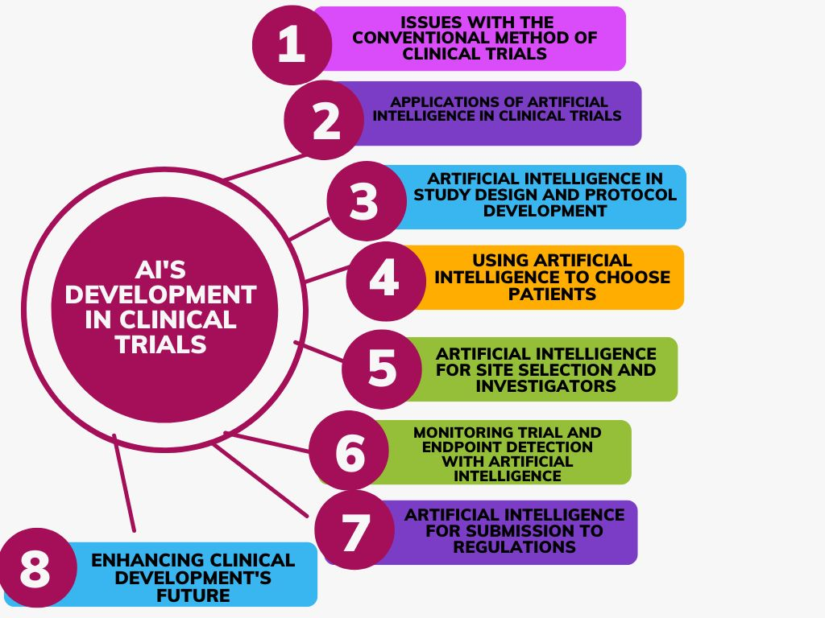

AI was first defined in 1955 and refers to the science and technology of developing intelligent computer systems [6]. AI is rapidly proving to be a complete answer to a variety of problems in healthcare administration. By 2030, the size of the global market for AI-based clinical trial solutions for patient matching is anticipated to reach USD 1,969 million. Clinical research and development, the second fastest-growing field, is expected to grow at a compound annual growth rate (CAGR) of 22.0% between 2023 and 2030 [7].

As new opportunities arise, the development of these tools will continue to enrich the clinical research landscape. Eight sciences, including DL, NLP, ML, Cognitive science, Robotic automation, automated reasoning, Computational Statistics, and Neural Net, represent a comprehensive collection of artificial intelligence. Numerous connections that build upon each other allow AI to advance into a more sophisticated future state [8].

* 1. **Issues with the Conventional Method of Clinical Trials**

The medication development process takes an average of 10 to 15 years, of which 5 to 6 years are required for research and development (R&D) and an additional 5 to 7 years are required for clinical trials. To bring a single new medicine to market, billions of dollars (about USD 1.5–2 billion) are spent on clinical trials [9]. Phase III trials are the most difficult and costly, and clinical trials account for around half of all expenses. One of the main challenges in the process of creating new medications is the high failure rate of clinical trials. Approximately one-third of Phase II compounds go to Phase III. The regulatory agency never approves more than one-third of Phase III compounds. Because the odds of a product passing each stage of clinical trials are different, only one out of ten compounds that start clinical trials make it to FDA approval. A substantial portion of the total R&D cost is lost with each failed trial, with losses ranging from US$0.8 to US$1.4 billion [10]. Only 10% of these large-scale clinical trials are effective, which is ironic. The most recent field of drug research to recognise and permit the positive effects of AI is clinical trials. Because it is difficult to mine different data sets for clinical trials and maintain data of every patient taking part in the trial method, artificial intelligence (AI) can help address all of these problems with the clinical trial process. By making major advancements in a number of R&D domains, including novel target identification, drug candidate selection, biometric data analysis from wearable devices, and the prediction of drug effects in disease patients, artificial intelligence (AI) holds promise for improving the chances of drug development success [9].

* 1. **Applications of Artificial intelligence in clinical trials**

The execution and conduct of clinical trials include clinical trial design, patient recruitment and selection, site selection, monitoring, data collection, and analysis. Of these, patient recruitment and selection is the most challenging; consequently, 30% of phase-III trials are terminated early, and 80% of studies complete the enrolment deadline. Additionally, the trial monitoring process for a multi-centered global study is an extremely expensive and time-consuming process. The time it takes from the "last subject last visit" to data submission to regulatory bodies, which entails extensive data collection and analysis procedures, is another challenge in clinical trials. AI and digitisation have led to these challenges in clinical trials [11]. The application of AI-based software in three primary domains—information engines, patient stratification, and trail operation—is the emphasis of this field's researchers. The application of artificial intelligence in clinical trials has a lot of promise and possibility. It is used by businesses worldwide due to its effectiveness, cost savings, and safety benefits (fewer mistakes). But technology also makes it possible for research to progress more quickly than ever before [12].

* 1. **Artificial Intelligence in Study Design and Protocol Development**

Every clinical trial begins with the creation of a clinical protocol. AI has the potential to enhance this process by collecting important data from each protocol, supplying essential metadata, and producing a standardised protocol document. Machine learning is becoming more important as pharmaceutical molecules approach human testing. Clinical trials can be made more efficient by developing AI-driven trial methods [13]. In order to identify potential barriers that can prohibit an experiment from being properly executed, researchers can upload protocols to additionally use NLP for protocol building. The cost, efficacy, and likelihood of success of clinical trials are all negatively impacted by inadequate research design. According to the FDA, AI models contribute to improving trial design standards. In addition to its many other applications, Bayesian nonparametric models (BNMs) have emerged as a powerful instrument for clinical trial design. This approach cuts down on the time needed for clustering and trial design. Two often utilised BNMs are Dirichlet process mixture models and Markov Chain Monte Carlo (MCMC) methods. These BNMs have uses in clinical trial design, including as dose selection in cancer patient studies, immuno-oncology, and cell treatment [14]. A more thorough study design can lead to shorter protocol development cycles, fewer protocol adjustments, and more efficient trials [15].

* 1. **Using Artificial Intelligence to Choose Patients**

AI can help with better patient selection by reducing population heterogeneity, prognostic enrichment, and predictive. There are various steps involved in selecting a patient for a clinical trial. Collecting the patient's data, past medical history, or new test results would be very costly and time-consuming. Linking patient data from the EMR with other patient data that is scattered across multiple locations, owners, and formats is made possible by AI. Such analysis using computer vision techniques such as OCR and NLP can give an efficient way to identify patients [5]. The FDA's published guideline outlines three ways that the clinical sector might implement to improve patient selection and optimise a drug's efficacy: reduced population heterogeneity, prognostic enrichment, and predictive enrichment. AI technology has the potential to enhance all of these tactics.

* 1. **Artificial Intelligence for Site Selection and Investigators**

One of the most important aspects of a trial is choosing good investigation sites. Administrative procedures, the availability of resources, and the presence of physicians with substantial experience and understanding of the condition are site attributes that can influence research durations as well as the quality and integrity of data [16]. AI technology can be used by clinical research organisations (CROs) to identify priority applicants, skilled investigators, and target sites. In order to demonstrate to authorities that the trial process conforms with GCP criteria, they might additionally collect and aggregate data [17].

* 1. **Monitoring Trial and Endpoint Detection with Artificial Intelligence**

AI can help a business keep tabs on a clinical trial by gathering and evaluating data in real-time. Wearable technology and AI techniques can work together to deliver effective, real-time, and customised patient monitoring that is automated and continuous throughout the trial. Recently, risk-based monitoring (RBM) has emerged as an effective, economical, and AI-enabled substitute for traditional monitoring. At the trial site, a more sophisticated version of RBM might be able to reduce expenses while improving the effectiveness and calibre of data monitoring [18]. AI-enabled medical image-based endpoint and disease identification is far quicker, easier, and less expensive than manual reading. According to recent findings, artificial intelligence (AI) has the potential to transform the conventional clinical trial procedure into one that is quicker, safer, and less expensive. This can increase the accuracy of endpoint assessments and procedure adherence [19].

* 1. **Artificial Intelligence for Submission to Regulations**

The regulatory application for a clinical trial involves a great deal of record-keeping. ML can automate this with the use of templates. By analysing the study protocol and the study analysis report, clinical study report (CSR) automation can use machine learning (ML) to automatically generate the CSR [20, 21]. The language of the CSR and the narratives can be changed using NLP approaches. The medical writer can then review these and make the required changes to produce the final CSR. It could be possible to finish all of this in two or three days. This method significantly speeds up the regulatory submission process while also enhancing the quality of the submission [22]. In the future, patient-centered decisions will be made by all stakeholders involved in clinical trial processes. The patient will receive information from sponsors about the trial, the process, and the participants [23]. Clinical trials can be revolutionised with greater success in attracting, engaging, and maintaining passionate participants throughout every stage of the study until its conclusion by utilising AI-enabled digital health technology and patient care systems.

* 1. **Enhancing Clinical Development's Future**

Future AI will be integrated with improved advances in computer simulation and personalised healthcare to set up clinical studies [24]. Virtual trials minimise the expenses, delays, and challenges that patients encounter by using the potential of contemporary digital technologies. Virtual trials could support up to 50% of all research, improving patient retention and speeding up clinical progress. Artificial Intelligence will save human time, money, and effort. Now, big pharmaceutical corporations are beginning to make AI investments. However, the usage of artificial intelligence in the research topics stated above still has room to grow. AI-powered investigations are conducted more rapidly, securely, and economically [25].

**3. Expertise, Technology, and Talent**

In the quickly changing world of clinical research, sponsors need the most recent data to make the best decisions that will increase predictability, shorten time to market, and boost productivity. By using these methods in clinical research, researchers may illustrate and improve the application of AI-derived insights in many areas of development [26]. Pharma firms require partners who can supply the following data in order to realise the full potential of AI in clinical development:

3.1. A THOROUGH UNDERSTANDING OF PHARMACOLOGY AND DOMAIN EXPERTISE

This expertise should include a thorough understanding of healthcare data for intelligent analysis, as well as awareness of international rules, financial expectations, patient and physician behaviour, and therapeutic abilities.  
  
3.2. THE CURRENT STATE OF SCIENCE AND TECHNOLOGY

To create high-quality models, the solution should be able to integrate discipline using the GXP Software Development Life Cycle (SDLC) approach with many datasets. It should also be able to identify regional and global patterns as well as provide in-depth insights at the physician and patient levels.   
  
3.3. EXPERTS IN MACHINE LEARNING AND DATA ANALYTICS

The vendor's team should include technical experts who can create machine learning algorithms pertinent to the clinical development process.

3.4. AVAILABILITY OF EXTENSIVE HEALTHCARE DATASETS

Machine learning algorithms are only as good as the data they have access to. The best systems will give users access to a wide range of global healthcare databases, such as prescription data, EMRs, drug sales data, patient and illness trend data, and data from electronic medical records.

3.5. THE POSSIBLE INTEGRATION OF THESE DIFFERENT DATASETS

Many healthcare datasets are difficult to analyse because of their inconsistencies. To enable the algorithms to generate more accurate findings, a perfect partner will put techniques in place to "clean" the data.

1. **The Novel Environment in Clinical Experiments**

The emergence of AI and new technologies is causing a significant transformation in the clinical trial ecosystem. For these new AI-software entrants, CROs can be seen as both an ally and a rival in some situations, particularly for larger firms that can already carry out the trial through their network of clinical partner locations [27]. CROs continue to provide the expertise and connections needed to conduct a typical clinical study. Although most CROs are still hesitant to work with AI start-ups at this early stage, they are starting to notice some collaborations in which CROs use AI technology to set themselves apart from other startups. Additionally, this will make go-to-market tactics for startups easier. In order to maintain their position as a key participant in the clinical trials process, CROs will eventually seem to use AI-based technology. Partnerships and startup assistance will be used to accomplish this in the short term, while more integrated solutions will be used in the long run [3]. A total of $5.2 billion has been invested in AI for clinical trials and medication research, and many collaborations between pharmaceutical corporations and AI start-ups have already been formed.

**Conclusion**

Clinical trials with artificial intelligence are a promising and developing area of study. AI has the potential to revolutionise future drug development and pave the way for a new paradigm of long-term, sustainable medical research. Every phase of a medicine's lifecycle is covered by the all-encompassing approach to incorporating AI into drug research and approval. AI has the ability to simplify the process, from target identification to drug clinical trials. Clinical trials for new compounds account for most of the time and resources invested in the drug development process, and artificial intelligence (AI) has been used to improve the quality of trial design, patient selection, dose selection, patient adherence, trial monitoring, and endpoint analysis. End users and regulatory bodies alike need AI technology to be ethical, repeatable, scalable, and understandable. In this regard, clinical research will be able to explore a variety of opportunities thanks to AI-enabled approaches, which could fundamentally change the course of future studies. It will take another five to eight years to fully appreciate the advantages of AI tools in the healthcare industry. The industry need specific laws, clear evaluation procedures, and positive viewpoints towards clinical validations because the broad use of AI technology is still fraught with challenges.

**References:**

1. McCarthy J (2007) What Is Artificial Intelligence?Stanford University, pp: 15.

2. Wang A, Xiu X, Liu S, Qian Q, Wu S (2022) Characteristics of Artificial Intelligence Clinical Trials in the Field of Healthcare: A Cross-Sectional Study on Clinical Trials. Gov. International Journal of Environmental Research and Public Health 19(20): 13-69.

3. Kristensen U (2020) The many faces of AI in clinical trials. Hit Consulant.

4. Taylor K, Properzi F, Cruz MJ, Ronte H, Haughey J (2020) Intelligent clinical trials: transforming through AIenabled engagement. Deloitte Insights 21: 1-32.

5. Harrer S, Shah P, Antony B, Hu J (2019) Artificial intelligence for clinical trial design. Trends Pharmacol Sci 40(8): 577-591.

6. Bhattamisra SK, Banerjee P, Gupta P, Mayuren J, Patra S, et al. (2023) Artificial Intelligence in Pharmaceutical and Healthcare Research. Big Data and Cognitive Computing 7(1): 10.

7. Dorota-owczarek (2021) A comprehensive look at the use of AI for clinical trials. Disrupting clinical development with Artificial Intelligence. Nexcode.

8. Bohr A, Memarzadeh K (2020) The rise of artificial intelligence in healthcare applications. Artificial Intelligence in Healthcare, pp: 25-60.

9. Kolluri S, Lin J, Liu R, Zhang Y, Zhang W (2022) Machine Learning and Artificial Intelligence in Pharmaceutical Research and Development: A Review. AAPS J 24(1): 19.

10. Hay M, Thomas DW, Craighead JL, Economides C, Rosenthal J (2014) Clinical development success rates for investigational drugs. Nature biotechnology 32(1): 40-51.

11. Jiang F, Jiang Y, Zhi H, Dong Y, Li H, et al. (2017) Artificial intelligence in healthcare: past, present and future. Stroke Vasc. Neurol 2(4): 230-243.

12. Spreafico A, Hansen AR, R Abdul Razak A, Bedard PL, Siu LL (2021) The future of clinical trial design in oncology. Cancer discovery 11(4): 822-837.

13. Intelligent clinical trials transforming through AIenabled engagement. Deloitte Insights.

14. Li M, Liu R, Lin J, Bunn V, Zhao H (2020) Bayesian semiparametric design (BSD) for adaptive dose-finding with multiple strata. Journal of biopharmaceutical statistics 30(5): 806-820.

15. Liu R, Lin J, Li P (2020) Design considerations for phase I/II dose-finding clinical trials in Immuno-oncology and cell therapy. Contemporary clinical trials 96: 106083.

16. Calaprice-Whitty D, Galil K, Salloum W, Zariv A, Jimenez B (2020) Improving clinical trial participant pre-screening with artificial intelligence (AI): a comparison of the results of AI-assisted vs standard methods in 3 oncology trials. Therapeutic Innovation & Regulatory Science 54(1): 69-74.

17. Lee Y, Dinakarpandian D, Katakam N, Owens D (2010) MindTrial An intelligent system for clinical trials. InAMIA Annual Symposium Proceedings, American Medical Informatics Association 2010: 442-446.

18. Glass L, Shorter G, Patil R (2019) Improving safety, and accelerating results. Ai in Clinical Development.

19. Bhatt A (2021) Artificial intelligence in managing clinical trial design and conduct: Man, and machine still on the learning curve? Perspectives in Clinical Research 12(1): 1-3.

20. Yang KK, Wu Z, Arnold FH (2019) Machine-learningguided directed evolution for protein engineering. Nature methods 16: 687-694.

21. Evans SR (2010) Fundamentals of clinical trial design. Journal of experimental stroke & translational medicine 3(1): 19-27.

22. Narayanan H, Dingfelder F, Butté A, Lorenzen N, Sokolov M, et al. (2021) Machine learning for biologics: opportunities for protein engineering, developability, and formulation. Trends in pharmacological sciences 42(3): 151-165.

23. Shah P, Kendall F, Khozin S, Goosen R, Hu J, et al. (2019) Artificial intelligence and machine learning in clinical development: a translational perspective. NPJ digital medicine 2: 69.

24. Wang Z, Gao C, Glass LM, Sun J (2022) Artificial Intelligence for In Silico Clinical Trials: A Review. Quantitative Biology.

25. Soni N, Sharma EK, Singh N, Kapoor A (2019) Impact of artificial intelligence on businesses: from research, innovation, market deployment to future shifts in business models. Economics.

26. Weissler EH, Naumann T, Andersson T, Ranganath R, Elemento O, et al. (2021) The role of machine learning in clinical research: transforming the future of evidence generation. Trials 22(1): 1-5.

27. Haleem A, Javaid M, Khan IH (2019) Current status and applications of artificial intelligence (AI) in the medical field: An overview. Current Medicine Research and Practice 9(6): 231-237.