**EXPERIMENTAL STUDIES ON GEOPOLYMER CONCRETE BEAM**

**MADE WITH GGBS & FLY ASH**

**MUNIRAJ MP1, YASHAVANTH G M2, CHETHAN N GUJJAR3, MOHAMED NOUMAN HUSSAIN4, MOHAMED FAROOQ NS5, Pruthvi Rani K M6**

1 P G scholar, Department of Civil, SJM Institute of Technology, Chitradurga, Karnataka, India

2 BE, Department of Civil, SJM Institute of Technology, Chitradurga, Karnataka, India

3 BE, Department of Civil, SJM Institute of Technology, Chitradurga, Karnataka, India

4 BE, Department of Civil, SJM Institute of Technology, Chitradurga, Karnataka, India

5 BE, Department of Civil, SJM Institute of Technology, Chitradurga, Karnataka, India

6 Assistant Professor, Department of Civil, SJM Institute of Technology, Chitradurga, Karnataka

**ABSTRACT**

A 7% portion of the world's greenhouse gas emissions come from the cement mill. Concrete relies on cement, one of its fundamental ingredients. For a more environmentally friendly alternative to Portland cement concrete, this study looks into geopolymer concrete (GPC) made from GGBS and fly ash, two industrial byproducts. We will combine GPC with solutions of sodium hydroxide and sodium silicate, then test it for mechanical properties with different amounts of GGBS and fly ash. Experimental specimens were cast and left to cure at room temperature for 7,14,28,56, and 112 days to assess the mechanical properties of the material. The research shown that the compressive, split tensile, and flexural strengths of the final material are enhanced when GGBS is added to the mixture. Even if the compressive strength drops with increasing fly ash content, the GPC stays robust. Gepolymer concrete, made from fly ash and GGBS, has the potential to increase sustainable construction practices while decreasing emissions of greenhouse gases. According to the results, GPC is a better option than traditional concrete when it comes to environmental impact, which helps achieve global sustainability goals.

**Keywords:** Geopolymer concrete (GPC), Flyash, beam design, double point test.

1. **INTRODUCTION**

Concrete is among the most popular; it is generally referred to as a product of the combination of cement and water, with the of Portland cement being the most common. Despite this there is increased demand for concrete as a construction material on the other hand there has been increased cases of global warming due to climate change, which has become one of the greatest threats to the environment especially in the last decade. The global warming is the rise in temperature of the atmosphere due to the release of greenhouse gases like CO2 through various human activities. With regards to contribution towards global warming, CO2 accounts for approximately sixty-five percent of the total GHGs. It is estimated that the cement industry contributes to about 6% of emissions of CO2 because the production of one ton of Portland cement generates almost one ton of emissions of CO2; notwithstanding, the use of Portland cement in concrete remains inevitable until further notice adequate measures have been put in place in a bid to reduce the incorporation of Portland cement in concrete. These efforts include the use of supplementary cementing materials like fly ash, silica fume, granulated blast furnace slag, rice-husk ash and Metakaolin; discovery of new binders for concrete industry other than the portland cement.In as much as this is concerned, the geopolymer technology seems to hold a lot of potentials when used as an option to the portland cement in concrete industry. In terms of reducing the global warming, the geopolymer technology could reduce the CO2 emission to the atmosphere caused by cement and aggregates industries by about 80%Heat-cured low-calcium fly ash-based geopolymer concrete has excellent compressive strength, suffers very little drying shrinkage and low creep, excellent resistance to sulfate attack, and good acid resistance. It can be used in many infrastructure applications: Low calcium fly ash can be used to produce geopolymer concrete and one ton of it can be used to produce 2.5m3 of high quality geopolymer concrete and the price of chemicals required to make this concrete is cheaper than the price of one tonne of OPC. The material used in low calcium fly ash-based geopolymer concrete is fly ash, which is classified as waste material and as a result the cost of the low calcium fly ash-based geopolymer concrete is cheaper than that of the Portland cement concrete. Geopolymer concrete has special properties that can help in increasing the economic benefits as well. Also, one should mention that one ton of carbon dioxide can be reduced by Secondary materials used in concrete include coarse aggregate, fine aggregate and cement. Examine the mechanical properties of concrete when fly ash in concrete mix is completely replaced and identify their mechanical properties and look for the special mechanical properties using acid attack and bond strength on the conventional concrete and geopolymeric concrete Geopolymer can be prepared from waste materials or by products among them fly ash and slag are more potentiality on preparation of geopolymer. Some of the studies that have been done regarding the use of these source materials include: The study of making fire-resistant geopolymer using granulated blast furnace slag combined with metakaolinite was reported by Cheng and Chiu (2003). The alkaline liquids were potassium hydroxide and sodium silicate which were mixed in appropriate ratio.

1. **LITERATURE REVIEW**

The exploration of geopolymer concrete as an alternative to traditional Portland cement-based concrete has gained momentum due to its potential for sustainability, durability, and economic benefits. This literature review synthesizes findings from key studies focusing on the behavior of geopolymer concrete beams incorporating Ground Granulated Blast Furnace Slag (GGBS) and fly ash.

Rangan (2008) extensively investigated the mechanical properties of geopolymer concrete produced using low-calcium fly ash and GGBS. The study highlighted that geopolymer concrete exhibits superior compressive strength and lower creep and shrinkage compared to conventional concrete. Furthermore, the incorporation of GGBS improved early-age strength development, making it suitable for structural applications. The research emphasized that the alkaline activator ratio significantly influences strength and setting time.

Chindaprasirt et al. (2011) examined the structural behavior of geopolymer concrete beams reinforced with steel bars. The inclusion of GGBS enhanced the bond strength between the reinforcement and the geopolymer matrix. Additionally, the study revealed improved flexural performance, attributed to the enhanced stiffness and reduced brittleness provided by the geopolymer binder.

Wallah and Rangan (2006) assessed the durability of geopolymer concrete beams under sulfate and acid attack. The results demonstrated that beams incorporating fly ash and GGBS resisted chemical degradation significantly better than Portland cement concrete beams. This resistance was due to the dense microstructure and reduced calcium content in the geopolymer matrix, which limited the formation of expansive compounds.

Cheng and Chiu (2003) conducted experiments on fire-resistant geopolymer concrete made from GGBS and metakaolin. Their findings indicated that geopolymer concrete maintained its structural integrity and strength under high-temperature conditions. This property is critical for applications in fire-prone environments, making it an attractive option for infrastructure projects requiring enhanced thermal performance.

Palomo et al. (1999) explored the economic and environmental benefits of using fly ash and GGBS in geopolymer concrete. The study concluded that geopolymer concrete not only reduces CO₂ emissions by 80% compared to Portland cement but also utilizes industrial waste, thereby addressing waste management challenges. The reduced dependence on Portland cement also lowers material costs, enhancing the overall feasibility of geopolymer concrete for large-scale construction.

Portland cement concrete, used by modern civil engineers, lasts 100-150 years. However, ancient Egyptians were skilled at building massive concrete blocks that could survive generations. Giza pyramids used GPC, and the GP Institute built five 10-ton pyramid-shaped blocks in 2002. GPC is a more environmentally friendly material than Portland cement due to its lower energy consumption and carbon dioxide emissions. GPs are durable, safe, and easy to make from cheap materials, making them suitable for heat and fire. They are also more heat- and fire-resistant than calcium-only cements. GPs are considered a replacement for organic polymers and inorganic cements due to their versatility, low cost, and long-term durability. India's cement industry uses coal, which generates 65% of its energy from thermal power plants. The yearly circulation rate of fine-grained slag (GGBS) is under 25%, but it is used in 15% of high-value items like concrete and building blocks, contributing to waste issues. GGBS, an inexpensive filler, improves concrete workability, density, durability, and alkali-silica resistance in Portland cement mixes.

1. **MATERIALS AND METHODOLOGY**

Specimens are prepared by concentrate by using the following material are stated below,

**3.1 Materials employed**

Materials employed to prepare the concrete are discussed in this sub-section.

**3.1.1 Ground Granulated Blast Furnace Slag**

Crushed Granulated Slag from a Blast Furnace. Ironmaking waste. Figure 3.2 shows the melting process of iron ore and scrap iron using coke fuel and fluxing agents made of limestone or dolomite. Slag from a hot furnace quickly turns into a glassy sand-like substance when cooled in water. The process of making GGBS involves crushing granulated slag to a fineness of 400-600 m2/kg, which produces particles that are less than 45μm in size. By incorporating GGBS with GPC, the latter gains strength and durability. Pay attention to Table 1, which shows that the composition satisfies the requirements of IS: 12089-1987.

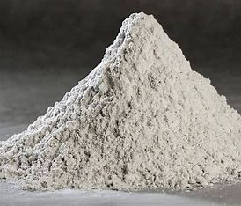

Figure Ground Granulated Blast Furnace Slag

• Specific gravity = 2.96

• Fineness (Sq.m/kg) is 405

• Loss on ignition is 1.9

Table Chemical composition of GGBS

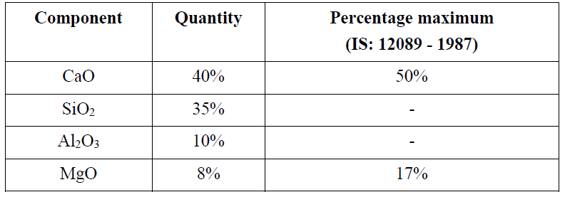

**3.1.2 Coarse aggregate (CA)**

This study investigated the production of hollow concrete blocks from sugarcane bagasse ash and silica fume using stone chips, testing them according to ASTM C136-06 standard.

Table : Physical properties of Coarse aggregate

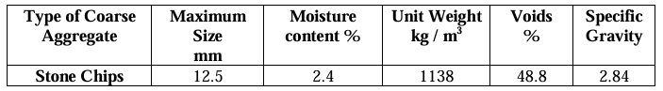

* + 1. **Fine aggregate**

Concrete beams' mechanical qualities are defined by the fine aggregate, which are known as coarse aggregates. Almost every concrete property, including strength, density, and longevity, is improved by using well-graded fine particles.

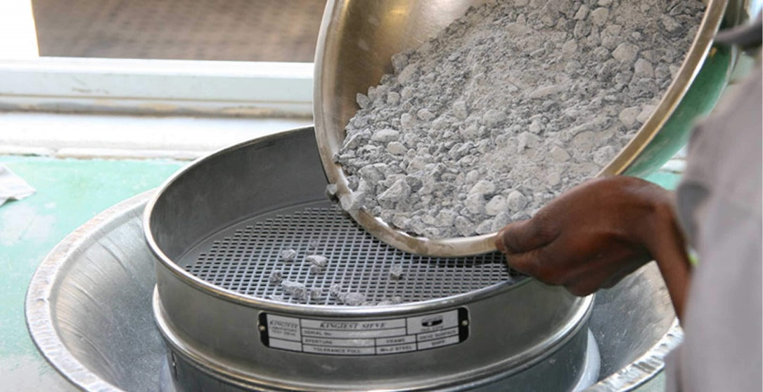

Figure Fine aggregate

Table : Fine aggregate properties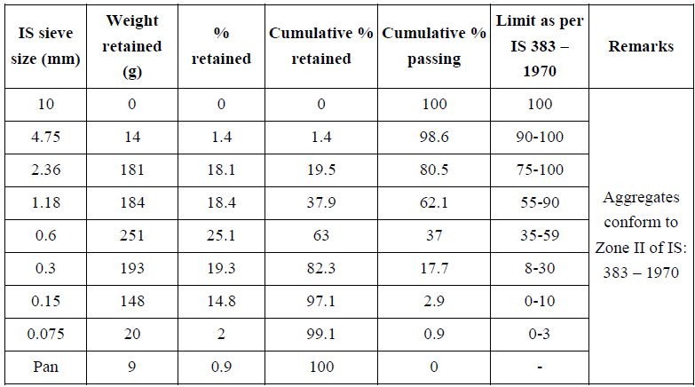

3. 1.4 **Flyash**

Thermal power plants produce fly ash from coal burning, which can be problematic for geopolymer concrete due to its complex chemical makeup. The majority of fly ash is composed of three oxides: SiO₂, AlₖOₜ, and Fe₂Oₜ. Its pozzolanic activity and function in geopolymerization are attributed to aluminum oxide. Hematite influences fly ash's color and density, while its lower levels of sulfur trioxide, magnesium oxide, calcium oxide, and alkali oxides affect its performance. The environmental impact of fly ash is undeniable, and understanding its chemical properties is crucial for effective use in geopolymer concrete. Chemical composition of flyash is provided in table 4

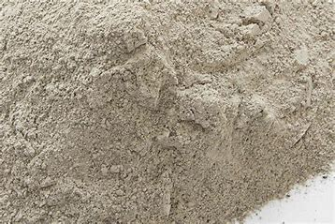

Figure Sample of Flyash

Table Chemical composition of flyash

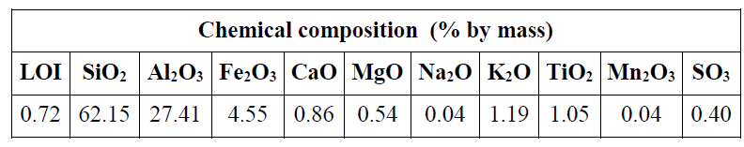

Table Sieve analysis of flyash

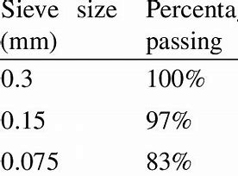

3.1.5 **Calcium**

Calcium is a crucial component in concrete, affecting its strength and durability. Ground-granulated blast furnace slag (GGBS) and fly ash variants, including calcium oxide, provide most of the calcium in concrete. Quick lime (CaO) is a fundamental element in concrete cementitious materials, with GGBS containing 30%-50% calcium. Calcium hydroxide, also known as Ca(OH)₂, maintains alkalinity for geopolymerization and increases concrete strength and durability when added to fly ash or other SCMs. Calcium carbonate, a small amount, can cause reactions in acidic environments. The exact type and percentage of calcium containing compounds can vary in concrete materials from different sources and raw materials.

Table Sieve analysis of calcium

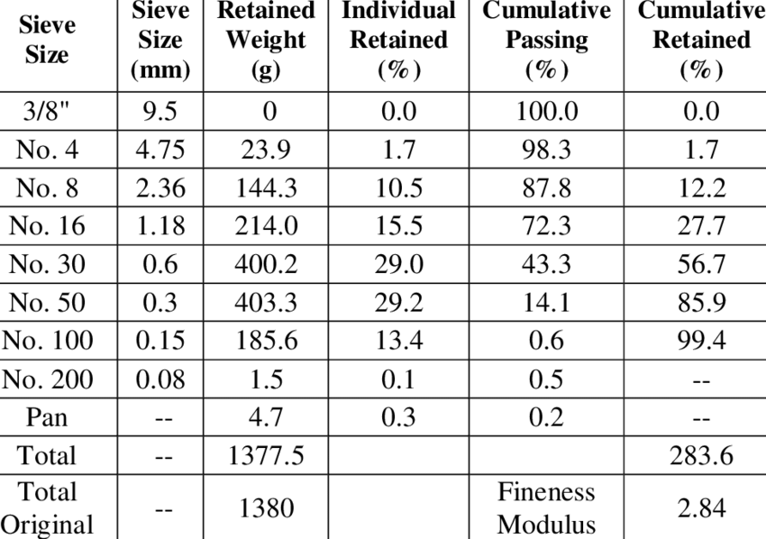

**3.1.6 Water**

Geopolymer concrete (GPC) replaces traditional hydration with polymerization, releasing water during the process, enhancing workability and consistency. To prevent contamination, potable water is used, sourced from Bangalore, meeting potable water standards, to ensure quality and performance of GPC, ensuring proper handling and placement.

* 1. **METHODOLOGY**

The M20 grade concrete mix design uses a 1:1 ratio, with a 5:3 proportion of constituent materials. The mix consists of cement, fine aggregate (sand), and coarse aggregate (gravel or crushed stone). After 28 days of curing, the cube compressive strength of this mix is 20 Mpa. It is commonly used for average strength elements like foundations of residential structures, floors, and pavements. The water-to-cement ratio, typically zero, affects the concrete's workability and strength. The water-to-cement ratio can vary depending on the context.

Procedure to prepare concrete

Measure Materials: Proper measuring tools are essential for portion measurements.

Mix Materials: Again, cement, sand, and coarse aggregate are mixed 1:1.5:3.

Add Water: Add the water cement ratio-calculated amount of water to get the required workability.

Mix well to achieve homogeneity and uniformity.

Location and Compact: M1: Transporting concrete into formworks, compacting it to minimise air pockets, and curing it.

Curing: The concrete may cure for a day or 28 days, depending on moisture, until it achieves the required strength.

Simple, volume-based mix ratios are excellent for minor building projects. If a project requires more concrete mix accuracy and stringency, gross mix design calculations should take into account material properties and environmental variables.

Design of beams and the calculations are given below

* Size of the beam is 150x200x1000 mm
* 2 bars of 12mm with the dia at top
* 2 bars of 12mm with the dia at bottom
* It has been made on the 200mm c/c
* Area of steel = (πd^2)/4 where d is 12 and area of steel is 113
* We are having 2 bars hence 113x2 = 226
* Percentage of steel = ptxbxd/100=100*226/150x161 =0.93%

Table : Calculation of mix design

|  |
| --- |
| **. Total Mass of Concrete** |
| * **Unit Weight of Concrete**: 2400 kg/m³ |
| **2. Aggregates** |
| * **Mass of Combined Aggregates**: 77% of total mass of concrete |
| * + 0.77×2400 kg/m3=1848 kg/m3 |
| **Breakdown of Aggregates:** |
| * **Coarse Aggregates (70%)**: |
| * + 0.60×1848 kg/m3=1109 kg/m3 |
| * + 20 mm: 0.60×1109 kg/m3=665 kg/m3 |
| * + 10 mm: 0.40×1109 kg/m3=444 kg/m3 |
| * **Fine Aggregate (30%)**: |
| * + 0.30×1848 kg/m3=554 kg/m3 |
| After adjusting for water absorption: |
| * 20 mm aggregates: 774 kg/m³ |
| * 10 mm aggregates: 516 kg/m³ |
| * Fine aggregate: 549 kg/m³ |
| **3. Geopolymer Binder and Alkaline Liquid** |
| * **Total Mass of Geopolymer Binder and Alkaline Liquid**: |
| * + 2400 kg/m3−1848 kg/m3=552 kg/m3 |
| * **Alkaline Liquid-to-Binder Ratio**: 0.35 |
| * + Mass of Geopolymer Binders (fly ash + GGBS): |
| * + - 5521+0.35=409 kg/m3 |
| * + Mass of Alkaline Liquid: |
| * + - 552−409=143 kg/m3 |
| **5. Water Content Calculation** |
| * **Water in Sodium Silicate Solution**: |
| * + 0.559×102=57 kg/m3 |
| * **Solids in Sodium Silicate Solution**: |
| * + 102−57=45 kg/m3 |
| * **Total Water Content**: |
| * + 57 kg+25 kg=82 kg |
| * **Total Geopolymer Solids**: |
| * + 409 kg (fly ash + GGBS)+45 kg (solids from Na₂SiO₃)+16 kg (solids from NaOH)=470 kg |
| **7. Water-to-Geopolymer Solids Ratio** |
| * 82/470=0.17 |
| **8. Additional Water for Workability** |
| * **Extra Water Added**: 5.5 liters |
| **Summary of GPC Mix Design:** |
| * **Total Mass of Concrete**: 2400 kg/m³ |
| * **Aggregates**: 1848 kg/m³ |
| * + Coarse Aggregates (20 mm): 774 kg/m³ |
| * + Coarse Aggregates (10 mm): 516 kg/m³ |
| * + Fine Aggregate: 549 kg/m³ |
| * **Geopolymer Binder (Fly Ash + GGBS)**: 409 kg/m³ |
| * **Water-to-Geopolymer Solids Ratio**: 0.17 |
| * **Additional Water for Workability**: 5.5 liters |

**3.2.1 Design of beam**

Beam size = 150x200x1000 and these dimensions are in mm

Volume of concrete is 0.15x0.2x1 = 0.03 m3

Mass of concrete = 0.03x2500 = 7.5 Kg

Percentage of steel = ptxbxd/100=100*226/150x161 =0.93%

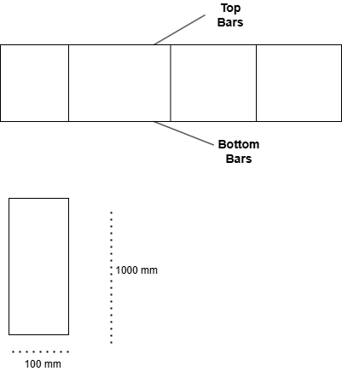

Figure : Design of beams

Finally the mixing propositions for final product are as follows,

Table : Final mix design

|  |
| --- |
| GGBS = 6Kg |
| FA = 22Kg |
| CA= 36 kg |
| Water = 5.5 litres |
| Water and cement ratio is 0.55 |

Table : Specimen on tension reinforcement

|  |  |  |
| --- | --- | --- |
| Grade of cement | Percentage of tension reinforcement= (Area of steels/width*depth)*100 | |
| M20 | (226/150*180)*100 = 0.838 % | |
| Description | | Dimensions in mm |
| Effective depth (d) | | Beam width = 150  Beam depth (D) = 200 m i.e. height |
| Area of steel reinforcement | | 113 |
| Number of bars = Area of steel / area of one bar | | 235/131.1 = 2.08 (round to 2 bars) |
| Shear force capacity | | 47.03 kN |
| Spacing of stirrups | | 50 mm |

1. **RESULTS AND DISCUSSION**

The study analyzes the experimental results of a geopolymer concrete mix, focusing on its workability, strength, and durability. The mix design aims to find the optimal combination of aggregates, binder, and alkaline solutions. The study considers factors like aggregate suitability, water-to-geopolymer solids ratio, and polymerization efficacy. The experimental findings will be compared to theoretical values to determine if the concrete meets geopolymer concrete standards. The mix's preparation process involves manufacturing sugarcane bagasse ash and ground granulated blast-furnace slag, ensuring a uniform mixture for concrete construction.

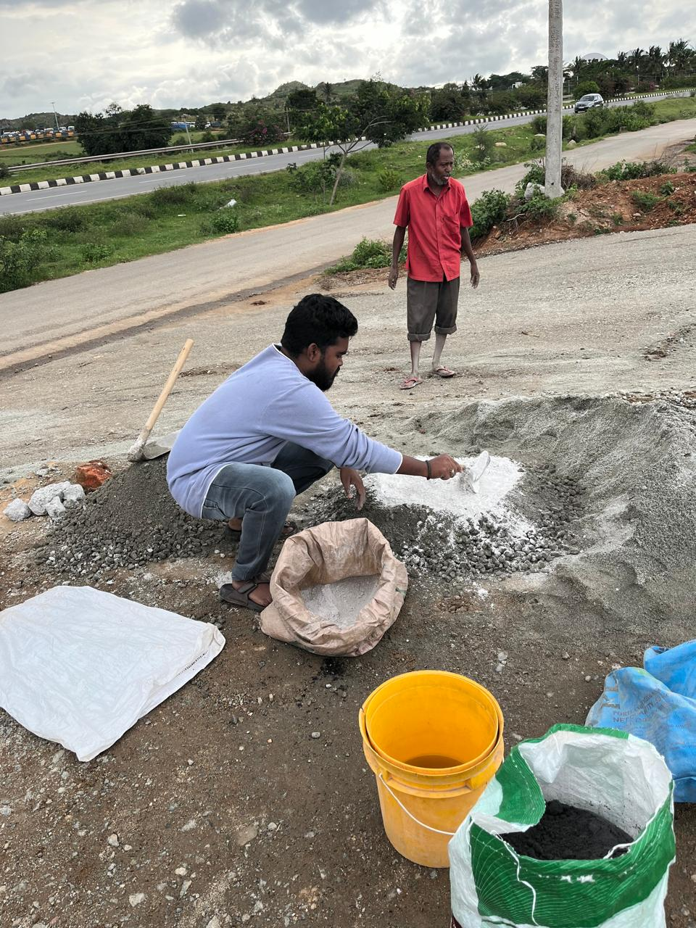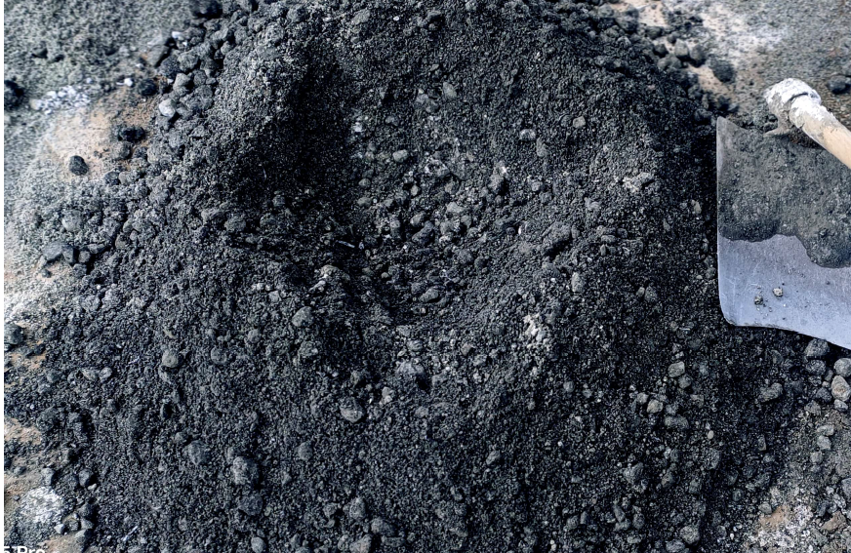

Figure : Mixing of materials

Designing beam structure using steel and it has been firmly held using binding wire, it as shown in below figure

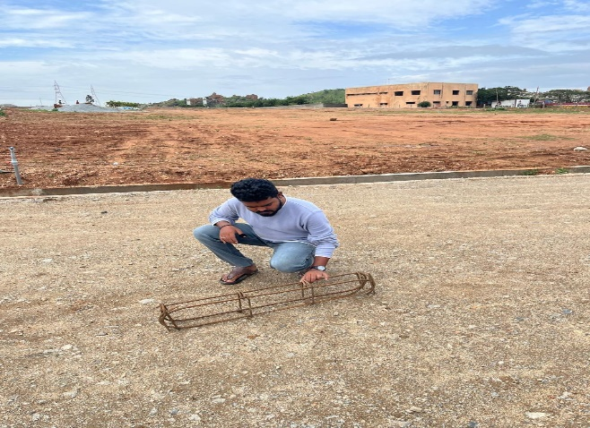

Figure beam design using steel and binding wire

Prepared material mixture is pored on the beam design showed in Fig.5

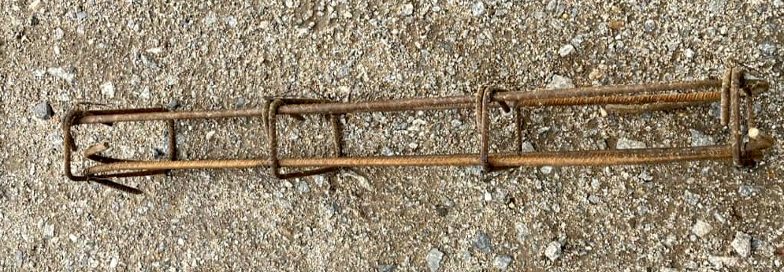

Figure : Designed beam

Filling concrete to designed beam from the steel, structure of steel is going to held concrete firmly and increases stability of it.

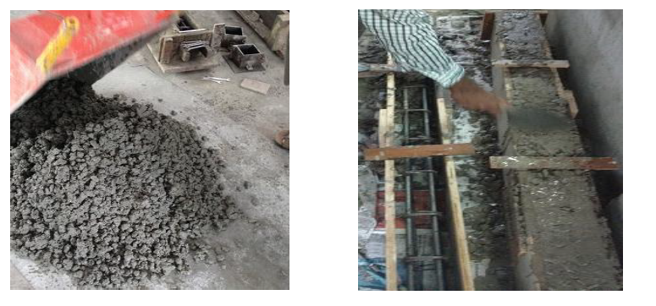

Figure Filling cement to steel structure

After concrete pored on the beam design end specimen is as shown in the below figure,

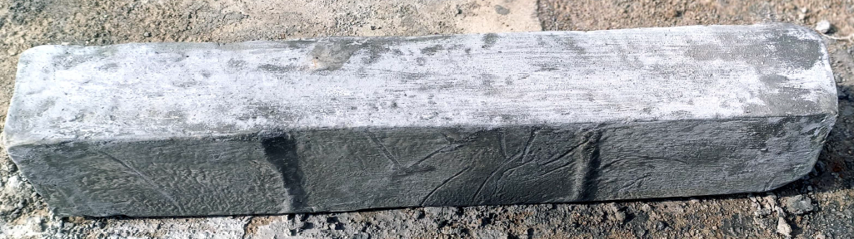

Figure : Prepared specimen

Curing is performed for 28 days on the prepared specimen for durability and setting of concrete. Is as shown in Fig.7.

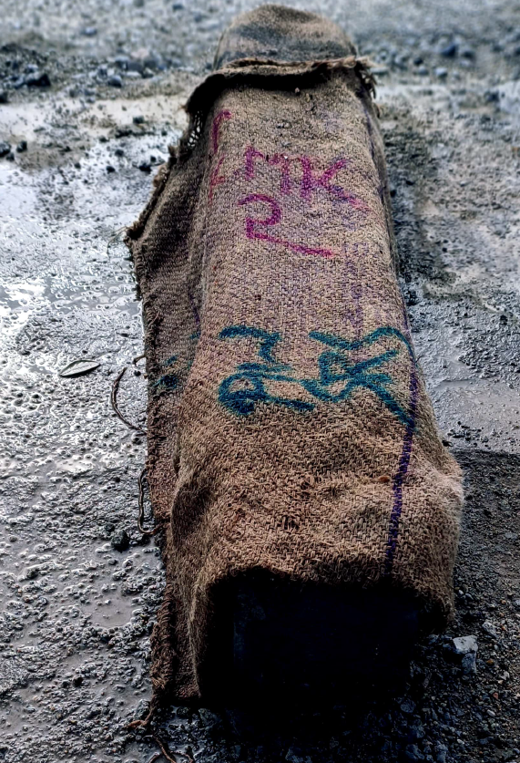

Figure : Curing to prepared specimen

Dimensions of the prepared specimen is as shown in Fig.8.

Table : Specimen dimensions

|  |  |
| --- | --- |
| Details of specimen | Dimensions (in mm) |
| length | 1000 |
| Width | 150 |
| Height | 200 |
| Type | BEAM |
| Type of test conducting | Double point load |

* 1. **Testing load using double point load**

Double point load testing is a method used to examine the behavior of concrete beams and girders under real-world loading conditions. This involves applying two focused loads at regular intervals throughout the beam's length, often in a symmetrical fashion around its centerline. The load is applied by a hydraulic or mechanical actuator, with the force distributed equally between the two locations. Instruments like strain gauges, displacement transducers, and load cells are used to measure the beam's reaction to stress. Double point load testing is crucial for understanding concrete beam behavior in real-world constructions, providing crucial information about safety and structural integrity, and enabling comparison of concrete mixes, reinforcement tactics, and building approaches.

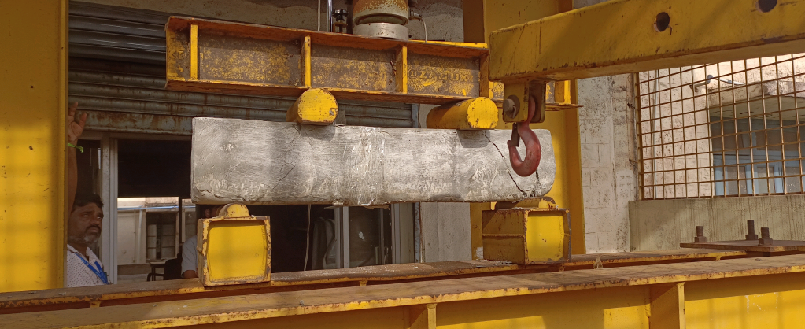

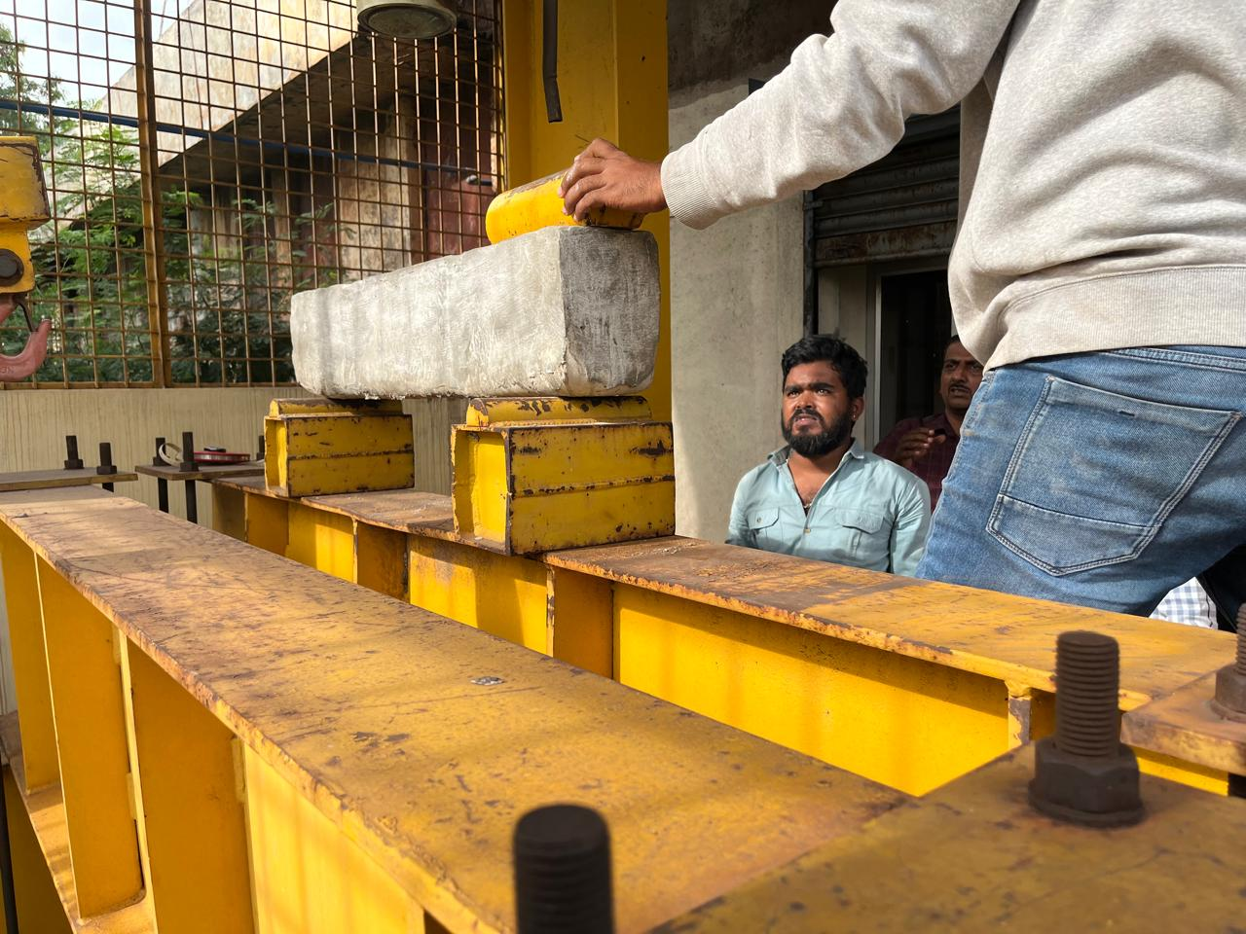

Figure : Testing of load framing using double point load.

The facility evaluated a specimen manufactured in Chitradurga and examined at Ballari RYMEC College. A graph was created to display the characteristics of a concrete beam subjected to stress test.

The double point load test is a crucial structural test that determines the flexural strength of beams and other structural members. It involves applying two equal loads at two points of the beam's span, allowing for study of load-carrying capacity, failure mode, and specimen behavior. The setup involves placing the beam horizontally to support its full length on two points, with load applicators placed at one-third of the beam's length. The loading frame has a high carrying capacity, and the bending moment is determined by the applied loads and span length. This information is crucial for engineers and researchers in developing new materials, designs, and construction methods.

**3.3.1 Time vs deflection**

The time vs. deflection data plot helps engineers understand a beam's behavior under loading conditions. Deflection, the degree of curvature after a load is applied, typically increases proportional to the load. However, as the load increases, deflection may become nonlinear, leading to permanent deformation. If the load continues, deflection will continue, ultimately causing the beam to fail. This graph provides crucial information on the beam's strength, flexibility, and failure point.

**3.3.2 Time vs strain**

The time vs. strain curve illustrates strain variation in a beam's deformation with time under loads. It indicates material extension or squishing, helping determine desired beam properties and stress capacity before failure.

**3.3.3 Time vs load**

The graph shows a X-Axis representing time in seconds and a Y-Axis representing load in KN. The load increases as time progresses, starting with a light load and ramping up until the maximum load is placed in the center.

**3.3.4 Time vs load**

The graph illustrates the time-to-load relationship in beam stability tests, illustrating the increasing load over time. It helps engineers understand the beam's response to stress, determining its maximum load capacity.

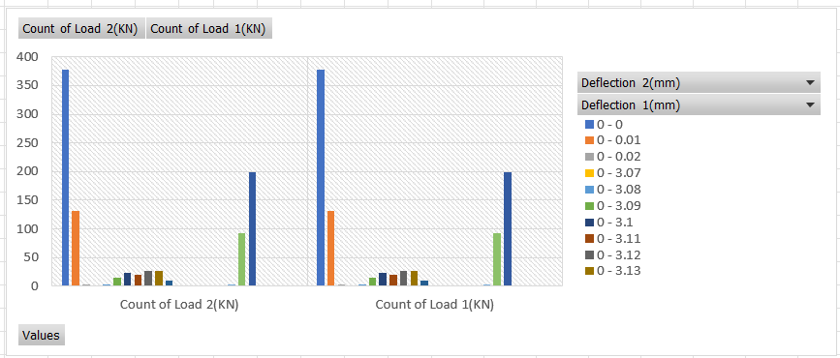

**Data acquisition system**

Data collected is imposed to the system to determine the above stated graphs such as time versus load, strain and deflection. Frond end of the data acquisition system is as shown in the Fig.12.

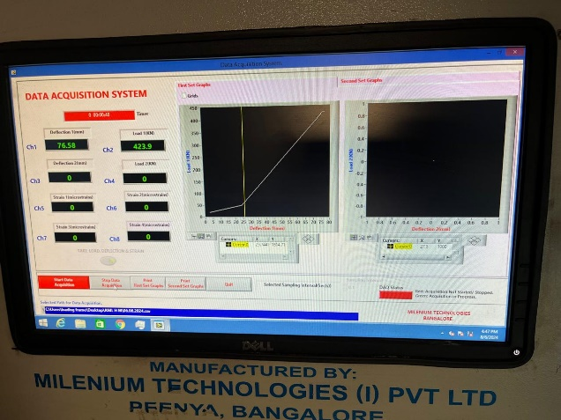

Figure : Data Acquisition system.

1. **CONCLUSION**

A 150 mm x 200 mm x 1000 mm beam was tested using M20 concrete with a 1:1:3 mix proportion. The beam's performance was assessed through loading frame testing, recording deformations and stresses with different loads. The results provided insights into the beam's applicability to real situations and structural code requirements, allowing for better understanding of its deformation behavior and load carrying capacity.

1. **REFERENCE**
2. M., S., Kavya., R., Satyanarayana., N., V., Krishna., T, A, S, Jayanth., G., P., Kumar. (2024). Experimental Investigation of Mechanical Properties of Geo–Polymer Concrete Using Flyash. International Journal for Research in Applied Science and Engineering Technology, doi: 10.22214/ijraset.2024.60513
3. Rajasekhar, Cheruvu., Kameswara, Rao, Burugapalli. "Experimental investigation on the performance evaluation of concrete binary blended with fly ash and ggbs." Jurnal teknologi, undefined (2024). doi: 10.11113/jurnalteknologi.v86.21056
4. D., Pavan, Kumar., V., Sai, Neeraja. "Effects of fly ash, maizecob ash, and groundnut shell ash on the properties of self-compacting geopolymer concrete with ggbs blend." undefined (2024). doi: 10.58532/v3bjce1p1ch1
5. B., Rajmohan., N, Harish., R., Ramesh, Nayaka., Kim, Hung, Mo. "Appraisal of Mechanical Properties of Fly Ash-Based Geopolymer Mortar Augmented with GGBS and Graphene Oxide." undefined (2024). doi: 10.1007/978-981-99-7464-1_2
6. Banoth, Gopalakrishna., P., Dinakar. "Study of Ambient Cured Fly Ash-GGBS-Metakaolin-Based Geopolymers Mortar." undefined (2024). doi: 10.1007/978-981-99-7464-1_3
7. K., G., Rao. "Experimental Study on Partial Replacement of Cement by GGBS and Fly Ash in Conventional Concrete." International Journal for Research in Applied Science and Engineering Technology, undefined (2023). doi:10.22214/ijraset.2023.56713
8. Ahmad, J., Manan, A., Asim, M., Ullah, S., Ullah, R., & Ali, A. (2020). Characteristics of Concrete Modified with Ground Granulated Blast-Furnace Slag (GGBS) as Binding Material. International Journal, 8(8).
9. J. Davidovits,“Geopolymers: Man-Made Geosynthesis and the Resulting Development of Very Early High Strength Cement”, J. Materials Education Vol. 16 (2&3), 1994, pp. 91-139.
10. P. Nath and P.K. Sarker, “ Effect of GGBS on setting, workability and early strength properties of fly ash geopolymer concrete cured in ambient condition”, Construction Building Materials Vol. 66, 2014, pp. 163 171
11. P.K. Sarker, S. Kelly and Z. Yao, “Effect of exposure on cracking, spalling and residual strength of fly ash geopolymer concrete”, Materials and Design Vol. 63, 2014, pp. 584-592.
12. P.S. Deb, P. Nath and P.K. Sarker, “The effects of ground granulated blast-furnace slag blending with fly ash and activator content on the workability and strength properties of geopolymer concrete cured at ambient temperature”, Materials and Design Vol. 62, 2014, pp. 32-39.
13. J. Davidovits, “Geopolymers: Inorganic Polymeric New Materials”, Journal of Thermal Analysis Vol.37, 1991, pp.1633-1656.
14. J. Davidovits, “Global Warming Impact on the Cement and Aggregate Industries”, World Resource review, Vol. 6, no. 2,1994, pp. 263-278.