To Evaluate the Support Provided By Solidworks for the Design for Additive Manufacturing (DfAM) Criteria

Bhupendra Chouhan1, Kumarpal Singh2, Pankaj Jain3

Research Scholar, Department of Mechanical Engineering, Aryabhatta College of Engineering and Research Center, Ajmer Rajasthan India1

Asst. Professor, Department of Mechanical Engineering, Aryabhatta College of Engineering and Research Center, Ajmer Rajasthan India2

Asst. Professor, Department of Mechanical Engineering, Aryabhatta College of Engineering and Research Center, Ajmer Rajasthan India3

**ABSTRACT**

Solidworks is a CAD software used to create 3D models and technical drawings that facilitate the production of parts. These tools are primarily designed to work with Subtractive Manufacturing (SM) and forming processes, which dominate global production. As a result, design guidelines typically align with the capabilities and constraints of traditional manufacturing methods. However, Additive Manufacturing (AM) introduces a new set of advantages and limitations that must be considered when designing parts. Design for Additive Manufacturing (DfAM) is a methodology similar to Design for Assembly (DFA) and Design for Manufacturing (DFM), with a focus on reducing component count and simplifying production. This research aims to establish DfAM criteria and assess the core features of Solidworks in supporting designs based on these criteria. DfAM criteria are categorized into two groups: Product DfAM, which is derived from the advantages of AM technology, and Process DfAM, which is based on the limitations of the specific AM method used.

**Keywords:**  Solidworks 2021, Design for Additive Manufacturing, Design for Assembly, Design for Manufacturing, Computer Aided Design.

**1. INTRODUCTION**

The rapid growth of Additive Manufacturing (AM) has introduced new possibilities and challenges for product design and production. Unlike traditional manufacturing methods, AM allows for more complex geometries, reduced material waste, and the potential for customized, on-demand production. However, to fully harness the benefits of AM, it is essential for CAD software to support the integration of AM-specific design guidelines and preparation steps throughout the modeling process. Solidworks, one of the leading CAD software platforms, is widely used for creating 3D models and technical drawings for manufacturing. Traditionally designed for use with subtractive manufacturing and forming processes, Solidworks now faces the challenge of adapting its tools to optimize designs for additive technologies. Integrating Additive Manufacturing considerations such as part orientation, support structures, and material constraints into the CAD workflow can significantly impact the performance and efficiency of 3D printing processes [1].

This evaluation aims to explore how Solidworks can be utilized to incorporate AM-specific design features and streamline part preparation for 3D printing within the CAD modeling process. By identifying key features within the software that facilitate or hinder AM integration, this research will provide insights into how Solidworks can evolve to better support the preparation of parts for AM. The goal is to assess whether Solidworks offers the necessary tools to simplify the transition from traditional manufacturing to additive processes, ensuring that designs are optimized for the unique requirements of 3D printing. Through this evaluation, the study will highlight Solidworks' strengths and limitations in enabling effective part preparation for Additive Manufacturing and offer recommendations for future improvements in CAD software to better support AM workflows [2].

**2. METHODOLOGY**

The primary DfAM criteria are categorized into two groups: Process DfAM, which focuses on process optimization, and Product DfAM, which is concerned with product optimization. These categories are mutually exclusive, as one leverages the advantages of additive manufacturing, while the other addresses the limitations of the technology. The criteria are summarized in Table 1.

Table 1

Dfam Criteria For The Evaluation Of Solidworks (2021)

|  |  |  |  |
| --- | --- | --- | --- |
| Type of DfAM Criteria | Product DfAM | | |
| DfAM Criteria | Topology  Optimization | Part Complexity | Part Consolidation |
| Supporting Features | Simulation | 3D Texture | Design Table |
| Instant 3D | File Conversion | Combine |

**3. EXAMPLES FOR ANALYSIS**

Each example applies one Product DfAM principle while addressing at least two Process DfAM criteria, as outlined in Table 2. Detailed descriptions of the process used to create the models in Solidworks (2021).

Table 2

Dfam Criteria Addressed By Examples

|  |  |  |  |
| --- | --- | --- | --- |
| Example | Product DfAM | Process DfAM | |
| 1 –Lid and Jar | Part Complexity | Feature Size and  Shape | Support  Optimization |
| 2 - Bracket | Topology  Optimization | Support  Optimization | Build Orientation |
| 3 - Hinge | Part Consolidation | Build Orientation | Feature Size and  Shape |

**3.1 Lid – Creation Process**

The lid was created by simply revolving a sketch, as shown in Figure 1, and adding a few fillets to shape it. Since the lid is designed to screw on, the thread needed more detailed definition. The 'Thread' feature, accessible from the 'Hole Wizard' drop-down menu, enables users to easily add a thread to any part with a circular edge. This feature works on both inner and outer diameters through cutting or extruding. However, it doesn't offer precise control over the thread profile, making it less ideal for 3D printing. Therefore, the thread was extruded using the 'Helix/Spiral' tool, along with a sketch of the thread profile and a 'Swept Boss' operation.

This approach allows for finer control over the thread's dimensions, which is particularly useful when creating parts that need to fit together using the 'Combine' feature. The thread profile sketch is shown in Figure 2, with a 700 angle to achieve a minimum of 650 from vertical. This angle was determined through FDM printer tests to be the limit for overhangs without defects, and it also eliminates the need for support in the thread. Additionally, the 'Draft Analysis' feature made it easy to verify this angle.

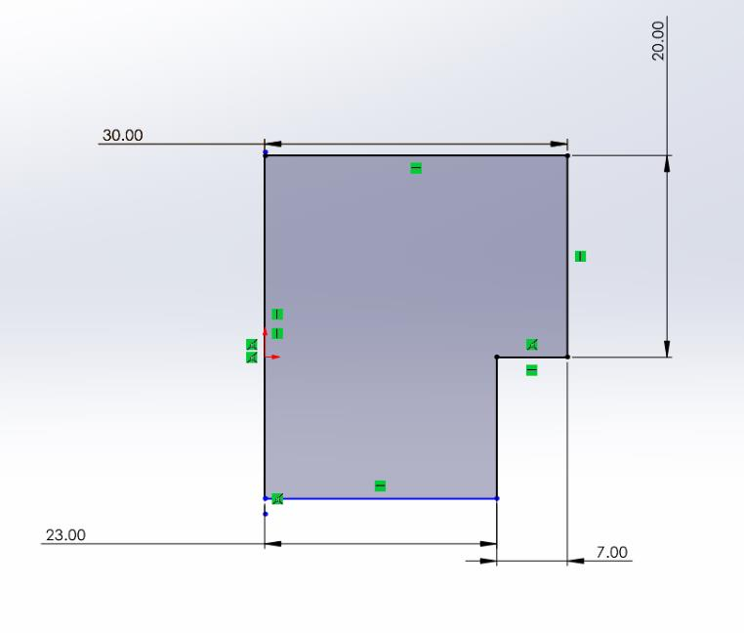

Figure 1: Sketch of lid example (screenshot from Solidworks (2021))

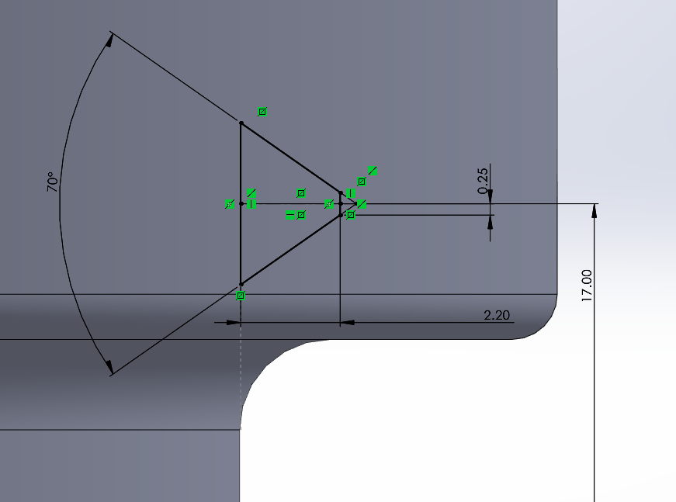

Figure 2: Sketch of the thread profile of lid example (screenshot from Solidworks (2021))

To create a proper fit using the 'Combine' function, a part with similar dimensions is required. However, this part must also feature a larger thread to allow for clearance between the intersecting threads of the two models. To achieve this, distinct names were assigned to the sketch that defined the thread profile. A 'Design Table' was then added, utilizing the thread sketch and 'Helix' pattern values. By introducing new parameters, a configuration was created with a 0.2 mm thread clearance in all directions. This 0.2 mm clearance was found to provide adequate results for a 'print-in-place' assembly. The thread was also extended by an additional millimeter using the 'Helix' values to ensure sufficient thread depth.

In this case, a 'Swept Cut' was used instead of a boss for the thread on the lid. A similar process was followed to create the inner thread on the jar, but this time, the tolerance was achieved by reducing the cut profile. Both methods produced satisfactory results. Additionally, grooves for grip were created on the lid by cutting a semi-circular profile from the outer diameter, adding fillets, and using the 'Circular Pattern' feature to replicate the geometry.

**3.2 Jar – Creation Process**

The jar is essentially a 50 mm tall cylinder with an external diameter of 60 mm, featuring an 'Extruded Cut' of 45 mm length and a 47.2 mm diameter, which hollows out the center. A few fillets were added to improve the design both aesthetically and functionally, facilitating an easy thread transition. The internal thread for the jar was created using the 'Combine' feature, allowing for the creation of the internal thread with a part that can be positioned using 'Mates'. After creating this part, an assembly was set up to check for clearance. The 'Measure' feature was then used in the assembly's cross section to ensure the thread had adequate clearance.

Additionally, a version of the jar was designed to demonstrate more complex geometry. This version was useful for showcasing both the cost of complexity in additive manufacturing (AM) and the accuracy of STL file conversion. It was created using two 'Extruded Cuts': one following a 'Helix' along the outer surface and the other cutting vertically with a 20mm simple semi-circle in a 'Linear Pattern'. This approach successfully produced a part with considerably more geometric complexity, as shown in Figure 3.

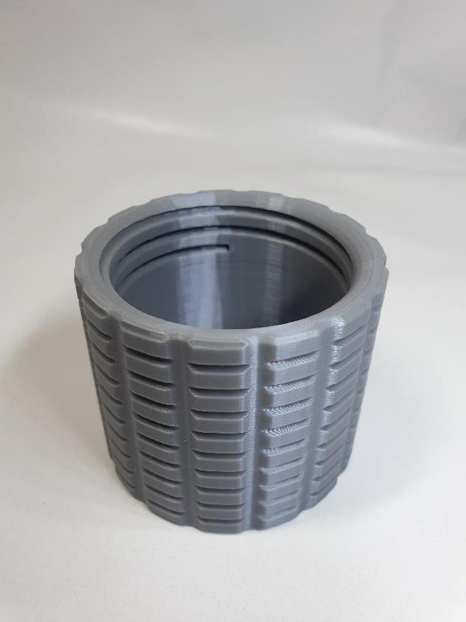

Figure 3: Jar with more complex outer geometry (screenshot from Solidworks (2021))

The lid and jar assembly also offered plenty of surface area to showcase another intriguing feature called '3D Texture.' This feature allows for the easy addition of significant complexity to a part with minimal user input.

**3.3 Bracket – Creation and Optimization Process**

To begin, a simple L-shaped bracket was extruded with a length of 100mm and a thickness of 10mm, extending 50mm in each direction from the front sketch plane, resulting in a 100 mm long bracket, as shown in Figure 4. Next, an 80mm rib was extruded 7.5 mm in each direction from the front sketch plane, creating a 15 mm-wide rib connecting the two sides, also visible in Figure 4.

After rounding the edges with fillets, three evenly spaced 10 mm holes were added to each side of the rib. With these features in place, the load case simulation could be set up. This involved creating a mesh and defining forces, fixtures, and 'Goals and Constraints.' The holes were treated as 'Fixed Geometry,' and a 20 N force was applied to the entire upper side, as depicted in Figure 4.3. The 'Simulation' process is explained in more detail in the next chapter. Based on the simulation results, the part's shape was adjusted using the 'Instant 3D' feature, which allowed for more flexibility in modifying sketches and cuts. This made the optimization process much smoother, leveraging the simulation data.

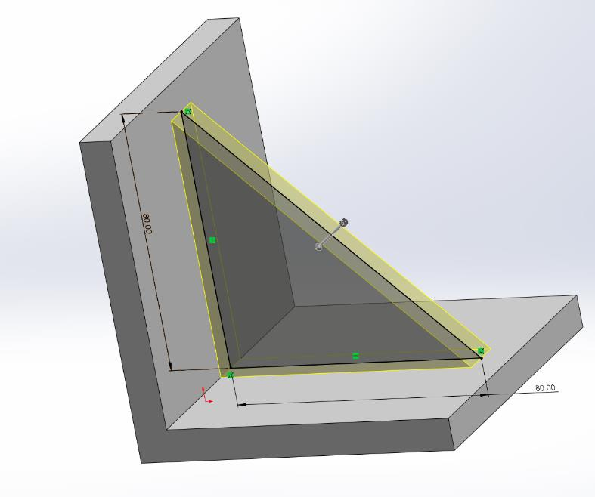

Figure 4: Bracket example construction (screenshot from Solidworks (2021))

Once the model was optimized, it was checked for overhangs using the 'Draft Analysis' feature and for thin features using the 'Thickness Analysis' feature. After completing all necessary checks, the part was printed in the orientation shown in Figure 5. This orientation was chosen after reviewing a representation of the 'striation lines' in the 'Print3D' feature and considering the applied load case. The mesh model generated directly from the simulation was also printed in the same orientation, but it required substantial support structures. In contrast, the 'self-optimized' model was designed to print without the need for supports.

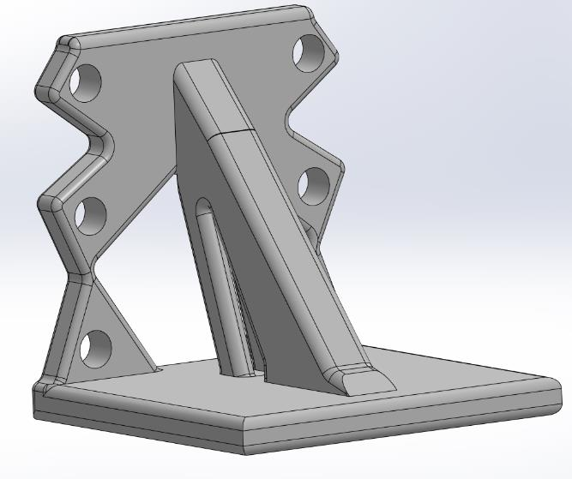

Figure 5: User-optimized bracket example in build orientation

(screenshot from Solidworks (2021))

**3.4 Hinge – Creation Process**

First, two 'Extruded Bosses' were created: one forming a 50 mm x 25 mm rectangle and the other adding an 8mm diameter spine to the rectangle. This basic shape is shown in Figure 6. Two holes were then added to the surface. Following that, two cuts were made, and an 'Extruded Cut' was applied with a 'Linear Pattern' along the spine, as depicted in Figure 7.

The next step involved using a 'Revolve Boss' to create the interlocking features for the hinge, as seen in Figure 8. The 'Mirror Entities' function was used to duplicate the sketch to the opposite side and then mirror the entire half, utilizing placed centerlines for the mirroring. These steps are also shown in Figure 8. After adding additional fillets to smooth the part, the design was complete.

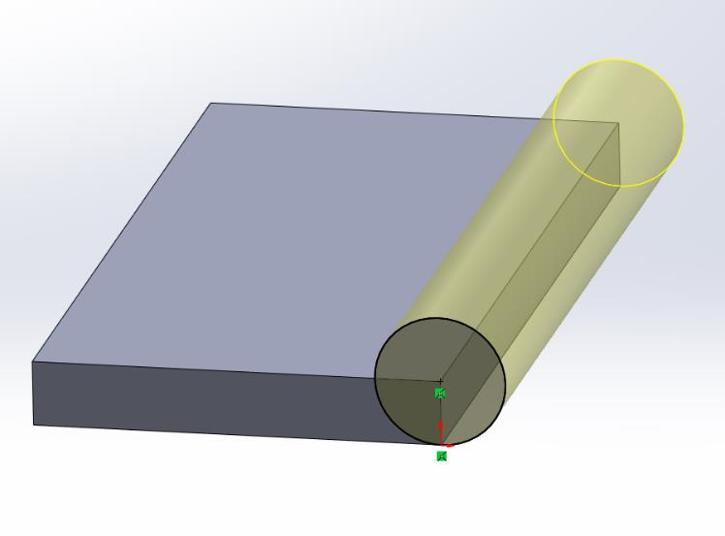

Figure 6: Hinge example - basic shape (screenshot from Solidworks (2021))

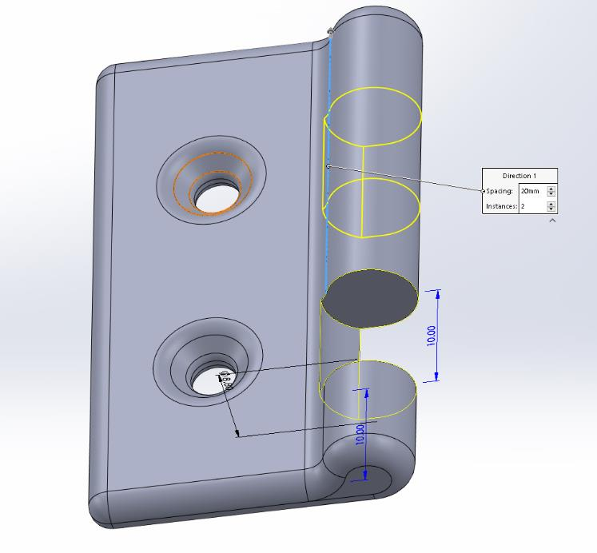

Figure 7: Hinge example - Linear pattern cut (screenshot from Solidworks (2021))

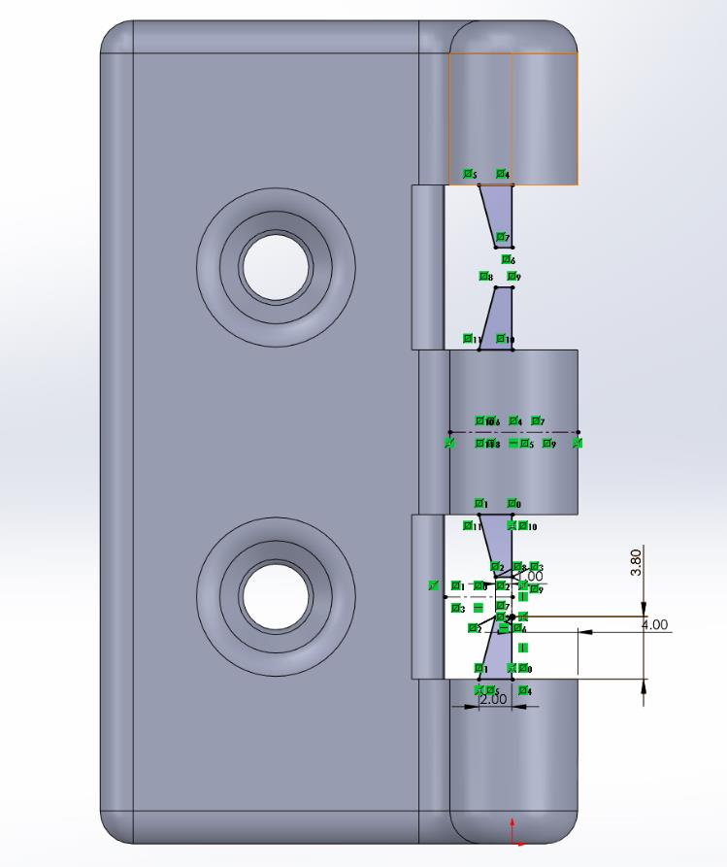

Figure 8: Hinge example - Revolved Boss sketch (screenshot from Solidworks (2021))

For the second hinge, the same steps were followed up until the 'Extruded Cut' with the 'Linear Pattern'. Instead of cutting directly from the surface, a plane was sketched with a 0.4mm offset, and a 10.8 mm cut was made, repeated twice more in a 'Linear Pattern' for a total of three cuts. The offset plane and the additional 0.8mm in the cut distance ensure that the mating parts have the desired 0.4 mm clearance, as shown in Figure 9. The choice of clearance is based on the nozzle width of the printer used.

Next, the 'Combine' feature was utilized to create the interlocking features of the second hinge. This required a version of the first hinge with a larger 'Revolve Boss' for the interlocking features. To achieve this, the dimensions of the first hinge's sketch were increased by 0.4 mm in all directions, as shown in Figure 10. This adjustment was made as a configuration of the default model using the 'Design Table' feature. The resulting configuration was then used in the 'Combine' function to create the interlocking features for the second hinge. The 'Combine' feature will be discussed in more detail in the next chapter.

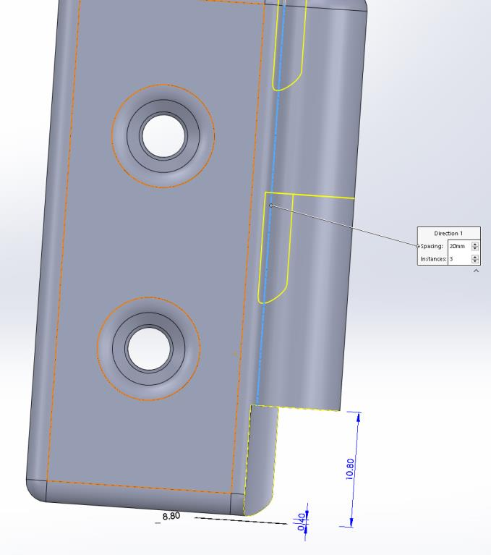

Figure 9: Hinge example - Linear Pattern cut (screenshot from Solidworks (2021))

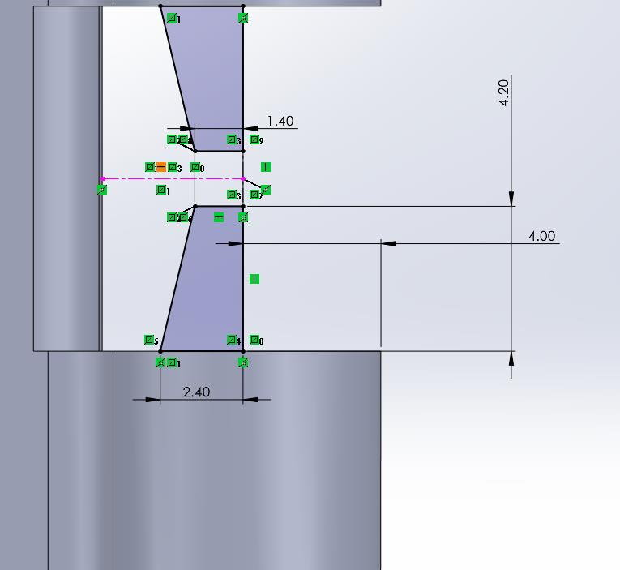

Figure 10: Hinge example - Increased dimensions for Revolve Boss

(screenshot from Solidworks (2021))

For the hinge assembly file, which is needed to create a single STL file for printing, only two mates are necessary to fully define the assembly in the correct position, as shown in Figure 11. These mates include a concentric mate between any two circular parts of the hinges, followed by a coincident mate on two bottom edges. Once the assembly is in its build position, clearance checks can be performed using a feature called 'Clearance Verification.' When the model is ready for printing, the entire assembly can be saved as a single STL file.

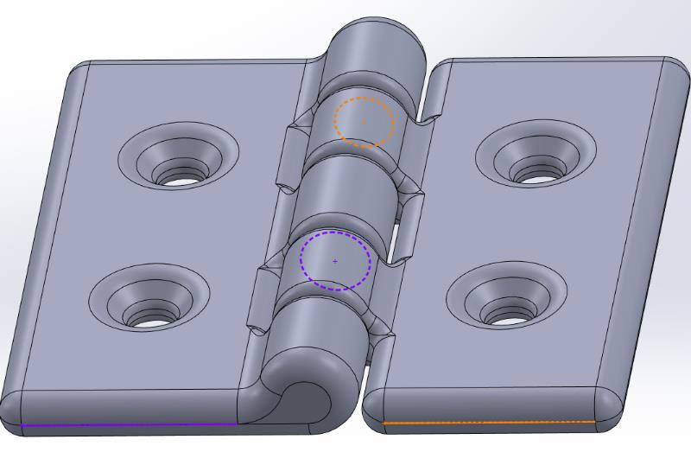

Figure 11: Hinge example - concentric and coincident Mates

(screenshot from Solidworks (2021))

**4. CONCLUSIONS**

This paper was to evaluate Solidworks (2021) in its ability to integrate part preparation for additive manufacturing (AM) into the design process. This was achieved by first defining the criteria for designing for AM, which were then categorized into two groups: one focusing on the advantages offered by AM technology (Product DfAM), and the other addressing the limitations of the process being used (Process DfAM). Using these criteria, three models were created, each representing one Product DfAM and two Process DfAM. Throughout the modeling and optimization process, features of the software that supported AM preparation were identified and analyzed. The models were then printed to demonstrate these features in practice. The findings from this analysis are summarized below, with support for the criteria found to be sufficient, limited, or insufficient.

**ACKNOWLEDGEMENT**

The First author wish to express his thanks to the Principal, Aryabhatta College of Engineering and Research Center, Ajmer, Rajasthan, India, to carry out the above work in Department of Mechanical Engineering and wish to express his sincere thanks to the Former Chairman Prof. Amit Shastri for their encouragement and support to undertake the present work and providing the facilities in Department of Mechanical Engineering. He also expresses his thanks to his colleagues in Department of Mechanical Engineering for their support.

**REFERENCES**

1. Snyder, J. C., Stimpson, C. K., Thole, K. A., and Mongillo, D. J., “Build Direction Effects on Micro channel Tolerance and Surface Roughness”, *Journal of Mechanical Design,* 137(11), 111411, 2002.
2. Strano, G., Hao, L., Everson, R. M., and Evans, K. E., “A New Approach to the Design and Optimization of Support Structures in Additive Manufacturing”, *The International Journal of Advanced Manufacturing Technology*, 66(9–12), 1247–1254, 2013.
3. Ulu, E., Korkmaz, E., Yay, K., Burak Ozdoganlar, O., and Burak Kara, L., “Enhancing the Structural Performance of Additively Manufactured Objects through Build Orientation Optimization”, *Journal of Mechanical Design*, 137(11), 111410, 2015.
4. Urbanic, R. J., and Hedrick, R., “Fused Deposition Modeling Design Rules for Building Large, Complex Components”, *Computer-Aided Design and Applications*, 13(3), 348–368, 2016.
5. Vicente, M. F., Canyada, M., and Conejero, A., “Identifying Limitations for Design for Manufacturing with Desktop FFF 3D Printers”, *International Journal of Rapid Manufacturing,* 5(1), 116, 2015.
6. Yang, S., & Zhao, Y. F., “Additive Manufacturing-Enabled Design Theory and Methodology: A Critical Review”, *The International Journal of Advanced Manufacturing Technology,* 80(1–4), 327–342, 2015.
7. Karin J. Chen, Ahmed Elkaseer, Steffen G. Scholz, and Veit Hagenmeyer, “On the Correlation Between Pre-Processing Workflow and Dimensional Accuracy of 3D Printed Parts in High-Precision Material Jetting”, *Additive manufacturing, Elsevier*, Volume 91, 5 July, 2024.
8. Ajay Kumar, Praveen Kumar, Ravi Kant Mittal, and Hari Singh, “Printing File Formats for Additive Manufacturing Technologies”, *Advances in Additive Manufacturing, Elsevier,* pp. 87-102, 2023.
9. Dama Y. B. , Bhagwan F. Jogi, and R. S. Pawade, “Application of Nonlinear Analysis in Evaluating Additive Manufacturing Process for Engineering Design Features: A Study and Recommendations”, *Communications on Applied Nonlinear Analysis,* ISSN: 1074-133X, Volume 31 No. 1s, 2024.
10. Rajat Choudhary, Paride Fabbri, Enrico Leoni, Francesca Mazzanti, Raziyeh Akbari and Carlo Antonini, “Additive Manufacturing by Digital Light Processing: A Review”, *Progress in additive manufacturing, Springer nature link*, Volume 8, Pages 331-351, 2023.