**ALTERNATIVE MATERIAL FOR CEMENT USING IRON SLAG, FLY ASH, STARCH**

**AGATHIYAN.S,JAIHIND D.S,KALAISELVAM.S,SABARI.T,SIVA.S,RAGHURAMAN.V**

*AResearch scholar, Department of Civil Engineering, Sri Shakthi Institute of Engineering and Technology*

*BGuide, M.E Scholar, Department of Civil Engineering, Sri Shakthi Institute of Engineering and Technology*

**Abstract**

**This study explores the potential of using iron slag, starch, and fly ash as alternative materials for cement in concrete. The objective is to evaluate their effects on compressive strength, workability, and durability. The findings indicate that a combination of these materials can significantly reduce the environmental impact of cement production while maintaining desirable concrete properties. The results provide insights into sustainable construction practices, reducing the carbon footprint associated with traditional cement production.**

**Keywords**

**Iron Slag, Starch, Fly Ash, Sustainable Concrete, Compressive Strength, Durability, Cement Alternatives**

**1. Introduction**

**• Background: The cement industry is a major contributor to CO₂ emissions, leading to increased interest in alternative materials to reduce environmental impact.**

**• Problem Statement: Traditional cement production is energy-intensive and environmentally harmful. Using industrial by-products like fly ash and iron slag, and natural polymers like starch, offers potential alternatives.**

**• Objectives: To assess the feasibility of using iron slag, starch, and fly ash in cement, focusing on compressive strength, workability, and long-term durability.**

**2. Literature Review**

**• Fly Ash in Concrete: Fly ash is commonly used as a supplementary cementitious material due to its pozzolanic properties, which enhance the strength and durability of concrete (Siddique, 2014).**

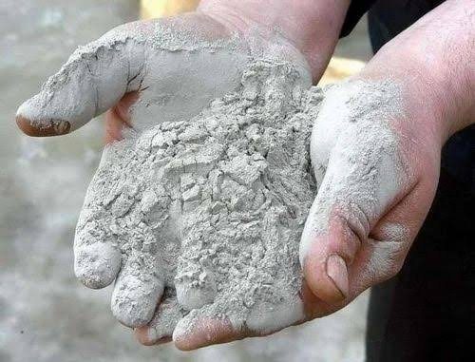

**• Iron Slag in Concrete: Ground granulated blast-furnace slag (GGBS) is a well-known by-product of steel production that improves the durability of concrete by reducing permeability and enhancing chemical resistance (Raman et al., 2017).**

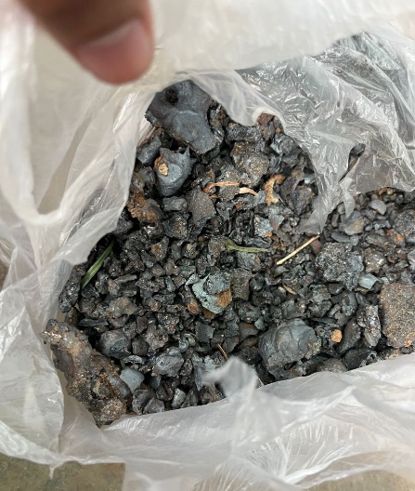

**• Starch in Concrete: Starch-based polymers have been explored as additives that improve workability, reduce shrinkage, and retain moisture during curing (Wang et al., 2020).**

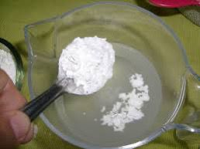

**3. Materials and Methods**

**• Materials:**

**• Fly Ash: Collected from a nearby thermal power plant.**

**• Iron Slag: Obtained from a local steel manufacturing plant.**

**• Starch: Corn starch used as a binder.**

**• Mix Proportions:**

**• Mix : 40% Fly Ash, 40% Iron Slag, 20% Starch.**

* **M20 grade concrete**

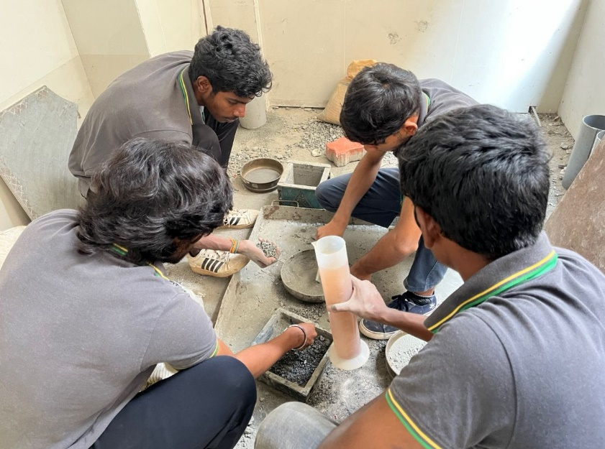

**• Methodology:**

**• Concrete cubes (150 mm x 150 mm x 150 mm) were prepared for each mix.**

**• Curing was done for 28 days in a standard curing tank.**

**• Tests:**

**• Compressive strength (ASTM C39) at 28 days.**

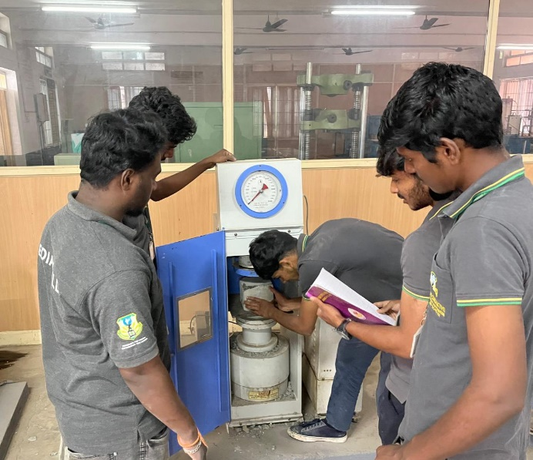

**4. Results and Discussion**

**• Compressive Strength:**

**• Fly Ash + Iron Slag + Starch (Mix): 2000KN after 28 days, showing a slight reduction in strength but better durability properties.**

**5. Conclusion**

**The use of iron slag, starch, and fly ash as partial replacements for cement offers a promising solution for sustainable concrete production. While there is a slight reduction in compressive strength, the environmental benefits, such as reduced carbon emissions and improved durability, make this approach highly feasible for construction applications. Future studies should focus on optimizing the mix ratios for enhanced strength while maintaining the sustainability benefits.**

**References**

**1. Siddique, R. (2014). “Utilization of Fly Ash in Concrete.” Cement and Concrete Research, 34(3), 1483-1487.**

**2. Raman, S., et al. (2017). “Incorporation of Ground Granulated Blast Furnace Slag in Concrete.” Construction and Building Materials, 35, 261-268.**

**3. Wang, Y., et al. (2020). “Starch-Based Polymers as Additives in Concrete.” Journal of Building Materials, 55, 112-118.**

**4. “Supplementary Cementing Materials” by R.D. Hooton, Michael D.A. Thomas**

**5.“Eco-efficient Concrete” edited by Fernando Pacheco-Torgal**

**6.“Alkali-Activated Materials: State-of-the-Art Report, RILEM TC 224-AAM” by John L. Provis and Jannie S.J. van Deventer**

**7.“Sustainable Construction Materials: Fly Ash” by Rafat Siddique**

**8. “Waste Materials in Construction: Putting Theory into Practice” edited by G.J.L. van Zomeren and H.A. van der Sloot**