Wi-Fi Scout – (Scan -Select -Connect)

|  |  |  |  |
| --- | --- | --- | --- |
| Mrs. J. Aarthy Suganthi Kani *Dept. of Electronics and Communication Engineering*  *T. John Institute of Technology*  Bangalore, India <https://orcid.org/0000-0002-5442-9334> | Jaganath S *Dept. of Electronics and Communication Engineering*  *T. John Institute of Technology*  Bangalore, India [jagansrns0105@gmail.com](mailto:jagansrns0105@gmail.com) | Naveen S *Dept. of Electronics and Communication Engineering*  *T. John Institute of Technology*  Bangalore, India [snaveenv786@gmail.com](mailto:snaveenv786@gmail.com) | Pradeep D *Dept. of Electronics and Communication Engineering*  *T. John Institute of Technology*  Bangalore, India [deva43205@gmail.com](mailto:deva43205@gmail.com) |

***Abstract*—** **Wi-Fi Scout introduces a dynamic Wi-Fi connectivity management system tailored for industrial environments. Leveraging the ESP32 microcontroller, the system integrates an OLED display and keypad to facilitate intuitive network selection and connection management. The modular system offers robust error handling, real-time connection feedback, and adaptability to fluctuating network conditions. A Python-based server supports logging and monitoring functionalities, enabling advanced analytics and troubleshooting. Built on the ESP-IDF framework, Wi-Fi Scout promises scalability and consistent connectivity in settings like warehouses and factories, minimizing user intervention while maximizing operational efficiency.**

***Keywords—ESP32 Microcontroller, Wi-Fi Network Management, Industrial Connectivity, Error Handling, Python Server, IoT Applications.***

1. Introduction

Modern industrial environments rely heavily on wireless communication to maintain operational efficiency, facilitate data transfer, and enable real-time decision-making. In order to connect devices, control workflows, and guarantee smooth communication, industrial operations—from manufacturing facilities to warehouses—rely significantly on dependable and flexible Wi-Fi networks. Nonetheless, these settings are dynamic in nature, with network configurations often changing as a result of equipment mobility, shifting operational zones, and changing connection needs. Effectively managing these networks is quite difficult.

Static network setups or hardcoded Wi-Fi credentials integrated in equipment are common examples of traditional methods for network connectivity in industrial environments. Although these approaches offer fundamental functionality, they are not flexible enough to adjust to shifting operational demands, security specifications, or network availability. Every time network settings change, technical personnel must manually reconfigure devices, which adds to maintenance costs, delays production, and increases downtime. This situation emphasizes how urgently an automated, flexible, and user-friendly system that can handle the particular difficulties of industrial networking is needed.

By launching a dynamic Wi-Fi management system that transforms network access and management in industrial settings, Wi-Fi Scout seeks to close this gap. Wi-Fi Scout, which is based on the reliable ESP32 microcontroller, combines hardware and software elements to produce an easy-to-use solution for connection management, network scanning, and choosing. The solution gives operators the opportunity to decide on connectivity in real time based on the performance and availability of the network, removing the need for pre-configured network credentials. In dynamic industrial installations where users and equipment regularly swap between access points or come across new networks, this functionality is extremely helpful.

Wi-Fi Scout's SCAN--SELECT--CONNECT approach is its primary innovation. This method simplifies the intricate process of wireless network management by offering an intuitive user interface with an OLED display and keyboard. Without the need for complex technical knowledge, users can quickly search for available Wi-Fi networks, choose the network of their choice, enter their login information, and create a secure connection. Additionally, the system offers real-time feedback at every stage of the connection process, guaranteeing that users are informed of the system's condition and capable of efficiently resolving problems.

Advanced error-handling algorithms are incorporated into Wi-Fi Scout to improve usability and dependability. These features guarantee proactive management of unsuccessful connection attempts, incorrect password submissions, and network outages. For example, based on preset options, the system can automatically retry connections, ask users to reenter their credentials, or recommend alternate networks. Even in difficult network situations, this degree of flexibility guarantees steady connectivity and reduces downtime.

In addition to its primary features, Wi-Fi Scout comes with a specially designed Python-based server for recording connection events and monitoring network efficiency. In order to diagnose problems, optimize network setups, and track connectivity trends, this server is essential. The server gives administrators the ability to make data-driven decisions to improve system performance by offering comprehensive insights into network activities.

Wi-Fi Scout, which is based on the ESP-IDF framework, makes use of the ESP32's low-level control capabilities to guarantee effective network management and smooth interaction with other Internet of Things devices. Future improvements like voice navigation, sensor integration, or increased analytics capabilities are supported by the system's modular architecture.

1. Motivation

The motivation behind Wi-Fi Scout lies in addressing these challenges through an innovative, user-friendly, and automated Wi-Fi management system. Industrial workflows demand systems that not only provide stable connectivity but also offer the flexibility to adapt to real-time changes in network conditions without significant human intervention. Furthermore, industries require solutions that empower operators, regardless of technical expertise, to manage connections efficiently while maintaining high levels of security and reliability.

Wi-Fi Scout was conceived to bridge this gap by leveraging the powerful capabilities of the ESP32 microcontroller and integrating advanced software and hardware components. Its SCAN-SELECT-CONNECT methodology ensures simplicity and efficiency, enabling operators to manage connections dynamically while minimizing the need for manual reconfigurations. This system aligns with the growing trend of adopting scalable, modular, and IoT-enabled solutions in industrial settings to ensure seamless communication, reduce downtime, and enhance overall productivity.

By introducing real-time feedback, robust error handling, and network analytics via a Python-based server, Wi-Fi Scout aspires to redefine connectivity management in industrial environments. The system is not just a response to the challenges faced in current setups but a forward-thinking solution aimed at empowering industries with tools to make proactive, data-driven decisions for optimal performance and resilience.

1. Objectives
2. *Automated Network Discovery and Display Integration:*
   * To Check for nearby Wi-Fi networks that are available.
   * Display Wi-Fi networks list on an OLED panel.
   * Display network SSID’s with signal strength.
   * Periodically refresh the networks that are presented.
3. *Interactive Network Selection and Authentication Protocol:*

* Navigate through networks using keypad.
* Select desired network from displayed list.
* Input password through keypad.
* Display connection initiation status.

1. *Exception Control System and Network Reliability:*

* Detect connection and authentication failures.
* Display error messages for incorrect credentials.
* Allow re-entry of network credentials.
* Switch to next available network if needed.

1. Problem Statement

In an industrial setup, the ESP32 device needs to dynamically connect to available Wi-Fi networks based on the user’s input. To provide flexibility in connecting to different Wi-Fi networks, the ESP32 should integrate with an OLED display and a keypad to list all the available Wi-Fi networks in the range. The user should be able to select a network, input the SSID and password, and initiate the connection. The system should handle exceptions in case of incorrect credentials or connection failure and attempt to connect to the next available network if needed. A small application will be developed to demonstrate this functionality, ensuring reliable and flexible Wi-Fi connectivity.

1. Literature Survey
2. D. Hercog, T. Lerher, M. Truntič, and O. Težak, "Design and Implementation of ESP32-Based IoT Devices," Sensors, 2023.

In their 2023 study, Hercog et al. examine the application of ESP32 microcontrollers for IoT device development, focusing on sensor integration and data transmission in educational settings. By leveraging ESP32’s Wi-Fi capabilities, students gain hands-on experience with embedded systems, PCB design, and network communication. The framework’s simplicity and flexibility demonstrate ESP32’s potential for diverse IoT applications, especially in dynamic environments where easy connectivity and data transfer are essential. This study provides a useful foundation for projects requiring a reliable, versatile microcontroller with robust Wi-Fi functionality.

1. Y. Guo, S. Zhang, and D. Xiao, "Overview of Wi-Fi Technology," in Proceedings of the 2nd International Conference on Computer Application and System Modeling, 2012.

Guo et al. (2012) present a comprehensive overview of Wi-Fi technology, outlining essential IEEE standards like 802.11a/b/g/n and discussing network types such as Ad-hoc and Infrastructure. The study highlights Wi-Fi’s adaptability in various environments and addresses limitations like range and interference, which are critical for designing reliable Wi-Fi-based systems. By detailing the evolution of Wi-Fi standards and configurations, this paper provides valuable background knowledge for projects that involve Wi-Fi connectivity, especially in applications where network performance and compatibility are crucial.

1. This S. R. Pokhrel, H. L. Vu, and A. L. Cricenti, "Adaptive Admission Control for IoT Applications in Home WiFi Networks.

Pokhrel et al. introduce an Adaptive Admission Control (AAC) approach for managing IoT traffic in Wi-Fi networks, focusing on balancing IoT-specific traffic with traditional network data. The AAC mechanism leverages priority-based admission control to enhance service quality in environments with high IoT device density. Using a combination of Markov regenerative processes and queue management, this model reduces congestion and ensures fairness in network traffic distribution. This research is particularly relevant for IoT projects that operate in congested networks, as it offers insights into managing traffic to optimize both reliability and performance.

1. This J. B. Minani, F. Sabir, N. Moha, and Y.-G. Guéhéneuc, "A Systematic Review of IoT Systems Testing: Objectives, Approaches, Tools, and Challenges," IEEE Transactions on Software Engineering, vol. 50, no. 4, pp. 1-20, Apr. 2024. doi: 10.1109/TSE.2024.3363611.

The paper titled "A Systematic Review of IoT Systems Testing: Objectives, Approaches, Tools, and Challenges" provides a comprehensive analysis of the current state of testing in Internet of Things (IoT) systems, synthesizing findings from 83 primary studies published between 2012 and 2022. It addresses critical aspects of IoT testing, including testing objectives framed through quality attributes, various testing approaches, and the tools and challenges associated with the testing process. The review highlights that IoT systems testing not only incorporates traditional software quality attributes but also introduces unique attributes such as connectivity, energy efficiency, and device lifespan expectancy. Furthermore, the paper identifies a range of testing tools and frameworks, noting their limitations and the need for further development to accommodate the complexities of IoT environments. By cataloging existing tools and approaches, the study offers valuable insights for practitioners while also pinpointing research opportunities to enhance testing methodologies in this rapidly evolving field. This systematic literature review serves as an essential resource for understanding the multifaceted challenges and considerations in ensuring the reliability and quality of IoT systems.

1. 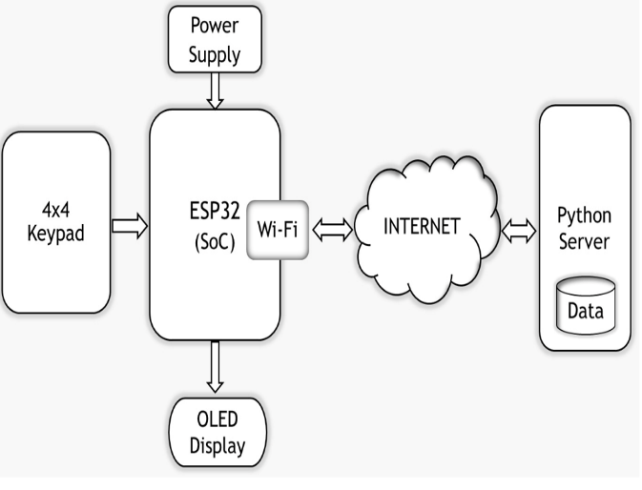Methodology

* ESP32 Board: This board serves as the central controller for this project. It processes & manages all the components - & it has built-in Bluetooth & WiFi capabilities.
* OLED Display: The OLED display provides an intuitive interface for users, facilitating interaction with the system. It shows a list of available Wi-Fi networks, allowing operators to easily choose their desired connection. The display can also provide real-time feedback during the connection process, such as connection success or failure messages, network signal strength, and other status updates. This visual feedback is crucial in industrial environments where immediate information is necessary for troubleshooting and operational efficiency.
* Keypad Input System: A keypad is integrated to allow users to navigate through available networks, select their preferred connection, and input credentials securely. This ensures ease of use in industrial settings where quick access is essential.
* Dynamic Network Scanning: Dynamic network scanning is a key feature that empowers the system to detect and list available Wi-Fi networks in real time. Unlike static systems that rely on hardcoded credentials, this capability offers greater flexibility, allowing users to connect to various networks depending on availability. This is especially beneficial in environments where network configurations frequently change or in mobile applications where the device may move between different networks.
* Custom Python Server: To manage the data generated by the ESP32, a dedicated Python server is deployed in the cloud. This server plays a critical role in logging connection attempts and
* performance metrics. By utilizing a cloud environment, the server ensures that data is accessible from anywhere, providing a centralized location for monitoring and analysis. The use of Python allows for robust data processing and flexibility in implementing custom analytics or visualization tools.
* Logging Mechanism: The logging mechanism is designed to capture essential data related to network connectivity. This includes timestamps for each connection attempt, the SSIDs of detected networks, the status of each connection (successful or failed), and any error messages that may arise during the process. This information is crucial for diagnosing issues, understanding user behavior, and optimizing network performance. The ESP32 sends this data to the Python server via HTTP requests, ensuring real-time updates.
* Data Uploading: Once the ESP32 establishes a connection to a Wi-Fi network, it proceeds to upload the logged data to the Python server for further analysis. This continuous data flow allows for ongoing monitoring of connection performance and user interactions, enabling the identification of trends or recurring issues. The ability to upload data post-connection ensures that even transient errors can be logged and analyzed, providing valuable insights into the operational environment and enhancing overall system reliability.

1. Work Done
   1. *Automated Network Discovery and Display Integration*

The Automated Network Discovery and Display Integration objective utilizes the advanced Wi-Fi scanning capabilities of the ESP32 microcontroller to identify and display nearby wireless networks. The ESP32 performs active Wi-Fi scanning by broadcasting probe requests to detect available networks. Nearby access points respond with details such as the network name (SSID), signal strength 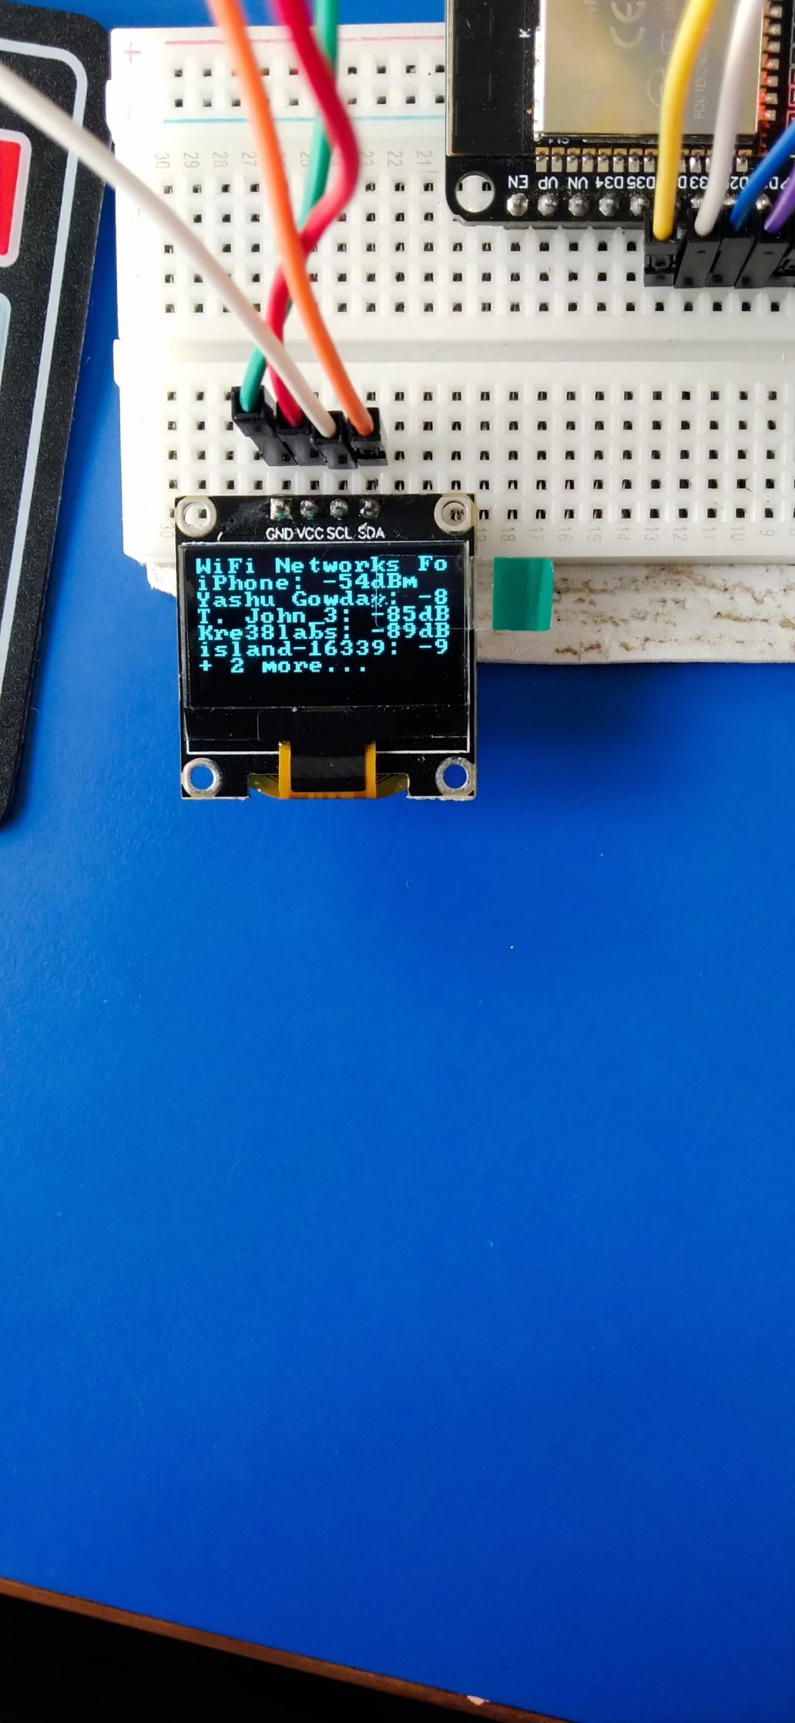(RSSI), and encryption protocols.

Fig 1-Displayed Networks

The ESP32 complies with the IEEE 802.11 standards, supporting Wi-Fi protocols including 802.11b, 802.11g, and 802.11n, ensuring compatibility across various Wi-Fi environments. Operating in the 2.4 GHz frequency band, the ESP32 achieves a scanning range of approximately 30–50 meters indoors and up to 100 meters outdoors, depending on environmental conditions such as obstacles and interference. This scanning process captures critical details like:

**SSID:** The name of the network.

**RSSI:** The signal strength, which helps assess the quality of the connection.

**Network Display and Refresh Rate:** The scanned network details are displayed on the SSD1306 OLED panel, showing SSIDs and corresponding signal strengths. The system refreshes the network list every 30 seconds, ensuring the display remains updated with real-time information. Each refresh cycle captures up to 20 networks, balancing accuracy and power efficiency.

This completed functionality ensures that users can monitor available Wi-Fi networks with essential details such as network name and signal strength. It provides a reliable mechanism for network discovery, making the device suitable for real-time network assessment. The successful integration of ESP32’s Wi-Fi scanning features and OLED display demonstrates the effectiveness of the system in achieving this project objective.

* 1. *Interactive Network Selection and Authentication Protocol :*

The Interactive Network Selection and Authentication Protocol enables users to connect to available Wi-Fi networks by selecting a network from a list and entering the necessary credentials. This feature provides an intuitive, interactive experience, utilizing the 4x4 keypad for network selection and password entry, along with the SSD1306 OLED display for feedback on the connection status.

**Network Navigation and Selection**

The process begins with the display of available networks on the OLED screen. Users can navigate through the list of networks using the 4x4 keypad, which allows for easy scrolling through the SSIDs of detected networks. The user can select the desired network by navigating to it and confirming the choice using the keypad.

**User Authentication and Password Input**

Once a network is selected, the system prompts the user to enter the network's password. The user inputs the password using the 4x4 keypad, which allows each character to be entered one at a time. To ensure privacy, the password is masked on the OLED display during input, preventing others from viewing sensitive information.

**Connection Initiation and Feedback**

After the user provides the correct password, the system attempts to establish a connection to the selected network. The ESP32 microcontroller handles the authentication process, using the entered credentials to connect to the Wi-Fi network. During this time, the OLED display shows connection status messages, such as “Connecting...” and “Connection Successful” once the device is connected to the network. If the connection fails (e.g., due to incorrect credentials), the display will show an error message, such as “Authentication Failed,” prompting the user to try again.

1. Experimental Results

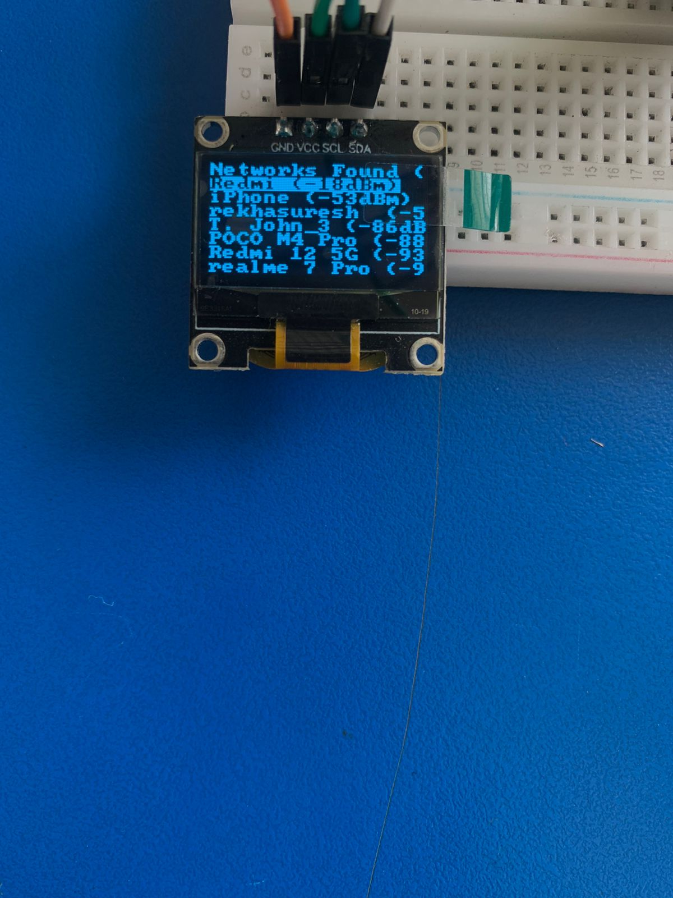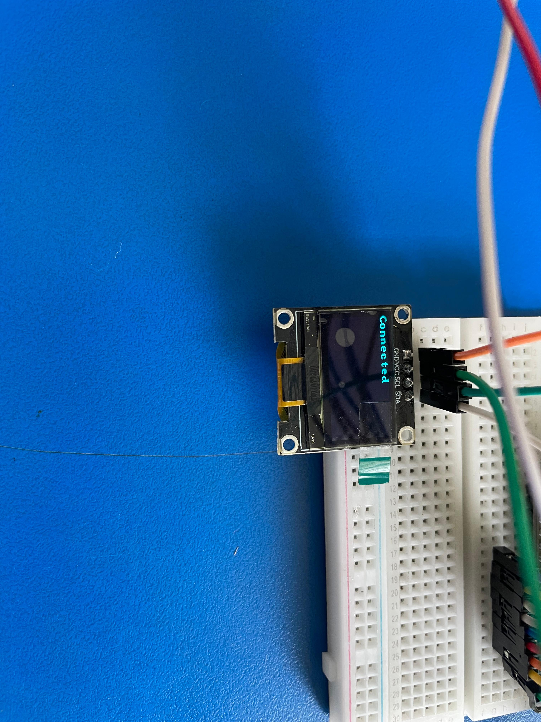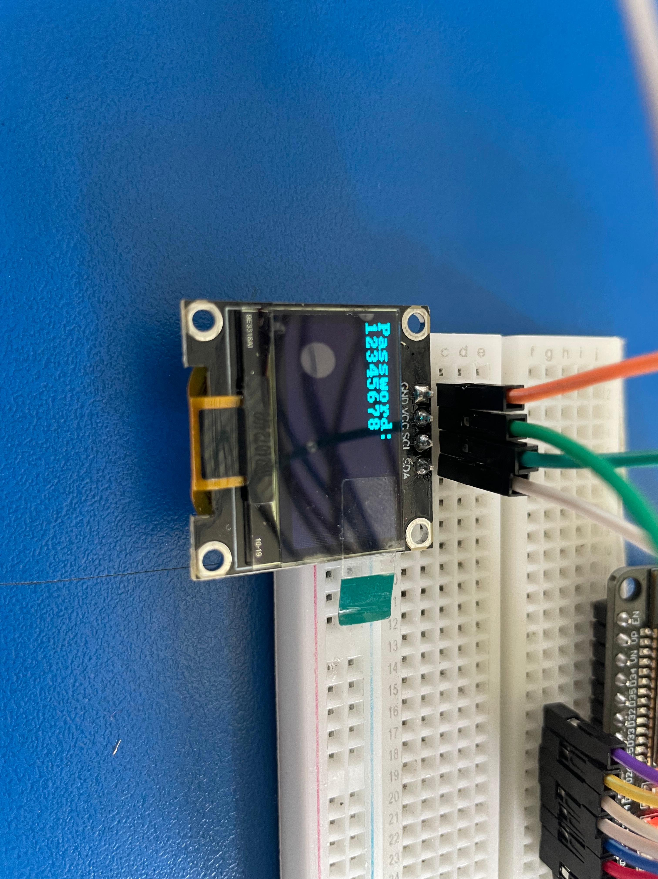

Fig 2 -Network Selection , Password Entry and Connection status.

1. Conclusion

The WI-FI SCOUT project demonstrates a remarkable leap forward in simplifying and enhancing wireless connectivity management in dynamic environments. With the successful completion of its key objectives, the project addresses critical challenges faced in industrial settings, where maintaining reliable network connections is paramount.

The Automated Network Discovery and Display integration objective empowers users to identify and monitor nearby Wi-Fi networks effortlessly. By leveraging the ESP32’s advanced Wi-Fi scanning capabilities and the high-contrast OLED display, the system provides real-time updates on available networks, including signal strength and encryption details. This feature ensures that users can make informed decisions about connectivity based on accurate, up-to-date information.

Building on this functionality, the completion of the Interactive Network Selection and Authentication Protocol objective enables users to seamlessly navigate available networks, select their preferred options, and enter authentication credentials using a tactile keypad interface. The system’s real-time feedback on connection status simplifies the process, eliminating the need for per-programmed credentials or external devices. This level of adaptability ensures flexibility in environments where network configurations change frequently, such as warehouses, manufacturing floors, or testing sites.

Together, these objectives create a robust and user-friendly solution for managing Wi-Fi connectivity. By integrating hardware components like the ESP32 microcontroller, SSD1306 OLED, and 4x4 keypad, the project achieves a high degree of reliability and functionality. The periodic refresh of network scans and the system’s ability to handle secure authentication further enhance its usability.

The WI-FI SCOUT system stands out as a transformative tool for real-world applications. It not only simplifies connectivity for users in industrial environments but also introduces a scalable and efficient approach to network management. This achievement highlights the system’s potential to improve operational efficiency, reduce downtime, and adapt to the growing demands of smart and Iot-enabled industries. With its innovative features and seamless integration,WI-FI SCOUT sets a new benchmark for wireless connectivity solutions.

References

1. D. Hercog, T. Lerher, M. Truntič, and O. Težak, "Design and Implementation of ESP32-Based IoT Devices," Sensors, 2023.
2. Y. Guo, S. Zhang, and D. Xiao, "Overview of Wi-Fi Technology," in Proceedings of the 2nd International Conference on Computer Application and System Modeling, 2012.
3. S. R. Pokhrel, H. L. Vu, and A. L. Cricenti, "Adaptive Admission Control for IoT Applications in Home WiFi Networks.”
4. J. B. Minani, F. Sabir, N. Moha, and Y.-G. Guéhéneuc, "A Systematic Review of IoT Systems Testing: Objectives, Approaches, Tools, and Challenges," IEEE Transactions on Software Engineering, vol. 50, no. 4, pp. 1-20, Apr. 2024. doi: 10.1109/TSE.2024.3363611
5. Espressif Systems. (2016). ESP32 Technical Reference Manual
6. <https://www.electronicwings.com/sensors-modules/ssd1306-oled-display>