**ENHANCING SOLAR ENERGY HARVESTING THROUGH FLYWHEEL INTEGRATION**

Kiruthika P 1, Aiswarya CK 2, Pavithara.S 3 , Vikranthi M 4

1, Associate Professor, Department of Instrumentation and Control Engineering, Sri Manakula Vinayagar Engineering College, Puducherry. 2,3,4, UG Student, Department of Instrumentation and Control Engineering, Sri Manakula Vinayagar Engineering College, Puducherry.

**Abstract:** The role of electricity is very important for emergency power cut or power blackout time for low power home utility such as lights, mobile charger and fan. Moreover, current source of emergency power production device are diesel generator, inverter and battery or some people use solar powered system but these three systems are more initial cost. But have limited lifetime for battery or high maintenance for diesel Engine. Renewable energy is the clean and endless source of energy that nature offers to humans. Renewable energy sources include solar energy, wind energy, biomass energy, ocean wave energy, geothermal energy, the most popular sources are solar and wind energy. However, wind and solar power sources are always subject to fluctuations due to weather and environmental conditions. In solar energy conversion system, the step up are more space required that is “space to energy density is low”. And some time Solar energy peak power compensation can be achieved through battery storage systems, which are more space required and the battery life time also less. This project combines Solar and Flywheel Energy Storage System to produce high energy output with low initial cost. In existing flywheel energy storage system use Grid power to spin the flywheel. This project prototype initially uses 12V solar panel 10-watt, low power motor with high RPM which is reduced by help of reduction gear box to produce high torque to rotate the flywheel and then flywheel is coupled with custom build generator step-up from the automobile alternator coil to generate electricity. In this prototype equipped with Hall Effect sensor for detect speed of flywheel according to the flywheel speed the motor will start and stop which result increases the efficiency.

Keywords—Flywheel, Solar panel, hall effect sensor.

# INTRODUCTION

This project aims to enhance solar energy utilization by integrating mechanical components to store and augment energy output. Utilizing solar panels as the primary energy source, a system comprising a DC motor, pulley system, flywheel, dynamo, and inverter circuit will be designed and implemented. Solar energy will be converted into mechanical energy to drive the flywheel, store kinetic energy, and further amplify it through electrical conversion. Successful implementation could offer an innovative approach to maximize solar energy efficiency, reducing reliance on

extensive solar panel installations and contributing to sustainable energy solutions. The objectives for this project are,

The system's goal is to produce more power with the least number of solar panels possible because it is expensive, requires more space, requires a complicated installation, requires maintenance, and so forth. By adding an additional component to the solar panel, such as a flywheel, alternator, inverter, and motor, we can generate more electricity while using fewer solar panels. The scopes for this project are, Integration of mechanical components allows for the conversion of solar energy into mechanical energy via the DC motor and pulley system. The mechanical energy is stored in a flywheel, further converted into electrical energy through an alternator and inverter circuit for amplification. The system's primary aim is to optimize solar energy utilization, potentially reducing the need for extensive solar panel installations while maintaining or increasing energy output. Assessment of the system's environmental implications throughout its lifecycle to ensure sustainability and minimal ecological footprint compared to traditional energy generation methods.

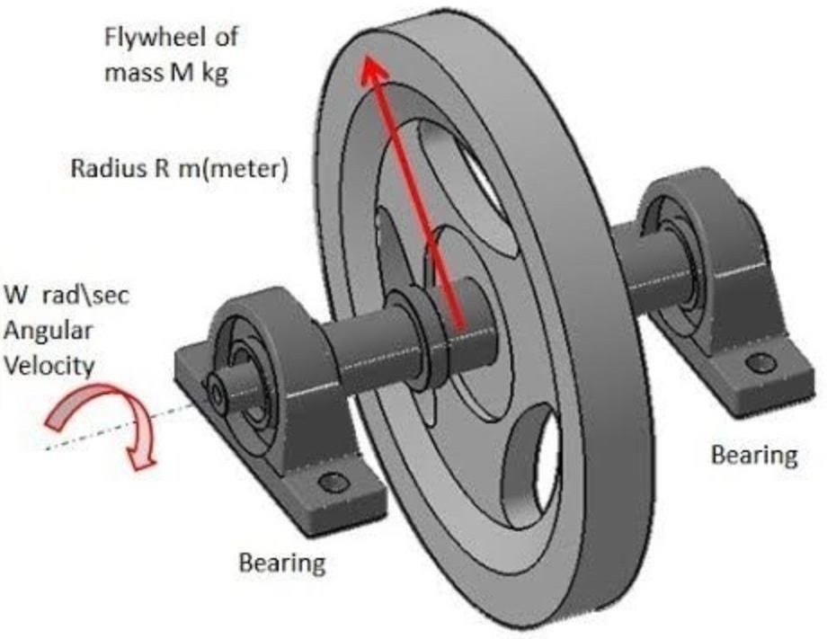

Flywheel, A flywheel is a mechanical device used to store rotational energy in the form of kinetic energy Here are the

details about a flywheel: Material: Flywheels are typically made from materials with high strength-to-weight ratios, such as steel, aluminum, or composite materials. These materials allow the flywheel to store energy efficiently and withstand high rotational speeds. Shape: They are often disc-shaped and can vary in size and diameter based on their intended application. Some flywheels have a solid construction, while others might have spokes or a rim design to reduce weight while maintaining strength. Energy Storage: Flywheels store kinetic energy by spinning at high speeds when energy is input into the system. This stored energy can be later retrieved and used when needed Inertia: The primary function of a flywheel is to provide inertia, acting as a rotating mass that resists changes in rotational speed. This property helps stabilize the rotation and smoothen out fluctuations in mechanical system Energy Storage Systems**:** Flywheels are used in energy storage systems, particularly in applications requiring rapid and short-term energy storage, such as uninterruptible power supplies (UPS) or regenerative braking systems in vehicles. Machinery and Engines: They are employed in various mechanical systems, including engines, where they help maintain rotational stability and provide a consistent output of power. Industrial Equipment: Flywheels are utilized in heavy machinery, manufacturing equipment, and certain types of machinery that require stabilization and smooth operation. Energy Storage: They offer high energy density storage, allowing for rapid energy discharge when needed. Efficiency: Flywheels have low energy loss during energy storage and retrieval, making them relatively efficient. Maintenance**:** Compared to some other energy storage systems, flywheels may require less maintenance.

# EXISTING SYSTEM

Solar energy harvesting involves the process of capturing sunlight using photovoltaic (PV) cells mounted on solar panels. When sunlight strikes these panels, the photovoltaic effect occurs, generating an electric current as photons dislodge electrons in the semiconductor material of the cells. This direct current (DC) electricity undergoes regulation through a charge controller, storing excess energy in batteriesfor later use when sunlight is insufficient. To power standard household or commercial appliances that require alternating current (AC) electricity, an inverter converts the stored DC energy into the necessary AC form. This converted electricity is then utilized by various electrical devices, offering a sustainable and environmentally friendly energy source. Solar energy harvesting minimizes reliance on fossil fuels, mitigates greenhouse gas emissions, and contributes to a more sustainable energy landscape while providing a clean and renewable energy solution. Block diagram of existing

system, Solar Panels (Photovoltaic Cells): Solar panels serve as the primary component for converting sunlight into electrical energy. Photovoltaic cells within the panels absorb sunlight and generate direct current (DC) electricity through the photovoltaic effect. Harvesting Circuit (Maximum Power Point Tracking - MPPT): The harvesting circuit, particularly the MPPT system, optimizes the power output from the solar panels. It continuously adjusts the electrical operating point of the panels to extract the maximum available power, ensuring efficiency even in varying sunlight conditions or panel orientations. Microcontroller (Controller): The microcontroller acts as the system's brain, managing and regulating various operations. It receives data from sensors, controls the MPPT algorithm, and supervises the overall functionality of the system. Its tasks include monitoring panel performance, managing energy flow, and overseeing safety features. DC-DC Converter: The DC-DC converter accepts the optimized DC electricity from the controller and adjusts its voltage levels to suit the requirements of the load. It ensures that the output voltage matches the needed level for the connected electrical devices or loads, allowing for efficient power transfer. Load (Electrical Devices): The load represents the various electrical devices or loads connected to the system. These devices can include lighting, appliances, pumps, or any other equipment requiring electrical power. The power supplied by the DC-DC converter is utilized by these loads to perform their intended functions. Load (Electrical Devices): The load represents the various electrical devices or loads connected to the system. These devices can include lighting, appliances, pumps, or any other equipment requiring electrical power. The power supplied by the DC-DC converter is utilized by these loads to perform their intended functions.

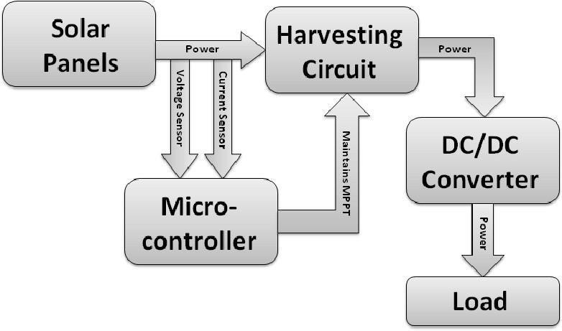Working**:** The solar energy system operates as follows: Solar panels, comprising photovoltaic cells, capture sunlight and convert it into direct current (DC) electricity using the photovoltaic effect. This generated electricity undergoes

optimization by the Maximum Power Point Tracking (MPPT) system within the harvesting circuit, ensuring maximal power extraction from the panels under changing sunlight conditions. The microcontroller, functioning as the system's central processor, coordinates various tasks.

It receives data from sensors, manages the MPPT algorithm, and supervises overall system functionality. This microcontroller regulates energy flow and monitors panel performance. The optimized DC electricity, directed by the microcontroller, reaches the DC-DC converter. This converter adjusts voltage levels to match the requirements of connected electrical devices or loads. Finally, the load, comprising various electrical devices like lighting or appliances, utilizes the converted electricity to perform specific tasks, thus demonstrating the efficient utilization of solar-generated power in practical applications.

# PROPOSED METHOD

The overview of the proposed system is, the escalating global demand for sustainable energy solutions in light of population growth and dwindling fossil fuel reserves has steered attention towards renewable sources, prominently, solar energy conservation. Renowned for its renewable and inexhaustible nature, solar energy has emerged as a pivotal alternative.

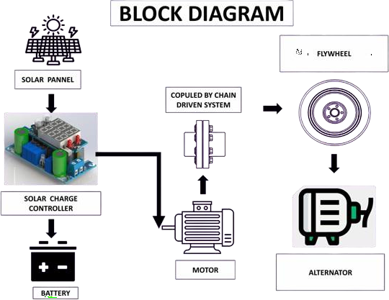

However, the proliferation of solar panels introduces challenges such as heightened installation expenses, limited space availability, intricate maintenance demands, and potential environmental implications from manufacturing to disposal. Yet, solar panels epitomize a clean, enduring energy source, promising long-term cost savings and reducing reliance on conventional fossil fuels. Seeking to curtail the number of solar panels utilized, a novelapproach harnesses solar energy to power a DC motor through a pulley-driven mechanism, subsequently storing kinetic energy in a flywheel. This rotational energy is transformed via an alternator connected to an inverter circuit, yielding surplus energy beyond its consumption threshold. This innovative setup not only optimizes solar energy utilization but also integrates mechanisms for monitoring flywheel revolutions, employing a hall effect sensor to regulate motor activation, thereby presenting an intricate yet, solar panels

epitomize a clean, enduring energy source, promising long- term cost savings and reducing reliance on conventional fossil fuels. Seeking to curtail the number of solar panels utilized, a novel approach harnesses solar energy to power a DC motor through a pulley-driven mechanism, subsequently storing kinetic energy in a flywheel. This rotational energy is transformed via an alternator connected to an inverter circuit, yielding surplus energy beyond its consumption threshold. This innovative setup not only optimizes solar energy utilization but also integrates mechanisms for monitoring flywheel revolutions, employing a hall effect sensor to regulate motor activation, thereby presenting an intricate yet efficient means of sustainableenergy utilization.

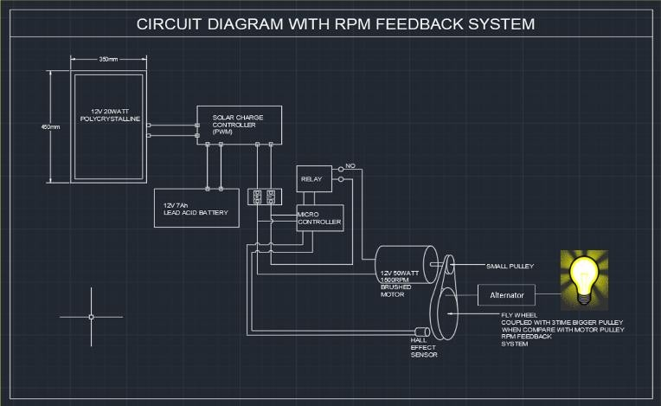

Working method of circuit diagram. The solar panel, rated at 12 volts, yields an output between 16 to 18 volts, producing 20 watts of power. This power is directed to a 12-volt solar charge controller equipped with pulse-width modulation (PWM) technology. The controller integrates a buck converter that regulates voltages surpassing the setpointlimit and transfers the power to a lead-acid battery, supplying 12 volts at 10 amps. Though the battery is labeled as a 12- volt system, its rated voltage stands at 13.5 volts. Utilizing this battery, a 12-volt brushed motor, rated at 15 watts, operates at 1500 revolutions per minute (rpm). Simultaneously, a small pulley attached to the motor rotates at 1500 rpm, transmitting this motion to a flywheel. Consequently, the flywheel rotates at 800 rpm, generating additional energy. Initially, the solar panel produces 20 watts at 0.5 amps, and through the flywheel's output, this increases to 25 watts at 1 amp. The flywheel, coupled with a 12-volt dynamo, produces electrical output, which is then directed to an inverter circuit. This circuit converts the dynamo's output. Into a usable form and supplies it to the intended load. A hall effect sensor, positioned in proximity to the flywheel, monitors its revolutions. Upon reaching a predetermined threshold, the sensor triggers the controller to signal the relay, ceasing motor activation. Conversely, if the sensor detects a reduction in flywheel revolutions, it prompts motor re-energization, maintaining the system's operation. This feedback mechanism ensures efficient and controlled rotational speed, optimizing energy generation and distribution.

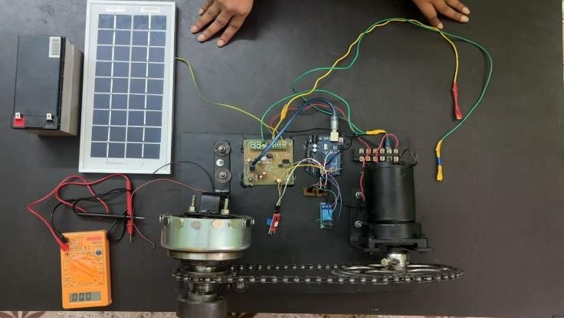

# RESULT

Achieved: Stable output of 16.4V AC; Motor at 2187 RPM; Flywheel sustained at 209.2 RPM.

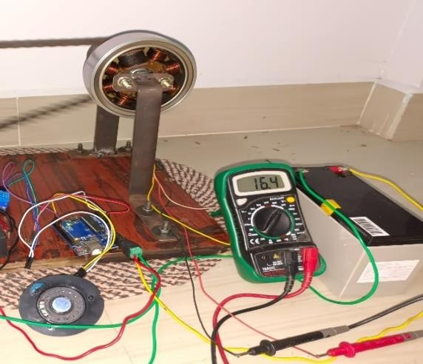

Output Voltage of Generator 16.4V AC

# OUTPUT VALUES

|  |  |  |
| --- | --- | --- |
| DC motor rpm=2187 | Motor rpm after gear box =92.1rmp | Flywheel rpm=209.2 |
| Input voltage from solar panel 22.8VDC | Input Charging voltage for Battery 13.6VDC | Output voltage of Flywheel 16.8VAC |

**CONCLUSION**

In conclusion, the implementation of our solar energy system utilizing a combination of solar panels, charge controllers, batteries, and mechanical components such as brushed motors and flywheels has exhibited promising results. Through harnessing solar energy efficiently and storing it in batteries, we've successfully utilized kinetic energy generated by the flywheel to produce additional power via the dynamo and inverter circuit. This project highlights the potential for integrating various renewable energy technologies to optimize energy capture, storage, and utilization. The reliable operation of the system, coupled with the utilization of kinetic energy, demonstrates a feasible approach towards sustainableand efficient energy production. The future scope is, movingforward, several avenues for further development and enhancement exist within this solar energy project: Optimization of Efficiency: Continued research and

refinement of the system components can significantly enhance overall efficiency, maximizing energy capture and storage. Integration of Advanced Technologies: Exploring more advanced components, such as high- efficiency solar panels, smart charge controllers, and advanced inverter systems, can further improve system performance. Scaling and Commercial Viability**:** Scaling up the system's capacity and exploring its commercial viability for broader applications in off-grid settings or distributed power generation is a promising direction for future exploration. Monitoring and Control Systems**:** Implementingsophisticated monitoring and control systems using IoT (Internet of Things) or AI-based technologies can enable real- time performance tracking, predictive maintenance, and remote system control. By pursuing these future avenues, weaim to enhance the efficiency, reliability, and scalability of our solar energy system, contributing to the advancement and widespread adoption of renewable energy solutions in the quest for a sustainable energy future.

# REFERENCE

1. Doe, J. K. (2021). Innovative Solar Panel Technologies: A Comparative Analysis of Efficiency and Durability).XYZ University, Los Angeles.
2. 3) CA. Garcia, M. S. (2023). Solar Energy Storage Solutions: Evaluating Battery Technologies for Residential Applications. MN College, Chicago.
3. IL. Brown, T. R. (2020). Smart Grid Integration of Solar Power Systems: Challenges andStrategies PQR University, Houston.

(4) 5) TX. Lee, H. W. (2019).

Optimization Techniques for Solar Photovoltaic Systems: Maximizing Energy Yield RST Institute, San Francisco.

1. CA .Robinson, A. C. (2018).Solar Energy Policy Analysis: Case Study of Government Incentives. UVW College, Boston.
2. MA. Smith, E. A., & Johnson,

R. B. (2021). Advances in Flywheel Energy Storage Systems: A Review of Applications and Technologies. Renewable and SustainableEnergy Reviews.