**DIGITAL TWIN AND MIXED REALITY-BASED PROCESS CONTROL FOR BOILER APPLICATION**

**Dr.D. Sivanandakumar1,S.Karthikeyan2, R. Deepak3, K.Vignesh4, S.Karthikeyan.5, R.Vimalraj6 , A. Senguttuvan7, M. Dhanush Kumar8 , T. Thamizh selvan9,A. Rohit10**

1Professor, Department of Instrumentation and Control Engineering, Sri Manakula Vinayagar Engineering College, Puducherry, [sivanandakumarice@smvec.ac.in](mailto:sivanandakumarice@smvec.ac.in)

2,3,4,5,6,7,8, Under Graduate Student, Department of Instrumentation and Control Engineering, Sri Manakula Vinayagar Engineering College, Puducherry,

[cukarthikeyan@gmail.com](mailto:cukarthikeyan@gmail.com),

[rajadee9,10pak1989@gmail.com](mailto:rajadeepak1989@gmail.com),

[vigneshkrishna7710@gmail.com](mailto:vigneshkrishna7710@gmail.com)

[vima86187@gmail.com](mailto:vima86187@gmail.com)

[senguttuvan12102003@gmail.com](mailto:senguttuvan12102003@gmail.com)

[dhanushkumar1032004@gmail.com](mailto:dhanushkumar1032004@gmail.com)

[thamizhselvan12122@gmail.com](mailto:thamizhselvan12122@gmail.com)

[rogithzayn@gmail.com](mailto:rogithzayn@gmail.com)

**Abstract**

Mixed reality (MR) integrates virtual reality components seamlessly with human vision. Head-mounted devices feature transparent screens, offering users an unobstructed view, while employing diverse technologies to project images onto these screens. Whether for monitoring industrial operations or power plants, MR offers a more convenient means of visualizing images and data compared to traditional charts or screens. MR introduces innovative ways of engaging users by projecting information in a 3D format. As medical schools and other institutions delve deeper into MR, experts will undoubtedly uncover novel applications for this technology. In a ground breaking move for the technology sector, the MR Vision system emerges as a pivotal tool for real-time machine monitoring and tracking. Leveraging image-based output and tracking capabilities, the MR Vision system sets a new standard for efficiency and precision in machine management*.*

**Problem**

Despite the potential benefits of Mixed Reality (MR) in various sectors such as industrial monitoring and medical education, there remains a need for advanced systems that effectively integrate virtual reality components with human vision. Current MR technologies offer transparent screens on head-mounted devices, but there is a lack of comprehensive solutions that seamlessly project images and data onto these screens for real-time machine monitoring and tracking. Therefore, the development of the MR Vision system aims to address this gap by leveraging image-based output and tracking capabilities to set a new standard for efficiency and precision in machine management.

**Solution**

To address the challenges outlined in the problem statement and abstract, the development of the MR Vision system will focus on several key components:

1. Advanced Hardware: Designing and manufacturing head-mounted devices with transparent screens that provide users with an unobstructed view, while integrating diverse technologies for projecting images and data onto these screens. This hardware will be optimized for durability, comfort, and seamless integration with MR software.

2. Cutting-edge Software: Developing MR software that utilizes innovative algorithms and techniques to project information in a 3D format, enhancing user engagement and comprehension. This software will also incorporate real-time machine monitoring and tracking capabilities, allowing users to visualize machine data overlaid onto their physical environment.

3. Machine Learning and Image Processing: Implementing machine learning algorithms for image-based output and tracking, enabling the MR Vision system to recognize and analyze machine components, anomalies, and performance metrics in real-time. This will enhance the system's efficiency and precision in machine management, facilitating proactive maintenance and optimization.

4. Integration and Compatibility: Ensuring seamless integration of the MR Vision system with existing industrial monitoring and management systems, as well as medical education platforms. Compatibility with industry standards and protocols will be prioritized to facilitate widespread adoption and interoperability.

5. User Interface and Experience: Designing an intuitive user interface that enables users to easily interact with the MR Vision system, access relevant information, and perform necessary tasks without hindering their workflow. User experience testing and feedback will be incorporated into the development process to optimize usability and satisfaction.

6. Security and Privacy: Implementing robust security measures to protect sensitive data transmitted and processed by the MR Vision system. This includes encryption protocols, access controls, and compliance with relevant data protection regulations to ensure the confidentiality and integrity of user and machine data.

By addressing these components comprehensively, the MR Vision system will provide a transformative solution for real-time machine monitoring and tracking, setting a new standard for efficiency and precision in various industries.

**Existing System**

No database based system available to compare or to analyse a person’s history of tracking and biomedical data. No updated technology for scanning like AR, VR and MR. No image based output in current method.

**Proposed System**

Mixed reality combines virtual reality elements with human vision. Head-mounted devices use clear screens to give users an unobstructed view, but various technologies can be used to project images onto the screen. For monitoring the industry or power plant, MR provides a means of viewing images and data far more convenient than charts or screens. Furthermore, MR can provide new ways of interacting with users by projecting information in 3D view. As medical schools and other organizations continue to explore MR, experts will devise novel uses for MR technology.

* First time in Technology MR Vision system utilizes for the real-time update and track of machines.
* The Images based output and tracking with MR vision system.

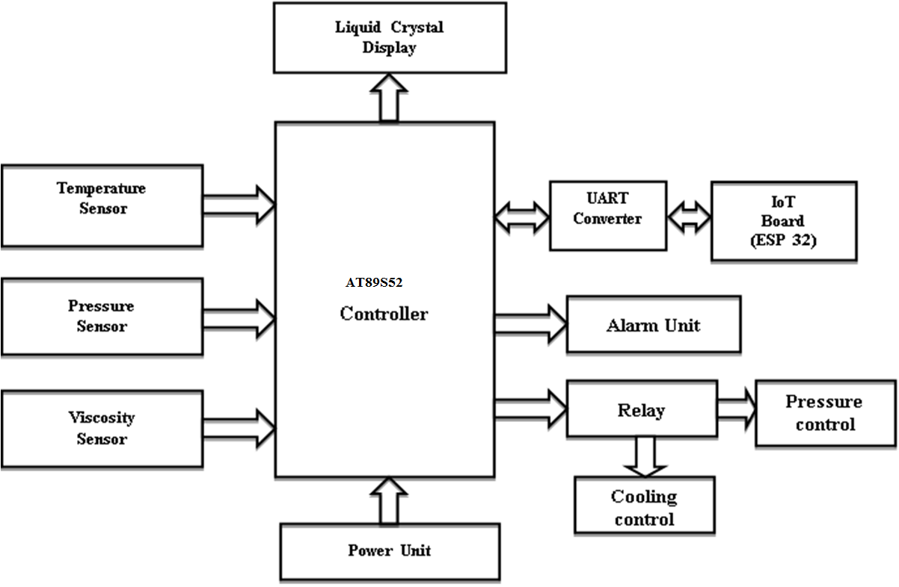

A system for monitoring and controlling industrial processes. It uses sensors to track temperature, pressure, and viscosity, with a microcontroller managing the data. An IoT board enables remote access, while a display and alarm unit provide real-time feedback and alerts. Actuators, like relays, adjust pressure and cooling as necessary for optimal operation. Overall, this setup enhances efficiency and safety in industrial settings.

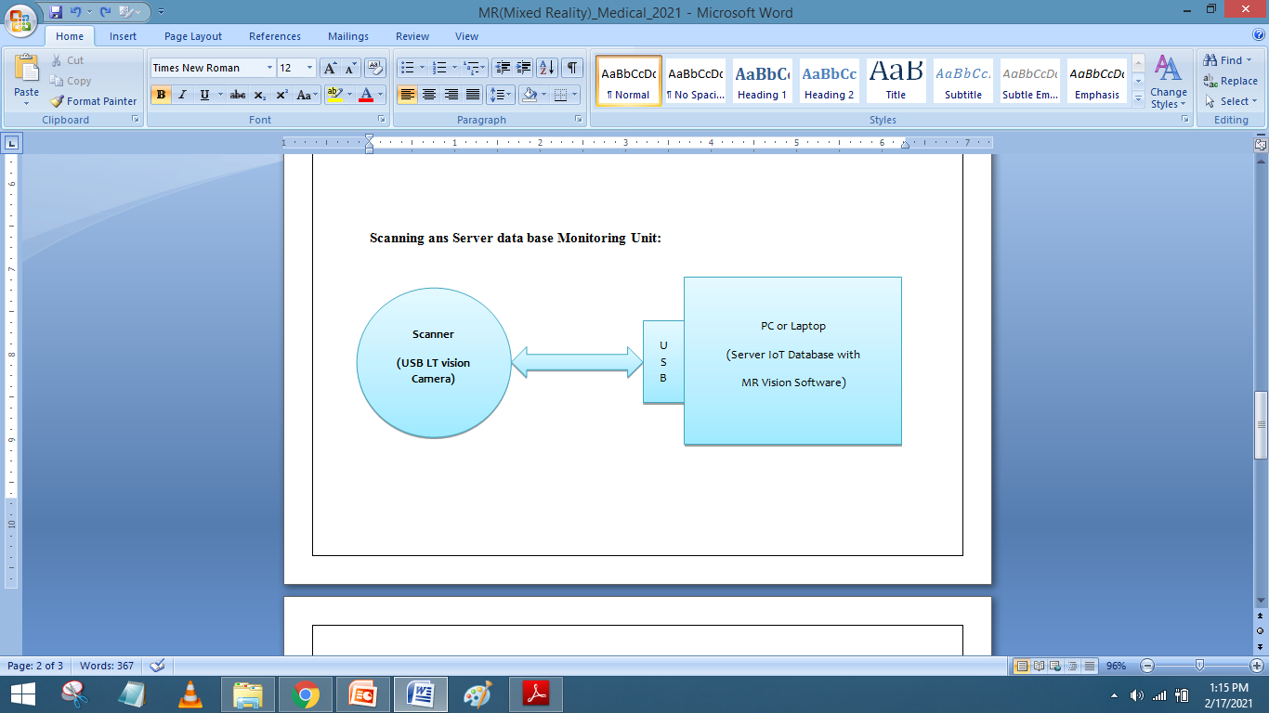

A system where a PC or laptop is connected to a server hosting an IoT database and MR vision software. A barcode scanner is linked to the PC, allowing barcode scanning for data input. Additionally, a USB LT vision camera provides visual input for tasks like image recognition. This setup offers versatile applications such as inventory management and quality control.

**RESULT AND DISCUSSION**

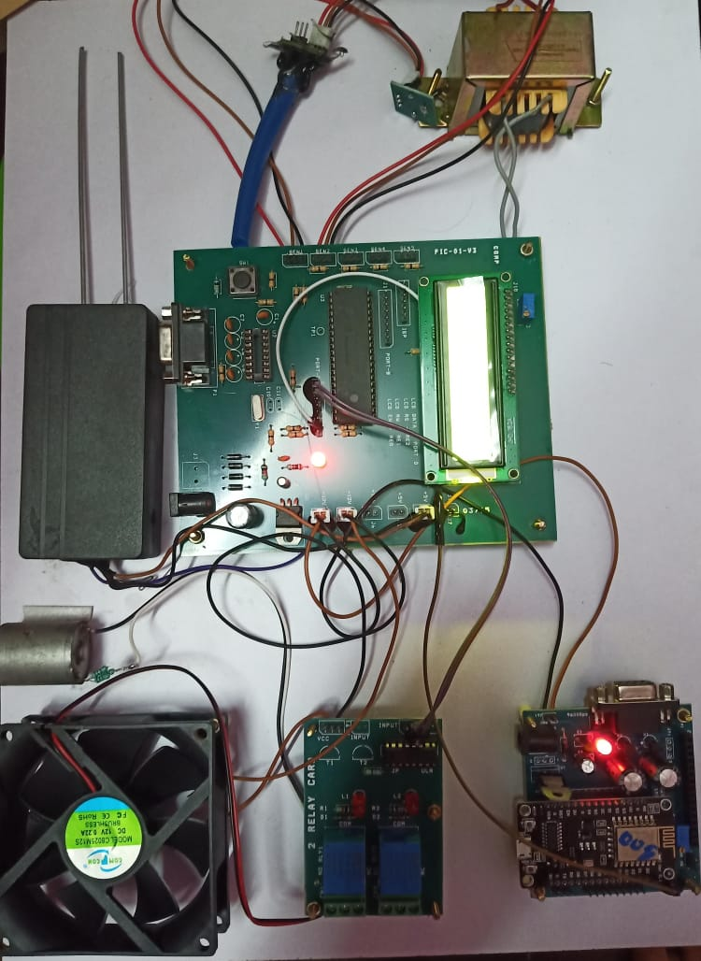

|  |  |  |
| --- | --- | --- |
| Type | Input Voltage | Output Voltage |
| Stepdown Transformer | 230V | 12V |
|  | | |

Power generation using stepdown transformers. It highlights key factors like efficiency, voltage regulation, and suitability. This comparison helps in choosing the right transformer type based on needs and constraints, making it useful for decision-makers in power systems.

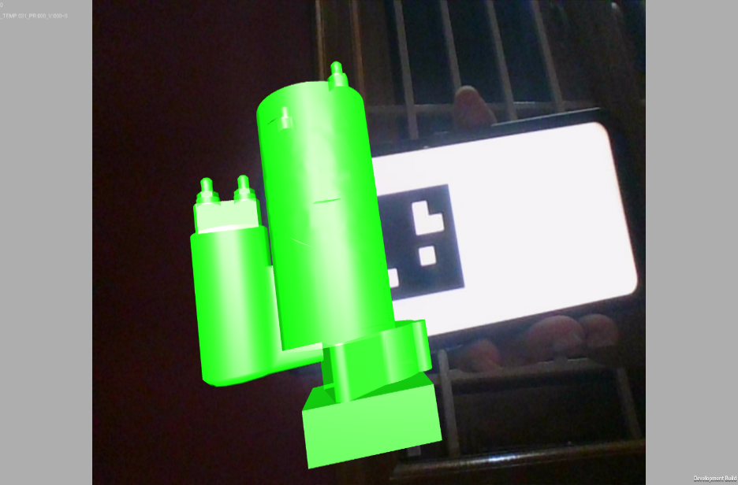A digital copy of a boiler system. It mimics the real boiler's components and how it works. providing a virtual representation of its physical components and operational dynamics. This digital model serves as a simulation tool for analyzing and optimizing boiler performance without the need for direct access to the physical equipment. By replicating the behavior of the actual boiler, including factors like fuel combustion, heat transfer, and steam generation, the digital replica enables engineers and operators to conduct virtual experiments, test different control strategies, and predict system behavior under various operating conditions.

**CONCLUSION**

In this survey we could able to Identify a promising solution for enhancing operational efficiency and safety. By creating virtual replicas of physical assets through Digital Twins, coupled with real-time data processing and visualization enabled by Mixed Reality, operators gain valuable insights into boiler performance, facilitating predictive maintenance and optimized operations. This approach not only minimizes downtime and maintenance costs but also improves overall system reliability and safety. As a result, the synergy between Digital Twin and Mixed Reality technologies offers a transformative paradigm for process control in thermal power plants, ensuring sustainable and resilient energy generation for the future.

**FUTURE SCOPE**

The future scope of the digital twin and mixed reality-based process control for boiler applications involves integrating advanced AI algorithms for proactive fault detection and performance optimization. Enhancing mixed reality interfaces with AR and VR technologies could provide operators with more immersive and intuitive experiences. Additionally, incorporating edge computing and IoT devices would improve system responsiveness and reliability. Expanding the project's applicability to various industrial sectors beyond thermal power plants could offer tailored solutions for diverse process control needs. Moreover, adapting the system to manage hybrid energy systems and renewables could support the transition to cleaner energy sources. Continuing innovation and research will ensure the system remains at the forefront of industrial process control advancements.

**REFERENCES**

[1] Digital Twin-Based Automated Fault Diagnosis in Industrial IoT Applications Samah Alshathri1, Ezz El-Din Hemdan, Walid El-Shafai, and Amged Sayed, DOI: 10.32604/cmc.2023.034048.

[2] Design and Simulation of Boiler Combustion Control System in Thermal Power, Plant,Kong Xiangyu, YuYang, Zhang Meng, Changchun University Changchun. China,Yin Hongzhi Beijing Rising Ensign Technology Co.,Ltd Beijing, China -2023.

[3] Boiler combustion control system optimization strategy, Yong Zhanga, Yuan Yao and Ting Luan -2013.

[4] Augmented Reality Authoring of Digital Twins: Design, Implementation and Evaluation in an Industry 4.0 Context - 2022.

[5] A Digital Twin-Based System to Manage the Energy Hub and Enhance the Electrical Grid Resiliency Gholamreza Nasiri and Abdollah Kavousi-Fard - 2023.

[6] An Interoperable Digital Twin with the IEEE 1451 Standardsm Helbert da Rocha , João Pereira , Reza Abrishambaf and Antonio Espirito Santo - 2022.

[7] Research on digital twin construction technology and application of large capacity utility boiler,Kai Xuan Yang; Yong Wang; Zhi Cheng Deng; Meng Sun; Gang Ding; Letian Li - 2021.

[8] Development and Application of a Digital Twin for Chiller Plant Performance Assessment, Mihir Kale- 2021.

[9] Research on Fault Diagnosis and Early Warning of Power Plant Boiler Reheater Temperature Deviation Based on Machine Learning Algorithm,Yu-jia Cui; Liang-wei Xia; Ying Huang; Xiao-chun Ma - 2023.

[10] Design Mechanism for the Fault Diagnosis System of Power Plant Boiler Based on Neural Networks, Jinghui Song; Yongxin Feng - 2023.

[11] Systematic review of digital twin technology and applications Jun‑Feng Yao , Yong Yang, Xue‑Cheng Wang and Xiao‑Peng Zhang - 2023

[12] Energy digital twin technology for industrial energy management: Classification, challenges and future Wei Yu , Panos Patros , Brent Young , Elsa Klinac , Timothy Gordon Walmsley - 2022

[13] Digital twin in energy industry: Proposed robust digital twin for power plant and other complex capital-intensive large engineering systems Ahmad K. Sleiti , Jayanta S. Kapat , Ladislav Vesely -2022

[14] Technologies and Applications of Digital Twin for Developing Smart Energy Systems Tang Wenhu, Chen Xingyu, Qian Tong, Liu Gang, Li Mengshi, Li Licheng - 2020

[15] Corsican Twin: Authoring In Situ Augmented Reality Visualisations in Virtual Reality Arnaud Prouzeau, Yuchen Wang, Barrett Ens, Wesley Willett, Tim Dwyer Monash University, Australia, University of Calgary, Canada- 2020

[16] Boiler Digital Twin Applying Machine Learning

hidetoshi aiki , kazuhiko saito , kazuhiro domoto , hirotomo Hirahara , kazutaka obara , soichiro sahara -2018

[17] Application of Digital Twins and Metaverse in the Field of Fluid Machinery Pumps and Fans: A Review

Bin Yang , Shuang Yang , Zhihan Lv , Faming Wang , and Thomas Olofsson - 2022

[18] Technologies and Applications of Digital Twin for Developing Smart Energy Systems Tang Wenhu, Chen Xingyu, Qian Tong, Liu Gang, Li Mengshi, Li Licheng-2020

# [19] LSTM-based soft sensor design for oxygen content of flue gas in coal-fired power plant [Hongguang Pan](https://journals.sagepub.com/doi/full/10.1177/0142331220932390#con1), [Zheng Wang](https://journals.sagepub.com/doi/full/10.1177/0142331220932390#con4), - 2021

[20] Development and implementation of advanced control strategies for power plant cycling with carbon capture Xin He, Fernando V. Lima