The Influence of Organizational Culture and Leadership Style on the Turnover Intention of PT Cipta Kridatama Employees in Kutai Kartanegara with Work Motivation as a Mediation Variable
Mabruri

¹Department of Psychology, 17 August 1945 University of Surabaya, Surabaya, East Java, Indonesia

ABSTRACT

Mining companies are one of the important sectors in economic growth. Based on data obtained in 2023, the number of mining production in East Kalimantan continues to decrease every year, indicated by a high turnover rate that causes mining companies in East Kalimantan to experience a shortage of human resources. This study focuses on the influence between organizational culture on employee work motivation, the influence between leadership style on employee work motivation, the influence between work motivation on employee turnover intention, the influence between organizational culture on employee turnover intention, the influence between leadership style on employee turnover intention, the influence between organizational culture on employee turnover intention mediated by work motivation, and the influence between leadership style on employee turnover intention mediated by work motivation. This study uses a quantitative methodology. Data collection uses the purposive sampling method to obtain a total of 308 respondents. The results showed that organizational culture had an effect on employee work motivation, leadership style had an effect on employee work motivation, organizational culture had no effect on employee turnover intention, leadership style had an effect on employee turnover intention, work motivation had an effect on employee turnover intention, work motivation mediates organizational culture affects employee turnover intention, and leadership style affects employee turnover intention of PT Cipta Kridatama in Kutai Kartanegara.
Keywords organizational culture, leadership style, work motivation and turnover intention.

- INTRODUCTION

Mining companies are one of the important sectors in economic growth. This is because mining companies provide the raw materials needed to produce goods that can support the sustainable economic growth of a region and country [1]. In Indonesia, especially in East Kalimantan, it is one of the regions with abundant mining products so that the mining sector is the main company for the economic growth of the province [2]. However, based on the data obtained, it can be seen that the number of mining production in East Kalimantan continues to decline every year [3].
The decrease in the number of mining products production in East Kalimantan is indicated by a high turnover rate that causes mining companies in East Kalimantan to experience a shortage of human resources. In fact, the key to the success of a mining company is the function of human resources in the mining company [4]. If a mining company can manage its employees, it can achieve its organizational goals and significantly contribute to national economic growth and job opening [4].
One of the reasons for employee resignation is driven by turnover intention, which is the tendency of employees to consider leaving the company where they work. This is done voluntarily or forcedly [5]. Turnover Intention can be caused by the dissatisfaction felt by the employee with his or her job or because the employee accepts other job opportunities that are considered more attractive and beneficial to the employee [5]. Turnover intention can be caused by various factors, one of which is organizational culture, leadership style, and employee motivation.
Research that examines the influence of organizational culture, leadership style, and employee motivation has been carried out a lot, but there are still variations related to the results of the research. This results in inconsistencies that lead to the need to study the influence of leadership style, organizational culture, and motivation on employee turnover intention to strengthen theories related to leadership style, organizational culture, and motivation and its influence on turnover intention. Therefore, the research gap in this study lies in the novelty of the formulation of the framework of factors and the influence between new factors related to the development of leadership theory.
The object of this research is an employee of PT Cipta Kridatama located in Kutai Kartanegara. Based on the data obtained, it is known that the turnover rate in 2021-2023 at PT Cipta Kridatama always exceeds the company's attrition target. The high level of turnover intention is caused by various problems in the company. One of the problems that exists is related to leadership. In the company, the communication that takes place between the company's leaders and its employees does not go well. Another problem is related to the recruitment of new employees. The high resignation rate in the company causes the company to have to look for new employees. In order to work well, the new employee should be given training according to his field. However, due to the large demand for production targets in the mining company, the training process for new employees is difficult to do. This causes the new employees to find it difficult to adjust to their new jobs.
Therefore, the researcher is interested in researching the influence between organizational culture, leadership style, and motivation on employee turnover intention at PT Cipta Kridatama with the research title "The Influence of Organizational Culture and Leadership Style on the Turnover Intention of PT Cipta Kridatama Employees in Kutai Kartanegara with Work Motivation as a Mediation Variable".

- METHODOLOGY

MATERIAL AND METHOD
This study uses a quantitative research design with a cross sectional approach because this study aims to find out the overview of organizational culture, leadership style, work motivation and turnover intention in the company PT Cipta Kridatama in Kutai Kartanegara.
Data Collection
The primary objective of this research is to investigate whether the variables of organizational culture (X1) and leadership style (X2) can be considered as determinants of turnover intention (Y), with work motivation (Z) as an intervening factor. The study's target population consists of all employees at PT Cipta Kridatama. The chosen sampling technique is non-probability sampling with purposive sampling methode. According to the Slovin formula, the sample size for this study is determined to be 308 respondents, who will be surveyed using Google Forms. The data analysis for this research using Partial Least Square (PLS) utility, which is implemented in SmartPLS version 4, with path analysis being employed to examine the relationships among the variables.
Variable Operational Definition
- Organizational Culture (X1)
Organizational culture includes determining organizational boundaries, the identity of organizational members, facilitating the birth of commitment to something greater than individual interests, increasing the stability of social systems, and the mechanism of sense making [5]. Increasing a sense of belonging, a tool for organizing, increasing organizational strength, controlling behavior, encouraging member performance, determining organizational goals [6]. To measure this (X1), according to [7], is applied, consisting of 7 indicators: innovation and risk-taking, attention to detail, results-oriented, people orientation, team orientation, stability and aggressiveness.

- Leadership Style (X2)
Leadership style can influence an employee's commitment to the company and the success or failure of a company is largely due to the leadership style of its leaders [8]. To measure this (X2), according to [7] is applied, consisting of 6 indicators: decision-making skills, motivational skills, communication skills, ability to control subordinates, responsibility, and emotional control skills.

- Turnover Intention (Y)
Turnover intention is defined in two types, first, voluntary turnover and second, involuntary turnover. The factors that influence turnover intention includes leadership style, organizational justice, climate organisation, opportunities promotion, income, culture organisation, stress at work and satisfaction [9]. To measure this (Y), according to [7] is applied, consisting of 3 indicators: intention to quit, job search, and thinking of quit.

- Work Motivation (Z)
Work motivation is defined as the encouragement of workers in choosing actions and perseverance in doing so. These impulses interact with environmental factors that determine a psychological process that provides energy, direction, and continuity of work behavior. [11] 3 characteristics of workers that show work motivation includes direction, effort and enthusiasm, persistence. To measure this (Z), according [10] is applied, consisting of 5 indicators: physiological needs, safety needs, social needs, the need for self-esteem and actualization.

- ANALYSIS

Hypothesis Development
Based on the theory and support of previous research in accordance with the formulation of the problem, the researcher proposes the following hypothesis:
- The Influence of Organizational Culture on Motivation
There is an influence of Organizational Culture on motivation in PT Cipta Kridatama employees in Kutai Kartanegara.

- The Influence of Leadership Style on Motivation
There is an influence of Leadership Style on motivation in employees of PT Cipta Kridatama in Kutai Kartanegara.

- The Influence of Organizational Culture on Turnover Intention
There is an influence of Organizational Culture on Turnover Intention in employees of PT Cipta Kridatama in Kutai Kartanegara.
- The Influence of Leadership Style on Turnover Intention
There is an influence of Leadership Style on Turnover Intention in employees of PT Cipta Kridatama in Kutai Kartanegara.

- The Effect of Motivational Mediation on Turnover Intention
There is an effect of Motivation mediation on Turnover Intention in employees of PT Cipta Kridatama in Kutai Kartanegara.

- The Influence of Organizational Culture on Motivation-Mediated Turnover Intention
There is an effect of Motivation mediation on the influence of Organizational Culture on Turnover Intention in employees of PT Cipta Kridatama in Kutai Kartanegara.

- The Influence of Leadership Style on Motivation-Mediated Turnover Intention
There is an effect of Motivation mediation on the influence of Leadership Style on Turnover Intention in employees of PT Cipta Kridatama in Kutai Kartanegara.
- RESULTS AND DISCUSSION

Respondent Characteristics

- Respondent Characteristics by Gender
The first characteristic of the respondents analyzed was the comparison of the number of respondents by gender.

Table 1. Respondent Characteristics by Gender
No | Gender | Sum | Percentage
1 | Male | 362 | 96.8%
2 | Female | 12 | 3.2%
Total |  | 374 | 100.0%
Source: Primary Data Processed, 2024

- Respondent Characteristics by Age
The second characteristic of the analyzed respondents was the comparison of the number of respondents based on age.

Table 2. Respondent Characteristics by Age
No | Age | Sum | Percentage
1 | 18 – 24 Years | 26 | 7.0%
2 | 24 – 30 Years | 66 | 17.6%
3 | > 30 Years | 282 | 75.4%
Total |  | 374 | 100.0%
Source: Primary Data Processed, 2024
- Respondent Characteristics Based on Length of Work
The third characteristic of the respondents analyzed was a comparison of the number of respondents based on the length of work.

Table 3. Respondent Characteristics Based on Length of Work
No | Length of Work | Sum | Percentage
1 | 1 – 3 Years | 131 | 35.0%
2 | 3 – 5 Years | 92 | 24.6%
3 | 5 – 7 Years | 24 | 6.4%
4 | > 7 Years | 127 | 34.0%
Total |  | 374 | 100.0%
Source: Primary Data Processed, 2024
- Respondent Characteristics Based on Position
The fourth characteristic of the respondents analyzed is a comparison of the number of respondents based on position.

Table 4. Respondent Characteristics Based on Position
No | Position | Sum | Percentage
1 | Non Staff | 205 | 54.8%
2 | Staff | 169 | 45.2%
Total |  | 374 | 100.0%
Source: Primary Data Processed, 2024

Descriptive Variables

- Descriptive Analysis of Organizational Culture Variables
The results of the descriptive analysis for the Organizational Culture variable can be seen in the following table :

Table 5. Descriptive Analysis of Organizational Culture Variables
Item | STS |  | TS |  | KS |  | S |  | SS |  | Average
 | F | % | F | % | F | % | F | % | F | %
BO1 | 1 | 0.3% | 11 | 2.9% | 87 | 23.2% | 152 | 40.5% | 123 | 32.8% | 4.03
BO2 | 1 | 0.3% | 25 | 6.7% | 115 | 30.7% | 108 | 28.8% | 125 | 33.3% | 3.89
BO3 | 1 | 0.3% | 15 | 4.0% | 114 | 30.4% | 123 | 32.8% | 121 | 32.3% | 3.93
BO4 | 0 | 0.0% | 6 | 1.6% | 104 | 27.7% | 127 | 33.9% | 137 | 36.5% | 4.06
BO5 | 2 | 0.5% | 15 | 4.0% | 67 | 17.9% | 165 | 44.0% | 125 | 33.3% | 4.06
BO6 | 9 | 2.4% | 19 | 5.1% | 99 | 26.4% | 109 | 29.1% | 138 | 36.8% | 3.93
BO7 | 3 | 0.8% | 5 | 1.3% | 72 | 19.2% | 149 | 39.7% | 145 | 38.7% | 4.14
BO8 | 3 | 0.8% | 12 | 3.2% | 118 | 31.5% | 91 | 24.3% | 150 | 40.0% | 4.00
BO9 | 0 | 0.0% | 1 | 0.3% | 56 | 14.9% | 138 | 36.8% | 179 | 47.7% | 4.32
BO10 | 5 | 1.3% | 21 | 5.6% | 101 | 26.9% | 99 | 26.4% | 148 | 39.5% | 3.97
BO11 | 0 | 0.0% | 17 | 4.5% | 105 | 28.0% | 107 | 28.5% | 145 | 38.7% | 4.02
BO12 | 4 | 1.1% | 3 | 0.8% | 60 | 16.0% | 155 | 41.3% | 152 | 40.5% | 4.20
Organizational Culture Grand Mean |  |  |  |  |  |  |  |  |  |  | 4.05
Source: Primary Data Processed, 2024

Based on table above, it can be seen that the average value obtained by the Organizational Culture variable is 4.05 or included in the good category.

- Descriptive Analysis of Leadership Style Variables
The results of the descriptive analysis for the Leadership Style variable can be seen in the following table:

Table 6. Descriptive Analysis of Leadership Style Variables
Item | STS |  | TS |  | KS |  | S |  | SS |  | Average
 | F | % | F | % | F | % | F | % | F | %
GK1 | 2 | 0.5% | 9 | 2.4% | 36 | 9.6% | 216 | 57.6% | 111 | 29.6% | 4.14
GK2 | 2 | 0.5% | 12 | 3.2% | 34 | 9.1% | 228 | 60.8% | 98 | 26.1% | 4.09
GK3 | 1 | 0.3% | 3 | 0.8% | 34 | 9.1% | 212 | 56.5% | 124 | 33.1% | 4.22
GK4 | 71 | 18.9% | 97 | 25.9% | 102 | 27.2% | 66 | 17.6% | 38 | 10.1% | 2.74
GK5 | 2 | 0.5% | 7 | 1.9% | 32 | 8.5% | 207 | 55.2% | 126 | 33.6% | 4.20
GK6 | 4 | 1.1% | 10 | 2.7% | 50 | 13.3% | 189 | 50.4% | 121 | 32.3% | 4.10
GK7 | 64 | 17.1% | 109 | 29.1% | 114 | 30.4% | 63 | 16.8% | 24 | 6.4% | 2.66
GK8 | 9 | 2.4% | 8 | 2.1% | 37 | 9.9% | 210 | 56.0% | 110 | 29.3% | 4.08
GK9 | 78 | 20.8% | 111 | 29.6% | 98 | 26.1% | 59 | 15.7% | 28 | 7.5% | 2.59
GK10 | 4 | 1.1% | 11 | 2.9% | 35 | 9.3% | 191 | 50.9% | 133 | 35.5% | 4.17
GK11 | 5 | 1.3% | 13 | 3.5% | 36 | 9.6% | 206 | 54.9% | 114 | 30.4% | 4.10
GK12 | 5 | 1.3% | 9 | 2.4% | 51 | 13.6% | 215 | 57.3% | 94 | 25.1% | 4.03
Leadership Style Grand Mean |  |  |  |  |  |  |  |  |  |  | 3.76
Source: Primary Data Processed, 2024

Based on table above, it can be seen that the average value obtained by the Leadership Style variable is 3.76 or included in the good category.
- Descriptive Analysis of Work Motivation Variables
The results of the descriptive analysis for the Work Motivation variable can be seen in the following table:

Table 7. Descriptive Analysis of Work Motivation Variables
Item | STS |  | TS |  | KS |  | S |  | SS |  | Average
 | F | % | F | % | F | % | F | % | F | %
MK1 | 1 | 0.3% | 3 | 0.8% | 30 | 8.0% | 174 | 46.4% | 166 | 44.3% | 4.34
MK2 | 3 | 0.8% | 14 | 3.7% | 53 | 14.1% | 182 | 48.5% | 122 | 32.5% | 4.09
MK3 | 1 | 0.3% | 2 | 0.5% | 21 | 5.6% | 128 | 34.1% | 222 | 59.2% | 4.52
MK4 | 0 | 0.0% | 1 | 0.3% | 10 | 2.7% | 162 | 43.2% | 201 | 53.6% | 4.51
MK5 | 1 | 0.3% | 1 | 0.3% | 22 | 5.9% | 209 | 55.7% | 141 | 37.6% | 4.30
MK6 | 0 | 0.0% | 5 | 1.3% | 33 | 8.8% | 214 | 57.1% | 122 | 32.5% | 4.21
MK7 | 1 | 0.3% | 10 | 2.7% | 59 | 15.7% | 149 | 39.7% | 155 | 41.3% | 4.20
MK8 | 46 | 12.3% | 89 | 23.7% | 118 | 31.5% | 78 | 20.8% | 43 | 11.5% | 2.95
MK9 | 0 | 0.0% | 1 | 0.3% | 19 | 5.1% | 209 | 55.7% | 145 | 38.7% | 4.33
MK10 | 1 | 0.3% | 4 | 1.1% | 22 | 5.9% | 197 | 52.5% | 150 | 40.0% | 4.31
Work Motivation Grand Mean |  |  |  |  |  |  |  |  |  |  | 4.18
Source: Primary Data Processed, 2024

Based on table above, it can be seen that the average value obtained by the Work Motivation variable is 4.18 or included in the good category.

- Descriptive Analysis of Turnover Intention Variables
The results of the descriptive analysis for the Turnover Intention variable can be seen in the following table:

Table 8. Descriptive Analysis of Turnover Intention Variables
Item | STS |  | TS |  | KS |  | S |  | SS |  | Average
 | F | % | F | % | F | % | F | % | F | %
TI1 | 224 | 59.7% | 73 | 19.5% | 51 | 13.6% | 16 | 4.3% | 10 | 2.7% | 1.70
TI2 | 184 | 49.1% | 90 | 24.0% | 67 | 17.9% | 27 | 7.2% | 6 | 1.6% | 1.88
TI3 | 173 | 46.1% | 92 | 24.5% | 61 | 16.3% | 35 | 9.3% | 13 | 3.5% | 1.99
TI4 | 186 | 49.6% | 96 | 25.6% | 49 | 13.1% | 31 | 8.3% | 12 | 3.2% | 1.90
TI5 | 156 | 41.6% | 91 | 24.3% | 58 | 15.5% | 48 | 12.8% | 21 | 5.6% | 2.16
TI6 | 135 | 36.0% | 91 | 24.3% | 75 | 20.0% | 47 | 12.5% | 26 | 6.9% | 2.30
TI7 | 147 | 39.2% | 93 | 24.8% | 78 | 20.8% | 36 | 9.6% | 20 | 5.3% | 2.17
TI8 | 205 | 54.7% | 98 | 26.1% | 49 | 13.1% | 13 | 3.5% | 9 | 2.4% | 1.72
TI9 | 170 | 45.3% | 105 | 28.0% | 60 | 16.0% | 24 | 6.4% | 15 | 4.0% | 1.95
TI10 | 178 | 47.5% | 111 | 29.6% | 58 | 15.5% | 16 | 4.3% | 11 | 2.9% | 1.85
Turnover Intention Grand Mean |  |  |  |  |  |  |  |  |  |  | 1.96
Source: Primary Data Processed, 2024

Based on table above, it can be seen that the average value obtained by the Turnover Intention variable is 1.96 or included in the bad category.
SEMPLS Analysis
This research was carried out using Structural Equation Modelling – Partial Least Square (SEM-PLS) analysis with the help of the SmartPLS 4 application. The Sem-PLS analysis in this study was carried out at two levels, namely First Order Confirmatory Factor Analysis (First-Order CFA) and Second Order Confirmatory Factor Analysis (Second-Order CFA). This is done because in the first level of analysis, there are indicators that are invalid constructively. So the indicator must be removed from the model and then re-analyzed in the CFA Second Order [12].

- First-Order Confirmatory Factor Analysis (First-Order CFA)

- Evaluation of Measurement Model (Outer Model)
The evaluation of the outer model of the research was carried out to four criterias, which are Convergent Validity, Discriminant Validity (for validity testing), Composite Reliability and Cronbach Alpha (for reliability testing).

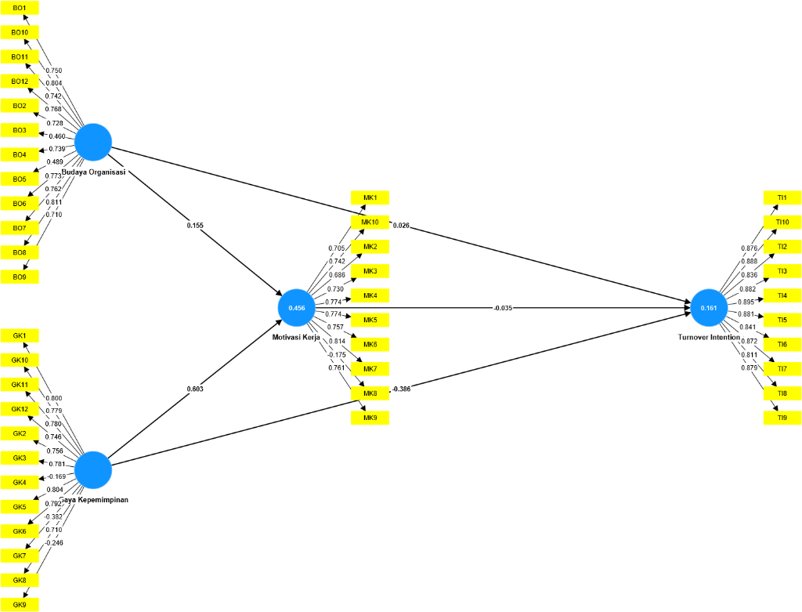
gggg
Figure 1. Outer Model
Source: Primary Data Processed, 2024

- Convergent Validity
In testing convergent validity, the value of outer loading or loading factor is used. The indicator is declared to meet the convergent validity in the good category if the outer loading value > 0.7 (more than 0.7) [13] [14].

The outer loading values of each indicator can be seen in the following table:

Table 9. Outer Loading
Variables | Indicators/Items | Outer Loading
Organizational Culture | BO1 | 0,750
 | BO2 | 0,728
 | BO3 | 0,460
 | BO4 | 0,739
 | BO5 | 0,489
 | BO6 | 0,773
 | BO7 | 0,762
 | BO8 | 0,811
 | BO9 | 0,710
 | BO10 | 0,804
 | BO11 | 0,742
 | BO12 | 0,768
Leadership Style | GK1 | 0,800
 | GK2 | 0,756
 | GK3 | 0,781
 | GK4 | -0,169
 | GK5 | 0,804
 | GK6 | 0,792
 | GK7 | -0,382
 | GK8 | 0,710
 | GK9 | -0,246
 | GK10 | 0,779
 | GK11 | 0,780
 | GK12 | 0,746
Work Motivation | MK1 | 0,705
 | MK2 | 0,686
 | MK3 | 0,730
 | MK4 | 0,774
 | MK5 | 0,774
 | MK6 | 0,757
 | MK7 | 0,814
 | MK8 | -0,175
 | MK9 | 0,761
 | MK10 | 0,742
Turnover Intention | TI1 | 0,876
 | TI2 | 0,836
 | TI3 | 0,882
 | TI4 | 0,895
 | TI5 | 0,881
 | TI6 | 0,841
 | TI7 | 0,872
 | TI8 | 0,811
 | TI9 | 0,879
 | TI10 | 0,888
Source: Primary Data Processed, 2024
Based on table above, indicators or variable items have items with an outer loading value
of less than 0.7 (outer loading < 0.7) in items BO3, BO5, GK4, GK7, GK9, MK2 and MK8 which
indicates that the relationship between verifiability and the construct of evidentiary ability is very weak, so in the CFA second-order analysis this item must be discarded. While other items have an outer loading value greater than 0.7 (outer loading > 0.7), so all items are declared feasible or valid for use in further research analysis.
- Discriminant Validity
Discriminant Validity is used to ensure that each concept of a latent variable is different from other latent variables. The most recent measurement is best to look at the Heterotrait-Monotrait Ratio (HTMT) value. If the HTMT value < 0.90, then a construct has good discriminatory validity [15]. The results of the discriminant variability test can be seen in the table below:

Table 10. Heterotrait-Monotrait Ratio (HTMT)
Variabel | Organizational Culture | Leadership Style | Work Motivation | Turnover Intention
Organizational Culture
Leadership Style | 0.385
Work Motivation | 0.402 | 0.739
Turnover Intention | 0.130 | 0.465 | 0.313
Source: Primary Data Processed, 2024

Based on table 10, it can be seen that the HTMT ratio of all variables has an HTMT value less than 0.9 (HTMT<0.9) so it can be said that all variable constructs have a good discriminant value.
- Composite Reliability
The composite reliability of the indicator block that measures the construct. A construct is said to be reliable if the composite reliability value is above 0.70 [16]. The results of the outer model that showing the composite reliability of each construct:

Table 11. Composite Reliability
Variables | Composite Reliability
Organizational Culture | 0,929
Leadership Style | 0,912
Work Motivation | 0,895
Turnover Intention | 0,966
Source: Primary Data Processed, 2024

Based on table above, it shows satisfactory composite reliability results, which have a value greater than 0.70 (composite reliability > 0.70), so it can be said that this research variable has good reliability.

- Cronbach Alpha
A variable can be declared reliable or meets the cronbach alpha if it has a cronbach alpha value > 0.7 [16]. The following are the cronbach alpha values of each variable:

Table 12. Cronbach Alpha
Variables | Cronbach Alpha
Organizational Culture | 0,913
Leadership Style | 0,830
Work Motivation | 0,869
Turnover Intention | 0,963
Source: Primary Data Processed, 2024

Based on the above data presentation in table above, it can be seen that the Cronbach Alpha value of each of the research variables > 0.7. Thus, these results can show that each of the

research variables has met the requirements of the Cronbach Alpha value, so it can be concluded that the entire variable has a high level of reliability.

- Structural Model Evaluation (Inner Model)

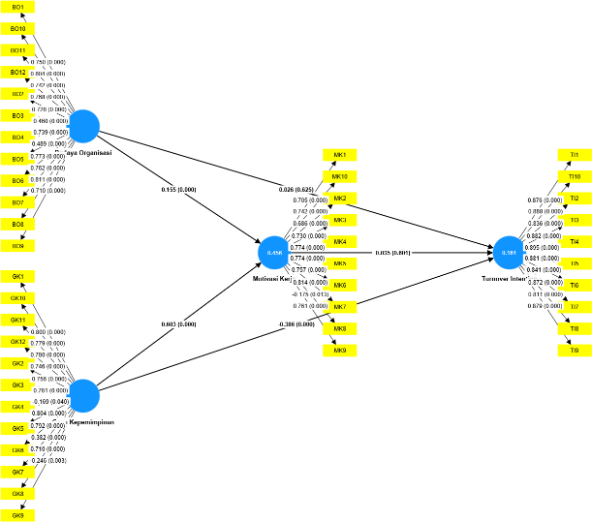
Figure 2. Inner Model
Source: Primary Data Processed, 2024

- Path Coefficient
Based on the inner model scheme that has been shown in figure 2 above, it can be explained that the largest path coefficient value is shown by the influence of Leadership Style on Work Motivation of 0.342, then it can be concluded that three paths of influence of path coefficient show positive numbers.

- Coefficient of Determination Test (R²)

Table 13. R Square Value
Variables | R Square | R Square Adjusted
Work Motivation | 0,456 | 0,453
Turnover Intention | 0,161 | 0,154
Source: Primary Data Processed, 2024
The R-Square value obtained by the Turnover Intention variable is 0.102, the value explains that the percentage of influence of Organizational Culture, Leadership Style and Work Motivation is 10.2%.

- Q-Square Test
The results of the calculation of the Q-Square value are as follows:

- Square value shown that this research model can be stated to have a good goodness of fit.
- F-square test
The value of f-square in this study can be known as follows:

Table 14. f Square Value
Variabel | Organizational Culture | Leadership Style | Work Motivation | Turnover Intention
Organizational Culture |  |  | 0,034 | 0,010
Leadership Style |  |  | 0,132 | 0,084
Work Motivation |  |  |  | 0,037
Turnover Intention
Source: Primary Data Processed, 2024

- Direct and Indirect Influence (Boostrapping)
The t-value value, sample average, sample deviation standard, and outer model calculation error standard can be seen in the following table:
Table 15. Direct and Indirect Influence (Boostrapping)
Influence of Variables | Original Sample (O) | Sample Mean (M) | Standard Deviation (STDEV) | T Statistics (O/STDEV) | P Values | Information
BO à MK | 0,174 | 0,179 | 0,049 | 3,554 | 0,000 | Significant Influence
BO à TI | -0,102 | -0,106 | 0,054 | 1,888 | 0,059 | No Influence
GK à MK | 0,342 | 0,348 | 0,071 | 4,833 | 0,000 | Significant Influence
GK à TI | -0,304 | -0,313 | 0,057 | 5,293 | 0,000 | Significant Influence
MK à TI | 0,201 | 0,207 | 0,052 | 3,886 | 0,000 | Significant Influence
BO à MK à TI | 0,035 | 0,037 | 0,014 | 2,507 | 0,012 | Significant Influence
GK à MK à TI | 0,069 | 0,073 | 0,025 | 2,710 | 0,007 | Significant Influence
Source: Primary Data Processed, 2024
- Second-Order Confirmatory Factor Analysis (Second-Order CFA)

- Evaluation of Measurement Model (Outer Model)

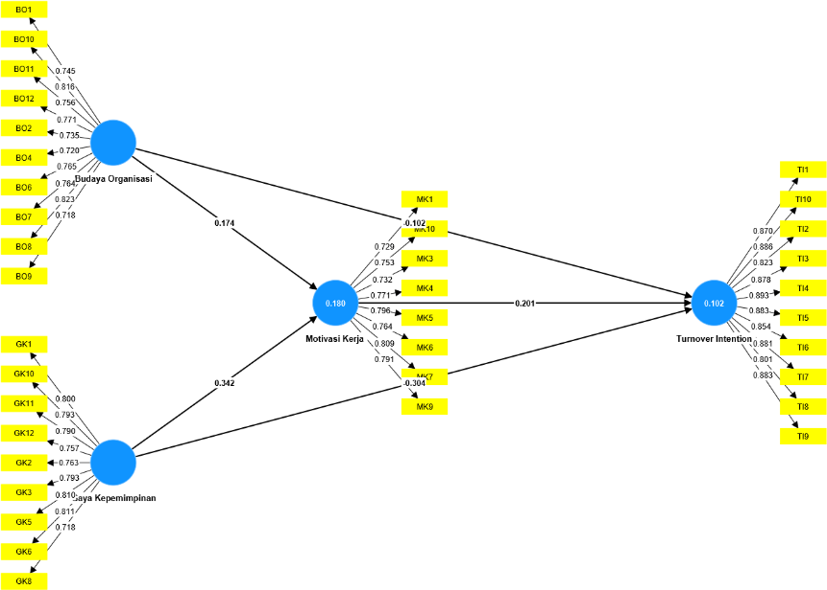
Figure 3. Inner Model
Source: Primary Data Processed, 2024

- Convergent Validity
An indicator is declared to meet convergent validity in the good category if the outer loading value > 0.7.

Table 16. Outer Loading
Variables | Indicators/Items | Outer Loading
Organizational Culture | BO1 | 0,745
 | BO2 | 0,735
 | BO4 | 0,720
 | BO6 | 0,765
 | BO7 | 0,764
 | BO8 | 0,823
 | BO9 | 0,718
 | BO10 | 0,816
 | BO11 | 0,756
 | BO12 | 0,771
Leadership Style | GK1 | 0,800
 | GK2 | 0,763
 | GK3 | 0,793
 | GK5 | 0,810
 | GK6 | 0,811
 | GK8 | 0,718
 | GK10 | 0,793
 | GK11 | 0,790
 | GK12 | 0,757
Work Motivation | MK1 | 0,729
 | MK3 | 0,732
 | MK4 | 0,771
 | MK5 | 0,796
 | MK6 | 0,764
 | MK7 | 0,809
 | MK9 | 0,791
 | MK10 | 0,753
Turnover Intention | TI1 | 0,870
 | TI2 | 0,823
 | TI3 | 0,878
 | TI4 | 0,893
 | TI5 | 0,883
 | TI6 | 0,854
 | TI7 | 0,881
 | TI8 | 0,801
 | TI9 | 0,883
 | TI10 | 0,886
Source: Primary Data Processed, 2024
The results of the analysis show that all items have an outer loading value greater than 0.7 (outer loading > 0.7), so all items are declared feasible or valid for use in further research analysis.
- Discriminant Validity
The most recent measurement is best to look at the Heterotrait-Monotrait Ratio (HTMT) value. If the HTMT value < 0.90, then a construct has good discriminatory validity [15]. The results of the discriminant variability test can be seen in the table below:

Table 17. Heterotrait – Monotrait Ratio (HTMT)

Variables | Organizational Culture | Leadership Style | Work Motivation | Turnover Intention
Organizational Culture
Leadership Style | 0.288
Work Motivation | 0.282 | 0.422
Turnover Intention | 0.130 | 0.256 | 0.070

Source: Primary Data Processed, 2024

Based on table above, it can be seen that the HTMT ratio of all variables has a HTMT value less than 0.9 (HTMT<0.9) so it can be said that all variable constructs have a good discriminant value.

- Composite Reliability
A construct is said to be reliable if the composite reliability value is above 0.70 [16]. The results of the outer model that shows the composite reliability of each construct:

Table 18. Composite Reliability
Variables | Composite Reliability
Organizational Culture | 0,927
Leadership Style | 0,924
Work Motivation | 0,903
Turnover Intention | 0,973
Source: Primary Data Processed, 2024

Based on table above, it shows satisfactory composite reliability results, which have a value greater than 0.70 (composite reliability > 0.70), so it can be said that this research variable has good reliability.

- Cronbach Alpha
A variable can be declared reliable or meets the cronbach alpha if it has a cronbach alpha
value > 0.7 [15]. The following are the cronbach alpha values of each variable:

Table 19. Cronbach Alpha
Variables | Cronbach Alpha
Organizational Culture | 0,920
Leadership Style | 0,921
Work Motivation | 0,901
Turnover Intention | 0,963
Source: Primary Data Processed, 2024

Based on the table above, it can be seen that the Cronbach alpha value of each of the research variables > 0.7. So it can be concluded that all variables have a high level of reliability

- .Structural Model Evaluation (Inner Model)

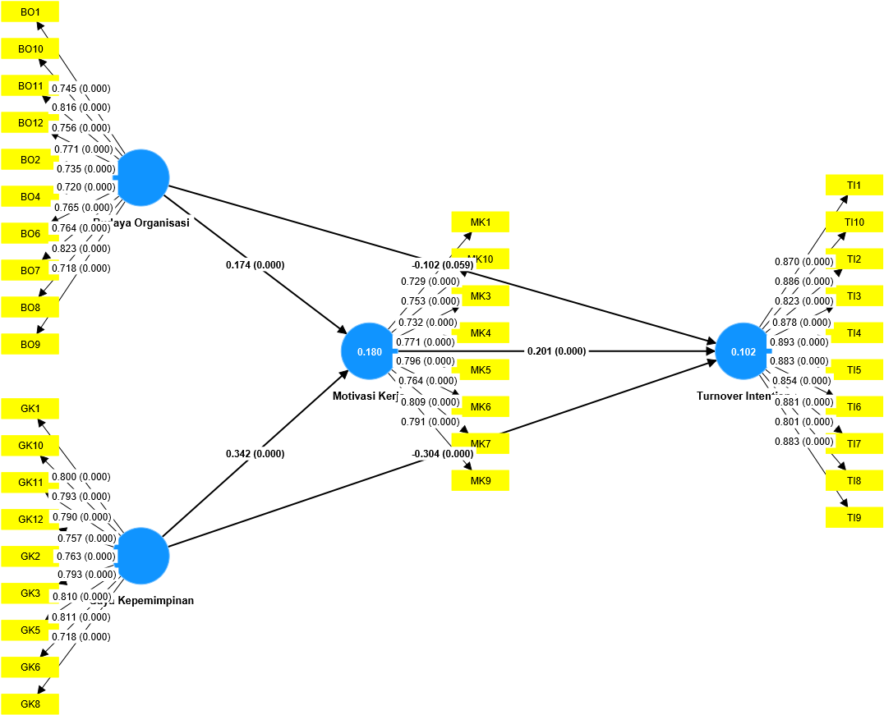
Figure 4. Inner Model
Source: Primary Data Processed, 2024

- Path Coefficient
Based on the inner model scheme that has been shown in figure above, it can be explained that the largest path coefficient value is shown by the influence of Leadership Style on Work Motivation of 0.342. So it can be concluded that the three pathways of influence of Path Coefficient show positive numbers.

- Determination Coefficient Test (R²)
The R-Square values are obtained as follows:

Table 20. R Square Values
Variables | R Square | R Square Adjusted
Work Motivation | 0,180 | 0,176
Turnover Intention | 0,102 | 0,094
Source: Primary Data Processed, 2024
Based on table above, it can be seen that the R-Square value for the Work Motivation variable is 0.180, the acquisition of this value explains that the percentage of the influence of Organizational Culture and Leadership Style on Work Motivation is 18.0%. Then for the R-Square value obtained by the Turnover
Intention variable of 0.102, the value explains that the percentage of influence of Organizational Culture, Leadership Style and Work Motivation is 10.2%.
- Q-Square Test
The goodness of fit assessment is known from the Q-Square value.

Based on the results of the calculation above, a Q-Square value of 0.042 was obtained. This shows that the diversity of the research data that can be explained by the research model is 4.2%.

- F-Square Test
The value of f-square in this study can be known as follows:

Table 21. F-Square Value
Variables | Organizational Culture | Leadership Style | Work Motivation | Turnover Intention
Organizational Culture |  |  | 0,034 | 0,010
Leadership Style |  |  | 0,132 | 0,084
Work Motivation |  |  |  | 0,037
Turnover Intention
Source: Primary Data Processed, 2024

- Direct and Indirect Influence (Boostrapping)
The t-value value, sample average, sample deviation standard, and outer model calculation error standard can be seen in the following table:

Table 22. Direct and Indirect Influence (Boostrapping) Results
Influence of Variables | Original Sample (O) | Sample Mean (M) | Standard Deviation (STDEV) | T Statistics (O/STDEV) | P Values | Information
BO à MK | 0,174 | 0,179 | 0,049 | 3,554 | 0,000 | Significant Influence
BO à TI | -0,102 | -0,106 | 0,054 | 1,888 | 0,059 | No Influence
GK à MK | 0,342 | 0,348 | 0,071 | 4,833 | 0,000 | Significant Influence
GK à TI | -0,304 | -0,313 | 0,057 | 5,293 | 0,000 | Significant Influence
MK à TI | 0,201 | 0,207 | 0,052 | 3,886 | 0,000 | Significant Influence
BO à MK à TI | 0,035 | 0,037 | 0,014 | 2,507 | 0,012 | Significant Influence
GK à MK à TI | 0,069 | 0,073 | 0,025 | 2,710 | 0,007 | Significant Influence
Source: Primary Data Processed, 2024
Judging from the t-value in the table above, there is a construct relationship that has a t-value of less than 1.96 (t-value < 1.96) and a p value greater than 0.05 (p value > 0.05), so that the construct relationship shows that the influence exerted by the independent variable on the dependent variable in the construction model is declared to have no effect.

Research Discussion

Organizational Culture on the Work Motivation of PT Cipta Kridatama Employees in Kutai Kartanegara

Based on the analysis of the research, the results showed that Organizational Culture had a significant effect on Work Motivation which was shown by the path coefficient value of 0.174, the T value of 3.554 and the p value of 0.000. The T value is greater than the T table (3.554 > 1.96) and the p value of 0.000 is smaller than the alpha standard of 0.05 (0.000 < 0.05), indicating that there is a significant influence of Organizational Culture on Work Motivation. The value of the path coefficient shows a positive value, then it can be stated that the better Organizational Culture is able to increase Work Motivation or the First Hypothesis (H1) is accepted.

Leadership Style on the Work Motivation of PT Cipta Kridatama Employees in Kutai Kartanegara

Based on the analysis of the study, the results showed that Leadership Style had a significant effect on Work Motivation which was shown by a path coefficient value of 0.342, a T value of 4.833 and a p value of 0.000. The T value is greater than the T table (4.833 > 1.96) and the p value of 0.000 is smaller than the alpha standard of 0.05 (0.000 < 0.05) indicating that there is a significant influence of Leadership Style on Work Motivation. The value of the path coefficient shows a positive value, then it can be stated that a better Leadership Style is able to increase Work Motivation or the Second Hypothesis (H2) is accepted.

Organizational Culture towards Turnover Intention of PT Cipta Kridatama Employees in Kutai Kartanegara

Based on the analysis of the research, the results show that Organizational Culture has no effect on Turnover Intention which is shown by the path coefficient value of -0.102, T value of 1.888 and p value of 0.059. The T value is smaller than the T table (1.888 < 1.96) and the p value of 0.059 is greater than the alpha standard of 0.05 (0.059 > 0.05) indicating that there is no influence of Organizational Culture on Turnover Intention. The value of the path coefficient shows a negative value, then it can be stated that the better Organizational Culture is not able to increase Turnover Intention or the Third Hypothesis (H3) is rejected.

Leadership Style towards Turnover Intention of PT Cipta Kridatama Employees in Kutai Kartanegara

Based on the analysis of the research, the results show that Leadership Style has a significant effect on Turnover Intention which is shown by a path coefficient value of -0.304, a T value of 5.293 and a p value of 0.000. The T value is greater than the T table (5.293 > 1.96) and the p value of 0.000 is smaller than the alpha standard of 0.05 (0.000 < 0.05) indicating that there is an influence of Leadership Style on Turnover Intention. The value of the path coefficient shows a negative value, then it can be stated that a better Leadership Style is able to reduce Turnover Intention or the Fourth Hypothesis (H4) is accepted.

Work Motivation for Turnover Intention of PT Cipta Kridatama Employees in Kutai Kartanegara

Based on the analysis of the research, the results showed that Work Motivation had a significant effect on Turnover Intention which was shown by a path coefficient value of 0.201, a T value of 3.886 and a p value of 0.000. The T value is greater than the T table (3.886 > 1.96) and the p value of 0.000 is smaller than the alpha standard of 0.05 (0.000 < 0.05) indicating that there is an influence of Work Motivation on Turnover Intention. The value of the path coefficient shows a positive value, then it can be stated that the better Work Motivation is able to reduce the Turnover Intention or the Fifth Hypothesis (H5) is accepted.

The Effect of Work Motivation Mediation on Organizational Culture on Employee Turnover Intention of PT Cipta Kridatama in Kutai Kartanegara

Based on the analysis of the research, the results showed that Work Motivation was able to mediate the influence of Organizational Culture on Turnover Intention which was shown by a path coefficient value of 0.035, a T value of 2.507 and a p value of 0.012. The T value is greater than the T table (2.507 > 1.96) and the p value of 0.012 is smaller than the alpha standard of 0.05 (0.012 < 0.05) indicating that there is an effect of Work Motivation mediation on Organizational Culture on Turnover Intention. The value of the path coefficient shows a positive value, then it can be stated that better Work Motivation is able to support the Organizational Culture in reducing Turnover Intention or the Sixth Hypothesis (H6) is accepted.

The Effect of Work Motivation Mediation on Leadership Style on Employee Turnover Intention of PT Cipta Kridatama in Kutai Kartanegara

Based on the analysis of the research, the results showed that Work Motivation was able to mediate the influence of Leadership Style on Turnover Intention which was shown by a path coefficient value of 0.069, a T value of 2.710 and a p value of 0.007. The T value is greater than the T table (2.710 > 1.96) and the p value of 0.007 is smaller than the alpha standard of 0.05 (0.007 < 0.05), indicating that there is an effect of Work Motivation mediation on Leadership Style on Turnover Intention. The value of the path coefficient shows a positive value, then it can be stated that the better Work Motivation is able to support the Leadership Style in reducing Turnover Intention or the Sixth Hypothesis (H6) is accepted.

- CONCLUSION
Based on the results of the research that has been carried out, the conclusions that can be drawn from this study are:
- Organizational Culture Affects the Work Motivation of PT Cipta Kridatama Employees in Kutai Kartanegara.
- Leadership Style Affects the Work Motivation of PT Cipta Kridatama Employees in Kutai Kartanegara.
- Organizational Culture has no effect on the Turnover Intention of PT Cipta Kridatama Employees in Kutai Kartanegara.
- Leadership Style Affects Employee Turnover Intention of PT Cipta Kridatama in Kutai Kartanegara.
- Work Motivation Affects Employee Turnover Intention of PT Cipta Kridatama in Kutai Kartanegara.
- Work Motivation Mediates the Influence of Organizational Culture on Employee Turnover Intention of PT Cipta Kridatama in Kutai Kartanegara.
- Work Motivation Mediates the Influence of Organizational Culture on Employee Turnover Intention of PT Cipta Kridatama in Kutai Kartanegara.

- REFERENCES
- Chen, J. K. C. 2020. Perspective on The Influence of Leadership on Job Satisfaction and Lower Employee Turnover in The Mineral Industry. Sustainability, 12(14), 1–16. https://doi.org/10.3390/su12145690. Switzerland.
- KaltimToday. 2023. Pertumbuhan Ekonomi Kalimantan Timur Kuarta II 2023 Capai Rekor Tertinggi, Kontribusi Utama dari Sektor Konstruksi dan Pertambangan. Retrieved from https://kaltimtoday.co/pertumbuhan-ekonomi-kalimantan-timur-kuarta-ii-2023-capai-rekor-tertinggi-kontribusi-utama-dari-sektor-konstruksi-dan-pertambangan.
- Kaltimprov. 2023. Data Pertambangan Prov. Kaltim Tahun 2016-2020.
- Bozovic, J., & Bozovic, I. 2019. Research and Improvement of Employee Motivation in Mining Companies: A Case Study of Ibarski Rudnici, Serbia. International Review of Management and Marketing, 9(2), 1–11.
- Robbins, S. P., & Judge, T. A. 2019. Organizational Behavior (18th ed.). Pearson Education. London.
- Soelistya D., Setyaningrum, R. P., Aisyah, N., Sahir, S. H., & Purwati, T. 2022. Budaya Organisasi dalam Praktik. In Suparyanto dan Rosad (2015 (Vol. 5). Sidoarjo: Nizamia Learning center.
- Robbins, S. P., Judge, T.A. 2021. Organizational Behavior, Updated Global Edition. Pearson Higher Ed. London.
- Swamy, V. 2018. Financial Inclusion And The Resilience Of Poor Households. The Journal of Developing Areas, 53(4). https://doi.org/10.1353/jda.2018.0079.
- Belete, A.K. 2018. Turnover Intention Influencing Factors of Employees: An Empirical Work Review. J Entrepren Organiz Manag 7: 253. doi: 10.4172/2169-026X.1000253.
- Maslow, A. H. 1954. Motivation and Personality. Harper & Row. New York.
- Dipboye, R. L. 2018. Work Motivation. In The Emerald Review of Industrial and Organizational Psychology. Emerald Publishing Limited. https://doi.org/10.1108/978-1-78743-785-220181006.
- Ghozali, Imam. 2023. Partial Least Squares: Konsep, Teknik, dan Aplikasi Menggunakan Program SmartPLS 4,0 untuk Penelitian Empiris. Badan Penerbit Universitas Diponegoro. Semarang.
- Hair, J. F., J. J. Risher, M. Sarstedt, dan C. M. Ringle. 2019. When to Use and How to Report the Results of PLS-SEM. European Business Review. 31(1) : 2-24.
- Henseler, J. 2020. Composte-Based Structural Equation Modeling: Analyzing Latent and Emergent Variables. Guilford Publications.
- Sarstedt M., C. M. Ringle., J. F. Hair. 2017. Partial Least Squares Structural Equation Modeling. Springer International Publishing AG 2017 C. Homburg et al. (eds), Handbook of Market Research. https://doi.org/10.1007/978-3-319-05542-8_15-1.

