**SUMMARAIZE PRO: ABSTRACTIVE NLP-BASED SUMMARIZATION FOR MULTI-DOMAIN APPLICATIONS**

**Prof. Shital Gadekar1, Chetan Kuyate2, Arti Misal3, Mayuri Balod4**

1Assistant prof., IT, Nagpur Institute of Technology, Nagpur, Maharashtra, India

2UG Student, IT, Nagpur Institute of Technology, Nagpur, Maharashtra, India

3UG Student, IT, Nagpur Institute of Technology, Nagpur, Maharashtra, India

3UG Student, IT, Nagpur Institute of Technology, Nagpur, Maharashtra, India

**ABSTRACT**

In today's digital era, the abundance of news content can overwhelm readers, making it challenging to absorb information efficiently. Automatic text summarization has emerged as a solution by condensing large volumes of text into shorter, meaningful summaries. This study presents an AI-based automatic text summarizer designed for news articles, utilizing the Bidirectional and Auto-Regressive Transformers (BART) model, a state-of-the-art natural language processing framework. BART's dual capabilities of encoding and decoding enable the generation of highly coherent and contextually accurate summaries. The model was trained and fine-tuned on large datasets of news articles, ensuring its adaptability to diverse writing styles and topics. The summarizer's performance was evaluated using ROUGE metrics, showing improvements in summary precision and recall compared to traditional models. The system reduces the time required to grasp key information from lengthy articles while maintaining essential content. Future research will focus on expanding multi-lingual support and exploring more advanced techniques for enhanced adaptability across domains.

**Keywords**: Text Summarization, BART, Natural Language Processing, ROUGE, AI, Deep Learning, Transformer Model, News Aggregation, Fine-tuning, Language Models, Automatic Summarization, Content Curation, Machine Learning

1. **INTRODUCTION**

The exponential growth of online information has revolutionized the way people consume content, particularly in the domain of news. With the increasing availability of online news platforms, individuals are constantly bombarded with a vast amount of information from various sources. While this influx of information offers readers a rich resource of knowledge, it also presents a significant challenge—information overload. The ability to sift through large volumes of text to extract relevant information efficiently has become a crucial skill in the modern world. Traditional methods of reading and summarizing are no longer feasible given the sheer quantity of content. This has led to the emergence of automatic text summarization as a vital tool for efficiently processing and understanding large bodies of text.

Automatic text summarization involves the use of algorithms to condense long articles or documents into shorter versions while preserving the core meaning and essential information. This technology is particularly useful for news articles, where readers often seek quick and concise overviews of events, developments, or trends without delving into full-length articles. While several techniques for text summarization exist, including extractive and abstractive methods, recent advancements in natural language processing (NLP) have paved the way for more sophisticated models. Abstractive summarization, which aims to generate summaries in a human-like manner by paraphrasing and rephrasing the original content, is gaining prominence over extractive techniques that simply select key sentences from the original text.

The Bidirectional and Auto-Regressive Transformers (BART) model, developed by Facebook AI, represents a significant breakthrough in NLP, particularly for tasks such as summarization, translation, and text generation. BART combines the strengths of both encoder-decoder architectures, enabling it to generate coherent, contextually accurate, and high-quality text summaries. Its ability to predict missing tokens and perform text reconstruction makes it well-suited for abstractive summarization tasks. By leveraging the BART model, our project aims to provide an AI-based automatic text summarizer specifically tailored for news articles. The objective is to create concise, meaningful summaries that retain the essential elements of the original articles, making it easier for users to stay informed without spending excessive time reading lengthy content.

In this paper, we discuss the implementation of BART for the summarization of news articles, including the training process, dataset preparation, and performance evaluation using metrics such as ROUGE. We also explore the potential applications of this summarizer in various fields, including journalism, media, content curation, and news aggregation platforms. Additionally, we analyze the challenges faced in building an effective summarization model, such as handling different writing styles, ensuring factual consistency, and maintaining fluency in the generated summaries.

1. **LITERATURE SURVEY**

Automatic text summarization has been an active area of research for several decades, with early approaches relying on extractive methods. These methods focus on selecting key sentences or phrases from the source text to create a summary. The popular TextRank algorithm (Mihalcea and Tarau, 2004), an unsupervised model inspired by Google's PageRank, ranks sentences based on their importance in the text, leading to efficient yet limited summaries. While extractive methods are computationally less expensive, they often fail to provide coherent and natural summaries, as they only lift sections from the original content without rephrasing or understanding context.

In contrast, abstractive summarization generates new phrases and sentences, often requiring a deeper understanding of the content. Early neural network-based models such as the sequence-to-sequence (Seq2Seq) model (Sutskever et al., 2014) and the pointer-generator network (See et al., 2017) paved the way for neural abstractive summarization. These models introduced the capability to rewrite the content rather than simply extract sentences, making them more suitable for creating human-like summaries. However, they struggled with maintaining factual accuracy and often produced summaries that included irrelevant information or hallucinations.

With the introduction of transformer-based models, particularly the Transformer (Vaswani et al., 2017), the field of natural language processing (NLP) saw significant advancements. Models like BERT (Bidirectional Encoder Representations from Transformers) (Devlin et al., 2019) and GPT (Generative Pretrained Transformer) (Radford et al., 2018) revolutionized text generation tasks, including summarization. While BERT was primarily designed for tasks like question answering and sentence classification, GPT showed potential in text generation. However, neither was specifically designed for summarization tasks.

The Bidirectional and Auto-Regressive Transformers (BART) model (Lewis et al., 2020) bridged the gap by combining the encoder-decoder architecture, making it well-suited for abstractive summarization. BART applies a denoising auto-encoder approach, where the model learns to reconstruct corrupted text sequences. This architecture enhances the ability to generate fluent, coherent, and contextually relevant summaries. Several studies have demonstrated the superiority of BART in summarization tasks, particularly in generating concise and accurate summaries, outperforming earlier models in terms of ROUGE and BLEU scores.

In summary, while early models laid the foundation for text summarization, recent advances in transformer-based models like BART have significantly improved the quality of automatic summarization, making it more coherent and context-aware. Our project builds on these developments, leveraging BART’s strengths to summarize news articles effectively.

1. **COMPONENTS REQUIRED**
2. **PRE-TRAINED BART MODEL :-**

* **Description**: BART (Bidirectional and Auto-Regressive Transformers) is a pre-trained transformer model specifically designed for text generation tasks like summarization. The model can be fine-tuned for abstractive text summarization, meaning it learns to generate a concise summary by understanding the context and structure of the input text.
* **Role**: Acts as the core component responsible for generating high-quality and coherent text summaries from news articles. It uses both encoding and decoding mechanisms to produce human-like summaries

1. **PYTHON PROGRAMMING ENVIRONMENT: -**

* **Description**: Python is the programming language used to implement the text summarization model. Popular Python libraries such as Hugging Face's transformers provide access to pre-trained models like BART. Python also supports a variety of tools for text processing, model training, and evaluation.
* **Role**: Serves as the platform to integrate and run the BART model, providing necessary libraries for model implementation, fine-tuning, and testing.

1. **DATASET FOR FILE-TUNING**

* **Description**: A dataset of news articles is required for training and fine-tuning the BART model. The dataset must consist of pairs of full-length articles and their corresponding summaries. Common datasets used for summarization include CNN/DailyMail and XSum.
* **Role:** Provides training data for the model to learn how to summarize news articles effectively, improving its accuracy and performance on real-world data.

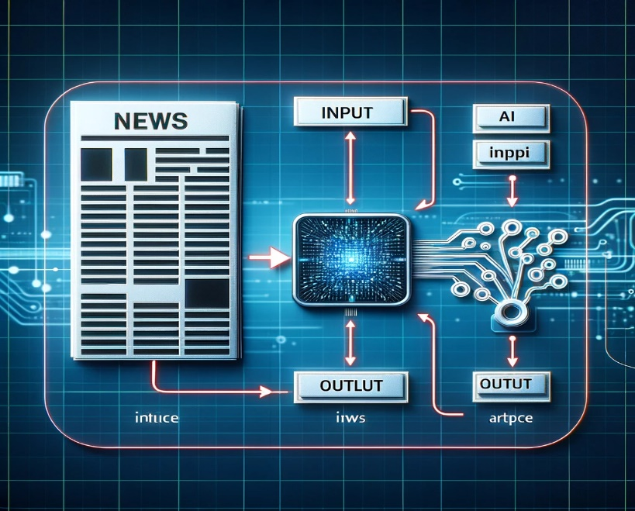

1. **TOKENIZATION TOOLS**

* **Description:** Tokenizers break down the input text into smaller units (words, subwords, or characters) that the BART model can process. Tools like Hugging Face Tokenizer or SpaCy are used for efficient tokenization, which is critical for handling large articles
* **Role:** Prepares the news articles by converting text into a form that the BART model can understand, ensuring consistent input for model training and inference

**5 EVALUATION METRICS (ROUGE)**: -

* **Description:** ROUGE metrics are commonly used to evaluate the quality of machine-generated summaries. They compare the generated summaries to reference summaries to assess accuracy, precision, and recall.
* 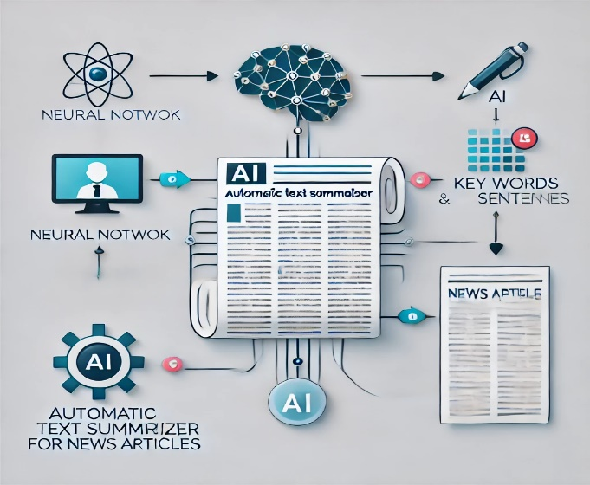**Role:** Measures the performance of the summarization model and ensures that it generates useful and accurate summaries.

1. **PROPOSED SYSTEM**

The proposed system leverages AI and natural language processing (NLP) to automate the summarization of news articles. This system replaces traditional methods of manually reading and condensing articles with a highly efficient, AI-driven approach that generates concise, coherent summaries. Below is an outline of the key components, workflow, and functionality of the proposed system.

1. **System Overview**  
   The proposed AI-based text summarization system consists of three primary components:  
   • **Text Input**: Receives full-length news articles as input for summarization.  
   • **AI Model (BART)**: Processes the input using the BART model to generate a coherent, contextually accurate summary.  
   • **Summary Output**: Provides a shortened version of the article, retaining key information and meaning.

The system is designed to operate in real-time and can be deployed either locally or in a cloud-based infrastructure, offering scalability to handle large volumes of data. This makes it suitable for news aggregation platforms, digital media, and news organizations.

1. **Proposed Workflow**
   1. **Article Input**:  
      o Users submit full-length news articles to the system through a user interface.  
      o The system accepts input in various formats such as text or web links.
   2. **Text Preprocessing**:  
      o The system uses tokenization and text-cleaning techniques to prepare the article for summarization.  
      o Any irrelevant content (e.g., ads, extra formatting) is removed to improve the quality of the input text.
   3. **Feature Extraction**:  
      o The system employs the BART model to extract contextual and semantic features from the text.  
      o These features are used to understand the article’s main topics, key phrases, and overall structure.
   4. **Summary Generation**:  
      o The BART model generates an abstractive summary that condenses the article into a shorter, readable format.  
      o The summary is reviewed to ensure it captures the essential points of the article.
   5. **Summary Output**:  
      o The summarized version of the article is displayed to the user, who can choose to save, edit, or use it directly.  
      o The system allows the export of summaries in different formats such as text files or PDFs for easy integration into content management systems.
   6. **Real-time Monitoring and Reporting**:  
      o Administrators can track the usage of the summarizer, including the number of articles processed and the time saved by using the system.
2. **Features of the Proposed System**  
   • **Fast and Accurate Summarization**: The BART model ensures that the summarization is both quick and contextually accurate, reducing the time required to process large amounts of text.  
   • **Abstractive Summarization**: Unlike extractive methods, the system generates human-like summaries by paraphrasing and rephrasing content, providing a more natural output.  
   • **Scalability**: Capable of handling a large volume of news articles, the system can be integrated into news aggregation platforms or large-scale media organizations.  
   • **Customizable Summaries**: Users can choose the length and style of the summary, tailoring it to their specific needs.  
   • **Multi-format Support**: The system supports various input formats, making it flexible for different use cases such as news websites or media content curation.
3. **System Requirements**  
   **Hardware**:  
   o High-performance CPU or GPU for fast processing of large datasets.  
   o Adequate storage for saving articles, summaries, and processing logs.

**Software**:  
o Python environment with transformers library for BART model implementation.  
o Preprocessing tools such as NLTK or SpaCy for text cleaning and tokenization.  
o A database (SQL or NoSQL) to store articles and summaries.  
o Web-based or desktop application for user interaction and summary display.

1. **Advantages of the Proposed System**  
   • **Time Efficiency**: Reduces the time spent manually reading and summarizing articles, providing users with quick overviews of long texts.  
   • **Improved Readability**: The abstractive approach ensures that summaries are more readable and natural compared to extractive methods.  
   • **Low Maintenance**: Once set up, the system operates autonomously, requiring minimal manual intervention.  
   • **Enhanced Data Management**: The system stores summaries and articles, allowing for easy retrieval and reference.
2. **Challenges and Considerations**  
   • **Quality of Input**: The system's performance may vary based on the quality of the input text. Poorly structured articles or low-quality writing can affect summary accuracy.  
   • **Processing Power**: High computational power is needed to fine-tune the BART model, especially for large-scale operations.  
   • **Data Security**: Handling sensitive or proprietary content requires the implementation of secure data storage and encryption protocols.
3. **CONCLUSION**

In the modern digital world, the overwhelming volume of online content has made it difficult for readers to consume news efficiently. With thousands of articles being published daily, manual reading and comprehension of large amounts of text has become time-consuming. Automatic text summarization offers a solution by condensing lengthy news articles into concise, meaningful summaries. This paper presents an AI-based approach to news summarization using the Bidirectional and Auto-Regressive Transformers (BART) model, a state-of-the-art framework in natural language processing.

BART’s encoder-decoder architecture enables it to produce coherent and contextually accurate summaries, offering an abstractive summarization approach. Unlike extractive methods that merely select key sentences, BART rephrases the content, generating more human-like outputs. The system has been trained on news datasets to handle different writing styles and topics effectively. The aim of this project is to develop an efficient tool that reduces the time required to grasp essential information from news articles without losing key details.

This project contributes to AI-driven news summarization, offering applications for media platforms, news aggregators, and personal use.

1. **FUTURE SCOPES**
2. **Multi-Lingual Summarization**  
   Future advancements can focus on incorporating multi-lingual capabilities, allowing the system to summarize news articles in various languages. This will enhance accessibility for users from different linguistic backgrounds, making the summarizer globally applicable.
3. **Improved Contextual Understanding**  
   The summarizer could evolve to better understand the deeper context of articles, including subtle nuances, emotions, and intentions. This would be especially useful in summarizing sensitive or complex topics such as international relations, legal cases, or financial markets.
4. **Real-Time News Summarization**  
   With improvements in cloud computing and processing power, real-time summarization of live news feeds and updates could become possible. This would allow users to get instant, concise summaries as events unfold.
5. **Personalized Summaries**  
   AI could learn user preferences over time, enabling it to provide personalized summaries. By identifying what topics or types of content a user prefers, the system can tailor the summaries to focus on what matters most to the individual.
6. **Sentiment-Based Summarization**  
   By integrating sentiment analysis, the system could not only summarize articles but also provide insights into the overall tone or sentiment (positive, negative, neutral) of the content. This could be valuable for news related to politics, business, and public opinion.
7. **Cross-Domain Adaptability**  
   While the current model is focused on news summarization, future versions could be applied to other domains such as research papers, legal documents, and social media content. This versatility would expand the utility of the summarizer across various fields.
8. **Audio Summaries (Text-to-Speech Integration)**  
   The summarization system could incorporate text-to-speech technology, allowing users to listen to audio versions of the summaries. This would be especially useful for people who prefer audio content while commuting or multitasking.
9. **Mobile and Wearable Device Integration**  
   Optimizing the summarizer for mobile and wearable devices can enable users to receive summaries on the go, offering a seamless and accessible experience. This would benefit users who need quick updates while traveling or during busy schedules.
10. **Collaborations with News Aggregators**  
    Future developments could include partnerships with major news platforms and aggregators, where the summarizer is integrated to provide concise news updates from multiple sources, enhancing its reach and influence in the media ecosystem.
11. **Summarization for Visual Content (Video/Multimedia)**  
    Beyond text, the summarizer could be enhanced to summarize visual content, including video transcripts and multimedia presentations. This would expand the utility to platforms like YouTube or news video streams.
12. **Topic-Based Summarization**  
    Users could request summaries based on specific topics or keywords. This would allow for a more focused summarization of long-form content, highlighting only the sections relevant to the desired subject.
13. **Multi-Document Summarization**  
    Future iterations of the system could handle multi-document summarization, where it extracts key points from multiple related articles and synthesizes them into a single, cohesive summary. This would be useful for comparing perspectives or summarizing evolving news stories.
14. **Ethical Summarization and Bias Mitigation**  
    As the use of AI in summarization grows, it will become increasingly important to address concerns around ethical AI use. Future models could include features that reduce bias, ensuring summaries remain neutral and fact-based without distorting the information.
15. **Enhanced Security and Privacy Protection**  
    As AI models handle large volumes of data, the need for robust security measures becomes critical. Future versions could incorporate secure, privacy-preserving technologies like differential privacy or homomorphic encryption to protect sensitive data and maintain user trust.
16. **Predictive Analytics and Insights**  
    The summarizer could be enhanced with predictive capabilities, providing not only summaries but also predictions or insights based on trends in the content. This could be valuable for fields like finance, where understanding trends in news could lead to actionable insights for investors or analysts.
17. **REFERENCES**
18. Lewis, M., Liu, Y., Goyal, N., Ghazvininejad, M., Mohamed, A., Levy, O., Stoyanov, V., & Zettlemoyer, L. (2020). BART: Denoising Sequence-to-Sequence Pre-training for Natural Language Generation, Translation, and Comprehension. In Proceedings of the 58th Annual Meeting of the Association for Computational Linguistics (pp. 7871–7880). Association for Computational Linguistics.
19. See, A., Liu, P. J., & Manning, C. D. (2017). Get To The Point: Summarization with Pointer-Generator Networks. In Proceedings of the 57th Annual Meeting of the Association for Computational Linguistics (pp. 1073–1083).
20. Dong, Y., Huang, S., Wei, F., Lapata, M., & Zhou, M. (2019). Unified Pre-training for Sequence-to-Sequence Learning via Conditional Masked Language Model. In Advances in Neural Information Processing Systems.
21. Liu, Y., & Lapata, M. (2019). Text Summarization with Pretrained Encoders. In Proceedings of the 2019 Conference on Empirical Methods in Natural Language Processing (pp. 3721-3731).
22. Cheng, J., & Lapata, M. (2016). Neural Summarization by Extracting Sentences and Words. In Proceedings of the 54th Annual Meeting of the Association for Computational Linguistics (pp. 484–494).