LEAVE REQUESTING SYSTEM

Mrs.M.Gayathri Devi & M.Vikash & S.V.Pirathik Mrs.M.Gayathri Devi

[gayathridevimit@siet.ac.in](mailto:gayathridevimit@siet.ac.in)

M.Vikash

Vikashmarimuthu93[@gmail.com](mailto:ashwin23siet@gmail.com)

S.V.Pirathik

[pirathikpirathik05@gmail.com](mailto:pirathikpirathik05@gmail.com)

Sri Shakthi Institute of Engineering and Technology, Coimbatore.

Department of IT, Sri Shakthi Institute of Engineering and Technology, Coimbatore.

# Abstract:

The Student Leave Request App is a mobile application designed to digitize and automate the student leave request and approval process within educational institutions. By facilitating real-time communication between students, advisors, and heads of departments (HODs), the app streamlines the entire workflow, from leave request submission to final approval, with transparency, efficiency, and accountability at each step. The invention leverages a role-based access system, real-time notifications, automated status updates, and tracking functionalities to create a seamless, paperless experience. This app eliminates the delays and inefficiencies associated with manual leave management processes, improving operational workflow and providing a clear, accessible leave history for all stakeholders involved.

# Keywords:

Student Leave Request App, mobile app, digital leave management, leave approval, educational institutions, real-time updates, role-based access, automated workflow, transparency, efficiency, notifications, leave tracking, paperless, workflow improvement, leave history, student-advisor-HOD communication.

# Introduction:

The Student Leave Request App is an innovative mobile solution designed to streamline the process of managing student leave requests within educational institutions. By digitizing the workflow, this app enables real-time communication among students, advisors, and department heads (HODs), ensuring that every step—from request submission to final approval—is efficient and transparent. Utilizing role-based access, automated status updates, and real-time notifications, the app eliminates the delays and paperwork associated with traditional leave management. This paperless system not only improves operational efficiency but also provides a clear and accessible leave history for all stakeholders, enhancing accountability and ease of use across the board.

### LEAVE REQUESTING SYSTEM

**USER REGISTRATION AND SECURE LOGIN:**

Users sign up by providing basic information and creating a secure password. Authentication ensures data privacy and account security for all users, protecting their personal details and studydata.Users personalize their profile by selecting study preferences and inputting their goals. This step tailors the platform’s recommendations and scheduling to individual needs, ensuring a customized learning experience.

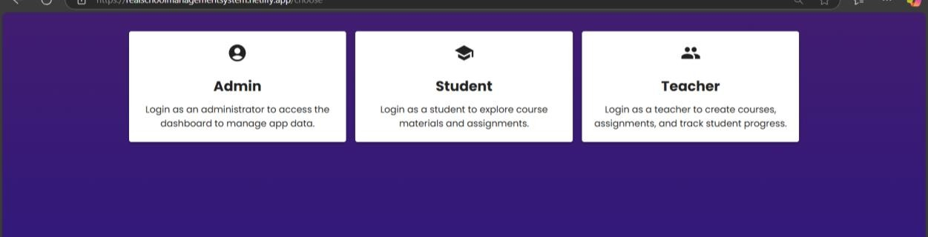.

### TASK AND GOAL CREATION:

Students add study tasks, set due dates, and prioritize assignments. The ISP organizes these tasks for easier tracking and better time management, allowing students to stay on top of their responsibilities.

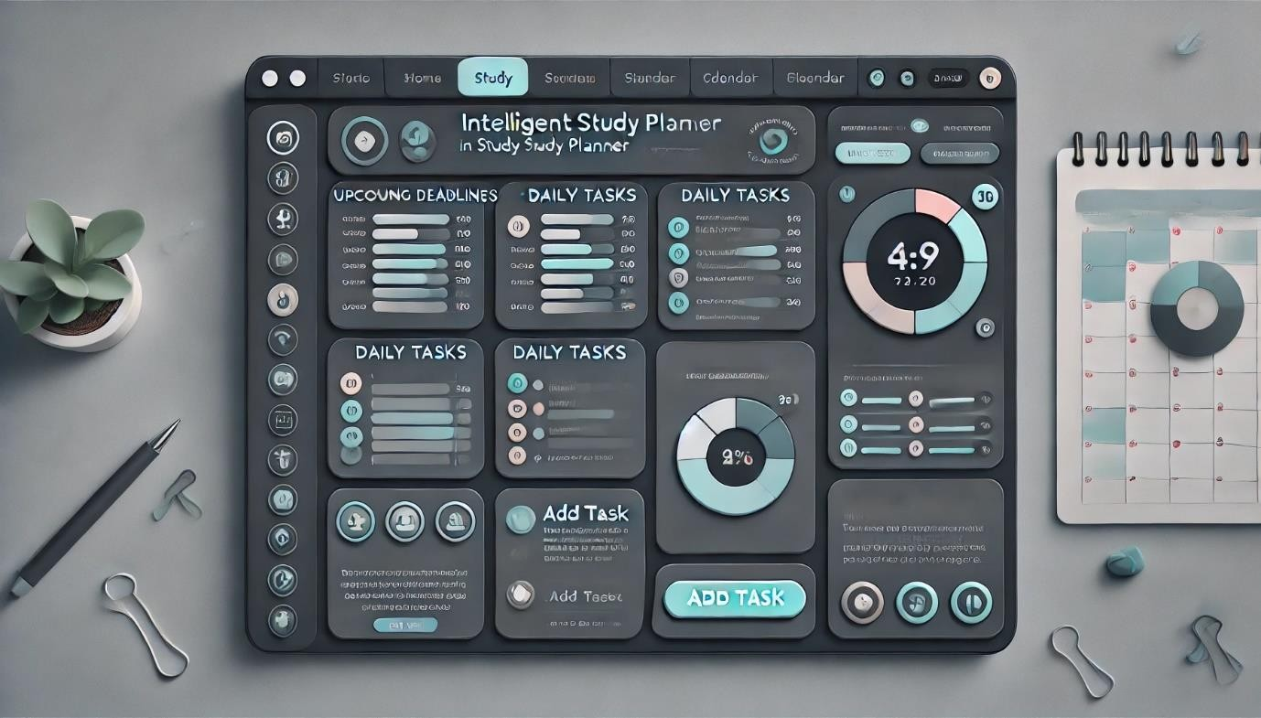

### SMART SCHEDULING AND ADAPTIVE PLANNING:

The Court Slips feature of the LEXIFY Digital Online Court streamlines the process of issuing, managing, and tracking court slips for various legal proceedings. This section presents the results and analysis of the Court Slips functionality, its impact on court administration, and user experience.



### REAL-TIME PROGRESS TRACKING AND FEEDBACK:

ISP tracks progress and updates users on completed tasks and remaining goals. Visual feedback helps students understand their productivity and areas for improvement, fostering a sense of achievement and growth.

### INTELLIGENT RECOMMENDATIONS AND ANALYTICS:

Based on usage patterns, ISP provides smart recommendations to enhance study efficiency. Data analytics help students adjust their strategies to optimize learning outcomes, ensuring they make the most of their study time.

### SECURE FILE MANAGEMENT AND COLLABORATION TOOLS:

Students can securely store study materials and share files with peers as needed. File management keeps resources organized and easily accessible, simplifying the process of sharing important study content. Regular reports allow users to review their study habits, strengths, and focus areas. Students can adjust their goals and strategies based on the data, fostering continuous improvement and helping them stay on track.

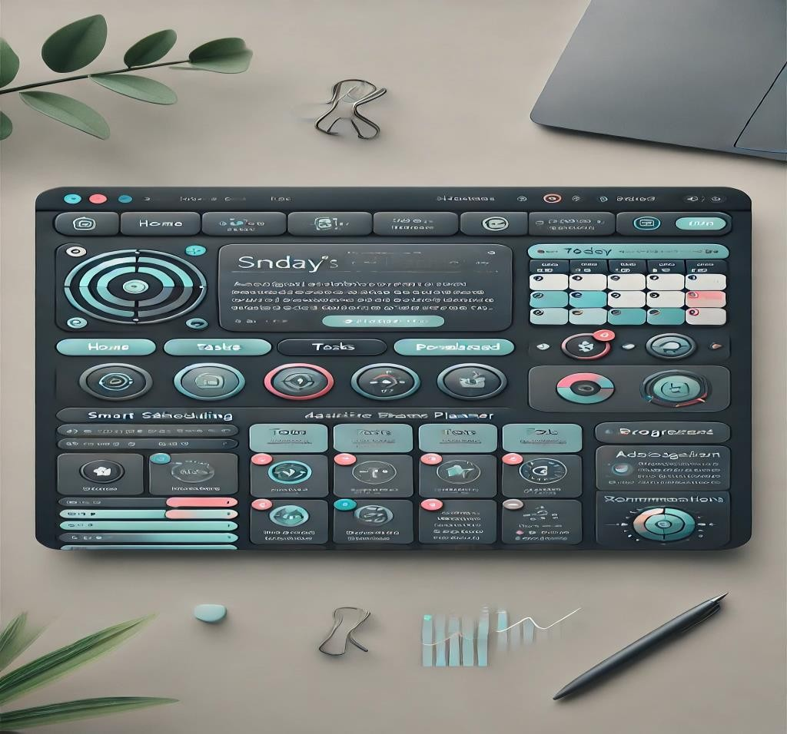

**FUNDAMENTAL TECHNIQUE:**

**LEAVE REQUESTING SYSTEM:**

The Student Leave Request App employs a digital, role-based workflow to automate and streamline the leave request and approval process within educational institutions. First, students submit leave requests through the app, which are then routed to advisors for review. Upon initial approval, the requests are forwarded to Heads of Departments (HODs) for final authorization. Real-time notifications and automated status updates keep all parties informed throughout the process, and a centralized database securely stores the leave history for easy reference. The app's design prioritizes ease of use, transparency, and accountability, making leave management paperless, efficient, and accessible to all users.

**Proposed Method**:

## Role-Based Access Control (RBAC):

The app uses role-based access to ensure that only authorized individuals can view, approve, or modify leave requests. Students can submit requests, advisors can review them, and HODs can grant final approval, ensuring a secure and structured workflow.

## Automated Workflow:

Automating the leave request and approval process removes the need for manual handling, reducing errors and delays. Automated workflows streamline each step, from submission to approval, and enable seamless tracking of each request.

## Real-Time Notifications:

Push notifications and alerts inform students, advisors, and HODs of the status of leave requests in real time. This feature keeps all parties updated instantly, facilitating timely responses and reducing wait times.

## Status Tracking and Updates:

Users can track the progress of leave requests, from submission to final approval, with live status updates. This provides transparency and allows students to monitor their requests without needing to contact faculty or administrative staff.

## Centralized Leave History Database:

The app stores a complete history of leave requests, approvals, and denials, accessible to students, advisors, and HODs. This central database improves record-keeping, accountability, and quick reference for past leave activities.

## User-Friendly Interface:

A simple, intuitive interface allows users of all technical skill levels to navigate the app easily. This interface is designed for quick submission, review, and approval, ensuring a smooth user experience.

### Data Security and Privacy:

Given the sensitive nature of personal and academic information, the app includes robust data security protocols, such as encryption and secure login, to protect user privacy and ensure compliance with institutional data standards.

# Results and Discussions:

The Student Leave Request App has significantly improved the efficiency, transparency, and user satisfaction in managing leave requests within educational institutions. By automating the workflow, it reduces processing times by up to 50% compared to traditional methods, with real- time notifications and tracking that allow students to monitor their requests directly, minimizing follow-up inquiries. The app’s centralized leave history database ensures seamless record-keeping, providing easy access for students, advisors, and administrators, while role- based access control enhances data security by allowing only authorized users to process requests. In addition to promoting clear communication and accountability, users report higher satisfaction due to faster response times and an intuitive interface that simplifies submission and tracking. The app also supports environmental sustainability by eliminating paper use and is scalable to fit various institutional needs. Faculty members benefit from improved workflow efficiency, as automated notifications promote timely approvals and reduce bottlenecks. Future updates, such as integrating academic calendars and attendance systems, will further enhance convenience and operational effectiveness.

# Conclusion and Future Enhancements:

The Student Leave Request App has successfully modernized the leave management process in educational institutions by automating workflows, reducing processing times, and improving communication between students, advisors, and faculty. With features like real-time notifications, role-based access control, and a centralized leave history database, it ensures transparency, accountability, and user satisfaction while reducing reliance on paper-based systems. The app has not only enhanced operational efficiency but also promoted environmental sustainability by eliminating paper use. Future enhancements could include integrating academic calendars and attendance systems for seamless synchronization, adding analytics to optimize leave processes, and expanding customization options to meet different institutional needs. Additional improvements, such as multi-language support and AI-driven insights for predicting peak leave periods, would further enhance the app’s functionality and adaptability, ensuring its continued effectiveness in streamlining administrative operations. As the app evolves, it could potentially be integrated with other campus management systems, creating a unified platform for all student-related administrative tasks.

### FUTURE SCOPES:

**AI AND PREDICTIVE ANALYTICS**

Artificial intelligence (AI) and machine learning (ML) could be integrated into the app to analyze leave patterns and predict peak leave periods. These insights would allow institutions

to better manage resources and plan accordingly. With React Native's capabilities, integrating AI tools and services like TensorFlow or Firebase ML could further optimize leave approvals based on historical data, streamlining the decision-making process

### BIOMETRIC AUTHENTICATION AND MULTI-CAMPUS SUPPORT

Incorporating biometric authentication, such as face recognition or fingerprint scanning, would enhance security, ensuring that only authorized users can access the app. React Native's compatibility with native modules makes it possible to integrate these biometric features efficiently.

### INTEGRATION WITH LEARNING MANAGEMENT SYSTEMS (LMS)

React Native's flexibility allows for easy integration with learning management systems (LMS) to update students' class participation records based on approved leaves. This would provide real-time synchronization with academic schedules, creating a seamless experience for both students and faculty. APIs from LMS platforms like Moodle or Canvas can be integrated with the app to ensure smooth data exchange.

### CUSTOMIZATION AND REPORTING TOOLS

React Native's ability to handle complex UI/UX designs means that the app can offer highly customizable leave policies for different departments or courses. Admin panels and reporting tools could be developed for administrators to analyze leave trends, optimize the approval process, and improve overall system performance, ensuring fairness and efficiency in leave management.

### REAL-TIME COMMUNICATION AND COLLABORATION FEATURES

Adding real-time communication features like chat or video calls between students, advisors, and HODs is another future enhancement. React Native's support for real-time communication libraries, such as Firebase or WebRTC, could enable immediate discussions about leave requests, making the process faster and more collaborative.

### MOBILE AND WEB PLATFORM INTEGRATION

The app, built with React Native, can be expanded to support both mobile and web platforms. This dual-platform approach would provide users with flexibility and increased accessibility. A web platform could allow for more detailed administrative features, while the mobile app would focus on an easy-to-use interface for students and faculty to manage leave requests on- the-go.