Hepatitis C: A Silent Epidemic and the Promise of a Cure

**ABSTRACT**

Hepatitis C is a worldwide health concern topic . Over 128-170 million are highly infected. Over 3-3.5 million death recorded every year from HCV. The most prevalence rates are reported from developing or poor countries in Africa and Asia, there is low prevalence rates in developed continent like Europe and North America. HCV is a viral infection that progresses mainly the liver and causes severe symptoms . There is both acute and chronic forms and can be life-threatening. There is no vaccine invented for this virus, but antiviral medications are used for treating HCV . diagnosis in early stage and prevention can help in controlling serious liver damage and treatment can improve long term infection. HCV is a bloodborne and can be transmitted through blood exposure procedures . Treatment is highly necessary for chronic hepatitis C.

**Keywords**; hepatitis C,chronic infection,jaundice,bloodborne transmission, liver biopsy.

**I. INTRODUCTION**

Hepatitis C is mainly affect liver and it is bloodborne viral infection the hepatitis C virus (HCV), primarily transmitted through blood-to-blood contact. The infection can be acute to chronic, with a significant proportion of individuals responsible for chronic liver disorders and complications are cirrhosis and liver cancer (hepatocellular carcinoma).HCV is a single-stranded RNA virus that belongs to the Flaviviridae family. Infected individuals may remain asymptomatic for years, with some progressing to chronic infection, liver fibrosis, cirrhosis, or liver cancer. Main cause of HCV is injecting of tinfected blood, sexual intercourse and it can be placental transmission during childbirth. Hepatitis C virus (HCV) enters hepatocytes via receptors such as CD81, SR-B1, and CLDN1. mostly involved developing countries which have more middle class and lower middle class families and that countries who is not able to afford expensive treatment and reuse drug injections equipment. And in this countries healthcare departments aren’t able to prevent or provide right suggestions and prevention programs to each and every side And continuously they are using unsafe healthcare care exposures. And when a Travelers visits they have high risk of contract and transmission of such diseases like HCV and blood to blood contact disease.

Pathophysiology;

•Once inside, the virus releases its RNA, and it is converted into viral proteins and replicated in the hepatocyte,and releases new virions.

•The host immune system mounts a response, particularly through T-cells, but HCV’s high mutation rate allows the virus to evade immune detection, leading to persistent viral replication.

•This persistent infection results in chronic inflammation in the liver.

Chronic inflammation leads to hepatocellular damage and fibrosis. Over time, this can progress to cirrhosis and liver dysfunction.In some patients, cirrhosis can cause liver failure and risk for liver cancer.

Most people are asymptomatic 7-10 days after infection. Symptoms may appear after 14 days and and sometimes take longer time

if symptoms do appear ,

• fever

• tiredness

• fatigue

• nausea and vomiting

• abdominal ache

• dark coloured urine

• faeces pale in colour

• joint stiffness

• jaundice (yellowing of the sbody skin or eyes).

Cirrhosis ≈10%–20% of people due to chronic infection after 21-28 years , and progression is occurs silently

Diagnosis and testing;

there are mainly Two types of diagnosis tests we do: IgG assays test it is for detection of HCV antibodies, and second we can do nucleic acid amplification to determine HCV RNA in blood of infected patients

Seological test includes;

•Anti-HCV Antibody (Anti-HCV): screening test in initial stage to detect antibodies against the HCV.

•Anti-HCV by ELISA

Molecular test;

•HCV RNA by PCR (Polymerase Chain Reaction)

•HCV Genotype Testing

Liver biopsy test

Treatment and prevention is necessary for hepatitis C includes, treatment is necessary to cure the symptoms for spreading and preventing liver damage. medications, including antiviral sofosbuvir and daclatasvir, are given. In some cases patients immune system fights with the infection on their own and they do not need treatment. Protease Inhibitors (e.g., glecaprevir, grazoprevir): Inhibit the NS3/4A protease.

preventing viral replication.

NS5A Inhibitors (e.g., ledipasvir, daclatasvir, velpatasvir): Inhibit the NS5A protein that is responsible for viral RNA replication and assembly.

NS5B Inhibitors (e.g., sofosbuvir, dasabuvir): Inhibit the RNA polymerase enzyme, preventing viral replication.

Treatment of chronic HCV with pegylated interferon (PegIFN)-alpha and ribavirin (RBV) containing regimens is absolutely contraindicated in: Uncontrolled depression, psychosis or epilepsy; pregnancy; severe concurrent medical diseases including retinopathy, autoimmune thyroid disorders; liver cell failure.Treatment durations typically range from 7 to 14 weeks, depending on the individual’s liver health.

some of the methods for prevent hepatitis C include:

• use of healthcare injections in safe way

•disposal of needles and medical waste after use

•safety for nurses and staff who inject needle .

• donated blood testing before taking

•training of healthcare services

•safe sex by using barrier methods .

* HCV Prevention Guidelines and 2030 Goals;

The 2030 goal for Hepatitis C elimination is ambitious but achievable. With global screening efforts, universal access to DAAs, safety and guidance programs for healthcare providers who inject drugs, and public health policies that ensure affordable treatment, it can play a major role in **prognosis**;

•Prevention through harm reduction, safe blood practices, and vaccination.

•Early diagnosis and rapid access to treatment.

•Affordable and scalable access to DAAs in low- and middle-income countries.

By 2030, the goal is to reduce new HCV infections, increase diagnosis and treatment rates, and significantly reduce hepatitis-related morbidity and mortality globally.

**Image-** this image has detailed view of viral hepatitis strategic plan 2025, and 2030 goals for hepatitis C virus infection.

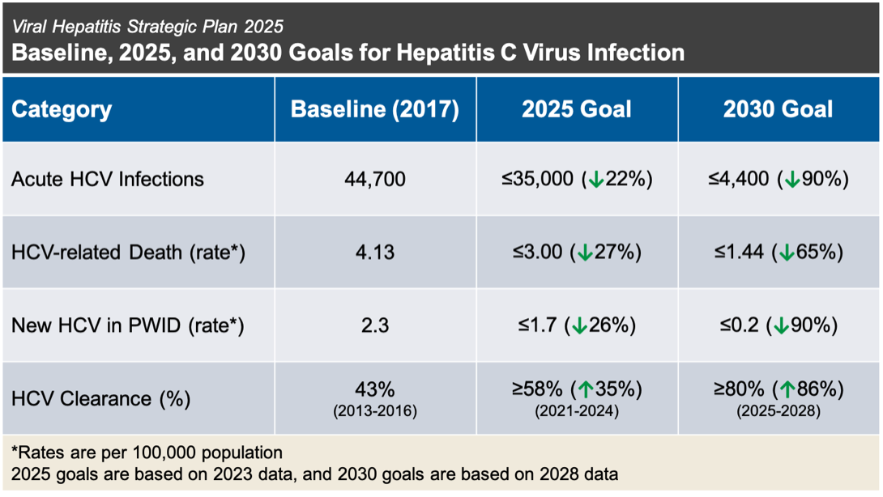

**II. RESULTS AND DISCUSSIONS**

* Histological findings: In chronic hepatitis C, inflammation is typically found in the portal areas of the liver, which can extend into the periportal regions. Infection spread after the immune response to the virus .inflammation at the interface between the portal tracts and the surrounding liver parenchyma.Hepatocellular ballooning, necrosis, and apoptosis (cell death) may be observed, contributing to the damage to liver tissue.

*laboratory findings : Elevated ALT and AST (usually more than 2-3 times the normal range)

AST/ALT ratio is typically <1 in chronic Hepatitis C. Positive test confirms active infection and helps measure viral load. Anti-HCV Antibodies: Positive indicates exposure to HCV but not necessarily active infection. Confirm with HCV RNA testing. Elevated bilirubin: May indicate liver dysfunction. Low albumin: Seen in advanced liver disease.Prolonged prothrombin time (PT)/INR: In cirrhosis or advanced liver disease. Low platelet count: Suggestive of portal hypertension or advanced cirrhosis. APRI (AST to platelet ratio index) and FIB-4: Non-invasive markers to assess fibrosis stage.

* imaging findings: Ultrasound: Hepatomegaly (enlarged liver) in early stages. Cirrhosis in advanced stages, with irregular liver contours and shrunken liver. Splenomegaly (enlarged spleen) due to portal hypertension. Ascites (fluid accumulation in the abdomen) in decompensated cirrhosis.Hepatocellular carcinoma (HCC) may appear as hypoechoic masses in cirrhotic livers.

Elastography (FibroScan): Increased liver stiffness (measured in kPa) correlates with fibrosis or cirrhosis.

CT/MRI (less commonly used for diagnosis);CT/MRI may show liver atrophy, portal hypertension, splenomegaly, and ascites in advanced disease. HCC can be identified as a mass with contrast enhancement.

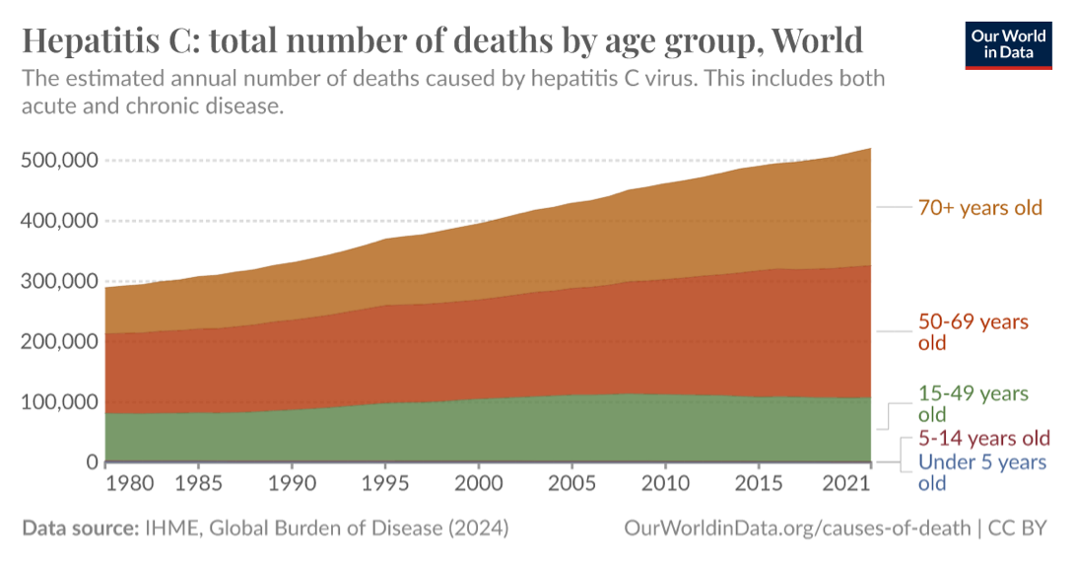

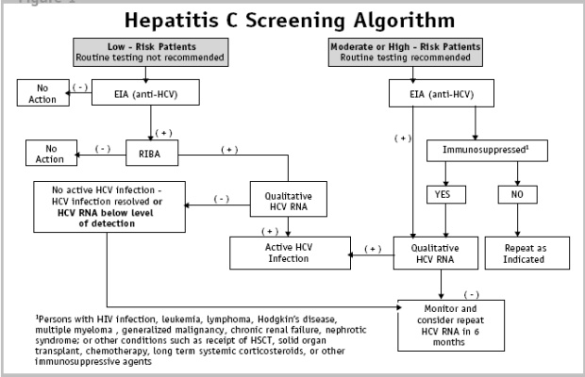

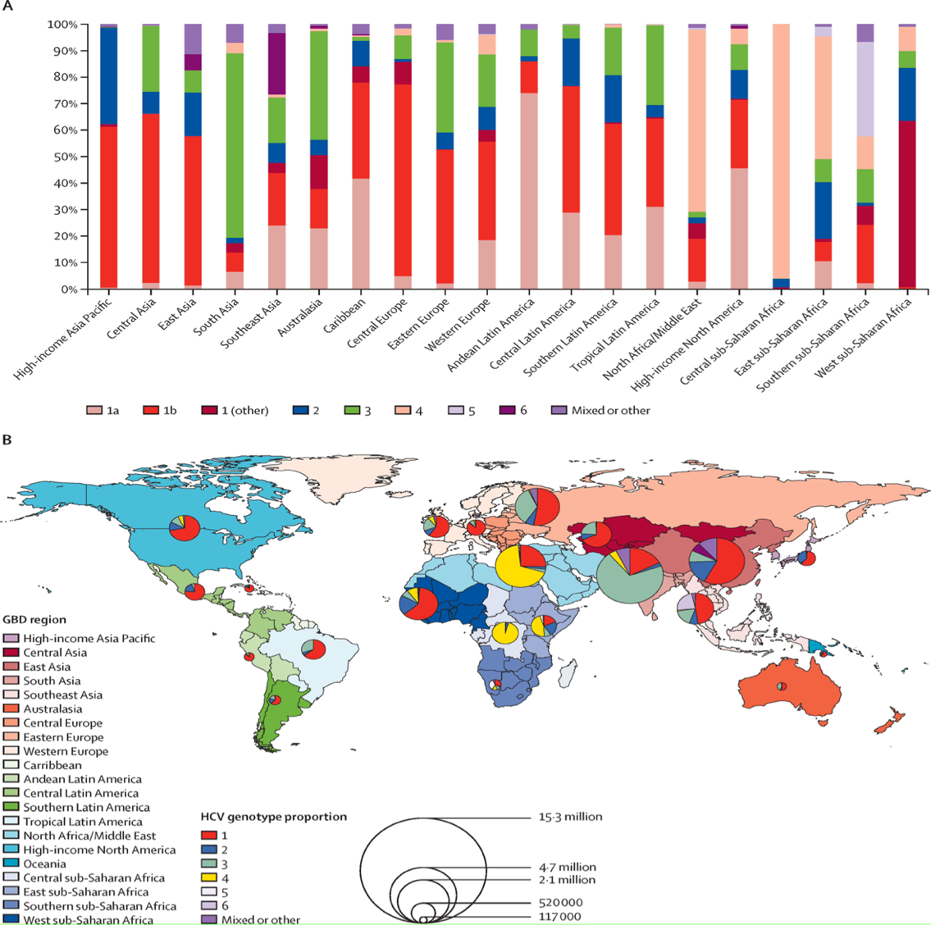

**III CONCLUSION**

Hepatitis C is a chronic viral infection . primarily transmitted through blood-to-blood contact. The infection often progresses silently and can cause chronic liver disease like cirrhosis, and liver cancer after 15-20 years of progression. with a significant proportion of individuals remaining asymptomatic until significant liver damage occurs.

With the advent of DAA therapy, Hepatitis C is now highly treatable, and cure rates have drastically improved. In Early stage diagnosis and cure can be helpful to prevent long-term complications such as cirrhosis and carcinoma. Prevention remains key, as there is no vaccine for HCV in world currently . rently with emphasis placed on screening, safe blood practices, and needle exchange programs. Regular monitoring and follow-up care ensure the best results for patients living with Hepatitis C.

**REVIEW**; This article covers majority of the aspects related to the HCV, epidemiology and prevalence of HCV, transmission, signs and its symptoms, its diagnosis and screening algorithms, prevention, and its treatment. It also includes prophylaxis and prognosis of its treatment.

**IV REFERENCE**

1. World Health Organization. (2016). Global Health Sector Strategy on Viral Hepatitis 2016–2021.Geneva:WorldHealthOrganization https://www.who.int/hepatitis/strategy2016-2021/ghss-hep/en/ This document outlines the strategy for the elimination of hepatitis C by 2030, including prevention, diagnosis, and treatment goals
2. https://www.who.int/news-room/fact-sheets/detail/hepatitis-c This page provides an overview of the global burden of Hepatitis C, its transmission, prevention methods, and current global goals.
3. PubMed/NCBIHepatitis C Virus Infection: Global Epidemiology and Public Health Implications : https://pubmed.ncbi.nlm.nih.gov/31021091/

Davidson’s Principles and Practice of Medicine (23rd ed.). (2018).

• Sir Mark R. S. White, Brian R. Walker, et al.

• Churchill Livingstone.

1. NCBI article discussing the role of harm reduction, needle exchange, and opioid substitution in meeting the WHO’s 2030 goals.NCBI: https://www.ncbi.nlm.nih.gov/pmc/articles/PMC7572060/
2. https://www.ncbi.nlm.nih.gov/pmc/
3. Harrison’s Principles of Internal Medicine (20th ed.). (2018).

• J. Larry Jameson, Anthony S. Fauci, et al.

• McGraw-Hill Education.