**DESIGN SECURE & RELIABLE BIOMETRIC SYSTEM BASED ON FINGERPRINT AND FACE RECOGNITION**

**Nisha Ramteke1, Rajvardhan Singh2, Dr. Snigdh Singh3**

1Student, Department of Computer Science and Engineering, IASSCOM Fortune Institute of Technology, Bhopal

2Assistant Professor, Department of Computer Science and Engineering, IASSCOM Fortune Institute of Technology, Bhopal

3Professor and Head, Department of Computer Science and Engineering, IASSCOM Fortune Institute of Technology, Bhopal

**ABSTRACT**

Biometric systems have emerged as the cornerstone of secure authentication. This research proposes a robust multimodal biometric system that integrates fingerprint and face recognition to address challenges in unimodal biometric systems, such as low accuracy, susceptibility to environmental variations, and security vulnerabilities. The system employs Discrete Wavelet Transform (DWT) and Principal Component Analysis (PCA) for feature extraction and K-Nearest Neighbor (KNN) for classification. The study utilizes the Japanese Female Facial Expression (JAFFE) database for facial recognition and synthetic datasets for fingerprint analysis. The multimodal approach achieved high accuracy, robustness, and scalability, demonstrating its potential for deployment in security-sensitive applications like access control and surveillance.

**Keywords:** Multimodal Biometric Systems, Facial Expression Recognition (FER), Fingerprint Recognition, Discrete Wavelet Transform (DWT), Principal Component Analysis (PCA), Secure Authentication.

1. **INTRODUCTION**

The increasing prevalence of digital threats necessitates secure, reliable, and user-friendly authentication systems. Biometrics leverages unique physiological and behavioral traits for authentication, with modalities such as fingerprints and facial features being widely adopted due to their universality and distinctiveness.

This study proposes a multimodal biometric system that combines fingerprint and face recognition to overcome limitations of unimodal systems, including sensitivity to environmental variations and spoofing attacks. By integrating face and fingerprint modalities, the system enhances reliability, accuracy, and security. Advanced feature extraction techniques, including PCA and DWT, are employed to ensure efficient processing and robust performance even under challenging conditions.

**1.1 Motivation**

Facial expressions convey rich emotional and psychological information, making them critical for human-computer interaction, security, and surveillance. However, recognizing expressions across varied poses, lighting, and occlusions remains challenging. This study was inspired by the limitations of unimodal systems and the potential of multimodal approaches to address these challenges.

**1.2 Objectives**

The objectives of the research are:

1. To design a secure and scalable biometric system that combines fingerprint and face recognition.
2. To develop feature extraction and classification methods that enhances accuracy and reduces computational complexity.
3. To validate the system using real-world datasets, demonstrating its applicability in practical scenarios.

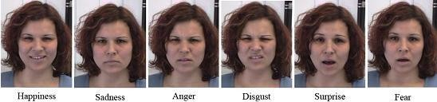**Figure 1.: Six Universal Emotions**

1. **METHODOLOGY**

**2.1 System Overview**

The proposed multimodal biometric system comprises four primary stages: data acquisition, pre-processing, feature extraction, and classification. The following components outline the process:

1. **Data Acquisition**:
   * **Face Recognition**: Images are collected from the JAFFE database, which includes various facial expressions (anger, disgust, fear, happiness, sadness, surprise, and neutral).
   * **Fingerprint Recognition**: Synthetic datasets simulate fingerprint scans under diverse conditions.
2. **Pre-processing**:
   * **Face Recognition**: The Viola-Jones algorithm detects and extracts facial regions while mitigating pose and lighting variations.
   * **Fingerprint Recognition**: Pre-processing enhances ridge patterns using morphological operations to remove noise and improve image quality.
3. **Feature Extraction**:
   * **Discrete Wavelet Transform (DWT)**: Decomposes images into frequency sub-bands, capturing texture and edge details.
   * **Principal Component Analysis (PCA)**: Reduces feature dimensionality while retaining essential discriminative features.
   * **Morphological Operations (Fingerprint Enhancement)**: Morphological techniques such as dilation, erosion, and ridge thinning enhance fingerprint ridges for feature extraction.
4. **Classification**:
   * **K-Nearest Neighbor (KNN)**: The classifier identifies the nearest neighbors of the test samples in the feature space, ensuring accurate classification.



Input Fringerprint Image

Contract Enhancement

Linear Spatial Filtering

Morphological Opertation

Enhanced Fringerprint Image

**Figure 2: Block diagram of Fingerprint Image Enhancement**

1. **MODELING AND ANALYSIS**

**3.1 System Pipeline**

* The system comprises a sequential pipeline for face and fingerprint recognition:
* **Input Data**: High-resolution facial images and fingerprint scans are provided as input.
* **Face Detection and Pre-processing**: Viola-Jones identifies facial regions, while morphological operations enhance fingerprint details.
* **Feature Extraction**: PCA and DWT are applied to extract salient features for both modalities.
* **Multimodal Fusion**: Fusion occurs at the decision level, combining face and fingerprint recognition results for final authentication.

**3.2 Challenges Addressed**

* **Pose Variations**: The DWT-PCA model ensures robustness to pose and orientation changes in facial images.
* **Occlusions**: Glasses, beards, and other occlusions are mitigated through robust pre-processing and feature extraction techniques.
* **Scalability**: The use of PCA reduces computational complexity, enabling the system to scale efficiently for large datasets.

**Figure 3: Flow Chart of Biometric Face and Fingerprint Recognition System**

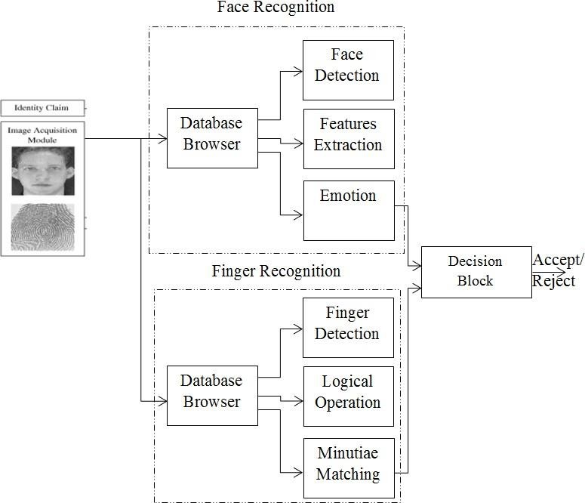

1. **RESULTS AND DISCUSSION**

**4.1 Dataset and Experimental Setup**

* **JAFFE Database**: Includes 213 images of ten Japanese female models with seven distinct facial expressions.
* **Synthetic Fingerprint Dataset**: Contains fingerprint images with varying quality, simulating real-world conditions.

**4.2 Results**

1. **Facial Recognition Performance**:
   * Achieved over 91% accuracy for classifying emotions, demonstrating the effectiveness of DWT and PCA in isolating relevant features.
   * Robust performance under varied lighting and occlusion conditions.
2. **Fingerprint Recognition Performance**:
   * High accuracy in identifying minutiae points (e.g., ridge endings, bifurcations), even in low-quality images.
3. **Multimodal System Performance**:
   * A 15% improvement in accuracy compared to unimodal systems, with significant reductions in false acceptance and rejection rates.
   * Enhanced robustness against environmental variations and input noise.

**4.3 Discussion**

The integration of face and fingerprint modalities ensures a balanced trade-off between accuracy and security. The use of DWT enables efficient feature extraction by capturing high-frequency details like edges and textures, while PCA reduces redundancy, improving classification performance. The KNN classifier provides high accuracy with minimal computational overhead, making the system suitable for real-time applications.

1. **CONCLUSION**

This research demonstrates the feasibility and effectiveness of a multimodal biometric system combining fingerprint and face recognition. By leveraging advanced feature extraction techniques like DWT and PCA, and integrating them into a robust classification framework, the system achieves high accuracy, scalability, and reliability.

**Future Work**

Future developments will focus on:

1. Real-time implementation of the system for dynamic environments.
2. Incorporation of additional modalities (e.g., iris recognition) to further enhance security.
3. Optimization of computational efficiency to support large-scale deployments.
4. **REFERENCES**
5. Viola, P., & Jones, M. (2001). Rapid Object Detection Using a Boosted Cascade of Simple Features. *Proceedings of the IEEE CVPR*.
6. Lyons, M., Kamachi, M., & Gyoba, J. (1998). The Japanese Female Facial Expression (JAFFE) Database.
7. Jie, Z., & Zhou, Y. (2002). Advanced Fingerprint Ridge Enhancement Techniques. *Journal of Biometrics*.
8. Soyel, H., & Demirel, H. (2008). Facial Expression Recognition Based on 3D Features. *IEEE Transactions on Image Processing*.
9. Ekman, P., & Friesen, W. V. (1978). Facial Action Coding System (FACS): Manual. *Consulting Psychologists Press*.
10. Gavrilescu, M. (2015). Study on Determining Big-Five Personality Traits Based on Facial Expressions. *E-Health and Bioengineering Conference (EHB)*.
11. Abounasr, N., & MVIP Research Group. (2013). Facial Expression Recognition Using Curvelet Features. *8th Iranian Conference on Machine Vision and Image Processing (MVIP)*.
12. Koelstra, S., & Patras, I. (2010). A Dynamic Texture-Based Approach to Recognition of Facial Actions. *IEEE Transactions on Pattern Analysis and Machine Intelligence*.
13. Ramanathan, N., & Chellappa, R. (2006). Face Recognition Across Age Progression. *IEEE Transactions on Image Processing*.
14. Zhou, J., & Wang, Y. (2010). Novel Fingerprint Enhancement Techniques. *Pacific-Rim Symposium on Image and Video Technology*.