**CINEMATIC POPCORN PARK**

**Haritha M , Arun A, Bhoomash A K,**  **Kavya G , Atharsh Vikram N**

Student, Computer Science Engineering, Sri Shakthi Institute of Engineering and Technology, Coimbatore, Tamil Nadu, India.

**ABSTRACT**

This is a specially designed parking solution aimed at enhancing the experience of theatergoers by offering convenient, accessible, and immersive parking options. Tailored to the unique needs of theater audiences, this parking facility incorporates features that optimize the guest experience before and after a performance. With proximity to theaters, the parking area is designed for efficiency, reducing the stress of finding a spot and ensuring quick access to the venue. Additionally, the space is integrated with user-friendly technologies, such as real-time availability updates, advanced booking systems, and valet services, streamlining the process for patrons. The design of Theater Parking also embraces aesthetic elements inspired by the arts, featuring visual cues and decor that reflect theater culture, from classic playbill designs to subtle lighting reminiscent of stage settings. By combining convenience, technology, and artistic ambiance, Theater Parking offers a seamless, enjoyable experience that complements the magic of live performance, ensuring patrons arrive and depart with ease and excitement.

**Keywords:** Theater Parking, Theatergoers, Accessible Parking, Convenience, Advanced Booking

**1.INTRODUCTION**

Integrated Movie Ticketing and Parking: " Cinematic popcorn park" allows users to book movie tickets and optionally reserve parking, making the outing more convenient from the start. Optimizing Parking for Movie-Goers: The system offers a simple way to secure parking close to the theater, reducing the stress of finding parking, even in less crowded areas. Improving User Experience: By combining ticketing and parking in one platform, " Cinematic popcorn park" streamlines the entire experience, helping users avoid delays and enjoy a hassle-free movie night.

**2. METHODOLOGY**

The development of Cinematic Popcorn Park, an integrated movie ticketing and parking reservation system, requires a systematic approach that combines user-centered design, technical development, and optimization strategies. Below is a breakdown of the methodology used to create an intuitive, efficient, and user-friendly platform

**2.1 User-Centered Design (UCD)**

The foundation of the platform is built upon understanding user needs and behaviors. This ensures that every aspect of the system is designed with the end user in mind, focusing on ease of use and reducing friction in the movie-going process.

**2.2 System Architecture and Integration**

Building a robust backend infrastructure is critical to ensuring smooth interactions between movie ticketing and parking reservation systems.

**2.3 Optimization and Performance Tuning**

To provide a seamless and efficient experience for users, the system incorporates advanced optimization techniques and performance enhancements. Key strategies include:

* **Load Balancing**: The platform uses load balancers to distribute traffic evenly across servers, ensuring consistent performance even during high-demand periods such as movie premieres or weekends.
* **Caching Mechanisms**: Frequently accessed data, such as movie schedules and available parking slots, are stored in high-speed caches to minimize server load and improve response times.
* **Scalability**: The system is designed to handle growth through vertical and horizontal scaling, allowing it to accommodate increasing numbers of users without performance degradation.
* **Error Handling and Recovery**: Automated systems monitor server health and address issues in real-time to minimize downtime.
* **User Data Analysis**: Advanced analytics tools are used to monitor user behavior and predict high-traffic periods, enabling proactive resource allocation to ensure smooth operations.

**MODELING AND ANALYSIS**

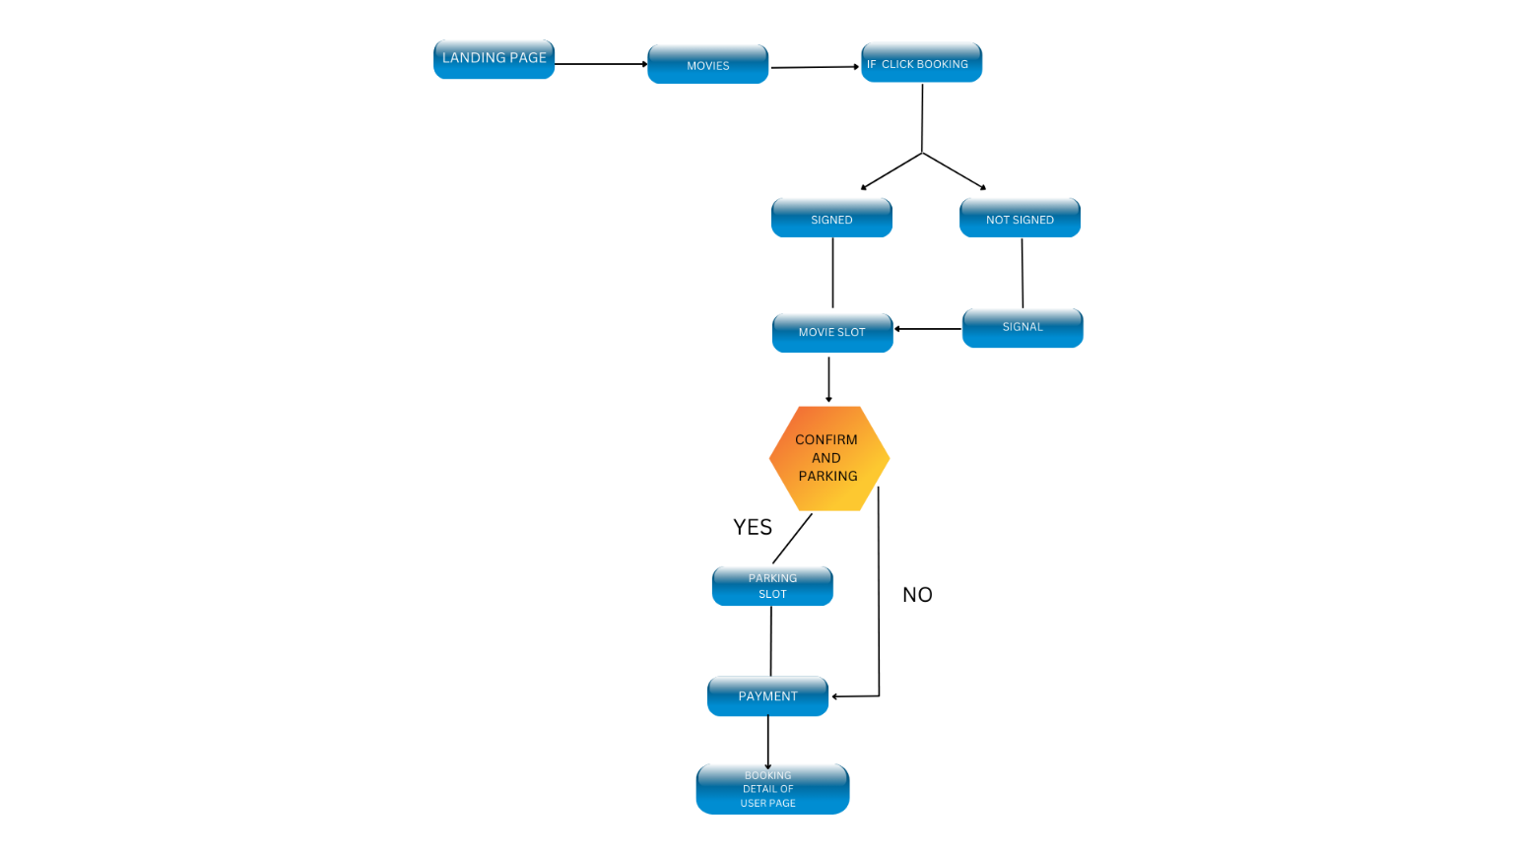

1. **RESULTS AND DISCUSSION**

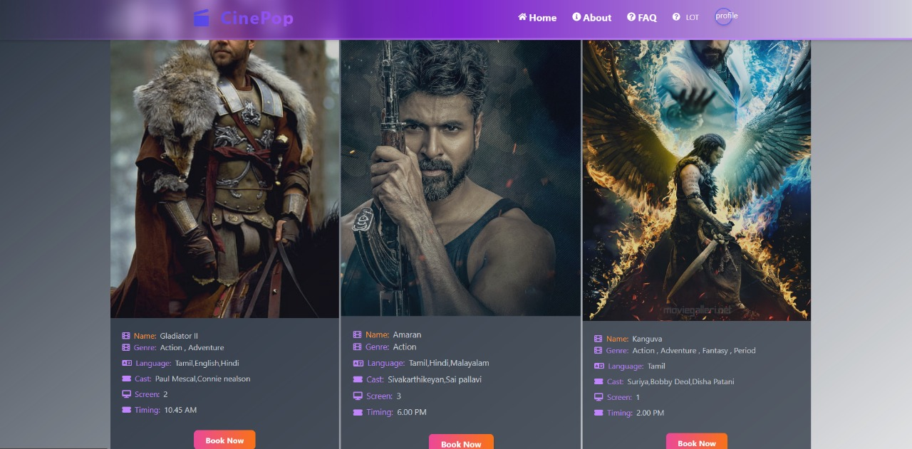

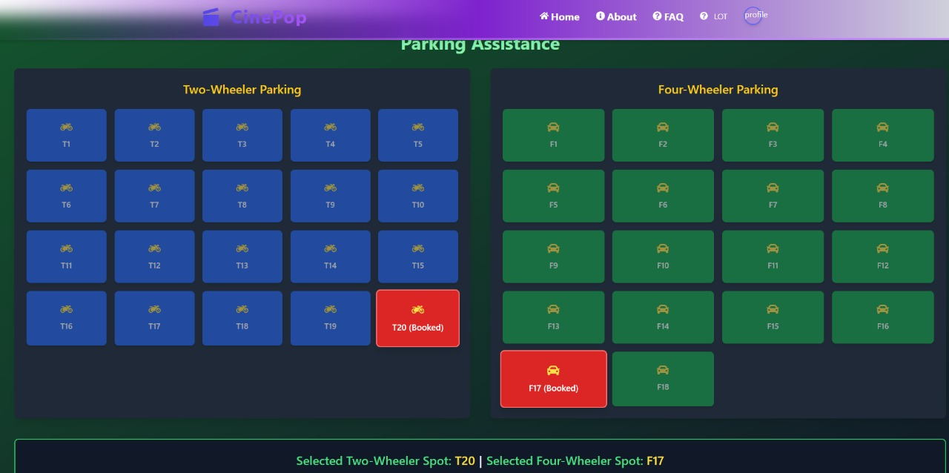

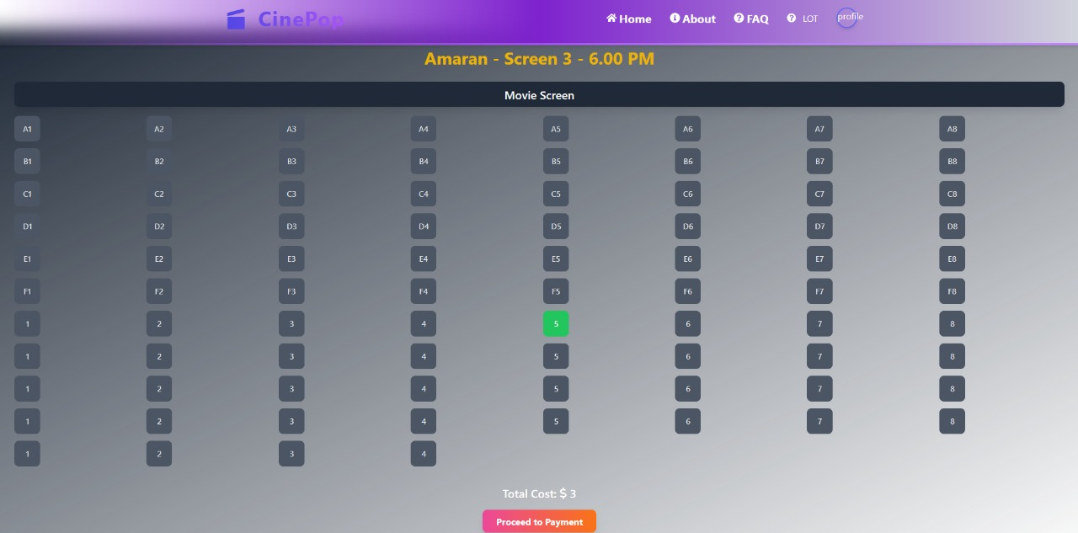

1. **CONCLUSION**

"Cinematic Popcorn Park" redefines the movie-going experience by integrating ticket booking and parking reservations into a single, user-friendly platform. This innovative approach eliminates the stress of last-minute parking searches, ensuring a hassle-free and enjoyable outing. By prioritizing convenience and optimizing logistics, the system enhances user satisfaction, making movie nights more seamless and stress-free. Ultimately, it sets a new standard for integrating entertainment and practical services, catering to the needs of modern, time-conscious users**.**

**ACKNOWLEDGEMENTS**

First and foremost, I would like to thank God Almighty for giving me the Strength. Without his blessings, this achievement would not have been possible. We express our deepest gratitude to our Chairman **Dr.S.Thangavelu** for his continuous encouragement and support throughout our course of study. We are thankful to our Secretary **Mr.T.Dheepan** for his unwavering support during the entire course of this project work. We are also thankful to our Joint Secretary **Mr.T.Sheelan** for his support during the entire course of this project work.

We are highly indebted to Principal **Dr. N. K. Sakthivel M. Tech.,Ph.D** for his support during the tenure of the project. We are deeply indebted to out Head of the Department, Computer Science and Engineering, **Mrs.Dr.K.E.Kannammal**, for providing us with the necessary facilities. It’s a great pleasure to thank our Project Guide **Mrs.M.Haritha** for her valuable technical suggestions and continuous guidance throughout this project work.

1. **REFERENCES**
2. Chaitanya, S., & Kaur, J. (2020). A Study on Online Movie Ticket Booking System. International Journal of Engineering Research and Technology (IJERT), 8(6), 10-14. ISSN: 2278-0181.2.
3. Singh, R., & Gupta, A.(2019). Development of Online Movie Ticket Booking System. International Journal of Computer Applications, 178(1), 6-10. DOI: 10.5120/ijca2019918871.3.
4. Kumar, S., & Sharma, A. (2018). Smart Movie Ticket Booking System Using Mobile Application. International Journal of Advanced Research in Computer Science and Software Engineering, 8(5), 1-5. ISSN: 2277-128X.