**Hybrid Electrical Energy Generation from Hydropower, Solar Photovoltaic**

**1Savale Nitin Ashok, 2Prof. S. S. Gadekar**

**Department of Electronics and Telecommunication**

**Shreeyash College of Engineering & Technology, Aurangabad,**

**Maharashtra**

**Abstract:** This project presents a hybrid energy harvesting system that integrates solar, wind, and piezoelectric energy sources to provide a reliable and sustainable power solution for small-scale applications. The system harnesses the photovoltaic effect of solar panels, the kinetic energy from wind through a miniature wind turbine, and mechanical stress or vibrations via piezoelectric discs. The harvested energy is stored in a rechargeable battery, ensuring consistent power availability. Diodes are employed to prevent reverse current flow, and a voltage regulation circuit maintains a stable output. This hybrid approach mitigates the intermittency of individual energy sources, offering an efficient, eco-friendly solution for powering low-energy devices. The proposed model demonstrates the feasibility of multi-source energy systems in promoting sustainability and reducing reliance on non-renewable energy.

**Keyword: Wind, Solar and Pizzo cell**

1. **INTRODUCTION**

Renewable energy sources are becoming increasingly essential in addressing global energy demands while reducing environmental impacts. Solar, wind, and mechanical energy are abundant and readily available but often underutilized due to limitations in energy capture or storage. This project explores a hybrid energy harvesting system that integrates photovoltaic (solar), piezoelectric (mechanical), and wind energy to overcome these challenges. By combining these sources, the system ensures consistent energy availability and improves overall efficiency. This introduction aims to highlight the growing demand for clean energy and the potential of hybrid systems in meeting this need.

The growing demand for sustainable energy solutions highlights the limitations of relying on individual renewable energy sources, which are often intermittent and dependent on environmental factors. Solar energy, for instance, is not available at night or during cloudy conditions, while wind energy is limited to areas with sufficient wind speeds. Similarly, piezoelectric systems generate small amounts of energy from mechanical stress, but they are not sufficient as standalone systems for continuous power generation. This project addresses the challenge of integrating multiple renewable energy sources to create a reliable and efficient hybrid system capable of generating and storing energy for low-power applications. By leveraging solar, wind, and piezoelectric technologies, the hybrid system seeks to mitigate the limitations of each source and provide a consistent energy supply, demonstrating the feasibility of such systems in small-scale power generation.

**Objectives**

* To develop a hybrid renewable energy system that integrates solar, piezoelectric, and wind energy to maximize energy harvesting efficiency.
* To design a compact and cost-effective prototype for small-scale power generation applications.
* To demonstrate the feasibility of combining multiple energy sources in a single system for consistent and reliable power output.
* To optimize energy storage and regulation mechanisms for efficient use of the harvested energy.
* To evaluate the system's performance under varying environmental conditions and quantify the contribution of each energy source.

1. **BACKGROUND RESEARCH**

* Solar Energy: Solar panels convert sunlight into electrical energy using the photovoltaic effect. Solar energy is abundant and clean, but its efficiency depends on weather conditions and daylight hours.
* Piezoelectric Energy: Piezoelectric materials generate electrical energy when subjected to mechanical stress, making them suitable for capturing vibrations or pressure changes. This technology is often used in sensors and small-scale energy applications.
* Wind Energy: Wind turbines transform kinetic energy from moving air into electrical energy. Small-scale wind turbines can be used in hybrid systems to complement other renewable sources during windy conditions.
* Hybrid Systems: Integrating multiple renewable energy sources into one system increases reliability and energy output, addressing the intermittent nature of individual sources. Research shows hybrid energy systems are particularly effective in areas with variable environmental conditions.

1. **PROPOSED MODEL**

The proposed model is a hybrid energy harvesting system designed to utilize solar, wind, and piezoelectric energy sources to generate and store electricity. The system consists of multiple power generation sources connected to form a hybrid system. For the power generation from the flowing water, an Archimedes screw principle is being used. The system integrates these renewable energy sources into a unified circuit, ensuring consistent power output for small-scale applications. Below is the detailed explanation of the components used in the model:

**Solar Panel:** The solar panel converts sunlight into electrical energy using the photovoltaic effect. It operates with an output voltage of 6V to 12V and a power range of 1W to 10W, making it efficient and ideal for small-scale applications.

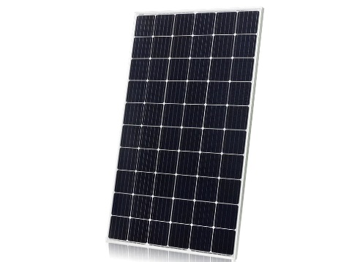

Fig.1: Solar panel

**Wind Turbine:** The wind turbine converts kinetic energy from wind into electricity using a miniature turbine coupled with a DC motor. It operates with an output voltage of 5V to 12V, depending on wind speed, and generates 1W to 5W of power, making it an effective supplemental energy source.

**Piezoelectric Discs:** The piezoelectric discs convert mechanical stress or vibrations into electrical energy. These piezoelectric transducers typically have an output voltage of 3V to 6V, depending on the stress applied, and come in common sizes with diameters ranging from 20mm to 30mm, making them ideal for capturing energy from motion or vibrations.

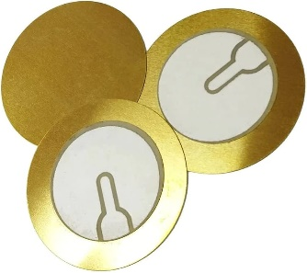

Fig.2: Piezoelectric Discs

**Rechargeable Battery:** The rechargeable battery stores energy harvested from renewable sources for later use. It can be a Lithium-ion or Lead-acid battery, operating with a voltage range of 6V to 12V. The capacity typically ranges from 1000mAh to 5000mAh, depending on the system's energy storage requirements.

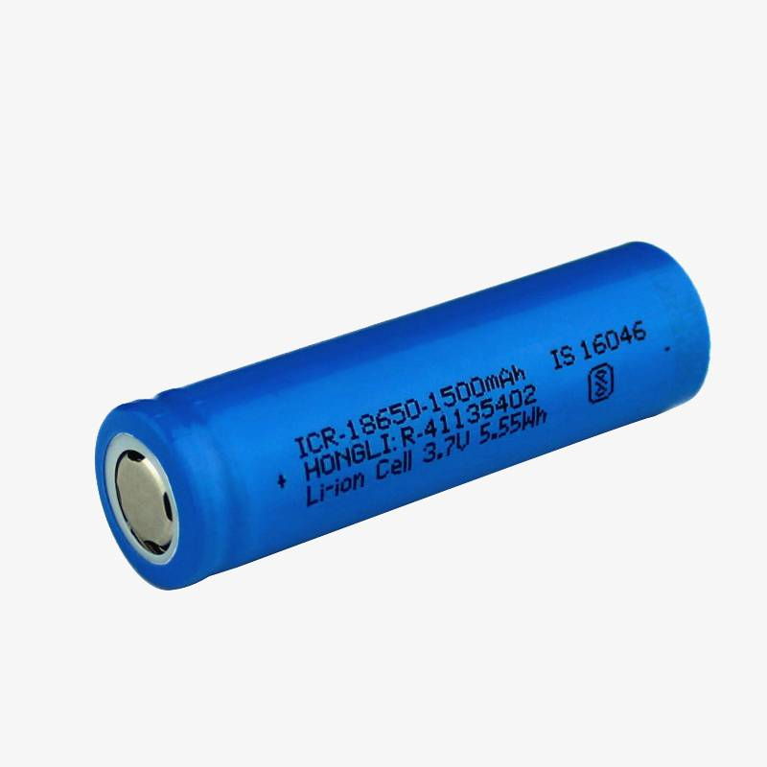

Fig.3: Rechargeable Battery

**Diodes:** The diodes prevent reverse current flow to protect the energy sources. Typically, rectifier diodes like the 1N4007 are used, with a voltage rating of 50V to 1000V and a current rating of 1A to 3A, ensuring efficient energy flow and safeguarding the system components.

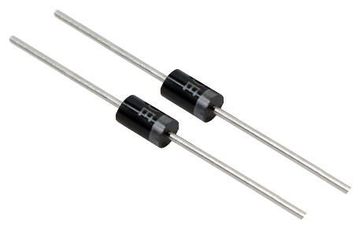

Fig.4: Diodes

1. **WORKING**

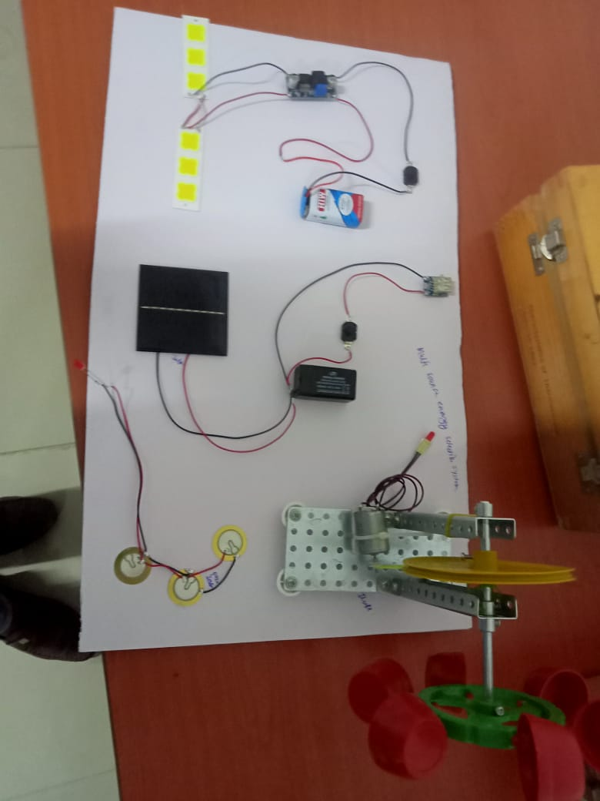

Fig.5: Working Model

The hybrid energy harvesting system combines three renewable energy sources: solar, wind, and piezoelectric energy. A solar panel converts sunlight into electrical energy using the photovoltaic effect, while a wind turbine harnesses kinetic energy from moving air and transforms it into electricity via a small DC motor. Additionally, piezoelectric discs generate electrical energy when subjected to mechanical stress or vibrations, making them ideal for capturing energy from motion or pressure.

The outputs from these sources are integrated into a unified circuit using diodes to prevent reverse current flow, ensuring efficient energy combination. The collected energy is regulated through a voltage control system, such as a buck or boost converter, to maintain a stable output voltage. The energy is then stored in a rechargeable battery, providing a reliable power supply for low-wattage devices.

The system is designed to operate under varying environmental conditions, such as fluctuating sunlight, wind speeds, and mechanical stress levels. During prototype testing, the system's energy output is monitored and measured to evaluate its performance and efficiency. By combining multiple renewable sources, the hybrid system overcomes the intermittent nature of individual sources, ensuring consistent power generation and demonstrating its viability for sustainable energy applications.

1. **CONCLUSION**

The hybrid energy harvesting system successfully integrates solar, wind, and piezoelectric energy to provide a reliable and sustainable power solution. By combining these renewable sources, the system addresses the limitations of individual sources, ensuring consistent energy output even under varying environmental conditions. The prototype demonstrates the feasibility of hybrid systems for small-scale energy applications, contributing to the broader goal of promoting renewable energy adoption and reducing reliance on non-renewable sources. This innovative approach highlights the potential of multi-source energy systems in creating efficient, eco-friendly solutions for future energy needs.

**Applications**

* Remote Monitoring Systems: Powering IoT-based sensors and devices in remote or off-grid locations.
* Portable Electronics: Charging small devices such as mobile phones, wearables, or medical devices.
* Smart Homes: Supporting low-power applications like LED lighting or home automation sensors.
* Disaster Relief: Providing energy for communication or emergency devices during power outages.
* Urban Infrastructure: Powering smart streetlights or signage in urban areas using hybrid energy sources.

**Advantages**

* Energy Reliability: Combines multiple energy sources to provide consistent power, mitigating the intermittent nature of individual renewables.
* Sustainability: Reduces dependence on non-renewable energy, contributing to environmental conservation.
* Scalability: Can be customized for various power requirements, from small devices to larger systems.
* Cost-Effective: Utilizes free, renewable energy sources, reducing operational costs over time.
* Eco-Friendly: Generates clean energy without emissions or pollutants, helping combat climate change.
* Versatility: Suitable for diverse applications, from rural areas with limited grid access to urban smart technologies.

**REFERENCES**

[1] Rajesh Giri, Ajay Kumar, Sujeet Mishra, Neha Shah. “Floating solar collector for hybrid hydro-solar power plant” IEEE publication

[2] Shammi Bahel, Harinder Singh. “A Distributed hybrid model of solar-wind-small hydro for power generation system” ISSN 2278-7690, 2015

[3] Krishna Neupane, Tore Marvin Undeland. “Smart Controller Design for Solar-Grid Hybrid System” IEEE publication

[4] Xiaoyu Duan, Sirui Wu, Rui Diao, Aobo Yang. “Design of Hybrid Solar-hydro Micro grid for Village School in China” IEEE publication

[5] Yu ZHANG, Xin CHEN, "Software Phase Locked Loop based on DSP 2812 [J]", Power Electronics Technology, vol. 42, no. 2, pp. 75-77, 2008

[6] U.S. Department of Energy, “SOLAR ENERGY GRID INTEGRATION SYSTEMS “SEGIS”” Program Concept paper October 2007, p. 17, 2007.

[7] A. Anderson et al., "Empowering Smart Communities: Electrification, Education, and Sustainable Entrepreneurship in IEEE Smart Village Initiatives," in IEEE Electrification Magazine, vol. 5, no. 2, pp. 6-16, June 2017