Artificial intelligence in pharmacy

**Abstract:**

Artificial Intelligence (AI) focuses in producing intelligent modelling, which helps in imagining knowledge, cracking problems and decision making. Recently, AI plays an important role in various fields of pharmacy like drug discovery, drug delivery formulation development, polypharmacology, hospital pharmacy, etc. In drug discovery and drug delivery formulation development, various Artificial Neural Networks (ANNs) like Deep Neural Networks (DNNs) or Recurrent Neural Networks (RNNs) are being employed. Several implementations of drug discovery have currently been analysed and supported the power of the technology in quantitative structure-property relationship (QSPR) or quantitative structure-activity relationship (QSAR). In addition, de novo design promotes the invention of significantly newer drug molecules with regard to desired/optimal qualities. In the current review article, the uses of AI in pharmacy, especially in drug discovery, drug delivery formulation development, polypharmacology and hospital pharmacy are discussed

**Keywords:** Artificial intelligence, Artificial neural network, Drug discovery, Drug delivery research, Hospital pharmacy

**Introduction**: Artificial Intelligence (AI) is a stream of science related to intelligent machine learning, mainly intelligent computer programs, which provides results in the similar way to human attention process.

1This process generally comprises obtaining data, developing efficient systems for the uses of obtained data, illustrating definite or approximate conclusions and self-corrections/adjustments.

2 In general, AI is used for analyzing the machine learning to imitate the cognitive tasks of individuals.

If right now, you were to look around for the forms of artificial intelligence, you'd be surprised to notice how deeply AI has penetrated every facet of our life. You can command Alexa or Siri right now to play your favourite song. You can ask the AI systems in your phone to set the alarm for you, remind you to run errands, and perform countless other tasks.

**What is Artificial Intelligence**

The 'intelligence' in Artificial Intelligence refers to machines' ability to make an informed decision or actions based on the given information. Humans are called intelligent beings because we can make independent decisions by factoring in information from our environment.

Our minds have a unique ability to learn, process billions of bits of information every second, solve problems, use logical reasoning, etc. In AI, this intelligence is simulated by machines. They are fed information and then programmed to exhibit human intelligence. When a machine can take actions on its own and simultaneously rationalize them, it will be deemed intelligent.

In short, artificial intelligence is when computer systems can perform tasks that require human intelligence, like solving complex problems, making decisions, etc.

**History of Artificial Intelligence**

If we go back to the times of the Romans and the Greeks, their mythology has countless mentions of mechanical men, the modern-day equivalent of a robot. One such popular name is Talos. In Greek mythology, Talos was a giant bronze automaton that was made to protect the city Greek city of Europa from the attacks of pirates and invaders.

Fast forward to the last century, our movies and books have been dotted with these machines, who think independently. Needless to say, humans have long had the idea of human-like objects with a mind of their own.

**Beginnings and Developments in Artificial Intelligence**

For ages, philosophers have thought of the human brain's thinking process as a 'symbolic system.' Whether they are on an intergalactic mission or fighting aliens, Robotic companions to humans have been at the heart of sci-fi pop culture.

From TARS from Interstellar, Arthur from Passengers, to Wall-E and cult movies like The Matrix, machines that think and talk and perform actions for humans have been embedded in the popular imagination for a long time.

**Key Components of AI**

**Machine Learning (ML)**

Machine Learning is a subset of AI that involves training algorithms to learn from and make predictions based on data. For example, a spam filter in your email uses machine learning to identify and move spam messages to a separate folder

**Natural Language Processing (NLP)**

NLP allows computers to understand, interpret, and respond to human language. This technology is behind virtual assistants like Siri and Alexa, enabling them to understand your voice commands and respond appropriately

**Computer Vision**

Computer Vision enables machines to interpret and make decisions based on visual data. For instance, self-driving cars use computer vision to navigate roads, recognize traffic signs, and avoid obstacles

**Robotics**

Robotics combines AI with physical machines to perform tasks autonomously. Examples include robotic vacuum cleaners and industrial robots that assemble products in factories

**Types of Artificial Intelligence**

Below are the various types of AI:

**1. Purely Reactive**

These machines do not have any memory or data to work with, specializing in just one field of work. For example, in a chess game, the machine observes the moves and makes the best possible decision to win.

**2. Limited Memory**

These machines collect previous data and continue adding it to their memory. They have enough memory or experience to make proper decisions, but memory is minimal. For example, this machine can suggest a restaurant based on the location data that has been gathered.

**3. Theory of Mind**

This kind of AI can understand thoughts and emotions, as well as interact socially. However, a machine based on this type is yet to be built.

**4. Self-Aware**

Self-aware machines are the future generation of these new technologies. They will be intelligent, sentient, and conscious.

**The Future of AI. What to expect from AI in the next few years or decades**

Artificial intelligence has come a long way, but it’s about to make a huge leap. Artificial general intelligence (AGI), the kind of AI capable of doing any intellectual task that a human being can do, is still a ways off, but we’re already starting to see plenty of progress in other areas of AI. Here’s what you can expect soon:

**Artificial Intelligence will make more jobs obsolete as it takes over more and more tasks**

The reason why is simple: if you can replace one person with an AGI system, you don’t need one computer to do the work – you can spread it out across thousands or millions of computers. That’s only possible because a general AI system can learn from past experiences and improve itself, meaning that it doesn’t have to be reprogrammed for every new task. In fact, there’s no reason why an AGI system would need humans at all – once it learns enough, it could design its own machines or find ways to automate entire industries.

The advent of AI is transforming the business landscape and changing people’s lives for the better. In the coming years, most industries will see a significant transformation due to new-age technologies like cloud computing, Internet of Things (IoT), and Big Data Analytics. All these factors profoundly influence how businesses operate today and are also finding applications in other areas like military, healthcare, and infrastructure development

**Health & medicine**

The application of AI in medicine and medical research has the potential to increase patient care and quality of life.Through the lens of the Hippocratic Oath, medical professionals are ethically compelled to use AI, if applications can more accurately diagnose and treat patients.

**Video game**

A video game, sometimes more specifically computer game,or more ambiguously just game, is an electronic game that involves interaction with a user interface or input device (such as a joystick, controller, keyboard, or motion sensing device) to affect computation and data access processing game logic as part of a simulation to ultimately generate visual feedback from a display device, most commonly shown in a video format on a television set, computer monitor, flat-panel display or touchscreen on handheld devices, or a virtual reality headset. Sections of interaction may be interspersed with non-interactive (usually story-based) portions (e.g., cutscenes). Most modern video games are audiovisual, with audio complement delivered through speakers or headphones, and sometimes also with other types of sensory feedback (e.g., haptic technology that provides tactile sensations). Some online video games also allow microphone and webcam inputs for in-game chatting and livestreaming.

**Industry roles**

Video games have a large network effect that draw on many different sectors that tie into the larger video game industry. While video game developers are a significant portion of the industry, other key participants in the market include

**Publishers:**

Companies generally that oversee bringing the game from the developer to market. This often includes performing the marketing, public relations, and advertising of the game. Publishers frequently pay the developers ahead of time to make their games and will be involved in critical decisions about the direction of the game's progress, and then pay the developers additional royalties or bonuses based on sales performances.

**Distribution:**

is the process of making a product or service available for the consumer or business user who needs it, and a distributor is a business involved in the distribution stage of the value chain. Distribution can be done directly by the producer or service provider or by using indirect channels with distributors or intermediaries. Distribution (or place) is one of the four elements of the marketing mix: the other three elements being product, pricing, and promotion.

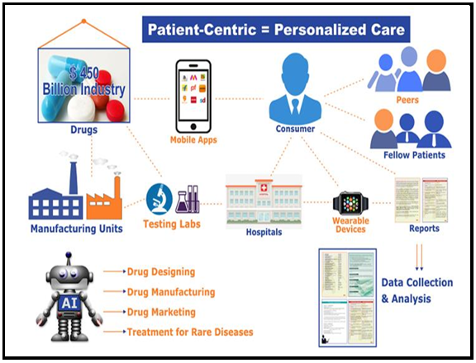

**Figure 1: Benefits of using Artificial Intelligence in drug development**

**Various AI fields to dispel common misunderstandings:**The most popular area of computer science right now is artificial intelligence. But with all the new research and technology, it's developing so quickly that it might be difficult to tell what is what. Additionally, AI encompasses a wide range of domains, each with unique algorithms. As a result, it is crucial to understand that artificial intelligence is a science that combines several different fields.  
  
The ability to program computers to perform tasks that would normally need human intelligence is known as artificial intelligence (AI). Machine Learning (ML) and Neural Networks (NN) are the two main subfields of artificial intelligence.

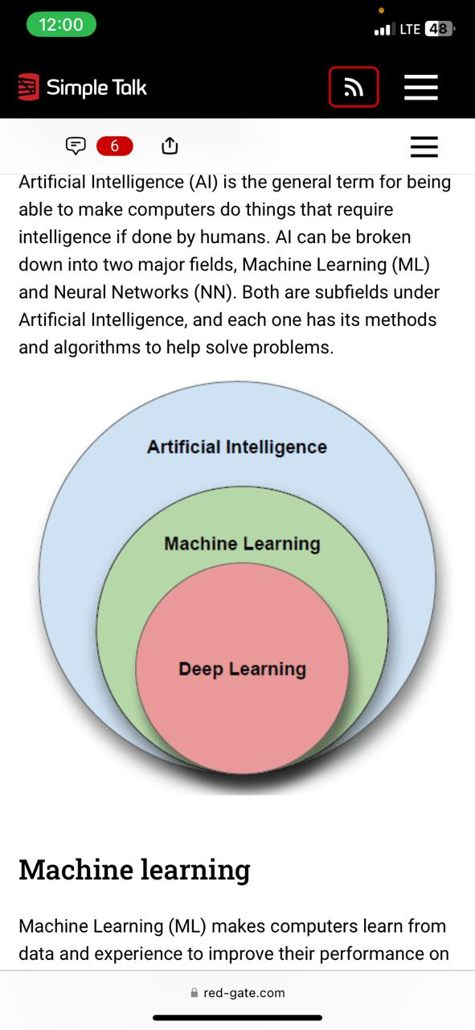

**Learning by machine:**  
Computers may learn from data and experience through machine learning (ML), which enhances their ability to do certain jobs and make decisions. For this, machine learning makes use of probability theory and statistics. Without the need for explicit programming, machine learning parses data, learns from it, and makes decisions using algorithms. It's common to classify machine learning algorithms as either supervised or unsupervised. While unsupervised algorithms can make deductions from datasets, supervised algorithms can apply previously learned information to new data sets. The goal of machine learning algorithms is to find both linear and non-linear correlations in a given data collection. This is accomplished by training the algorithm to classify or predict from a dataset using statistical techniques.

**Deep learning:**  
  
Deep learning is a branch of machine learning that achieves cutting-edge accuracy in language translation, speech recognition, and object detection by utilizing multi-layered artificial neural networks. A key component of autonomous vehicles, deep learning allows for the computer interpretation of vast volumes of complicated data, such as identifying faces in photos or videos.  
  
**Networks of neurons:**  
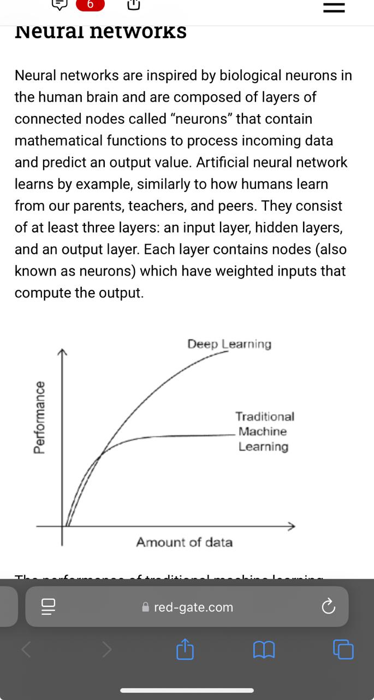  
Inspired by actual neurons found in the human brain, neural networks are made up of layers of interconnected nodes known as "neurons" that interpret incoming data and forecast an output value using mathematical functions. Similar to how people learn from their parents, instructors, and friends, artificial neural networks also learn by imitation. At least three layers make them up: an input layer.

A picture of a graph. Performance is on the Y axis, and data volume is on the X axis. While traditional machine learning reaches a plateau, the Deep Learning curve keeps rising with new data.  
  
Conventional machine learning models reach a plateau in performance, and adding new data has no effect. With additional data, deep learning models continue to perform better.  
  
The algorithms used in these domains vary according on the application case. For machine learning, for instance, we have k-nearest neighbors (kNN), support vector machines (SVM), boosting, decision trees, random forests, and others. Convolutional neural networks (CNNs), recurrent neural networks (RNNs), long short-term memory networks (LSTMs), and other types of neural networks are available.

**Conclusion:**

The field of computer science that seeks to develop machine intelligence is known as artificial intelligence (AI). The dominant technology of today, artificial intelligence (AI) will play a major role in many different industries for years to come. In addition to having the potential to upend numerous industries, increasingly sophisticated AI systems also pose questions about how humans should respond to such amazing ability.  
  
Over time, this field has undergone significant change. From being the focus of popular science fiction, it now plays a big role in our daily life. As we have done in this article, a deeper understanding of AI's present and future can be achieved by looking at its past.

**Reference:**

* Cite this article: Das S, Dey R, Nayak AK. Artificial Intelligence in Pharmacy. Indian J of Pharmaceutical Education and Research. 2021;55(2):304-18.
* Nikhil Singh*, Sunil Kumar, K. Prabhu, Aman Shukla, Ashish Yadav Department of Pharmacy, Nandini Nagar Mahavidyalaya College of Pharmacy, Nawabganj, Gonda, UP, India.
* Arrieta, A. B., Rodríguez, N. D., Ser, J., Bennetot, A., Tabik, S., Barbado, A., ... & Herrera, F. (2019). Explainable Artificial Intelligence (XAI): Concepts, Taxonomies, Opportunities and Challenges toward Responsible AI. Information Fusion, 58, 82-115.
* Sadybekov, A. V., & Katritch, V. (2023). Computational approaches streamlining drug discovery. Nature, 616, 673-685.
* Raza, M. A., Aziz, S., Noreen, M., Saeed, A., Anjum, I., Ahmed, M., & Raza, S. M. (2022). Artificial Intelligence (AI) in Pharmacy: An Overview of Innovations. Innovations in Pharmacy, 13.
* Troulis M, Everett P, Seldin E, Kikinis R, Kaban L, Development of a three-dimensional treatment planning system based on computed tomographic data, 2002; 31:349–357.
* Arimura H, Soufi M, Kamezawa H, Ninomiya K, Yamada M, Radiomics with artificial intelligence for precision medicine in radiation therapy, J. Radiat. Res, 2019; 60: 150–157.
* Schmidt-Erfurth U, Sadeghipour A, Gerendas B.S, Waldstein S.M, Bogunovi H, Artificial intelligence in retina, Retin Eye Res, 2018;67:1- 29.
* Carreras J, Hamoudi R, Artificial Neural Network Analysis of Gene Expression Data Predicted Non-Hodgkin Lymphoma subtypes with High Accuracy, Mach. Learn Knowl. Extr, 2021; 3: 720–739.
* Carreras J, Nakamura N, Hamoudi R, Artificial Intelligence Analysis of Gene Expression Predicted the Overall Survival of mantle Cell Lymphoma and a Large Pan-Cancer Series, 2022; 10:155.