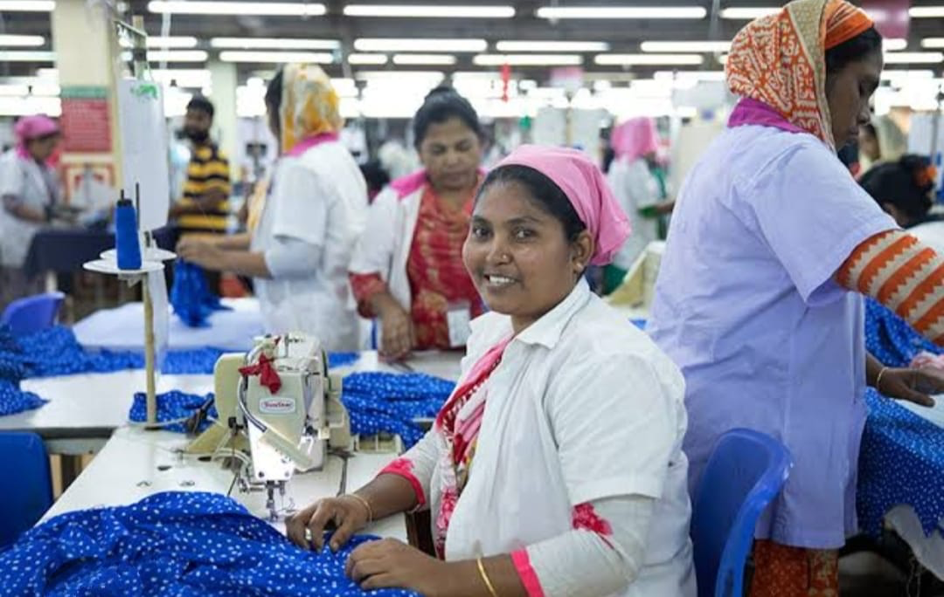

**Empowering Women, Ensuring Peace: Exploring Women’s Security in the RMG Sector of Bangladesh**

**Abstract**

This study explores the potential and difficulties faced by women in Bangladesh's ready-made garment (RMG) industry, highlighting the vital connection between peacebuilding, empowerment, and workplace security. The study is based on an extensive survey and interviews that the author performed with 300 female garment workers from factories in Dhaka, Gazipur, and Chittagong, as well as with policymakers and factory management. The results draw attention to structural issues that continue to impede women's empowerment, such as widespread workplace harassment, insufficient safety precautions, and salary inequality. Notwithstanding these obstacles, there has been success in a few areas, including regulatory compliance and the implementation of worker-friendly measures like childcare centers and training programs. For example, factories participating in the Better Work Program report increased production and fewer conflicts. But these gains are intermittent, and the majority of women continue to face unstable employment situations. In order to make the RMG industry a safer and fairer place to work, this paper offers practical suggestions that center on strong regulatory enforcement, infrastructural upgrades, and teamwork. The sector may support gender equality and long-term peace in Bangladesh in addition to economic growth by tackling systemic issues and expanding effective solutions. 

**Keywords**: Women’s empowerment, RMG sector, workplace security, Bangladesh, peace-building, gender equality.

**______________________________________________________________________________**

**Introduction**

A key component of Bangladesh's economy, the ready-made garment (RMG) industry employs around 4.4 million people, with women accounting for 65–80% of the workforce (BGMEA, 2023) [1]. With 81% of export revenue and a significant 11% GDP contribution, this predominantly female workforce plays a crucial role in maintaining the country's economic trajectory [1]. In addition to growing the business, women's active involvement has established Bangladesh as a world leader in clothing production.

Notwithstanding these noteworthy accomplishments, women in the field nevertheless encounter numerous obstacles that impede their ability to advance both professionally and personally. There is still a lot of workplace harassment, such as verbal and physical violence, which makes people feel uncomfortable and frightened. Furthermore, their health is seriously endangered by hazardous working conditions, especially those pertaining to structural integrity, fire safety, and insufficient security at night. Because women are frequently paid less for doing the same work as men, wage differences further increase gender inequality. Women's empowerment is impeded by these systemic problems, which also make it more difficult for them to become economically independent and fully contribute to social progress and workplace peace.

The article provides an in-depth perspective on the realities of women's security in the RMG sector and is based on the author's direct and committed contact with stakeholders and the workforce. In order to identify the urgent problems that female workers confront, such as insufficient legal safeguards, restricted access to resources, and unequal policy implementation, the author worked alone to conduct extensive surveys and interviews. The results are intended to address systemic issues and advance women's rights by offering practical insights and significant reform recommendations. The paper aims to contribute to a safer, more equal, and sustainable future for the RMG industry in Bangladesh by analyzing the state of women's security today and pinpointing important areas for development.

**Present Status of Women’s Security in the RMG Sector**

**Harassment and Exploitation:** In Bangladesh's Ready-Made Garment (RMG) industry, workplace harassment is a serious and widespread problem that persists in compromising the rights, safety, and dignity of female employees in spite of labor rules designed to protect them. Because of the different forms of abuse that women in this industry experience, harassment is a constant barrier to their well-being and empowerment.

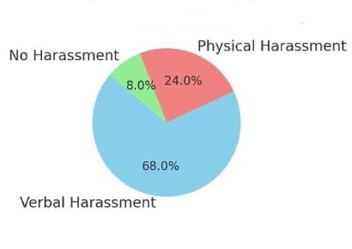

**Figure 1:** Work place harassment types

**- Pervasive Harassment:** According to the survey, 68% of female respondents reported verbal abuse, ranging from disparaging comments to harsh reprimands from coworkers or bosses, underscoring the startlingly high frequency of workplace harassment. Furthermore, 24% of those surveyed said they had experienced physical harassment, which included unwanted physical contact and, in certain situations, open violence. Such occurrences cause long-lasting emotional and psychological damage, which further lowers their self-esteem and output.

**- Reluctance to Report:** Even though harassment is common, only 15% of cases are officially reported [2]. Due to a deep-rooted fear of reprisals, many women are reluctant to speak up for fear of punishment, social rejection, or even termination. The problem is made worse by the lack of strong and independent grievance procedures, which deprive victims of trustworthy and secure channels for reporting wrongdoing. In addition, social constraints and cultural stigmas prevent women from speaking out about their experiences, which feeds the cycle of inaction and silence.

In order to overcome these obstacles, it is essential to set up reliable, accessible, and functional reporting systems. It is crucial to empower women by educating them about their legal rights and safeguards and by enforcing anti-harassment regulations strictly. The RMG industry can make its largely female workforce feel safer and more supported by addressing workplace harassment holistically, which will promote both individual empowerment and harmony within the workplace.

**Workplace Safety Concerns:** In Bangladesh's Ready-Made Garment (RMG) industry, workplace safety is still a major concern that disproportionately affects the primarily female workforce. Even with improvements in some areas, systemic problems still endanger employees' physical and mental health, especially during vulnerable periods like night shifts.

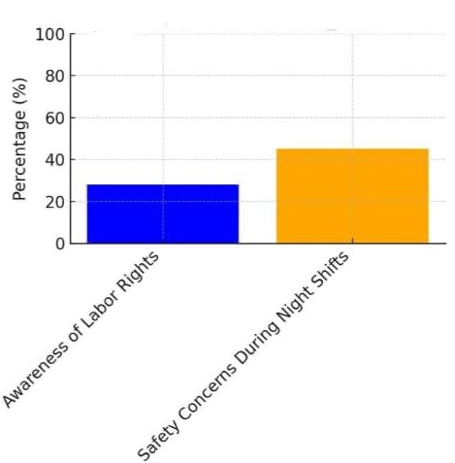

**Figure 2:** Women’s Awareness and Safety Issues

**- Transportation and Lighting:** Lack of safe transportation and sufficient illumination is one of the major safety issues faced by female employees. 45% of respondents to the author's poll said they felt insecure traveling to and from factories while working night shifts. A dearth of dependable and reasonably priced transportation choices, as well as dimly illuminated factory buildings and the surrounding surroundings, contribute to this feeling of fear. The urgent need for better infrastructure and secure transportation services is highlighted by the numerous reports of harassment and intimidation experienced by women while commuting. Women who work late hours are particularly vulnerable since they frequently have no other option but to work in these hazardous environments in order to keep their livelihoods.

**- Building Safety Compliance:** A wake-up call for the RMG industry was the 2013 collapse of Rana Plaza, which prompted stronger laws and pressure from all over the world to increase building safety. But improvement hasn't been consistent. About 40% of companies still fall short of the necessary requirements, despite the fact that some have made impressive progress in meeting fire and structural safety regulations [3]. Workers' lives are constantly in danger due to persistent non-compliance in areas including structural integrity, electrical wiring, and fire exit maintenance. Women are particularly vulnerable during calamities, such as fires or building collapses, because they frequently operate in crowded settings with few escape routes.

Enforcing stronger compliance regulations, carrying out routine inspections, and holding offenders accountable are all crucial to ensuring workplace safety. Furthermore, offering safe transportation alternatives and well-lit factory spaces can greatly improve women's safety, especially when working nights. In addition to being ethically essential, addressing these issues is strategically necessary to promote a more secure, efficient, and just workplace in the RMG industry.

**Wage Discrimination and Limited Growth Opportunities:** In Bangladesh's Ready-Made Garment (RMG) industry, women's economic empowerment is severely limited by ongoing wage discrepancies and limited prospects for professional growth. These issues impede workplace harmony and production by undermining the workforce's potential and perpetuating gender inequality.

**- Wage Inequality:** In the RMG industry, the wage gap is still a visible reality, with women routinely earning 12–15% less than males for doing equivalent work [4]. This discrepancy is a result of ingrained gender prejudices, where women's contributions are underappreciated despite playing a vital part in propelling the sector. Lack of transparency in pay structures and inadequate execution of labor rules requiring equal pay further widen the wage disparity. Women have financial instability and less possibilities to escape poverty cycles as a result of their lower incomes. Women's work is consistently undervalued, which affects not only their short-term well-being but also their long-term financial independence.

**- Stagnant Roles:** In the RMG industry, the majority of women are limited to low-skilled, low-paying jobs like assistance or sewing machine operators. These jobs are frequently labor-intensive, repetitious, and provide few chances for skill advancement or career advancement. Only a small fraction of women break past this invisible ceiling and move into managerial or supervisory roles. This stagnation is further exacerbated by cultural norms, restricted training opportunities, and discriminatory hiring practices, which deny women leadership positions where they could advocate for their rights and impact workplace regulations.

It demands focused initiatives to address stagnant positions and wage discrimination. Important actions include enforcing laws pertaining to equal pay, ensuring salary structure transparency, and encouraging women's participation in skill-development initiatives. Developing leadership programs and mentorship opportunities specifically for women can also promote upward mobility by allowing them to move into higher-paying, decision-making positions. The RMG industry can unleash the full potential of its workforce and make significant progress toward gender equality by reducing the salary gap and encouraging career advancement.

**Awareness and Training Gaps:** The Ready-Made Garment (RMG) industry in Bangladesh has significant obstacles to women's empowerment, including a lack of knowledge about their rights at work and limited access to training opportunities. In addition to impeding individual growth, these disparities impair the workforce's collective ability, hence sustaining inequality and decreasing production.

**- Awareness of Legal Protections:** For women working in RMG, a major obstacle is a lack of awareness regarding their rights at work. Only 28% of workers were aware of their rights under the Bangladesh Labour Act (2018), which includes important protections like safe working conditions, maternity leave, and fair salaries, according to the author's poll. Due to their inability to identify when their rights are being infringed or know how to seek remedy, workers who have this low degree of awareness are more susceptible to exploitation. Employers frequently neglect to notify employees about these protections, and the problem is made worse by a lack of efficient lines of communication. Women are consequently left without the resources necessary to speak up for themselves or ask for equal opportunities at work.

**- Impact of Training Programs:** Opportunities for skill development and training are essential for improving women's worker efficiency, self-esteem, and professional advancement possibilities. According to the poll, manufacturers that provided leadership and skill development programs saw a significant decrease in absenteeism and a 15% increase in employee job satisfaction. Women who took part in these programs acquired vital skills that allowed them to pursue higher-paying jobs and take on more responsibility. But these kinds of projects are rare and frequently focused on a small number of forward-thinking factories. Most RMG employees are still not able to take advantage of these chances, which restricts their ability to advance in their careers and feeds the cycle of low-skill, low-wage employment.

Expanding access to training programs and increasing awareness of legal safeguards are two specific actions required to close these gaps. Companies should be urged to invest in skill development programs and hold frequent workshops on workers' rights, with an emphasis on enabling women to assume leadership positions. Government, non-profit, and business partnerships can scale these initiatives, promoting a more educated and competent workforce and advancing workplace harmony and gender equality in the RMG industry.

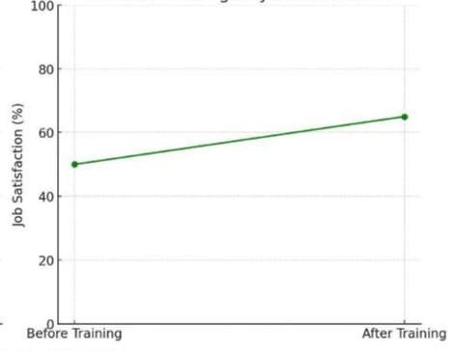

**Figure 3:** Effect on training on job satisfaction

**Emerging Progress:** Though women in Bangladesh's Ready-Made Garment (RMG) industry confront numerous obstacles, there has been significant advancement in some areas, especially in companies that follow best practices and international standards. Despite their narrow focus, these developments offer important new perspectives on how focused interventions might improve worker morale and productivity while fostering safer, more egalitarian workplaces.

**- Better Work Program:** Significant improvements in working conditions have been shown by factories taking part in the Better Work Program, which is a partnership between the International Finance Corporation (IFC) and the International Labour Organization (ILO). Due to improved labor standards enforcement, improved management-employee communication, and an emphasis on cultivating an environment of accountability and respect, these manufacturers reported a 20% decrease in workplace conflicts. Additionally, these factories saw a 10% increase in productivity, demonstrating the clear link between better working conditions and increased operational effectiveness. By focusing on tackling issues like harassment, salary inequality, and safety compliance, the initiative has established a standard that other manufacturers can follow, demonstrating the real advantages of putting employee well-being first.

**- Childcare Facilities:** For female employees, childcare is still a major worry because many of them find it difficult to juggle their work and caregiving obligations. The impact of on-site childcare services is significant, even though only 5% of factories surveyed now offer them. Since having access to childcare lowers stress and improves concentration, women who worked in these workplaces reported noticeably greater attendance rates and higher morale. In order to retain talented employees and improve job happiness, this program also encourages a family-friendly work atmosphere.

Expanding access to childcare facilities and scaling up programs like the Better Work Program are crucial to building on these gains. Cooperation between international organizations, industry associations, and factory owners can aid in the sector's replication of these effective models. These initiatives can encourage a wider adoption of best practices by proving that worker-centric policies produce quantifiable benefits, which will help to create a more equitable and sustainable RMG sector in Bangladesh.

|  |  |  |
| --- | --- | --- |
| Aspect | Key Findings | Percentage/ Insights |
| Workplace Harassment | Verbal Abuse, physical harassment reported | 68% verbal, 24% physical harassment |
| Safety Concerns | Night shift safety, inadequate transport | 45% felt unsafe |
| Awareness of Rights | Knowledge of labor rights | Only 28% aware |
| Impact of Training | Effectiveness of training programs | 15% increase in satisfaction, reduced absenteeism |
| Daycare Facilities | Availability in surveyed factories | Only 5% factories provide daycare facilities |
| Policy Compliance | Factories under Better Work Program | 20% fewer conflicts, 10% productivity increase |

**Table 1: Summary of key findings**

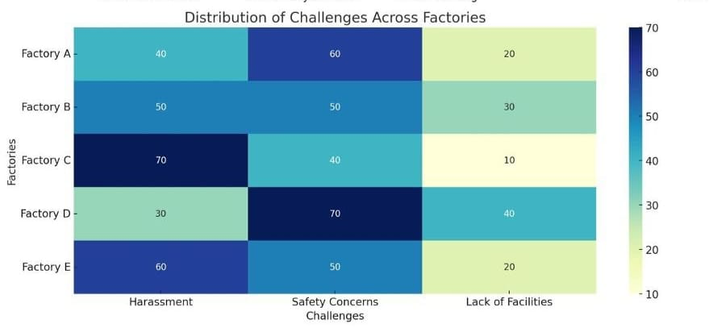

**Figure 4:** Distribution of challenges across factories

**Recommendations**

**Policy Implementation and Enforcement:** Establishing strong regulations and successfully enforcing them are crucial to addressing structural issues in Bangladesh's ready-made garment (RMG) industry and promoting a safer and more equal workplace. The RMG industry can contribute to gender equality and sustainable economic advancement by putting these policies into place and upholding them, which will make the workplace safer and more welcoming. 

**- Strengthening Labor Law Enforcement:** Protecting workers' rights and ensuring adherence to safety regulations need a high priority for labor law enforcement. To evaluate compliance with labor laws, such as those pertaining to pay, workplace safety, and harassment prevention, factories should undergo routine, surprise inspections. To get rid of any potential bias and corruption, independent organizations should conduct these inspections. Strict sanctions, including fines, manufacturing license suspensions, or even closure for extreme non-compliance, must be applied to violators. Accountability can be further improved and proactive adherence to standards can be encouraged by transparent reporting of inspection results.

**- Establishing Independent Grievance Mechanisms:** Independent grievance procedures are essential for enabling employees to report harassment and other abuses at work without worrying about reprisals. These safeguards must to include anonymous reporting venues run by unbiased third parties, including secure online channels or private hotlines. Grievance redressal procedures also need to be prompt, transparent, and built to preserve the privacy and dignity of those who file them. To make sure that all employees are aware of and have faith in these channels, factories should aggressively promote them through training sessions, banners, and consistent communication.

**- Empowering Workers through Awareness**: It is essential to educate employees on their rights and the resources at their disposal. Frequent training sessions on anti-harassment policies, labor regulations, and workplace safety help promote a mutually respectful and accountable culture.

**Infrastructure Improvements:** To protect the safety, dignity, and general well-being of workers—especially women, who bear a disproportionate amount of risk—in the ready-made garment (RMG) industry, infrastructure must be improved. Workplace security and productivity can be greatly increased by addressing issues with transportation, manufacturing illumination, and adherence to safety regulations. By ensuring a safer workplace, increasing employee confidence, and adhering to international labor norms, the RMG industry can support gender equity and long-term sustainability.

**- Safe and Reliable Transportation and Lighting:** Lack of safe transportation, particularly for those working night hours, is one of the biggest issues faced by female garment workers. Due to the lack of suitable transportation choices and dimly illuminated factory environments, many women report feeling dangerous while commuting. Employers and legislators should work together to address this by offering workers safe, dependable, and reasonably priced transportation options, especially after hours. Transportation companies and factory owners can collaborate to set up shuttle services with drivers who have been screened and trained. It's also critical to upgrade the lighting surrounding the factory's grounds, entrances, and exits, as well as the nearby streets. Well-lit spaces give employees a sense of security by lowering the possibility of harassment, theft, and intimidation. For enduring advantages, governments and industry owners should spend money on setting up and maintaining suitable lighting systems that are fueled by renewable energy sources like solar panels.

**- Fire and Structural Safety Compliance:** The 2013 Rana Plaza collapse and the safety issues that followed bring to light the continuous difficulties in adhering to fire and structural safety regulations. A sizable portion of factories continue to fall short of minimal safety standards, even with advancements in certain areas. Regulations pertaining to emergency readiness, fire exits, and building upkeep must be closely followed by factory owners. Certified authority should be required to conduct routine inspections, and noncompliance should result in harsh fines. Industry participants must work with international organizations like the ILO to embrace global best practices in order to maintain progress.

**Capacity Building:** Enhancing workplace equity, increasing overall productivity, and empowering women workers in Bangladesh's Ready-Made Garment (RMG) sector all depend on building their capabilities. To build a more diverse and equitable workforce, it is imperative to close knowledge gaps and support women in leadership roles. The RMG industry can unleash the potential of its largely female workforce by investing in capacity building through training and leadership development, promoting economic growth and creating a more sustainable and fair industry.

**- Mandatory Training on Workplace Safety, Legal Rights, and Leadership:** Enforcing mandatory training on leadership, legal rights, and workplace safety is crucial to giving women the information and abilities they need to succeed in the workplace. Workplace safety workshops can teach employees how to recognize hazards, use protective gear, and handle crises.Equally important is legal rights training, which increases knowledge of the Bangladesh Labour Act's protections, such as maternity leave, fair salaries, and anti-harassment policies. Only 28% of female employees knew their rights, according to a poll, underscoring the need for such programs. By increasing their self-esteem and equipping them for decision-making positions, leadership training can further empower women. In order to help women escape low-skilled, low-paying jobs, these programs ought to emphasize strategic thinking, communication skills, and dispute resolution. The significance of these programs has been highlighted by the fact that factories who implement them report increased worker retention rates, decreased absenteeism, and enhanced job satisfaction.

**- Promoting Women’s Leadership Through Quotas:** Setting quotas to guarantee that a sizable portion of management and supervisory posts are set aside for women would help solve gender gaps in these areas. Only a small percentage of top positions in the industry are currently held by women, frequently as a result of discriminatory hiring practices, cultural norms, and inadequate training. Quotas can give competent women the chance to assume leadership positions, influencing workplace regulations and promoting gender equality.

**Collaborative Efforts:** Stakeholder cooperation is necessary to overcome the structural issues that women in Bangladesh's ready-made garment (RMG) industry confront. It is feasible to scale up effective initiatives and produce long-lasting gains in women's empowerment, gender equality, and workplace safety by establishing collaborations and utilizing international funds.

**- Fostering Partnerships Between Government, Private Sector, and NGOs:** Developing Collaborations Between NGOs, the Private Sector, and the Government: For proven interventions to be scaled up and widely implemented, effective collaborations are essential. By developing policy frameworks and providing incentives for private-sector engagement, the government can play a key role. In order to implement worker-centric initiatives like training programs, childcare facilities, and grievance processes, factory owners and corporations must partner with NGOs and civil society organizations that have experience in doing so. Partnerships can result in quantifiable improvements in working conditions, fewer conflicts, and higher productivity, as the Better Work Program, a partnership between the International Finance Corporation (IFC) and the International Labour Organization (ILO), has shown. Solutions suited to the particular difficulties faced by the RMG industry are made possible by fostering innovation and resource sharing across varied stakeholders. Frequent multi-stakeholder discussions can help coordinate efforts and share best practices, resulting in inclusive and successful initiatives.

**- Securing International Funding for Long-Term Projects:** Large-scale, long-term initiatives aimed at enhancing workplace safety and empowering female employees require international investment. Potential partners for the mobilization of resources and technical skills include the World Bank, UN Women, and the ILO. Initiatives including capacity-building programs, infrastructural development, and women's leadership training can be funded using these grants. Bangladesh's RMG industry can conform to international labor norms and gender equality objectives by gaining foreign support. In addition to improving the lives of employees, cooperative actions boost the industry's standing and promote sustainable development and economic progress.

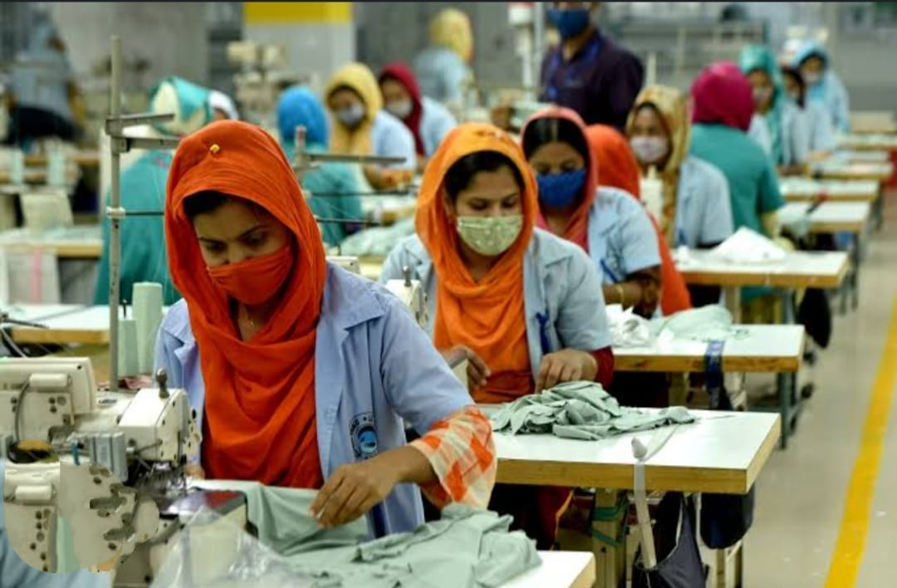

**Figure 5:** Women working in a garments factory at Gazipur

**______________________________________________________________________________**

**Conclusion**

In Bangladesh, the ready-made garment (RMG) industry is a significant economic sector that makes a substantial contribution to both employment and GDP. Nonetheless, the industry's core labor, which is primarily female, still faces structural obstacles that impede their well-being and empowerment. These women's rights, safety, and dignity are undermined by widespread problems like wage discrimination, job harassment, and hazardous working circumstances. In addition to being an issue of social justice, addressing these issues is essential to guaranteeing the industry's long-term viability and competitiveness in the global market.

Harassment at work fosters a hostile atmosphere that lowers employee morale and productivity. Inadequate safety measures expose workers to everyday risks, undermining industry trust, while wage discrepancies and limited career growth prospects sustain gender inequality and financial insecurity. These enduring problems endanger not only the welfare of the workforce but also the industry's standing internationally, as customers and buyers are calling for more ethical production methods.

A change roadmap is provided by scaling up effective interventions, such those found in factories taking part in Better Work initiatives. Government, business, and non-governmental organizations working together can promote the industry's adoption of best practices, enhancing working conditions, guaranteeing equitable pay, and cultivating an environment of accountability and respect. Additionally, funding for leadership development, infrastructure, and training can enable women to assume decision-making responsibilities, promoting organizational and individual advancement.

More than just a moral duty, empowering women is strategically necessary to promote resilience, peace, and success both inside and outside of the RMG industry. Bangladesh's RMG sector may establish itself as a global leader by emphasizing gender parity and ethical production, promoting economic growth and the rights and ambitions of its employees.

**Contribution of Author**

The author, independently conducted this study, ensuring adherence to the principles of integrity, transparency, and accountability throughout the research process. She personally carried out extensive fieldwork, including surveys and interviews with 300 female garment workers across various regions in Bangladesh—Dhaka, Gazipur, and Chittagong—while also engaging with policymakers and factory management. The research was designed to address the systemic barriers faced by women in the Ready-Made Garment (RMG) sector, such as workplace harassment, inadequate safety measures, and wage inequality, while also recognizing the positive impacts of initiatives like the Better Work Program. The author meticulously followed ethical practices, ensuring confidentiality and fairness in data collection and analysis. Her commitment to transparency and accountability is evident in the unbiased presentation of findings and recommendations, aimed at creating safer, more equitable working conditions for women and contributing to gender equality and long-term peace in Bangladesh’s RMG industry.

**__________________________________________________________________________**

**References**

[1] Bangladesh Garment Manufacturers and Exporters Association (BGMEA). (2023). Bangladesh's RMG industry: Workforce statistics and economic impact. Retrieved from [BGMEA official website] (<https://www.bgmea.com.bd>)

[2] IEOM Society International, 2021; Worker Diaries, 2020

[3] International Labour Organization (ILO). (2022). Improving fire and structural safety in the ready-made garment sector of Bangladesh.

https://www.ilo.org] (https://www.ilo.org).

[https://www.ilo.org/global/publications/lang--en/index.htm] (<https://www.ilo.org/global/publications/lang--en/index.htm>).

[4] TIB (Transparency International Bangladesh). (2022). Gender Pay Gap in the Garment Industry

[5] International Finance Corporation (IFC)

[www.ifc.org] (https://www.ifc.org).