**"Addressing Bias and Ensuring Fairness in Artificial Intelligence Systems: Challenges and Solutions"**

Ms.Chanchal Tiwari Dept. of Artificial Intelligence & Data Science, Poornima Institute of Engineering Technology, Jaipur, Rajasthan, India

Email:chanchal.tiwari@poornima.org

Sanjeev Ranjan

Dept. of Artificial Intelligence & Data Science

Poornima Institute of Engineering and Technology,

Jaipur, Rajasthan, India

Email: 2021pietcasanjeev050@poornima.org

**Abstract:**

The growing adoption of artificial intelligence (AI) in sectors like healthcare, recruitment, criminal justice, credit assessment, and content creation has sparked significant concerns about fairness and bias. These issues become even more critical with the advancement of generative AI (GenAI), which creates synthetic media. If left unchecked, these systems may reinforce existing inequalities and produce outcomes that disproportionately impact certain groups. Generative AI, in particular, risks amplifying societal stereotypes by misrepresenting individuals in synthetic outputs.

This paper examines the origins, effects, and potential solutions for bias in AI systems, providing a concise analysis with a focus on generative AI. It identifies key contributors to bias, such as unbalanced datasets, algorithmic design flaws, and human decision-making. The broader societal impact of these biases, including their ability to perpetuate inequality and reinforce harmful narratives, is critically assessed. Special attention is given to generative AI’s role in shaping public opinion through synthetic content that may unintentionally magnify disparities.

To address these challenges, various mitigation strategies are explored, though ethical and practical hurdles persist. The importance of collaboration across disciplines is emphasized as a way to ensure that these solutions are effective and sustainable. By reviewing literature across multiple fields, this study offers insights into different forms of AI bias and their implications for society, particularly in the context of generative AI. Techniques such as pre-processing (modifying data before training), algorithmic enhancements, and post-processing corrections are analyzed as potential remediation strategies.

The unique challenges posed by generative AI require tailored solutions. This study highlights the value of diverse and representative datasets, increased transparency in system design, and alternative frameworks that prioritize fairness and ethical considerations. The findings contribute to the ongoing conversation about building equitable AI systems, providing actionable recommendations for reducing bias and fostering inclusivity in AI-driven decision-making.

**Keywords**: Artificial Intelligence, fairness, bias, ethical AI, generative AI, mitigation strategies.

**Introduction**

AI is no longer a dream of the future but has become an integral part of our daily life, impacting sectors like health and wellbeing, finance, and justice. While one could imagine how beautiful things can change through the intervention of AI, it does raise several issues, including ethical and societal ones, with reference to bias and fairness because systems trained based on data will repeat the prejudices.It has transformed many aspects of modern life, from health to finance and entertainment and communication. Becoming integrated into every kind of daily life, ensuring the fairness of those AI systems holds high importance. Bias in AI systems can have massive consequences by adopting and even exacerbating existing social inequalities and injustices.

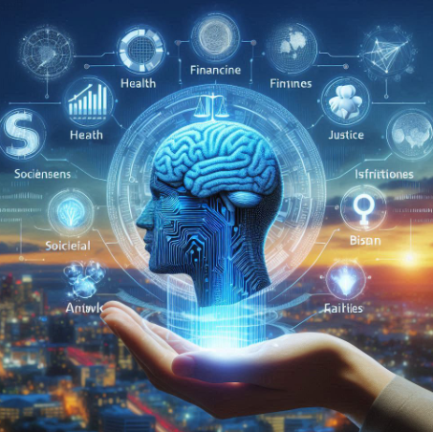

Fig 1: AI Representation

This review paper tries to confront the challenges and potential solutions that could be introduced in reducing bias and achieving fairness in AI systems. Bias in AI can find its roots from various sources: biased training data, flawed algorithm design, and inappropriate deployment contexts. In this, the biases reveal themselves in ways that unfairly favor one group over others and skew outcomes in decisions that AI systems make.

More simply, the paper delineates that racial, gender, and socioeconomic biases are some of the various types of biases affecting AI systems to be discussed. The paper outlines the various methodologies and frameworks developed to detect, measure, and mitigate bias in AI. By giving an overview of the current state of research and practice in the domain, it attempts to achieve an all-inclusive understanding of the complexities surrounding this issue.

The paper would be on the ethical and social impacts of bias from AI and stress collaboration across disciplinary boundaries in addressing these issues. It would be through integration of expertise from computer science, ethics, sociology, and law that one may develop a more holistic and effective approach to counter bias and ensure an element of fairness in AI systems.This paper articulates challenges in detecting and reducing bias in AI. It takes into consideration the methodologies for ensuring fairness in AI decisions. It traces the causes of bias from data imbalances to design choices, motivating the need for strong unbiased AI that respects equity and justice. It is going to critically analyze the literature and case studies that bring bias in AI to light while ultimately providing hands-on solutions for its improvement; it aims to equip such researchers, developers, and policymakers with valuable tools who can, in turn, build into their quest fairer and more just AI systems.

This review will outline sources of bias in AI decision-making and discuss the ethics that find their genesis in such a process. It illustrates the actual impact these biases have on people and communities by offering case studies in healthcare, criminal justice, education, and legal systems. Moreover, the paper introduces a set of mitigation methods that would help ease bias in effect while underlining the importance of ethical standards for AI systems. Here, we identify and analyze this interplay of bias and ethical considerations as contributing to this discourse that continues over the responsible development and deployment of AI. Ultimately, because AI is increasingly playing a pivotal role in decision-making processes, understanding and addressing bias will prove essential to ensuring that these technologies serve to enhance and not undermine fairness and equity in society.

### **2. Real-World Instances of Bias in AI**

Biases in AI systems have been observed in various sectors worldwide, including healthcare, criminal justice, and generative AI technologies. A well-known instance involves the COMPAS system, used in the U.S. criminal justice sector to estimate the likelihood of reoffending. Studies have shown that African-American defendants were disproportionately flagged as high-risk, even in cases where they had no prior convictions. Similar findings emerged in Wisconsin, where a related system exhibited comparable biases (Angwin et al., 2016).

In the healthcare field, an AI model developed to predict patient mortality was found to discriminate against African-American patients. Research by Obermeyer et al. (2019) indicated that, despite controlling for factors such as age and overall health, these patients were assigned higher risk scores, potentially leading to inadequate treatment or denial of critical care.

Facial recognition technology, widely adopted by law enforcement, is another area where AI bias has surfaced. A study conducted by the National Institute of Standards and Technology (NIST) revealed that these systems were less accurate in identifying individuals with darker skin tones. This inaccuracy resulted in a higher likelihood of false positives, raising serious concerns about wrongful arrests and legal misjudgments (Schwartz et al., 2022).

Generative AI tools have introduced additional dimensions of bias. Models such as OpenAI's DALL-E, Stable Diffusion, and MidJourney have been criticized for producing outputs that reinforce harmful stereotypes. For instance, when tasked with creating images of CEOs, these models predominantly generated images of men, reflecting and perpetuating gender bias. Similarly, when asked to depict criminals or terrorists, the outputs disproportionately represented people of color, highlighting racial prejudices ingrained in the training data (Ferrara, 2023; Ferrara, 2023b).

These cases illustrate how generative AI systems often replicate and amplify societal inequalities present in their training datasets. They emphasize the urgent need for curating diverse and balanced datasets to mitigate these biases and promote fairness in AI-generated outputs. Properly addressing these issues is essential to ensure equitable and ethical use of AI across various applications.

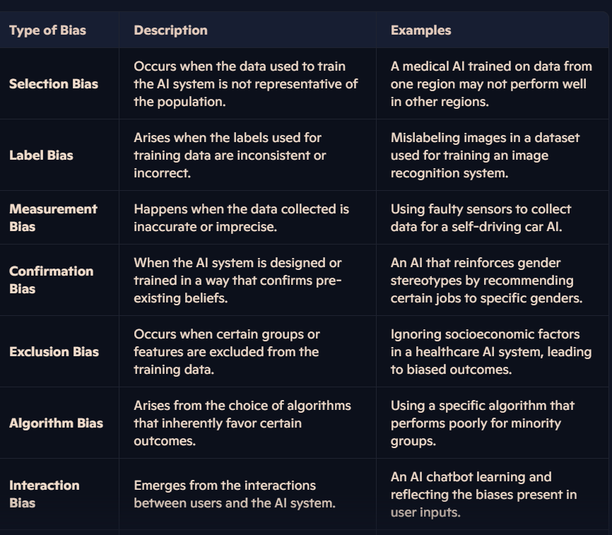

Fig 2: Comparative Analysis of Bias

### **3. Impacts of Bias in AI**

The rapid growth of AI technology brings significant benefits but also introduces serious risks and challenges, particularly concerning bias. Bias in AI systems can negatively affect individuals and society by exacerbating existing inequalities, limiting access to critical services, and reinforcing harmful stereotypes. Beyond perpetuating traditional forms of discrimination, AI systems can also generate new biases based on factors such as ethnicity, skin color, or physical traits. To create fair and inclusive systems, addressing these biases is essential.

Bias in AI also raises profound ethical concerns, including fostering discrimination, undermining public trust in technology, and curbing human autonomy. Tackling these issues requires collective action from developers, policymakers, and ethicists to establish ethical standards and regulatory measures. These frameworks should emphasize fairness, transparency, and accountability throughout the lifecycle of AI development and deployment.

#### **3.1 Negative Impacts on Individuals**

The effects of bias in AI are often most acutely felt at the individual level, where discriminatory outcomes can have life-altering consequences. Biased algorithms frequently replicate and intensify existing societal inequalities (Sweeney, 2013). In the criminal justice system, for example, racial biases in predictive algorithms have been linked to disparities, such as marginalized groups facing higher rates of wrongful convictions or harsher penalties (Angwin et al., 2016).

In healthcare and finance, biased AI systems can restrict access to essential services. Credit scoring algorithms, for instance, often disadvantage individuals from low-income or minority communities, making it difficult for them to secure loans or mortgages (Dwork et al., 2012).

Bias in AI also perpetuates harmful gender stereotypes. Image classification and facial recognition technologies, frequently trained on datasets skewed towards male representation, often fail to accurately identify women, reinforcing gender disparities in areas like security and access control (Buolamwini & Gebru, 2018). Similarly, generative AI models tasked with visualizing professional roles, such as CEOs, disproportionately depict men, reinforcing stereotypes about leadership and gender roles (Nicoletti & Bass, 2023).

By understanding and addressing these impacts, stakeholders can work to mitigate the negative consequences of bias in AI systems, ensuring that these technologies benefit all users equitably.

Moreover, AI systems may introduce new forms of discrimination based on physical characteristics, such as skin tone or ethnicity. Generative AI models have demonstrated racial bias by disproportionately associating people of color with negative stereotypes, such as criminality or terrorism. This highlights the need for greater attention to fairness and inclusivity in AI training datasets and model design.

#### **3.2 Negative Impacts on Society**

The widespread deployment of biased AI systems can lead to significant societal repercussions, including denial of services, loss of employment opportunities, and, in extreme cases, wrongful arrests and convictions. These systems pose a dual risk:

* **At the individual level**, biased AI systems influence how people are perceived, potentially limiting their access to opportunities and affecting their social interactions.
* **At the societal level**, the pervasive use of such systems can reinforce discriminatory narratives, undermining efforts to achieve equality and inclusivity.

As AI becomes increasingly integrated into everyday life, its potential to shape culture and societal structures grows. This underscores the urgency of addressing biases during the developmental stages of AI systems to mitigate their adverse impacts (Ferrara, 2023; Ferrara, 2023b).

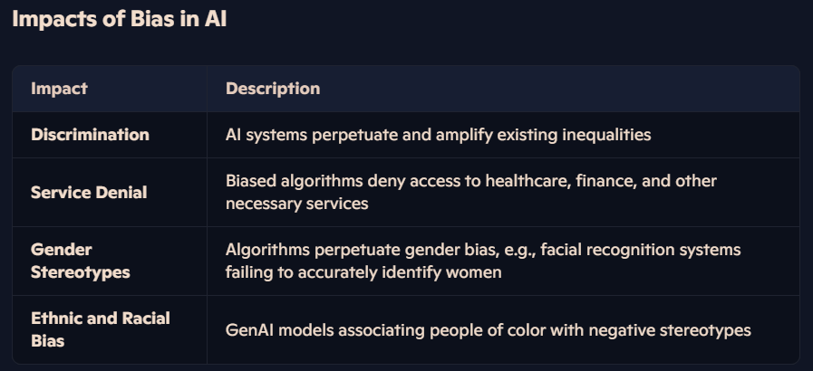

Fig 3 Impacts on Bias

#### **3.3 Ethical Considerations**

The ethical concerns associated with biased AI include:

* **Discrimination**: Biased AI systems often perpetuate or exacerbate discrimination against marginalized groups.
* **Responsibility**: It is imperative for developers and policymakers to uphold principles of equity and accountability in AI systems.
* **Public Trust**: The presence of bias undermines public confidence in AI and related technologies.
* **Human Autonomy**: Biased decision-making in AI can restrict individuals' freedom to make independent choices.

### **4. Comparing Fairness and Bias in AI**

Fairness and bias are interconnected concepts in the realm of artificial intelligence, yet they differ in their definitions and applications. Bias refers to a systematic deviation in an AI algorithm’s output from what is considered an expected or unbiased result (Zliobaite, 2021). In contrast, fairness is defined as the absence of discrimination or bias against individuals or groups based on attributes like race, gender, age, or religion (Dwork et al., 2012).

A primary distinction between fairness and bias lies in their origins and purposes:

* **Bias**: Often unintentional, bias typically arises due to imbalanced datasets, flawed algorithmic design, or inherent biases in the data collection process.
* **Fairness**: Achieving fairness requires intentional efforts to ensure that AI systems do not discriminate against any individual or group. In this sense, bias represents a technical issue, while fairness is grounded in ethical and societal considerations (Barocas & Selbst, 2016).

Bias can manifest as either positive or negative. Positive bias occurs when an AI system disproportionately favors a particular group, whereas negative bias leads to systemic discrimination against certain groups. Fairness, however, focuses on mitigating negative bias and ensuring that outcomes are equitable and just (Zliobaite, 2021).

#### The Interplay of Fairness and Bias:

While bias and fairness often overlap in AI systems, addressing bias is an essential step toward achieving fairness. Reducing bias in training datasets or refining algorithm design can help decrease instances of unfair outcomes. However, fairness involves more than just the absence of bias. Achieving fairness may require additional steps, such as fostering inclusivity, promoting diverse representation, and aligning AI systems with broader societal values and ethical principles (Kleinberg et al., 2017).

By understanding these distinctions and their interplay, stakeholders can better navigate the complexities of designing AI systems that are both unbiased and fair, ultimately contributing to more equitable and socially aligned outcomes.

| **Aspect** | **Challenges** | **Solutions** |
| --- | --- | --- |
| Data Bias | Biased training data leading to unfair outcomes | Use diverse and representative datasets, data pre-processing to remove biases |
| Algorithmic Bias | Bias embedded in algorithms due to flawed design or training | Develop fair algorithms, use model selection techniques to mitigate bias |
| Human Bias | Human decision biases influencing AI outcomes | Implement transparency and accountability measures, interdisciplinary collaboration |
| Transparency | Lack of understanding of how AI systems make decisions | Enhance transparency in AI systems, provide clear explanations of decision-making processes |

**5. Future Directions for Fairness in Artificial Intelligence: Trends, Predictions, and Strategies for Mitigating Bias**

The existing body of literature on AI bias is still in its initial development stage, offering many opportunities for further study. The paper has important limitations, in particular, regarding its methodological approach, which was mainly narrow and focused on literature in the fields of business, management, and accounting. Subsequent research may open up the scope in the following areas:

1. Expanding Disciplines:

* **Computing and Medicine**: The above examples can be extended on to the ones of computer science and medicine, where biased algorithms can take up much more dangerous outcome.

2. Consumer and Pricing Bias:

* **E-commerce Portal**s: Investigate consumer and pricing biases during product purchases through e-commerce platforms, analyzing how AI influences buying decisions and contributes to income inequality.

3. Job Automation Bias:

* **Recruitment processes** should investigate job automation bias to reduce gender and racial biases inherent in AI-driven recruitment practices, thereby upholding equal and fair hiring standards.

4. Social Data Bias:

* **Data Security and Ethics**: The research into social data bias, especially regarding data security and ethics, will also help address potential problems in the use of AI.

5. Health Insurance Bias:

* **Product Development and Risk Evaluation:** Discuss the domain of AI biases in the health insurance industry. How product development and risk evaluation using AI may lead to customer biases, especially in cases when derived from limited or biased training data. Such areas addressed by potential research can enhance a well-rounded understanding of artificial intelligence bias and help in developing strong solutions ensuring fairness and ethics in artificial intelligence systems for different sectors.

**6. Conclusion:**

There is, therefore, an important and multi-dimensional problem demanding much attention to addressing bias and ensuring fairness in AI systems. This review paper has highlighted how pervasively AI bias arises from imbalances in training data, algorithmic design choices, and deployment contexts. Such biases undermine credibility and reliability in AI systems and reinforce and exacerbate existing social inequalities.

Based on focused literature review, the paper has opened all ways of strategies and frameworks to reduce AI bias and enhance fairness. From pre-processing and in-processing techniques to post-processing interventions, a strategy has its strengths and weaknesses. The focus was made clear that interdisciplinary collaboration and ethics in the AI development processes hold the crux for acquiring equitable AI systems.

Notwithstanding considerable progress, the field is still in its nascent stages, characterized by numerous unresolved inquiries and unexplored areas. Subsequent research ought to persist in investigating a variety of sectors, such as healthcare, e-commerce, recruitment, and insurance, in order to formulate more thorough and contextually relevant solutions. Furthermore, the imperative for regulatory frameworks, transparent methodologies, and ongoing monitoring is of utmost importance.

Deep within the historical and philosophical fabric, artificial intelligence continues to revolutionize different aspects of society. This calls for justice and fairness to be guiding the evolution process. When embraced, stakeholders will unlock the transformative power of artificial intelligence while guarding against its pitfalls to pave a brighter future in which everyone has an equal place.

### **References**

1. Alvarez, J. M., Bringas Colmenarejo, A., Elobaid, A., Fabbrizzi, S., Fahimi, M., Ferrara, A., Ghodsi, S., Mougan, C., Papageorgiou, I., Reyero, P., Russo, M., Scott, K. M., State, L., Zhao, X., & Ruggieri, S. (2024). Policy recommendations and practices for addressing bias and promoting fairness in AI. *Ethics and Information Technology*, 26(31), 1–31. Available on SpringerLink.
2. Rao, D. (2021). Understanding Fairness and Bias in Artificial Intelligence Systems. Persistent. Retrieved from the Persistent Blog.
3. Basics of Bias and Fairness in AI Systems. (n.d.). Available at Bias and Fairness in AI Systems.
4. Barocas, S., & Selbst, A. D. (2016). Big Data’s Disparate Impact. *California Law Review*, 104(3), 671–732. Retrieved from JSTOR.
5. Buolamwini, J., & Gebru, T. (2018). Gender Shades: Analyzing Intersectional Accuracy Disparities in Commercial Gender Classification Systems. *Proceedings of Machine Learning Research*, 81, 1–15. Preprint available on arXiv.
6. Sturm, B. L., & Ben-Tal, O. (2018). The Ethical Implications of AI in Music and Art. *Artificial Intelligence in the Arts*, 1(1), 35–42. doi:10.1080/23261998.2018.1427511.
7. Colton, S., & Wiggins, G. (2012). A Survey on the Current Landscape of Creativity in Computers. *Computers and Creativity*, 11–18. doi:10.1007/978-3-319-00547-3_2.
8. Chouldechova, A., & Roth, A. (2018). Exploring the Boundaries of Fairness in Machine Learning. *Communications of the ACM*, 61(6), 56–64. Retrieved from the ACM Digital Library.
9. Chuan, C. H., & Tzanetakis, G. (2018). Artificial Intelligence and the Future of Fairness: Insights from Music, Art, and Literature.