**Predicting charging response of electric vehicle’s using Machine Learning algorithms**

**M.Nikhitha**

**Department of Computer Science & Engineering GMRIT, Rajam, Andhra Pradesh, India**

ABSTRACT

The most important aspect of transportation is electric vehicles. Electric vehicles are the foundation of a smart city transportation application. The lack of charging infrastructure is one of the most significant barriers to electric vehicle adoption. To address the problem of EV charging duration and consumption. To address the issue, in this paper ML algorithms are employing to predict charging analysis, which is beneficial to drivers. It shows how long it takes for the battery to charge fully and provides detailed information about an electric vehicle's energy consumption. Electric vehicles (EVs) are becoming increasingly popular for their contribution in reducing greenhouse gas emissions. Using data-driven tools and machine learning algorithms to learn the EV charging behavior can improve scheduling algorithms. Researchers have focused on using historical charging data for predictions of behavior such as departure time and energy needs. This paper concentrate on the charging dataset in conjunction with energy consumption and session duration. In this case, combination of two machine learning algorithms for prediction analysis of predict EV session duration and energy consumption using popular machine learning algorithms including random forest, SVM, XGBoost and deep neural networks.

Keywords: Electric vehicle, Machine learning, Charging prediction, Session duration, Energy consumption, smart city, smart transportation.

INTRODUCTION

In recent years, climate change has emerged as a pressing global concern, prompting numerous countries to declare a climate emergency. One of the significant contributors to this crisis is the global energy consumption, particularly within the transportation sector, which accounts for over a quarter of the world's energy usage. With the United Nations projecting that two-thirds of the global population will reside in urban areas by 2050, the demand for urban mobility is set to rise, leading to increased energy consumption and greenhouse gas emissions. Electric vehicles (EVs) have emerged as a promising solution, with the potential to reduce carbon emissions by 45% compared to traditional internal combustion engine (ICE) vehicles. EVs have witnessed remarkable advancements in reliability, battery range, and charging infrastructure, garnering trust among owners and gaining popularity. However, challenges related to charging time and public charging infrastructure persist, necessitating effective solutions to optimize charging scheduling. This paper explores the prediction of EV charging behavior using machine learning, focusing on session duration and energy consumption. The study aims to address the growing demand for urban mobility, driven by the rise of EVs, and the associated challenges in managing charging infrastructure. While previous research has primarily relied on historical charging data, this work takes a novel approach by incorporating additional factors such as weather conditions, traffic patterns, and local events to enhance the accuracy of charging behavior predictions. The paper employs various machine learning algorithms, including Random Forest, Support Vector Machines, XGBoost, and Artificial Neural Networks, to predict session duration and energy consumption on an adaptive charging network dataset. The results indicate that leveraging additional data significantly improves the prediction accuracy compared to prior studies that relied solely on historical charging information.

RELATED WORK

There have been numerous papers published that introduce and compare various solutions for Predicting Charging Response of Electric vehicle’s using Machine Learning Algorithms.

F. Gromann, in *IEEE Transactions* (2024)[1] The primary objective is to optimize the charging schedules for electric vehicle (EV) fleets, ensuring that the charging power is efficiently managed across different user types and fleet sizes. The paper aims to evaluate the accuracy of the proposed charging optimization method by comparing the optimal charging power with the actual scheduled charging power .

Akshay, K.C., *Sci Rep* 14, 6497 (2024) [2] The primary aim is to develop a robust time series model to predict the power consumption of electric vehicle charging stations (EVCS) effectively, which is crucial for managing charging infrastructure. The study also seeks to forecast income generated from charging stations, helping companies devise competitive pricing strategies.

Shanmuganathan, *Sustainability*, *14*(16), 10207(2022) [6] The primary objective of the research is to create a novel predictive model for forecasting the charging demand of electric vehicles (EVs). This model is designed to address the limitations of existing models and provide more accurate predictions. The research aims to leverage deep learning techniques, specifically recurrent neural networks (RNNs) and long short-term memory (LSTM) networks, to build the predictive model. These techniques are known for their ability to handle sequential data effectively.

Shibl, M., Ismail, *Energies*, *14*(19), 6199(2021) [4] The primary objective is to develop a system that optimizes the operation of the distribution grid. This includes minimizing voltage fluctuations, reducing power losses, and managing transformer loading effectively.The research aims to minimize the charging cost associated with electric vehicles (EVs). This is essential for making EVs more cost-effective.

Shahriar, S., Al-Ali, A. R., *IEEE Access*, *8*, 168980-168993(2020) [8] The paper aims to address challenges related to EV charging, such as long charging times, grid constraints, and the unpredictability of user behavior. The paper acknowledges the growth of the EV market due to advancements in battery technology and improved reliability. RF, XGBoost, KNN algorithms are used.

Cheng, Y., Chen, Q. (2022) *Electronics*, *11*(13), 1933[11] Develop an energy management strategy for a hybrid electric vehicle (HEV) powered by a supercapacitor and a lithium battery. Utilize reinforcement learning techniques to optimize energy allocation and reduce energy losses in the hybrid system. By minimizing fluctuations in the lithium battery current, the strategy may extend the

service life of the supercapacitor and lithium battery. The abstract doesn't mention real-world validation of the proposed strategy, which is crucial for practical application.

N. Al-Dahabreh *et al*., "*Transportation Systems*, June 2024[3] The primary objective is to create a comprehensive framework that enhances the assessment of Quality-of-Experience (QoE) at public Electric Vehicle Charging Stations (EVCS) using real-world data. Another key goal is to utilize the formulated metrics as inputs for a Machine Learning model to predict future EV charging demands, ensuring infrastructure can meet rising needs The long-term forecast model's accuracy is evaluated using metrics such as RMSE (Root Mean Square Error), MSE (Mean Squared Error), MAE (Mean Absolute Error), and MAPE (Mean Absolute Percentage Error).

Ge, X., Shi, L., Fu, *Electric Power Systems Research*, *187*, 106469(2020)[14] The primary objective of this research is to improve the accuracy of predicting electric vehicle (EV) charging demand. This is crucial for the optimal dispatching and safe operation of the power grid, especially as the number of EVs on the road continues to grow. By optimizing the parameters of the random forest (RF) prediction model for different types of EVs using the harmony search (HS) algorithm, this research improves the prediction accuracy. This is a significant advantage for power grid management.

3.Methodology

3.1 Data Collection

To analyze the charging behavior of electric vehicles (EVs), data can be collected from various sources. Companies that manage public charging networks, such as ChargePoint, Electrify America, EVgo, and Tesla Superchargers, typically collect detailed data on charging sessions, including energy consumed, session duration, and location. U.S. Department of Energy’s Alternative Fuels Data Center (AFDC), Provides data on charging station locations, types, and utilization trends. European Alternative Fuels Observatory (EAFO), Offers data on charging points, EV market development, and policy impacts in Europe. National Renewable Energy Laboratory (NREL), collects and shares datasets related to EV infrastructure usage, grid impacts, and driver behavior, often through its Transportation Secure Data Center (TSDC). Many modern EVs are equipped with telematics that collect real-time data on battery status, location, and driving patterns, which can be used to analyze charging behavior. IoT platforms collecting data from charging infrastructure (such as sensors and meters) may offer access to information on energy usage, charge frequency, and charging time.

3.2 Dataset Description:

This dataset can be used to analyze patterns such as average charging costs, charging durations, and energy consumption rates by various user types, vehicle models, or charger types. It also allows for analysis based on time and location, giving insights into peak charging hours and preferred stations.

* A unique identifier for each user in the dataset.
* Timestamps indicating when the charging session started and ended.
* The amount of energy consumed during the charging session, measured in kilowatt-hours (kWh).
* The rate of charging in kilowatts (kW), representing the power of the charging session.
* The total cost incurred for each charging session, measured in USD.
* The distance the vehicle has traveled since its last charge, measured in kilometers.
* The model of the electric vehicle being charged, which could be a categorical feature.
* Identifies the location of the charging station, likely as a categorical feature.
* Indicates the type of charger used, such as Level 1, Level 2, or DC Fast Charger.
* The type of user which may help in understanding charging behavior patterns.

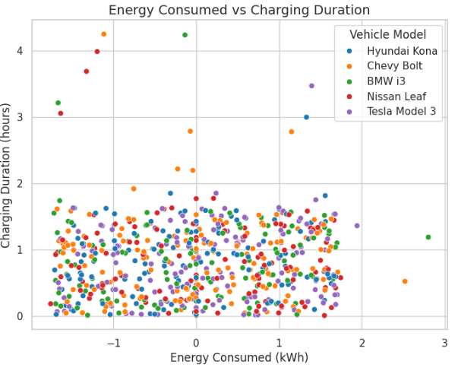

3.3 Data Preprocessing

Cleaning and preprocessing the dataset is vital to ensuring the quality of the predictive models. These include removing faulty records and outliers.

Load the Data: First, load the data from the CSV file to begin preprocessing.

Handle Missing Values: Fill missing values in numeric columns Charging Rate (kW), Distance Driven with the mean or median value. For categorical features like Vehicle Model and Charger Type, you could fill missing values with the most common category or create a separate category, e.g., "Unknown". If Charging Start Time or Charging End Time have missing values, they may be dropped or interpolated based on context.

One-Hot Encoding: Use for nominal categorical columns like Vehicle Model, Charging Station Location, Charger Type, and User Type.

Label Encoding: Alternatively, use label encoding for columns that have a clear ordinal relationship if any.

Feature Scaling: Standardize or normalize numerical columns such as Energy Consumed (kWh), Charging Rate (kW), and Distance Driven (km) to ensure all features have a similar range, which can be beneficial for many machine learning algorithms.

Splitting the Dataset: After preprocessing, split the data into training and testing sets if you plan to train a machine learning model on it.

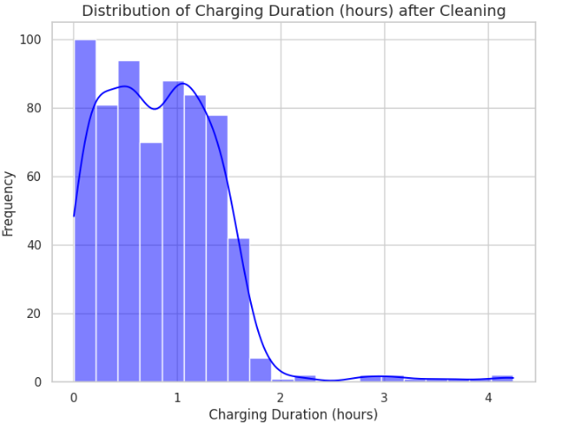

3.4 Machine Learning And Predictive Analytics

1. Support Vector Machine:

A support vector machine (SVM) is mainly used for classification problems but can also be used for regression in which case they are often referred to as support vector regression (SVR) SVM separates the classes with the best hyperplane that can maximize the margin between the respective classes.Using kernels such as linear, polynomial, and radial basis function (RBF), the inputs can be mapped to high dimensional feature spaces where they can be linearly. A support vector machine (SVM) is mainly used for classification problems but can also be used for regression in which case they are often referred to as support vector regression (SVR) SVM separates the classes with the best hyperplane that can maximize the margin between the respective classes. Using kernels such as linear, polynomial, and radial basis function (RBF), the inputs can be mapped to high dimensional feature spaces where they can be linearly separable. One of the main disadvantages of SVM is the lengthy training time. Therefore, for larger datasets SVM may not be suitable.

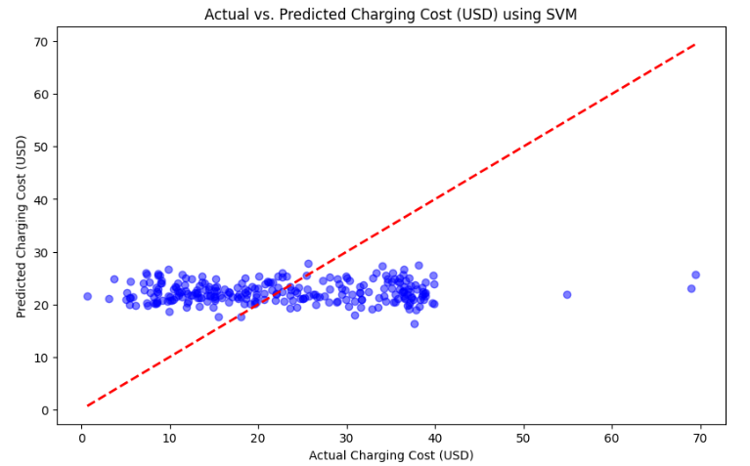

2. Decision Trees:A decision tree (DT) can be used for both classification and regression problems [35]. Similar to a flow chart, DTs separate complex decisions into a combination of simpler decisions using split points from the input features. The point where decisions take place is called a decision node. The points where no further split is made are called the leaf nodes.

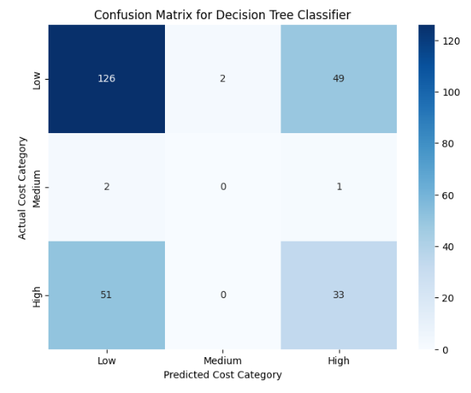

For regression problems, the average value of all the items in the leaf node is taken for prediction. For classification problems, the leaf nodes are the set of classes being predicted. DTs are simple to explain particularly using a tree diagram which can help to understand the prediction making process. However, a single DT often fails to provide good predictions and is prone to overfitting.

3.Random Forest :

random forest (RF), predictions are made by aggregating multiple decision trees. Bagging method is used in this case where the trees are created from various bootstrap sample, The aggregation for regression is done by taking the average value of the predictions by all the trees and for classification majority vote across the trees are takenRF is an example of ensemble ML, where individual ML models are first evaluated and then integrated into a single model that can often produce superior predictive performance than the individual models. The motivation behind such approach is similar to asking multiple experts about an opinion, and then taking their votes to make the final decision Similarly, a gradient boosting algorithm or XGboost uses multiple DTs, with the key difference being gradient boosting builds each tree one after another while taking the errors made by the previous trees into consideration.

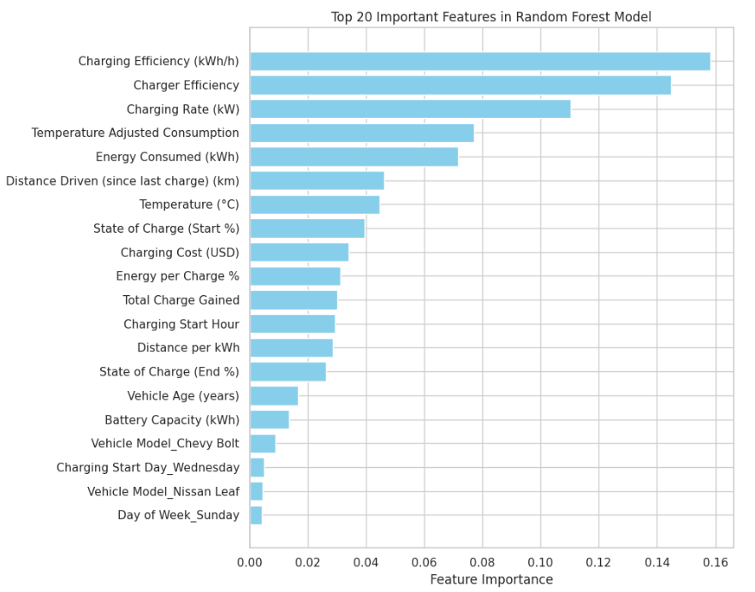

RF is an example of ensemble ML, where individual ML models are first evaluated and then integrated into a single model that can often produce superior predictive performance than the individual models. The motivation behind such approach is similar to asking multiple experts about an opinion, and then taking their votes to make the final decision Similarly, a gradient boosting algorithm or XGboost uses multiple DTs, with the key difference being gradient boosting builds each tree one after another while taking the errors made by the previous trees into consideration.

3.5 Machine Learning for Analysis and Prediction Of Charging Behavior

ML models are trained from labeled training dataset. As such the dataset contains both the input variables and the corresponding response variable, often called the target variable. The model iteratively learns the mapping between the input and the response variables by optimizing a given objective function.

|  |  |  |  |  |
| --- | --- | --- | --- | --- |
| Metric/Model | RMSE | MAE | R2 | SMAPE |
| SVM | 5.65 | 3.53 | 0.67 | 12.6 |
| XGBoost | 5.56 | 3.49 | 0.68 | 12.4 |
| RF | 5.49 | 3.40 | 0.69 | 11.9 |
| Deep ANN | 5.61 | 3.60 | 0.67 | 12.9 |

Table 1: Training scores for energy consumption

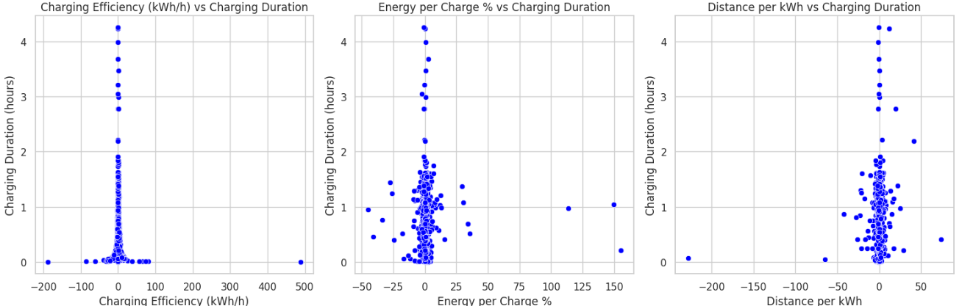

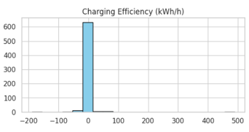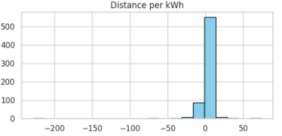

Table 2: Test scores for session duration

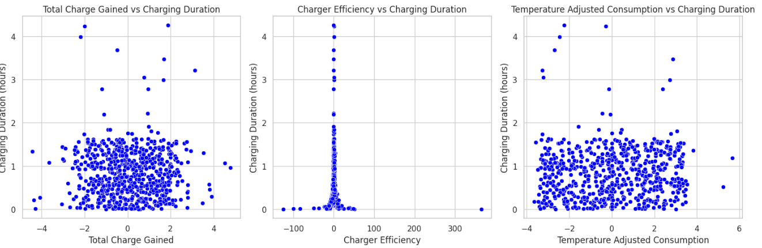

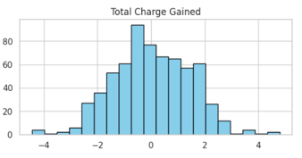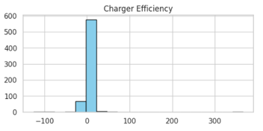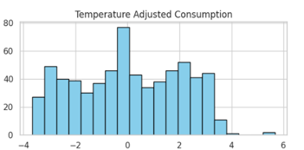

4. Perfomance Evaluation:

During the testing process, performance was evaluated. The original dataset would be divided into training and test data, with 80% and 20% being used for training. When evaluating the classifier's performance on the testing dataset, four statistical numbers were used: the absolute mean error (MAE), the root mean squared error (RMSE) and mean absolute percentage error (MAPE). RMSE and MAPE describe how close the prediction value and the true value are. Specifically, MAPE describes the relative error, RMSE and MAE describe the absolute error. Accuracy measures model performance in terms of the number of accurate predictions made by the model. Precision measures R2 score, MAPE, MSE and finally accuracy.

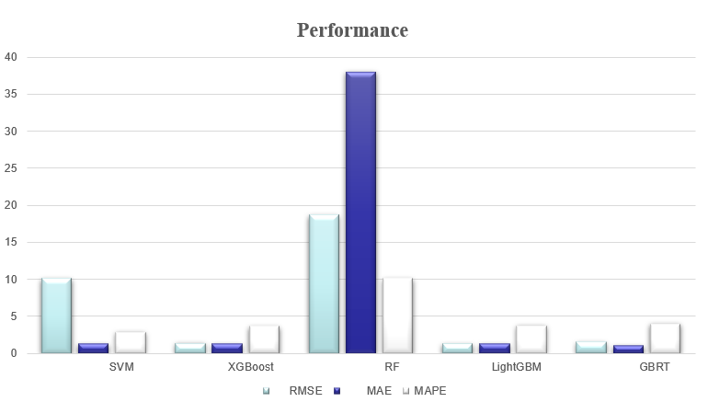

1. Results:

Three statistical measures are used to evaluate our method, including the absolute mean error (MAE), the root mean squared error (RMSE) and mean absolute percentage error (MAPE). RMSE and MAPE describe how close the prediction value and the true value are. Specifically, MAPE describes the relative error, RMSE and MAE describe the absolute error. We compared eight different machine learning algorithms including XGBoost, LightGBM, GBRT, Neural network, Random forest, linear regression, etc. for preliminary selection Random forest, linear regression, etc. for preliminary selection. We randomly split all trips into trainset and test-set with the proportion of 1:1, and then these algorithms were trained and tested on the trainset and the test-set, respectively.

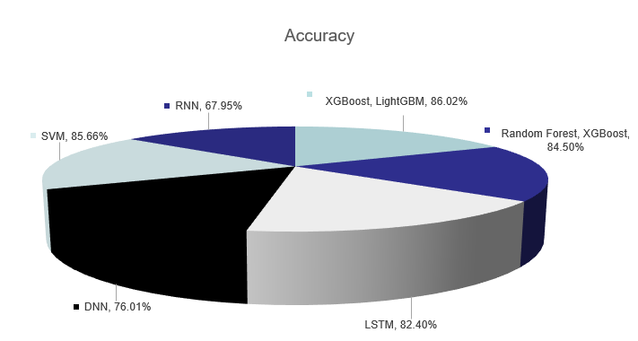

6. Discussion:

Machine learning (ML) applications have shown promise in enhancing the accuracy and effectiveness of traditional methods for detecting charging behavior anomalies in electric vehicles (EVs). While significant strides have been made in this field, there remain critical challenges and unresolved issues that need attention. This discussion will delve into the complexities of ML-based detection systems for charging behavior in EVs, addressing issues such as user awareness, data sample limitations, and the need for lightweight models. To enhance the widespread adoption of ML-based charging behavior detection systems, there is a need for lightweight models that can run efficiently on small computing devices commonly found in EVs. Designing models that require minimal computational resources while maintaining high accuracy is a key research challenge. Investigating and refining lightweight algorithms tailored to the constraints of EV onboard systems is essential for practical implementation.

Conclusion:

The transformative impact of machine learning (ML) in addressing critical challenges within the electric vehicle (EV) domain. The studies collectively contribute advancements in predicting various facets of EV performance, including driving range, charging demand, and market dynamics. Notable outcomes include the development of innovative predictive models, such as the two-stage framework blending XGBoost and LightGBM for accurate remaining driving range prediction, and the EMD-AOA-DLSTM predictor model demonstrating superior efficiency in forecasting charging demand. Furthermore, the research highlights the significance of feature importance analysis and interpretability in ML models, as seen in the EVs charging time prediction study utilizing EML models. The LSTM-based multi-parameter prediction for battery systems introduces a Weather-Vehicle-Driver analysis, considering environmental factors and human interventions, improving accuracy without compromising online prediction stability. Additionally, the ML-based market share and sales prediction model offer valuable insights for car manufacturers, dealers, and policymakers, aiding strategic decision-making in a highly competitive market. Overall, these studies collectively emphasize the adaptability and efficacy of ML methodologies in addressing nuanced challenges within the EV ecosystem. From enhancing predictive accuracy to providing interpretable insights, these advancements contribute to the ongoing evolution of EV technology and market dynamics. As the research landscape progresses, continued exploration of additional factors and the application of advanced ML models hold the potential to further refine and expand the capabilities of EV-related predictions and analyses.

References:

1. Zhao, L., Yao, W., Wang, Y., & Hu, J. (2020). Machine learning-based method for remaining range prediction of electric vehicles. IEEE Access, 8, 212423-212441.
2. Shibl, M., Ismail, L., & Massoud, A. (2021). Electric vehicles charging management using machine learning considering fast charging and vehicle-to-grid operation. Energies, 14(19), 6199.
3. Shanmuganathan, J., Victoire, A. A., Balraj, G., & Victoire, A. (2022). Deep learning LSTM recurrent neural network model for prediction of electric vehicle charging demand. Sustainability, 14(16), 10207.
4. Lopes, J. P., Almeida, P. M. R., Silva, A. M., & Soares, F. J. (2009). Smart charging strategies for electric vehicles: Enhancing grid performance and maximizing the use of variable renewable energy resources.
5. Shahriar, S., Al-Ali, A. R., Osman, A. H., Dhou, S., & Nijim, M. (2020). Machine learning approaches for EV charging behavior: A review. IEEE Access, 8, 168980-168993.
6. Zhou, X., Zhang, K., Jia, X., & Fan, J. (2023, March). Electric Vehicle Charging Load Demand Forecasting Model based on Spatial and Temporal Characteristics. In Journal of Physics: Conference Series (Vol. 2465, No. 1, p. 012005). IOP Publishing.
7. Shi, Y., Tuan, H. D., Savkin, A. V., & Poor, H. V. (2021). Model predictive control for on–off charging of electrical vehicles in smart grids. IET Electrical Systems in Transportation, 11(2), 121-133
8. Cheng, Y., Xu, G., & Chen, Q. (2022). Research on Energy Management Strategy of Electric Vehicle Hybrid System Based on Reinforcement Learning. Electronics, 11(13), 1933.
9. Helmus, J. R., Wachlin, S., Vermeulen, I., & Lees, M. H. (2019). SEVA: A data driven model of electric vehicle charging behavior. arXiv preprint arXiv:1904.08748.
10. Ullah, I., Liu, K., Yamamoto, T., Zahid, M., & Jamal, A. (2022). Prediction of electric vehicle charging duration time using ensemble machine learning algorithm and Shapley additive explanations. International Journal of Energy Research, 46(11), 15211-15230
11. Ge, X., Shi, L., Fu, Y., Muyeen, S. M., Zhang, Z., & He, H. (2020). Data-driven spatial-temporal prediction of electric vehicle load profile considering charging behavior. Electric Power Systems Research, 187, 106469.
12. Chung, Y. W., Khaki, B., Li, T., Chu, C., & Gadh, R. (2019). Ensemble machine learning-based algorithm for electric vehicle user behavior prediction. Applied Energy, 254, 113732.
13. Esteban, J. (2023). Application of Machine Learning to Predict Electricity Demand from Electric Vehicles in Workplace Settings (Master's thesis, Universitat Politècnica de Catalunya).
14. Hong, J., Wang, Z., Chen, W., & Yao, Y. (2019). Synchronous multi-parameter prediction of battery systems on electric vehicles using long short-term memory networks. Applied Energy, 254, 113648.
15. Afandizadeh, S., Sharifi, D., Kalantari, N., & Mirzahossein, H. (2023). Using machine learning methods to predict electric vehicles penetration in the automotive market. Scientific Reports, 13(1), 8345.

|  |  |  |  |  |  |  |  |
| --- | --- | --- | --- | --- | --- | --- | --- |
|  | Title | Year | Objectives | Limitations | Advantages | Performance metrics | Gaps |
| 1 | Machine Learning-Based Method for Remaining Range Prediction of Electric Vehicles. | 2020 | Providing precise information about how far an EV can travel before exhausting the battery. | Requires high-fidelity vehicle-specific models. | XGBoost and LightGBM demonstrated superior performance in remaining range prediction. | Prediction accuracy-92% | Scalability to a wide range of EV models and driving conditions are not thoroughly discussed. |
| 2 | Electric Vehicles Charging Management Using  Machine Learning | 2021 | To propose a predictive charging system for EVs to minimize charging costs. | Limited data availability, hardware requirements. | Cost-effective charging, Reduced peak load. | More accurate-89%. | Integration with renewable energy sources, grid stability. |
| 3 | Electric Vehicle Charging Behavior Prediction Using Recurrent Neural Networks | 2019 | To use recurrent neural networks to predict EV charging behavior for grid management. | Data privacy concerns, computational complexity. | High prediction accuracy, real-time predictions. | Prediction accuracy-87% | Privacy-preserving methods, efficient hardware implementation. |
| 4 | Optimal Charging Control of ElectricVehicle Fleets Based on Demand Aggregation and User-Oriented Disaggregation. | 2024 | The protocol aims to optimize the scheduling of EV charging by sharing status information among multiple CSs. | Higher Delay in Sparse Networks,  Dependence on V2V Communications | Improved Message Delivery Ratio,  Reduced Network Overhead. | Prediction accuracy-61% | Lack of comprehensive evaluation in sparse network conditions. |

|  |  |  |  |  |  |  |  |
| --- | --- | --- | --- | --- | --- | --- | --- |
| 5 | Power consumption prediction for  electric vehicle charging stations and forecasting income. | 2024 | The primary aim is to develop a robust time series model to predict the power consumption of electric vehicle charging stations (EVCS). | Data Quality Issues,  Model Complexity. | Optimized Operations,  Improved Infrastructure Planning,  Enhanced User Experience. | Overall accuracy-73% | Need to do more research. |
| 6 | A Data-Driven Framework for Improving Public EV  Charging Infrastructure: Modeling and Forecasting. | 2024 | The primary objective is to create a comprehensive framework that enhances the assessment of Quality-of-Experience (QOE) at public Electric Vehicle Charging Stations (EVCS) | Dependence on Data Quality,  Geographical Specificity,  Dynamic Factors. | In-Depth Insights,  Real-World Data Utilization. | Prediction accuracy-52% | Expansion Strategies,  Inadequate Existing Metrics,  Lack of Location-Aware Metrics |
| 7 | Siting and sizing charging  infrastructure for electric vehicles with coordinated recharging. | 2022 | To determine optimal locations for both slow and fast charging stations. This is intended to minimize the extra time spent on charging during everyday trips | Not be perfectly accurate, which could affect the performance of the proposed system. | Reduces the average potential extra time spent on charging by about 50% | Prediction accuracy-51% | Overall system performance require further investigation to fully understand their implications. |
| 8 | Machine Learning Approaches for EV Charging  Behavior: A Review | 2020 | To provide a comprehensive review of machine learning models for EV charging prediction. | Highlights challenges such as long charging times, grid constraints. | Summarizes various ML approaches, recent advancements. | Accuracy Rate-64% | Identifying challenges and future research directions. |
| 9 | Electric Vehicle Charging Load Demand Forecasting Model based on Spatial and Temporal Characteristics. | 2023 | To survey the state of the art in demand forecasting of EV charging loads. | Does not discuss the complexity of the predictive models. | Covers various forecasting methods, data sources. | Prediction accuracy-73% | Future research directions or potential areas of improvement in EV models. |
| 10 | Model predictive control for on–off charging of electrical vehicles in smart grids | 2020 | To review predictive control methods for managing EV charging. | The abstract lacks specific technical details about the proposed strategy | Provides insights into control strategies. | Mixed integer non‐linear  programming  (MINP)-84% | Large-scale deployment across a diverse range of Ev’s |
| 11 | Research on Energy Management Strategy of Electric Vehicle Hybrid System Based on the Reinforcement Learning | 2022 | To use reinforcement learning for optimizing EV charging and discharging strategies. | Training complexity, need for continuous learning. | Adaptive strategies, potential for grid balancing. | Grid stability, charging cost reduction.  Lithium battery-35.17% reduces loss. | Robust RL algorithms, scalability to large EV fleets. |
| 12 | A Data driven model of Electric Vehicle  Charging Behavior. | 2019 | To develop data-driven models for predicting EV charging behavior. | Data quality issues, model interpretability. | Data-driven insights, real-world applicability. | Prediction accuracy-79% | Addressing data quality challenges, model explainability |
| 13 | Prediction of electric vehicle charging duration time using ensemble machine learning algorithm and Shapley additive explanations. | 2022 | To evaluate the performance of various machine learning algorithms for EV charging demand prediction. | Dataset-specific results, generalization challenges. | Algorithm comparison, model selection guidance. | Overall accuracy-83% | Generalizable model selection criteria, transfer learning for diverse datasets. |
| 14 | Data-driven spatial-temporal prediction of electric vehicle load profile considering charging behavior | 2020 | To incorporate spatial and temporal factors into predictive models for EV charging behavior. | Data complexity, computational intensity. | Improved accuracy, consideration of location-based patterns. | prediction accuracy is not evaluated. | Scalable models, real-time spatial-temporal integration. |
| 15 | Ensemble machine learning-based algorithm for electric vehicle user behavior prediction | 2019 | To propose an ensemble learning approach for EV charging behavior prediction. | Ensemble model complexity, parameter tuning. | Improved prediction accuracy, ensemble model robustness. | Ensemble model metrics, individual algorithm metrics  MAPE-19.5%. | Automated ensemble model selection, scalability. |

METHODOLOGIES

A methodical technique to developing a Text summarization using NLP is described in this methodology. We will explore the process of gathering data, which includes building an extensive dataset with both actual and deepfake. We will examine the preparation stages and the methods by which the Text data was ready for model training. Next, we will examine the Natural Language processing model.

# Conceptual Framework:

# 

Fig 1: Architecture of proposed model

This architecture appears to illustrate a complex architecture for processing documents, combining multiple components such as Latent Dirichlet Allocation (LDA), Graph Attention Networks (GAT), and Transformers, to generate meaningful representations and output. Here’s a step-by-step breakdown of each part of this architecture:

1. LDA Model (Latent Dirichlet Allocation)

- Purpose: The LDA model here is used for topic modeling, which means it’s identifying themes or topics within the document.

- Components:

-α (Dirichlet Parameter): Controls the document-topic distribution. It represents the prior distribution over topics for each document, influencing the spread of topics across documents.

- Θ (Document-Topic Distribution): For each document \( D \), this distribution shows how likely each topic is within that document.

- Z (Topic Assignment): This component indicates which topic is assigned to each word in a document.

- W (Word-Topic Assignment): After identifying the topics, each word is assigned a topic based on the word-topic distribution.

- Topics: These are the final sets of themes derived from the document, represented by colors in the diagram.

- Output: The LDA model produces a topic distribution for each word in a document, helping identify which topics are more relevant.

2. Graph Attention Layer

- Purpose: It processes the document as a graph of nodes, with words and sentences as nodes, to capture relationships between them. The Graph Attention Network (GAT) enables focusing on important words and sentences based on their interconnections.

- Components:

- Word Nodes (W1, W2, W3, W4): These nodes represent individual words within the document.

- Topic Nodes (T1, T2, T3): These nodes represent the topics identified from the LDA model.

- Sentence Nodes (S1, S2): These nodes represent sentences within the document.

- Edge Feature (TF-IDF): Term Frequency-Inverse Document Frequency (TF-IDF) is used as an edge feature between nodes, reflecting the importance of words relative to the document and across the corpus.

- Operation: The Graph Attention Layer takes the nodes and the edge features to create a graph where the model can attend to connections between words, topics, and sentences. It enables the model to dynamically weigh the connections, focusing on more informative relationships.

3. Embedding Layers

- Purpose: Embeddings provide a dense representation for each word and sentence, capturing contextual, positional, segment, and token information.

- Components:

- Contextual Embeddings: Capture information about the context in which each word appears.

- Position Embeddings: Encode the position of each word in the sentence, which helps the model understand the order of words.

- Segment Embeddings: Distinguish between different parts (e.g., sentences) within the document.

- Token Embeddings: Represent the actual word tokens in a vectorized form.

- Output: This layer produces embeddings that combine context, position, segment, and token information for each word and sentence.

4. Transformer Layers (for Words and Sentences)

- Purpose: The Transformer layers process the embeddings to produce high-level representations by applying self-attention mechanisms.

- Operation: For both word and sentence nodes, the Transformer uses self-attention to weigh the importance of each token relative to others. This allows it to create contextually enriched embeddings for both individual words and sentences.

- Output: The output from the Transformer layers are embeddings that capture the relationships and importance of words and sentences in the document.

5. Output Pathway (From Transformer Layers to Final Output)

- Masked Multi-Head Attention: Applies attention over the transformed embeddings, allowing the model to focus on various parts of the input simultaneously.

- Add & Norm: Normalizes the embeddings and adds residual connections, which help prevent information loss and maintain stability during training.

- Feed Forward Layers: Process the normalized embeddings further to add non-linearity and increase expressiveness.

- Decoder: This layer transforms the processed embeddings into the final representation suitable for the output layer.

- Linear Layer and Softmax: The final step in the output pathway, where the linear layer maps the embeddings to the desired output space, and Softmax is applied to get probability distributions for classification or generation tasks.

RESULTS AND DISCUSSIONS:

Datasets:

A wide range of datasets, each suitable to a particular topic and application case, are used to train text summarization algorithms. Datasets including news stories from a variety of sources covering a broad range of subjects are among the frequently used datasets. These datasets are crucial for training summarization models that help people remain up to date on current events by rapidly summarizing the most important aspects of news articles. Another important category consists of research articles and scientific publications from many areas. Summarization models are trained on these kinds of datasets, enabling them to quickly and effectively extract significant information and knowledge from lengthy academic texts.

Metrics:

The overlap between the n-grams (word sequences) in the generated summary and the reference (human-created) summary is measured using a set of metrics called ROUGE. By comparing machine-generated text with one or more reference texts, BLEU evaluates the text's quality. It compares the generated summary's n-gram precision to the reference summaries. When evaluating the quality of generated summaries, METEOR takes word order, precision, recall, synonymy, and splitting into consideration. This metric calculates the overlap between the generated summary and reference summary for n-grams, or word sequences of length 'n'. These standard metrics evaluate their harmonic mean (F1 score), recall (completeness of recovered information), and precision (accuracy of relevant information).

Fig 5: Result chart

1. CONCLUSION

NLP-powered text summarization represents a groundbreaking shift in how we manage and digest vast amounts of information by converting lengthy texts into coherent, concise summaries. This transformation relies primarily on two techniques: extractive and abstractive summarization, each with its own strengths and applications.

Extractive summarization works by identifying and selecting the most relevant sentences or phrases directly from the original text to form a summary. Techniques like TextRank utilize algorithms inspired by Google’s PageRank, creating a network of sentences scored by relevance to ensure that key information is preserved. Frequency-based methods, such as term frequency-inverse document frequency (TF-IDF), further aid in selecting high-value content by highlighting frequently occurring terms, making extractive summarization an effective choice for technical or factual documents where preserving the original phrasing is essential. Although extractive summaries retain the style and tone of the source, they sometimes lack readability or flow, particularly when pulling sentences from different sections without rephrasing or restructuring.

Abstractive summarization, on the other hand, generates new sentences that capture the main ideas of the text. This approach leverages advanced neural networks and transformer-based models such as BERT (Bidirectional Encoder Representations from Transformers) and T5 (Text-To-Text Transfer Transformer), which are designed to understand context and relationships between words through self-attention mechanisms. Abstractive methods allow these models to synthesize information into shorter, coherent phrases, creating more natural and readable summaries. This approach is particularly useful for summarizing narrative content or complex, lengthy documents where direct extraction might lead to redundancy or disjointed sentences. However, abstractive models require significant computational resources and can occasionally introduce inaccuracies or "hallucinations" by generating information that was not present in the source text.

**Challenges and Future Directions:** Both extractive and abstractive techniques present unique challenges. Ensuring accuracy and reliability is crucial, particularly for abstractive summarization, where misinterpretations can lead to summaries that diverge from the original meaning. Reducing bias and improving fairness in summarization models is essential, as these models learn from large datasets that may reflect real-world biases. Additionally, the demand for multilingual and multimodal summarization—capable of summarizing text in various languages or incorporating different media types like images or audio—continues to grow. Finally, research is focusing on creating user-controlled summarization, where users can customize summaries to emphasize certain aspects, providing more tailored information access.

As NLP evolves, overcoming these challenges will broaden the applicability of summarization, making it more accessible, accurate, and adaptable across languages, industries, and contexts. With advancements in summarization techniques, NLP will continue transforming how individuals and organizations interact with information, making knowledge more efficient to access and understand in our information-rich world.

REFERENCES

* Khaliq, A., Khan, A., Awan, S. A., Jan, S., Umair, M., & Zuhairi, M. F. A. (2024). Integrating Topic-Aware Heterogeneous Graph Neural Network with Transformer Model for Medical Scientific Document Abstractive Summarization. *IEEE Access*.
* Goutom, P. J., Baruah, N., & Sonowal, P. (2024). Attention-based Transformer for Assamese Abstractive Text Summarization. *Procedia Computer Science*, *235*, 1097-1104.
* Ahmad, A., Ahmad, T., Masood, S., Siddiqui, M. K., Abd El-Rahiem, B., Plawiak, P., & Alblehai, F. (2024). A probabilistic approach for extractive summarization based on clustering cum graph ranking method. *IEEE Access*.
* Ulker, M. and Ozer, A.B., 2024. Abstractive Summarization Model for Summarizing Scientific Article. *IEEE Access*.
* Raza, H., & Shahzad, W. (2024). End to End Urdu Abstractive Text Summarization With Dataset and Improvement in Evaluation Metric. *IEEE Access*.
* Ma, B. (2024). Mining both Commonality and Specificity from Multiple Documents for Multi-Document Summarization. *IEEE Access*.
* Wibawa, A. P., & Kurniawan, F. (2024). A survey of text summarization: Techniques, evaluation and challenges. *Natural Language Processing Journal*, *7*, 100070.
* Sutar, S., Surve, I., Munawwar, M., Nanaware, V., & Dhumal, P. (2024). Text Summarization Using NLP.
* Bhuyan, S. S., Mahanta, S. K., Pakray, P., & Favre, B. (2023). Textual entailment as an evaluation metric for abstractive text summarization. *Natural Language Processing Journal*, *4*, 100028.
* Ulker, M., & Ozer, A. B. (2024). Abstractive Summarization Model for Summarizing Scientific Article. *IEEE Access*.
* Liu, S., Cao, J., Deng, Z., Zhao, W., Yang, R., Wen, Z., & Philip, S. Y. (2023). Neural abstractive summarization for long text and multiple tables. *IEEE Transactions on Knowledge and Data Engineering*.
* Barros, T. S., Pires, C. E. S., & Nascimento, D. C. (2023). Leveraging BERT for extractive text summarization on federal police documents. *Knowledge and Information Systems*, *65*(11), 4873-4903.
* Biswas, P. K., & Iakubovich, A. (2022). Extractive summarization of call transcripts. *IEEE Access*, *10*, 119826-119840.
* Jang, H., & Kim, W. (2021). Reinforced abstractive text summarization with semantic added reward. *IEEE Access*, *9*, 103804-103810.
* Fan, J., Tian, X., Lv, C., Zhang, S., Wang, Y., & Zhang, J. (2023). Extractive social media text summarization based on MFMMR-BertSum. *Array*, *20*, 100322.
* Mahalakshmi, P., & Fatima, N. S. (2022). Summarization of text and image captioning in information retrieval using deep learning techniques. *IEEE Access*, *10*, 18289-18297.
* Batra, P., Chaudhary, S., Bhatt, K., Varshney, S., & Verma, S. (2020, August). A review: Abstractive text summarization techniques using NLP. In *2020 International Conference on Advances in Computing, Communication & Materials (ICACCM)* (pp. 23-28). IEEE.
* Syed, A. A., Gaol, F. L., & Matsuo, T. (2021). A survey of the state-of-the-art models in neural abstractive text summarization. *IEEE Access*, *9*, 13248-13265.
* Givchi, A., Ramezani, R., & Baraani-Dastjerdi, A. (2022). Graph-based abstractive biomedical text summarization. *Journal of Biomedical Informatics*, *132*, 104099.
* Kolambkar, V., Shingade, B., Matha, Y., Kasar, S., & Palve, P. (2024). A Survey of Text Summarization Using NLP. *A Survey of Text Summarization Using NLP (March 24, 2024)*.
* Mridha, M. F., Lima, A. A., Nur, K., Das, S. C., Hasan, M., & Kabir, M. M. (2021). A survey of automatic text summarization: Progress, process and challenges. *IEEE Access*, *9*, 156043-156070.
* Awais, M., & Nawab, R. M. A. (2024). Abstractive Text Summarization for the Urdu Language: Data and Methods. *IEEE Access*.
* Xie, Q., Tiwari, P., & Ananiadou, S. (2023). Knowledge-enhanced graph topic transformer for explainable biomedical text summarization. *IEEE journal of biomedical and health informatics*.
* Salam, M. A., Aldawsari, M., Gamal, M., Hamed, H. F., & Sweidan, S. (2024). MSG-ATS: Multi-level Semantic Graph for Arabic Text Summarization. *IEEE Access.*