REVOLUTIONIZING ATTENDANCE MANAGEMENT THROUGH BIOMETRIC AUTHENTICATION AND IOT INTEGRATION
A.Usha¹ ,P.Sujidha², Dr.S.Lakshmi Kanthan Bharathi³
^{1,2} Assistant Professor, Department of Electrical and Electronics Engineering, Mohamed Sathak Engineering College, Kilakarai, Tamilnadu, India
³Associate Professor, Department of Electrical and Electronics Engineering, Mohamed Sathak Engineering College, Kilakarai, Tamilnadu, India

ABSTRACT
The “Revolutionizing Attendance Management Through Biometric Authentication and IoT Integration" is an innovative solution designed to automate and enhance attendance tracking processes using biometric authentication and Internet of Things (IoT) technology. This system leverages unique biometric identifiers, such as fingerprints or facial recognition, to ensure accurate and secure identification of individuals. The project integrates IoT capabilities to enable real-time data transmission to cloud-based servers, allowing centralized storage, monitoring, and analysis of attendance records. Authorized users can access attendance data remotely through web or mobile applications, providing seamless management across multiple locations. Key features of the system include high accuracy, elimination of fraudulent practices such as proxy attendance, and scalability to accommodate diverse environments such as schools, offices, and industries. The system also emphasizes user convenience with features like automated notifications, data analytics, and integration with payroll or academic systems. By combining biometrics with IoT, this project offers a cost-effective, efficient, and technologically advanced approach to attendance management, addressing the growing demand for reliable and secure solutions in the digital era.

Keywords: : Microcontroller, Fingerprint, Biometric, Recognition, Embedded.
- INTRODUCTION
The In an era dominated by rapid technological advancements, traditional attendance management systems are becoming increasingly inadequate to meet the demands of modern workplaces. Manual processes and conventional systems often lack reliability, are prone to manipulation, and fail to provide real-time insights. These shortcomings underline the need for a smarter, more secure, and efficient approach to workforce management.Biometric authentication has emerged as a robust solution to ensure accuracy and eliminate fraudulent practices in attendance tracking. By leveraging unique physiological traits such as fingerprints, facial recognition, or retinal scans, biometric systems offer unparalleled security and reliability. However, the integration of biometric systems with the Internet of Things (IoT) takes this innovation a step further. IoT technology enables seamless communication between devices, real-time data transfer, and remote accessibility, transforming biometric attendance systems into a holistic, interconnected solution.This paper explores the design and implementation of a Biometric Attendance System over IoT, highlighting its potential to revolutionize attendance management. The proposed system aims to provide secure, real-time attendance tracking, minimize administrative overhead, and enhance data accessibility. By combining the strengths of biometric authentication with IoT, the system ensures scalability, adaptability, and efficiency for diverse applications, from educational institutions to corporate environments.The following sections detail the architecture, technologies, and implementation strategies of the system, along with a discussion of its benefits, limitations, and future prospects.
- MATERIALS FOR THE PROPOSED SYSTEM
Manual attendance systems suffer from various shortcomings including inaccuracies due to human error, time inefficiency in recording and processing data, susceptibility to falsification or buddy punching, and limited scalability for large organizations. Additionally, manual systems lack real-time monitoring capabilities and cannot provide insightful data analysis compared to automated solutions.

To address the issues of traditional attendance systems, different researchers provide different solutions based on tag/card or biometric sensors or multimodal systems. The current attendance system is roughly classified into biometric-based attendance system and non-biometric-based attendance system [3,4]. Non-biometric-based attendance systems can use punch card, RFID tags, barcode tags, or Bluetooth-based electronic tags as authentication methods. Biometric-based attendance systems can use face, fingerprint, eye, or speech as authentication methods [5,6]. Table 1 compares the work of different researchers on parameters such as authentication method used, processor- or microcontroller-based system, availability of short message service (SMS) facility, wired or wireless data feeding facility, IoT- or non-IoT-based system, and portability of system. According to Table 1, it is found that most of the researchers use fingerprint biometric authentication techniques, but SMS sending facility is not available, and database data are not accessible worldwide. This indicates that there are still research issues in the existing system. The proposed system suggests a fingerprint-based attendance system with SMS facilities, where the data can be accessed worldwide, in order to address the issues present in the previous attendance systems.

- PROPOSED SYSTEM DESIGN
The proposed system is developed in two phases. In the first phase, hardware is developed using a controller and sensors, and in the second phase, software is developed for the portable module as well as the server's frontend and backend. The block diagram of the proposed system is shown in Figure 1. It consists of an ESP32 module, a fingerprint sensor, an OLED display, and a power supply section. The description of the hardware and software components is as follows:
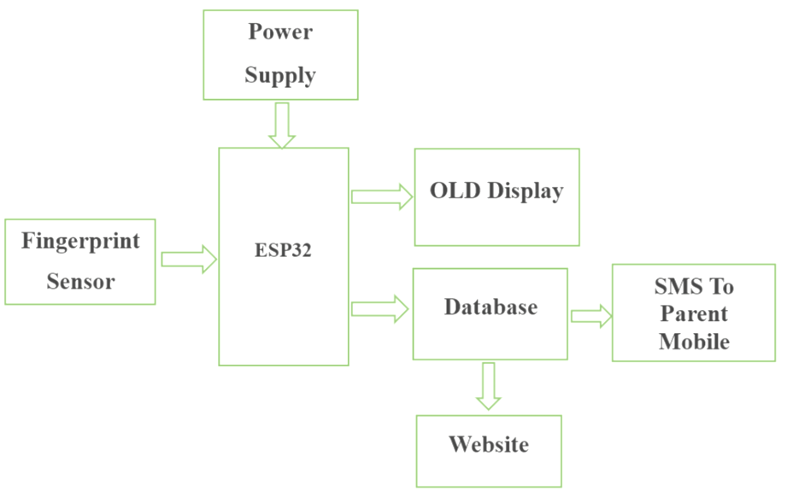
Figure 1. Proposed System Topology

5. HARDWARE DESCRIPTION OF PROPOSED SYSTEM

In today's fast-paced world, effective attendance management is critical for enterprises of all sizes. The introduction of technology has transformed old attendance tracking methods, creating the method for advanced systems that provide accuracy, dependability, and ease. This hardware description describes the components and features of SAS intended to streamline attendance management processes.

ESP32

Espressif Systems create the powerful and flexible ESP32 microprocessor board for IoT applications [17]. It comes with a dual-core Tensilica LX6 processor that can be clocked up to 240 MHz and Wi-Fi and Bluetooth connections. The board includes a rich set of peripherals such as analog to digital converters (ADCs), digital to analog converters (DACs), universal asynchronous receiver-transmitter (UART), serial peripheral interface (SPI), inter-integrated circuit (I2C), and pulse width modulation (PWM). It also supports encryption and safe boot. The ESP32 is ideal for battery-powered projects because it can work with a wide range of voltages and has low-power modes. The ESP32 works with a number of development platforms, such as the Arduino Integrated Development Environment and the Espressif IoT Development Framework. The ESP32 board has a Tensilica LX6 CPU with two cores that can run at up to 240 MHz, Bluetooth 4.2, and Wi-Fi (IEEE 802.11 b/g/n) connection. The RAM is 520 KB, and the ROM is 448 KB. The SRAM is for data storage. There are 34 general-purpose input/output (GPIO) pins, eighteen 12-bit ADC channels, and two 8-bit DAC channels on the board. Communication methods like UART, SPI, I2C, integrated inter-IC sound bus, controller area network, Ethernet MAC, and secure digital/secure digital input output/MultiMediaCard can be used with it. The ESP32 also incorporates support for PWM. Figure 2 shows the ESP32 board with its pin numbers.

R307 fingerprint sensor module:

The R307 module integrates a fingerprint reader, a CPU, and a storage unit to provide a complete fingerprint recognition system [18]. The R307 fingerprint sensor is reliable and efficient, capable of identifying and storing fingerprints. A high-speed digital signal processor (DSP) equips it, enabling fast and precise fingerprint detection, collection, and matching. The sensor can store up to 1,000 fingerprints and features numerous communication interfaces like UART and USB, making it simple to integrate with microcontrollers and PCs. The device's compact dimensions and consistent functionality make it well suited for use in security systems, time attendance systems, and access control applications. This module has an optical fingerprint reader with a high resolution of 500 DPI, ensuring that a high-quality fingerprint image is acquired. The UART transfer link facilitates the connection between microcontrollers and other devices. This device's operation necessitates a power supply with a voltage range of 3.6 V to 6.0 V. In order to get distinct fingerprint images, it is recommended that the image size be set to 256 × 288 pixels. Processing and matching typically take less than a second. The R307 functions optimally within a temperature range of -20°C to +50°C and has a configurable baud rate ranging from 9,600 to 1,15,200 bps. The dimensions of its tiny size are around 55 mm in length, 32 mm in width, and 21.5 mm in height. Moreover, it is compatible with Arduino libraries, which simplifies the process of development.

OLED display:

OLED is an advanced display technology known for its vibrant colors, profound black levels, and high energy efficiency. OLEDs differ from ordinary LCDs in that they do not need a backlight. Instead, each pixel produces its own light, leading to improved contrast and reduced screen sizes. This system utilizes a 1.44-inch OLED, which is sometimes known as a 1.44-inch thin-film transistor LCD. This small screen boasts a pixel resolution of 128 × 128, ensuring sharp and intricate visuals. The device uses a serial peripheral interface to establish contact with microcontrollers and provides excellent visibility from many viewing points, often within a range of 160 degrees or less. The display is capable of reproducing a wide spectrum of colors, has a built-in backlight for use in low-light environments, and has minimal energy consumption, making it ideal for devices that run on batteries. The compact size of this device makes it well suited for portable and wearable applications. Additionally, it is often compatible with widely used programming platforms like Arduino and Raspberry Pi.

6.SOFTWARE DESCRIPTION OF PROPOSED SYSTEM

The software description entails the integration of hardware components with software solutions to create an effective attendance management system. This system utilizes the ESP32 microcontroller, R307 fingerprint sensor, XAMPP software, Twilio API, and IoT technology. The ESP32 firmware connects to the R307 fingerprint sensor, establishes an internet connection, gathers fingerprint data, and communicates with the server to record attendance. The ESP32 uses its Wi-Fi capabilities to transmit fingerprint data to the XAMPP server for processing. XAMPP is a widely used web server that allows developers to efficiently construct and test their applications on a server that is installed on their own computer [19]. It comes with MySQL for database administration, PHP for server-side scripting, and Apache for hosting web applications. XAMPP manages the attendance database and offers a platform for accessing and modifying data.

Twilio is a cloud-based communication platform that offers an application programming interface (API) for sending and receiving SMS messages, making phone calls, and performing other related functions [20]. This proposed system utilizes Twilio to dispatch SMS messages to parents on their children's attendance status or updates. The ESP32 establishes communication with the server via Wi-Fi protocols in order to upload attendance data, hence facilitating remote monitoring and system control.

6.WORKING METHADALOGY OF PROPOSED SYSTEM

A fingerprint-based attendance system operates in numerous interrelated phases, including enrollment, attendance logging, data transmission, database management, notification, and remote monitoring and management. The procedure for enrolling a user and assigning a unique code follows these steps: 1) The user begins the registration process by selecting the "enrollment" option in the system. The system then prompts the user to enter a unique identification (ID) number associated with this particular fingerprint. This ID allows the system to distinguish the fingerprint from others stored in the sensor's memory. Users enter the ID through the web-based interface, which is crucial for identifying them in subsequent actions. 2) To ensure accurate fingerprint capture, the system requires two independent scans of the same finger. First, the system prompts the user to place their finger on the sensor. The R307 sensor then captures the fingerprint image, temporarily storing it in buffer 1. The user is then instructed to remove their finger and reposition it on the sensor. The system collects and saves the second scan in buffer 2. This dual-scan strategy reduces errors and increases fingerprint matching accuracy by enabling the system to check for consistency between the two images. 3) After capturing both images, the system analyzes the data to generate a fingerprint template, which is a digital representation of the fingerprint based on distinguishing characteristics such as ridges and minutiae points. If the two scans match closely, the system accepts the fingerprint as legitimate. The R307 sensor then links the template with the user's ID and saves it in its memory. The ESP32 microcontroller then connects to the R307 sensor, which processes and stores the fingerprint templates locally. When a user places their finger on the R307 sensor during the attendance logging phase, the sensor captures their fingerprint image. The ESP32 verifies the user's identity by comparing the collected fingerprint to the saved templates. Following successful verification, the ESP32 stores the attendance data and user information, such as the ID and timestamp, locally. During the data transmission phase, the ESP32 connects to the internet via WiFi protocols and transfers attendance data to the XAMPP server via HTTP. The ESP32 sends the attendance data to the XAMPP server, which is equipped with Apache, MySQL, and PHP, during the server-side processing phase. PHP scripts analyze the incoming data and populate the MySQL database with the latest attendance records. During the database management phase, the MySQL database in XAMPP holds attendance records, including user IDs, timestamps, and attendance status (e.g., present or absent).

The alerts phase uses Twilio's SMS API to send attendance alerts to selected contacts, such as parents. Notifications for events like late arrivals or absences are manually generated and sent to recipients via SMS. Finally, during the remote monitoring and management phase, administrators may access the attendance system through the XAMPP web interface. They are able to monitor attendance in real time, track attendance patterns, and manage user profiles. Figure 5 shows the functioning of the proposed system, while Figure 6 depicts the SMS sending mechanism for a single student or a group of students' parents.

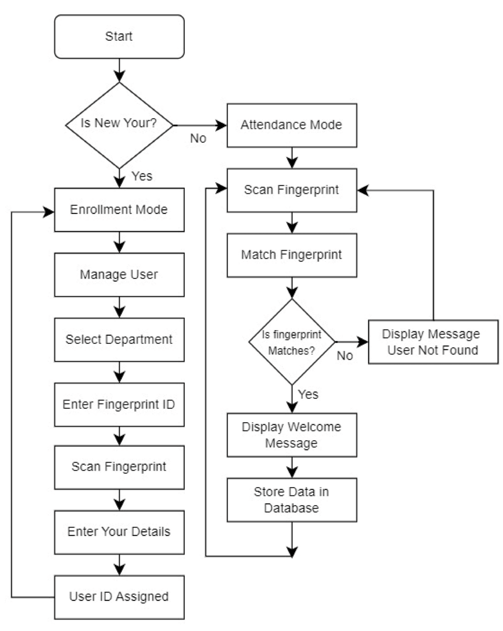

Figure 1.Flow chart for Proposed System Topology

6.HARDWARE IMPLEMENTATION
The circuit diagram shows how an OLED Display & Fingerprint Sensor is interfaced with NodeMCU ESP8266 12E Board. The I2C pins of OLED Display, i.e SDA & SCL are connected to NodeMCU D2 & D1 pins respectively. Similarly, the fingerprint sensor is connected to UART pins D5 & D6. The fingerprint sensor Tx and Rx wire’s color may vary. In my case, the color is yellow and blue where yellow is Tx and Blue is Rx. So connect it by finding appropriate color wires else the module won’t be detected by NodeMCU.The R305 fingerprint sensor is supplied with 5V through Vin pins of NodeMCU. In my case, the sensor didn’t work at 3.3V. Similarly, connect OLED Vcc pin to 3.3V of NodeMCU..
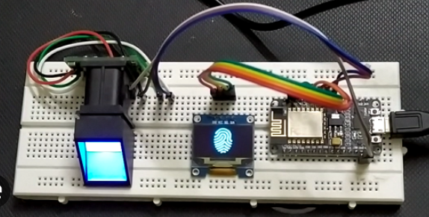

Figure 3. Hardware Implementation

7.CONCLUSION
The integration of biometric authentication and IoT technologies is revolutionizing the landscape of attendance management. By leveraging advanced biometric techniques such as facial recognition, fingerprint scanning, and iris recognition, organizations can significantly enhance the accuracy, efficiency, and security of their attendance tracking systems.IoT, on the other hand, enables seamless connectivity between devices and cloud platforms, facilitating real-time monitoring and remote control of attendance systems. This integration allows for automated data collection, analysis, and reporting, reducing the need for manual intervention and minimizing human error.By combining these powerful technologies, organizations can reap numerous benefits.As technology continues to evolve, we can expect even more innovative solutions to emerge in the realm of attendance management. By embracing biometric authentication and IoT integration, organizations can unlock the full potential of their workforce and drive organizational success.
REFERENCES
- S. Mohammed K, Tolba AS, Elmogy M: Multimodal student attendance management system (MSAMS). Ain Shams Engineering Journal. 2018, 9:2917-2929. 10.1016/j.asej.2018.08.002
- Qureshi KN, Naveed A, Kashif Y, Jeon G: Internet of Things for education: A smart and secure system for schools monitoring and alerting. Computers and Electrical Engineering. 2021, 93:107275. 10.1016/j.compeleceng.2021.107275
- Elaskari S, Imran M, Elaskri A, Almasoudi A: Using barcode to track student attendance and assets in higher education institutions. Procedia Computer Science. 2021, 184:226-233. 10.1016/j.procs.2021.04.005
- Hameed S, Saquib SMT, Hassan M, Junejo F: Radio frequency identification (RFID) based attendance & assessment system with wireless database records. Procedia - Social and Behavioral Sciences. 2015, 195:2889-2895. 10.1016/j.sbspro.2015.06.414
- Hoo SC, Ibrahim H: Biometric-based attendance tracking system for education sectors: A literature survey on hardware requirements. Journal of Sensors. 2019, 2019:1-25. 10.1155/2019/7410478
- Budiman A, Fabian, Yaputera RA, Achmad S, Kurniawan A: Student attendance with face recognition (LBPH or CNN): Systematic literature review. Procedia Computer Science. 2023, 216:31-38. 10.1016/j.procs.2022.12.108
- Yadav DK, Singh S, Pujari S, Mishra P: Fingerprint based attendance system using microcontroller and LabView. International Journal of Advanced Research in Electrical Electronics and Instrumentation Engineering. 2015, 4:5111-5121. 10.15662/ijareeie.2015.0406029
- Adal H, Promy N, Srabanti S, Rahman M: Android based advanced attendance vigilance system using wireless network with fusion of bio-metric fingerprint authentication. 2018 20th International Conference on Advanced Communication Technology (ICACT). 2018, 217-222. 10.23919/ICACT.2018.8323702
- Saraswat D, Bhattacharya P, Shah T, Satani R, Tanwar S: Anti-spoofing-enabled contactless attendance monitoring system in the COVID-19 pandemic. Procedia Computer Science. 2023, 218:1506-1515. 10.1016/j.procs.2023.01.129
- Lodha R, Gupta S, Jain H, Narula H: Bluetooth smart based attendance management system. Procedia Computer Science. 2015, 45:524-527. 10.1016/j.procs.2015.03.094
- Dey S, Barman S, Bhukya RK, Das RK, Haris BC, Prasanna SRM, Sinha R: Speech biometric based attendance system. 2014 Twentieth National Conference on Communications (NCC). 2014, 1-6. 10.1109/NCC.2014.6811345
- Yang H, Han X: Retracted: Face recognition attendance system based on real-time video processing. IEEE Access. 2020, 8:159143-159150. 10.1109/access.2020.3007205
- Alhanaee K, Alhammadi M, Almenhali N, Shatnawi M: Face recognition smart attendance system using deep transfer learning. Procedia Computer Science. 2021, 192:4093-4102. 10.1016/j.procs.2021.09.184
- Ezema LS, Joe-Uzuegbu CKA, Eneh JN, Amanze I: Fingerprint based attendance management system. International Journal of Scientific & Engineering Research. 2015, 6:1623-1628.
- Miao Q, Xiao F, Huang H, Sun L, Wang R: Smart attendance system based on frequency distribution algorithm with passive RFID tags. Tsinghua Science and Technology. 2020, 25:217-226. 10.26599/tst.2018.9010141
- Zainal NI, Sidek KA, Gunawan TS, Manser H, Kartiwi M: Design and development of portable classroom attendance system based on Arduino and fingerprint biometric. The 5th International Conference on Information and Communication Technology for The Muslim World. 2014.

