**REVIEW OF COMPRESSED AIR STORAGE SYSTEM INTEGRATION WITH SOLAR AND WIND ENERGY FOR POWER PRODUCTION**

**Dr. M. Rajagopal1, Bragadeesh K2 ,** **Abinesh L3, Harish M4, Kaviyarsan M5**

1Professor, Department of Mechanical Engineering, PERI Institute of Technology, Chennai – 600048

2,3,4,5Students, Department of Mechanical Engineering, PERI Institute of Technology, Chennai – 600048

**ABSTRACT**

Compressed air energy storage (CAES) technology has drawn increasing attention due to its critical role in large-scale renewable energy access, particularly in view of the robust progress of the global carbon reduction plan and the rapid expansion of renewable energy. This study highlights the benefits and drawbacks of each system while summarizing the coupling systems of CAES with wind and solar energy from the standpoint of system topology. It is demonstrated that wind energy and CAES are typically coupled in series and parallel, with the possibility of some wind power being transformed into thermal energy when coupled to CAES. One significant type of interaction between solar energy and CAES is that between solar heat and CAES. Expander inlet air is primarily heated by solar energy in solar-heat-coupled CAES. Different CAES forms, different heat heating sequences, reheating, bottom cycle, and other elements are the basis for the coupling forms of solar energy and CAES. Although it has certain technological difficulties, an integrated system with wind, solar, and CAES multiple coupling is anticipated to develop into a promising large-scale form for the use of renewable energy in the future.

**Keywords:** Compressed Air, Energy Storage, Solar Energy, Wind Energy, CAES

1. **INTRODUCTION**

Many engineers and scientists are considering renewable energy options as they look to the future due to the implications of climate change. Although solar and wind power systems are environmentally benign energy sources, their maximum efficiency depends on specific weather conditions. A possible solution to this issue is storage of energy that could readily improve the generation as well as effectiveness of a power plant. Compressed air is used in one such storage system to conserve energy for later use. Although compressed air energy storage has been a concept for several decades, it has recently gained more attention as a way to support renewable energy systems.

The process of storing energy for later use in the form of compressed air is known as compressed air energy storage, or CAES. In order to store more energy for periods in which it is most needed, as during peak energy hours, CAES can be used in conjunction with the present energy grid and other power sources. One example of how this combines other forms of energy production is wind power. The wind turbines rotate to generate energy whenever there is wind, but the electricity they produce is squandered because it may not always be needed at the time it is produced.

On the other hand, when there is insufficient wind to turn the turbines and provide enough electricity, peak energy demand can happen. When there is insufficient wind to power the wind turbines or during periods of high energy demand, the stored compressed air energy can be utilized for storing the extra energy generated by the wind turbines. Compressed air energy transforms electricity from other power sources, such wind turbines, into very pressurized compressed air, which is then stored for later use. This compressed air is then discharged into turbine generators to be converted back into electricity when the energy is required. Irrespective of the weather or other circumstances, compressed air energy storage allows energy to be stored and then used at any time of day or year.

## Achieving sustainable energy objectives and lowering carbon emissions depend heavily on renewable energy sources like wind and solar. Despite their benefits, their reliance on atmospheric conditions causes variations in power generation, which poses problems for grid stability and dependability. Compressed Air Energy Storage is a large-scale energy storage system that stores energy in the form of compressed air in underground caverns or tanks. In order to generate electricity, the stored air is subsequently heated and expanded. This present work focuses on integrating CAES with solar and wind energy to address their intermittency issues, optimize energy storage and retrieval processes to minimize energy losses, and evaluate economic feasibility, environmental benefits, and scalability of the proposed system. Figure 1 shows the schematic of compressed air storage system integrated with solar and wind forms and Figure 2 shows compressed air storage system from renewable and non-renewable energy.

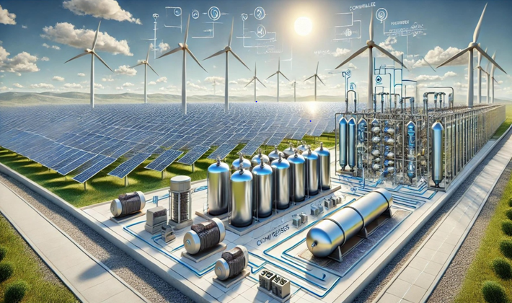

**Figure1 Schematic of Compressed Air Storage System integrated with Solar and Wind Forms**

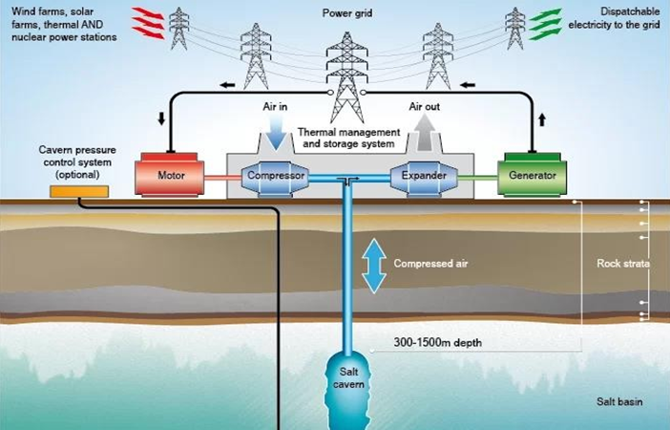

**Figure 2 Compressed Air Storage System from Renewable and Non-Renewable Energy**

## 1.1 CAES And Renewable Energies

* **Technical Potential:** CAES systems can achieve efficiencies of **70–80%**, making them a competitive option compared to traditional energy storage technologies like pumped hydro and batteries. This higher efficiency is due to advancements in thermodynamic processes and better integration with renewable energy sources.
* **Case Studies:** The McIntosh CAES plant in Alabama demonstrates the viability of this technology at a commercial scale. Operational since 1991, it provides reliable grid support, leveraging underground caverns for large-scale energy storage.
* **Integration Challenges:** Suitable geological formations (such as salt caverns) are essential, restricting deployment to specific regions. Significant investment in infrastructure, including excavation and compression systems, poses economic challenges, especially in emerging markets or areas without existing suitable formations.

## Advancements in CAES Technology

* **Adiabatic CAES:** Captures and stores the heat generated during air compression. Reuse the stored heat during the expansion phase, significantly reducing energy loss and increasing overall efficiency. It eliminates the need for external fuel sources like natural gas, making it a greener solution.
* **Isothermal CAES:** Maintains a constant temperature during both compression and expansion processes. It achieves higher efficiency by minimizing energy loss associated with temperature fluctuations. Requires advanced heat management systems to continuously regulate the temperature.

## 1.2 Hybrid Energy System Configuration

This system integrates solar energy, wind energy, and Compressed Air Energy Storage (CAES) to maximize renewable energy utilization and ensure grid reliability.

**Components:**

**Solar Energy (Photovoltaics)**

**Function**: Generate electricity during the day, particularly during peak sunlight hours.

**Advantages**: Abundant and predictable daily energy source.

**Wind Energy (Turbines)**

**Function**: Produce electricity during windy conditions, often complementing solar energy by generating power at night or during overcast weather.

**Advantages**: Reliable in regions with consistent wind patterns, enabling round-the-clock renewable energy production.

**Compressed Air Energy Storage (CAES)**

**Function**: Stores excess electricity by compressing air into underground caverns or high-pressure tanks. When demand rises, the stored compressed air is released to drive turbines and generate electricity.

**Role in System**: Balances supply and demand by providing backup power during periods of low solar or wind output.

**Key Benefits**

**Flexibility**: CAES mitigates the intermittency of solar and wind energy, ensuring a steady energy supply.

**Efficiency**: CAES systems can achieve high round-trip efficiency, especially with advancements like adiabatic or isothermal designs.

**Sustainability**: Reduces reliance on fossil fuels for grid stability, supporting decarbonization goals.

**Operational Workflow**

**Daytime**: Solar and wind energy power the grid, with surplus electricity used to compress air for storage.

**Night or Low-Wind Periods**: Stored compressed air is released, generating electricity to meet demand.

**2. CAE SYSTEMS INTEGRATION WITH WIND ENERGY STORAGE**

The integration of **wind power** and **CAES** systems has been extensively studied, with a focus on their **coupling characteristics**. This coupling is essential for managing wind energy's inherent intermittency and providing a more stable and reliable power output. The two primary coupling configurations, **series** and **parallel**, each serve distinct purposes, and further hybrid approaches aim to maximize system performance.

**Topological Structures of Wind Power and CAES Coupling**

1. **Series Connection**

**Configuration**: During the energy storage phase, all wind power is directed to CAES. During the energy release phase, CAES outputs stable electrical energy.

**Advantages**:

* + - Enables consistent and predictable power delivery to the grid.
    - Effectively absorbs fluctuations in wind energy during storage.

**Use Case**: Suitable for systems requiring a steady and reliable output to meet demand.

1. **Parallel Connection**

**Configuration**:

* + - During energy storage, CAES absorbs excess wind energy or low-cost, low-demand electricity from the grid.
    - During energy release, CAES supplements wind power to stabilize overall output.

1. **Hybrid Series-Parallel Connection**

**Configuration**:

* + - **Series during energy storage**: CAES absorbs surplus wind power beyond grid dispatch needs.
    - **Parallel during energy release**: CAES works with wind power to provide stable and increased total energy output.

**Advantages**:

* + - Combines the benefits of both series and parallel connections.
    - Maximizes wind power utilization while stabilizing grid contributions.

**Advanced Coupling Methods**

**Thermoelectric Coupling**

* Focuses on integrating CAES systems with **thermal energy storage** or **combined heat and power (CHP)** to enhance overall energy efficiency.
* Potential Benefit: Utilizes waste heat from CAES processes for heating applications or additional power generation.

**Mechanical Coupling**

* Involves direct mechanical integration of wind turbines and CAES systems, reducing energy conversion losses.
* Challenge: Complex mechanical design and limited studies on real-world implementations.

### 2.1 Wind Power Connecting To CAES in Series

Zhang et al. studied a wind power coupling system that connects to A-CAES in series. In Zhang's work, the effects of steady and unstable wind speeds on the coupling system were examined and contrasted for system and energy conversion efficiency. It was discovered that each component of the coupling system's energy conversion efficiency clearly gets influenced by the wind's intensity and speed fluctuations. The high efficiency of the coupling system, which is predicated on the relative high energy conversion efficiency of the wind turbine and the A-CAES system, allows for improved utilization of wind energy when the wind speed is appropriately stable.Figure 3 shows the schematic diagram of coupling system of wind power connecting with A-CAES in series.

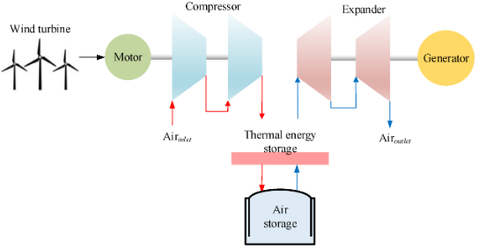

**Figure 3 Schematic diagram of coupling system of wind power connecting with A-CAES in series**

Meng et al. investigated a system in which wind power was directly linked to a traditional CAES compressor, taking into account the components' off-design behaviors. According to the findings, the CAES system operating in variable shaft speed mode is able to store more compressed air, produce more electricity, use greater amounts of wind energy, and discharge for a longer period of time than one operating in constant shaft speed mode. Additionally, it was discovered that a variable shaft speed mode had a lower levelized cost of electricity (LCOE) than a constant shaft speed mode. Additionally, coupling systems coupled in series were examined by Ghorbani et al. Using phase change material (PCM) thermal storage as a case study, the paper demonstrated a recovery strategy. Phase shift heat storage has been found to increase system sustainability, efficiency, and lessen irreversibility. The system may achieve 70.83 and 80.71% energy and energy efficiency, respectively. A cooperative control framework for a wind energy conversion system (WECS) that is directly coupled to CAES was presented by Abouzeid et al. The goal of the suggested coordination strategy was to resolve the conflict between WECS's frequency modulation signal and speed regulation system. When compared to the non-coordinated control operation, the results demonstrate that the suggested coordination can enhance the system's frequency response.

### 2.2 Wind Power Connecting to CAES in Parallel

There isn't much research on wind power connecting to CAES only in parallel. Hasan et al. suggested connecting a wind turbine in parallel to the CAES system in order to minimize wind power variations and supply the grid system with electricity continuously. The findings demonstrate that wind power plus a parallel CAES system can reduce wind power variations and supply the grid system with steady electricity at low power consumption.

### 2.3 Wind Power Connecting to CAES in Series and in Parallel

Succar et al. investigated the scheduling problems when wind and CAES are connected in parallel and series. The flow chart for the system is shown in Figure 4. According to studies, LCOE can be considerably decreased by fully optimizing wind storage systems. These modifications raise a wind farm's capability factor. In contrast to linking the wind farm to CAES by optimizing the wind farm alone, the coupling method lowers the storage capacity needs of the base load plant and lowers the GHG emission rate of the combined system. The dispatch of a comparable combined system taking economic hazards into consideration was examined by Sriyakul et al. The three markets in which the system traded were the day-ahead, intraday, and balancing markets. To improve financial risk management, stochastic formulas were used to predict the downside risk constraint approach (DRCA). Although the DRCA approach is less profitable (1.97%), it offers the power aggregator a 100% risk reduction and a guaranteed risk control method.

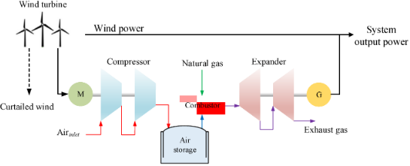

**Figure 4 Schematic diagram of coupling system of wind power connecting with A-CAES in series and in parallel**

#### 2.4 Wind Power and Wind Heat Connecting to CAES

The compressor is driven by high-frequency wind power variations, which are also transformed into resistive heat to warm the expander's inlet and boost output power. In contrast to a scenario in which wind power solely powers the compressor, CAES is able to absorb more fluctuating wind power in this manner. A coupling CAES system for the hybrid utilization of wind power was investigated by Yang et al. Figure 5 shows the Schematic diagram of a coupled system combining wind power, wind heat, and CAES. In order to boost power output and wind energy usage, wind power not only powers the compressor but also heats the thermal storage device via a resistance wire. With identical compressors, thermal energy storage (TES) units, and turbines of the same size, a theoretical thermodynamic analysis demonstrates that the coupling CAES system is more capable of absorbing thermal energy than the A-CAES system. This additional wind power has a recovery efficiency of roughly 41–47% based on the TES ultimate storage temperature.

A similar coupling method was also suggested by Zhao et al., where the compressor is driven by the low-frequency, part of the wind energy and the expander inlet is heated by the high-frequency part of the energy using a resistance wire to increase output. In the meantime, two sets of compressors/expanders with varying powers are installed to guarantee the system's broad functioning conditions. According to the simulation results, the CAES system with a dual-power-level turbo machinery construction is one of the more efficient methods to remove variations in wind power generation.

Zhao et al. also proposed a similar coupling system, in which the low-frequency part of the wind energy drives the compressor and the high-frequency part of the energy uses the resistance wire to heat the expander inlet to improve the output. Meanwhile, two sets of compressors/expanders of different powers are equipped to ensure the wide operating conditions of the system. The simulation results show that one of the more effective ways to eliminate fluctuations in wind power generation is the CAES system with a dual-power- level turbo machinery structure.

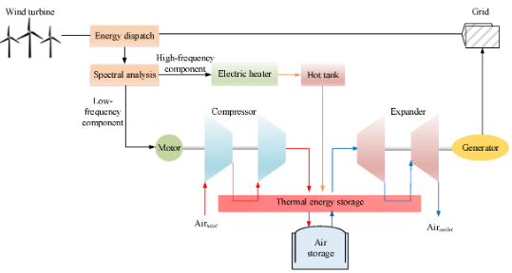

**Figure 5 Schematic diagram of a coupled system combining wind power, wind heat, and CAES**

### 2.5 Other Coupling Types

Other methods, such mechanical connection, are also included in the coupling of wind power with CAES. A mechanical coupling method between wind turbines and CAES as shown in Figure 6 was proposed by Sun et al. This mechanism was made achievable by the establishment of a prototype test bench. The system's energy conversion efficiency under various operating situations and modes was examined using simulation and experimental study. With an energy efficiency of about 50%, the suggested system has been shown to be technically possible. The suggested system is only appropriate for small-scale wind energy utilization systems because of the capacity of conventional scroll expanders.

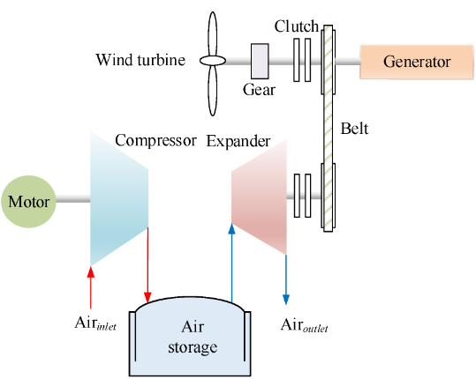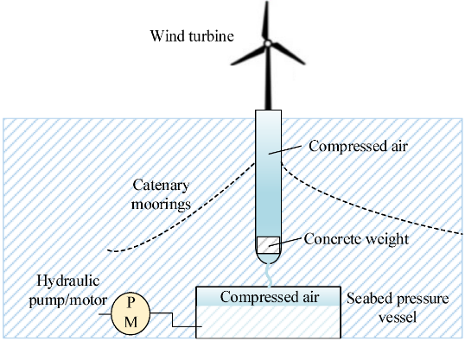

**Figure 6 Schematic diagram of a mechanical coupling system of CAES and wind turbines Figure 7 CAES concept integrated into a FOWT spar-type structure**

Sant et al. presented a design for incorporating CAES into spar-type floating wind turbine platforms, combining CAES and wind energy into a structure as shown in Figure 7. The system completes the power transfer with a turbine and hydraulic pump. A traditional floating offshore wind turbine (FOWT)-spar setup without an energy storage system was used to compare the findings. Studies have demonstrated that it is technically possible to integrate short-term energy storage capacities in the order of megawatt-hours, despite the fact that doing so significantly increases the weight of the floating structures. A compressor air–hydraulic energy storage system as shown in Figure 8 was proposed by Saadat et al. The system stored and released energy using a liquid pump/turbine. An air compressor/expander with liquid pistons and enhanced heat transfer was designed. Porous media, droplet sprays, and decreased leakage were used to improve heat transmission. While the down-tower hydraulic pumps and drives were able to precisely track the necessary generator power, the liquid piston compressors and expanders were only able to loosely maintain accumulator pressure ratios. By linking to CAES, wind energy may also be integrated with other energy systems to create massive hybrid systems that reduce pollution emissions, increase wind power revenue, and regulate grid frequency.

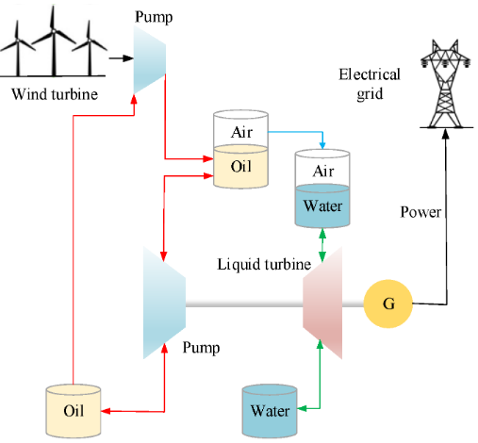

**Figure 8 Schematic diagram of a compressor air–hydraulic energy storage system**

The following are the some of the related research.

Li et al. investigated the scheduling issues that arise when wind, gas, power systems, and conventional CAES are combined in the face of significant uncertainty brought on by a high penetration of wind generation. Information gap decision theory was used in their study to illustrate the inherent unpredictability of wind power. The numerical test results show that when the demand response mechanism is included, the overall cost is reduced by 3.63%. The design issues and coupling impacts of a wind-powered UW-CAES system for grid peak shaving and dispatch ability augmentation were investigated by Astolfi et al. They assessed how system performance and plant flexibility would be affected by a realistic power input. The average unplanned energy injection into the grid system is reduced by 10–15%, according to annual simulations based on realistic wind data and taking part-load characteristics into account. The worldwide round-trip efficiency is approximately 75. The function of CAES in district energy systems was assessed by Rahmanifard et al. Using CMG STARS, they developed a model that simulated the functioning of CAES-geothermal power plants in a typical hot, dry rock reservoir, with or without wind power. Studies show that wind/CAES-geothermal schemes offer the lowest emission intensity (88–126 g CO2/kWh) and the lowest LCOE (7.8–11.8¢/kWh).

# 3. CAES SYSTEMS COUPLED WITH SOLAR ENERGY

There are numerous ways to combine solar energy with CAES, just like there are different ways to combine wind power and CAES. Photovoltaic power generation and CAES coupling and solar heat and CAES coupling are the two categories of the solar energy and CAES coupling. The first kind of coupling is rather straightforward: photovoltaic energy, like wind power, directly powers the CAES compressor. The second kind entails the somewhat complicated matching of several heat sources and power producing apparatus. Thus, this article will only concentrate on the second instance. Numerous academics have researched coupling types, primarily the combination of CAES with solar thermal power generation. These coupling systems cancel the expander of the original solar thermal power generating system and use solar energy to heat the expander inlet air of the CAES. The technologies employed in the CAES, whether it is coupled with other thermal systems, and whether it solely delivers electrical energy are some of the ways that the coupled systems differ from one another. enumerates the pertinent studies on the relationship between solar energy and CAES. It is discovered that: (1) the CAES does not use compressed heat when it has a combustion chamber; (2) the system typically does not have regeneration when it is configured with a bottom cycle (organic Rankine cycle (ORC), etc.); and (3) the expander inlet can be heated in cascades using fuel, solar energy, and compressed heat.

**Several typical coupling schemes are described in detail as follows**.

**3.1 Solar-Assist CAES by Combining the Heating Sources at Expander Inlet**

* **Regenerator, solar energy, and combustion chamber combined heating**

Jalili et al. investigated the scheduling of CAES systems in conjunction with several renewable energy sources that heated the expander inlet successively using combustion chambers, solar energy, and regenerators. It was investigated how a solar-powered CAES system affected the energy hub's (EH) operational efficiency and performance. The efficiency of the coupling system can lower operating costs and emissions in day-ahead energy management, as demonstrated by the application of the suggested framework to a typical EH. Mohammadi et al. designed and analyzed a solar dish collector system, CAES system, and integrated micro gas turbine. In addition to compression heat, the system heats the expander inlet using fuel, regenerator, and solar energy. Energy and exergy analysis techniques were used to examine the system's performance. The results show that round-trip efficiency increases when the pressure differential between the minimum and maximum air caverns increases.

* **Compression heat and solar combined heating**

As seen in Figure 9, Li et al. investigated a combined CAES system that used solar energy and no regenerator to heat the expander intake while releasing heat outdoors. The performance under five heat distribution methods (100, 75, 50, 25, and 0%), which reflect the ratio of the amount of air used to heat the expander inlet to the amount used by the user in the compression heat, was examined and addressed from the standpoints of thermodynamics and economics. The findings indicate that when the heat distribution ratio decreases, the exergy efficiency and net present value rise. Depending on the position, the heat exchanger's effectiveness has a different impact on system performance.

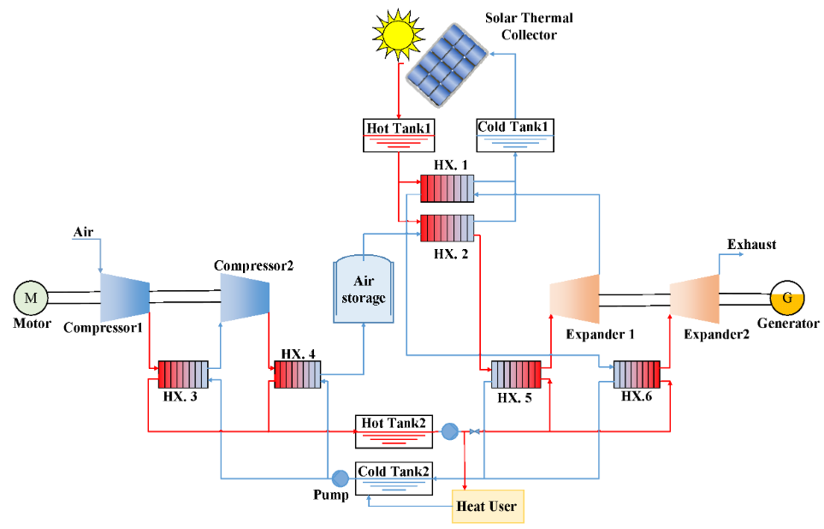

**Figure 9 Schematic diagram of the cogeneration system based on AA-CAES coupled with solar auxiliary heat**

* **Regenerator and solar combined heating**

Morteza Saleh Kandezi et al. investigated a solar CAES system as shown in Figure 10 that uses solar energy and regenerative heat in succession to heat the expander's inlet. In the meantime, cold is created using the compressed heat. In order to lower peak energy demand, this hybridization concurrently produces power, cooling capacity, and hot water. This combination yields an exergy efficiency of 45.6% and a round-trip efficiency of 67.5. In the meantime, the pressure regulator, heliostat field, and solar receiver tower all have substantial exergy destruction. Yang et al. investigated the LAES and solar energy coupling system, which heats the LAES expander inlet air successively using a regenerator, compression heat, and solar energy. Simultaneously, they examined the combined system's performance under isothermal compression, which eliminates the need for compression heat, and discovered that it had improved. Under the design parameters, the round-trip efficiency of the coupled systems are increased by 56.46 to 87.17% when adiabatic compression is used. The systems' round-trip efficiencies are greatly increased to 112.73 and 120.71%, respectively, when isothermal compression is used.

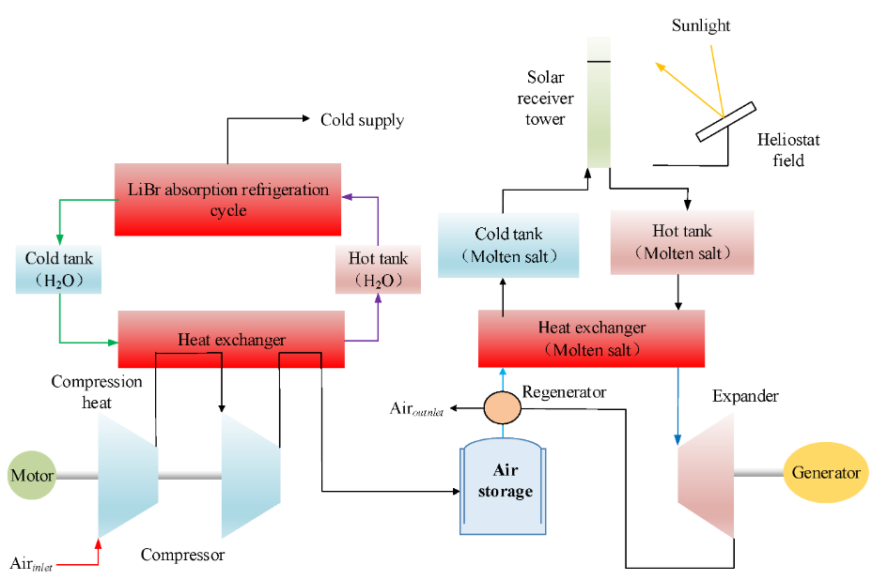

**Figure 10 Schematic diagram of the CAES-CSP hybrid system coupled with an ARC heat recovery system**

### 3.2 Solar-Assist CAES with Bottom Cycle

The majority of the systems mentioned above might produce too much heat. This is because solar heating raises the expander's inlet temperature while lowering its inlet pressure in relation to the elevated temperature. Furthermore, the temperature at the expander's exit is significantly higher than the surrounding air temperature. As a result, some academics have suggested combination systems with a bottom cycle in addition to using lost heat. Since the turbine's exhaust air serves as a heat source for the organic Rankine cycle (ORC) power generation, Wang et al. directly heated the inlet air of a CAES turbine using solar energy. In the meantime, users receive heat from the compression heat. According to the findings, the coupling system's energy and exergy efficiencys achieve 98.30 and 68.94%, respectively. A CAES coupled with an ORC that uses solar and geothermal energy as the thermal source was proposed by Mousavi et al. Potential approaches for observing and assessing a design system's performance included consumption, energy, and a consumption-economics study. According to the multi-objective optimization, under ideal circumstances, the system's energy efficiency and total cost rate are 29% and 1560 Rs/h, respectively.

### Solar-Assist CAES with CCHP or Producing Other Products

A multi-product output can also be achieved by combining solar energy and CAES systems with other technologies. By utilizing a regenerator and solar energy to directly heat the expander inlet, Wang et al. suggested a CAES in conjunction with a gas turbine and refrigeration cycle. The system concurrently delivers electricity, heat, and cold (CCHP) to the exterior. It has been demonstrated that the compressor pressure ratio, the turbine's inlet pressure and temperature, and the efficiency of the heat exchanger all significantly affect the suggested system's performance. According to the findings, under maximum heating and maximum cooling settings, the system's ideal energy efficiency is roughly 53.10 and 45.36%, respectively.

In order to produce both power and drinkable water, Alirahmi et al. suggested a revolutionary dual-purpose green energy storage device. Compression heat and turbine exhaust supply the energy needed for desalination. The round-trip efficiency is 48.7% and the overall cost ratio is 265000rs/h under ideal design parameters. Using San Francisco as an example, the suggested system produced 226,782 m3 cubic meters of potable water, generated 27,551 MWh of electricity, and had a 2.65-year payback period. Wen et al. suggested an energy hub that included solar cells, a wind turbine, and a CCHP system. Both an energy storage system and an ice storage conditioner are features of the energy hub system. They looked into how the energy hub's performance was affected by a solar-powered CAES. The modeling results indicate that a system energy management strategy can lead to good performance from the energy storage system.

# CAES SYSTEMS COUPLED WITH BOTH SOLAR ENERGY AND WIND ENERGY

There is less research on the coupling of wind, solar, and CAES systems collectively than there is wind, solar, and CAES systems independently. However, because solar and wind energy complement each other (solar energy is abundant during the day and wind power is often abundant at night), some researchers have conducted primary studies of the coupling of solar energy, wind power, and CAES, which can currently be divided into two categories. Systems in the first category use solar energy to heat the air at the expander's inlet while wind power powers the compressor. The second group includes systems where the compressor is powered by both photovoltaics and wind power to finish the energy storage process, whereas CAES discharges without the coupling of solar and wind energy. The performance of coupling systems and their function in enhancing wind power and solar energy absorption are the primary areas of study in the two scenarios mentioned above. Currently, the research on wind and solar energy alone with CAES is still the basis for the wind, solar, and CAES coupling form. The following are the pertinent studies.

A novel kind of wind-solar-complementary energy storage integration system was proposed by Xu et al. The compressor is powered by wind, while the expander's air input is heated by solar radiation. The system's efficiency ranges from 59 to 67%. In order to highlight the benefits of energy storage technology, Garrison et al. proposed a hybrid system of wind–solar-coupling CAES in which the CAES is powered by concentrated solar thermal storage and excess wind energy at night. This allows the excess energy sources to be dispatched during peak and valley periods. Ji et al. also investigated the CAES coupling system, that utilizes solar energy to heat the expander and wind power to drive the CAES compressor. In the meantime, the compression heat is utilized for ORC power generation or for outdoor heating. The system has an exergy efficiency of 65.4%, a round-trip efficiency of 61.2, and a power storage efficiency of 87.7. For rural mobile base stations, Zhao et al. investigated the coupling system of photovoltaic, wind, and CAES coupled in tandem. The findings indicate that there is a 0.988% chance of power loss in the coupling system. In the meantime, the supply and demand of cold energy, as well as the monthly load and electrical consumption of a single device, are all in good balance.

In addition to the abovementioned research, some academics have examined how CAES affects local energy systems by examining how it affects the use of solar and wind energy. Wu et al., for instance, assessed the risks associated with economic management when wind, solar, and tidal energy systems were combined with CAES systems along the coast. The economy, the environment, and management were found to have fourteen essential criteria. According to the findings, the offshore hybrid system's risk rating is more in line with middle-high. Decision makers are advised to adopt targeted risk response strategies in light of the aforementioned findings. The tactics aid in achieving appropriate risk aversion and a fair distribution of resources. The function of various energy storage devices in the application of solar and wind energy usage was highlighted by Denholm et al. Options for storing electricity include TES, CAES, pumped hydro, and batteries. The findings indicate that, if long-distance transmission options are disregarded, a mix of load shifting and storage equivalent to around 12 hours of typical demand may maintain renewable energy curtailment below 10%. In the presence of energy management, Marano et al. investigated the functioning properties of a coupling system that included wind, photovoltaic, power grid, and CAES. Using CAES technology, daily periodic energy, economic, and environmental impact studies of wind farm and solar system integration were conducted. An ideal management approach based on dynamic planning was put out with the aim of optimizing earnings. The findings demonstrate that integrating the CAES system can significantly lower CO2 emissions while boosting the economic feasibility of renewable energy sources.

1. **CONCLUSION**

This study highlights the benefits and drawbacks of each system while summarizing the coupling systems of compressed air energy storage (CAES) with wind and solar energy from the standpoint of system topology. The following are the particular findings. There are three different ways to connect wind power to CAES: in series, in parallel, and in series–parallel combination. The most popular coupling method is the series–parallel combination. In order to fully utilize wind energy and increase CAES production, wind power can also convert heat to create a coupling between wind heat and CAES. Furthermore, mechanical linkage and coupling with other types of energy storage are also possible with wind power and CAES.

One significant type of interaction between solar energy and CAES is that between solar heat and CAES. The primary function of solar heat-coupled CAES is to heat expander inlet air using solar radiation. There are numerous coupling forms of solar energy and CAES that generate work through the expander and reasonably use system heat, depending on the different CAES forms and heat heating sequences. Recent years have also seen the proposal of solar-assist CAES with bottom cycle or multi-generation systems to completely utilize solar heat. Although the energy utilization efficiency of these systems has been somewhat enhanced, the system complexity has also increased.

The wind–solar–CAES multiple coupling system is anticipated to develop into a promising large-scale form for the utilization of renewable energy in the future due to the complementary nature of solar and wind energy, as well as the global abundance of solar and wind resources. The integrated system is a potentially significant system configuration. Coupling system integrated design and multi-subsystem collaborative control present obstacles and problems because of factors including multi-physical process coupling, system structural variety, and the unpredictability of renewable energy.

1. **REFERENCES**

[1] Guo, H.; Xu, Y.; Yan, M.; Kang, H.; Cheng, L.; Huang, L.; Xu, D.; Zhu, Y.; Chen, H. Chapter One—Effect of Thermal Storage and Heat Exchanger on Compressed Air Energy Storage Systems. In Advances in Heat Transfer; Abraham, J.P., Gorman, J.M., Minkowycz, W.J., Eds.; Elsevier: Amsterdam, The Netherlands, 2013; Volume 55, pp. 1–39.

[2] Jin, H.; Liu, P.; Li, Z. Dynamic modeling and design of a hybrid compressed air energy storage and wind turbine system for wind power fluctuation reduction. Comput. Chem. Eng. **2019**, 122, 59–65.

[3] Luo, X.; Wang, J.; Dooner, M.; Clarke, J. Overview of current development in electrical energy storage technologies and the application potential in power system operation. Appl. Energy **2014**, 137, 511–536.

[4] Xu, Y.; Chen, H.; Liu, J.; Tan, C. Performance Analysis on an Integrated System of Compressed Air Energy Storage and Electricity Production with Wind-solar Complementary Method. Proc. CSEE **2012**, 32, 88–95.

[5] Tong, Z.; Cheng, Z.; Tong, S. A review on the development of compressed air energy storage in China: Technical and economic challenges to commercialization. Renew. Sustain. Energy Rev. **2021**, 135, 110178.

[6] Li, Y.; Miao, S.; Yin, B.; Han, J.; Zhang, S.; Wang, J.; Luo, X. Combined Heat and Power dispatch considering Advanced Adiabatic Compressed Air Energy Storage for wind power accommodation. Energy Convers. Manag. **2019**, 200, 112091.

[7] Crotogino, F.; Mohmeyer, K.U.; Scharf, R. Huntorf CAES: More than 20 years of successful operation. Nat. Gas **2001**, 45, 55.

[8] Nakhamkin, M.; Andersson, L.; Swensen, E.; Howard, J. AEC 110 MW CAES plant: Status of project. ASME J. Eng. Gas Turbines Power **1992**, 114, 695–700.

[9] Hobson, M.J. Conceptual Design and Engineering Studies of Adiabatic Compressed Air Energy Storage (CAES) with Thermal Energy Storage; Nasa Sti/recon Technical Report, N; Pacific Northwest Lab.: Richland, WA, USA; Acres American, Inc.: Columbia, MD, USA, 1981; Volume 82.

[10] Guo, H.; Xu, Y.; Chen, H.; Zhou, X. Thermodynamic characteristics of a novel supercritical compressed air energy storage system. Energy Convers. Manag. **2016**, 115, 167–177.

[11] Morgan, R.; Nelmes, S.; Gibson, E.; Brett, G. Liquid air energy storage—Analysis and first results from a pilot scale demonstration plant. Appl. Energy **2015**, 137, 845–853.

[12] Ameel, B.; T’Joen, C.; De Kerpel, K.; De Jaeger, P.; Huisseune, H.; Van Belleghem, M.; De Paepe, M. Thermodynamic analysis of energy storage with a liquid air Rankine cycle. Appl. Therm. Eng. 2013, 52, 130–140.

[13] Vasel-Be-Hagh, A.; Carriveau, R.; Ting, D.S.-K. Underwater compressed air energy storage improved through Vortex Hydro Energy. Sustain. Energy Technol. Assess. 2014, 7, 1–5.

[14] Gouda, E.M.; Fan, Y.; Benaouicha, M.; Neu, T.; Luo, L. Review on Liquid Piston technology for compressed air energy storage. J. Energy Storage 2021, 43, 103111.

[15] Hashemi-Tilehnoee, M.; Tsirin, N.; Stoudenets, V.; Bushuev, Y.G.; Chorążewski, M.; Li, M.; Li, D.; Leão, J.B.; Bleuel, M.; Zajdel, P.; et al. Liquid piston based on molecular springs for energy storage applications. J. Energy Storage 2023, 68, 107697.

[16] Guo, H.; Xu, Y.; Guo, C.; Zhang, Y.; Hou, H.; Chen, H. Off-design performance of CAES systems with low-temperature thermal storage under optimized operation strategy. J. Energy Storage 2019, 24, 100787.

[17] Arabkoohsar, A.; Rahrabi, H.R.; Alsagri, A.S.; Alrobaian, A.A. Impact of Off-design operation on the effectiveness of a low-temperature compressed air energy storage system. Energy 2020, 197, 117176.

[18] Zhang, Y.; Yang, K.; Li, X.; Xu, J. Thermodynamic analysis of energy conversion and transfer in hybrid system consisting of wind turbine and advanced adiabatic compressed air energy storage. Energy 2014, 77, 460–477. [[Google Scholar](https://scholar.google.com/scholar_lookup?title=Thermodynamic+analysis+of+energy+conversion+and+transfer+in+hybrid+system+consisting+of+wind+turbine+and+advanced+adiabatic+compressed+air+energy+storage&author=Zhang,+Y.&author=Yang,+K.&author=Li,+X.&author=Xu,+J.&publication_year=2014&journal=Energy&volume=77&pages=460%E2%80%93477&doi=10.1016/j.energy.2014.09.030)] [[CrossRef](https://doi.org/10.1016/j.energy.2014.09.030)]

[19] Hasan, N.S.; Hassan, M.Y.; Abdullah, H.; Rahman, H.A.; Omar, W.Z.W.; Rosmin, N. Improving power grid performance using parallel connected Compressed Air Energy Storage and wind turbine system. Renew. Energy 2016, 96, 498–508. [[Google Scholar](https://scholar.google.com/scholar_lookup?title=Improving+power+grid+performance+using+parallel+connected+Compressed+Air+Energy+Storage+and+wind+turbine+system&author=Hasan,+N.S.&author=Hassan,+M.Y.&author=Abdullah,+H.&author=Rahman,+H.A.&author=Omar,+W.Z.W.&author=Rosmin,+N.&publication_year=2016&journal=Renew.+Energy&volume=96&pages=498%E2%80%93508&doi=10.1016/j.renene.2016.04.088)] [[CrossRef](https://doi.org/10.1016/j.renene.2016.04.088)]

[20] Sriyakul, T.; Jermsittiparsert, K. Risk-controlled economic performance of compressed air energy storage and wind generation in day-ahead, intraday and balancing markets. Renew. Energy 2021, 165, 182–193.

[21] Zhao, P.; Xu, W.; Zhang, S.; Wang, J.; Dai, Y. Technical feasibility assessment of a standalone photovoltaic/wind/adiabatic compressed air energy storage based hybrid energy supply system for rural mobile base station. Energy Convers. Manag. 2020, 206, 112486.

[22] Mohammadi, A.; Ahmadi, M.H.; Bidi, M.; Joda, F.; Valero, A.; Uson, S. Exergy analysis of a Combined Cooling, Heating and Power system integrated with wind turbine and compressed air energy storage system. Energy Convers. Manag. 2017, 131, 69–78.

[23] Sant, T.; Buhagiar, D.; Farrugia, R.N. Evaluating a new concept to integrate compressed air energy storage in spar-type floating offshore wind turbine structures. Ocean Eng. 2018, 166, 232–241. [

[24] Sant, T.; Buhagiar, D.; Farrugia, R.N. Modelling the Dynamic Response and Loads of Floating Offshore Wind Turbine Structures with Integrated Compressed Air Energy Storage. In Proceedings of the ASME 2017 36th International Conference on Ocean, Offshore and Arctic Engineering, Trondheim, Norway, 25–30 June 2017.

[25] Meng, H.; Wang, M.; Olumayegun, O.; Luo, X.; Liu, X. Process design, operation and economic evaluation of compressed air energy storage (CAES) for wind power through modelling and simulation. Renew. Energy 2019, 136, 923–936.

[26] Ghorbani, B.; Mehrpooya, M.; Ardehali, A. Energy and exergy analysis of wind farm integrated with compressed air energy storage using multi-stage phase change material. J. Clean. Prod. 2020, 259, 120906. [[Google Scholar](https://scholar.google.com/scholar_lookup?title=Energy+and+exergy+analysis+of+wind+farm+integrated+with+compressed+air+energy+storage+using+multi-stage+phase+change+material&author=Ghorbani,+B.&author=Mehrpooya,+M.&author=Ardehali,+A.&publication_year=2020&journal=J.+Clean.+Prod.&volume=259&pages=120906&doi=10.1016/j.jclepro.2020.120906)]

[27] Abouzeid, S.I.; Guo, Y.; Zhang, H.-C. Cooperative control framework of the wind turbine generators and the compressed air energy storage system for efficient frequency regulation support. Int. J. Electr. Power Energy Syst. 2021, 130, 106844.

[28] Succar, S.; Denkenberger, D.C.; Williams, R.H. Optimization of specific rating for wind turbine arrays coupled to compressed air energy storage. Appl. Energy 2012, 96, 222–234.

[29] Yang, Z.; Wang, Z.; Ran, P.; Li, Z.; Ni, W. Thermodynamic analysis of a hybrid thermal-compressed air energy storage system for the integration of wind power. Appl. Therm. Eng. 2014, 66, 519–527.

[30] Zhao, P.; Wang, P.; Xu, W.; Zhang, S.; Wang, J.; Dai, Y. The survey of the combined heat and compressed air energy storage (CH-CAES) system with dual power levels turbomachinery configuration for wind power peak shaving based spectral analysis. Energy 2021, 215, 119167.

[31] Zhao, P.; Gou, F.; Xu, W.; Shi, H.; Wang, J. Multi-objective optimization of a hybrid system based on combined heat and compressed air energy storage and electrical boiler for wind power penetration and heat-power decoupling purposes. J. Energy Storage 2023, 58, 106353.

[32] Sun, H.; Luo, X.; Wang, J. Feasibility study of a hybrid wind turbine system—Integration with compressed air energy storage. Appl. Energy 2015, 137, 617–628.

[33] Saadat, M.; Shirazi, F.A.; Li, P.Y. Modeling and control of an open accumulator Compressed Air Energy Storage (CAES) system for wind turbines. Appl. Energy 2015, 137, 603–616.

[34] Zhang, X.; Chen, H.; Xu, Y.; Zhou, X.; Guo, H. Isothermal Compressed Air Energy Storage. In Energy Engineering, Compressed Air Energy Storage: Types, Systems and Applications; Institution of Engineering and Technology: London, UK, 2021; pp. 29–54. [[Google Scholar](https://scholar.google.com/scholar_lookup?title=Isothermal+Compressed+Air+Energy+Storage&author=Zhang,+X.&author=Chen,+H.&author=Xu,+Y.&author=Zhou,+X.&author=Guo,+H.&publication_year=2021&pages=29%E2%80%9354)]

[35] Rahmanifard, H.; Plaksina, T. Hybrid compressed air energy storage, wind and geothermal energy systems in Alberta: Feasibility simulation and economic assessment. Renew. Energy 2019, 143, 453–470.

[36] Li, Y.; Wang, J.; Han, Y.; Zhao, Q.; Fang, X.; Cao, Z. Robust and opportunistic scheduling of district integrated natural gas and power system with high wind power penetration considering demand flexibility and compressed air energy storage. J. Clean. Prod. 2020, 256, 120456.

[37] Astolfi, M.; Guandalini, G.; Belloli, M.; Hirn, A.; Silva, P.; Campanari, S. Preliminary Design and Performance Assessment of an Underwater Compressed Air Energy Storage System for Wind Power Balancing. J. Eng. Gas Turbines Power 2020, 142, 091001.

[38] Jalili, M.; Sedighizadeh, M.; Fini, A.S. Stochastic optimal operation of a microgrid based on energy hub including a solar-powered compressed air energy storage system and an ice storage conditioner. J. Energy Storage 2021, 33, 102089.

[39] Li, P.; Hu, Q.; Sun, Y.; Han, Z. Thermodynamic and economic performance analysis of heat and power cogeneration system based on advanced adiabatic compressed air energy storage coupled with solar auxiliary heat. J. Energy Storage 2021, 42, 103089.

[40] Kandezi, M.S.; Naeenian, S.M.M. Thermodynamic and economic analysis of a novel combination of the heliostat solar field with compressed air energy storage (CAES); a case study at San Francisco, USA. J. Energy Storage 2022, 49, 104111.

[41] Yang, M.; Duan, L.; Tong, Y.; Jiang, Y. Study on design optimization of new liquified air energy storage (LAES) system coupled with solar energy. J. Energy Storage 2022, 51, 104365.

[42] Wang, X.; Yang, C.; Huang, M.; Ma, X. Off-design performances of gas turbine-based CCHP combined with solar and compressed air energy storage with organic Rankine cycle. Energy Convers. Manag. 2018, 156, 626–638.

[43] Alirahmi, S.M.; Mousavi, S.B.; Razmi, A.R.; Ahmadi, P. A comprehensive techno-economic analysis and multi-criteria optimization of a compressed air energy storage (CAES) hybridized with solar and desalination units. Energy Convers. Manag. 2021, 236, 114053.

[44] Sun, S.; Kazemi-Razi, S.M.; Kaigutha, L.G.; Marzband, M.; Nafisi, H.; Al-Sumaiti, A.S. Day-ahead offering strategy in the market for concentrating solar power considering thermoelectric decoupling by a compressed air energy storage. Appl. Energy 2022, 305, 117804.

[45] Wen, P.; Xie, Y.; Huo, L.; Tohidi, A. Optimal and stochastic performance of an energy hub-based microgrid consisting of a solar-powered compressed-air energy storage system and cooling storage system by modified grasshopper optimization algorithm. Int. J. Hydrog. Energy 2022, 47, 13351–13370.

[46] Su, D. Comprehensive thermodynamic and exergoeconomic analyses and multi-objective optimization of a compressed air energy storage hybridized with a parabolic trough solar collectors. Energy 2022, 244, 122568.

[47] Mohammadi, A.; Mehrpooya, M. Exergy analysis and optimization of an integrated micro gas turbine, compressed air energy storage and solar dish collector process. J. Clean. Prod. 2016, 139, 372–383.

[48] Mousavi, S.B.; Ahmadi, P.; Pourahmadiyan, A.; Hanafizadeh, P. A comprehensive techno-economic assessment of a novel compressed air energy storage (CAES) integrated with geothermal and solar energy. Sustain. Energy Technol. Assess. 2021, 47, 101418.

[49] Udell, K.; Beeman, M. Thermodynamic Analysis of an Advanced Solar-Assisted Compressed Air Energy Storage System. In Proceedings of the ASME 2016 10th International Conference on Energy Sustainability Collocated with the ASME 2016 Power, Conference and the ASME 2016 14th International Conference on Fuel Cell Science, Engineering and Technology, Charlotte, NC, USA, 26–30 June 2016; American Society of Mechanical Engineers: New York, NY, USA, 2016; Volume 2, p. V002T01A006.

[50] Wang, X.; Yang, C.; Huang, M.; Ma, X. Multi-objective optimization of a gas turbine-based CCHP combined with solar and compressed air energy storage system. Energy Convers. Manag. 2018, 164, 93–101.

[51] Garrison, J.B.; Webber, M.E. An Integrated Energy Storage Scheme for a Dispatchable Solar and Wind Powered Energy System and Analysis of Dynamic Parameters; American Society of Mechanical Engineers: New York, NY, USA, 2011. [[Google Scholar](https://scholar.google.com/scholar_lookup?title=An+Integrated+Energy+Storage+Scheme+for+a+Dispatchable+Solar+and+Wind+Powered+Energy+System+and+Analysis+of+Dynamic+Parameters&author=Garrison,+J.B.&author=Webber,+M.E.&publication_year=2011)]

[52] Ji, W.; Zhou, Y.; Sun, Y.; Zhang, W.; An, B.; Wang, J. Thermodynamic analysis of a novel hybrid wind-solar-compressed air energy storage system. Energy Convers. Manag. 2017, 142, 176–187.

[53] Wu, Y.; Zhang, T. Risk assessment of offshore wave-wind-solar-compressed air energy storage power plant through fuzzy comprehensive evaluation model. Energy 2021, 223, 120057.

[54] Denholm. Enabling Technologies for High Penetration of Wind and Solar Energy; ASME International Conference on Energy Sustainability: New York, NY, USA, 2011.

[55] Marano, V.; Rizzo, G.; Tiano, F.A. Application of dynamic programming to the optimal management of a hybrid power plant with wind turbines, photovoltaic panels and compressed air energy storage. Appl. Energy 2012, 97, 849–859.

[56] Diyoke, C.; Aneke, M.; Wang, M.; Wu, C. Techno-economic analysis of wind power integrated with both compressed air energy storage (CAES) and biomass gasification energy storage (BGES) for power generation. RSC Adv. 2018, 8, 22004–22022.

[57] Zhang, Y.; Xu, Y.; Zhou, X.; Guo, H.; Zhang, X.; Chen, H. Compressed air energy storage system with variable configuration for accommodating large-amplitude wind power fluctuation. Appl. Energy 2019, 239, 957–968.

[58] Johlas, H.; Witherby, S.; Doyle, J.R. Storage requirements for high grid penetration of wind and solar power for the MISO region of North America: A case study. Renew. Energy 2020, 146, 1315–1324.