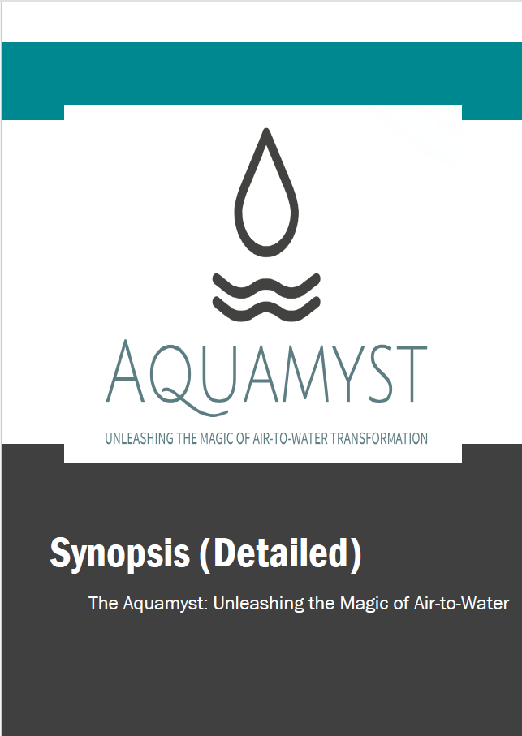

The Aquamyst

Unleashing the magic: Air to Water

**The Aquamyst: Unleashing the Magic of Air-to-Water Transformation**

**Thakur Rudra Pratap Singh**

**1. Introduction and Importance**

Access to clean drinking water is a fundamental human right, yet it remains a pressing challenge in various parts of the world. According to the United Nations, over **2 billion people** globally face water scarcity issues. This crisis demands innovative solutions that balance practicality, affordability, and sustainability.

The **Magical Cup**, or **Aquamyst**, is an ambitious invention designed to address these challenges. Inspired by Atmospheric Water Generators (AWGs), this device integrates cutting-edge technology into a portable, compact form factor that redefines how we perceive and utilize water generation.

Unlike conventional AWGs that are large and stationary, the Aquamyst introduces a **portable and aesthetic solution**, demonstrating how science and technology can intersect with everyday convenience.

**2. Problem Statement and Need Analysis**

**Global Water Scarcity**

* **Statistics:**
  + **One in three people** globally lacks access to safe drinking water.
  + By **2025**, half of the world's population is projected to live in water-stressed areas.
* **Arid Regions:** Communities in deserts or remote areas often depend on expensive water transportation or limited natural sources.

**Existing AWGs**  
While atmospheric water generators are groundbreaking, they:

1. Require high energy consumption.
2. Are bulky and immobile.
3. Depend on specific environmental conditions.

The **Magical Cup** addresses these issues by providing an accessible and compact solution that transforms air into water with lower energy demands, ensuring portability and affordability.

**3. Design and Engineering of the Magical Cup**

The Magical Cup is not merely a theoretical concept but a well-thought-out design that integrates the following core components:

1. **Air Inlet:** Allows air to flow into the system.
2. **Cooling Chamber:** Lowers air temperature to facilitate condensation.
3. **Condensation Plates:** Extract moisture by cooling air below the dew point.
4. **Filtration Unit:** Purifies the collected water to ensure it meets potable standards.
5. **Storage Compartment:** Holds purified water.

**Innovative Design Features:**

* **Portability:** Compact and lightweight, making it easy to carry.
* **Energy-Efficient:** Utilizes renewable energy sources like solar power for operations.
* **Aesthetic Appeal:** Designed to blend functionality with elegance, appealing to a broad audience.

**4. Working Mechanism in Detail**

The Magical Cup works on **three fundamental principles**:

**a) Cooling and Condensation**  
The system draws in ambient air through the inlet, directing it into a cooling chamber. Using advanced thermoelectric coolers, the chamber cools the air below its dew point, causing water vapor to condense into droplets.

**b) Filtration Process**  
The water droplets pass through a multi-layered filtration system, including:

* **Carbon Filters:** Remove impurities and odour.
* **UV Sterilization:** Eliminates bacteria and pathogens.

**c) Storage and Dispensation**  
The purified water is stored in an internal chamber and can be dispensed through a tap integrated into the cup's design.

**5. Innovative Features**

* **Miniaturization of AWG Technology:** Adapting AWG technology into a portable cup form is a significant leap.
* **Renewable Power Integration:** Incorporates solar cells to power the cooling and filtration systems, reducing dependency on external electricity.
* **Self-Cleaning Mechanism:** Ensures hygiene by using UV light to sterilize the internal components periodically.

**6. Advantages Over Existing Solutions**

| **Feature** | **Conventional AWGs** | **The Magical Cup** |
| --- | --- | --- |
| **Size and Portability** | Bulky and stationary | Compact and portable |
| **Power Requirements** | High | Low, with solar integration |
| **Accessibility** | Expensive and complex setup | Affordable and user-friendly |

**7. Challenges and Limitations**

While the concept is revolutionary, it faces certain limitations:

* **Environmental Dependency:** Performance varies with humidity and temperature levels.
* **Water Output:** Limited to small quantities due to size constraints.
* **Energy Efficiency:** Achieving optimal energy consumption in compact devices remains a challenge.

**8. Proposed Applications and Use Cases**

1. **Emergency Relief Operations:** Ideal for disaster-stricken areas where water access is disrupted.
2. **Military and Exploration:** Compact size makes it suitable for soldiers and adventurers in remote locations.
3. **Urban Use:** Provides a sustainable solution for individuals in water-stressed urban zones.

**9. Sustainability and Environmental Impact**

The Aquamyst emphasizes sustainability through:

1. **Energy Efficiency:** Use of renewable energy reduces environmental impact.
2. **Reduced Plastic Waste:** Eliminates dependency on bottled water.
3. **Carbon Neutrality:** Designed to operate with minimal carbon emissions.

**10. Future Scope and Enhancements**

The Magical Cup opens avenues for further advancements:

* **Enhanced Efficiency:** Research into advanced materials and cooling systems to increase water output.
* **Smart Integration:** IoT-enabled features for performance monitoring and optimization.
* **Mass Production:** Scaling up to reduce costs and improve accessibility.

**11. Conclusion**

The **Magical Cup** represents a harmonious blend of innovation, sustainability, and practicality. By transforming the air we breathe into potable water, this invention offers a glimpse into a future where access to clean water is no longer a privilege but a universal right.

As we continue to refine and develop this concept, the Magical Cup promises to revolutionize water generation, providing hope and sustenance to millions in need. It stands as a beacon of human ingenuity, reminding us that even the most daunting challenges can be addressed with creativity and determination.

