RISK AND COUNTERMEASURES OF ARTIFICIAL INTELLIGENCE FOR COLLEGE STUDENT’S GROWTH

***Diksha Kumawat1, Girdhari Lal Sharma2***

*1Student, Department of Artificial Intelligence, Poornima Institute of Engineering and Technology, Jaipur, India*

*2Assistant Professor, Department of Artificial Intelligence, Poornima Institute of Engineering and Technology, Jaipur, India*

# Abstract

**Keywords**: artificial intelligence, translation skills, translator education, challenges,opportunities.

*All trades and professions have felt the influence of the rapid advancement of artificial intelligence in the twenty-first century. The translation sector is particularly noteworthy; it has experienced even greater effects than many othersWhile artificial intelligence has brought into this industry a plethora of new opportunities for growth, it has also brought unprecedented challenges.Students majoring in translation have to deal with structural changes that machine translation has imposed on the field of language services. In these times of change, the need for improving students' skills with translation technology must be clearly understood by educators. Consequently, this paper discusses the prospects and challenges of developing college students' translation technology skills in the context of artificial intelligence and ways to effectively tackle these prospects and challenges. Research shows that the major issues in cultivating students' translation skills in the face of the emergence of artificial intelligence are ethical and resource competition.*

# Introduction

* 1. *Overview of AI in Translation Technology*

artificial Rapid progress of artificial intelligence in the 21st century has also affected the translation industry quite a lot. With time, AI technologies have upgraded the technical aspects of the translation process and the efficiency of the translation. But translation technology training forms the essential element for acquiring the translation skills. With AI dominating more and more today, the fear is of how translators' creativity and subjectivity are being minimized.

* 1. *Motivation and Objective*

This research paper is motivated to discuss the challenges and opportunities presented by AI in translation technology, particularly within education. It seeks to determine strategies that integrate AI use without compromising the creativity aspects of human translators. Among the things is building high-quality translation technology skills within college students so they can get an idea about how much it is a must to work with AI tools but at the same time maintaining cultural and linguistic nuances.

* 1. *Significance of the Study*

This research is significant in the need for balance in translation education between technology training and linguistic skills. It provides insights into curricula that meet industry requirements while improving students' technical capabilities and creativity.

# .2.Requirements

* + 1. *Integration of Critical Thinking Exercise*

Design curriculum elements that challenge students to perform tasks in which they must analyze and evaluate AI outputs. This will enable the development of analytical skills as well as the recognition of the strengths and weaknesses of AI translations.

* + 1. *Emphasis on Cultural Competency Training*

Add training modules to educate students on cultural context, idiomatic expressions, and nuances of language usage. This way, the students will be able to complement AI translations with insights on cultural context that may elude machines.

* + 1. *Promotion of Creativity through Hands-On Projects* Design projects that combine AI help with creative problem- solving involving students experimenting with different translation approaches, thus fostering creativity and innovation.

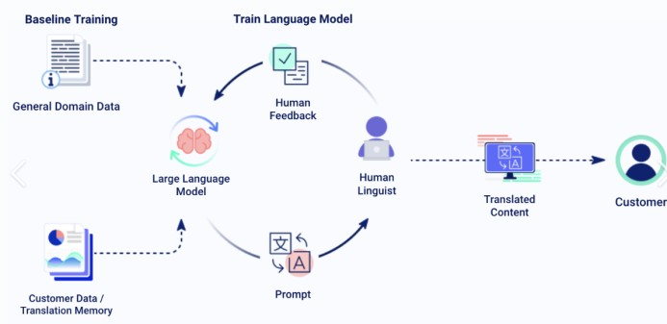

Fig. 1 Machine Translation Process

# College English Educating Mode and Discourse Acknowledgment Show Strategy Based on Profound Learning and Manufactured Insights

* 1. *Artificial Intelligence and Deep Learning*

Artificial Intelligence (AI) is an within computer science that emulates human cognitive functions . It draws knowledge from a variety of fields. As depicted in Figure 2, AI encompasses disciplines such as mathematics, philosophy, computer science, psychology, and cybernetics, along with cognitive science, information theory, and others, reflecting its interdisciplinary nature. This indicates that AI technology is built upon extensive theoretical insights from various domains as well as temporal analysis. The collaborative impact of different areas has contributed to the wide application of AI, outlined in Figure

1. This figure highlights a few zones where AI innovation is utilized, such as neural systems, machine learning, complex frameworks, cleverly look, common dialect handling, and design acknowledgment

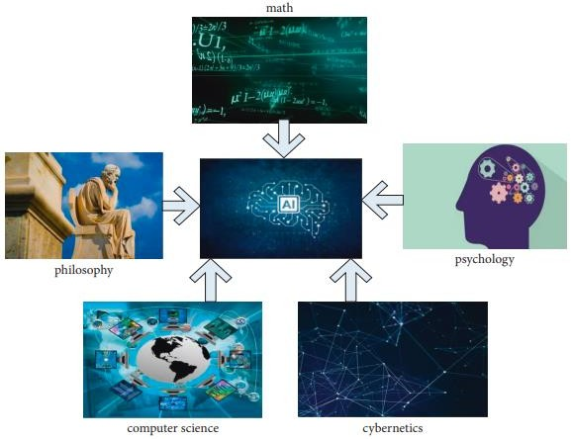

. Fig. 2 Machine Translation Process

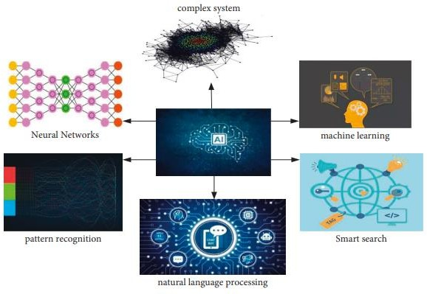

Fig.3 AI-Applications Areas

*3.2DeepLearning*

Deep learning is a sophisticated method for algorithmic data analysis using neural network models. The fundamental principle of deep learning involves continuously updating parameters during training, allowing the model to progressively refine the features of the analyzed data from low- level to high-level through layer-by-layer operations. Ultimately, the model classifies and outputs these features.

*3.3. BP Neural Network*

The BP (Backpropagation) neural network is a supervised algorithm model that can transmit information forward and propagate errors back through layer training.

The preparing approach essentially spins around comparing the specified yield from the preparing dataset with the genuine yield to calculate the mistake esteem The organize continually adjusts its preparing parameters to play down this blunder, in this way building up the utilitarian relationship between the input and output in stage. Amid the forward proliferation of data, we are able signify the input esteem at the ath hub inside the covered up layer as Aa. The input flag for the direct change is spoken to by Sc, and ωac indicates the association weight between the ath hub and the cth hub of the covered up layer. In conditions (1) and (2), x alludes to the number of input hubs. The exchange among these factors is enunciated as takes after:

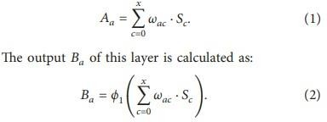

Assuming that the input to the r-th node in the output layer is denoted by Rr, the output of that layer is denoted by Br. The variable y in equations (3) and (4) indicates the number of nodes in the hidden layer. According to the aforementioned computational principles, the equations for these two values can be obtained from equations (3) and (4).

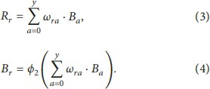

Here, ϕ represents the activation function, with the subscript 1 indicating the activation function for the hidden layer and the subscript 2 representing the activation function for the output layer.

During the backpropagation of errors, the function expression for calculating the error must first be defined, after which the error value for each training layer is computed using the error

function. Gradient descent is continuously adjusted to minimize this error. Assume the total number of input samples in the training set is L and the sample indices are from 1 to L. When the Lth sample enters the training process, and the actual output value is B^L*r and the target output value is M^L*r, the calculation error for the Lth sample is:

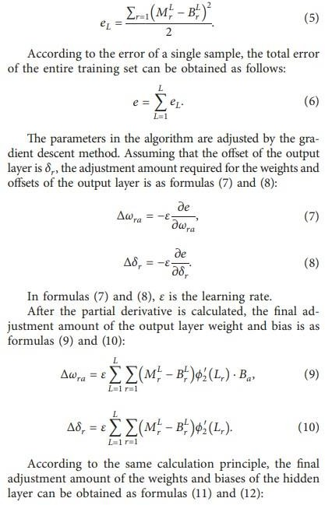

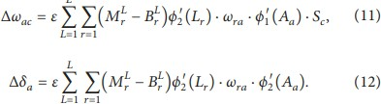

* 1. *Restricted Boltzmann Machine (RBM)*

A Restricted Boltzmann Machine (RBM) is a further development of a Boltzmann Machine (BM). The main difference between the two is that in an RBM, nodes in the same layer are independent of each other, whereas in a BM, nodes in the same layer are interconnected.**.**The RBM improves upon the BM by minimizing the connections

between nodes in the same layer, thereby saving considerable computational time.

Let F represent the total number of visible layer nodes and G denote the total number of hidden layer nodes. The energy function of the RBM can be expressed as follows:

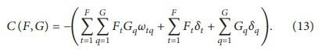

Assuming that the state of the visible layer nodes is known, the activation probability of the hidden layer nodes can be derived as follows:

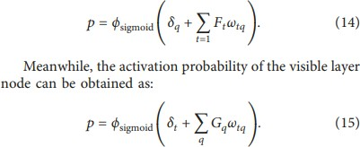

* 1. *Deep Belief Network(DBN)*

A deep belief network (DBN) consists of multiple Restricted Boltzmann Machine (RBM) layers followed by layers of backpropagation (BP) neural networks. The output of each RBM layer serves as the input of the subsequent RBM layer until the output of the last RBM layer is the input of the BP neural network.

The DBN is trained through a series of RBMs in layers, finally leading to the application of the BP neural network for supervised learning. Many studies have shown that this layered training approach allows DBNs to achieve better global parameters, while the backpropagation of errors in the BP neural network can significantly improve the training accuracy of the entire network. At present, most universities mainly use multimedia technology in teaching English. This has a positive effect on the development of students' listening ability and makes it easier for teachers to explain and practice English sentences.

However, this approach has its limitations; the classroom dynamic still primarily revolves around the teacher, making it challenging for students to engage actively. Additionally, college English classes often have large numbers of students, resulting in minimal communication between students and teachers, and a lack of in-depth understanding of individual students' learning needs.

AI can assist students in organizing their learning materials, helping them identify areas where they need improvement. It also enables teachers to better understand student learning patterns. The workload for the teachers gets reduced by much since it saves time from the manual assessments and gives a clear picture about the mistakes that the student has done. AI, in turn, can make the teaching of subjects more interesting to students, for example, in English language.

# College English Teaching Experiment

* 1. *Dataset*

This study utilized a DBN to evaluate English pronunciation according to an AI-driven evaluation system and compared the outcome with the manual evaluations. Participants comprised 30 junior non-English majors from a normal university, with an equal male to female distribution of 15 males and 15 females.Recordings were made using specialized software. To test the model's recognition accuracy, a dialogue from the third lesson of the first volume of the college English listening textbook was selected. The experimental setup, as shown in Table 3, maintained consistent sampling rates and coding parameters across both groups, with the Mel Frequency Cepstral Coefficients (MFCC) feature parameters standardized to the 13th order.

* 1. *Pronunciation Evaluation Using DBN*

The tasks involved the recording of eight sentences that were formed from common patterns and phrases that are frequently employed in an ordinary spoken conversational English. They employed the Deep Belief Network (DBN) model of neural network in evaluating the pronunciation. The research’s goals concentrated on evaluating the impacts brought about by the increase of the number of hidden layer nodes and the number of layers on the recognition accuracy. Distinct input durations were also accounted for to achieve the most efficient setup. A varied length of speech features needed to embed into fixed sized speech units during speech units embedding explained the data preprocessing procedure. This step was made up of splitting the speech signal into four main segments, and subsequently into smaller parts. Each segment was broken down into four, and these smaller segments were averaged in order to create a mean vector. Compiled these vectors were then agglutinated to form a matrix and the processed speech signal had 16 frames. The eight sentences that were used in the experiment were:Don’t bury your head in the sand.

* + 1. You need to stand your ground.
    2. Thanks, I’m looking forward to working with you..
    3. I had quite a nice time here.
    4. I understand your position.
    5. Not everybody can be satisfied.
    6. Do you think you will enjoy your new place of employment.?
    7. One reaps what one sows.
  1. *Experiment Results*

*4.3.1 Test Results*

The experiment examined how the number of hidden layers and nodes in the configurations influenced the performance of the model as shown in Figure 9.The results showed that increasing the number of hidden nodes generally led to a lower error rate, improving the model's ability to accurately recognize and evaluate pronunciation. The analysis also revealed that longer input durations enhanced the recognition

accuracy, likely because short segments did not provide enough context for effective understanding.

However, simply increasing the number of hidden nodes did not always lead to significant improvements for longer sequences. For shorter sequences, adding more hidden nodes proved to be beneficial.

Regarding the number of hidden layers, increasing the count did not always yield better accuracy. The data suggested that there is an optimal number of hidden layers where the model performs best, depending on the length of the time series. For shorter time-series data, the model achieved the lowest error rate with six hidden layers, while for slightly longer sequences, the best performance was achieved with four hidden layers.

The lower the model's error rate, the higher the training accuracy, leading to more precise recognition and evaluation of pronunciation. The choice of time series duration also affects recognition performance. Data from Figure 4 shows that longer time series improve the model's training results, likely because short segments fail to capture the full meaning of a sentence, which hinders accurate recognition. While increasing the number of hidden nodes does not significantly enhance performance for longer sequences, it does improve recognition for shorter time series. Overall, adding more hidden nodes tends to improve the model's recognition accuracy for both short and long time series.

However, simply increasing the number of hidden layers does not always lead to better training accuracy. The trend in Figure 4 indicates that, for both long and short sequences, there is an optimal number of hidden layers that maximizes performance. For short time series, six hidden layers yield the lowest error rate, while for slightly longer sequences, the best results are achieved with four hidden layers.

The analysis of the test results confirms the validity and feasibility of the model used in this study, showing that training accuracy is also influenced by the selected voice data. Therefore, the study will choose the optimal combination of parameters based on these findings.

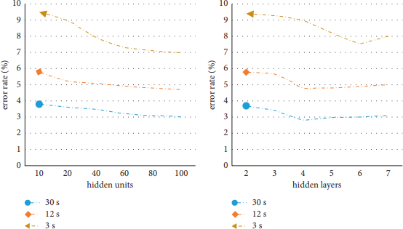

Fig.4 : Influence trend of hidden layer parameters

# Conclusion

In this article, we introduce a model of teaching English in higher education using AI and develop an English pronunciation evaluation system using a Deep Belief Network (DBN). The effectiveness of this evaluation system was tested through an experiment in which participants with no English proficiency participated in the evaluation of pronunciation quality. In this study, we compared and analyzed the match rate and adjacent match rate between manual evaluation and the machine evaluation model developed in this study. The results showed that the AI pronunciation evaluation method was almost consistent with the human evaluation results.

Addressing current challenges in college English education, such as teacher shortages, limited evaluation methods, and the lack of student engagement and spoken English activities, this study suggests that AI and Internet-based technologies can help overcome these issues. The experiment on English pronunciation evaluation demonstrated the effectiveness of this approach, indicating its potential to enhance English teaching practices.

# References

1. Z. Wen, B. Wang, D. Coniam, and B. Xie, "Calibrating the CEFR with China English Standards for English vocabulary teaching in Chinese higher education institutions," Language Testing in Asia, vol. 7, No. 1, pp. 1-18, 2017.
2. X. Li, "Characteristics and rules of university English teaching based on the simulation of cognitive processes," Cognitive Systems Research, vol.
3. J. Gong, "Innovative Approaches to English Language Teaching in Higher Education in the New Media Environment," Boletin Tecnico/Technical Bulletin, Vol. 55, No. 13, pp. 449-455, 2017.
4. Z. Nie, "Study on the application of training modes to English teachers in universities in the Internet+ era," Boletin Tecnico/Technical Bulletin, Vol. 55, no. 11, pp. 504-511, 2017.
5. K. Liu, "An Empirical Study on English O2O Education System in Higher Education Based on MOOC Training," Revista de la Facultad de Ingenieria, vol. 32, no. 14, pp. 784- 789, 2017.
6. Y. Hao and J. Su, "A Study on the Flipped Classroom Teaching Model of University English Considering Educational Information," Revista de la Facultad de Ingenieria, Vol.
7. Y. Zhang, "Improvement and optimization of functional modules of university English distance education based on intercultural theory," Revista de la Facultad de Ingenieria, vol. 32, No. 15, pp. 174-177, 2017. 32, no. 14, pp. 41–46, 2017.
8. C.J. Lin, "An Online Peer Assessment Approach to Support Mind Mapping Flip Learning Activities in University English Writing Courses," Journal of Computers in Education, Vol. 6, No. 3, pp. 385-415, 2019.
9. M. Ravanelli, P. Brakel, M. Omologo, and Y. Bengio, “Light-controlled recurrent units for,speech

recognition,”,IEEE Transactions on Emerging Topics in Computational Intelligence,, vol. 2, S. 92–102, 2018.

[10] R. Yazdani, A. Segura, and J. 1, pp. 2171-2175, 2014. M. Arnau and A. Gonzalez, "Low-power automatic speech recognition using mobile GPUs and Viterbi accelerators," IEEE Micro, vol. 1, pp. 2171-2175, 2014. 22–29, 2017.,

,[11] E. Pakoci, B. Popovic, and D.J. Pekar, "Improving Serbian Speech Recognition Using Sequence-Trained Deep Neural Networks," SPIIRAS Proceedings, Vol. 3, No. 58, p. 53, 2018.

[12] W. Bo, K. Li, F. Ge, et al., "An end-to-end deep learning approach to simultaneous phonetic cloning and acoustic modeling for robust speech recognition," IEEE Journal of Selected Topics in Signal Processing, Vol. 11, No. 8, 2016. S. 1289–1300, 2017.,

,[13] P. Glauner, J. A. Meira, and,P. Valtchev, R. State, and F. Bettinger, "Challenges of Non-Technical Loss Detection Using Artificial Intelligence: A Survey," International Journal of Computational Intelligence Systems, Vol. 10, No. 1, pp.

135-142. 760, 2017.

1. P. Havea, N. Meratnia, and M. Bahrepour, "AI-based event detection in wireless sensor networks," University of Twente, vol. 85, no. 6, S. 1553–1562, 2017.
2. L. Caviglione, M. Gaggero, J. F. Lalande, W. Mazurczyk, and M. Urbanski, “Uncovering hidden,communications of mobile malware via energy consumption and AI,”,IEEE Transactions on Information Forensics and Security,, vol. 11, Nr. 4, S. 799–810, 2017.
3. D. Hassabis, D. Kumaran, C. Summerfield, and M. Botvinick, “Neuroscience-inspired artificial intelligence,” Neuron, Vol. 95, No. 2, p. 245–258, 2017.