ERROR EFFECT AND CONTROL SYSTEM RESPONSE IN PID CONTROLLED KILNS

1 Elisha. A Joseph and 2 Suraju A. Fadare

1,2Department of Electrical/Electronics Engineering, The Federal Polytechnic, Ilaro Ogun State, Nigeria.

E-mail: 1 elisha.joseph@federalpolyilaro.edu.ng; 2 suraju.fadare@federalpolyilaro.edu.ng

Abstract

A resounding clinker must be the output of a modern kiln system. In order to achieve this, the kiln room must be well controlled. This state of the art control depends on the state of the error. In a layman’s language, error is a departure of the output from the input. Control wise, error entails the departure of the process variable, PV, (output of plant) from the set-point, SP, (input desired value), as well as the environment impact force. The error in control was well corrected in order to combat the errors caused by conduction, convection and radiation, regardless of the control system. The utilized methodology was based on the ideology of error/error change to the determination of the temperature response of the kiln using a PID controller. It could be observed that at Error 1, kiln response equals 450 oC, at Error 2, kiln response equals 900 oC, and at Error 3, kiln response equals 1250 oC. The unit step in error indicated a remarkable increasing effect in the kiln response (Table 1). Also, a constant change in error (0.2) at 1.4, 1.6 and 1.8 gave unique equal value difference of 450 oC in between error change (Table 2). This research work finds application in thermal control firms.

Keywords: Control Response; Change in temperature; Error; Error effects; kiln; PID controller.

Introduction

The role of error in control system cannot be over-emphasized, it is a fundamental component required by a control system to drive its field elements to achieve its proposed target (Dahleh et al., 2011; Liu et al., 2020; Schleicher and Blasinger, 2013; Vinay Kumar et al., 2022). Ordinarily, error is the departure of the output from the input source. Control wise, error entails the dissension in terms of process variable (PV) and the set-point (SP), as well as environment impact force. The error in control must be corrected in order to combat the errors caused by conduction, convection and radiation, regardless of the control system (Liu et al., 2020; Phan et al., 2024; Yan et al., 2001; Zhang, 2017). An automatic controller compares the actual value of the plant output with the reference input (desired value), determines the deviation, and produces a control signal that will reduce the deviation to zero or to a small value (Dahleh et al., 2011; Schleicher and Blasinger, 2013; Yan et al., 2001). The way an automatic controller generates the control signal is regarded as the control action.

Control system could be applied in the modification of the operation of a system to align to a specific desirable way with time (Nagrath & Gopal, 2013). This could be related to the control of temperature in a cement kiln, in order to produce a good quality clinker. The baking temperature must be within the required temperature range of 800 oC - 1450 oC (Karstensen, 2007). This temperature range is maintained by the action of the control system, without human intervention, based majorly on the internal error. This work tends to look into the effect of error in control system.

Review of Related Works

Boles & Could (1972) ascertained the history of a single error, with their investigation giving a most successful outcome by promise. This work also relates about the effect of error in system control. Going about the modern kiln control, the kiln environment must be well controlled (Liu et al., 2020; Phan et al., 2024; Yan et al., 2001; Zhang, 2017). This state of the art controller, such as PID depends on the state of the error (Getu, 2019; Pekh et al., 2023; Schleicher and Blasinger, 2013; Wang, 2020; Yan et al., 2001). Proportional-Integral-Derivative (PID) controller primary function is based on the comparison between the reference input signal and the output signal of the control system to effect control action (Liu et al., 2020; Schleicher and Blasinger, 2013; Wang, 2020; Zhang, 2017). The difference is the error signal which is the basis on which the controller depends on for its required performance (Ogata and Brewer, 2010; Schleicher and Blasinger, 2013; Wang, 2020). PID controller could be described as a controller whose idea is to take the present, the past, and the future of the error into consideration. It detects the actuating error signal, at a low power level, amplifies it to a high level. Consequently, this high level signal is fed to an actuator which is a device that produces the input signal to the plant according to the control signal in order to ensure that the output signal approaches the reference input signal.

In the kiln thermal control system, the temperature sensing device measures the process variable in the kiln and is fed to the error detector (Liu et al., 2020; Phan et al., 2024; Yan et al., 2001; Zhang, 2017). The SP and PV are compared, to give an actuating signal (Error) to control the gas solenoid valve. This outputs a linear motion of the valve stem, which adjust the flow of gas to the burner of the gas fire. Usually, this error defines the behavioural control (temperature response) of the internal burning temperature of the kiln. PID controller is a type of controller that incorporate human interference to enhance its performance (Joseph, 2017). Therefore it can be deployed for electronic controlled kiln.

Methodology

In order to analysis the work, a graphical user interface (GUI) of Matlab® Simulink was used for the simulation system as depicted in Figure 1. PID controller was exploited to approach the dynamic control of the error signal. Equation (1) display the PID compensator configuration utilized for the kiln control.

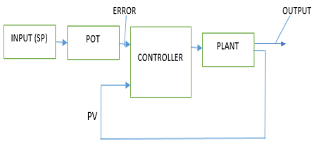

Figure 1: Error Effect in Industrial Temperature Control System

$P+\frac{I}{S}+D\frac{N}{\frac{S+N}{S}}$ (1)

Note: the initialization values of the PID parameters are P = 1, I = 1, D = 0, N (the filter coefficient) = 100. Furthermore, the after turning values for the PID are P= 0.54, I= 0.09, D = -0.23 and N = 0.32.

Results and Discussion

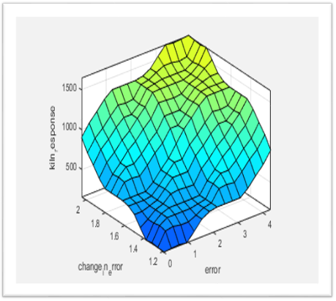The obtained results via simulation of the system are shown in Figure 2, Figure 3 and Figure 4.

Figure 2: Rule Base for the Three Parameters

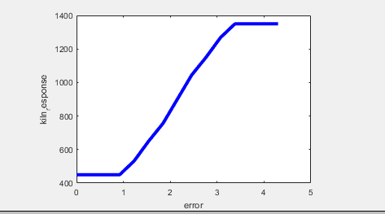

Figure 3: Kiln Response versus Error

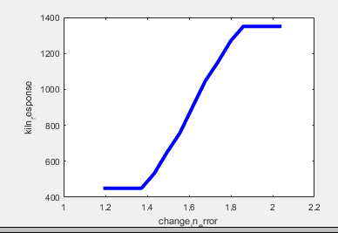Figure 4: Kiln Response versus Change-in-Error

Table 1 displays the result of analysis of the graph depicted by Figure 3.

Table 1: Kiln Response Versus Error

|  |  |
| --- | --- |
| Error | Kiln Response oC |
| 1 | 450 |
| 2 | 900 |
| 3 | 1250 |
| 4 | 1350 |

Table 2 displays the result of analysis of the graph depicted by Figure 4.

Table 2: Kiln Response versus Change-in-Error

|  |  |
| --- | --- |
| Change in Error | Kiln Response oC |
| 1.4 | 450 |
| 1.6 | 900 |
| 1.8 | 1350 |

Figure 2 shows the surface of the rule base for kiln temperature, the change-in-error and the error in the system control. Figure 3 and Table 1 indicate that as the error increases in step of one (1), the actuating signal or voltage increases, thereby causing an increase in the plant (Kiln) response. So, this effect could be an increase in the kiln temperature, as the error or actuating voltage increases.

Furthermore, in Figure 4 and Table 2, the change in error is 0.2; a constant figure. This resulted to a constant change in the kiln response, as shown in Table 2. When the change in error is 1.4, the kiln response is 450 oC; at 1.6, it is 900 oC. Therefore, the difference between these two is 900 oC – 450 oC = 450 oC. In addition, at 1.8, the kiln response is 1350 oC, so, the difference between 1.8 and 1.6 is, 1350 oC – 900 oC = 450 oC. Thus, change in error (which is constant) leads to a constant error, which causes the same amount of deviation in one direction only. The results is not like random error whose measurements deviate by varying amounts, which may either be higher or lower than their real values.

Conclusion

Conclusively, control system allows modification of control system behaviour in all ramification in respect to an actuating signal, the error. This entails the refinement of the difference between two signals (PV and SP), to give the said signal called error. The effect of the error was the major concern in this research work. It was observed that one of the effects of the error in the control system analysis is the response of the system in contention was an increase. Similarly, in another vein, (though there is an increase in the linage) there was a remarkable equal change in the progressive line of its response. Summarily, the research work contributed to knowledge by establishing the fact that the unit step in error show a remarkable increase effect in the kiln response, to give a remarkable quality product and product cost. This knowledge is applicable in production of a dynamic control kiln system using PID controllers.

References

Boles, S.J. and Could J.D. (1972). A Behavioral Analysis of Programming on the Frequency of Syntactical Errors. *IBM Research, Yorktown Heights*, N.Y., RC-3907.

Dahleh, M. M. A., Dahleh, M. M. A., and George Verghese. (2011). 6.241J Lectures on Dynamic Systems and Control. *Massachusetts Institute of Technology*. https://web.mat.upc.edu/carles.batlle/ioc17013/MIT_6.241/chapter_2.pdf

Getu, B. N. (2019). Tuning the Parameters of the PID Controller Using MATLAB. *ARPN Journal of Engineering and Applied Sciences*, *14*(Special Issue 8). https://doi.org/10.36478/JEASCI.2019.2538.2545

Joseph, E. A. (2017). Developed Fuzzy-PID Temperature Controller for Cement Industry. *LAP Lambert Academic Publishing*, Germany.

Karstensen, K. H. (2007). Cement Production Technology in South Africa and an Evaluation of their ability to co-process AFRs and Treat Hazardous wastes, *Report to the National Policy on High Temperature Thermal Waste Treatment and Cement Kiln Alternative Fuel Use*, No. 66011-xx.

Liu, R., Hu, E. D., Zhu, Z., Mao, L., and Ma, Z. (2020). Study on temperature control system of ceramic kiln based on fuzzy PID cascade. *Proceedings of 2020 IEEE 4th Information Technology, Networking, Electronic and Automation Control Conference, ITNEC 2020*. https://doi.org/10.1109/ITNEC48623.2020.9085049

Nagrath, I. J & Gopal, M. (2013). *Control System Engineering*, 4th Edition, New Age.

Ogata, K., and Brewer, J. W. (2010). Modern Control Engineering(5th Edition). In *Pearson*. New York

Pekh, P., Khrystynets, N., Gubysh, R., and Shulgach, V. (2023). Simulation of two-stage temperature regulation system. *COMPUTER-INTEGRATED TECHNOLOGIES: EDUCATION, SCIENCE, PRODUCTION*, *53*. https://doi.org/10.36910/6775-2524-0560-2023-53-08

Phan, V. Du, Nguyen, X. H., Dinh, V. N., Dang, T. S., Le, V. C., Ho, S. P., Ta, H. C., Duong, D. T., and Mai, T. A. (2024). Development of an Adaptive Fuzzy-Neural Controller for Temperature Control in a Brick Tunnel Kiln. *Electronics (Switzerland)*, *13*(2). https://doi.org/10.3390/electronics13020342

Schleicher, M., and Blasinger, F. (2013). Control Engineering a guide for beginners. In *Journal of Chemical Information and Modeling* (Vol. 53, Issue 9).

Vinay Kumar, C. H., Rao, G. M., Raghu Ram, A., and Prasanna Kumar, Y. (2022). Designing of Neuro-Fuzzy Controllers for Brushless DC Motor Drives Operating with Multiswitch Three-Phase Topology. *Journal of Electrical and Computer Engineering*, *2022*. https://doi.org/10.1155/2022/7001448

Wang, L. (2020). PID Control System Design and Automatic Tuning using MATLAB/Simulink. In *PID Control System Design and Automatic Tuning using MATLAB/Simulink*. https://doi.org/10.1002/9781119469414

Yan, G. C. K., De Silva, C. W., and Wang, X. G. (2001). Experimental modelling and intelligent control of a wood-drying kiln. *International Journal of Adaptive Control and Signal Processing*, *15*(8), 787–814. https://doi.org/10.1002/acs.656

Zhang, J. (2017). Research on the design of ceramic kiln control system based on PID. *Chemical Engineering Transactions*, *59*. https://doi.org/10.3303/CET1759119