OPTIMIZING INDOOR AIR QUALITY IN AIR-CONDITIONED ENVIRONMENTS
Dr.S.Lakshmi Kanthan Bharathi¹, P.Sujidha², Dr.G.Vijayasri³

¹Associate Professor, Department of Electrical and Electronics Engineering, Mohamed Sathak Engineering College, Kilakarai, Tamilnadu, India.
²Assistant Professor, Department of Electrical and Electronics Engineering, Mohamed Sathak Engineering College, Kilakarai, Tamilnadu, India.
³Associate Professor, Department of Physics, Mohamed Sathak Engineering College, Kilakarai, Tamilnadu, India.

ABSTRACT
Maintaining optimal indoor air quality (IAQ) in air-conditioned environments is critical for ensuring occupant health, comfort, and productivity. This study explores advanced strategies and technologies to improve IAQ in residential, commercial, and industrial settings where air conditioning systems are integral. The research evaluates the role of ventilation, filtration, and humidity control in mitigating airborne pollutants such as particulate matter, volatile organic compounds (VOCs), and biological contaminants. Innovative approaches like smart sensors, real-time monitoring, and integration of air purification systems with HVAC frameworks are examined. Additionally, the study considers the impact of design factors, such as airflow patterns and material selection, on IAQ optimization. By addressing energy efficiency alongside air quality, this research aims to provide a comprehensive framework for enhancing indoor environments sustainably. Findings from this study offer actionable insights for building designers, facility managers, and policymakers to promote healthier indoor ecosystems.
Keywords:,Indoor Air Quality (IAQ),Air-conditioning systems,HVAC (Heating, Ventilation, and Air Conditioning), Airflow optimization, Smart sensors.
- INTRODUCTION
The Indoor air quality (IAQ) plays a critical role in maintaining the health, comfort, and productivity of individuals in air-conditioned environments. With increasing reliance on air conditioning systems in homes, offices, and public spaces, ensuring clean and breathable indoor air has become more important than ever. Poor IAQ can lead to adverse health effects, including respiratory problems, allergies, and the spread of airborne diseases, as well as reduced cognitive performance and overall well-being..

This project explores strategies for optimizing IAQ in air-conditioned settings, focusing on identifying common pollutants, assessing ventilation effectiveness, and implementing advanced air filtration and monitoring technologies. By addressing the challenges associated with IAQ, this study aims to develop practical solutions that balance energy efficiency with improved air quality, fostering healthier indoor environments for all occupants.

- EXISTING SYSTEM
An existing system for optimizing indoor air quality in air-conditioned environments typically includes several components and methods aimed at maintaining a comfortable, healthy, and energy-efficient atmosphere. Here's a breakdown of how such systems function:

2.1.HVAC Systems
Heating, Ventilation, and Air Conditioning (HVAC) systems are the backbone of maintaining indoor air quality.These systems regulate temperature, humidity, and airflow while filtering contaminants.

2.2. Air Filters
Filters such as HEPA (High-Efficiency Particulate Air) or activated carbon filters are used to trap dust, pollen, and airborne particles.Advanced systems may use UV-C light or ionization to neutralize pathogens.

2.3. Sensors and Monitoring Devices
Sensors for detecting temperature, humidity, carbon dioxide (CO₂), carbon monoxide (CO), volatile organic compounds (VOCs), and particulate matter (PM2.5/PM10).Monitoring systems provide real-time data on air quality parameters.

2.4.Ventilation Systems
Fresh air intake systems to reduce indoor air stagnation and control pollutant levels.Balanced ventilation ensures proper air circulation and prevents over-pressurization.

2.5.Humidifiers/Dehumidifiers
To maintain ideal indoor relative humidity levels (typically 30–50%).

2.6.Building Management Systems (BMS)
Automated systems for centralized control of HVAC, ventilation, and monitoring systems.These systems optimize energy consumption and maintain indoor air quality.

- PROPOSED SYSTEM
Our proposed system is mainly to overcome the aforementioned problems, as well as provide a provision to visualize the data from the air pollution monitoring system in a graphical and tabular manner. The system is designed to detect various harmful
gases present in air apart from detecting particle pollutants. It also keeps track of the temperature and humidity of the surrounding. The system also provides an alarm so that the user is made aware of the fact that the surrounding air is not safe for living and the user should take necessary actions to help reduce air pollution. This makes it a simple system which effectively provides valuable inputs to the user regarding the air quality.

- PROPOSED SYSTEM DESIGN
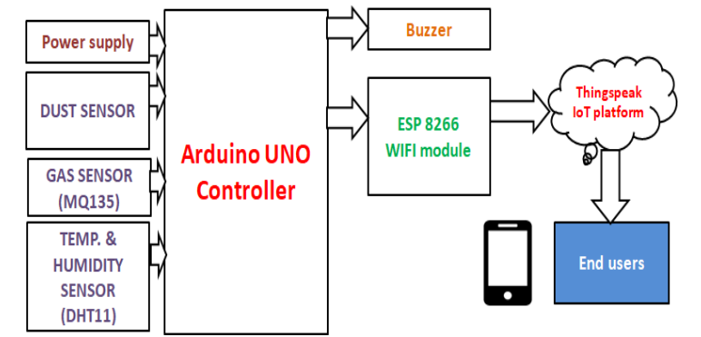
Figure 1. Proposed System
IoT-based air pollution monitoring systems comprise several components that work together to collect and analyze air quality data. The components include:

4.1.Sensors
Sensors are the primary components of IoT-based air pollution monitoring systems. They measure various air quality parameters such as particulate matter, carbon monoxide, sulfur dioxide, and nitrogen oxides. The sensors can be classified into two categories: physical and chemical sensors. Physical sensors measure parameters such as temperature, humidity, and pressure, while chemical sensors measure air pollutants.

4.2.Microcontroller
The microcontroller is the brain of IoT-based air pollution monitoring systems. It receives data from the sensors, processes it, and sends it to the cloud server. The microcontroller is usually a microprocessor such as Arduino, Raspberry Pi, or similar devices.
4.3.Communication Module
The communication module is responsible for transmitting data from the microcontroller to the cloud server. Communication modules can use various wireless technologies such as Wi-Fi, Bluetooth, or cellular networks.

4.4.Cloud Server
The cloud server is a centralized platform for storing, analyzing, and sharing air quality data. It collects data from the communication module and stores it in a database. The cloud server also provides web and mobile applications for users to access the data.

4.5.Power Supply
IoT-based air pollution monitoring systems require a power supply to operate. In case of permanent installations external power supply is provided and batteries are provided for portable devices.

4.6.Enclosure
The enclosure is the outer covering that protects the components from environmental factors such as dust, water, and temperature.

5.MODELLING OF PROPOSED SYSTEM

5.1.System Overview

The system uses IoT devices to collect air quality data (e.g., PM2.5, PM10, CO₂, VOCs, temperature, humidity) and sends it to a central server or cloud platform for processing, analysis, and visualization. MATLAB is used for Data simulation,Algorithm development ,Visualization,Decision-making support.Simulate sensors like gas sensors (CO₂, CO, NO₂), particulate matter (PM) sensors, and temperature-humidity sensors.Use simulated IoT protocols (MQTT, HTTP) for data communication.Process the collected data to identify trends and detect anomalies. Trigger warnings for high pollution levels.Create dashboards for real-time and historical air quality data.

5.2. Develop System Architecture
- Sensors Layer:

Virtual sensors for collecting pollution data.
- Communication Layer:

Simulate wireless communication protocols like Wi-Fi or LoRaWAN.
- Processing Layer:

Use MATLAB for data preprocessing and analytics.
- Visualization Layer:

MATLAB’s plotting tools for real-time dashboards.

5.3. Implementation in MATLAB

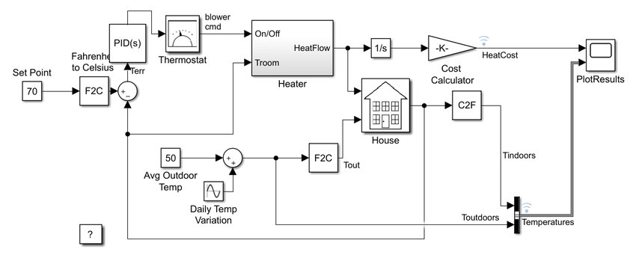
Figure 2. Modeling of air quality monitoring sytem

5.3.1 Simulating Sensor Data

% Simulate sensor readings

time = datetime(2024, 12, 6, 0, 0, 0):minutes(1):datetime(2024, 12, 6, 23, 59, 0);

PM2_5 = 10 + 5 * randn(size(time)); % PM2.5 in µg/m³

CO2 = 400 + 50 * randn(size(time)); % CO2 in ppm

Temperature = 25 + 3 * randn(size(time)); % Temperature in °C

% Ensure data is within realistic bounds

PM2_5 = max(PM2_5, 0);

CO2 = max(CO2, 0);

Temperature = max(Temperature, -10);

5.3.2.Data Processing

Apply filters to remove noise (e.g., moving average or Kalman filters).Detect anomalies based on thresholds or statistical deviations. Remove outliers, noise, and missing values using techniques like outlier detection, smoothing, and interpolation.

Create new features like hourly averages, daily averages, and pollution indices.

5.33.Real-Time Dashboard

% Real-time visualization

figure;

for i = 1:length(time)

subplot(3, 1, 1);

plot(time(1:i), PM2_5(1:i), '-b');

title('PM2.5 Levels');

xlabel('Time'); ylabel('PM2.5 (µg/m³)');

grid on;

subplot(3, 1, 2);

plot(time(1:i), CO2(1:i), '-r');

title('CO2 Levels');

xlabel('Time'); ylabel('CO2 (ppm)');

grid on;

subplot(3, 1, 3);

plot(time(1:i), Temperature(1:i), '-g');

title('Temperature');

xlabel('Time'); ylabel('Temperature (°C)');

grid on;

pause(0.01);

end

5.3.4. Add IoT Features

Simulate data transmission via MQTT or HTTP using MATLAB's ThingSpeak toolbox or similar platforms.

% ThingSpeak Simulation

writeAPIKey = 'YOUR_API_KEY'; % Replace with your API key

channelID = YOUR_CHANNEL_ID; % Replace with your channel ID

% Upload data to ThingSpeak

for i = 1:length(time)

data = [PM2_5(i), CO2(i), Temperature(i)];

thingSpeakWrite(channelID, data, 'WriteKey', writeAPIKey);

pause(15); % Send data every 15 seconds

end

5.3.5 Simulation Outputs

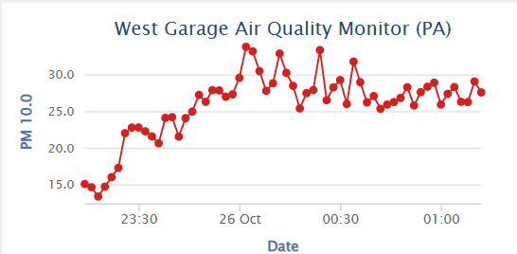
Figure 3. Simulation Results of Air quality monitoring

Use MATLAB's Data Acquisition Toolbox to connect to sensors and acquire real-time data.. Utilize MATLAB's cloud connectivity tools to integrate with cloud platforms like ThingSpeak or AWS IoT Core. Implement alert mechanisms using MATLAB's notification functions or third-party tools.Create user-friendly interfaces using MATLAB's App Designer to monitor and control the system.

6.CONCLUSION
IoT-based air quality monitoring systems represent a significant advancement in environmental monitoring. By leveraging the power of interconnected devices, these systems provide real-time, accurate, and comprehensive data on air pollution levels. This enables informed decision-making, effective policy implementation, and proactive measures to improve air quality and public health. As technology continues to evolve, we can anticipate even more sophisticated and integrated solutions to address the challenges of air pollution.

REFERENCES
- A. Martinez, E. Hernandez-Rodríguez, L. Hernandez, O. Schalm, R. A. González-Rivero and D. Alejo-Sánchez, "Design of a Low-Cost System for the Measurement of Variables Associated With Air Quality," in IEEE Embedded Systems Letters, vol. 15, no. 2, pp. 105-108, June 2023, doi: 10.1109/LES.2022.3196543.
- I. N. K. Wardana, S. A. Fahmy and J. W. Gardner, "TinyML Models for a Low-Cost Air Quality Monitoring Device," in IEEE Sensors Letters, vol. 7, no. 11, pp. 1-4, Nov. 2023, Art no. 6007804, doi: 10.1109/LSENS.2023.3315249.
- S. Al-Eidi, F. Amsaad, O. Darwish, Y. Tashtoush, A. Alqahtani and N. Niveshitha, "Comparative Analysis Study for Air Quality Prediction in Smart Cities Using Regression Techniques," in IEEE Access, vol. 11, pp. 115140-115149, 2023, doi: 10.1109/ACCESS.2023.3323447.
- D. Iskandaryan, F. Ramos and S. Trilles, "Graph Neural Network for Air Quality Prediction: A Case Study in Madrid," in IEEE Access, vol. 11, pp. 2729-2742, 2023, doi: 10.1109/ACCESS.2023.3234214.
- Y. Cao, D. Zhang, S. Ding, W. Zhong and C. Yan, "A Hybrid Air Quality Prediction Model Based on Empirical Mode Decomposition," in Tsinghua Science and Technology, vol. 29, no. 1, pp. 99-111, February 2024, doi: 10.26599/TST.2022.9010060.
- K. S. E. Phala, A. Kumar and G. P. Hancke, "Air Quality Monitoring System Based on ISO/IEC/IEEE 21451 Standards," in IEEE Sensors Journal, vol. 16, no. 12, pp. 5037-5045, June15, 2016, doi: 10.1109/JSEN.2016.2555935.
- K. Chatterjee et al., "Future Air Quality Prediction Using Long Short-Term Memory Based on Hyper Heuristic Multi-Chain Model," in IEEE Access, vol. 12, pp. 123678-123693, 2024, doi: 10.1109/ACCESS.2024.3441109.
- K. Zheng, S. Zhao, Z. Yang, X. Xiong and W. Xiang, "Design and Implementation of LPWA-Based Air Quality Monitoring System," in IEEE Access, vol. 4, pp. 3238-3245, 2016, doi: 10.1109/ACCESS.2016.2582153.
- X. Lin, H. Wang, J. Guo and G. Mei, "A Deep Learning Approach Using Graph Neural Networks for Anomaly Detection in Air Quality Data Considering Spatiotemporal Correlations," in IEEE Access, vol. 10, pp. 94074-94088, 2022, doi: 10.1109/ACCESS.2022.3204284.
- W. Cao, R. Zhang and W. Cao, "Multi-Site Air Quality Index Forecasting Based on Spatiotemporal Distribution and PatchTST-Enhanced: Evidence From Hebei Province in China," in IEEE Access, vol. 12, pp. 132038-132055, 2024, doi: 10.1109/ACCESS.2024.3460187.
- J. Han, H. Liu, H. Xiong and J. Yang, "Semi-Supervised Air Quality Forecasting via Self-Supervised Hierarchical Graph Neural Network," in IEEE Transactions on Knowledge and Data Engineering, vol. 35, no. 5, pp. 5230-5243, 1 May 2023, doi: 10.1109/TKDE.2022.3149815.
- Q. P. Ha, S. Metia and M. D. Phung, "Sensing Data Fusion for Enhanced Indoor Air Quality Monitoring," in IEEE Sensors Journal, vol. 20, no. 8, pp. 4430-4441, 15 April15, 2020, doi: 10.1109/JSEN.2020.2964396.
- M. A. Zaidan et al., "Dense Air Quality Sensor Networks: Validation, Analysis, and Benefits," in IEEE Sensors Journal, vol. 22, no. 23, pp. 23507-23520, 1 Dec.1, 2022, doi: 10.1109/JSEN.2022.3216071.

