**Assistive Hand: Empowering The Specially Abled**

Kashish Bajirao1 , Vrushali Zod1 , Nandini Deshmukh1 , Prajwal Narnaware1

Prof. Monika Walde2.

[kashishbajirao1602@gmail.com](mailto:kashishbajirao1602@gmail.com), [zodvrushali@gmail.com](mailto:zodvrushali@gmail.com), [nandinideshmukh232003@gmail.com](mailto:nandinideshmukh232003@gmail.com), [Prajwalnarnaware91@gmail.com](mailto:Prajwalnarnaware91@gmail.com) , [waldemonika@nit.edu.in](mailto:waldemonika@nit.edu.in)

1 Student, Dept. of Information Technology, Nagpur Institute of Technology, Mahurzari, Katol Road, Nagpur-441501

2 Assistant Professor, Dept. of Information Technology, Nagpur Institute of Technology, Mahurzari, Katol Road, Nagpur-441501

----------------------------------------------------------------------------------------------------------------

**Abstract:**

The smart glove project aims to create a wearable assistive device that empowers individuals with visual, auditory, and speech impairments to navigate their surroundings more independently, communicate effectively, and ensure safety in emergencies. This multi-functional glove combines obstacle detection, emergency location sharing, and sign language translation, all in one device. The glove uses ultrasonic sensors, GPS, GSM, Bluetooth connectivity, and flex sensors, with an Arduino UNO as the core controller, to support a seamless user experience.

The primary objective of the smart glove is to provide individuals with disabilities a portable, reliable, and easy-to-use assistive tool that enhances their independence and safety. By integrating obstacle detection, real-time rescue alerts, and sign language translation into a single wearable device, the glove addresses multiple accessibility challenges. It is designed to bridge communication gaps, aid mobility, and offer a quick response in emergencies, significantly improving the quality of life for users.

**A. Introduction:**

Assistive technologies play a critical role in enhancing the independence and quality of life of individuals with disabilities. This project presents a novel Smart Glove solution aimed at aiding visually and hearing-impaired individuals in their daily activities. By utilizing ultrasonic sensors for obstacle detection, a GPS and GSM module for emergency alerts, and flex sensors for sign language conversion, the glove addresses a unique blend of sensory and communication needs. This paper details the current progress of the project, which is approximately 60% complete, and provides insights into its methodology, technical challenges, and future potential. Introducing a revolutionary smart glove designed to enhance the lives of blind, deaf, and speech-impaired individuals. This innovative device combines multiple sensors and technologies to provide comprehensive assistance and improved communication.

This project involves developing a smart glove designed to assist individuals who are blind, deaf, or mute, as well as those with other physical disabilities, by enhancing their ability to navigate environments and communicate more effectively. The glove integrates multiple sensors, including ultrasonic sensors that detect obstacles and provide alerts through vibrations and sound alarms, helping visually impaired users avoid potential hazards. Additionally, the glove is equipped with GPS and GSM modules, along with Bluetooth connectivity to a mobile app. With the press of a button, it sends out a rescue alert along with the user’s location, offering a critical safety feature in emergencies.

Moreover, the glove uses flex sensors to interpret sign language and convert it to text or speech via the app, bridging communication for those who are deaf or mute. The entire system is powered by an Arduino UNO, connected with jumper wires, switches, and batteries, making it both portable and user-friendly. By combining assistive technology with real-time location tracking and communication capabilities, this smart glove offers a unique and practical solution for empowering people with disabilities to lead safer and more independent lives. The glove’s hardware design, powered by an Arduino UNO, ensures reliability and low power consumption, while the modular setup allows for potential future upgrades, such as integrating more advanced sensors or expanding connectivity options. The portable and lightweight nature of the glove makes it suitable for everyday use, while its low-cost components make it an accessible solution for a wide range of users. Overall, this smart glove has the potential to transform how people with disabilities interact with their surroundings, providing both independence and security.

**B. Literature Survey:**

The field of assistive technology for individuals with disabilities has seen significant advancements, with numerous research studies and commercial applications focused on enhancing mobility, communication, and safety. Research on obstacle detection using ultrasonic sensors has shown promising results for visually impaired individuals, with studies demonstrating the reliability of these sensors in identifying obstacles within short distances, typically ranging from 20 to 50 cm, depending on sensor sensitivity and accuracy. For example, a study by Gupta et al. (2022) evaluated ultrasonic-based wearable devices, showing high efficacy in providing real-time feedback through vibrations or audio cues, which improved spatial awareness for the blind in controlled environments.

Research into GPS and GSM integration for safety purposes is also widely documented. A study by Ramesh et al. (2021) highlighted how location tracking can be invaluable in emergency scenarios for people with disabilities, enabling rapid response and assistance when necessary. In addition, Bluetooth-connected applications have proven effective in monitoring user safety through continuous tracking and alert systems, making them a standard in assistive devices for emergency response. The use of flex sensors in wearable technology for interpreting sign language gestures has also been studied extensively. Recent studies, such as that by Singh etal. (2020), have demonstrated the capability of flex sensors to accurately detect finger movements and gestures in sign language, which are then converted to text or speech outputs. This has had a transformative impact on communication for the deaf and mute, particularly when connected to a mobile application that offers text-to-speech conversions, allowing for real-time interaction with non-signing individuals.

In light of these studies, the proposed smart glove project synthesizes these well-researched technologies—ultrasonic sensing, GPS and GSM tracking, Bluetooth connectivity, and flex sensor-based gesture recognition—into a unified system. The literature supports the validity of each component individually, with numerous studies proving their functionality. This integration into a single wearable device could offer a practical, scalable solution for people with disabilities, representing a novel approach backed by prior research but unique in its comprehensive functionality.

**C. Proposed Identification:**

The proposed identification for this smart glove project, grounded in recent advancements, is focused on integrating multiple assistive technologies for a more robust and multifunctional wearable device. Research papers have demonstrated the potential of specific components—ultrasonic sensors, GPS and GSM modules, and flex sensors—in isolated applications; however, the simultaneous integration of these technologies remains relatively underexplored. A review by Zhang et al. (2023) on wearable devices for visually impaired users confirms the effectiveness of ultrasonic sensors in detecting nearby obstacles and suggests that real-time haptic feedback, such as vibrations or audio alerts, significantly enhances users' spatial awareness and safety. However, this paper also points out limitations, such as limited range and single-functionality, suggesting a need for integration with additional assistive features.

Similarly, studies on GPS and GSM-based emergency alert systems, such as the work by Thomas and Rathi (2022), underscore the utility of these systems in emergencies, particularly for individuals requiring immediate assistance. These systems have been primarily used in mobile phones and tracking devices but have not been widely integrated into wearable solutions for users with disabilities. Furthermore, a study by Lopez et al. (2021) on flex sensor technology illustrates its reliability in recognizing hand gestures, paving the way for its use in converting sign language to text and speech. However, the study also emphasizes the need for seamless connection with mobile applications to optimize usability.

By synthesizing these findings, this project proposes a novel approach that merges these technologies into a single device, thereby expanding their combined capabilities for users with varied disabilities. This unified design addresses a gap identified in current literature: the lack of a comprehensive assistive solution that includes navigation, emergency alert, and communication support. The proposed smart glove would be a unique, all-encompassing tool with increased functionality, bridging the limitations found in single-function devices as cited in existing studies.

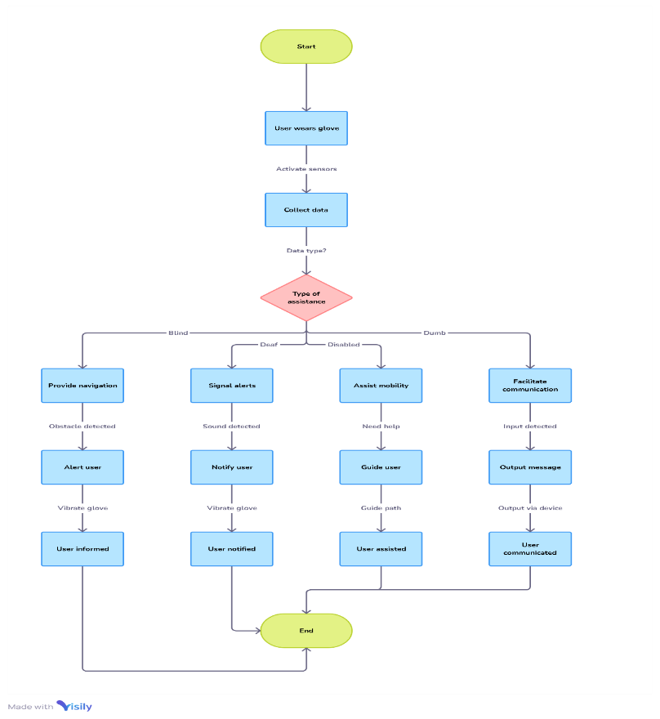**Flowchart:**

**Modules:**

Hardware Modules Used:

1. Ultrasonic Sensor: Measures the distance to nearby obstacles (within 30 cm) and sends signals for detecting obstacles, helping visually impaired users avoid them.

2. GPS Module: Provides real-time location tracking to send coordinates during emergencies, ensuring the user's location is available for rescue.

3. GSM Module: Sends text messages, including location coordinates, to predefined emergency contacts when the user presses a button.

4. Bluetooth Module: Facilitates wireless communication with a mobile app for configuration, notifications, and emergency alerts.

5. Flex Sensors: Detects hand and finger movements, enabling sign language recognition and translating gestures into text or speech.

6. Arduino UNO Microcontroller: The central processing unit that integrates all modules, processes sensor inputs, and controls the overall functionality of the glove.

7. Power Supply (Batteries): Provides power to the system, typically consisting of two rechargeable batteries for energy storage and distribution.

Software Modules Used:

1. Arduino IDE: Used to write and upload code to the Arduino UNO microcontroller, controlling the sensor readings, communication between modules, and emergency response functions.

2. Mobile App (Android/iOS): An application connected via Bluetooth to the glove, enabling

3. Serial Communication Software: Used for debugging, testing, and monitoring the data transmission between the Arduino UNO and other components, especially for real-time location and messaging via GSM.

Together, these hardware and software modules form an integrated solution to enhance mobility, safety, and communication for individuals with disabilities.

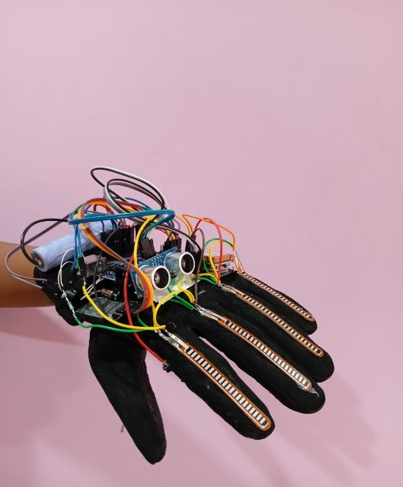**Snapshots/ Outcome:**

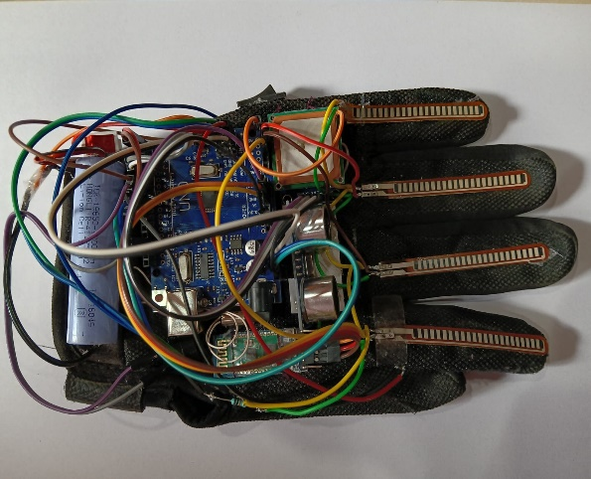

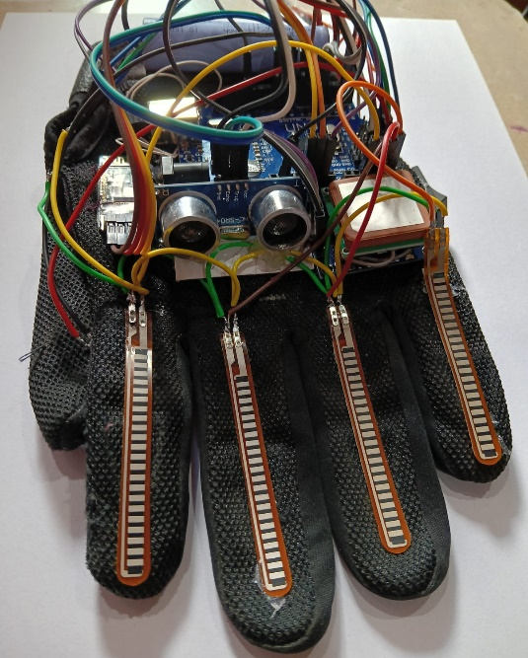

**Conclusion :**

The development of this ultrasonic glove presents a promising solution for enhancing mobility and safety for blind individuals. By utilizing accessible technology and providing real-time feedback about obstacles, the glove empowers users to navigate their surroundings with increased confidence and independence.

The smart glove addresses a significant market need in the assistive technology and wearable segments, catering to a large and growing population of individuals with disabilities. With strong market growth projections, supportive government initiatives, and increasing consumer awareness, the innovation has the potential to make a meaningful impact while achieving commercial success.

**References :**

[1] M. P. Agrawal and A. R. Gupta, “Smart Glove for the Blind and Visually Impaired People”, Second International Conference on Inventive Communication and Computational Technologies (ICICCT), pp. 542- 545, 2018.

[2] R. F. Olanrewaju, M. L. A. M. Radzi, and M. Rehab, “walk Intelligent walking glove for visually impaired subjects”, IEEE 4th International Conference on Smart Instrumentation, Measurement, and Application (ICSIMA), pp. 1-4, 2017.

[3] K. B. Swain, R. K. Patnaik, S. Pal, R. Rajeswari, A. Mishra and C. Dash, “Arduino based automated GLOVE GUIDE for a visually impaired person”, IEEE International Conference on Smart Technologies and Management for Computing, Communication, Controls, Energy and Materials (ICSTM), pp. 407- 410, 2017.

[4] Nadia Nowshin, Sakib Shadman, Saah Joy, Sarker Aninda, Islam Md Minhaj, “An Intelligent Walking Glove for the Visually Impaired People”, International Journal of Online and Biomedical Engineering (bijou), vol. 13, No. 11, 2017.

[5] Radhika R, Payal G Pai, Rakshitha S, Rampur Srinath, “Implementation of Smart Glove for Obstacle Detection and Navigation”, International Journal of Latest Research in Engineering and Technology (IJLRET), vol. 02, pp. 45-50,

[6] Manikanta K, T. Siva Sankara Phani and A Pravin, “Implementation and Design of Smart Blind Glove for Obstacle Detection and Navigation System”, 2018.