# . Automatic Medicine Reminder Box

Prathmesh Kayarkar ^1 ,Ayush Lonare ^2

UG student at TGPCET College Nagpur , contact : prathmeshkayarkar.ece@tgpcet.com

Department of Electronics & Communication Engineering

Guide :Mr.Abhay Bagade

|  |  |
| --- | --- |
|  | ABSTRACT: The application of Smart Medicine Reminder is very wide and can be used by patients at home, doctors at hospitals, and at many other places. When it comes to reminding, there can be many ways to remind it .At hospitals, there are many patients and it is difficult to remind every patient to take medicine on time.    Keywords automatic reminder , time reminder , patient health |

INTRODUCTION:

We can combine ways depending upon the need. To keep things simple here we made a **simple Medicine Reminder using Arduino** which reminds us to take medicines 1 or 2 or 3 times a day. The time slot can be selected using push buttons. Also, it shows the current Date and Time. We will further extend it to an IoT project incoming articles where an email or SMS notification will be sent to the user.

1. ***COMPONENT USED ;*** Arduino Uno
2. RTC DS3231 module
3. 16x2 LCD Display
4. Buzzer
5. Led(any color)
6. Breadboard
7. Push Buttons
8. 10K,1K Resistors
9. Jumper Wires
10. 10K Potentiometer

PINS CONFIFURTATION :

* 2                     -----> D7 of 16x2 LCD Display
* 3                     -----> D6 of 16x2 LCD Display
* 4                     ---> D5 of 16x2 LCD Display
* 5                     -> D4 of 16x2 LCD Display
* 7                     ----> 3rd push button
* 8                     ------> 2nd push button
* 9                     -------> 1st push button
* 11                   -----------> EN pin of 16x2 LCD Display
* 12                   -----------> RS pin of 16x2 LCD Display
* 13                   ---------> +Ve Pin of Buzzer and Led
* A0                   ------> Stop Push Button
* A4                   ---------------> SDA of DS3231
* A5                   -------------> SCL of DS3231
* 3.3V                --------------> Vcc of DS3231

Gnd                 ---------------------> Gnd

BLOCK DIAGRAM :

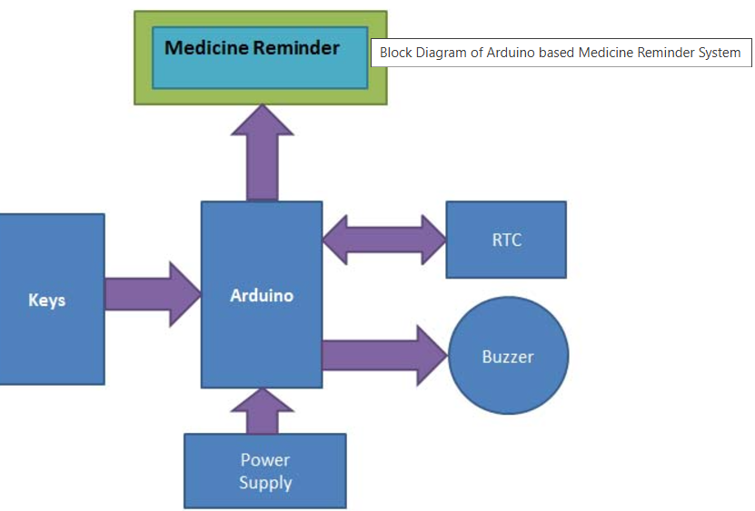

WORKING : The **Medicine Reminder Box**  is powered using 5V supply.

1. **Power On:** When you turn it on, it shows a welcome message.
2. **Screen Display:** It has three screens:
   * **Screen 1:** A friendly message to wish you well.
   * **Screen 2:** Instructions on how to set reminders.
   * **Screen 3:** You can choose from three reminder modes:
     + **Mode 1:** One reminder per day at 8 AM.
     + **Mode 2:** Two reminders per day at 8 AM and 8 PM.
     + **Mode 3:** Three reminders per day at 8 AM, 2 PM, and 8 PM.

You can select your preferred mode by pressing the corresponding button.

This device is a simple and useful tool to help you stay on top of your medication

slot to remind (once/twice/thrice in a day). The time slot is changeable in program and can be configured accordingly. Right now we have fixed this into three durations i.e. 8am, 2pm, and 8pm.

p

ADVANTAGES: .Less weight

Easily Portable

Less cost

Working with Real Time

DISADVANTAGES : Working fully depend upon power supply

CONCLUSION : over all it is a day to day life usable machine espessaly used for elder people Or else used for managing huge no of patients in Large hospitals Overall, automatic medicine reminder boxes have the potential to significantly improve medication adherence and health outcomes for many individuals. As the technology continues to evolve, we can expect even more advanced and user-friendly solutions to emerge in the future.

REFRENCE’S :

##### **The Industrial Electronics Handbook**

##### Editors: Bogdan M. Wilamowski, J. David Irwin

##### **Practical Design of Digital Circuits** Author: Ian Kampel