Index

|  |  |  |
| --- | --- | --- |
| **Sr. no** | **Topic** | **Page no** |
| 1 | Introduction | 1 |
| 2 | Cleaning Validation   * Advantage Of Cleaning Validation * Importance and purpose of cleaning validation * Objectives of Cleaning Validation | 1-2 |
| 3 | Basic Principle for Process Validation | 3 |
| 4 | Installation Qualification (IQ)   * IQ considerations are: | 3 |
| 5 | Operational Qualification (OQ)   * OQ considerations include | 3 |
| 6 | Performance Qualification (PQ)   * PQ considerations include | 4 |
| 7 | Re-Qualification | 4 |
| 8 | Validation Protocol | 4-5 |
| 9 | Cleaning Mechanism | 5-6 |
| 10 | Cleaning Validation Program   * Selection of Cleaning Method * Manual Cleaning Method * Clean-In-Place (CIP) Method * Clean-Out-Of-Place (COP) Method | 6-8 |
| 11 | Cleaning Procedures   * Equipment Parameters to be evaluated * Residues to be cleaned * Cleaning agent parameters to be evaluated * Cleaning Agent selection | 8-10 |
| 12 | Evaluation of Cleaning | 10-11 |
| 13 | Analysis of Cleaning Validation Samples | 12 |
| 14 | ELISA | 12-13 |
| 15 | The Regulatory Basis for Process Validation | 13 |
| 16 | Approach to Process Validation | 14 |
| 17 | Conclusion | 15 |
| 18 | References | 16 |

Cleaning Validation Process in PharmaceuticalIndustry

# Introduction

Pharmaceutical Process Validation is the most well-known and widely used CGMP parameter. The quality system (QS) regulation includes process validation standards. A qualitysystem's goal is to generate products that are fit for their intended use. The regularity of the validation documents that must be presented with the submission file for a marketing license is known as process validation. The process validation is meant to help producers understand the needs of their quality management system (QMS) for process validation, and it may be applied to any manufacturing process. According to the FDA, product quality assurance comes from paying close attention to a number of key criteria, including the selection of quality processes and in-process and end-product testing. Validation is a term that originated in the 1960s (Harpreet et al., 2013)1.

# Cleaning Validation

Cleaning means to make any article, piece of equipment and area free from dirt, marks,or any unwanted matter.In pharmaceutical industry there is a great need of cleaning of equipment apparatus and processing area. The improper cleaning can lead to contamination and cross contamination. Pharmaceutical products can be contaminated by various materials such as residue of previously used active pharmaceutical ingredients, raw material, cleaning agents and dust particles. The main objective of GMP consists of prevention of contamination and cross contamination of materials. Therefore a perfect cleaning method is required for avoiding the possibilities of contamination and cross contamination, for this a validated program is required, this program is known as cleaning validation. “Cleaning validation is documented evidence which assures that cleaning of equipment, piece of equipment or systemwill obtain pre-determined and acceptable limits”. Cleaning validation helps in analytical investigation of a cleaning procedure. The Purpose of cleaning validation is to verify the efficacy of the cleaning methods for removal of residues of previous product, preservatives, or cleaning agents and microbial contaminants. Cleaning validation fulfills the requirement of regulatory bodies and maintains product quality and safety of consumers (Asgharian et al., 2014)2;( Lodhi et al., 2014)3.

**Advantage Of Cleaning Validation** (Babita et al., 2014)4

* Assurance of quality & safety.
* Government regulations.
* Product integrity,
* Microbial integrity,
* Cross-contamination integrity,
* Batch integrity,
* Equipment reuse,
* Reduction of
* Making good business sense.
* Fewer batch failures

# Importance and purpose of cleaning validation

Cleaning validation is

Not only is it required to comply with regulations, but also it is necessary to satisfy customer‟s requirements.

It ensures the safety, identity, purity, and strength of the product which are the basic prerequisites of cgmp (Current Good Manufacturing Practice).

It provides manufacturers with enough confidence that internal control is wellestablished (Patel et al., 2011)5; (Vinay, 2020)6.

# Objectives of Cleaning Validation

Equipment cleaning and cleaning validation in an Active Pharmaceutical Ingredient (API) area is needed to prevent contamination of a future batch with the previous batch material. Cleaning validation in an API service is really important as cross contamination in one of the pharmaceutical dosage forms will increase the problem therefore it is suitable to perform at least three repeated and successful applications of the cleaning procedure in order to prove that the method is validated7.

It is necessary to validate cleaning procedures for the following reasons:

It is a prime customer requirement as it ensures the quality and safety of the product tobe consumed.

It is a regulatory requirement in API (Active Pharmaceutical Ingredient) product manufacture.

It also confirms the quality of the process through internal control and compliance (Fauziya et al., 2020)7.

**Basic Principle for Process Validation** (Harpreet et al., 2013)1; (Kathiresan et al., 2010)8

# Installation Qualification (IQ)

The set up by objective evidence that all the key aspects of the process equipment and additional system installation adhere to the manufacturers approved specification and that the recommendation of the supplier of the equipment is suitably considered.

# IQ considerations are:

1. Equipment design features (i.e. Material of construction cleanability, etc.)
2. Installation conditions (wiring, utility, functionality, etc.)
3. Calibration, preventative maintenance, cleaning schedules.
4. Safety features.
5. Supplier documentation, prints, drawings, and manuals.
6. Software documented.
7. Spare parts list.
8. Environmental conditions (like- temperature, humidity, cleanroom and requirements).

# Operational Qualification (OQ)

Operational Qualification includes a series of tests which ensures that equipment and its systemis operated within their specific limits.

### OQ considerations include

1. Process control limits like (Pressure, temperature, time, line speed, setup conditions,etc.)
2. Software parameters.
3. Raw material specifications.
4. Process operating procedures.
5. Material handling requirements.
6. Process change control.
7. Training.
8. The process of the capability and Short term stability and capability of the process. Action levels, Potential failure modes, and defeat -case conditions.

# Performance Qualification (PQ)

Performance Qualification gives assurance of the system or the performance of the equipment that is documented in the system. Performance Qualification requires a performance check which is made through the test of the series.

### PQ considerations include

1. Process guidelines and actual products and Procedures accepted in OperationalQualification
2. Acceptability of the product.
3. The assurance for the process capability as accepted in Operational Qualification.
4. Process repeatability, long-term process stability.

# Re-Qualification

It is an action in which reconfirming the process, product or equipment which is suitable for a particular task or position. Requalification of system and equipment is done under the Schedule or according to the schedule.

**Validation Protocol** (Sandhya et al., 2015)10

The validation protocol should be signed, dated, and numbered. Validation protocol contains as a minimum the following information:

* Title
* Objective & Scope
* Responsibility
* Protocol Approval
* Validation Team
* Product Composition
* Process Flow Chart
* Manufacturing Process
* Review of Equipments / Utilities
* Review of Raw materials and Review of the Packing Materials
* Review of Batch Quantities for Validation in manufacturing like (Raw Materials)
* Review of Batch Quantities for Validation for packing (Packing Materials)
* HSE Requirements
* Review of Process Parameters Validation Procedure
* Sampling Location
* Documentation
* Acceptance Criteria

# Cleaning Mechanism

Several basic mechanisms exist to remove residues from equipment, including Mechanical action refers to physical actions such as brushing, scrubbing, and pressurized water to remove particulates.Dissolution involves dissolving residues with a suitable solvent. The most common and used solvent is water due to its properties like - water is cheap and non- toxic, does not leave residues, and it is ecofriendly. Sometimes, it may be preferred or use asa non-aqueous solvent or a combination of both aqueous and non-aqueous solvents because of its solubility characteristics of the materials. Alkaline or acidic solvents, for example, increase the dissolution of the materials and could be beneficial.

Detergency requires the use of surfactant, in an aqueous system. Detergents act in four different ways like - Solubilized, wetting agents, emulsifiers, and dispersants. Usually, detergents possess all these properties which enlarge their action.

It includes Chemical reactions like - oxidation and hydrolysis, Examples are: Sodium Hypochlorite.

**Cleaning of Equipment** (Maurya et al., 2016)11

Instructions for Cleaning of Equipment: The equipment is cleaned with the help of the respective SOP of cleaning that particular equipment using a suitable nylon brush and cleansing agent. Then the cleansing agent is removed with potable/raw water and laterrinsed with demineralized water. Compressed air or Clean dry lint-free cloth is used to dry the equipment. After completion of the cleaning activity, the “CLEANED” status label is then labeled by the production personnel and attached to the equipment after that the QA personnel shall verify only after inspecting the equipment visually for cleanliness. Line clearance of equipment should be made by visually examining the equipment and should be found satisfactory if not found then repeat the clean for the same.

There are two types of cleaning procedures for equipment used in manufacturing.

# Type A Cleaning Procedure for equipment

1. **Type B Cleaning Procedure for equipment**

Type- A Cleaning Procedure For Equipment: All the parts of the equipment are dismantled and

transferred to the washing area cleaned out of place (COP). In the washing area, the dismantledparts of equipment shall be cleaned with a cleansing agent (i.e. 0.5% w/w SLS) or other cleaning aids as per the procedure mentioned in their respective sops of cleaning of equipment. Equipment having non dismantled parts should be cleaned in place (CIP) as per their sops for cleaning. The washing/rinsing water sample should be collected after visual verification by production chemists and QA and then sent to Quality Control along with a sample request for determination of the residual drug and cleansing agent.

Type B cleaning for Equipment: It having some following conditions like-

1. Batch to the batch changeover of the same product having the same strength.
2. Same color and same flavor
3. Batch to batch changes over but from lower strength to higher strength.
4. After completion of the batch.
5. After minor breakdown
6. Cleaning is done after completion of preventive maintenance work if product contactparts are not contaminated, touched, or disturbed.
7. After any major breakdown where product contact parts are contaminated.
8. After completion of preventive maintenance work.

Type B cleaning procedure for equipment: All gross accumulations from equipment and area are removed. Then the equipment should be cleaned without dismantling and dust from the previous product is removed with the help of a vacuum cleaner. Then equipment shall be mopped with a clean moist lint-free cloth (moist with demineralized water) and later with a clean dry cloth.

**Cleaning Validation Program** (Rajpal et al., 2016)12; (Shayne et al., 2018)13

* 1. Selection of cleaning Level (Type)
  2. Selection of cleaning method
  3. Selection of sampling method
  4. Selection of the scientific basis for the contamination limit
  5. Selection of defeat case related to the equipment
  6. Selection of defeat case related to the product
  7. Establishing the storage period after cleaning
  8. Selection of analytical method
  9. Documentation

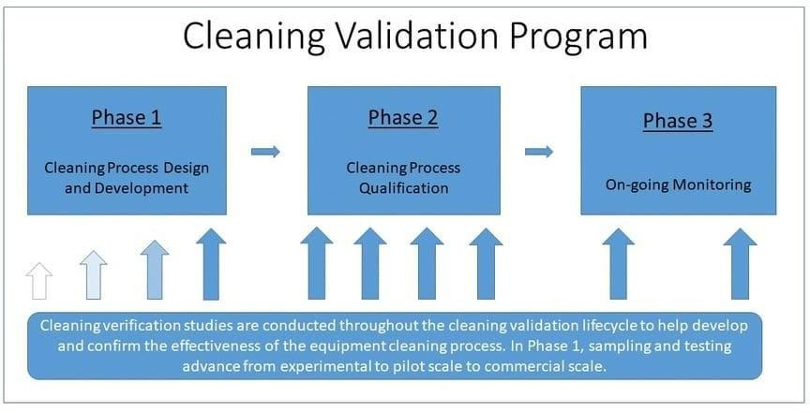

## Figure no 1

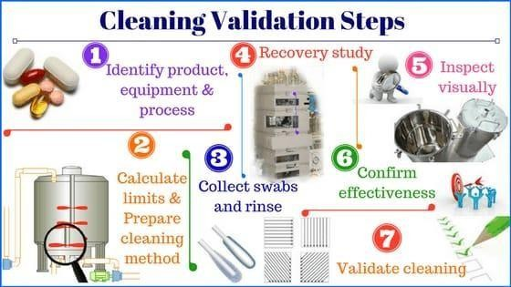

Figure no 2

### Selection of Cleaning Method

1. Manual cleaning
2. Semi-automatic procedures
3. Automatic procedures
4. CIP (Clean-in-place)
5. COP (Clean-out-of-place)

### Manual Cleaning Method

It is difficult to validate.

For this detailed cleaning procedures are necessary. A high-quality training program is essential.

The risk which is involved in manual cleaning process are as follows : Proper washroom design with drying, protection, and storage requirements. Detailed cleaning sops are required.

Training of cleaning operators is mandatory.

### Clean-In-Place (CIP) Method

Equipment cleaning is performed in place without disassembling.

The process of cleaning is controlled manually or by an automatic program. It is a very reproducible cleaning method.

Can be validated readily.

### Clean-Out-Of-Place (COP) Method

Disassembled parts of the equipment are cleaned or the process of cleaning is performedin a central washing machine.

The washing machine also needs validation like ultrasonic activity, cycle time,temperature, cleaning operation sequence, detergent quantity dispensed, etc.

# Cleaning Procedures

Standard cleaning procedures for every piece of equipment and process should be prepared. It is important that the equipment design is figured out in detail in combination withthe product residues which are to be removed, the available cleaning agents and cleaning techniques, when determining the most beneficial cleaning procedure for the equipment. Cleaning procedures should be sufficiently and properly detailed to avoid the possibility of anyinconsistencies during the cleaning process. Following parameters are being considered duringcleaning procedures.

### Equipment Parameters to be evaluated

1. Identification of the equipment to be cleaned.
2. 'Difficult to clean' areas.
3. Property of materials.
4. Ease of disassembly.
5. Mobility.

### Residues to be cleaned

1. Cleaning limits.
2. Solubility of the residues.
3. Length of campaigns.

### Cleaning agent parameters to be evaluated

1. Preferable materials that are usually used in the process.
2. Detergents available (as a general guide, minimal use of detergents recommendedunless absolutely required).
3. Solubility properties.
4. Environmental considerations.
5. Health and safety considerations.

### Cleaning Agent selection

Cleaning agents fall into several broad categories;

1. Water.
2. Solvents.
3. Commodity chemicals.
4. Formulated cleaning agents

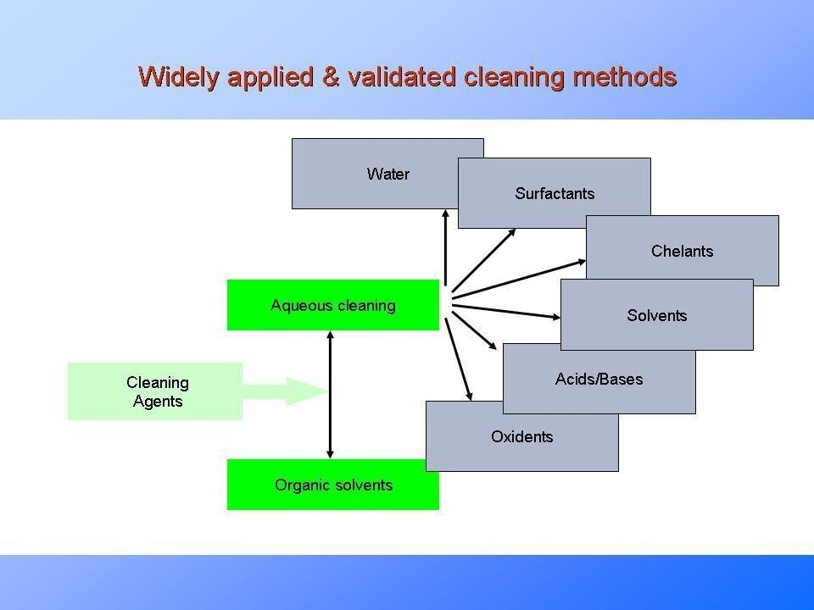

Figure no 3

Water: It is the universal solvent. If water alone will efficiently clean the product without undue time or physical effort to remove the residues, by all means water shouldbe employed alone. For many, however, the water alone requires an unacceptable increase in time to get the

cleaning finished. So other approaches must be screened.

Solvent: These are basically applied in processes where solvent usage is already calledfor by the manufacturing process. For example, mother liquors are used as the solventsfor cleaning of apis. As the mother liquor is already known to dissolve the primary residue, There is little risk in using it for cleaning.

 Commodity Chemicals: Here, chemicals such as NaOH can be used for cleaning as well. Like their solvent counterparts, there can be hazard issues, effluent issues associated with these materials. Their typically high basicity or low acidity, however, often makes them helpful in inactivation processes. However these chemicals do not have the detergency of a formulated cleaning agent and they can be difficult to rinse, taking larger volumes of water to rinse free from systems than would a formulated cleaning agent.

Formulated Cleaning Agent: Is the largest class of cleaners. This category consists of solvent based formulations and aqueous formulations. Typically formulated cleaning agents can include one or more alkalinity or acidity sources, sequestrants, surfactants builders, chelates and either a solvent or water. For industrial uses, unlike consumer- use products, these materials are prepared to be low foaming and therefore are more easily rinsable and are appropriate for high delinquency or high turbulence cleaning (Lakshmana et al., 2010)17; (Agalico et al., 2008)18

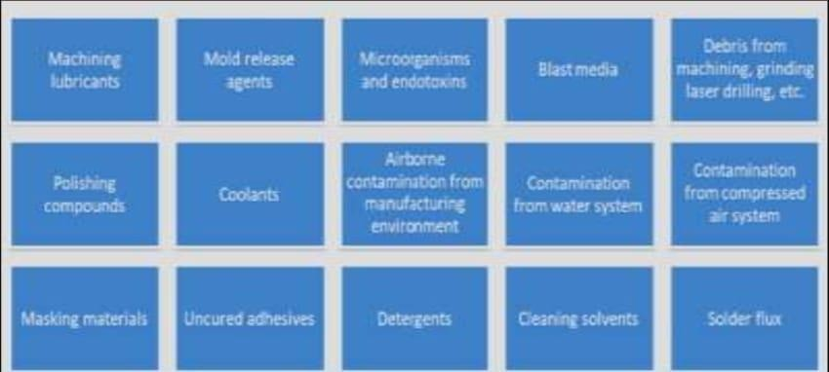

Figure no 4

**Evaluation of Cleaning** (Lodhi et al., 2014)3

Visual Cleaning Test: All parts of equipment that are in direct contact and non-contactwith

products should be visually checked and verified for cleanliness.

Spiking Test: This test validates that equipment has been thoroughly cleaned; no residueshould be visible. In a volatile solvent, a diluted series of the worst case is prepared andapplied to the test equipment surface, which is similar to the sample surface (e.g. 25 cm2). The active component quantity should be evenly dispersed on the test equipment's surface; the test should be carried out with various concentrations while simulating the identical test conditions with an approximate volume. After that, the solvents are evaporated and compared to the test surfaces of the equipment to determinethe visual limit of detection. However, light intensity, surface properties, and operator or operator-initiated method handling can all influence this limit.

 Bracketing or Worst Case Rating: In the pharmaceutical industry, when we are dealing with two or more similar products and the same process is being used, there is no requirement to validate individual equipment for the same product, to minimize the number of the validation; a single study is taken into consideration for the worst-case or bracketing approach of validation is used. This approach is based on a scientific rationale with appropriate justification. First, the grouping of substances/ products orequipment is done for similar products manufactured in the same equipment.

Substances can be grouped as follows

1. Grouping by Product: The formulations are grouped based on the dosage form for example if a company has 5 tablet formulations, 5 ointment formulations, and 5 liquidformulations. They are categorized into 3 groups; these groups can be further classifiedinto subgroups like tablets can be classified into 2 subgroups based on the manufacturing procedure. Likewise, ointment and liquid formulation can also be classified into subgroups. After establishing formulations, the group and subgroups „worst case‟ of each group is determined
2. Grouping by Substances: The products are grouped or categorized as they are producedin the same train substances with the same cleaning procedure. Then they are categorized into subgroups as they are produced in the same train substances with verylow therapeutic dose and/or low batch sizes or with very low/high acceptable daily exposure (Then subgroups to be formed based on the cleaning process). Once the product groups have been established the next step is determining the „worst case‟ representative of each group and cleaning validation of the same.

# Analysis of Cleaning Validation Samples

There are various analytical techniques available that can be used in cleaning validation(Heinig et all, 1998)20. But selecting the appropriate analytical tool depends on a variety of factors (Maurya, 2016)11; (Govind et al., 2018)21; (Nassani, 2005)22; (Yang et al., 2009)23. The most important factor is to determine the specifications or parameters to be measured (Kaiser et al., 1999)24. The limit should always be established before the selection of the analytical tool (leblanc, 1998)25;( Fourman et al., 1993)26.

1. Specific and non-specific methods: A specific method detects unique compounds in the presence of probable contaminants. Ex: HPLC.
2. Non-specific methods: These are those methods that identify any compound that produces a fixed response Ex: Total Organic Carbon (TOC), ph and conductivity.
3. Otherstechniquesincludes;

Thin layer chromatography (TLC): TLC is broadly used for the qualitative determination of surfactants.

Atomic absorption spectroscopy (AAS): AAS (atomic absorption spectroscopy) is usedfor the determination of inorganic contaminants.

Bioluminescence: This is useful for biologicals. This type of analysis usually uses ATP- bioluminescence.

Optically stimulated electron emission (OSEE): In some cases the limits of residue areso low that they can't be detected by conventional methods. OSEE is a very sensitive method that can be used in both qualitative and quantitative manner in this regard.

 Portable mass spectrometer: Portable mass spectrometer can be used to find ultra- sensitive measurements and identification of the residue (Bosdorf et al., 1996)27; (Read, 1985)28; (Henrich, 1992)29; (Raghavan et al.), 2000)30; (Davidson et al., 1999)31. 4. Additional Techniques: Apart from the above mentioned techniques the biopharmaceutical industries apply a wide range of techniques (Inampudi et al., 1996)32. These includes;

Enzyme-Linked Immunosorbent Assay (ELISA)

Limulus amebocyte lysate (LAL) technique (Rowell et al., 1988)33.

# ELISA

ELISA stands for enzyme-linked immunosorbent assay, also often referred to as enzyme immunoassay (EIA). An ELISA assay is usually performed in a multi-well plate (96- or 384-wells). The multi-well plate supplies the solid surface to immobilize the antigen. Immobilizations of the analytes promote separation of the antigen from the rest of thecomponents in the sample. This attribute makes ELISA one of the easiest assays to perform onmultiple samples simultaneously. The Limulus

Amebocyte Lysate test is approved in international pharmacopoeias as it is the method for identifying bacterial toxins/contaminationboth in the raw materials used for the synthesis of medicines and for the final products. This test is also useful for the cosmetics industry and in food production as it is the method approved by the FDA (Food and Drug Administration) for the identification of pyrogens (Fauziya et al.,2020)7.

**The Regulatory Basis for Process Validation** (Murthy et al., 2013 ;) 34

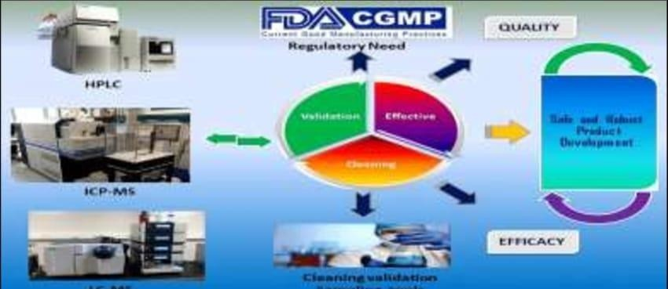FDA regulatory experts established that there was a legal foundation for needing process validation once the concept of being able to forecast process performance to fulfil userneeds arose. The ultimate legal authority is Section 501(a)(2)(B) of the FD&C Act, which statesthat a drug is deemed to be adulterated if the methods used in, or the controls utilised in its manufacture, processing, packing, or storage do not comply with CGMP, or were not managedor administered in accordance with CGMP. It must be guaranteed that the medicine will meet the act's safety criteria, as well as that it will have the identity, strength, and quality and purity qualities that it purported or was represented to have. Because active pharmaceutical ingredients are likewise considered medications under the act that provision of the act establishes the foundation for process validation requirements for both finished pharmaceuticals and active pharmaceutical components. The 21 CFR 210 and 211 CGMP standards for finished pharmaceuticals were created to enforce the act's obligations. Despite the lack of a definition under these regulations.

## Figure no 5

**Approach to Process Validation** (Shruthi et al., 2014)37

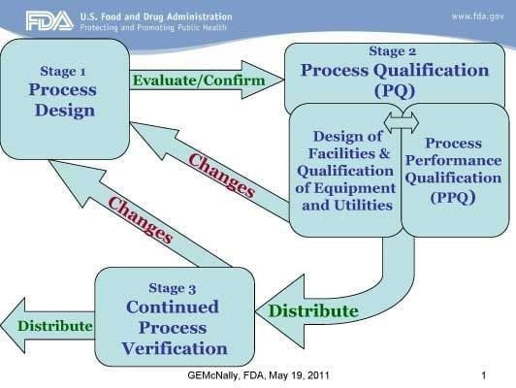

Figure no 6

Stage 1: Process Design: During this stage, knowledge gained from development andscale- up activities is used to define a commercial manufacturing process.

Stage 2: Process Qualification: During this stage, the method design is estimated to seeif the process can be replicated and turned into a viable product.

Stage 3: Ongoing Process Verification: Throughout ordinary production, constant assurance is received that the process is under control.

# Conclusion

Validation is the most commonly used term in the fields of medication research, manufacturing, and completed product specification. For the industry, consistency and reliability of a verified process to deliver a quality product are critical. Quality assurance procedures must be utilised throughout the manufacturing process, not only at the end, to ensure that the product is of high quality. Process validation entails a series of activities that take place throughout the product and process lifecycle.

From the study, it can be stated that with the help of cleaning validation any departmentof the pharmaceutical industry can achieve a high degree of assurance regarding the cleaning; with this we can minimize any kind of contamination or cross-contamination which may be any residue of the previous product, the substance of machine or any microbial contamination. The pharmaceutical industry should be free of any contamination or cross contamination; it would be safe for the consumer.

# References

1. Kaur Harpreet*, Singh Gurpreet, Seth Nimrata. REVIEW ARTICLE PHARMACEUTICAL PROCESS VALIDATION: A REVIEW. Journal of Drug Delivery & Therapeutics; 2013, 3(4), 189-194.
2. 2)Asgharian R, Mehtarpour F, Heydari H A, Step by Step How to Do Cleaning Validation, IJPLS, 2014, 3345-3366.
3. Lodhi B, Padamwar P, Patel A, Cleaning Validation For The Pharmaceuticals, Biopharmaceuticals, Cosmetic And Nutraceuticals Industries, J. Inno. In Pharma. Bio. Sci. 2014, 1 (1), 27-38.
4. Babita Lodhi; Cleaning validation for the pharmaceuticals, biopharmaceuticals, cosmetic and nutraceuticals industries; Journal of Innovations in Pharmaceuticals and Biological Sciences; 2014; 1(1); 27 – 38
5. Patel Payal K, Patel NM and Patel PM. An Overview on Cleaning Validation. Int J Pharm Biol Arch. 2011;2(5):1332-36.
6. Vinay Jain G. Department of Pharmaceutical Analysis and QA, Mallareddy College of Pharmacy. Cleaning validation. 22 January 2020.
7. Fauziya Khan, Abdul Sattar Khan and Nutan Rao*. CLEANING VALIDATION IN PHARMACEUTICAL INDUSTRIES. INTERNATIONAL JOURNAL OF RESEARCH IN PHARMACY AND CHEMISTRY. IJRPC 2020, 10(2), 205-214.
8. Kathiresan K*, Moorthi C, Prathyusha Y, Grade B. R, Reddy B. K, Manavalan R, ; An overview of pharmaceutical validation; Research Journal of Pharmaceutical, Biological and Chemical Sciences; ISSN: 0975-8585; October – December 2010; RJPBCS 1(4); Page No. 1026.
9. [Https://images.app.goo.gl/SK94a45vhpTGubWt6](https://images.app.goo.gl/SK94a45vhpTGubWt6)
10. Ch. Sandhya, Brahmaiah B., Pusuluri D. L. Konkipudi V. S., Process validation: an essential process in the pharmaceutical industry. International Journal of Advances in Scientific Research, 1(4): 179-182,(2015).
11. Maurya Sadanand, Goyal Devendra and Verma Chandan. Cleaning Validation in Pharmaceutical industryan Overview. Pharmatutor. 2016;4(9):14-20.
12. Rajpal G, Arya R, Kunwar N. Basic concept of process validation in solid dosage form (tablet): a review. Journal of Drug Delivery and Therapeutics, 2016; 6(4):79- 87.doi:10.22270/jddt.v6i4.1282.
13. Shayne C G, Pharmaceutical Manufacturing Handbook, Regulations and Quality. Cary, North Carolina: Wiley-Inter science, 2018 8(9), 553-554.
14. [Https://images.app.goo.gl/wawpvsnhdfv6b3yq7](https://images.app.goo.gl/WawpVsNhdfV6b3YQ7)
15. [Https://images.app.goo.gl/qa2ttwf9payrszhr7](https://images.app.goo.gl/qA2tTWf9PaYrsZhR7)
16. [Https://images.app.goo.gl/ztvtrn7nr9oruznt6 13572](https://images.app.goo.gl/zTVTrN7Nr9oruZnT6%2013572)
17. Lakshmana Prabu S and Surya Prakash TNK. Cleaning Validation and its importance in

Pharmaceutical Industry, Pharma Times. 2010;42(7):20-25.

1. Agalico J and Frederick Carlton J. A Text Book of Validation of Pharmaceutical Process. 3rd ed. Spring Publisher. 2008;525-65.
2. [Https://images.app.goo.gl/5GN9mPVZFGFFENYV9](https://images.app.goo.gl/5GN9mPVZFGFFENYV9)
3. Heinig K, Vogt C and Werner G. Determination of Linear Alkyl benzene Sulfonates in Industrial and Environmental Sample by capillaryelectrophoresis. Analyst. 1998;123:349-353
4. Govind Raj Pal, Arya Rajeshwar Kamal Kant, Joshi Tanuj and Bisht Dheeraj. A review on cleaning validation in the pharmaceutical industry. Journal of drug delivery and therapeutics. 2018;8(3):138-146.
5. Nassani M. Cleaning Validation In Pharmaceutical Industry. J Vali. 2005;38- 58.
6. Yang P, Burson K, Feder D andmacdonald F. Method Development of Swab Sampling for Cleaning Validation of a Residual Active Pharmaceutical Ingredient. Pharm tech 2009, 86-94.
7. Kaiser HJ, Tirey JF and leblanc DA. Measurement of Organic and Inorganic Residues Recovered from Surfaces. J Van Tech. 1999;6(1):424-36.
8. Leblanc DA. Establishing Scientifically Justified Acceptance Criteria for Cleaning Validation of Finished Drug Products. Pharm Tech. 1998;22(10):136-148.
9. Fourman GL and Mullen MV. Determining Cleaning Validation Acceptance Limits for Pharmaceutical Manufacturing Operations. Pharmtech. 1993;17:54- 60.
10. Bosdorf V and Krüsymann H. Analysis of detergents and cleaning Agents with Thin-Layer Chromatography. Fourth World Surfactants Congressional Association. Barcelona, Spain. 1996;4:92-95.
11. Read H. Surfactant Analysis Using HPTLC and the Latroscan. Proceedings of the International Symposium on Instrumental High Performance Thin-Layer Chromatography. 3rd ed. Kaiser R. Editor. Institute of Chromatography. Federal Republic of Germany. 1985;157-171.
12. .Henrich LH. Separation and Identification of Surfactants in Commercial Cleaners. J Planar Chrome. 1992;5(2):103-17.
13. Raghavan R and Mulligan JA. Lowlevel (PPB) Determination of Cisplatin in Cleaning Validation (Rinse Water) Samples. I. An Atomic Absorption Spectrophotometric Technique. Drug Device Ind Pharm. 2000;26(4):423-28.
14. Davidson CA, Griffith CJ, Peters AC and Fielding LM. Evaluation of Two Methods for Evaluating Surface Cleanliness ATP Bioluminescence and Traditional Hygiene Swabbing. Luminescence. 1999;14:33-38.
15. Inampudi P, Lombardo S and Ruezinsky G. An Integrated Approach for Validating Cleaning Procedures in Biopharmaceutical Manufacturing Facilities. Annals of the New York Academy of Sciences. 1996;782(1):363- 374.
16. Rowell FJ, Miao ZF and Neeve RN. Pharmaceutical Analysis Nearer the Sampling Point, Use of Simple, Rapid On-Site Immunoassays for Cleaning Validation, Health and Safety, and Environmental Release Applications. J Pharm and Pharmacology. 1998;50(S9):47
17. Murthy D. N., Chitra K., Review article on process validation as a quality assurance tool and a theoretical approach. Internationale Pharmaceutica Sciencia, 3(2): 6-14, (2013) 13573
18. [Https://images.app.goo.gl/arwqsuhqbm82hpkj7](https://images.app.goo.gl/ArwQsUHqBM82hpKJ7)
19. Https://[www.google.com/imgres?Imgurl=http%3A%2F%2Fwww.antrix.com%2Fservices%2](http://www.google.com/imgres?Imgurl=http%3A%2F%2Fwww.antrix.com%2Fservices%252) Fservice_list%2Fimages%2F13_1_validation_manufacturing_process.jpg&imgrefurl=http%3 A%2F%2Fwww.antrix.com%2Fservices%2Fservice_list%2F13_validation_manufacturing_p rocess.htm&tbnid=pe4dl3zuagrrfm &vet=1&docid=Nd9QH_lxjwabdm&w=527&h=368&source=sh%2Fx%2Fim
20. Shruthi N. K., Gupta V.N., Raghunandan H.V., Kashyap UN., USFDA guidelines on process validation - a review. International Journal of pharmtech Research, 6(3): 920-923, (2014) Quality costs.