A REVIEW ON ANTIHYPERTENSIVE DRUGS APPROVED BY FDA

### PRACTICE SCHOOL SUBMITTED TO THE JAWAHARLAL NEHRU TECHNOLOGICAL UNIVERSITY ANANTHAPURAMU , ANDHRA PRADESH



**SUBMITTED BY MOHAMMAD ISSAQ 21ER1R0088**

### Under the Supervision of

**B. AKHILA, M. PHARM, (Ph. D) Assistant professor,**

### Department of Pharmaceutical analysis,

**Dr. K. V. Subba Reddy Institute of Pharmacy.**



### K.V. SUBBA REDDY INSTITUTE OF PHARMACY DUPADU, KURNOOL 518218.

**NAAC A+ NOVEMBER –2024**



# CERTIFICATE BY SUPERVISOR

This is to certify that the work contained in the practice school report REVIEW ON ANTIHYPERTENSIONDRUG APPROVED BY FDA submitted by **K.MOHAMMAD ISSAQ** (21ER1R0088) for the award of the

degree of Bachelor of pharmacy to the Dr. K. V. Subba Reddy Institute of Pharmacy, is a record of Bonafide research

works carried out by me under my direct supervision and guidance.

I considered that the has reached the standards and fulfilling the requirements of the rules and regulations relating to the nature of the degree. The contents embodied in the thesis have not been submitted for the award of any other degree or diploma in this or any other university.

### DATE:

**PLACE**

Signature of supervisor

### B. AKHILA

**M. PHARM, (Ph. D) Associate professor**

### Department of Pharmaceutical analysis

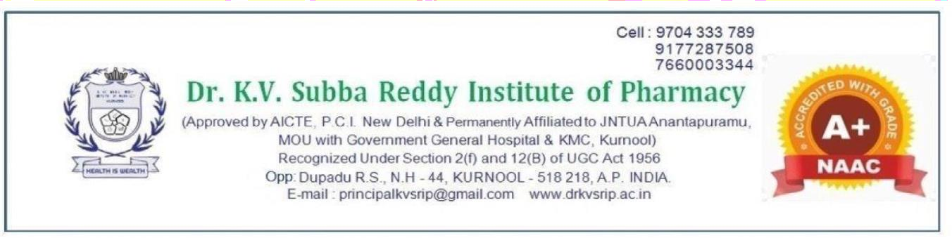

**CERTIFICATE BY HEAD OF THE INSTITUTE**

This is to certify that the dissertation entitled **“**REVIEW ON ANTIHYPERTENSION DRUG APPROVED BY FDA**”** was done for the partial fulfillment for the award of degree of **BACHELOR OF PHARMACY** has been carried out by **MOHAMMAD ISSAQ .K ( 21ER1R0088** under the guidance and supervision of **B AKHILA M.PHARM, Ph.D** at **Dr. K. V. Subba Reddy Institute of Pharmacy**, Dupadu, Kurnool, during the

period of 2024-2025. It is further certified that this work or any part of this has not been submitted in part or full for the award of any degree or fellowship.

DATE ; PLACE ;

**Signature of the Principal**

Dr. B.V. Ramana

M. Pharm, Ph.D Department of pharmaceutics

### DECLARATION

I certify that;

1. The work contained in the thesis is original and has been done by myself under the supervision of my supervisor.
2. The work has not been submitted to any other Institute for any degree or diploma.
3. I have conformed to the norms and guidelines given in the Ethical Code of Conduct of the Institute.
4. Whenever I have used materials (data, theoretical analysis, and text) from other sources, I have given due credit to them by citing them in the text of the thesis and giving their details in the references.
5. Whenever I have quoted written materials from other sources and due credit is given to the sources by citing them.

### DATE:

**PLACE:**

K. **MOHAMMAD ISSAQ 21ER1R0088**

**ABSTRACT**

Hypertension, commonly known as high blood pressure, is a prevalent chronic condition affecting millions worldwide. This article reviews the pathophysiology, risk factors, complications, and management strategies for hypertension. The global burden of hypertension continues to rise, contributing to cardiovascular diseases, kidney failure, and premature mortality. Effective management includes lifestyle modifications and pharmacological interventions tailored to individual patient needs. This overview emphasizes the importance of early detection and continuous monitoring, aiming to improve patient outcomes and reduce healthcare costs associated with hypertension-related complications.

In 2023, the FDA approved Tryvio (Aprocitentan), an endothelin receptor antagonist, for treating resistant hypertension. Treatment goals and strategies must be individualized to a patient’s lifestyle, comorbidities, and preferences to minimize potential harm and increase the likelihood of long-term compliance. Lifestyle modifications are recommended before initiation of pharmacological therapy in low-moderate risk patients, and alongside pharmacological therapy in higher risk patients. Monotherapy with first-line anti-hypertensive agents, including diuretics, RAAS inhibitors, CCBs, and beta-blockers, is often inadequate formost hypertensive patients. As such, single-pill combinations are recommended to approve the speed.

*KEYWORDS: Hypertension, Blood pressure, Heart, Kidney, Medication,*

### ACKNOWLEDGEMENT

I am profoundly grateful to my supervisor, B AKHILA, M. Pharm (Ph.D.), Assistant Professor, Department of Pharmaceutical Analysis, Dr. K.V. Subba Reddy Institute of Pharmacy, for his invaluable guidance and support throughout this project. Her insights and dedication have been instrumental in the successful completion of this work.

I extend my heartfelt thanks to the faculty and staff at the Dr.K.V. Subba Reddy Institute of Pharmacy, who have provided continuous encouragement and resources. I am especially grateful to Jawaharlal Nehru Technological University, Anantapur, for offering the platform to undertake and present this research.

Lastly, I would like to acknowledge the unwavering support of my family and friends, whose patience and motivation have been my strength during this journey

K.MOHAMMED ISSAQ

**LIST OF ABBREVATIONS**

|  |  |
| --- | --- |
| **ABBREVATION** | **DESCRIPTION** |
| ATP | Adenosine triphosphate |
| ACE | Angiotensin converting enzyme |
| AUC | Area under curve |
| AAN | American Academy Neurology |
| AHA | American heart Association |
| ACC | American heart college cardiology |
| ACOG | American college of obstetricians |
| ASCUD | Atherosclerotic cardio vascular disease |
| AAP | American Academy Paediatric |
| CTIS | Clinicals trials information system |
| EU | European union |
| ECU | Eudora clinical trial |
| FDA | Food drug administration |
| HCM | Human capital management |
| HDL | High density lipoprotein |
| IV | Intra venous |
| LDL | Low density lipoprotein |
| PKA | Protein kinase |
| SR | Sarcoplasmic reticulum |
| VLDL | Very low-density lipoprotein |

LIST OF FIGURES

**FIGURE 1 –** PATHOPHYSIOLOGY OF HYPERTENSION

**FIGURE 2 –** SYSTOLIC AND DIASTOLIC NORMAL RANGE OF BLOOD

**FIGURE 3 –** BLOOD PRESSURE AND RANGES

**FIGURE 4 –** CAUSE OF HYPERTENSION

**FIGURE 5-** COMPLICATIONS OF HIGH BLOOD PRESSURE

# CONTENTS

Page no

CHAPTER 1

Introduction 1

1.1 Epidemiology 10

1.2 Pathophysiology 12

|  |  |
| --- | --- |
| 1.3 High blood pressure readings | 13 |
| 1.4 Symptoms | 15 |
| 1.5 Causes of high blood pressure  CHAPTER 2 | 15 |
| 2.1 Literature survey | 7 |

CHAPTER 3

* 1. Symptoms of hypertension 18
  2. Effects of high blood pressure on the body 18-9
  3. Devices used to detect hypertension 19
  4. Treatment options for high blood pressure 20
  5. Lifestyle tips to lower your risk of hypertension 22

CHAPTER 4

* 1. Treatment of alcohol-induced hypertension 23
  2. New FDA drug
  3. Medical uses 24
  4. Adverse effects 25

CHAPTER 5

* 1. Future scope
  2. Conclusion 26
  3. References 30

#### INTRODUCTION

Hypertension is a multifaceted health issue characterized by elevated blood pressure, defined by the American College of Cardiology andthe American Heart Association as systolic blood pressure (SBP)

≥ 130 mmHg and/or diastolic blood pressure (DBP) ≥ 80 mmHg. As a significant risk factor for cardiovascular disease (CVD), stroke, and renal failure, hypertension poses a substantial public health challenge globally. The World Health Organizationestimates that hypertensionaffects approximately

1.28 billion adults aged 30-79, with only about 27% of those diagnosed receiving adequate treatment.

The pathophysiology of hypertension is complex, involving a combination of genetic, environmental, and lifestyle factors. Key contributors include obesity, physical inactivity, excessive sodium intake, and chronic stress. Secondary hypertension, resulting from identifiable underlying conditions such as renal disease or endocrine disorders, accounts for a smaller proportion of cases.

The complications associated with uncontrolled hypertension are profound, leading to significant morbidity and mortality. Heart failure, coronary artery disease, and acute kidney injury are among the most severe outcomes linked to prolonged high blood pressure. Furthermore, the economic burden of hypertension is substantial, with healthcare costs rising due to the management of its complications.

This article aims to provide a comprehensive overview of hypertension, focusing on its epidemiology, risk factors, pathophysiology, complications, and current management strategies. Through better understanding and awareness, we can improve prevention, diagnosis, and treatment outcomes for individuals affected by this chronic condition.

# EPIDEMIOLOGY

More than one billion adults worldwide have hypertension, with up to 45% of the adult populace being affected by the disease. The high prevalence of hypertension is consistent across all socioeconomic and income strata, and the prevalence rises with age, accountingfor up to 60% of the population above 60 years of age.

In the year 2010, the global health survey report published in Lancet, which was comprised of patient data from 67 countries, reported Hypertension as the leading cause of death and disability-adjusted life years worldwide since the year 1990.

In the United States, HTN alone accounts for morecardiovascular disease-related deaths than any other modifiable risk factor and is second only to cigarette smoking as a preventable cause of death for any reason.

Department of pharmaceytical analysis

Recent estimates have suggested the number of patients with hypertension could increase as much as 15% to 20%, which could reach close to 1.5 billion by 2025

HYPERTENSION

Hypertension, also known as high blood pressure, is a condition where the force of the blood against the artery walls is consistently too high. It is a long term medical condition in which the blood pressure in the arteries is persistently elevated. The systolic will be more than or equal of 140 mmHg and diastolic will be more than or equal of 90 mmHg.

Narrow arteries create more resistance for blood flow out of the heart. The narrower your arteries, the more resistance there is, and the higher your blood pressure will be. Over the long term, the increased pressure can cause health issues, including heart diseases.

Hypertension is quite common. Since guidelines changed in 2017 nearly half trusted sourcesof American adults have high blood pressure, according to the American Heart Association.

Hypertension typically develops over several years, usually without causing any symptoms. But even without symptoms, high blood pressure can cause damage to your blood vessels and organs, especially the brain, heart, eyes, and kidneys.

Early detection is important. Regular blood pressure readings can help you and a doctor notice any changes. If your blood pressure is elevated, a doctor may have you check your blood pressure over a few weeks to see if the number stays elevated or falls back to typical levels.

Treatment for hypertension includes both prescription medication and healthy lifestyle changes. Without treatment, it could lead to health issues, including heart attack and stroke.

History of blood pressure and hypertension Early knowledge and measurements

In the Yellow Emperor’s Classic of Medicine (first written approximately 200 –400 BCE), the Yellow Emperor of China (approximately 2600–2700 BCE) was believed to have talked about the so-called ‘hard pulse disease’, claiming that ‘if too much salt is used in food, the pulse hardens’ and suggested the use of venesection for treatment. Physicians in ancient Egypt (approximately 1500 BCE) and India (approximately 150 BCE) also noted the relationship between pulse quality and the development of afflictions of the heart and brain. Pulse also had an essential role in ancient Greek medicine, and its relationshipwith environment and disease wasdiscussedatlength by physicians including Hippocrates

(460– 370 BCE), Erasistratus (304–250 BCE) and Galen (130–210 CE). However, these physicians did not note the connection between apoplexy and high blood pressure or hardening of the pulse.

In 1628, William Harvey described the process of blood flowing out of the heart and then returning to the heart via arteries, peripheries and veins. Nearly 300 years later, blood pressure was discovered, and a reliable method for its measurement was devised. Even before this technology was developed, the work of a few physicians, including Richard Bright and Frederick Akbar Mahomed, led to the first description of essential hypertension in the nineteenth century, for example, hypertension in the absence of renal disease.

he first accurate, direct measurement of human blood pressure was performed by the surgeon Faivre with the use of a mercury manometer during a limb amputation in 1856, with a reported arterial blood pressure of 115–120 mmHg. Devices for the indirect measurement of blood pressure (that is, to measure the counter-pressure needed to stop the blood flow in an artery) evolved from the first sphygmograph to visualize pulse waves, invented by Karl

Vierordt in 1855, to Samuel Siegfried Ritter von Basch’s sphygmomanometer in 1880. In 1896, Scipione Riva Rocci invented an inflatable cuff that compressed around the whole circumference of the arm to apply uniform pressure. The cuff size was later changed to 12 cm in 1901 from the original 5 cm , and it became the prototypeof cuffs that continueto be used in modern devices. In 1905, Nikolai Korotkoff, a Russian surgeon, reported a method that uses the tapping sounds detected through a stethoscope at different phases during the deflation of the cuff to determine the pressure at which blood flow was completely blocked, that is, SBP, and the pressure at which blood flow was no longer restrained, that is, DBP. Together, Korotkoff’s auscultatory technique and Rocci’s cuff formed the basis of modern blood pressure measurement devices

## PATHOPHYSIOLOGY

There are variousmechanisms described for the development of hypertension, which includeincreased salt absorption resulting in volume expansion, an impaired response of the reninangiotensinaldosterone system (RAAS), and increased activation of the sympathetic nervous system. These changes lead to the development of increased total peripheral resistance and increased afterload, which in turn leads to the development of hypertensi

Blood pressure in men and women

Men are known to have a higher blood pressure than women 140, but this relationship could vary by age and geography. According to NCD-RisC data, in 2015, men had a higher agestandardized mean SBP than women in most countries. Men also had higher DBPand prevalence of raised blood pressure than women in most countries, except in sub-Saharan

Africa and a few countries in Oceania and Asia, where the sex-specific pattern was reversed. The male–female differences in the age-standardized mean and prevalence were mainly owing to sexspecificdifferences before theage of 50 years. Men and women aged ≥50 years had more similar mean SBP and DBP and prevalence.

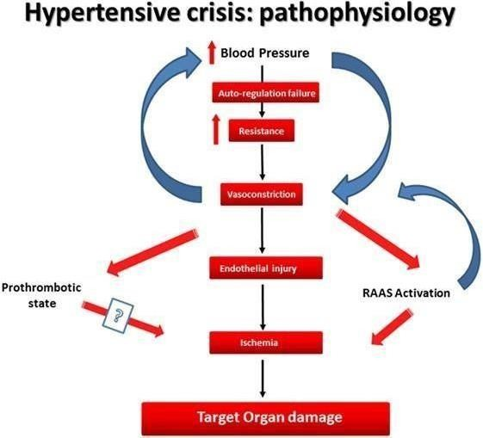

#### FIG: 1 Pathophysiology of hypertension

* 1. **High blood pressure readings**

Your blood pressure readings of two members :

* Systolic pressure (top number): the pressure in your arteries when your heart beats and pumps out blood
* Diastolic pressure (bottom number): the pressure in your arteries between beats of your heart

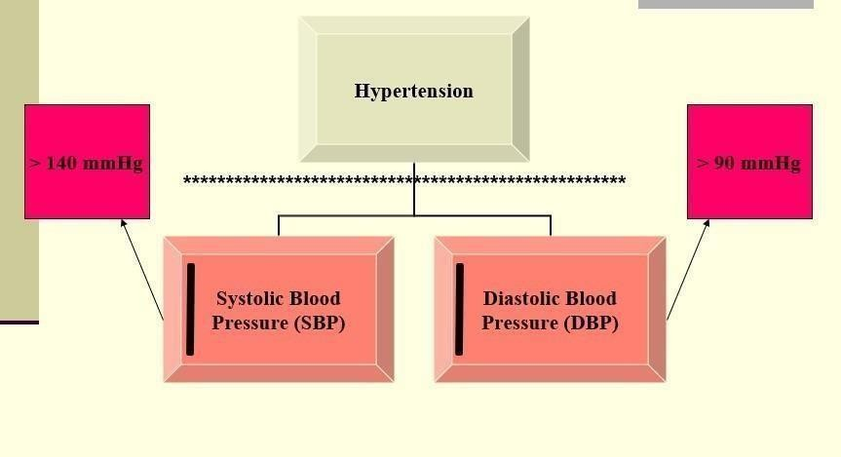

#### FIG 2 systolic and diastolic normal range of blood pressure

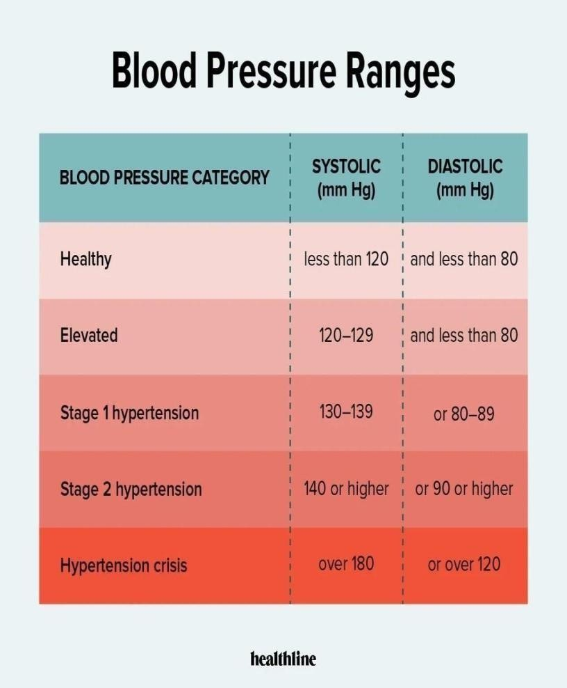

**FIG 3 blood pressure and ranges**

#### Five categories define blood pressure readings for adults:

* Healthy: A healthy blood pressure reading is a systolic pressure of less than 120 millimeters of mercury (mm Hg) and a diastolic pressure of less than 80 mm Hg. This is typically written as 120/80 or spoken as “120 over 80.”
* Elevated: The systolic number is between 120 and 129 mm Hg, and the diastolic number is less than 80 mm Hg. Doctors usually don’t treat elevated blood pressure with medication. Instead, they may encourage lifestyle changes to help lower your numbers.
* Stage 1 hypertension: The systolic number is between 130 and 139 mm Hg, or the diastolic number is between 80 and 89 mm Hg.
* Stage 2 hypertension: The systolicnumber is 140 mm Hg or higher, or the diastolic number is 90 mm Hg or higher.
* Hypertensive crisis: The systolic number is over 180 mm Hg, or the diastolic number is over 120 mm Hg. Blood pressure in this range requires urgent medication attention. If symptoms, such as chest pain, headache, shortness of breath, or visual changes occur when blood pressure is this high, medical care in an emergency department is needed.

A blood pressure reading is taken with a pressure cuff. It’s important to have a cuff that fits for an accurate reading. An ill-fitting cuff may deliver inaccurate readings.

Blood pressure readingsare different for children andteenagers. Ask your child’s doctorfor the healthy ranges for your child if you need to monitor their blood pressure.

## SYMPTOMS

Hypertension, especially in its early stages, often doesn’t have noticeable symptoms, which is why it’s sometimes called the "silent killer." However, when blood pressure becomes very high or remains elevated for a prolonged period, it can cause various symptoms and complications. Some possible symptoms and signs of high blood pressure include:

* + 1. Headaches: Severe headaches, particularly in the morning, can be a sign of high blood pressure.
    2. Dizziness or Light headness : Feeling dizzy or lightheaded may occur, particularly if blood pressure is extremely high.
    3. Shortness of Breath: Difficulty breathing or shortness of breath can be associated with high blood pressure.
    4. Chest Pain: High blood pressure can sometimes cause chest pain.

## CAUSES OF HIGH BLOOD PRESSURE

There are two types of hypertension. Each type has a different cause. Essential (primary) hypertension

Essential hypertension, also called primary hypertension, develops over time. Most people have this

type of high blood pressure.

A combination of factor trusted source typically play a role in the development of essential hypertension:

* Genes: Some people are genetical predisposed to hypertension. This may be from gene mutations or inherited from your parents.
* Age: People over 65 yr old trusted source are more at risk for hypertension.
* Race: Black people have a higher incidence of hypertension in the United States. research trusted sources suggests that systemic, cultural, and geneticfactors contribute to this inequity.
* Living with obesity: Living with obesity can lead to a few cardiovascular issues, including hypertension.
* High alcohol consumption: it has been shown that even one drink per day can increase your risk of hypertension, with higher alcohol consumption further increasing your risk.
* Living a sedentary lifestyle: secondary behaviour trusted sources have links to several cardiovascular issues, including hypertension.

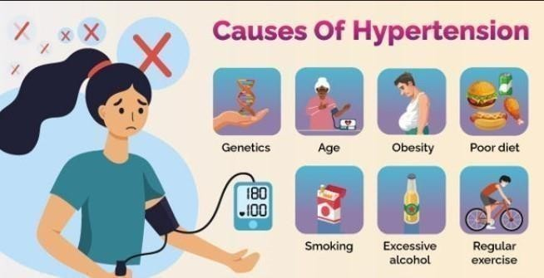

FIG 4 cause of hypertension

* Living with diabetes or metabolic syndrome: People diagnosed with either diabetes or metabolic syndrome are at a higher risk of developing hypertension.
* High sodium intake: There’s a close link trusted source between daily high sodium intake (more than 5 grams a day) and hypertension.

Secondary hypertension

Secondary hypertension often occurs quickly and can become more severe than primary hypertension.

Several conditions that may cause secondary hypertension include:

Kidney disease Obstructive sleep apnea

Structural heart issue present from birth Problems with your thyroid

Adrenal gland problems

certain endocrine tumors

Secondary hypertension may also be a side effect of certain medication.

### 2.1 Literature of survey :

**Authors : Et oll** Anandita

1. Camptothecin (CPT) and paclitaxel (PTX), derived from natural products, are recognized for their significant efficacy in clinical cancer treatments. Despite its therapeutic advantages, CPT is challenged by issues of toxicity and solubility, necessitating its use in conjugation with other compounds for enhanced compatibility.

**Authors : Et oll** Naoki Shida

1. The production of cyclic amines, which are vital to the pharmaceutical industry, relies on energy-intensive thermochemical hydrogenation. Herein, we demonstrate the electrocatalytic hydrogenation of nitrogen-containing aromatic compounds, specifically pyridine, at ambient temperature and pressure via a membrane electrode assembly with an anion-exchange membrane.

**Authors :** Naoki Shida

1. Pulmonary hypertension is a cardiovascular disease with a low survival rate. The protein galectin-3 (Gal-3) binding β-galactosides of cellular glycoproteins plays an important role in the onset and development of this disease. Carbohydrate-based drugs that target Gal-3 represent a new therapeutic strategy in the treatment of pulmonary hypertension.

4’The endothelin axis and in particular the two endothelin receptors, ETA and ETB, are targets for therapeuticintervention in humandiseases. Endothelin-receptor antagonists are in clinical use to treat

pulmonary arterial hypertension and have been under clinical investigation for the treatment of several other diseases, such as systemic hypertension, cancer, vasospasm, and fibrogenic diseases **.**

# SYMPTOMS OF HYPERTENSION

Hypertension is generally a silent condition. Many peoplewon’t experience any symptoms. It may take years or even decades for the condition to reach levels severe enough that symptoms become apparent. Even then, some people may attribute these symptoms to other causes.

Getting regular blood pressure readings is the best way to know if you have hypertension. Most doctors’ offices take a blood pressure reading at every appointment.

Symptoms of severe hypertension, such as in a hypertensive crisis, can include:

* + - headaches
    - nausea
    - vomiting
    - visual disturbances
    - chest or back pain
    - difficulty breathing

#### Effects of high blood pressure on the body

Because hypertension is often a silent condition, it can cause damage to your body for years before symptoms become obvious. Without treatment, you may face serious, even fatal, complications.

Hypertension can damage your arteries, making them tougher, tighter, and less elastic. This damage makes it easier for deposits to collect in your arteries and restrict blood flow through your body, affecting multiple systems.

Complications of hypertension include

* + - heart attack
    - heart failure
    - arrhythmia
    - sudden cardiac death
    - kidney disease or failure
    - vision loss
    - stroke
    - sexual dysfunction
    - cognitive issues, including dementia

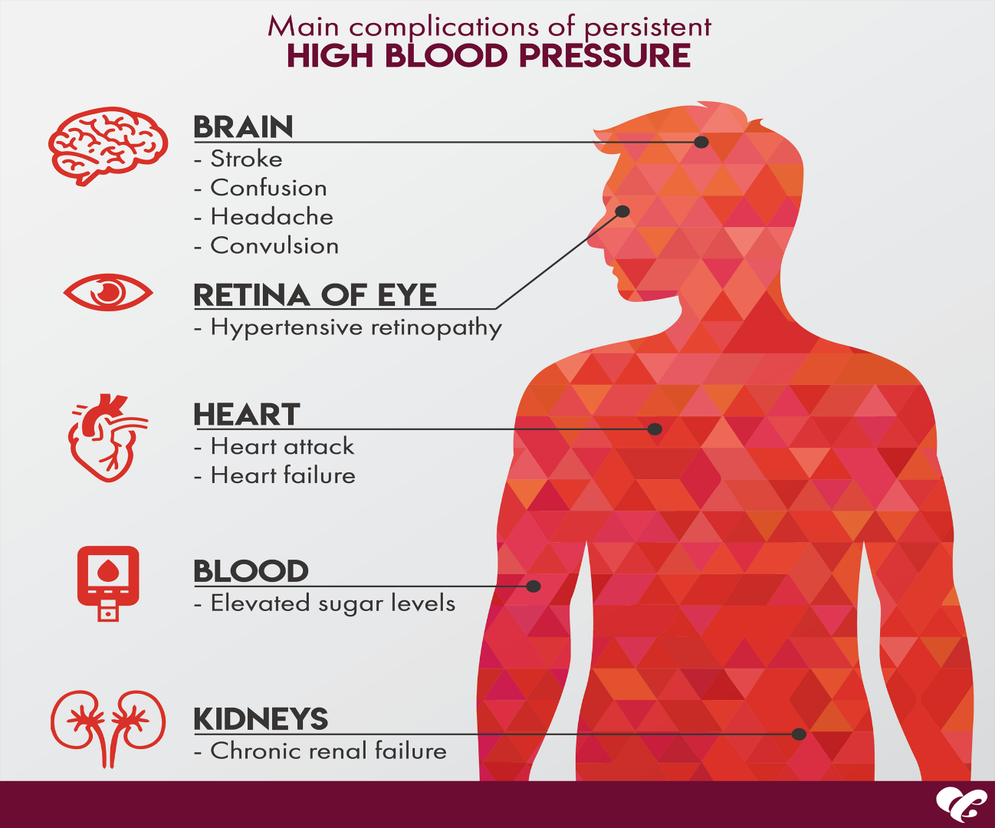

#### FIG 5 complications of high blood pressure

Diagnosis of high blood pressure Diagnosing hypertension is as simple as taking a blood pressure reading. Most doctors’ offices check blood pressure as part of a routine visit. If you don’t receive a blood pressure reading at your next appointment, feel free to request one.

# DEVICES USED TO DETECT HYPERTENSION

If your blood pressure is elevated, a doctor may request more readings over the course of a few days or weeks. Doctors rarely diagnose hypertension after just one reading. They’ll need to see evidence of a sustained problem.

That’s because your environment can contribute to increased blood pressure, like the stress you may feel by being at the doctor’s office . Also, blood pressurechanges throughout the day.

If your blood pressure remains high, a doctor will likely conduct more tests to rule out underlying conditions. These tests can include:

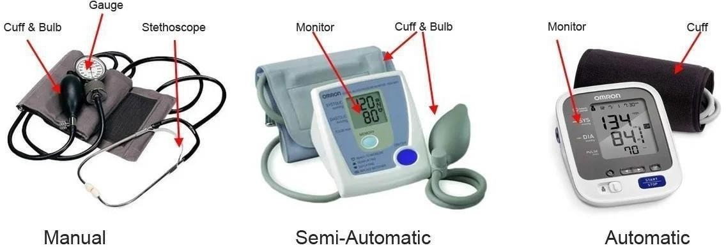

* + - cholesterol screening other blood tests
    - test of your heart’s electrical activity with an electrocardiogram (EKG, sometimes referred to as an ECG)
    - ultrasound of your heart or kidneys
    - home blood pressure monitor to monitor your blood pressure over a 24-hour period at home

## TREATMENT OPTIONS FOR HIGH BLOOD PRESSURE

If a doctor diagnoses you with primary hypertension, lifestyle changes may help reduce your high blood pressure. If lifestyle changes alone aren’t enough, or if they stop being effective, they may prescribe medication. Medications for hypertension

Many people go through a trial-and-error phase with blood pressure medications. A doctor may need to try different medications until they find one or a combination that works for you.

Some of the medications used to treat hypertension include:

* + - beta blockers
    - diuretics, aka water pills
    - ACE Inhibitors
    - Angiotensin II receptor blockers
    - Calcium channel blockers
    - alpha-2 agonists

Name

When they’re used

Side effects

|  |  |  |
| --- | --- | --- |
| Diuretics | These are often usedas first-line treatment, particularly the thiazide type. | depends on the type, but may lead to low or high potassium or other electrolyte imbalance |
| Alpha-blockers | These may beusedas an additional treatment option or in combination with other drugs. | headaches, nausea, dizziness, tremors, and more |
| Alpha-2 receptor agonists | These are primarily prescribed for other conditions, such as attention deficit hyperactivity disorder (ADHD) but may be used in unique circumstances. For example, methyldopa may be prescribed during pregnancy, as it’s safer than other drugs. | drowsiness or dizziness |
| Beta-blockers | These may be used when other medications like diuretics don’t work. | slow heart rate, cold extremities,insomia, weight gain, and others |
| Angiotensin | These may used treat heart failure or after | dry cough, rash, loss of taste, and |
| converting | a heart attack. | rarely kidney damage |
| enzyme (ACE) |  |  |
| inhibitors |  |  |

|  |  |  |
| --- | --- | --- |
| Angiotensin II receptor blockers | These may used treat heart failure or after a heart attack. | dizziness, headache, fatigue, and others |
| Calcium channel blockers | These may used an additional treatment option or in combination with other drugs. | depends on the type, but may lead to ankle swelling, flushing, constipation, slow heart rate, or heart palpitations |
| Vasodilators | These are often usedwhenthe systolic blood pressure is greater than 180 millimeters of mercury (mm Hg) and/or the diastolic blood pressure is greater than 120 mm Hg or to treat preeclampsia. | headache, eye swelling, joint pain, heart palpitations, weight gain |
| Aldosterone receptor antagonists | These are used mainly in casesof heart failure or a concern that heart failure may occur. | high potassium and impaired kidney function. |
| Direct renin inhibitors | Only one drug, aliskiren, is approved to treat high blood pressure, but it may not be the first choice. | diarrhea, cough, rash, headaches, dizziness, and various metabolic imbalances. |
| Peripheral adrenergic inhibitors | These are used only in cases when other medications don’t work. | diarrhea, heartburn, dizziness, weakness |

Treating secondary hypertension

If a doctor discovers an underlying issue causing your hypertension, treatment will focus on that other condition. For example, if a medication you’vestarted taking is causing increased blood pressure, your doctor will try other medications that don’t have this side effect.

Sometimes, hypertension is persistent despite treatment for the underlying cause. In this case, a doctor may work with you to develop lifestyle changes and prescribe medications to help reduce your blood pressure.

Treatment plans for hypertension often evolve. What worked at first may become less useful over time. Your doctor will continue to work with you to refine your treatment.

Home remedies for high blood pressure

Healthy lifestyle changes canhelpyou control thefactors that cause hypertension. Experts recommend the following:

* + - consuminga heart-healthydiet, emphasizingfruits, vegetables, whole grains, and lean proteins like fish
    - increasing physical activity, aiming for 150 minutes of moderate activity each week
    - maintaining a moderate
    - managing stress
    - quiting smoking if you do
    - limiting alcohol consumption

## LIFESTYLE TIPS TO LOWER YOUR RISK OF HYPERTENSION

If you have risk factors for hypertension, you can take steps now to lower your risk for the condition and its complications, such as:

* + - eating fruits each day
    - limiting the amount of refined sugar you consume
    - reducing your daily sodium intake to 1.5 to 2 gms setting weight loss goals you have overweight or obesity
    - monitoring your blood pressure regularly . Alcohol-induced hypertension:

Central nervous system in alcohol-induced hypertension. The World hypertension League speculated that the relatively greater effect alcohol on systolic blood pressure compared with diastolic blood pressure may indicate an imbalance between central nervous system factors influencing cardiac output and the peripheral vascular effects of alcohol. Thereis increasing evidence that alcohol initiates central as well as peripheral reactions which in a synergistic manner have a hypertensive action. In addition, alcohol induces an increased sympathetic outflow, most probably linked to secretion of corticotropinreleasing hormone. Some investigators have suggested that the association between alcohol and hypertension is related to the temporal sequence of alcohol use and blood pressure measurement. Since many community programs require an overnight or twelve-hour fasting period, alcohol withdrawal, albeit subclinical, may be occurring. Similarly, patients may abstain or diminish alcohol intake before visiting a clinic or physician. Thus, the observed elevations in blood pressure could be due to excessive central-nervous-system excitability and adrenergic discharge associated with the withdrawal period

# TREATMENT OF ALCOHOL-INDUCED HYPERTENSION

There are no definite clinical data available on the efficacy of specific drugs in the treatment of alcoholinduced hypertension. Randin et al have reported that dexamethasone (2 mg per day) in human suppresses the acute alcohol-induced hypertension. It is suggested that ACE inhibitors/angiotensin II receptor type 1 (AT1) blockers, because of their ability to increase the cardiac output in patients with alcohol-induced cardiomyopathy will be useful in the treatment of alcohol-induced hypertension. Cheng et alhave shown that angiotensin II type 1 receptor blockade prevents alcoholic cardiomyopathy in dogs. The calcium channel blockers, because of the probability of the involvement of calcium in the development of alcoholinduced hypertension, may also likely be the drug of choice for the treatment of alcoholinduced hypertension.

High blood pressure during pregnancy

People with hypertension may be more likely to experience challenges during pregnancy or childbirth,includes:

* + - decreased kidney function
    - low birth weight

Some people may develop hypertension during pregnancy. This often resolves once the baby is born. However, developing hypertension during pregnancy may increase your risk developing hypertension and other cardiovascular conditions later in life.

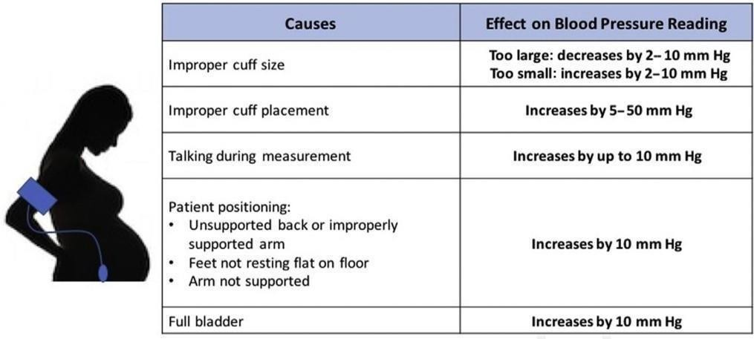

## CLASSIFICATION :

1. DIURETICS:

Thiazides: Hydrochlorothiazide,Chlorthalidone, Indapamide High ceiling: Furosemide, etc. K+ Sparing: Spironolactone, Amiloride

1. RENIN-ANGIOTENSIN SYSTEM INHIBITORS:

ACE inhibitors :Captopril,

Enalapril, Lisinopril, Perindopril, Ramipril, Fosinopril, etc.

Angiotensin (AT1 receptor) blockers: Losartan, Candesartan, Irbesartan, Valsartan, Telmisartan Direct renin inhibitor: Aliskiren

1. SYMPATHETIC INHIBITORS:

β Adrenergic blockers

Propranolol, Metoprolol, Atenolol, etc.

β + α Adrenergic blockers : Labetalol, Carvedilol α-Adrenergic blockers: Prazosin, Terazosin, Doxazosin, Phentolamine, Phenoxybenzamine Central sympatholytics: Clonidine, Methyldopa. Role of Diuretics in Management of Hypertension

Treatment of hypertension that uses a diuretic-based strategy has been effective in preventing stroke and cardiac disease in the earliest randomized clinical trials in the 1960s. A very high fraction of all hypertensives, but especially African-Americans, can be well controlled on simple two-drug regimens, combining a thiazide-type diuretic with either a β-blocker or an ACE inhibitor, each given once a day. Cost is minimal, control rates are high, and adherence to medication is probably optimum. There is a substantial argument that a thiazide-type diuretic should be the initial treatment for all hypertensives. A side issue related to that argument is that there is no detectable difference between chlorthalidone (used in ALLHAT and SHEP) and other thiazides. That said, diuretics are not a single drug class but rather can be divided into three distinct subclasses, and each of these has an important role to play in the management of most hypertensive patients. Although most diuretics have been in clinical use for many years, there has been drug development within this class. We will focus on the three diuretic classes used to treat hypertension: thiazide-type, loop-active agents, and the potassium-sparing agents, which act as either mineralocorticoid antagonists or inhibitors of the epithelial sodium channel of the

late distal renal tubule or collecting duct. Another subclass, the carbonic anhydrase inhibitors, is not used to treat hypertension.

Thiazide-Type Diuretics

As monotherapy and in combination with β-blockers, ACE inhibitors, or angiotensin receptor blockers, hydrochlorothiazide and its many variants lower blood pressure. There remains some controversy as to whether a thiazide-type diuretic should be the initial treatment for all hypertensives. The evidence from the SHEP study emphasizes the value of a low-dose thiazide-type drug as initial therapy for isolated systolichypertension in older patients, and ALLHAT strongly supports that choice for African- American hypertensives. For others, who are started on a β-blocker, ACE inhibitor, or angiotensin receptor blocker and whose pressure remains above goal, there is a convincing argument that a diuretic should be the next step. Either way, most hypertensives placed on one of these two drug combinations can be well controlled. Using a thiazide-type drug requires baseline serum electrolyte measurement and monitoring of serum potassium. Gout remains an occasional adverse reaction as a consequence of diuretic-induced hyperuricemia, and infrequently, hypercalcemia may occur.

These effects are the result of thiazide-related reductions in urinary urate or calcium excretion. Type 2 diabetes may develop during the course of thiazide-type diuretic reatment, yet in elderly patients, there seems to be little added risk for cardiovascular events compared with preexisting diabetes. For those patients who develop hypokalemia on low-dose thiazide-type diuretics, a diagnosis of primary aldosteronism may be considered. Addition of potassiumsparing drugs, spironolactone, eplerenone, or amiloride, may achieve effective control of hypertension .

K+ sparing diuretics :

Normally, sodium is reabsorbed in the collecting tubules of a renal nephron. This occurs via epithelial sodium channels or ENaCs, located on the luminal surface of principal cells that line the collecting tubules. Positively-charged Na+ entering the cells during reabsorption leads to an electronegative luminal environment causing the secretion of potassium (K+) into the lumen/ urine in exchange. Sodium reabsorption also causes water retention.

When the kidneys detect low blood pressure, the renin angiotensin aldosterone system (RAAS) is activated and eventually, aldosterone is secreted. Aldosterone binds to aldosterone receptors (mineralocorticoid receptors) increasing sodium reabsorption in an effort to increase blood pressure and improve fluid status in the body. When excessive sodium reabsorption occurs, there is an increasing loss of K+ in the urine and can lead to clinically significant decreases, termed hypokalemia. Increased sodium reabsorption also increases water retention.

Potassium-sparing diuretics act to prevent sodium reabsorption in the collecting tubule by either binding ENaCs (amiloride, triamterene) or by inhibiting aldosterone receptors (spironolactone,

eplerenone). This prevents excessive excretion of K+ in urine and decreased retention of water, preventing hypokalemia. Role of Renin Angiotensin Aldosterone System ACE Inhibitors:

Angiotensin-converting enzyme (ACE) inhibitors are medicines that help relax the veins and arteries to lower blood pressure. ACE inhibitors prevent an enzyme in the body from making angiotensin 2, a substance that narrows blood vessels. This narrowing can cause high blood pressure and forces the heart to work harder. Angiotensin 2 also releases hormones that raise blood pressure.

Angiotensin-converting enzyme regulates the balance between the vasodilatory and natriuretic properties of bradykinin and the vasoconstrictive and salt-retentive properties of Angiotensin II. ACE inhibitors alter this balance by decreasing the formation of Angiotensin II and the degradation of bradykinin. ACE inhibitors also alter the formation and degradation of several other

vasoactive substances, such as substance P, but the contribution of these compounds to the therapeutic

or adverse effects of ACE inhibitors is uncertain. AT1 Receptor Blockers:

ARBs reduce the action of the hormone angiotensin II. This hormone has a powerful constricting

effect on blood vessels, increasing blood pressure. Angiotensin II also stimulates salt and water retention in the body, which further increases blood pressure.ARBs work by blocking receptors that the hormone acts on, specifically AT1 receptors, which are found in the heart, blood vessels and kidneys. Blocking the action of angiotensin II helps to lower blood pressure and prevent damage to the heart and kidneys. β Adrenergic blockers:

The catecholamines, epinephrine, and norepinephrine bind to B1 receptors and increase cardiac automaticity as well as conduction velocity. B1 receptors also induce renin release, and this leads to an increase in blood pressure. In contrast, binding to B2 receptors causes relaxation of the smooth muscles along with increased metabolic effects such as glycogenolysis.

Beta-blockers vary in their specificity towards different receptors, and accordingly, the effects produced depend on the type of receptor(s) blocked as well as the organ system involved. Some betablockers also bind to alpha receptors to some degree, allowing them to induce a different clinical outcome when used in specific settings.

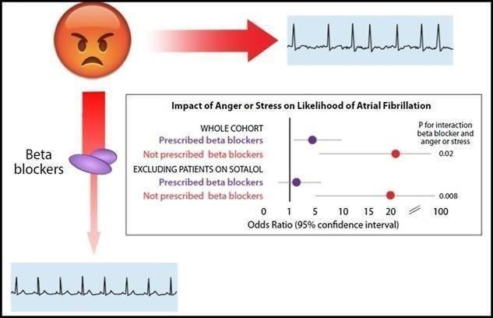

Once beta-blockers bind to the B1 and B2 receptors, they inhibit these effects. Therefore, the chronotropic and inotropic effects on the heart undergo inhibition, and the heart rate slows down as a result. Beta-blockers also decrease blood pressure via several mechanisms, including decreased renin and reduced cardiac output. The negative chronotropicand inotropic effects lead to a decreased oxygen demand; that is how anginaimproves afterbetablocker usage. Thesemedications also prolong the atrial refractory periods and have a potent antiarrhythmic effect.

Beta-blockers classify as either non-selective or beta-1 selective. There are also beta-blocking drugs that affect both beta-2 and/or beta-3 selectively; neither has a known clinical purpose to date. Nonselective agents bind to both beta-1 and beta-2 receptors and induce antagonizing effects via both receptors. Examples include propranolol, carvedilol, sotalol, and labetalol. Beta-1 receptor-selective blockers like atenolol, bisoprolol, metoprolol, and esmolol only bind to the beta-1 receptors; therefore, they are cardio-selective.

Beta-blockers lower the secretion of melatonin and hence may cause insomnia and sleep changes in some patients.

Alpha-1 receptors induce vasoconstriction and increased cardiac chronotropy; this means agonism at the alpha-1 receptors leads to higher blood pressure and an increased heart rate. In contrast, antagonism at the alpha-1 receptor leads to vasodilation and negative chronotropic, which leads to lower blood pressure and decreased heart rate. Some beta-blockers, such as carvedilol, labetalol, and bucindolol, have additional alpha-1 receptor blockage activity in addition to their non-selective beta receptor blockage. This property is clinically useful because beta-blockers that block the alpha-1 receptor have a more pronounced clinical effect on treating hypertension.

Sotalol is a beta blocker and also blocks potassium channels. It is a class III antiarrhythmic. β

+ α Adrenergic blockers

Beta blockers are medicines that lower blood pressure. They also may be called betaadrenergic blocking agents. The medicines block the effects of the hormone epinephrine, also known as adrenaline.

Beta blockers cause the heart to beat more slowly and with less force. This lowers blood pressure. Beta blockers also help widen veins and arteries to improve blood flow.

Other mechanisms of action of beta-blockers include:

* Inhibiting renin release
* Reducing venous return and plasma volume
* Reducing peripheral vascular resistance
* Improving vascular compliance
* Resetting of baroreceptor levels
* Reducing norepinephrine release α-Adrenergic blockers

Alpha blockers typically aren't the first treatment option for high blood pressure. Instead, they're used together with other medicines, such as diuretics, when high blood pressure is difficult to control.

Alpha blockers are sometimes given to prevent, treat or improve symptoms of an enlarged prostate, also called benign prostatic hyperplasia.

Alpha blockers are a type of blood pressure medicine. Alpha blockers lower blood pressure by keeping a hormone called norepinephrine from tightening the muscles in the walls of smaller arteries and veins. As a result, the blood vessels remain open and relaxed. This improves blood flow and lowers blood pressure.

Alpha blockers also relax other muscles throughout the body. So, these medicines are sometimes used to improve urine flow in older men with prostate problems.

**NEW FDA DRUGS**

In 2023, the FDA approved Tryvio (Aprocitentan), an endothelin receptor antagonist, for treating resistant hypertension. This drug works by blocking endothelin, a molecule that causes blood vessels to constrict, and is prescribed alongside other antihypertensive drugs for individuals whose blood pressure remains uncontrolled despite taking multiple medications. It represents one of the first new

treatment pathways for hypertension in decades, offering hope for patients with particularly hardtomanage cases.

Each of these medications is approved based on rigorous clinical trials and evidence of effectiveness. For patients seeking treatment abroad, it’s essential to confirm whether these FDA-approved treatments are recognized and available in other countries.

#### Overview:

Tryvio (Aprocitentan) is a newly FDA-approved drug designed to treat resistant hypertension, a condition where patients’ blood pressure remains elevated despite taking multiple antihypertensive medications. Approved in 2023, Tryvio is an endothelin receptor antagonist developed by Idorsia Pharmaceuticals, and it represents a significant breakthrough for patients who struggle to achieve adequate blood pressure control with existing treatments.

Mechanism of Action:

Aprocitentan, sold under the brand name Tryvio, is a medication used to treat hypertension (high blood pressure). It is developed by Idorsia. It is taken by mouth.

Aprocitentan is a receptor antagonist that targets both endothelin A and endothelin B receptors.

Aprocitentan was approved for medical use in the United States in March 2024. It is the first endothelin receptor antagonist to be approved by the Us food and drug adminstrartion (FDA) to treat systemic hypertension.

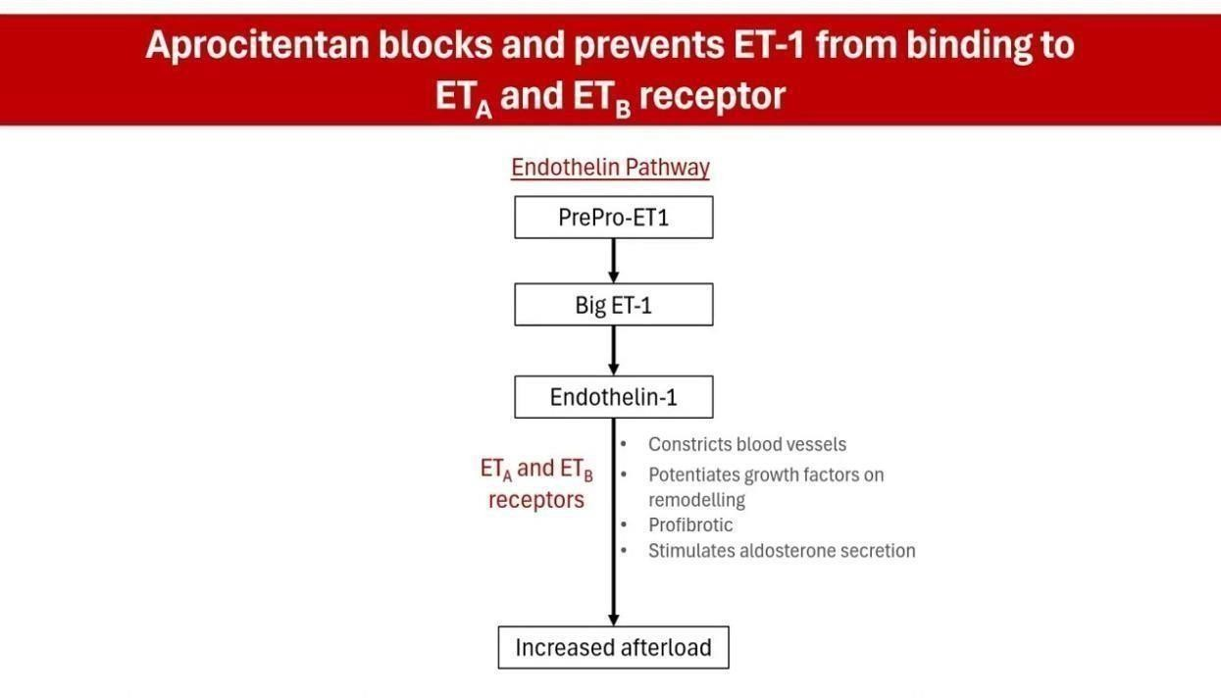

### MEDICAL USES

Aprocitentan is indicatedfor the treatment of hypertension in combinationwith other antihypertensive drugs, to lower blood pressure in adults who are not adequately controlled on other medications.

### ADVERSE EFFECTS

Aprocitentan may cause hepatoxicity (liver damage), edema (fluid retention), anemia (reduced hemoglobin), and decreased sperm count.

Contraindications

Data from animal reproductive toxicity studies with other endothelin-receptor agonists indicate that use is contraindicated in pregnant women.

Tryvio works by blocking the endothelin receptor. Endothelin is a potent vasoconstrictor, meaning it causes blood vessels to narrow. By inhibiting this receptor, Tryvio helps relax blood vessels, leading to a reduction in blood pressure. It is particularly useful for patients whose hypertension remains resistant, even when treated with at least three other blood pressure medications

## CLINICAL TRIALS AND APPROVAL:

The FDA’s approval of Tryvio was based on data from the PRECISION clinical study, which included more than 700 patients. Participants had systolic blood pressure levels above 140 mmHg, despite being on at least three antihypertensive medications. The trial showed that aprocitentan consistently reduced blood pressure across all subgroups, making it a valuable option for difficult-totreat cases.

Indications and Usage:

Tryvio is intended for patients with resistant hypertension who have not achieved control with other therapies. It is administered once daily, either with or without food, and has been shown to provide sustained blood pressure reduction even in high-risk populations ￼.

Significance:

Resistant hypertension is a serious condition that affects millions of people worldwide. Uncontrolled blood pressure significantly raises the risk of cardiovascular and cerebrovascular events such as heart attacks and strokes. Tryvio offers a new hope for patients whose hypertension has been difficult to manage, addressing a major unmet medical need.

In conclusion, Tryvio represents a promising new treatment for hypertension, offering an additional option for patients with difficult-to-control blood pressure. Its approval adds to the limited pool of treatments for resistant hypertension, a critical area in cardiovascular care.

Absorption

The absolute oral bioavailability of aprocitentan is unknown.6 The mean Cmax and AUC0tau following a single oral dose of 25mg are approximately 1.3 mcg/mL and 23 mcg.h/mL, respectively, with a Tmax between 4-5 hours.

Volume of distribution

The apparent volume of distribution of aprocitentan is approximately 20 L. Protein binding

Aprocitentan is highly (>99%) protein-bound in plasma, primarily to albumin. Metabolism

Aprocitentan is primarily metabolized by UGT1A1- and UGT2B7-mediated N-glucosidation and

nonenzymatic hydrolysis.

Route of elimination

Following the administration of a single radiolabeled dose of aprocitentan, approximately 52% of the dose was eliminated via urine (0.2% un hanged) and 25% via feces (6.8% unchanged). 6

Half-life

The effective half-life of aprocitentan is approximately 41 hours. Clearance

The apparent clearance of aprocitentan is approximately 0.3 L/h.

## CONCLUSION

In conclusion, hypertension is globally theleadingcauseof cardiovascular disease and prematuredeath, Although the classifications and definitions ofhypertension vary across guidelines, there is a sharedgoal of utilizing evidence-based research to provideeffective strategies to prevent and manage hyperten-sion. Treatment goals and strategies must be individ-ualized to a patient’s lifestyle, comorbidities, andpreferences to minimize potential harm and increasethe likelihood of long -term compliance. Lifestylemodifications are recommended before initiation ofpharmacological therapy in low-moderate riskpatients, and alongside pharmacological therapy inhigher risk patients.

Monotherapy with first-line anti-hypertensive agents, including diuretics, RAAS inhibi-tors, CCBs, and beta-blockers, is often inadequate formost hypertensive patients. As such, single-pill combinations are recommended to approve the speed

In 2023, the FDA approved Tryvio (Aprocitentan), an endothelin receptor antagonist, for treating resistant hypertension. This drug works by blocking endothelin, a molecule that causes blood vessels to constrict, and is prescribed alongside other antihypertensive drugs for individuals whose blood pressure remains uncontrolled despite taking multiple medications. It represents one of the first new treatment pathways for hypertension in decades, offering hope for patients with particularly hardtomanage cases.

# REFERENCES

1. Anandita Mitra, Rituparna Roy, Sandip Paul. Modulating the Self-Assembly of a Camptothecin Prodrug with Paclitaxel for Anticancer Combination Therapy: A Molecular Dynamics Approach. *The Journal of Physical Chemistry B* **2024**, *128* (44) , 10799-10812. https://doi.org/10.1021/acs.jpcb.4c04798
2. Naoki Shida, Yugo Shimizu, Akizumi Yonezawa, Juri Harada, Yuka Furutani, Yusuke Muto, Ryo Kurihara, Junko

N. Kondo, Eisuke Sato, Koichi Mitsudo, Seiji Suga, Shoji Iguchi, Kazuhide Kamiya, Mahito Atobe.

Electrocatalytic

Hydrogenation of Pyridines and Other Nitrogen-Containing Aromatic Compounds. *Journal of the American Chemical Society* **2024**, *146* (44) , 30212-30221. https://doi.org/10.1021/jacs.4c09107

1. Rosamond W Flegal K Furie K Go A Greenlund K Haase N Hailpern SM Ho M Howard V Kissela B Kittner S Lloyd-Jones D McDermott M Meigs J Moy C Nichol G O’Donnell C Roger V Sorlie P Steinberger J Thom T Wilson MHong Y. Heart disease and strokestatistics: 2008 updateat-a-glance. Dallas: American Heart Association, 2008.
2. Nangia-Makker, P.; Honjo, Y.; Sarvis, R.; Akahani, S.; Hogan, V.; Pienta, K. J.; Raz, A. Galectin-3 induces endothelial cell morphogenesis and angiogenesis. *Am. J. Pathol.* **2000**, *156* (3), 899– 909, DOI: 10.1016/S0002-9440(10)64959-0
3. Laaf, D.; Bojarová, P.; Pelantová, H.; Křen, V.; Elling, L. Tailored multivalent neo-glycoproteins: synthesis, evaluation, and application of a library of galectin-3-binding glycan ligands. *Bioconjugate Chem.* **2017**, *28* (11), 2832– 2840, DOI: 10.1021/acs.bioconjchem.7b00520

6, Barman, S. A.; Li, X.; Haigh, S.; Kondrikov, D.; Mahboubi, K.; Bordan, Z.; Stepp, D. W.; Zhou, J.; Wang, Y.; Weintraub, D. S.Galectin-3 is expressed in vascular smooth muscle cells and promotes pulmonary hypertension through changes in proliferation, apoptosis, and fibrosis. *Am. J. Physiol. Lung Cell Mol. Physiol.* **2019**, *316* (5), L784– L797, DOI: 10.1152/ajplung.00186.2018

1. Hara, A.; Niwa, M.; Kanayama, T.; Noguchi, K.; Niwa, A.; Matsuo, M.; Kuroda, T.; Hatano, Y.; Okada, H.; Tomita, H. Galectin-3: A potential prognostic and diagnostic marker for heart disease and detection of early stage pathology. *Biomolecules* **2020**, *10* (9), 1277, DOI: 10.3390/biom10091277
2. Tian, L.; Chen, K.; Cao, J.; Han, Z.; Wang, Y.; Gao, L.; Fan, Y.; Wang, C. Galectin-3 induces the phenotype transformation of human vascular smooth muscle cells *via* the canonical Wnt signaling. *Mol. Med. Rep.* **2017**, *15* (6), 3840– 3846, DOI: 10.3892/mmr.2017.6429
3. Hoeper, M. M.; Humbert, M.; Souza, R.; Idrees, M.; Kawut, S. M.; Sliwa-Hahnle, K.; Jing, Z. C.; Gibbs, J. S. A global view of pulmonary hypertension. *Lancet Respir. Med.* **2016**, *4* (4), 306– 322, DOI: 10.1016/S2213-2600(15)00543-3
4. Mazurek, J. A.; Horne, B. D.; Saeed, W.; Sardar, M. R.; Zolty, R. Galectin-3 levels are elevated and predictive of mortality in pulmonary hypertension. *Heart Lung Circ.* **2017**, *26* (11), 1208– 1215, DOI: 10.1016/j.hlc.2016.12.012