**Tubulointerstitial Nephritis: From Pathogenesis to Precision Medicine**

Singh Aditi*1 , Kumar Rajneesh*2, sonkar Kamal*3, Musaeva B.S *4 * 1,*2,*3 student of 5th Year International Medical Faculty, Osh State University , Osh, Kyrgyzstan

*4 Practical Teacher Hospital therapy (General Medicine) ,IMF, Osh State University, Osh, Kyrgyzstan

**ABSTRACT**

Tubulointerstitial nephritis (TIN) is a kidney disease which is characterized by the inflammation in the kidney's tubules and interstitium. It can be acute or chronic, and is often caused by immune-mediated reactions to medications, infections, or other underlying conditions. Symptoms may include decreased urine output, fatigue, and edema. Diagnosis typically involves blood tests, urine tests, and kidney biopsy. Treatment depends on the underlying cause and may include discontinuing medications, treating infections, or using immunosuppressive therapy. In some cases, TIN can progress to chronic kidney disease.

Keywords: Tubulointerstitial Nephritis Kidney disease , interstitium, kidney biopsy, immunosuppressive therapy, etc.

1. **INTRODUCTION**

Tubulointerstitial nephritis (TIN) is a kidney disease which affects the tubules and the surrounding tissue (interstitium) of the kidneys. In this condition, the immune system mistakenly attacks the kidney tissue, leading to inflammation and damage.

TIN can be acute or chronic. Acute TIN often develops rapidly, usually within days or weeks after exposure to a triggering agent. Chronic TIN, on the other hand, progresses more slowly over months or years.

The causes of TIN are diverse. Some common causes include:

* Medications: Certain medications, such as antibiotics (penicillin, sulfa drugs), pain relievers (NSAIDs), and diuretics, can trigger an allergic reaction that damages the kidneys.

* Infections: Viral or bacterial infections can spread to the kidneys and cause inflammation.

* Autoimmune diseases: Conditions like systemic lupus erythematosus (SLE) and Sjögren's syndrome can affect the kidneys.

* Environmental toxins: Exposure to certain chemicals or heavy metals can damage the kidneys.

* Genetic disorders: Some inherited conditions can predispose individuals to TIN.

The symptoms of TIN can vary depending on the severity and underlying cause. They may include:

* Decreased urine output

* Fatigue

* Edema (swelling)

* Fever

* Rash

* Pain in the sides or back

* Changes in urine color or odor

Diagnosis of TIN often involves a combination of blood tests, urine tests, and imaging studies. The kidney biopsy can be necessary to confirm the diagnosis and determine the underlying cause.

Treatment for TIN focuses on addressing the underlying cause and managing symptoms. This may involve:

* Discontinuing the offending medication

* Treating infections with antibiotics

* Using immunosuppressive medications to reduce inflammation

* Managing kidney function and preventing complications

Early diagnosis and prompt treatment are very crucial to prevent the progression to chronic kidney disease.

1. **RESULTS AND DISCUSSION**

**Results**

* Histological Findings: Kidney biopsies from patients with TIN typically reveal inflammation and damage to the tubules and interstitium. This includes infiltration of inflammatory cells like lymphocytes and eosinophils, tubular injury, and interstitial edema. In chronic cases, fibrosis and scarring may develop.

* Laboratory Abnormalities: Blood tests may show elevated creatinine levels, indicating impaired kidney function. Urine tests often reveal abnormalities such as proteinuria (protein in the urine), hematuria (blood in the urine), and white blood cell casts.

* Imaging Studies: Ultrasound or CT scan of the kidneys may show enlarged kidneys or other abnormalities, but these are often nonspecific.

**Discussion**

Pathogenesis: TIN is an immune-mediated disease. The exact mechanisms(ary depending on the underlying cause. In drug-induced TIN, the offending medication may trigger an allergic reaction, leading to inflammation. In infection-related TIN, immune cells may attack the kidney tissue in response to the infection. In autoimmune TIN, the body's immune system mistakenly targets the kidney.

Clinical Presentation: The clinical presentation of TIN is often nonspecific, making diagnosis challenging. Symptoms may include decreased urine output, fatigue, edema, fever, rash, and pain in the sides or back. There may be changes in the color and odor of urine.

Diagnosis: Diagnosis of TIN often requires a combination of clinical findings, laboratory tests, and imaging studies. A kidney biopsy is usually the definitive diagnostic tool, as it allows for direct examination of the kidney tissue.

Treatment: Treatment of TIN depends on the underlying cause. In cases of drug-induced TIN, discontinuing the offending medication is often sufficient. Infections may require antibiotic therapy. In autoimmune TIN, immunosuppressive medications can be necessary to ease inflammation.

Prognosis: The prognosis of TIN varies on the underlying cause and the severity of kidney damage. In many cases, prompt detection and timely treatment can lead to complete recovery. However, in some cases, TIN can progress to chronic kidney disease.

Future Directions: Further research is needed to better understand the pathogenesis of TIN and to develop more targeted therapies. Identifying biomarkers for early diagnosis and monitoring disease progression is also an important area of research.

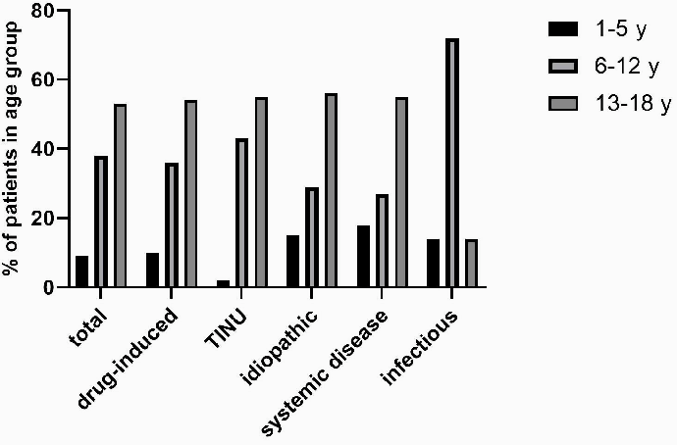

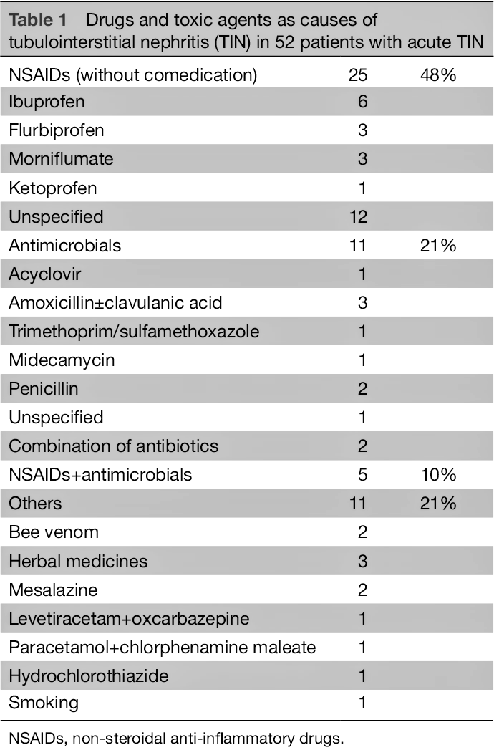

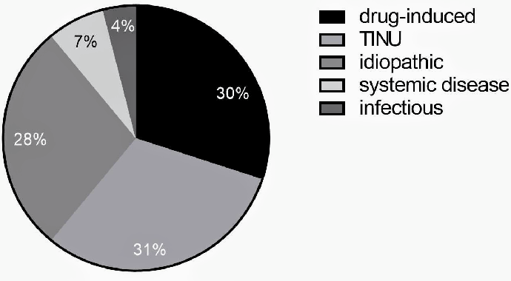

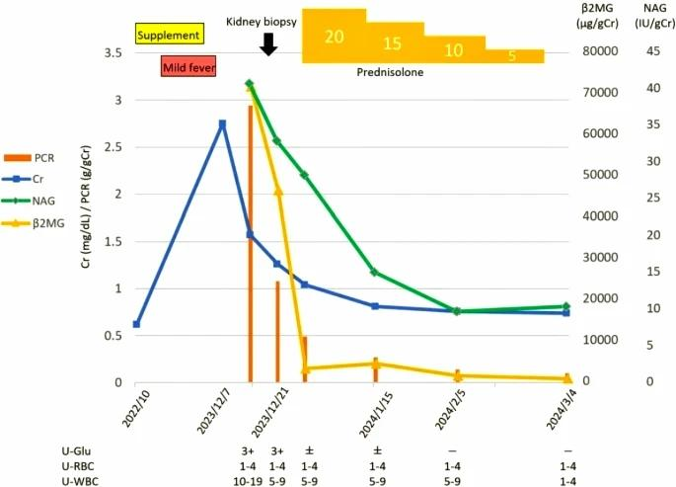

1. **CONCLUSION**

Tubulointerstitial nephritis (TIN) is a kidney disease that results in the inflammation at tubules of kidney and the surrounding tissue. It can be caused by numerous reasons which includes medications, infections, and autoimmune diseases. TIN can lead to kidney failure if left untreated.

The evaluation of TIN is usually based on a combination of symptoms, blood tests, and a kidney biopsy. Treatment for TIN depends on the root causes. usually In some cases, simply stopping the offending medication is enough to resolve the problem. In other cases, treatment may involve medications to restrain the immune system or treat the underlying autoimmune disease.

Early diagnosis and treatment of TIN are important to hinder the kidney damage and enhance the prognosis.

1. **REFERENCE**

Comprehensive Review:

* Tubulointerstitial Nephritis: Diagnosis, Treatment and Monitoring:

* Joyce E, Glasner P, Ranganathan S, Swiatecka-Urban A. Pediatr Nephrol. 2017 Apr; 32(4):577-587.

* https://pmc.ncbi.nlm.nih.gov/articles/PMC5099107/

Pathophysiology and Etiology:

* Tubulointerstitial Nephritis: Practice Essentials, Pathophysiology, Etiology:

* Bhandari J, Thada PK, Rout P, Arif H. Tubulointerstitial Nephritis. 2024 Jan.

* https://emedicine.medscape.com/article/243597-overview

Drug-Induced Tubulointerstitial Nephritis:

* Drug-Induced Tubulointerstitial Nephritis: Insights From the World Health Organization Safety Database:

*https://www.researchgate.net/publication/360394853_Drug-induced_tubulointerstitial_nephritis_insights_from_the_WHO_Safety_Database

Additional Resources:

* Tubulointerstitial Nephritis - MSD Manual Professional Edition:

*https://www.merckmanuals.com/professional/genitourinary-disorders/tubulointerstitial-diseases/tubulointerstitial-nephritis

* Tubulointerstitial nephritis | Radiology Reference Article | Radiopaedia.org:

* https://radiopaedia.org/articles/tubulointerstitial-nephritis

Remember to cite these references in your article according to the appropriate style guide (e.g., APA, MLA, Chicago).