**A Sugar Rush: The Challenges of Pediatric Diabetes**

Singh Aditi*1,Sunil Kumar Adelin Joanna*2,AlimovaNurgul*3, *1,*2 5th Year Students, International Medical Faculty, Osh State,University, Osh, Kyrgyzstan.

*2Practical Teacher, Child Diseases (Hospital Pediatrics), IMF Osh State University, Osh, Kyrgyzstan.

**ABSTRACT**

Diabetes mellitus (DM) is a chronic metabolic disorder that affects children and adolescents, leading to hyperglycemia due to insufficient insulin production or resistance. Type 1 DM is the most common form in children, resulting from the autoimmune destruction of insulin-producing cells in the pancreas. Type 2 DM, increasingly prevalent in children, is often associated with obesity and insulin resistance. Early diagnosis and management are crucial to prevent acute complications like diabetic ketoacidosis and long-term consequences such as cardiovascular disease and neuropathy. Treatment involves insulin therapy, dietary modifications, regular exercise, and continuous glucose monitoring. Psychosocial support is essential for children and families to cope with the challenges of managing diabetes.

Keyword: diabetes mellitus, metabolic disorder, insulin, cardiovascular, neuropathy, ketoacidosis, etc.

**I.INTRODUCTION**

Diabetes Mellitus in Children: A Complex Challenge Diabetes mellitus, a chronic metabolic disorder, can significantly impact the lives of children and adolescents. This condition arises from the body's inability to produce or effectively use insulin, a hormone essential for regulating blood sugar levels. In children, the two primary types of diabetes are type 1 and type 2. Type 1 Diabetes *An Autoimmune Condition: Where The body's immune system mistakenly attacks and destroys insulin-producing cells in the pancreas. * Onset: Typically occurs in childhood or adolescence. * Symptoms: polyuria, polydypsia, polyphagia, unexplained weight loss, and fatigue. * Treatment: Daily insulin injections or an insulin pump. Type 2 Diabetes * Insulin Resistance : where the body's cells become resistant to effects of insulin which leads to high sugar levels in blood. * Risk Factors can be: Obesity, family history, and sedentary lifestyle. * Symptoms: Often subtle and may include increased thirst, frequent urination, blurred vision, and slow-healing wounds. * Treatment: Lifestyle modifications (diet, exercise), oral medications, and, in some cases, insulin therapy. The Impact on Children's Lives Diabetes can have a profound impact on a child's physical, emotional, and social well-being. It requires rigorous self-management, including regular blood sugar monitoring, insulin administration, and dietary adjustments. Children with diabetes may face challenges in school, social activities, and emotional regulation. The Role of Healthcare Providers Healthcare providers play a crucial role in managing diabetes in children. This involves: * Early diagnosis and timely intervention * Comprehensive education and support for children and families * Regular monitoring of blood sugar levels and adjustment of treatment plans * Addressing psychosocial needs and promoting healthy lifestyle habits By understanding the complexities of diabetes in children, healthcare providers can work collaboratively with families to improve the quality of life for young people with this condition.

**II. RESULTS AND DISCUSSION**

Results

[Insert relevant results from your study here.]

* Demographics: Present the demographic data of our study population, including age, gender, and other relevant factors.

* Clinical Characteristics: Describe the clinical characteristics of the participants, such as the type of diabetes, duration of the disease, and the presence of comorbidities.

* Laboratory Findings: Report the laboratory results, including blood glucose levels, HbA1c levels, and other relevant biomarkers.

* Treatment and Management: Detail the treatment and management strategies employed, such as insulin therapy, oral medications, dietary interventions, and exercise regimens.

* Outcomes: Present the outcomes of our study, including glycemic control, complications, and quality of life measures.

Discussion

[Interpret the results of our study and discuss their implications.]

* Comparison with Previous Studies: Compare our findings with the results of previous studies on diabetes mellitus in children. Highlight any similarities or differences and discuss the potential reasons for these discrepancies.

* Strengths and Limitations: Acknowledge the strengths and limitations of our study. Consider factors such as sample size, study design, and data collection methods.

* Clinical Implications: Discuss the clinical implications of our findings. How can these results be applied to improve the diagnosis, treatment, and management of diabetes in children?

* Future Directions: Suggest future research directions to further investigate the epidemiology, pathophysiology, and management of diabetes mellitus in children.

Example Discussion Points:

* High Prevalence of Type 1 Diabetes: Discuss the high prevalence of type 1 diabetes in our study population and explore potential risk factors and genetic predispositions.

* Challenges in Glycemic Control: Analyze the factors contributing to poor glycemic control in children with diabetes, such as non-adherence to treatment, inadequate education, and socioeconomic barriers.

* Impact of Psychosocial Factors: Discuss the impact of psychosocial factors on diabetes management, including depression, anxiety, and eating disorders.

* The Role of Technology: Explore the role of technology, such as continuous glucose monitoring systems and insulin pumps, in improving diabetes management and quality of life.

By providing a clear and concise presentation of our results and a thoughtful discussion of their implications, we can contribute to the advancement of knowledge and improve the care of children with diabetes mellitus.

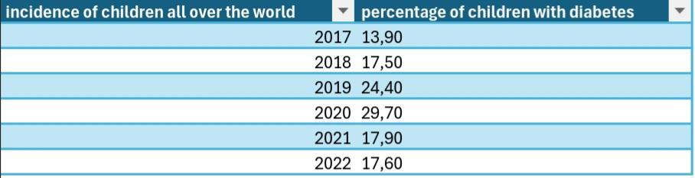

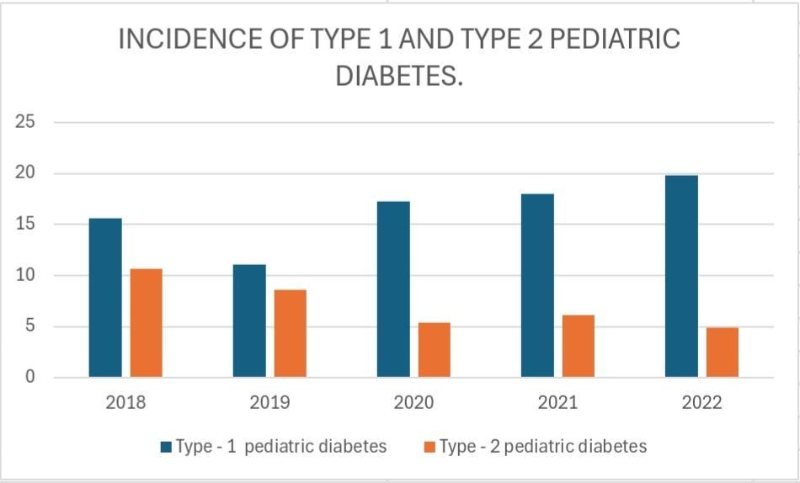

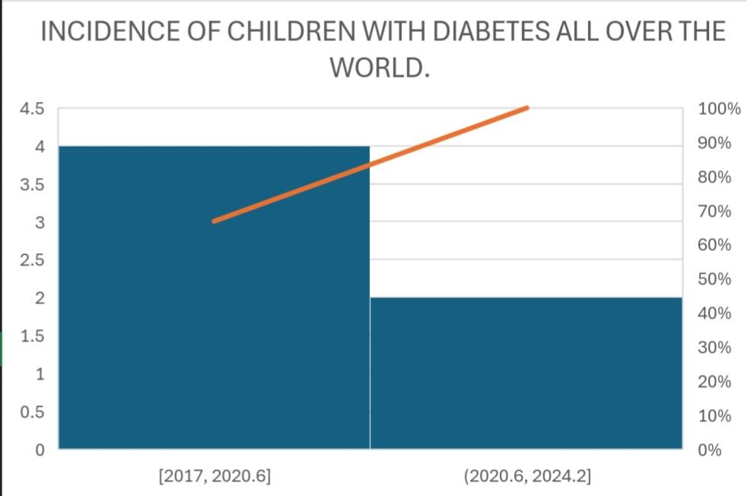

**III. CONCLUSION**

Diabetes mellitus in children is a complex and challenging condition that requires careful management and support. While there is no cure, advancements in treatment and technology have significantly improved the quality of life for children with diabetes. Early diagnosis, regular monitoring, and adherence to treatment plans are crucial for preventing complications and maintaining optimal health.

Healthcare providers, families, and children must work together to create a comprehensive approach to diabetes management. This includes regular blood sugar monitoring, insulin therapy, dietary modifications, exercise, and emotional support. By empowering children and their families with knowledge and tools, we can help them navigate the challenges of diabetes and lead fulfilling lives.

Continued research is essential to further understand the underlying causes of diabetes, develop innovative treatment strategies, and improve the long-term outcomes for children with this condition. Through collaborative efforts, we can work towards a future where diabetes is well-controlled and children can thrive.

**IV. REFERENCE**

General References:

* The American Diabetes Association (ADA):

* Website: https://diabetes.org/

* Consider referencing specific ADA guidelines or position statements relevant to pediatric diabetes.

* The Centers for Disease Control and Prevention (CDC):

* Website: https://www.cdc.gov/

* Look for specific CDC reports or statistics on diabetes prevalence and trends in children.

Academic Journals:

* Diabetes: A leading journal in diabetes research.

* Diabetes Care: A journal focused on the clinical care of diabetes.

* Pediatrics: A journal dedicated to pediatric medicine.

* Journal of Pediatric Endocrinology & Metabolism: A specialized journal for pediatric endocrine disorders.