**A STUDY ON IMPACT OF COMPENSATION MANAGEMENT ON**

**EMPLOYEES’ PERFORMANCE - SRI RAMALINGESWARA PAPER MILLS PRIVATE LIMITED, RAJAHMUNDRY, AP**

Yenugupalli durga Prasad, MBA 2nd year

Email ID: durgaprasadyenugupalli95@gmail.com

And

Dr.R.Raja

Assistant professor

Department of management studies

Godavari institute of engineering and technology (Autonomous)

Rajamahendravaram, Andhra Pradesh, India

Email ID: rachagundlaraja@giet.ac.in

#### ABSTRACT

In order to accomplish its goals, every business must employ a staff that is both capable and experienced. The degree of expertise required in the workplace must rise, as must workers' adaptability and flexibility. Investment in employee compensation management of employee performance is not just a good idea, but a must for any company that wants to keep its workforce competitive and well-informed.

The purpose of the research was to determine how successful financial performances and strategies are in improving the knowledge and skills of staff members at the Sri ramalingeswara papermills the information was gathered from 120 workers who were chosen at random. Currently Working at the Sri Ramalingeswara paper mills. The goal of this effort has been to compile a body of information on financial performance that may be used as a resource by anyone doing.

**KEYWORDS:** performance, compensation management, Organization, Effectiveness.

## INTRODUCTION

Human Resource Management has come to be recognized as an inherent part of management, which is concerned with the human resource of an organization. Its objective is the maintenance of better human relations in the organization by the development, application and evaluation of policies, procedures and programmed relating to human resource to optimize their contribution towards the realization of organizational objectives.

#### Scenario of Paper Mill Industry

India first Machine-made paper was manufactured in 1812. During this time there were 15 mills with a total production of lakh tones. In India the Soft wood is the principal raw material used for making paper especially newsprint and high-class printing papers. Indian paper industry needs the following for being globally more competitive. Sustained availability of good quality of raw materials (forest based) and bulk import of waste paper to supplement the availability of raw materials.

* Adequate modernization of the manufacturing assets.
* Improvement of the infrastructure.
* Quality improvements and reduction in cost of production
* Import policy conducive for import of material, equipment, instruments, rawmaterials & technologies which are bearing of the quality and environment.
* Based on the recommendations made in the Report and in consultant

with the industry Associations, action plans are being finalized in consultation with other Ministries/Departments concerned.

**PROFILE OF SRI RAMALINGESWARA PAPERPRODUCTS PRIVATE LIMITED**

Being authorized dealer for supplying Hydraulic Paper Plate Machine. They are reckoned as one of the most coveted suppliers, trader, exporters and service providers of Hydraulic Paper Plate Machine.

It is a private company which is a leading supplier and it is classified as the Indian Non- Government Company Indian Non-Government Company. It was established in15/05/1995. So, it has 23 Years 4 Months 3 Days year of trust.

The total paid-up capital is INR 2.29 cr. The company also has secured loans in the amount of INR 5.30 cr. The last reported AGM (Annual General Meeting) of the company, per our records, was held on 26 September, 2018. Also, as per our records, its last balance sheet was prepared for the period ending on 31 March, 2018. Counted as one of the top suppliers, they are involved in offering a wide range of Hydraulic Paper Plate Machine. These Hydraulic Paper Plate Machine are widely recommended by clients owing to its quality and consistent performance. Their Hydraulic Paper Plate Machine are sourced from reliable suppliers of the industry, who supplies these as per international industrial standards. Their Hydraulic Paper Plate Machine are widely appreciated in suppliers’ market and offering Hydraulic Paper Plate Machine which is in great demand to the clients.

**LITERATURE REVIEW :**

#### Lin Grensing-Pophal -Published in HR Daily Advisor, she highlights the complexities HR professionals face in balancing inflation-driven salary demands with economic uncertainties. Her work emphasizes benefits enhancement, wellness programs, and tailored compensation strategies for diverse employee needs.

#### Ronald G. Sica-A contributor to Salary.com, Sica has analyzed trends in wage transparency and the labor market's competitive nature. His findings discuss the impact of economic factors on compensation, the rise of pay transparency regulations, and strategies to mitigate wage compression.

#### Sheri Atwood-CEO of SupportPay, Atwood provides industry insights into the growing emphasis on holistic benefit packages. Her research ties financial wellness to employee retention and suggests expanding support for life-stage-specific benefits like eldercare and child care.

#### WorldatWork Team-A collective effort from WorldatWork, their annual "Compensation Best Practices" reports explore evolving compensation strategies, including shifts toward pay equity, the role of remote work in compensation structuring, and innovations in total rewards programs.

#### Jessica Miller-Merrell-Through her HR and recruitment expertise, Miller-Merrell has published studies and articles discussing how companies adapt to the gig economy and flexible work arrangements, emphasizing agile compensation frameworks.

#### Mercer Research Team-Mercer's compensation trend analyses focus on the strategic integration of financial and non-financial rewards, leveraging data analytics for personalized compensation, and exploring the intersection of DE&I and pay equity

#### .NEED FOR THE STUDY

1. An effective compensation strategy motivates current employees and is used as a tool to attract new ones

2. Organizations use a compensation strategy to define how it views and manages employee pay and benefits.

3. The main purpose of this study would be to gauge the extent to which compensation system affects the employees’ intention to stay in the organization, being moderated by working environment

#### SCOPE OF THE STUDY

The compensation management in Sri Ramalingeswara Paper Mill. Refers to a person’s feeling of satisfaction on their job. It is different from person to person. The researcher has chosen to measure the level compensation management in Sri Ramalingeswara Paper Mill.

The study considers the impact of 10 factors on compensation management in it concentrates on the effect of factors in general, but no exclusive study is made on them.

The study considers only the perceptual elements of employees and does not focus on ground realities. The scope of study cover: work conditions, compensation, extra benefits, conveyance treatment of superiors, colleagues, duly timings, and grievance reprisal mechanism and promotion policy.

#### OBJECTIVES OF THE STUDY

#### T understand in details how to establish pay rates to different level of employee

#### To understand the impact of compensation management on performance level To determine the extent at which compensation management affect employee’s performance

#### To know whether the employees are getting fair and equitable remuneration

#### To know whether the workers are getting enough motivation to work more efficiently.

#### Methodology of the study

#### Primary Data:

**Surveys:** A structured questionnaire will be designed to assess perceptions of compensation management and its impact on performance.

#### Secondary Data:

Company records and reports on employee performance metrics.

Existing literature on compensation management and its effects on employee performance.

#### RESULTS AND FINDINGS

1. **Designation:**

**Table 5.1**

|  |  |  |
| --- | --- | --- |
| **Opinion** | **No of Responses** | **% of Responses** |
| Employee | 100 | 83.33% |
| Intern | 4 | 3.33% |
| Department Head | 0 | 0 |
| Studying | 2 | 1.66% |
| Working | 2 | 1.66% |
| Head | 12 | 10% |
| Total | 120 | 100% |

Source: primary data

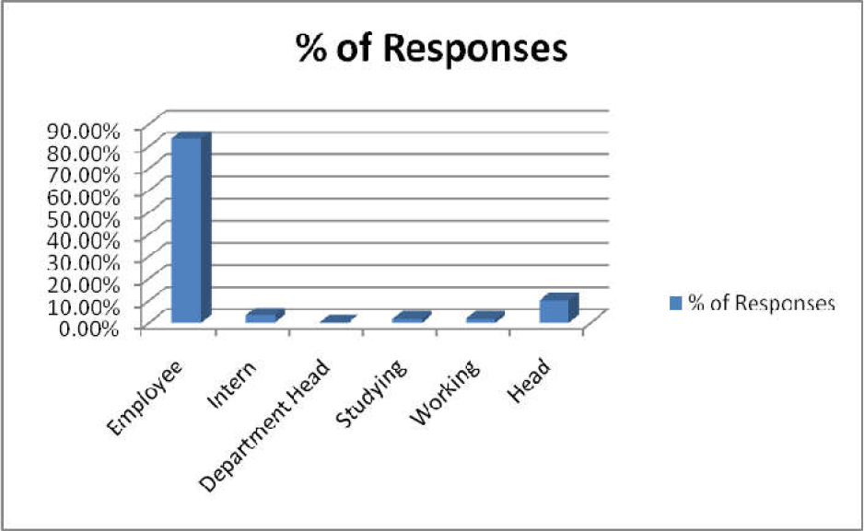

Table 5.1 explains that table and graph we see that the total respondents are 120, 83.33%. In that employee are 100, and interns are 4, 3.33%, and department head are 12, 10%, and studying are 2, 1.66%, and working are 2,1.66%, and head are 0%.

#### Department:

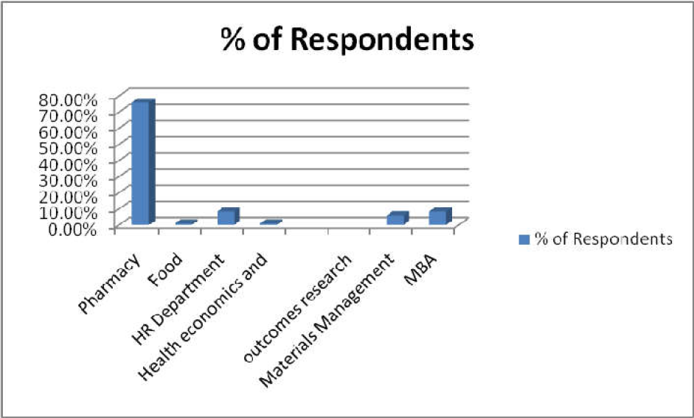**Table 5.2**

|  |  |  |
| --- | --- | --- |
| **Opinion** | **No of Respondents** | **% of Respondents** |
| Pharmacy | 91 | 75.83% |
| Food | 1 | 0.83% |
| HR Department | 10 | 8.33% |
| Health economics and  outcomes research | 1 | 0.83% |
| Materials Management | 7 | 5.83% |
| MBA | 10 | 8.33% |
| Total | 120 | 100% |

Source: primary data

Table 5.2 explains that from the above table and graph we see that the total no of respondents is 120, 100%,and in that the pharmacy are of 75.83%, and food are 1,0.83%, and hr. department are 10,8.33%, and health economics and outcomes research are 1. 0.83%, and material management are 7, 5.83%,

#### 3.Are you getting staff facilities, including toilets, washing facilities and refreshment at workplace

**Table 5.3**

|  |  |  |
| --- | --- | --- |
| Opinion | No of Respondents | % of Respondents |
| Strongly Agree | 34 | 28.33% |
| Agree | 47 | 39.16% |
| Neutral | 20 | 16.66% |
| Disagree | 11 | 9.16% |
| Strongly Disagree | 8 | 6.66% |
| Total | 120 | 100% |

Source: primary data

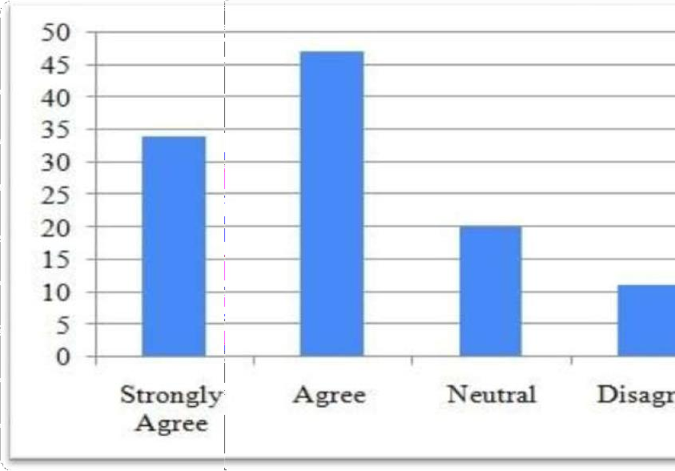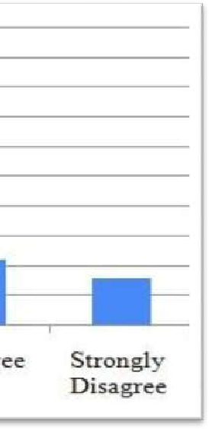

Table 5.3 explains the above table and graph we see that the strongly agree are of 34, 28.33%, andagree are of 47, 39.16%, and neutral are of 20, 16.66%, and disagree are of 11, 9.16%,and strongly disagree are of 8, 6.66%, and total respondents are of 120, 100%

#### 4.Employee opinion about cooperative with a store

**Table 5.4**

|  |  |  |
| --- | --- | --- |
| Opinion | No of Respondents | % of Respondents |
| Strongly Agree | 54 | 45% |
| Agree | 39 | 32.5% |
| Neutral | 10 | 8.33% |
| Disagree | 9 | 7.5% |
| Strongly Disagree | 8 | 6.66% |
| Total | 120 | 100% |

Source: primary data

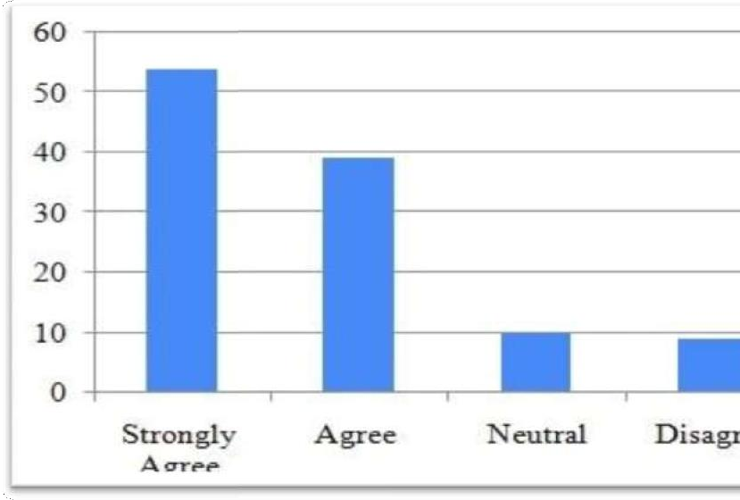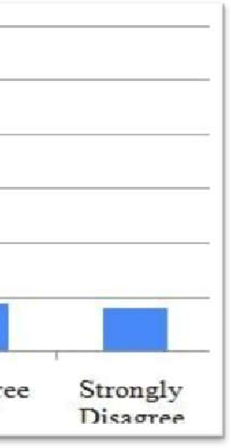

Table 5.4explains the above table and graph we see that the strongly agree are of 54, 45%, andagree are of 39, 32.5%, and neutral are of 10, 8.33%, and disagree are of 9, 7.5%, and

strongly disagree are of 8, 6.66%, and total respondents are of 120, 100%

#### 5. Are you getting suitable personal protective equipment (PPF) for free of charge

**Table 5.5**

|  |  |  |
| --- | --- | --- |
| Opinion | No of Respondents | % of Respondents |
| Strongly Agree | 20 | 16.66% |
| Agree | 51 | 42.5% |
| Neutral | 18 | 15% |
| Disagree | 16 | 13.33% |
| Strongly Disagree | 15 | 12.5% |
| Total | 120 | 100% |

Source: primary data

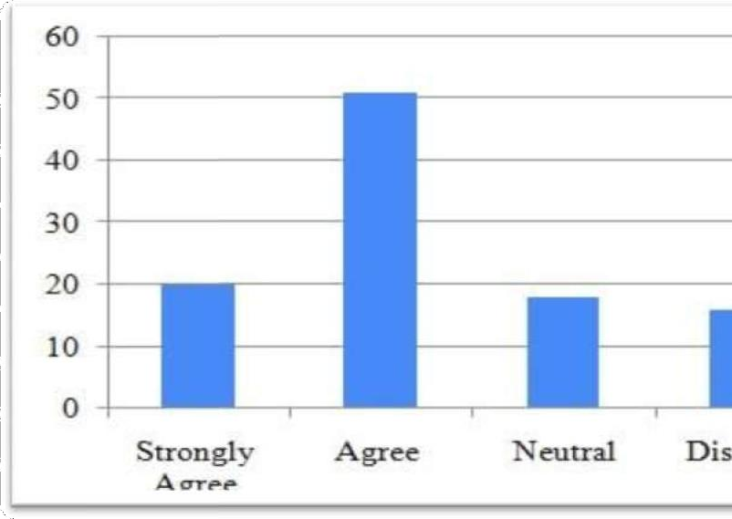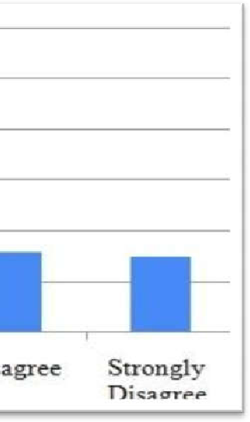

Table 5.5 explaions that the above table we see that the strongly agree are of 20, 16.66%, and agree are of51, 42.5%, and neutral are of 18, 15%, and disagree are of 16, 13.33%, and strongly

disagree are of 15, 12.5%, and total respondents are of 120, 100%

**FINDINGS**

1. It is found that in total respondents 83.33%. are employee
2. It is found that in total respondents 100%, are related to pharma department
3. 69.16% are females it is considered to employee and their gender in the organization.
4. 45% of Employees treated with due respect to employee opinion
5. Majority of employees Management providing performance-based incentives quarter facility
6. Majority of employees agreed Employer manage and conduct their work activitiesin such a manner as they ensure your safety
7. Majority of employees agreed company proving health insurance in emergency
8. 48% Employer manage and conduct their work activities in such a manner as theyensure your health and welfare

#### SUGGESTIONS

* Organizations must make sure that there is friendly and positive relationship between employers and employees in the organization.
* Management creates good and friendly working conditions that will aid employee’s performance.
* Organizations should ensure the provision of good welfare packages that will encourage and promote employee’s performance.
* It is the desire of every organization’s to constantly increase productivity, thereby necessitating the need to motivate employees through comprehensive compensation policies and friendly working conditions.

#### CONCLUSION

Employee performance is very important in contribute to the Organizational success, in order to boost the level of performance the organizational must plan the effective strategies for employee.The compensation and benefits can help to increase the level of performance but there is other factor that contributes more increase the level of performance.Organizational should focus on other factor besides of rewards such as supportive and caring environment and good working condition that allow employee to balance the personal and professional success

**REFERENCE:**

1. Daniel, C. O. (2019). Compensation management and its impact on organizational commitment. *International Journal of Contemporary Applied Researches*, *6*(2), 26-36.
2. Reddy, V. S. (2020). Impact of compensation on employee performance. *IOSR Journal of Humanities And Social Science*, *25*(9), 17-22.
3. Naidu, A. T., & Satyanarayana, G. (2018). Impact of compensation on employee performance. *Intercontinental journal of human resource research review*, *6*(4), 1-7.
4. Patnaik, P., & Suar, D. (2019). Analyses of publications on compensation management from 2004 to 2017. *Compensation & Benefits Review*, *51*(2), 55-76.
5. Lipuku, F., Sang, H., & Rop, W. (2022). Reward and Compensation Management Initiatives on Employee Performance: An Evidence of Organization Development Initiatives.