**A STUDY ON EMPLOYEE REWARDS AND RECOGNITION PRACTICES OF NESTLE INDIA LIMITED, GUNTUR, AP.**

**Yanamala Archana, MBA 2nd year**

Email ID : yanamalaarchana1@gmail.com

And

**Dr. Bandaru Venkata Reddi Naidu**, *M.Com, MBA, Ph.D.,*

**Professor & Head**

Department of Management Studies

Godavari Institute of Engineering and Technology (Autonomous)

Rajamahendravaram, Andhra Pradesh, India.

Email ID: drnaidubandaru@gmail.com

**ABSTRACT**

Human resource is considered as a strategic asset in any organization because the accomplishment of an organization’s objectives largely depends on employees. Therefore, it is important to identify factors which motivate employees for achieving goals. The objective of this study is to illustrate to what extent does employee rewards have an impact on employee performance in the selected organisation. Hence, this study has examined the relationship between extrinsic reward, intrinsic reward and employee performance in the organisation. In order to accomplish the research objectives, quantitative research design was carried out under the deductive approach. Self designed questionnaire was used as the primary data collection method. The data was analyzed using descriptive statistics and inferential statistics. The results revealed that there is a positive relationship between extrinsic reward, intrinsic reward and employee performance. The research results can be used as a guideline for the Nestle India Limited, Guntur to have better understanding the significance of reward system on employee performance and furthermore it will help to design and implement strategic reward system to bring competitive advantage. The results derived from the current study is restricting the generalisability to the wider population since the study focused on Nestle India Limited, Guntur in the light of the findings, recommendations are outlined.

*****

Keywords: Employee Performance; Extrinsic Rewards; Intrinsic Rewards

### INTRODUCTION

### Every organization irrespective of its nature and size has four resources namely men, material, money and machinery of these men i.e., people are the most vital resources and they make all the differences in an organization. In this connection L.F URWICK says that ―business houses are made broken in the long-run not by the markets or capital, patents or equipment, but by men‖. Of all the resources manpower is the only resource which does not depreciate with the passage of time. This resource is called Human Resource. As the central subsystem controls the functions of each sub-system and the whole organization. The prosperity and growth of an organization depends mainly on the policies, programs and practices of HR sub-systems. According to LEON C.MEGGINSON, the term human resources thought of as “the knowledge, skills, creative abilities, talents and aptitudes of an organization workforce, as well as the value, aptitudes and beliefs of the individuals involved”. Thus human resources represent the quantitative and qualitative measurements of the workforce requires in organization. Human resource is regarded as human factor, human asset and human capital. Human Resource management is concerned with human being in an organization. It reflects a new philosophy, a new outlook, approach and strategy which views organization manpower as its resources and assets.Human Resource management is a managerial function which facilitates the effective utilization of people in achieving the organization individuals and goals. Earlier HRM was called by different names like Personal Management, Personal Administration, Staff Management, Manpower Management, Industrial Relations, Employee-Employer Relation, Human Capital Management and Human Asset Management. HRM is a management function that helps to recruit, select, train and develop the organization members for the purpose achieving the stated organizational goals.

### 

### Scenario of Food Industry:

India's food ecosystem offers huge opportunities for investments with stimulating growth in the food retail sector, favorable economic policies and attractive fiscal incentives. The Food & Grocery market in India is the sixth largest in the world. Food & Grocery retail market in India further constitutes almost 65per cent of the total retail market in India. The Government of India through the Ministry of Food Processing Industries (Mo FPI) is also taking all necessary steps to boost investments in the food processing industry. The government has sanctioned 42 Mega Food Parks (MFPs) to be set up in the country under the Mega Food Park Scheme. Currently, 17 Mega Food Parks have become functional. The Processed food market is expected to grow to $ 543 bn by 2020 from $ 322 bn in 2016, at a CAGR of 14.6 per cent. Food processing has an important role to play in linking Indian farmers to consumers in the domestic and international markets. The Ministry of Food Processing Industries (MoFPI) is making all efforts to encourage investments across the value chain. The industry engages approximately 1.85 Mn people in around 39,748 registered units with fixed capital of $ 32.75 bn and aggregate output of around $ 158.69 bn. Major industries constituting the Food processing industry are grains, sugar, edible oils, beverages 10 and dairy products. The key sub-segments of the Food Processing industry in India are: Dairy, Fruits & Vegetables, Poultry & Meat processing, Fisheries, Food retail etc.

**PROFILE OF NESTLE INDIA LIMITED**

NESTLÉ's relationship with India dates back to 1912, when it began trading as The NESTLÉ Anglo- Swiss Condensed Milk Company (Export) Limited, importing and selling finished products in the Indian market. After India's independence in 1947, the economic policies of the Indian Government emphasized the need for local production. NESTLÉ responded to India's aspirations by forming a company in India and set up its first factory in 1961 at Moga, Punjab, where the Government wanted NESTLÉ to develop the milk economy. Progress in Moga required the introduction of NESTLÉ's Agricultural Services to educate, advise and help the farmer in a variety of aspects. From increasing the milk yield of their cows through improved dairy farming methods, to irrigation, scientific crop management practices and helping with the procurement of bank loans. NESTLÉ set up milk collection centers that would not only ensure prompt collection and pay fair prices, but also install amongst the community, a confidence in the dairy business. Progress involved the creation of prosperity on an on-going and sustainable basis that has resulted in not just the transformation of Moga into a prosperous and vibrant milk district today, but a thriving hub of industrial activity, as well. NESTLÉ has been a partner in India's growth for over a century now and has built a very special relationship of trust and commitment with the people of India. The Company's activities in India have facilitated direct and indirect employment and provides livelihood to about one million people including farmers, suppliers of packaging materials, services and other goods. The Company continuously focuses its efforts to better understand the changing lifestyles of India and anticipate consumer needs in order to provide Taste, Nutrition, Health and Wellness through its product offerings. The culture of innovation and renovation within the Company and access to the NESTLÉ Group's proprietary technology/Brands expertise and the extensive centralized Research and Development facilities gives it a distinct advantage in these efforts. It helps the Company to create value that can be sustained over the long term by offering consumers a wide variety of high quality, safe food products at affordable prices. NESTLÉ India manufactures products of truly international quality under internationally famous brand names such as Nescafé, Maggi, Milkybar, Kit Kat, Bar-One, Milkmaid and Nestea and in recent years the Company has also introduced products of daily consumption and use such as Nestlé Milk, Nestlé Slim Milk, Nestlé Dahi and Nestlé Jeera Raita. NESTLÉ India is a responsible organization and facilitates initiatives that help to improve the quality of life in the communities where it operates. After more than a century-old association with the country, today, NESTLÉ India has presence across India with 8 manufacturing facilities and 4 branch offices. NESTLÉ India set up its first manufacturing facility at Moga (Punjab) in 1961 followed by its manufacturing facilities at Choladi (Tamil Nadu), in 1967; Nanjangud (Karnataka), in 1989; Samalkha (Haryana), in 1992; Ponda and Bicholim (Goa), in 1995 and 1997, respectively; and Pantnagar (Uttarakhand), in 2006. In 2012, Nestlé India set up its 8th manufacturing facility at Tahliwal (Himachal Pradesh). The 4 Branch Offices located at Delhi, Mumbai, Chennai and Kolkata help facilitate the sales and marketing activities. The NESTLÉ India‘s Head Office is located in Gurgaon, Haryana. Purpose Enhancing quality of life and contributing to a healthier future. Driven by our purpose we want to help shape a better world and inspire people to live healthier lives. This is how the company contribute to society and ensure our long-term success.

**Need and Scope for the Study:**

This project aims to understand the impact of extrinsic rewards on employee performance, and tries to recommend suggestions to the organization to improve employee engagement and employee retention. Also tries to find relationship between employee performance, employee retention and employee engagement with respect to extrinsic rewards. The data will be collected from various levels of organization through a survey method. In order to understand the perception of employee on extrinsic rewards, middle level management and operational level employees have been consider to collected the data .

**Objectives of the Study:**

The present study has been taken up to achieve the following objectives:

* To understand the impact of extrinsic rewards on employee performance at Nestle India Limited.
* To analyses the relationship between extrinsic rewards and employee engagement at Nestle India Limited.
* To understand the impact of extrinsic rewards in retaining the employees at Nestle India Limited.

**Methodology of the Study:**

The data required for this study is collected from two major sources. They are

**Primary data:**

The **Primary** data is collected from employees through a structured questionnaire.

**Secondary data:**

The secondary source of data was collected from various journals, company records and websites

**RESULTS DISCUSSION**

**Table -5.1**

**RESPONDENT’S OPINION ON EXTRINSIC REWARDS**

|  |  |  |
| --- | --- | --- |
| **Options** | **No of Responses** | **Percentage** |
| Bonuses | 6 | 4% |
| Medical benefits | 6 | 4% |
| Increments | 0 | 0% |
| Promotion | 0 | 0% |
| All of the above | 138 | 92% |
| Total | 150 | 100% |

Source: Questionnaire

### Graph: 5.1

**RESPONDENT’S OPINION ON EXTRINSIC REWARDS**

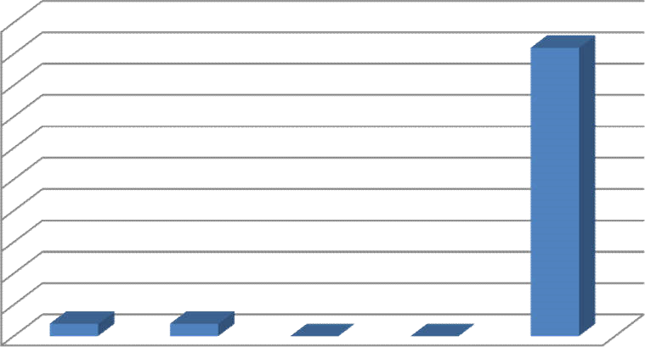

100

%

90

%

80

%

70

%

60

%

50

%

40

%

30

%

20

%

10

%

0

%

Bonuses

Medical

Increments

Promotion

All

of

the

benefits

above

Source: Table 5.1

Table 5.1 Explains that4 per cent of respondents said that they are provided with bonuse, 4 per cent employees said that they are provided with medical benefits and 92 per cent of the employees are provided with all the rewards bonuses, medical benefits, increment and promotion. Majority of the employees are provided with bonuses, medical benefits, increment, and promotion.

**Table-5.2**

**RESPONDENT’S OPINION ON AWARENESS OF MONETARY AND NON-MONETARY REWARDS**

|  |  |  |
| --- | --- | --- |
| **Options** | **No of Responses** | **Percentage** |
| Strongly Disagree | 24 | 16% |
| Disagree | 21 | 14% |
| Neutral | 30 | 20% |
| Agree | 72 | 48% |
| Strongly Agreed | 3 | 2% |
| Total | 150 | 100% |

Source: Questionnaire

### Graph: 5.2

**RESPONDENT’S OPINION ON AWARENESS OF MONETARY AND NON-MONETARY REWARDS**

### 

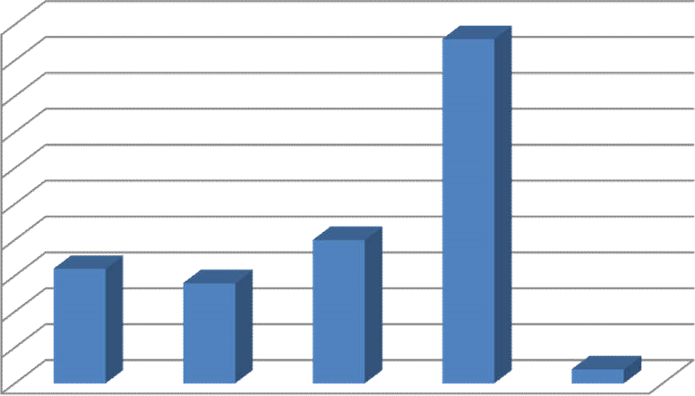

50

%

45

%

40

%

35

%

30

%

25

%

20

%

15

%

10

%

5

%

0

%

1

2

3

4

5

Source: Table 5.1

Table 5.2 explainsthat 16 per cent of the employees are strongly disagreed, 14 per cent disagreed, 20 per cent are neutral, 48 per cent agreed and 1per cent strongly agreed Most of the employees are aware of various monetary and non – monetary rewards of the organization.

### Table-5.3

**RESPONDENT’S OPINION ON TYPE OF REWARDS PREFERRED**

|  |  |  |
| --- | --- | --- |
| **Options** | **No of Responses** | **Percentage** |
| Monetary | 81 | 54% |
| Non – monetary | 15 | 10% |
| Both | 54 | 36% |
| Total | 150 | 100% |

Source : Questionnaire

### Graph: 5.3

**RESPONDENT’S OPINION ON TYPE OF REWARDS PREFERRED**

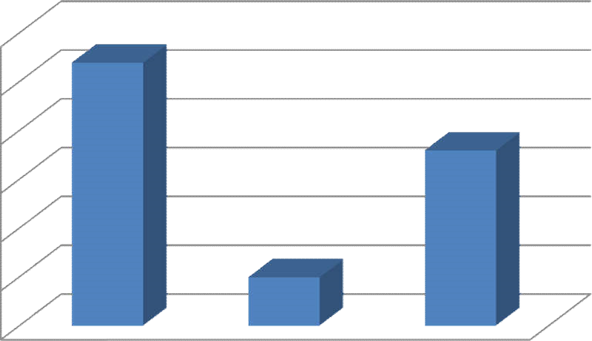

60

%

50

%

40

%

30

%

20

%

10

%

0

%

Monetary

Non

–

monetary

Both

Source: Table 5.3

Table 5.3 explains that 54 per cent of the employees say monetary rewards are preferred, 10 per cent say they prefer non – monetary rewards and 36 per cent of employees prefer both. Majority of the employees prefer monetary rewards.

**Table-5.4**

**RESPONDENT’S OPINION ON REWARDS SYSTEM.**

|  |  |  |
| --- | --- | --- |
| **Options** | **No of Responses** | **Percentage** |
| Yes | 70 | 70% |
| No | 9 | 6% |
| Maybe | 36 | 24% |
| Total | 150 | 100% |

Source: Questionnaire

### Graph: 5.4

**RESPONDENT’S OPINION ON REWARDS SYSTEM.**

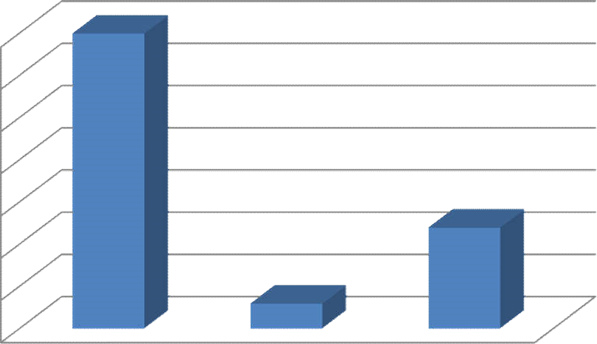

70

%

60

%

50

%

40

%

30

%

20

%

10

%

0

%

Yes

No

Maybe

Source: Table 5.4

Table 5.4 explainsthat 70 per cent of the employees agreed that the reward system is genuinely followed, 6 per cent say that the reward system is not genuinely followed, 24 per cent of the employees say that reward system may be genuinely followed. Majority of the employees agreed that the reward system of the organization is followed genuinely.

**Table-5.5**

**RESPONDENT’S OPINION ON SATISFACTION LEVEL TOWARDS REWARDS**

|  |  |  |
| --- | --- | --- |
| **Options** | **No of Responses** | **Percentage** |
| Strongly Disagree | 33 | 22% |
| Disagree | 12 | 8% |
| Neutral | 18 | 12% |
| Agree | 81 | 54% |
| Strongly Agree | 6 | 4% |
| Total | 150 | 100% |

Source:Questionnaire

### Graph: 5.5

**RESPONDENT’S OPINION ON SATISFACTION LEVEL TOWARDS REWARDS**

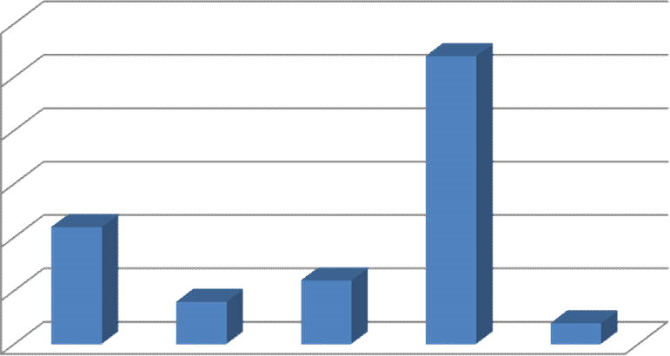

60

%

50

%

40

%

30

%

20

%

10

%

0

%

strongly

disagree

Disagree

Neutral

Agree

Strongly

agree

Source: Table 5.5

Table 5.5 explains that 22 per cent are strongly disagreed, 8 per cent disagreed, 12 per cent are neutral, 54 per cent agreed and 4 per cent strongly agreed .Most the employees are satisfied with the rewards provided by the organization.

**FINDINGS:**

**The following are the various observations from the study:**

1. 92 per cent of the employees are provided with bonuses, medical benefits, increments, and promotions.
2. 48 per cent of the employees are aware of various monetary and non-monetary rewards of the organization.
3. 54 per cent of the employee prefers monetary rewards.
4. 70 per cent of the employees agreed that the reward system is genuinely followed.
5. 54 per cent of the employees satisfied with the rewards provided by the organization.
6. 52 per cent of the employees are provided with high salary and pay rise on good performance.

**SUGGESTIONS**

1. Most of the employees need non-monetary rewards to be improved.

2. Majority of the employees suggest to improve the medical benefits of the organization.

3. Organization can provide better promotional opportunities for the employees.

4. Most of the employees suggest to improve the pay regarding the among the organization.

5. Working conditions can be further more improves to reach the level of satisfaction.

## **CONCLUSION**

The study has revealed the factors that salary, performance bonuses and working conditions impact the employee performance. The employers can retain the employees through extrinsic rewards .The employers should try to focus on the factors which can motivate employees and enhance their performance. The objectives of the study were to determine the relationship between extrinsic rewards on job performance, as well as to examine the most significant types of rewards that may boost workers performance. Based on the above mentioned findings, firstly, there is a high and positive relationship between extrinsic rewards on job performance. Secondly the most influential rewards booster job performance of the employees in Nestle India Limited is extrinsic rewards.

Therefore, the study shows extrinsic rewards motivate workers to increase their job performance, extrinsic rewards and employees job performance , which was also found to be supportive or accepted .These results showed that the individuals enjoyed the payment given security and the environment in the work place including their relationship among employees and at the same time may enhance their performances. These are the basic needs in any normal working condition as they need to fulfill the other wants as mentioned in Maslow‘s hierarchy of needs. When an individual‘s basic needs are fulfilled, there is always the tendency for the individual‘s needs to rise up to another level to achieve their aims in life.

**REFERENCES**

1. Richard Pettinger (2010) , Organizational behaviour, performance management in practice.
2. Jennifer M. George & Gareth R. Jones, Organizational behaviour, Edition : 5.
3. Biswajeet Pattanayak (2001) , Human Resource Management , New Delhi.
4. Jacobsen & Thorsvik , (2002).
5. K.Aswathappa, Human resource and personal management, Edition : 3.
6. Irshad.A (2016), Journal of Global Economics : Impact of Extrinsic Rewards on Employees‘ Performance
7. TOBIAS ERIKSSON (2011), reward systems and incentives
8. Journal of Service Science and Management, (2015)
9. Haga-Helia (2017),Danila Filimonov ,Extrinsic motivation rewards and incentives.