**A STUDY ON WORKING CAPITAL MANAGEMENT PRACTICES OF BAJAJ ALLIANZ LIFE INSURANCE CO., LTD, VIJAYAWADA**

**Surada Papa, MBA 2nd year**

Email ID : papa.surada2003@gmail.com

And

**Dr. Bandaru Venkata Reddi Naidu**, *M.Com, MBA, Ph.D.,*

**Professor & Head**

Department of Management Studies

Godavari Institute of Engineering and Technology (Autonomous)

Rajamahendravaram, Andhra Pradesh, India.

Email ID: drnaidubandaru@gmail.com

**ABSTRACT**

Financial Management is that managerial activity which is concerned with the planning and controlling of firm’s financial resources. Working Capital Management is an important tool of financial management. It helps to provide more information regarding financial operations. It deals with the management of all short-term assets and short-term liabilities. It helps to know about the day-to-day liquidity position of the company, and day to day operations of the company. All techniques will surround around the working capital management . It places an important role in financial management. Comparing all others techniques under financial management, it provides more information regarding the firm. To reach optimal working capital Management firm manager should control the trade-off between profitability and liquidity accurately. Efficient management of working capital is one of the pre- conditions for the success of an enterprise. From this point of view, the purpose of this study is to investigate the relationship between working capital management and profitability of Bajaj Allianz Life Insurance Co., Ltd, Vijayawada **.** In this study the effect of different variables of working capital management including the Cash conversion cycle and Current ratio on the profitability of the firm has been studied. The study shows that there is positive relationship between Current Ratio and Profitability of firms. This increasing the current ratio results into profitability increase.

key words: profitability, current ratio, short-term liabilities.

### INTRODUCTION

### Financial Management is about preparing, directing and managing the money activities of a company such as buying, selling and using money to its best results to maximize wealth or produce best value for money. It is basically applying general management concepts to the cash of the company. Financial Management can also be defined as – The management of the finances of a business in order to achieve financial objectives. “Financial management is concerned with raising financial resources and their effective utilization towards achieving the organizational goals” Dr. S. N.Maheshwari “Financial management is the process of putting the available funds to the best advantage from the long term point of view of business objectives” Richard A. Brealey It is crucial for both public and private sector organisations.

### Scenario of Insurance Industry:

### While conceding that insurance is a risk-transfer tool, corporate should be made to understand that it does not suffice merely to transfer the risk but they have to participate in the effort of loss prevention. New techniques and technology have to be adapted from them to time in order to improve performance and this has special significance to the order to improve performance and this has special significance to the Indian insurance Industry. The Indian insurance industry has always suffered from drawbacks like lack of proper understanding of the purpose of insurance, lopsided growth etc., with the opening up of the industry, it is hoped that the row entrants with their better channels would spread to the real message of insurance, leading to a dynamic growth. Emphasis should be on finding new technological avenues, although it has been observed world over that for selling insurance, an eye to eye contact is essential. Internet can be used for better servicing which would eventually, lead to business development. With the entry of foreign companies into the insurance arena, a fresh life has been inducted and there is a great deal of optimism in the air that the market would automatically create a vibrant competition leading to the customer being the ultimate winner.

By 1938, the insurance market in India was buzzing with 176 companies (both life and non-life). However, the industry was plagued by fraud. Hence a comprehensive set of regulations was put in place to stem this problem. By 1956, there were 154 Indian companies, 16 non-Indian insurance companies and 75 provident societies that were issuing life insurance policies. Most of these policies were entered in the cities (especially around big cities like Bombay, Calcutta, Delhi and Madras). In 1956, the finance minister Sri S D. Deshmukh announced nationalization of the life insurance business.

**Working Capital Management :**

Working Capital is what makes or breaks a business, and no business can run successfully without enough capital to cover both short- and long-term needs. Maintaining sufficient levels of short-term capital is a constantly ongoing challenge, and in today’s turbulent financial markets and uncertain business climate external financing has become both harder and more costly to obtain. Company is therefore increasingly shifting away from traditional sources of external financing and turning their eyes towards their own organizations for ways of improving liquidity. One efficient but often overlooked way of doing so is to reduce the amount of capital tied-up in operations, that is, to improve the working capital management of the company. Working capital is a financial metric of operating liquidity which describes the amount of cash tied up in operations and defines the short-term condition of a company. A positive working capital position is required for the continuous running of a company’s operations, i.e. to pay short term debt obligations and to cover operational expenses. A company with a negative working capital balance is unable to cover its short-term liabilities with its current assets.

**PROFILE OF BAJAJ ALLIANZ LIFE INSURANCE ;-**

Bajaj Allianz Life Insurance Co. Ltd. is a joint venture between two leading companies- Allianz AG, one of the world’s largest insurance companies, and Bajaj Auto, one of the biggest 2 and 3 wheeler manufacturers in the world. Bajaj Allianz Life Insurance is the fastest growing private life. Insurance Company in India Currently has over 440,000 satisfied customers. We have a presence in more than 550 locations with 60,000 Insurance Consultant providing the finest customer service. One of India’s leading private life insurance companies

**Indian Operations:** Growing at a breakneck pace with a strong pan Indian presence Bajaj Allianz has emerged as a strong player in India. Bajaj Allianz Life Insurance Company Limited is a joint venture between two leading conglomerates Allianz AG and Bajaj Auto Limited. Characterized by global presence with a local focus and driven by customer orientation to establish high earnings potential and financial strength, Bajaj Allianz Life Insurance Co. Ltd. was incorporated on 12th March 2001. The company received the Insurance Regulatory and Development Authority (IRDA) certificate of Registrahon (R3) No 116 on 3rd August 2001 to conduct Life Insurance business in India.

**LITERATURE AND REVIEW;**-

The operating cycle theory posits that the length of time it takes for a company to convert its investments in inventory and accounts receivable into cash is a critical factor in determining the need for working capital. Shorter cycles typically lead to a more efficient use of working capital. The theory suggests that firms should aim to reduce the operating cycle to enhance liquidity and profitability (Soleimani et al., 2020).

According to this theory, firms need to balance the costs of holding too much working capital (e.g., increased risk of obsolescence, storage costs) with the benefits (e.g., reduced risk of financial distress, ability to take advantage of discounts or avoid stockouts). The optimal level of working capital is thus the point at which marginal benefits equal marginal costs (Baños-Caballero et al., 2014).

Firms can either take an aggressive or conservative approach to working capital management. An aggressive strategy involves minimizing current assets to maximize profitability, relying on external financing and short-term credit. A conservative strategy, on the other hand, involves maintaining higher levels of current assets, thereby minimizing risk but potentially sacrificing some return on investment (Deloof, 2003).

Efficient cash management ensures that a company has enough liquidity to meet day-to-day operational expenses without holding excessive cash, which could reduce profitability. Scholars have developed models for cash flow forecasting and optimal cash balances, with recent work incorporating new digital tools like real-time cash management systems (Harris, 2022).

**NEED OF THE STUDY ;-**

A business firm must maintain an adequate level of working capital in order to run its business smoothly. It is worthy to note that both excessive and inadequate working capital positions are harmful. Out of two, inadequacy of working capital is more dangerous for a firm.

Excessive working capital results in idle funds on which no profit is earned. Similarly insufficiency of working capital results in interruptions of production. This will lead to inefficiencies, increase in costs and reduction in profits.

Working capital is just like the lifeblood of business. If it becomes weak, the business can hardly prosper and survive. No business can run successfully without an adequate amount of working capital.

**OBJECTIVES OF THE STUDY ;-**

The present study has been taken up to achieve the following objectives:

1. To study the theoretical aspects of working capital.

2. To study changes of working capital of the company.

3. To analyze profitability, liquidity position of the company.

4. To find out the present and future senario of working capital position.

**METHODOLOGY OF THE STUDY;-**

The data in this project is enabling in secondary in nature. Financial reports, company records were referred for data analysis. The study has been undertaken by collecting relevant data from the balance sheet, profit and loss a/c, annul report & Audit report of the BALIC the company is used financial tools for the analyzing and interpretation data.

However primary data is also collected by observation discussing with company officials. This primary data is used to fill in the gaps while preparing this report and to know the latest procedures adopted by the company. This has helped to draw inferences and conclusions.

### RESULTS DISCUSSION

##### **Table - 5.1**

**STATEMENT OF CURRENT ASSETS OF BAJAJ ALLIANZ FROM 2019 - 2023**

|  |  |  |  |  |  |
| --- | --- | --- | --- | --- | --- |
| **Fisal Year** | **Sundry Debtors** | **Cash and Bank balance** | **Loan and advance** | **Other C. A** | **Total** |
| **2019/20** | 639,948 | 3,515,993 | 76,970 | 1,148,475 | 5,381,386 |
| **2020/21** | 1,089,070 | 2,186,908 | 130,275 | 2,022,560 | 5,298,538 |
| **2021/22** | 1,341,359 | 4,285,098 | 147,078 | 2,344,020 | 8,217,555 |
| **2022/23** | 1,223,706 | 4,520,165 | 170,660 | 3,832,457 | 9,746,988 |

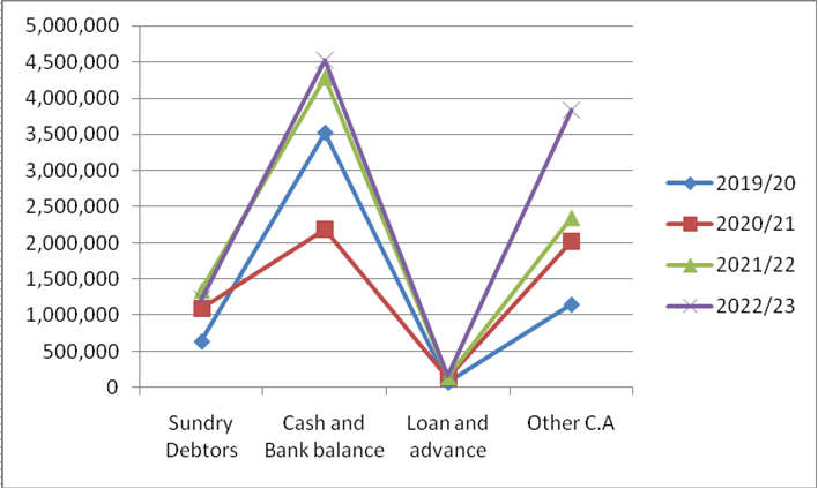Source: Annual Report of company

Source: Table 5.1 **Graph 5.1** statement of current assets of Bajaj Allianz from 2019 - 2023

Table 5.1 explains assets of company were amounted to Rs. 5,460,356 which included Rs. 3,552963 of cash and bank balance, Rs. 76,970 of loan and advance, Rs. 1,828,423 of miscellaneous current assets. Current assets of the company increase in all four years.

##### **Table No: 5.2**

**STATEMENT OF CURRENT LIABILITIES OF BAJAJ ALLIANZ FROM 2019 - 2023**

|  |  |  |  |  |  |
| --- | --- | --- | --- | --- | --- |
| **Fiscal Year** | **Creditors** | **Deposit** | **Bills Payable** | **Other C.L** | **Total** |
| **2019/20** | 2,249,357 | 3,318,900 | 87,607 | 2,396,492 | 8,052,356 |
| **2020/21** | 3,701,079 | 4,129,900 | 196,168 | 2,491,564 | 10,518711 |
| **2021/22** | 3,281,079 | 4,430,900 | 98,372 | 1,690,564 | 9,500,915 |
| **2022/23** | 4,246,449 | 4,142,491 | 97,087 | 2,368,827 | 10,654,854 |

Sources: Annual Report of company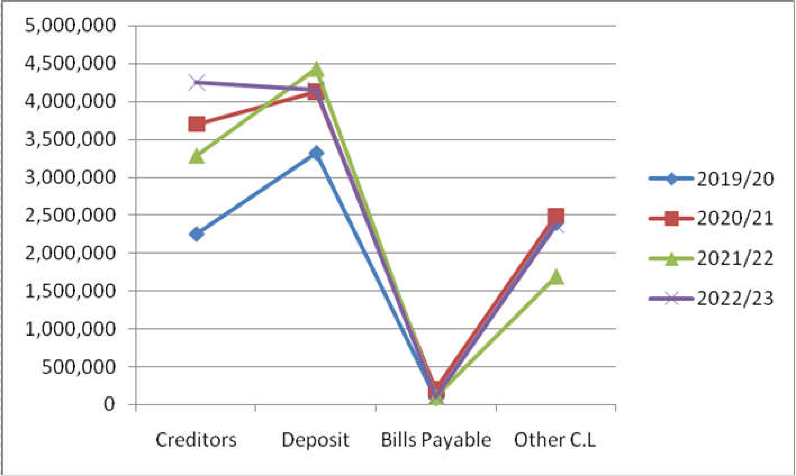

##### Source: Table 5.2

##### **Graph No: 5.2** Statement of current liabilities of Bajaj Allianz from 2019 – 2023

Table 5.2 explains that the current liabilities of the company is increasing in fiscal year 2019/20 the total amount of current liabilities Rs. 8,052,356 for the increasing impact of deposits and other current liabilities. In all four year deposits and other current liabilities are increased.

##### **Working capital of BALIC:**

Working capital is required to run business smoothly and efficiently in the context of set objectives. It is no doubt that no organization can achieve its goal without proper use of working capital. It means money invested on working capital should be neither more nor less because both the position of working capital affects not only liquidity but also profitability of the organization. The investment decision should be made on any type of current assets by considering their role in company and determining which one is more beneficial to the company and which is not. The following table shows the amount of working capital of BALIC of the study period.

##### **Table No: 5.3**

##### **STATEMENT OF WORKING CAPITAL OF BAJAJ ALLIANZ FROM 2019 - 2023**

|  |  |  |  |
| --- | --- | --- | --- |
| **Year** | **Total C.A** | **Total C.L** | **WC= CA-CL** |
| **2019/20** | 5,381,386 | 8,052,356 | 4,470,970 |
| **2020/21** | 5,298,538 | 9,500,915 | 4,202,377 |
| **2021/22** | 8,217,555 | 10,518,711 | 2,301,156 |
| **2022/23** | 9,746,988 | 10,654,854 | 907,866 |

Sources: Annual Report of company

Source: Table 5.3 **Graph 5.3** statement of working capital of Bajaj from 2019 - 2023

Table 5.3 explains the current assets, current liabilities and working capital condition of BALIC from fiscal year 2019/20 to 2022/23. Working capital condition of the company is at satisfactory level. All the year of the study period the working capital of the company is negative.

##### **Current Ratio:**

This ratio indicates the short-term solvency position of bank. In other words current ratio indicates better liquidity position. It is calculated as follows:

##### **Current ratio**

Current assets (CA) / Current liabilities (CL)

The following table shows the current ratio to compare the following capital management of BALIC.

##### **Table No: 5.4**

##### **STATEMENT OF CALCULATING CURRENT RATIO OF BAJAJ ALLIANZ**

|  |  |  |  |
| --- | --- | --- | --- |
| **Year** | **Total CA** | **Total CL** | **Current ratio** |
| **2019/20** | 5,381,386 | 8,052,356 | 0.67 |
| **2020/21** | 5,298,538 | 10,518,711 | 0.50 |
| **2021/22** | 8,217,555 | 9,500,915 | 0.86 |
| **2022/23** | 9,746,988 | 10,654,854 | 0.91  Average=0.74 |

Sources: Annual Report of company

Source: Table 5.4 **Graph No: 5.4** statement of calculating current ratio

Table 5.4 explains the CA, CL and current ratio of the BALIC. The current ratio of the BALIC is fluctuating over the year. The highest current ratio is in fiscal year 2022/23, 0.91. And in all year it is increasing. The average ratio is 0.74.

##### **Cash and bank balance to Current Assets:**

The cash and bank balance is almost liquids from the current assets; this ratio shows the percentage of readily available fund within the banks. It can be calculated by dividing cash and bank balance by current assets, which is given below.

Cash and bank balance / Current assets

This ratio shows that the percentage of current assets cover cash and bank balance. The following table and figure shows the cash and bank balance to current assets ratio of BALIC over the study period.

Cash and Bank to Current Assets Ratio of BALIC

**Table No: 5.5**

**STATEMENT OF CALCULATING QUICK (%) RATIO OF BAJAJ ALLIANZ**

|  |  |  |  |
| --- | --- | --- | --- |
| **Year** | **Cash& Bank**  **Balance** | **Current Assets** | **Ratio (%)** |
| **2019/20** | 3,552,963 | 5,381,386 | 0.67 |
| **2020/21** | 2,186,908 | 5,298,538 | 0.41 |
| **2021/22** | 4,385,098 | 8,217,555 | 0.53 |
| **2022/23** | 4,382.396 | 9,746,988 | 0.44 |

Sources: Annual Report of company

Source: Table 5.5 **Graph 5.5** Statement of calculating quick (%)

Table 5.5 explains Cash and Bank balance to current assets ratio of the company is in 2020/21 decreased and in 2021/22 it increased and again in 2022/23 is decreased.

### FINDINGS

* Current assets for the year 2020/21 is decreases and its application for the company and current liabilities of the company is increased by 2,466,355 and by putting formula (W.C= C.A- C.L)working capital of the company for year 2020/21 is 4,470,970.
* Current assets for the year 2020/21 is increases and it is good condition for the company and current liabilities of the company is decreased by 1,017,796 that’s shows the working capital of the company is increased. Here debtors increased means cash balance of company decreased.
* Current assets for the year 2020/21 is increases and it is good condition for the company and current liabilities of the company is increased by 1,153,939 that’s shows working capital of company decreased. Here debtors decreased that’s good for company it shows cash of company increased.
* Current ratio (C.R) of fiscal year 2019/20 to 2022/23 showed slightly increase i.e.

0.67 to 0.91. But in fiscal year 2020/21 C.R decreased comparatively in deposits and in fiscal year 2021/22 C.R is again increase 0.86 due to increase in factors which influence it.

#### **SUGGESTIONS ;-**

On the basis of the analysis and observation an attempt made to present some suggestions.

1. In the year 2020-2021 the current assets of the company has declined and current liability of the company has increases therefore the net working capital declined. There for the current ratio has declined. The net working capital of the company has increased remaining year.
2. The company has able to repay the liability of the creditors because the profit of the company has increased every year.
3. Because of the current assets has declined in the year 2021-2022 but profit of the company has increased in the year 2019-2020. There for the return on current assets is high.
4. Company has able to full fill the standard level of current ratio i.e. 2:1 .There for the company has able to repay the liability and loan of company.

#### **CONCLUSION;-**

At the end it is stated that the working capital management is a part of money invested in the business. Working capital may be regarded as lifeblood of a business. Its effective provision can do much to ensure the success of a business. Working capital is considered to be an important tool for progress. Working capital management techniques are playing significant role in assisting the management for decision making. The study of working capital management at Bajaj Allianz Life Insurance Pvt. Ltd.Is found to be very effective. The working capital contains the management of Cash, Debtors, and creditors. The Bajaj Allianz Life Insurance Pvt. Ltd has profit oriented company .The profit of the company will be increases every year .The company has able to the repay the amount of the creditor. The company has more working capital and also sale has increases year to year.

REFERENCES ;-

I.M.PANDEY (1999), “Financial Management” Vikas Publishing House Pvt.Ltd. New Delhi.

o M Y KHAN & P K JAIN, “Management Accounting”. Tata MC Graw Hill Publishing Company Limited, New Delhi.

o R.K.SHARMA & SHASHIK GUPTA, “Management Accounting” Kalyani Publishing.