**A STUDY ON RATIO ANALYSIS PRACTICES OF BHARAT HEAVY ELECTRICALS**

**LIMITED HEAVY PLATES & VESSEL PLANTS VISAKHAPATNAM-AP, INDIA.**

**Perisetty Bharat Venkat Krishna Sai ram, MBA 2ND Year**

E-MAIL-ID: bharatperisetty@gmail.com

**Dr. Bandaru Venkata Reddi Naidu**, M. Com, MBA, Ph.D.,

**Professor & Head**

Department of Management Studies

**Godavari Institute of Engineering and Technology (Autonomous)**

**Rajamahendravaram, Andhra Pradesh, India.**

Email ID: Rajeek@giet.ac.in

**Abstract**

This project explores ratio analysis as a critical tool for assessing the financial health and performance of a business. Ratio analysis involves examining relationships between various financial metrics on a company's balance sheet, income statement, and cash flow statement. Through analysing key ratios—such as profitability, liquidity, efficiency, and solvency ratios—this study provides insights into a company’s operational effectiveness, financial stability, and market position. This project applies ratio analysis to selected companies within a specific industry, comparing findings to industry benchmarks and identifying trends over time. The results demonstrate how ratio analysis can support stakeholders in making informed financial decisions, identifying areas of strength, and opportunities for improvement. The purpose of the research was to determine how successful training and development strategies are in improving the knowledge and skills of staff members at the “BHARAT HEAVY ELECTRICAL LIMITED”, in Visakhapatnam. The information was gathered from 500 workers who were chosen at random. Currently employed by the BHARAT HEAVY ELECTRICAL LIMITED. The vast majority of respondents to a recent survey agreed that ratio analysis programs are effective in increasing workers' levels of expertise.

****

KEYWORDS: FINANCE, RATIO ANALYSIS, ASSETS, LIABILITIES.

**INTRODUCTION:**

Financial management is managerial activity which is concerned with the planning and controlling of firm’s financial resources. It was a branch of economics till 1980 and as a separate discipline it was of recent origin. Still, it has no unique body of knowledge of its own and draws heavily from economics for its theoretical concepts even today. Theory of financial management provides conceptual and analytical insights to make decisions relating to the financial aspects of organization skilfully.

“Financial management is concerned with the efficient use of an important resource namely, capital funds”. –EZRA SOLOMAN

“Financial management is concerned with the managerial decisions that result in the acquisition and financing of long-term and short-term credits for the firm”. – PHILLIPPATUS.

**Introduction to ratio analysis:**

RATIO ANALYSIS is a widely used tool for financial analysis. it can be used to compare the risk and return relationships of firms of different sizes. It is the process of establishing and interpreting ratios for helping in making certain decisions. However, ratio analysis is not an end for itself. It is only a means of better understanding of financial strengths and weakness of a firm. This analysis is a technique of analysis and interpretation of financial Statements. It is the process of establishing and interpreting ratios for helping in making certain decisions. However, ratio analysis is not an end for itself. It is an only a means of better understanding of financial strengths and weakness of a firm.

**Profile of bhel**:

BHPV was established in 1966 at Visakhapatnam, Andhra Pradesh. It got merged with BHARAT HEAVY ELECTRICALS LIMITED (BHEL) in August’2013by virtue of an order of Honorable Board for Industrial and Reconstruction (BIFR). BHEL named the unit as HEAVY PLATES & VESSELS PLANT (BHEL-HPVP). It is 17th manufacturing unit of BHEL and incidentally this is only unit among 17 manufacturing units of BHEL, situated in port city. BHPV was established in the year 1966 as a public sector undertaking under the Department of Heavy Industry, Government of India. It has been catering to the specialized equipment & plants required for oil refineries, fertilizer plants, steel plants, defense sector etc. HPVP's product range includes Pressure Vessels, Columns, Heat Exchangers, Air Fin Coolers, LPG Bullets, LPG Spheres, LPG Mounded Bullets, Storage Tanks, Reactors, Nitrogen and Oxygen Plants, Ammonia Storage Tanks, Cryogenic Storage Tanks, Purge Gas Recovery Units, Evaporators, Industrial Boilers, Deaerators, Fired Heaters etc. BHPV’s beginning was humble; it had a turnover of just Rs 1.95 crores in 1971-72 when commercial production first commenced. Since then, BHPV has come a long way and exceeded a turnover of Rs 300 crores expanding its product line to include high technology equipment and systems like Multilayer Vessels, Turn Key Cryogenics Plants, Storage and Distribution Systems, Industrial Boilers, Waste Heat Recovery Systems, Oil and Gas Processing Systems etc. BHEL have a range of electrical and mechanical industrial products like oil rigs, wellheads and Xmas tree valves, fabricated equipment and boiler feeds pumps, compressors and AC machines. They manufacture seamless steel tubes with varying diameter of 19 to 133 mm. They build piping systems for nuclear power stations, Combined Cycle Power Plants and Industrial boiler in process industry. BHEL’s valuable contribution can be seen from the 55% share in India’s total installed capacity and dominating share (58%) in India’s total generation from thermal utility sets. BHEL is one of the largest manufacturing and engineering companies in India with a widespread network comprising of 17 manufacturing units and 2 repair units. BHEL employees 42,000+ people and it has 4 regional offices, 8 service centres, 1 subsidiary, 6 joint ventures and 15 regional marketing centres.

**LITERATURE REVIEW:**

Bhunia et al. (2011) In their study on Indian companies, Bhunia and colleagues examined the relationship between profitability and liquidity ratios, underscoring their role in corporate performance.

Anderson and Reeb (2003) Their work explored financial ratios in family-owned firms, showing distinct patterns compared to non-family businesses, particularly in profitability and leverage.

Gupta and Gupta (2021) Recent research has highlighted the integration of machine learning and advanced statistical techniques into ratio analysis, enabling deeper insights and automation in financial diagnostics.

Lev and Sunder (1979) Lev and Sunder critiqued the usefulness of financial ratios, questioning their consistency and relevance across industries. Their work encouraged the development of industry-specific benchmarks.

Nissim and Penman (2001) They analyzed financial ratios in the context of equity valuation, highlighting their importance in predicting future earnings and stock performance.

**NEED FOR THE STUDY:**

* BHEL-HPVP has emerged as one of the leading heavy engineering manufacturing plants to manufacture custom built capital equipment required by the process industries like fertilizers, Petro chemical & chemical industries. After merger the company moving into manufacturing of capital equipment required for power plants.
* After its commissioning & commencement of production, the plant has been continuously updating its technologies, by entering into Collaborations with renowned multinational companies like Air liquid, BSL, Delas, HCG, Alstom etc.
* Mammoth Engineering capabilities & excellent designing network & Manufacturing facilities, high degree of customer confidence, with sound work Cultures are some of the vital factors involved in achieving continuous growth of HPVP.
* However, in the early 2000s, the financial performance of the industry went under great strain, due to a combination of adverse factors, which got bunched year by year.
* BHEL, from the date of taking over of this unit in 2008, started to look after key areas like utilization of plant capacity to the fullest extent, attention on financial discipline, HR related problems, Capex etc. From the year 2008 the company re-started its business with new look, strategies, diversification and once again started gaining customer confidence, thereby earning positive financial figures and on the way of regaining past glory.
* By 2013, the company has been merged with BHEL and has become its 17th unit. Legally the company BHPV Limited got closed. By this way the company and brand called BHPV has disappeared from Indian industrial map for ever and in its place new name and brand BHEL-Heavy Plates and Vessels Plant (HPVP) has emerged.

These Enterprises managed the overall finance operations in an efficient manner, they would have generated resources for its growth as well as economic growth.

**OBJECTIVES OF THE STUDY:**

This study of HPVP has been undertaken to evaluate the financial efficiency of the organization by establishing the following objectives.

• To know about the various sources of finances, working capital to HPVP

• To judge the financial position, of HPVP.

• To measure the operational efficiency of HPVP

• To determine the profitability trends of HPVP.

• To assess the overall financial position of HPVP.

• To assess the investment analysis of HPVP.

• To identify the financial risks of HPVP.

**METHODOLOGY: -**

Data which is required for the analysis and that could full fill our objectives have been collected from 2 sources.

1.PRIMARY DATA

2.SECONDARY DATA

**PRIMARY DATA:**

Data collected from employees through questionnaires, Interviews and discussions with staff with open ended and close ended questions.

**SECONDARY DATA:**

Other external sources like magazines, other publications and internet, annual reports, circulars, journals, information brochures and other literature of the company.

**RESULTS DISCUSSION:**

|  |  |  |  |
| --- | --- | --- | --- |
| YEAR | CURRENT ASSETS | CURRENT LIABILITIES | CURRENT RATIO |
| 2019-2020 | 29713.69 | 18612.61 | 1.60 |
| 2020-2021 | 22896.65 | 16142.84 | 1.42 |
| 2021-2022 | 31821.43 | 21125.47 | 1.51 |
| 2022-2023 | 34842.89 | 25809.50 | 1.35 |

**TABLE -1**

Source: Compiled from the Annual Reports of BHEL PVT LTD.

**Graph-1**

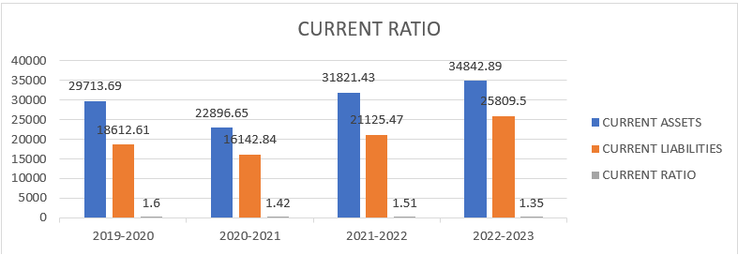

Source: Table-1

Table-1 is considered as ideal. Initially during the period FY 2019-2020 the current ratio is 1.60 and for the next year that is FY 2020-2021the current is calculated and considered as 1.42 where it has been decreased and furthermore, in the FY 2021-2022 the current ratio is considered as 1.51 where the increase as been observed and at the FY 2022-2023 the current ratio is calculated and achieved as 1.35. Therefore, referring to the company’s ideal values the current ratio is considered as satisfactory.

**TABLE -2**

|  |  |  |  |
| --- | --- | --- | --- |
| YEAR | QUICK ASSETS | CURRENT LIABILITIES | QUICK RATIO |
| 2019-2020 | 15661.37 | 18612.61 | 0.84 |
| 2020-2021 | 10384.65 | 16142.84 | 0.64 |
| 2021-2022 | 12221.53 | 21125.47 | 0.58 |
| 2022-2023 | 14194.59 | 25809.50 | 0.55 |

Source: Compiled from the Annual Reports of BHEL PVT LTD.

**Graph-2**

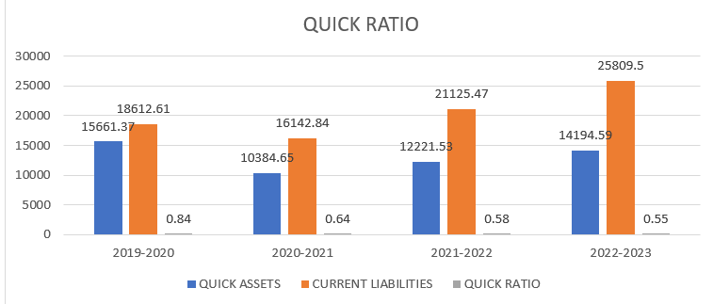

Source: Table-2

Table-2 explains A Quick ratio of table -5.2 is considered as ideal. A higher ratio indicates the company could pay off current liabilities several times over. The Quick ratio of the firm was maintained at 0.84 during FY 2019-20 and in 2020-2021 the ratio decreased to 0.64. The quick ratio during FY 2021-2022 is slightly reduced to 0.58 and During FY 2022-23 Quick ratio settled at 0.55.

**TABLE -3**

|  |  |  |  |  |
| --- | --- | --- | --- | --- |
| YEAR | OUTSIDER’S FUND | SHAREHOLDERS FUNDS | RATIO | RATIO % |
| 2019-2020 | 93664.02 | -76101.39 | -1.23 | -123.1% |
| 2020-2021 | 99578.52 | -85612.86 | -1.16 | -116.3% |
| 2021-2022 | 112498.84 | -94507.09 | -1.19 | -119.0% |
| 2022-2023 | 116933.08 | -100503.84 | -1.16 | -116.3% |

Source: Compiled from the Annual Reports of BHEL PVT LTD.

**Graph-3**

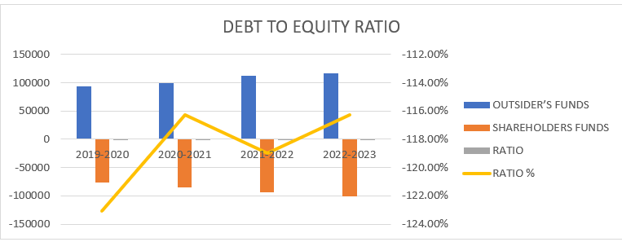

Source: Table-3

Table-3 explains a debt-to-equity ratio of table-5.3 is considered satisfactory. The unit which continuously suffered with losses because of various reasons, by this its shareholders’ fund were valued at negative values. Because of these the Debt-Equity ratio shows that this manufacturing unit is in risky situation.

**TABLE -4**

|  |  |  |  |
| --- | --- | --- | --- |
| YEAR | PBIT | INTEREST | RATIO |
| 2019-2020 | -6288.06 | 749.32 | -0.12 |
| 2020-2021 | -9121.38 | 679.65 | -0.07 |
| 2021-2022 | -8133.05 | 761.17 | -0.09 |
| 2022-2023 | -4654.92 | 1342.36 | -0.29 |

Source: Compiled from the Annual Reports of BHEL PVT LTD.

**Graph-4**

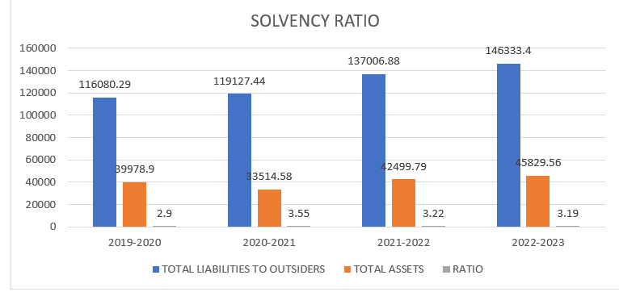

Source: Table-4

Table-4 explains lower solvency ratio is an indicator of the firm which is in good position. The solvency position of the unit always shows that, it is going to be continued in coming no of years.

|  |  |  |  |
| --- | --- | --- | --- |
| YEAR | GROSSPROFIT/ LOSS | NET REVENUE | RATIO |
| 2019-2020 | -4860.71 | 15678.32 | -0.31 |
| 2020-2021 | -7709.24 | 9537.18 | -0.81 |
| 2021-2022 | -7361.25 | 9843.62 | -0.75 |
| 2022-2023 | -3848.72 | 23876.71 | -0.16 |

**TABLE -5**

Source: Compiled from the Annual Reports of BHEL PVT LTD.

**Graph-5**

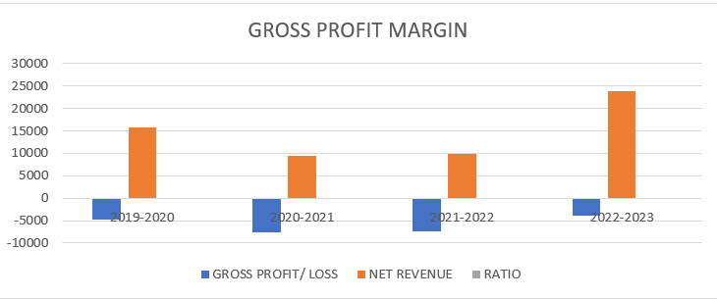

Source: Table-5

Table -5 explains the higher the gross profit ratio the better the financial performance of the firm. In 2008-09 the unit suffered with huge losses because of this the Gross Profit ratio was decreased. In immediately next year the Gross Profit ratio was decreased its negativity because of decreased in indirect expenses. After that the unit gained profits, even though those were small amounts. It shows favourable condition. But from the year of merger i.e. from 2013-14, the unit incurring losses continuously even though sales were increased.

**FINDINGS:**

The following are the various observations from the study:

* The current ratio of the unit is well balanced but the level of current assets being lowered during the year end 2020-21
* The interest coverage ratio during the periods 2022-23 is not looking good for the unit.
* Though the gross profit and net profit ratios of the firm are on the negative path, there is a considerable improvement observed.
* Operating profit ratio even though it was not up to the mark till 2020 it was in negative pattern, but during the year end 2021 it drastically fallen down and then during 2022-23 it was recovered though on the negative path.
* The firm failed in employing the capital efficiently and hence return on assets is not favorable during the periods 2019-21.
* Inventory turnover ratio need to be managed well since an ideal ratio ranged at 8% but at present the unit maintained it at 1.06.
* Average payment period of the unit is also not good to maintain healthy relation with the clients.

**SUGGESTIONS:**

➢ Liquidity ratio here reflects the firm ability to meet short term current obligation. Analysis of these ratio revealed that the liquidity position has been satisfactory.

➢ Turnover ratio indicates the turnover position of the company, here ratio reflects high turnover on the basis of five years is good.

➢ The financial performance of the company is good, so this company capture high market share and growth.

➢ Fund is proper allocated to fixed assets and current assets. It should possible for the company to carry on the work smoothly.

**CONCLUSION:**

BHEL touched the highest turnover of Rs 214.01 Crore, registering a growth of 14% over 2021-22. The firm has kept up its winning streak even in this period of global economic recession by grabbing orders worth Rs 50,270 Crore. This company has continued producing profits for its shareholders and owners as evident by various ratios so calculated. By looking at financial ratios of BHEL, one can easily come to a conclusion that it is financially sound and is backed by a strong management and fundamentals of hard work and dedication towards their motto for electricity for everyone.

**REFERENCES:**

* Annual Reports of BHPV-HPVP
* BHEL official website (https://www.bhel.com/annual-reports)
* Financial management – INSTITUTE OF CHARTERED ACCOUNTENTS OF INDIA
* Horrigan, J. O. (1965). Some empirical bases of financial ratio analysis. *Accounting Review*, *40*(3).
* Haralayya, B. (2021). Ratio Analysis at NSSK, Bidar. Iconic Research And Engineering Journals, 4(12), 170-182.