**A STUDY ON CAPITAL BUDGETING PRACTICES OF RAVALI SPINNERS PRIVATE LIMITED, TANUKU, AP, INDIA.,**

**Gopisetti Priyamvada Seshasri, MBA 2nd Year**

Email ID: priyamvadaseshasri@gmail.com

And

**Dr. R .Raja *MBA., Ph.D.,***

**Professor & Head**

*Department of Management Studies*

**Godavari Institute of Engineering and Technology (Autonomous)**

**Rajahmahendravaram, Andhra Pradesh, India**

Email ID: rachagundlaraja@giet.ac.in

**ABSTRACT**

A financial plan is a strategy communicated in quantitative term. The term has been gotten from the French word “roll” which implies a little pack. The spending plan gives a measuring stick from which the presentation can be assessed. It is smarter to contrast the genuine outcomes and the spending plan as opposed to the paste since the previous outcomes may not be responsible for current and anticipated conditions. It bargains in earthenware tails to supply the over all in the Andhra Pradesh. The significance of the investigation is capital budgeting helps uncertainty making measure in making trail esteem. Capital budgeting is the drawn-out monetary arranging measure for taking long haul speculations. The assessment of strategies of capital budgeting is utilized for breaking down the venture in Ravali spinners private Tanuku. Finance function has become so important that it has given birth to financial management as a separate subject. So, this subject Finance in the modern business world is regarded as life and blood of a business is acquiring a universal applicability. Financial management is that managerial activity which is concerned with the planning and controlling of the firms’ resources.

*****

**KEYWORDS:** Capital, budgeting, Organization, Effectiveness.

###### Introduction

Finance function has become so important that it has given birth to financial management as a separate subject. So, this subject Finance in the modern business world is regarded as life and blood of a business is acquiring a universal applicability. Financial management is that managerial activity which is concerned with the planning and controlling of the firms’ resources. As a separates activity or discipline is of recent origin it was a branch of economics till 1890. Still today it has no unique body of knowledge of its own, and it draws heavily on economics for its theoretical concepts. The objects of financial management are of immense interest to both academicians and practicing managers. It is of great interest to academicians because the subject is still certain areas where controversies exist for which no unanimous solution has been reaching as yet. Practicing managers are interested in this subject because among the most crucial decisions of the firms are those which relate to finance and understanding of theory of financial management provides them with conceptual as analytical insights to make decisions skill fully.

**Concept of Capital budgeting:**

Capital budgeting is making long-run planning decisions for investment in project. Capital budgeting is vital in marketing decisions. Decisions on investment, which take time to mature, have to be based on the returns which that investment will make. Unless the project is for social reasons only, if the investment is unprofitable in the long run, it is unwise to invest in it now. Often, it would be good to know what the present value of the future investment is, or how long it will take to mature (give returns). It could be much more profitable. putting the planned investment money in the bank and earning interest, or investing in an alternative project. Capital budgeting decisions refer to assets which are in operation and yield a return over a period of time, usually exceeding one year. It is a long-term investment decision involving huge capital expenditures.

**Indian Textile Industry :**

India’s textiles sector is one of the oldest industries in the Indian economy, dating back to several centuries. The industry is extremely varied, with hand-spun and hand-woven textiles sectors at one end of the spectrum, with the capital-intensive sophisticated mills sector at the other end. The fundamental strength of the textile industry in India is its strong production base of a wide range of fibre/yarns from natural fibers like cotton, jute, silk, and wool, to synthetic/man-made fibers like polyester, viscose, nylon and acrylic. The decentralized power looms/ hosiery and knitting sector form the largest component of the textiles sector. The close linkage of textiles industry to agriculture (for raw materials such as cotton) and the ancient culture and traditions of the country in terms of textiles makes it unique in comparison to other industries in the country.

India’s textiles industry has a capacity to produce a wide variety of products suitable for different market segments, both within India and across the world. In order to attract private equity and employee more people, the government introduced various schemes such as the Scheme for Integrated Textile Parks (SITP), Technology Upgradation Fund Scheme (TUFS) and Mega Integrated Textile Region and Apparel (MITRA) Park scheme.

**RAVALI SPINNERS PRIVATE LIMITED.**

Ravali Spinners Pvt Ltd. was established in the year 2005 by Mr. Vanka Ravindranath, an eminent exporter in India. We commenced with a small start and now have grown into a full-fledged organization manufacturing high quality cotton yarn for our esteemed clients worldwide. We are a client centric organization and we always endeavour to fulfil their expectation with satisfying results. At present we are having spindle capacity of 101,520 a sign of growth and development. The turnover of our company is 450 crore per annum. Ravali Spinners Pvt.Ltd., is a well reputed name among the leading Compact (Com4) Cotton Yarns manufacturers and suppliers. We manufacture and supply premium quality Yarns that are made from best quality materials using advanced technology. We have been leading new and revolutionary change in the textiles industry, by offering world class yarns at competitive prices. The large international clientele, we cater to testifies the exceptional quality of our cotton yarns. The Ring Spun & Compact Yarns offered by us are considered the best available in the market due to the the stringent quality check norms followed by us. Each and every vial of yarn being delivered by us, is personally checked for quality, weave and such other features. The constant zeal to achieve excellence and leadership among the spun yarn manufacturers and suppliers, keeps us motivated to deliver quality products at competitive prices.

**Literature review:**

###### Jorge Mota and António Carrizo Moreira (2023) examined capital budgeting practices among small and medium-sized enterprises (SMEs) in Portugal's footwear and metalworking industries. They found varying preferences for tools like Net Present Value (NPV) and Payback Period (PBP), emphasizing differences in application and perceived importance across sectors.

###### Sureka et al. (2022) and Malenko (2019) explore capital budgeting in multinational corporations, focusing on complexities introduced by currency fluctuations, geopolitical risks, and global market dynamics. Tools like scenario and sensitivity analyses have become crucial for risk assessment and informed decision-making

###### Andor et al. (2015) explored capital budgeting practices in Central and Eastern Europe, documenting a shift toward sophisticated techniques and a greater emphasis on aligning investments with corporate strategy and risk mitigation.

###### Graham and Harvey (2001)Their survey of CFOs revealed that NPV and IRR are the most widely used techniques, but capital budgeting practices vary by firm size and industry. This study bridged academic theories with real-world applications.

###### James Van Horne (1976)Van Horne's research on financial management provided insights into practical challenges of capital budgeting, such as estimating cash flows and the role of management judgment.

###### .Need For the Study:

* Capital investments, representing the growing edge of a business, are deemed to be very important for three inter- related reasons.
* The influence firm growth in the long-term consequences capital investment decisions have considerable impact on what the firm can do in future.
* They affect the risk of the firm; it is difficult to reverse capital investment decisions because the market for used capital investments is ill organized and /or most of the capital equipment’s bought by a firm to meet its specific requirements.
* Capital investment decisions involve substantial out lays.
* For a growing concern, capital budgeting is more or less a continuous process and it is carried out by different functional areas of management such a production, marketing, engineering, financial management etc.

**Scope of the Study:**

These percentages help in analyzing the funds for investment purpose. The main characteristic of a capital expenditure is that the expenditure is incurred at one point of time whereas benefits of the expenditure are realized at different points of time in future. Capital expenditure involves non flexible long-term commitment of funds. Thus, capital expenditure decisions are also called as long-term investment decisions. Capital budgeting involves the planning and control of capital expenditure. It is the process of deciding whether or not to commit resources to a particular long-term project whose benefits are to be realized over a period of time, longer than one year. The importance of capital budgeting can be well understood from the fact that an unsound investment decision may prove to be fatal to the very existence of the concern.

###### 

###### Objective of the Study

* To evaluate the financial investments associated with the replacement of existing assets so far the purchase of new assets.
* To find out the profitable capital expenditure.
* To know whether the replacement of any existing fixed assets gives more return than earlier.
* To decide whether a specified project is to be selected or not.

###### Methodology of the Study

Research is defined as a systematic, gathering recording and analysis of data about problem relating to any particular field. It determines strength reliability and accuracy of the project

Primary Data:

It is the information collected directly without any reference in this study. It is gathered through interviews with concerned officers and staffs either individually or collectively some of the information.

Secondary Data:

The secondary data was collected from already published source such as pamphlets of annual reports, return and internal records. Accounting manuals of BHEL, broachers, magazines of unit, News of paper.

**Result Discussions:**

The results of the study are discussed in the following tables:

**Table-1**

###### PAY BACK PERIOD OF RAVALI SPNNIER PVT LTD.,

|  |  |  |  |
| --- | --- | --- | --- |
| **SI .NO** | **YEAR** | **CASH INFLOW** | **CUMULATIVE CASH**  **FLOWS** |
| 1 | 2019-2020 | 1244.84 | 1244.84 |
| 2 | 2020-2021 | 1300.02 | 2544.86 |
| 3 | 2021-2022 | 1481.32 | 4026.18 |
| 4 | 2022-2023 | 2169.96 | 6196.14 |
| 5 | 2023-2024 | 3348.75 | 9544.89 |

###### Source: Compiled from the Annual Reports of the Ravali Spinner Pvt Ltd.,

**GRAPH-1**

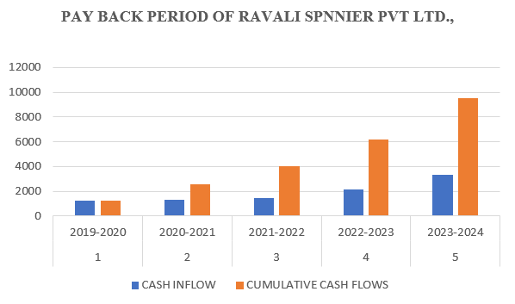

Source: Table-1

Table-1explains that the PBP can be used as a criterion to accept or reject an investment proposal. A proposal whose actual payback period is more than what is pre-determined by the management. PBP thus, is useful for the management to accept the investment decision and also to assist the management to know that the initial investment is recovered in 1.1884years.

**Table-2**

###### AVERAGE RATE OF RETURN OF RAVALI SPNNIER PVT LTD.,

|  |  |
| --- | --- |
| **YEARS** | **EARNINGS AFTER TAX (EAT)** |
| 2019-2020 | 1244.84 |
| 2020-2021 | 1300.02 |
| 2021-2022 | 1481.32 |
| 2022-2023 | 2169.96 |

###### 

###### 

###### Source: Compiled from the Annual Reports of the Ravali Spinner Pvt Ltd.,

**GRAPH-2**

###### 

Source: Table-2

Table 2. explains that the ARRmethod allows fixing a minimum rate of return. Any project expected to give a return below it will be straight away rejected. The average rate of return is as good as 50.02 % of depicts the prospects of management efficiency.

**Table-3**

**DISCOUNTED CASH FLOW OF RAVALI SPNNIER PVT LTD.,**

|  |  |  |  |
| --- | --- | --- | --- |
| **YEARS** | **CFAT’S** | **PVIF @ 10%** | **PV’S** |
| 2019-2020 | 1244.84 | 0.909 | 1131.55 |
| 2020-2021 | 1300.02 | 0.826 | 1073.81 |
| 2021-2022 | 1481.32 | 0.751 | 1112.47 |
| 2022-2023 | 2169.96 | 0.683 | 1482.08 |
| 2023-2024 | 3348.75 | 0.620 | 2076.22 |
| TOTAL | | | 6876.13 |
| LESS: Initial Investment | | | 2687.87 |
| NPV: | | | 4188.26 |

Source: Compiled from the Annual Reports of the Ravali Spinner Pvt Ltd

**GRAPH-3**

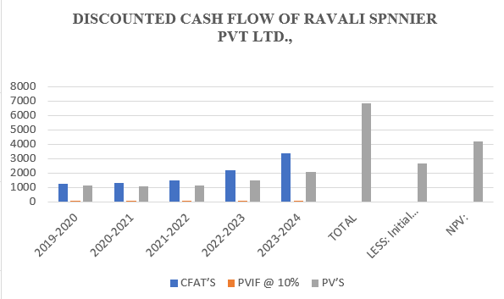

Source: Table-3

Table 3. explains that the accept -reject decision of NPV is very simple. If the NPV is positive then the project should be accepted and if NPV is negative then the project should be rejected

**Table-4**

**PROFITABILITY INDEX OF RAVALI SPNNIER PVT LTD.,**

|  |  |  |  |
| --- | --- | --- | --- |
| **YEARS** | **CFAT’S** | **PVIF @ 10%** | **PV’S** |
| 2019-2020 | 1244.84 | 0.909 | 1131.55 |
| 2020-2021 | 1300.02 | 0.826 | 1073.81 |
| 2021-2022 | 1481.32 | 0.751 | 1112.47 |
| 2022-2023 | 2169.96 | 0.683 | 1482.08 |
| 2023-2024 | 3348.75 | 0.620 | 2076.22 |
| TOTAL: | | | **6876.13** |

Source: Compiled from the Annual Reports of the Ravali Spinner Pvt Ltd.,

**GRAPH-4**

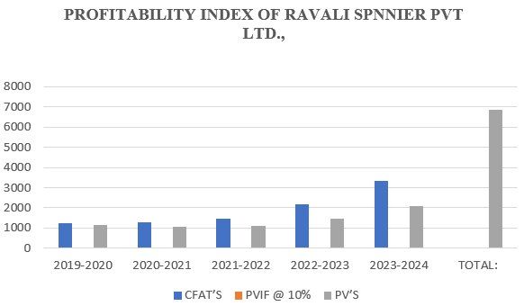

Source: Table-4

Table 4. explains that the There is a slight difference between present value index method and profitability index method. Under profitability index method the present value of cash inflows and

cash outflows are taken as accept-reject decision.

###### Table-5

###### INTERNAL RATE OF RETURN OF RAVALI SPNNIER PVT LTD.,

|  |  |  |  |  |  |  |  |
| --- | --- | --- | --- | --- | --- | --- | --- |
| **Year** |  | **PVF** | **PV** | **PVF** | **PV** | **PVF** | **PV** |
| **2019-2020** | 1244.84 | 0.531 | 661.2 01 | 0.529 | 658.52 | 0.526 | 654.78 |
| **2020-2021** | 1300.02 | 0.2921 | 379.73 | 0.2799 | 362.70 | 0.277 | 360.10 |
| **2021-2022** | 1481.32 | 0.1579 | 223.90 | 0.1481 | 219.23 | 0.145 | 214.79 |
| **2022-2023** | 2169.96 | 0.0858 | 186.18 | 0.0783 | 169.90 | 0.076 | 164.91 |
| **2023-2024** | 3348.75 | 0.0461 | 151.37 | 0.0414 | 138.63 | 0.04 | 133.95 |
|  |  |  | 1602.19 |  | 1548.98 |  | 1528.53 |

Source: Compiled from the Annual Reports of the Ravali Spinner Pvt Ltd.,

###### Graph-5

###### 

###### Source: Table-5

Table 5. explains that the IRR is the maximum rate of interest, which an organization can afford to pay on capital, invested in, is accepted if IRR exceeds the cut off rates and rejected if it is below the cut off rate. The cut off rate of is 10%, which is less than the IRR i. e76.51% hence the acceptance of .is quiet a good investment decision taken by management.

###### FINDINGS

* + - PBP thus, is useful for the management to accept the investment decision and also to assist the management to know that the initial investment is recovered in 1.884years
    - The average rate of return is as good as 50.02% of depicts the propose of management efficiency.
* The cut off rate of is 10%, which is less than the IRR i.e. 76.51% hence the acceptance of is quite a good investment decision taken by management
* Under profitability index method the present value of cash inflows and cash outflow are taken as accept reject decision

###### SUGGESTIONS

* As large sum of money is involved which influences the profitability of the firm making capital budgeting an important task.
* Long term investment once made cannot be reversed without significance loss of invested capital.
* A proper mix of capital investment is quite important to ensure adequate rate of return on investment, calling for the need of capital budgeting.

###### CONCLUSION

However, the Ravali Spinners Private Limited (RSPL) is supplying crude to Tatipaka Phase II from internal sources (from Producing wells & Production installations) at cost. So that the project remains unaffected by the situations. It means the project is fully insulated/protected by increase in crude price and/or increase in exchange rate. This Project is evaluated as an independent undertaking to check the resistance, impact of outside market forces on the project.It is concluded that the project is viable in all the cases in Ravali Spinners Private Limited (RSPL) point of view as long as it maintains the Normal Annual Production Capacity.As per the above table the project showing positive returns except Crude price increased by 10% , Exchange rate increased by 10%, production decreased by 10%Hence the project is commercially viable for Ravali Spinners Private Limited (RSPL) under normal economic conditions.

**References:**

* 1. www. Ravali Spinners Private Limited **.**com
  2. www.wikepedia in reply
  3. http://rspl.ind.in

###### 